University of Wales Trinity Saint David


BA Developing leadership and Management

A quantitative study of customer perceptions and motivations influencing purchasing decisions on the fast fashion digital platform SHEIN

Module name: independent project
Student Name: Aliaa Nabhan Danouni
Student ID: 2309830
Module code: BMSW6009
Tutor: Jaliya De Silva
Supervisor: Dr Badir Miftah
Submission date: 10/07/2026
Word count: 8800

Al acknowledgement

I confirm that this dissertation is entirely my own work and has not been written by anyone else.
All research, analysis, interpretation of findings, and conclusions are my own independent work.
I have retained drafts, notes, and supporting materials used during the preparation of this dissertation and can provide them if required.

Executive Summary

This dissertation investigated the factors influencing customer purchasing motivation and overspending behaviour on the SHEIN digital retail platform. The study aimed to identify the key factors that motivate consumers to purchase from SHEIN, examine the relationships between customer perception, pricing factors, social media influence, purchasing motivation, and overspending behaviour, and provide recommendations for reducing unnecessary consumer spending.
A quantitative research method was adopted. Using a convenience sampling technique, 90 valid responses were collected through an online questionnaire distributed via Google Forms. The collected data were analysed using descriptive statistics, Pearson’s correlation analysis, and independent-samples t-tests.
The findings showed that customer perception, competitive pricing, and social media influence all had significant positive relationships with purchasing motivation. Social media influence demonstrated the strongest relationship with purchasing motivation, while purchasing motivation was also positively associated with overspending behaviour. Furthermore, customer perception showed a moderate positive relationship with overspending behaviour. However, the independent-samples t-test revealed no statistically significant difference in purchasing motivation between participants who had previously purchased from SHEIN and those who had not.
The study concluded that SHEIN’s low prices, promotional offers, and social media marketing strategies strongly encouraged purchasing behaviour and may contribute to consumer overspending. Based on the findings, several practical recommendations were offered for both consumers and digital retailers to promote more responsible purchasing behaviour. The study also acknowledged several limitations, including the use of convenience sampling and a small sample size, and suggested opportunities for future research involving larger and more diverse populations.

Acknowledgements
I would like to express my sincere gratitude to my supervisor Dr Badir Miftah for the valuable guidance, constructive feedback, and continuous support provided throughout this dissertation.
I would also like to thank the academic staff at the University of Wales Trinity Saint David for the knowledge, support, and learning opportunities that contributed to the completion of this study.
My sincere appreciation is extended to all the participants who kindly completed the questionnaire and made this research possible.
Finally, I would like to thank my family for their encouragement, patience, and continuous support throughout my academic journey.

Table of contents:
Chapter 1
1.1. Introduction to organisation..........................................................................................6
1.2. Aim and Objectives.......................................................................................................9
1.3. Research question .......................................................................................................9
Chapter 2: Literature Review
2.1 Customer perception.....................................................................................................10
2.2 Customer Motivation......................................................................................................11
2.3 Price and Cost-Related Factors.....................................................................................12
2.4 Purchasing Behaviour....................................................................................................13
2.5 Overspending Behaviour................................................................................................14
Chapter 3: Research Methodology
3.1 Research Methodology...................................................................................................15
3.2 Research Philosophy and Research Onion....................................................................17
3.3 Ethical Considerations....................................................................................................18
3.4 Data Analysis Techniques..............................................................................................18
3.5 Research Hypotheses....................................................................................................20
3.6 Chapter Summary...........................................................................................................20
Chapter 4: Analysis of Data and Discussion of Results
4.1 Introduction......................................................................................................................21
4.2 Demographic Profile of Respondents..............................................................................21
4.3 Customer Perceptions and Pricing Motivations ..........................................................… 22
4.4 Analysis of Social Media Influence on Purchasing Decisions ...................................…. 23
4.5 Analysis of Consumer Behaviour and Overspending Tendencies...............................… 24
4.6 Correlation Analysis and Hypothesis Testing..................................................................26
4.7 Independent Sample T-Test Analysis..............................................................................28
Chapter 5: Discussion, Implication and Future Research
5.1 Introduction......................................................................................................................29
5.2 Discussion of Findings.....................................................................................................30
5.2.1 Discussion of Hypothesis 1...........................................................................................30
5.2.2 Discussion of Hypothesis 2...........................................................................................30
5.2.3 Discussion of Hypothesis 3...........................................................................................31
5.2.4 Discussion of Hypothesis 4...........................................................................................32
5.2.5 Discussion of Hypothesis 5...........................................................................................33
5.3 Practical Implications........................................................................................................33
5.4 Limitations of the Study....................................................................................................34
5.5 Recommendations for Future Research......................................................................…. 34
6-conclusion....................................................................................................................…… 34
7-References ....................................................................................................................…. 35
8-Appendix ........................................................................................................................… 41

Table | Title | Page
Table 1 | Demographic Characteristics of Respondents | 21
Table 2 | Customer Perceptions and Pricing Related Motivational Factors on SHEIN | 22
Table 3 | Social Media Influence and Consumer Purchasing Motivation | 23
Table 4 | Analysis of Consumer Behaviour and Overspending Tendencies | 24
Table 5 | Pearson Correlation Analysis of the Research Hypotheses | 26
Table 6 | Independent Samples t-Test Results for Purchasing Motivation by Previous SHEIN Purchase Experience | 28
List of Tables

  - Introduction to organisation

Over the past decade, rapid developments in digital technology and increased internet availability have significantly transformed consumer purchasing behaviour. Online shopping has become an essential part of everyday life for many consumers. However, this shift has also encouraged faster and less considered purchasing decisions.
As a result, consumers may rely more on immediate impressions rather than careful evaluation when making purchasing decisions. Research suggests that specific website features, such as design, layout, and promotional cues, can encourage impulsive purchasing behaviour in online shopping environments (Narimanfar and Ghafari Ashtiani, 2021).

Against this background, the fast fashion industry has expanded rapidly, driven by the growing demand for affordable and trend-driven clothing. This model is particularly attractive to younger consumers influenced by social media and changing trends. Studies have shown that social media exposure plays a significant role in shaping consumer preferences and increasing purchasing frequency (Farivar, Wang, and Yuan, 2023).
Among fast fashion platforms, SHEIN has become prominent global retailer due to its competitive pricing and strong digital presence. The platform regularly updates its product range to reflect current trends, encourages more frequent visits consumers to visit the platform more frequently. In addition, SHEIN uses data-driven technologies and digital strategies to respond quickly to consumer demand and personalise the shopping experience. These strategies aim to increase user engagement and may encourage repeated purchasing behaviour (Zhou, 2025).

In this context, several key variables can be showed in relation to consumer behaviour on SHEIN. These include price attractiveness, promotional strategies, social media influence, and digital engagement features. These variables shape customer perceptions and motivations, influencing purchasing decisions. For example, low prices and frequent discounts may attract consumers and create a perception of value. At the same time, features such as flash sales and limited time offer may create a sense of urgency, encouraging consumers to make quicker decisions.
Furthermore, SHEIN uses digital engagement strategies, such as reward systems, point collection, and personalised recommendations, to encourage regular user interaction. These features may increase app usage and purchasing activity.
Research indicates that promotional strategies and time pressure can significantly increase impulsive buying behaviour in online shopping environments (Sun, Zhang, and Zheng, 2023).
In recent years, digital fashion platforms such as SHEIN have gone beyond traditional pricing strategies by introducing a range of interactive and promotional features designed to maintain continuous user engagement. Regular product updates and ongoing promotions continually expose consumers to new purchasing opportunities.
This type of environment may influence how consumers make decisions, as repeated exposure to offers and incentives can reduce the time spent evaluating purchases. As a result, users may be more likely to make quicker and unplanned buying decisions. While such strategies can be effective in increasing customer engagement and sales, they also raise questions about their impact on consumer behaviour.
In particular, the combination of promotional pressure and continuous interaction may encourage patterns of purchasing that are not always planned or necessary.

Overspending has become a key issue in the fast fashion industry. Platforms such as SHEIN offer constant new products and frequent discounts, which can encourage consumers to buy more than they actually need. As a result, the distinction between necessary and non-essential purchases may become less clear, contributing to higher levels of spending. From a broader perspective, this pattern reflects concerns related to overspending within the fast fashion industry, where rapid product turnover and constant availability encourage repeated purchasing behaviours that are not always planned or required (Mathew and Spinelli, 2025).

Despite the rapid growth of SHEIN and the increasing attention given to online consumer behaviour, there remains a lack of research that specifically examines how these variables interact within a single platform. In particular, limited studies have focused on the relationship between customer perceptions, motivations, and overspending behaviour in the context of SHEIN, especially within the UK market. Most existing research tends to examine general online shopping behaviour or fast fashion consumption, rather than analysing the combined effect of pricing strategies, promotional tools, and digital engagement features within one platform. Therefore, the present study investigates show customer perceptions and purchasing motivations are shaped by key platform-related factors and how this influence overspending behaviour among SHEIN customers.

1.2 Aim and objectives

The Aim:
To examine customer perceptions and motivations influencing purchasing decisions on the fast fashion digital platform SHEIN.

The Objectives:

1.To identify key factors that motivate customers to shop from SHEIN.

2. To analyse the relationship between customer perception and purchasing motivation on the SHEIN platform.

3. To examine the key factors that contribute to overspending behaviour among SHEIN customers.

1.3 The questions:
1-What factors motivate customers to shop from SHEIN?

2-How do customer perceptions influence purchasing motivations on SHEIN?

3- What is the relationship between customer perception, motivation, and overspending behaviour?

2-Literature Review
This literature review examines the key factors influencing consumer decision-making in fast fashion digital platforms. It focuses on several important variables identified in previous research, including customer perception, consumer motivation, price-related factors, purchasing behaviour, and overspending.
Existing studies suggest that consumer decision-making is influenced by a combination of psychological, economic, and digital factors. However, there is still limited understanding of how these variables interact within a single platform context. Therefore, this section critically reviews the existing literature to provide a foundation for analysing consumer behaviour across the key variables examined in this study.

2.1 Customer Perception:
Customer belief refers to the way consumers evaluate a digital platform based on their experiences, expectations, and the information available to them. In online retail environments, perceptions shaped by several factors, including perceived value, trust, website usability, and the overall shopping experience. These factors contribute to shaping customers’ attitudes towards a platform and determine whether they consider it reliable and suitable for purchasing.

According to the Theory of Planned Behaviour (TPB) by Ajzen, consumer attitudes and perceptions play a significant role in shaping behavioural intentions, which ultimately influence actual purchasing decisions. In digital shopping contexts, positive perceptions, such as trust and perceived value, can increase consumers’ willingness to engage with a platform and complete purchases (Ajzen, 1991). This is particularly relevant in fast fashion environments, where consumers are continuously exposed to digital content, promotional activities, and trend-driven products.

Previous studies support this view, showing that perceived value and trust are significant predictors of online consumer behaviour (Dam, 2020). In addition, research by Rita et al. (2019) highlights that website quality and user experience strongly influence customer perceptions and, consequently, purchase intentions (Hanaysha, Ramadan and Alhyasat, 2025).
However, some studies focus on general online retail contexts rather than fast fashion platforms, which limits their applicability to platforms such as SHEIN. This highlights the need for research that specifically examines consumer behaviour within fast fashion digital environments.

In fast fashion environments, perception is often associated with low pricing, product variety, and convenience, particularly among younger consumers who frequently engage with digital platforms.
However, although customer perception is a crucial factor, it may not be sufficient on its own to fully explain purchasing decisions within highly competitive fast fashion markets. Consumers may prioritise price and promotional offers over their initial perceptions, suggesting that perception alone cannot fully predict decision-making. Therefore, it is necessary to examine how perception interacts with price-related factors to better understand consumer decision-making within fast fashion digital platforms such as SHEIN.

2.2 Customer Motivation
Consumer motivation is defined as the internal and external factors that drive consumers to engage in purchasing behaviour. In online shopping contexts, purchasing behaviour is often driven by a range of factors such as convenience, cost, product diversity, and social influence. With the growth of digital retail platforms, customers interact with products and make purchase decisions differently. Online shopping enables easier access to products and services within a single platform.
Maslow’s Hierarchy of Needs theory suggests that consumer behaviour is influenced by multiple levels of human needs, ranging from basic functional needs to psychological and social needs (Maslow, 1943). Therefore, purchase decisions on online platforms may be influenced not only by economic needs, but also by needs for self-expression, confidence, convenience, and social belonging. Digital platforms can meet these needs by providing low-cost products, personalisation, and access to a wide range of product categories. However, some researchers argue that Maslow’s theory may oversimplify consumer behaviour, as modern consumers can be influenced by multiple needs simultaneously rather than following a fixed hierarchical order (Li, 2025).

In addition to internal motivations, consumer behaviour in online shopping environments may also be shaped by external digital stimuli. The Stimulus–Organism–Response (S-O-R) model explains how marketing-related factors within digital retail platforms can affect consumers’ emotional and behavioural responses. According to this model, elements such as discount offers, reward points, coupons, promotional messages, scarcity strategies, and social media exposure can influence consumers’ emotions and encourage purchasing behaviour.

Recent studies continue to apply the S-O-R framework when examining online consumer behaviour and purchasing intentions. Several studies suggest that discounted prices and social influence can encourage impulsive buying within digital shopping environments. Emotional attachment may also strengthen this behaviour (Tanaporn Hongsuchon, Chen and Khan, 2025).
However, many existing studies focus on general online retail contexts, which may not fully capture the unique dynamics of fast fashion platforms such as SHEIN.

Consumers who are regularly exposed to online marketing content may become more engaged with digital retail platforms, particularly when promotional content appears frequently through notifications and social media advertisements. As a result, some consumers may make purchasing decisions more quickly and with less consideration.

This can be observed in platforms such as SHEIN, which frequently use promotional strategies, personalised notifications, and reward systems to maintain consumer engagement. In addition to clothing products, the platform also offers accessories, beauty products, and household items within the same application. This may increase convenience for consumers and encourage more frequent use of the platform.

Nevertheless, although the S-O-R model is widely used in consumer behaviour research, some researchers argue that relying on a single theoretical framework may not fully explain the complexity of consumer decision-making in digital environments. Purchasing behaviour can also be influenced by private experiences, emotional differences, and social factors that vary between consumers (Li, García-de-Frutos and Ortega-Egea, 2025).

2.3 Price and Cost-Related Factors:
Price is one of the most critical factors influencing consumer decision-making in online purchasing contexts. Consumers in digital retail environments regularly compare prices across multiple platforms before making a purchase, especially during periods of economic uncertainty and rising living costs. Therefore, pricing, and perceived value have become increasingly important in shaping online purchasing behaviour. Research shows that customers are more likely to engage with platforms offering competitive prices, discounts, and a strong sense of value for money (Escobar-Farfán et al., 2025).

In addition to basic affordability, digital retail platforms increasingly apply promotional pricing strategies to attract consumers and sustain purchasing activity. Offering discount codes, flash sales, free delivery, and limited time offers can enhance consumers’ perception of value and encourage quicker purchasing decisions. Existing research suggests that time-limited promotions and discounted pricing can increase impulsive buying behaviour in online shopping environments (Ngo et al., 2024). As a result, consumers may perceive promotional offers as opportunities to save money, even when they do not have an immediate need to purchase.

This can be observed in platforms such as SHEIN, which promote low-cost products across a wide range of categories, including fashion items, accessories, beauty products, and home goods. Having multiple product categories within a single platform increases convenience for consumers and may encourage more frequent use. Furthermore, consumer engagement and repeat purchasing behaviour can be strengthened by promotional strategies such as reward systems, discounts, and personalised recommendations.

However, while affordability and promotional pricing strategies may improve accessibility for consumers, they may also have unintended consequences. Repeated exposure to promotional offers may be perceived as an opportunity to save money; however, such strategies can lead to impulsive buying and increased spending over time. This suggests that price-related factors influence consumer behaviour not only through economic value but also through psychological and emotional responses within online shopping environments (Zhao et al., 2021).

2.4 Purchasing Behaviour
Consumer purchasing behaviour within digital retail environments has changed significantly due to the increasing accessibility of online shopping platforms and mobile applications. Consumers are now able to browse products, compare alternatives, and complete purchases more quickly and conveniently than in traditional retail environments. Research suggests that digital retail environments may influence consumer decision-making through convenience, continuous product exposure, and interactive online engagement (Ngo et al., 2024).

The development of digital retail platforms has also changed the way consumers interact with products and brands. Features such as personalised recommendations, customer reviews, and targeted advertisements may encourage consumers to spend longer periods browsing online platforms, even without an initial intention to purchase. Continuous browsing behaviour may increase exposure to additional products and influence purchasing decisions over time. Previous studies show that recommendation systems and digital interaction tools can shape consumer preferences and online purchasing patterns within e-commerce platforms (Xiao et al., 2023).

Social media platforms also play a vital role in influencing purchasing behaviour, particularly among younger consumers who are frequently exposed to influencer marketing, online reviews, and trend-driven content. Continuous exposure to such digital content may encourage faster purchasing decisions and repeated interaction with online retail platforms (Farivar, Wang, and Yuan, 2023). This can be observed in platforms such as SHEIN, where products are continuously updated and promoted through personalised feeds designed to maintain consumer engagement and encourage repeated browsing behaviour.

However, although digital retail platforms may improve convenience and accessibility for consumers, some researchers argue that continuous exposure to personalised marketing content and repeated product recommendations may reduce rational decision-making during the purchasing process. Consumers may become more influenced by emotional responses and habitual browsing behaviour rather than actual purchasing need, which may contribute to impulsive and repetitive purchasing patterns (Zhao et al., 2021).

2.5 Overspending Behaviour:
Overspending behaviour has become more common in digital retail contexts, where consumers are continuously exposed to products, promotional content, and personalised marketing strategies. The accessibility of online shopping platforms enables consumers to browse and purchase items more frequently and conveniently than in traditional retail environments. Frequent exposure to digital marketing content and social media advertisements can encourage impulsive purchasing decisions and excessive spending. Studies show that social media exposure and digital engagement can significantly influence impulse buying behaviour in online retail environments (Singh et al., 2023).

Digital retail platforms increasingly utilise personalised recommendations, flash sales, reward systems, and limited time offers to maintain consumer engagement and promote repeated purchasing activity. Consumers may view promotional offers as opportunities to save money; however, frequent low-cost purchases may cumulatively lead to increased overall spending. Continuous engagement with digital retail platforms may also reduce consumers' awareness of their actual spending behaviour over time.

This is evident in platforms such as SHEIN, where users are consistently exposed to continuous product updates, personalised feeds, and trend-based advertising designed to maintain engagement and encourage habitual browsing behaviour. The platform offers not only fashion items but also beauty products, household goods, and accessories, thereby increasing access to multiple product categories within a single application. Such strategies may encourage habitual purchasing behaviour and contribute to higher levels of online spending among consumers.

However, while digital retail platforms can enhance accessibility and convenience for consumers, some researchers argue that social commerce and continuous digital exposure may promote excessive spending and reduce rational financial decision-making. Consumers may become increasingly influenced by emotional satisfaction, entertaining shopping experiences, and online interaction strategies rather than actual purchasing needs (Elshaer et al., 2024). Therefore, overspending in digital contexts may reflect not only economic behaviour but also psychological and behavioural responses influenced by highly interactive digital retail environments.

3.1 Research Methodology
This study adopts a quantitative research method to investigate the factors influencing consumer purchasing behaviour and overspending tendencies within digital retail platforms such as SHEIN. Quantitative research is widely used to collect numerical data and examine relationships between variables through statistical techniques. This approach is considered appropriate for the current study because it allows behavioural patterns and purchasing tendencies to be measured in a structured and objective manner. According to Saunders, Lewis, and Thornhill (2019), quantitative research is particularly suitable for studies that aim to analyse relationships between variables and generate measurable findings.

The quantitative method was selected because the aim of the study is to examine several variables associated with online consumer behaviour, including customer perception, consumer motivation, pricing factors, purchasing behaviour, and overspending behaviour. Using quantitative methods may support the identification of behavioural trends across a larger number of participants and improve the objectivity of the findings. However, although quantitative research provides measurable data, some researchers criticise this method because it may not fully capture the deeper emotional experiences and personal meanings associated with consumer behaviour in digital shopping environments. Despite this limitation, the approach remains appropriate for the current study due to the behavioural and pattern-based nature of the research objectives.

Data will be collected through an online questionnaire distributed using Google Forms. The questionnaire will consist of close-ended questions designed to measure participants’ attitudes, behaviours, and experiences related to online shopping platforms such as SHEIN. Online questionnaires are widely used in consumer behaviour research because they allow data to be collected efficiently from multiple participants within a brief period. Nevertheless, relying on self-reported responses may increase the possibility of response bias, as participants may not always provide fully accurate representations of their purchasing behaviour.

A five-point Likert scale, ranging from “strongly disagree” to “strongly agree,” used to assess participants’ responses. Likert scales are commonly used in quantitative research, as they provide a systematic approach for measuring opinions, attitudes, and behavioural responses (Jebb, Ng, and Tay, 2021). The use of a Likert scale is considered appropriate as it facilitates the quantification and statistical analysis of responses (Koo and Yang, 2025). However, some studies suggest that Likert scales may limit the expression of deeper opinions by restricting responses to specific categories. Despite these limitations, the scale is widely recognised in consumer behaviour research for its practicality and suitability for statistical analysis.

The study employs a convenience sampling technique, whereby participants are selected based on their accessibility and availability. The questionnaire is distributed to university students, as well as friends, relatives, and colleagues who are familiar with the SHEIN platform.

The target sample size for this study ranges from 80 to 100 participants. This size is considered appropriate for an exploratory quantitative study that aims to examine customer perceptions, purchasing motivation, purchasing behaviour, and overspending tendencies within digital retail environments. According to Taherdoost (2017), the adequacy of sample size depends on the research objectives, the target population, and the statistical techniques used.

Accordingly, this sample size is expected to provide sufficient data for descriptive statistics, correlation analysis, and independent sample t-tests...
, while remaining manageable within the scope of an undergraduate dissertation.
A total of 90 valid responses were obtained, indicating that the targeted sample size was successfully achieved and was appropriate for addressing the research objectives.

However, convenience sampling may limit the generalisability of the findings, as participants are selected from easily accessible groups rather than from a broader consumer population. Despite this limitation, the chosen sampling strategy is considered-appropriate for achieving the study’s objectives and collecting relevant data from SHEIN consumers.

The collected data will be analysed using descriptive statistics, t-tests, and correlation analysis to identify behavioural patterns and examine relationships between variables related to online purchasing behaviour and overspending within digital retail environments. Although statistical analysis may improve the reliability of the findings, the results may still be influenced by participants’ subjective responses and individual shopping experiences.

3.2 Research Philosophy and Research OnionFramework:

The current study follows the positivist research philosophy, which is commonly associated with quantitative research methods. Positivism focuses on objective measurement, observable facts, and the statistical examination of relationships between variables. This philosophy is widely applied in consumer behaviour research because it supports the collection of measurable data and the identification of behavioural patterns through structured analysis. According to Saunders, Lewis, and Thornhill (2019), positivism allows researchers to produce objective findings through the use of numerical data and statistical techniques. Similarly, Queirós, Faria, and Almeida (2017) argue that quantitative research is particularly effective when the aim of the study is to examine relationships between variables and generate measurable results across larger participant groups.

The positivist philosophy was considered-appropriate for the current study because it aims to investigate consumer purchasing behaviour and overspending tendencies within digital retail platforms such as SHEIN using numerical data and statistical analysis. The study seeks to identify patterns associated with customer perception, consumer motivation, pricing factors, overspending and purchasing behaviour within online shopping environments. Therefore, adopting a positivist stance supports the use of structured data collection methods and statistical analysis in order to produce objective findings.

The study also follows Saunders’ Research Onion framework to support the selection of the research methodology and overall research design. The Research Onion provides a systematic framework that assists researchers in making methodological decisions related to research philosophy, research approach, data collection methods, sampling strategies, and data analysis techniques. In the current study, the positivist philosophy supports the use of a quantitative research approach, a questionnaire for data collection, and various statistical analysis methods such as descriptive statistics, t-tests, and correlation analysis.

Nevertheless, although positivism supports objectivity and measurable findings, some researchers argue that quantitative approaches may not always capture the deeper emotional meanings and subjective experiences associated with online consumer behaviour (Lim, 2024). Consumer purchasing decisions within digital retail environments may sometimes be influenced by emotional responses, individual experiences, and psychological factors that cannot always be fully explained through numerical data alone. Despite this limitation, the positivist philosophy remains suitable for the current study because the research primarily focuses on identifying measurable behavioural patterns and relationships between variables within digital shopping environments

3.3 Ethical Considerations:
Ethical considerations are important in ensuring that research is conducted responsibly and professionally. According to Resnik (2020), research ethics help protect participants’ rights, maintain confidentiality, and ensure integrity throughout the research process. Since the current study involves collecting primary data through an online questionnaire, particular attention has been given to maintaining ethical standards during data collection and participant involvement.

Participation in the study entirely voluntary, and respondents have informed about the purpose of the research before completing the questionnaire. As highlighted by Bos (2020), informed consent and participant protection are considered essential elements of ethical research involving human participants. Therefore, participants have the right to withdraw from the study at any stage without pressure or negative consequences. In addition, no sensitive personal information requested. Moreover, all responses will remain anonymous in order to protect participants’ privacy.

The questionnaire distributed via Google Forms to individuals familiar with online shopping platforms such as SHEIN. All collected information used solely for academic purposes related to this dissertation have not shared with external organisations or third parties. Furthermore, the collected data stored securely and handled confidentially throughout the research process.
However, although online questionnaires may provide convenience and accessibility for both researchers and participants, self-reported responses may sometimes be influenced by personal interpretation or response bias. As a result, participants may not always provide fully accurate representations of their purchasing behaviour. Despite this limitation, online questionnaires remain widely used in consumer behaviour research because they allow researchers to collect data efficiently from larger participant groups while maintaining anonymity and flexibility.

3.4 Data Analysis Techniques:
The data collected from the questionnaire were analysed using statistical techniques to identify behavioural patterns and relationships associated with online purchasing behaviour and overspending tendencies within digital retail platforms such as SHEIN.
Quantitative data analysis is considered-appropriate for the current study because it allows numerical responses to be interpreted systematically and supports the production of measurable findings. According to Mishra et al. (2019), descriptive statistical analysis plays a significant role in organising, summarising, and interpreting quantitative data in research studies.
In the current study, descriptive statistics were used to present the collected data through percentages, frequencies, tables, and charts.
This method is considered useful for identifying general patterns in participants’ responses and providing a clearer understanding of customer attitudes, purchasing habits, and overspending behaviour within online shopping environments.

Descriptive analysis may also enhance the interpretation of behavioural trends associated with digital retail platforms such as SHEIN.
In addition to descriptive statistics, independent-samples t-tests were conducted to examine whether significant differences exist between demographic groups, particularly male and female participants, in relation to purchasing behaviour and overspending tendencies. T-tests are commonly used in quantitative research to compare mean differences between two groups and determine whether these differences are statistically significant (Mishra et al., 2019). This analysis is considered-appropriate for the current study because consumer purchasing behaviour may vary according to demographic characteristics and online shopping experiences.
Correlation analysis was also conducted to examine the relationships between customer perception, consumer motivation, pricing factors, purchasing behaviour, and overspending behaviour.
This analysis helped determine whether significant associations existed between these variables and assess the strength and direction of these relationships. According to Akoglu (2018), correlation analysis is widely used to measure relationships between variables and provide a clearer understanding of behavioural patterns. Within the current study, correlation analysis was used to test the proposed research hypotheses and examine how digital retail factors may influence consumer purchasing behaviour and overspending tendencies.

Nevertheless, although statistical analysis may improve the reliability and objectivity of the findings, the interpretation of quantitative data may still be influenced by participants’ subjective responses and individual shopping experiences. Furthermore, statistical relationships identified in the study may indicate associations between variables without necessarily confirming direct causation. Despite these limitations, the selected analysis techniques remain appropriate for the current research, as they support the identification of measurable behavioural patterns within online shopping environments.

3.5 Research Hypotheses
In quantitative research, hypotheses are used to provide clear and testable predictions about the relationships between variables, helping to guide statistical analysis. They allow researchers to examine whether significant relationships exist between the variables being studied and to test the research objectives in a structured manner (Saunders, Lewis, and Thornhill, 2019). Based on the research objectives, research questions, and relevant literature, the following hypotheses have been developed for this study.

H1: Customer perception is significantly related to purchasing motivation among SHEIN consumers.
H2: Pricing factors (such as low prices, discounts, and promotional offers) are significantly related to purchasing motivation among SHEIN consumers.
H3: Social media influence is significantly related to purchasing motivation among SHEIN consumers.
H4: Purchasing motivation is significantly related to overspending behaviour among SHEIN consumers.
H5: Customer perception is significantly related to overspending behaviour among SHEIN consumers.
3.6 Chapter Summary
This chapter outlined the research methodology adopted for the current study. It explained the use of a quantitative approach and justified its suitability for examining customer perceptions, purchasing motivation, purchasing behaviour, and overspending tendencies among SHEIN consumers.
Furthermore, the chapter discussed the research philosophy, sampling strategy, ethical considerations, data collection method, and data analysis techniques. The research hypotheses were also developed to guide the statistical analysis and examine the relationships between the study variables.
The following chapter presents and analyses the findings obtained from the questionnaire survey and discusses the results in relation to the research objectives and hypotheses.

4-Analysis of Data and Discussion of Results

4.1Introduction
This chapter presents and analyses the findings obtained from the questionnaire survey conducted among consumers familiar with the SHEIN platform. It focuses on examining customer perceptions, purchasing motivation, purchasing behaviour, and overspending tendencies within the context of online fast-fashion retailing. The chapter also aims to address the research objectives and answer the research questions outlined in Chapter 1.
The collected data were analysed using quantitative techniques, including descriptive statistics, correlation analysis, and independent sample t-tests, as discussed in Chapter 3. Descriptive statistics were used to summarise participants’ responses and demographic characteristics, while correlation analysis was used to explore the relationships between the study variables and test the proposed hypotheses. In addition, independent sample t-tests were applied to identify any significant differences between demographic groups.
The results are presented using tables and statistical outputs, followed by an interpretation of the findings in relation to the research objectives, hypotheses, and relevant literature.

4.2 Demographic Profile of Respondents

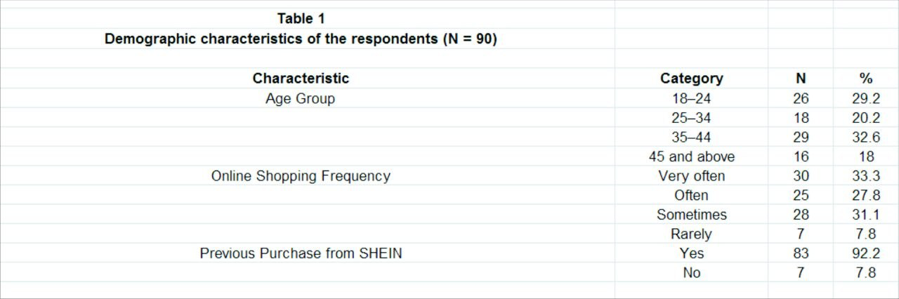
Table 1: Demographic Characteristics of Respondents

Table 1 presents the demographic characteristics of the respondents who participated in this study. The results show that the largest proportion of participants (32.6%) were aged between 35 and 44, followed by those aged 18–24 (29.2%). In contrast, respondents aged 45 and above represented the smallest group (18.0%). This indicates that the sample included a reasonably diverse age range of consumers familiar with online shopping platforms.
In terms of online shopping frequency, 33.3% of respondents reported shopping online very often, while 31.1% stated that they sometimes shop online and 27.8% indicated that they shop often. Only 7.8% reported that they rarely shop online. This suggests that most participants were active online shoppers and therefore had relevant experience with digital retail environments.
Additionally, 92.2% of respondents confirmed that they had previously purchased products from SHEIN, while only 7.8% had no prior experience with the platform. This shows that the majority of participants were familiar with SHEIN, making them well positioned to provide meaningful insights into customer perceptions, purchasing motivation, purchasing behaviour, and overspending tendencies.
Overall, the demographic profile indicates that the sample was suitable for addressing the research objectives and exploring consumer behaviour in the context of SHEIN.

4.3 Customer Perceptions and Pricing Motivations
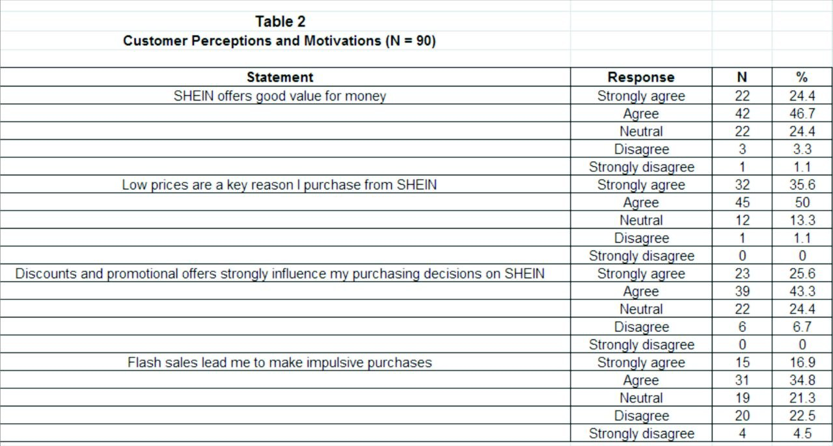
Table2: Customer perceptions and pricing -related Motivational Factors on SHEIN.

Table 2 presents respondents’ perceptions of SHEIN’s pricing strategies and how these factors influence their purchasing decisions. The results show that most participants held positive views of the platform’s value proposition. A large proportion of respondents agreed or strongly agreed that SHEIN offers good value for money, saying that consumers generally perceive the platform as providing affordable products relative to its prices.
Low prices also emerged as one of the strongest motivations for purchasing from SHEIN. Most respondents agreed or strongly agreed that price is a key reason for choosing the platform, highlighting the importance of price competitiveness in attracting and retaining customers within the fast-fashion sector.
In addition, discounts and promotional offers were found to play a significant role in influencing purchasing decisions. Many respondents reported that such promotions encourage them to buy from SHEIN, suggesting that marketing incentives, such as discounts and special offers, remain effective in stimulating consumer demand.
However, responses related to flash sales were more mixed. While a number of participants agreed that flash sales can encourage impulsive purchases, others expressed neutral or differing opinions. This may indicate that time-limited promotions influence some consumers more than others rather than having a uniform effect across all customer groups.
Overall, the findings suggest that perceived value, low pricing, and promotional incentives are important motivational factors influencing purchasing behaviour on SHEIN. These findings support the first research objective, which aimed to identify the key factors motivating consumers to shop on the platform.

4.4-Analysis of Social Media Influence on Purchasing Decisions
Table 3: Social Media Influence and Consumer Purchasing Motivation
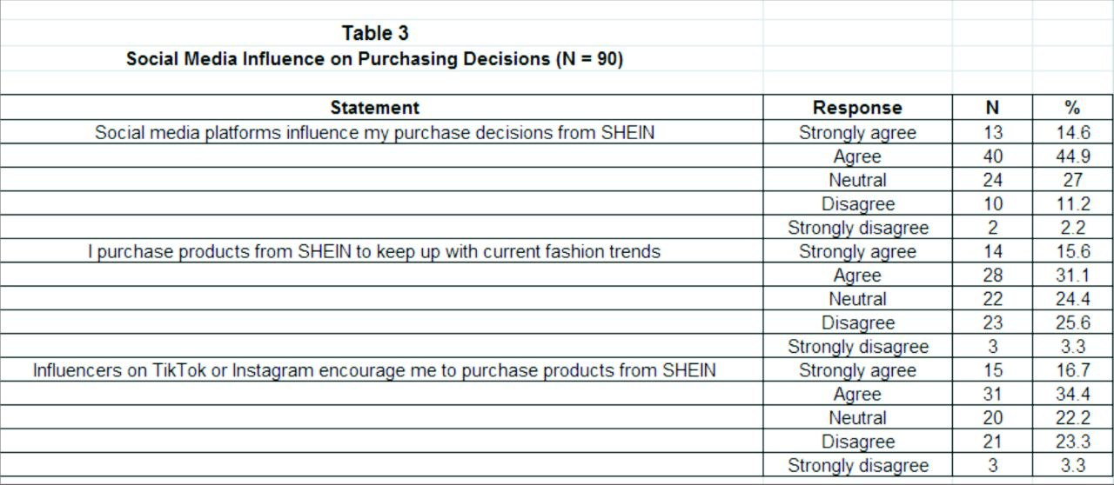
Table 3 presents respondents’ views on the influence of social media on their purchasing decisions when shopping from SHEIN. The results show that social media plays a noticeable role in shaping consumer behaviour and purchasing motivation.
A large proportion of respondents agreed that social media platforms influence their purchasing decisions. This indicates that social media has become an important source of product information and awareness within the fast-fashion industry.
Similarly, many participants reported purchasing from SHEIN in order to keep up with current fashion trends. This suggests that consumer decisions are not only driven by price and availability, but also by the desire to stay updated with popular styles promoted online.
Moreover, a considerable number of respondents agreed that influencers on platforms such as TikTok and Instagram encourage them to buy from SHEIN. This highlights the growing importance of influencer marketing in shaping consumer attitudes and driving purchasing behaviour in online retail.
However, some respondents expressed neutral or differing views regarding the influence of social media and influencers. This suggests that purchasing decisions are influenced by multiple factors and that the impact of social media may differ across individuals.
Overall, the results indicate that social media platforms, fashion trends, and influencer marketing play a significant role in influencing purchasing motivation among SHEIN consumers. These findings support the study’s objective of examining key motivational factors and appear to support Hypothesis 3, which proposes a relationship between social media influence and purchasing motivation.
4.5 Analysis of Consumer Behaviour and Overspending Tendencies
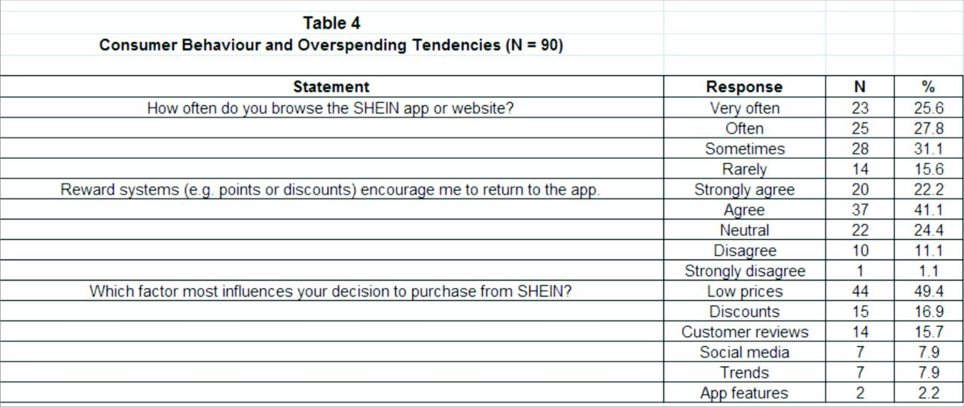

Table 4 presents respondents’ browsing behaviour, engagement with reward systems, and the main factors influencing their purchasing decisions on SHEIN. The results provide useful insight into consumer behaviour and the factors that may contribute to increased purchasing activity and potential overspending.
The findings show that many respondents regularly browse the SHEIN app or website. While 25.6% reported browsing very often and 27.8% stated that they browse often, the largest group (31.1%) indicated that they sometimes browse the platform. This reflects a high level of engagement, which may increase exposure to products and encourage more frequent purchasing.
Reward systems such as points, discounts, and promotional offers were viewed positively by a large proportion of participants. More than half agreed or strongly agreed that these incentives encourage them to return to the platform. This highlights the role of loyalty rewards in supporting repeated visits and ongoing purchasing behaviour.
When asked about the most important factor influencing their purchasing decisions, almost half of the respondents selected low prices. Discounts were identified as the second most influential factor, while customer reviews also played a noticeable role. In contrast, factors such as social media, fashion trends, and app features were mentioned less frequently.
However, not all respondents shared the same view regarding reward systems, as some expressed neutral or negative opinions. This suggests that the impact of promotional incentives may vary depending on individual preferences and shopping habits.
Overall, the results indicate that frequent engagement, competitive pricing, and reward systems all contribute to purchasing behaviour on SHEIN. These findings support the study’s objective of examining factors related to consumer behaviour and overspending tendencies among SHEIN consumers.

4.6 Correlation Analysis and Hypothesis Testing

To further investigate the relationships among the key variables examined in this study, correlation analysis was conducted. Pearson's correlation analysis is a statistical technique used to measure the strength and direction of the linear relationship between two continuous variables (Akoglu, 2018). It was selected because it is appropriate for examining the relationships among continuous variables and testing the research hypotheses developed in Chapter 3. In this study, Pearson's correlation analysis was used to examine the relationships between customer perception, pricing factors, social media influence, purchasing motivation, and overspending behaviour among SHEIN consumers.
Pearson's correlation coefficient (r) ranges from −1 to +1, where values closer to +1 indicate a strong positive association, values closer to −1 indicate a strong negative association, and values close to 0 indicate little or no association between the variables (Akoglu, 2018). Furthermore, the statistical significance of each correlation was evaluated using the p-value, with a significance level of p < 0.05 adopted as the criterion for determining statistical significance. The results of the Pearson correlation analysis are presented in Table 5 and are interpreted in relation to the proposed research hypotheses.
Table 5. Pearson Correlation Analysis of the Research Hypotheses (N = 90)
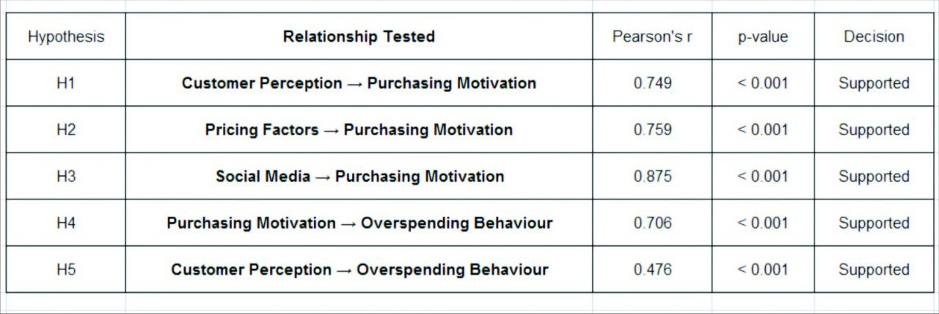

Note. Pearson correlation coefficients (r) are reported. All relationships were statistically significant (p < .001). Therefore, all five research hypotheses (H1–H5) were supported.

Interpretation of the Correlation Results
The results presented in Table 5 show that all five proposed hypotheses were supported, as statistically significant positive relationships showed among the study variables (p < .001). The findings suggest that customer perception, pricing factors, and social media influence are positively associated with purchasing motivation among SHEIN consumers. Furthermore, purchasing motivation was found to be positively associated with overspending behaviour, while customer perception also demonstrated a significant positive relationship with overspending behaviour. The strength of these relationships varied across the variables, indicating that some factors exert a stronger influence on consumer behaviour than others. Overall, these findings provide empirical support for the conceptual framework developed in Chapter 3 and demonstrate that both marketing-related factors and social influences play a significant role in shaping purchasing motivation and spending behaviour among SHEIN consumers.

Hypothesis 1 (H1)
Hypothesis 1 proposed that customer perception is positively associated with purchasing motivation among SHEIN consumers. As shown in Table 5, Pearson's correlation analysis revealed a strong positive relationship between customer perception and purchasing motivation (r = 0.749, p < .001). This suggests that consumers with more favourable perceptions of SHEIN tend to show higher levels of purchasing motivation. The relationship was statistically significant, indicating support for the proposed hypothesis. Therefore, Hypothesis 1 was supported

Hypothesis 2 (H2)
Hypothesis 2 proposed that pricing factors are positively associated with purchasing motivation among SHEIN consumers. As shown in Table 5, Pearson's correlation analysis revealed a strong positive relationship between pricing factors and purchasing motivation (r = 0.759, p < .001). This finding suggests that competitive pricing, discounts, and promotional offers are associated with higher levels of purchasing motivation among SHEIN consumers. The relationship was statistically significant, indicating that pricing-related factors play a significant role in influencing consumers' purchase decisions. These results provide support for Hypothesis 2.

Hypothesis 3 (H3)
Hypothesis 3 proposed that social media influence is positively associated with purchasing motivation among SHEIN consumers. As shown in Table 5, Pearson's correlation analysis revealed a strong positive relationship between social media influence and purchasing motivation (r = 0.875, p < .001). This finding indicates a strong positive association between social media influence and purchasing motivation among SHEIN consumers; however, this correlation does not imply that social media causes purchasing motivation. Among all the relationships examined in this study, this association showed the highest correlation coefficient, highlighting the particularly significant role of social media in motivating purchases among SHEIN consumers.

Hypothesis 4 (H4)
Hypothesis 4 proposed that purchasing motivation is positively associated with overspending behaviour among SHEIN consumers. As shown in Table 5, Pearson's correlation analysis revealed a strong positive relationship between purchasing motivation and overspending behaviour (r = 0.706, p < .001). This result indicates that consumers with higher purchasing motivation are more likely to engage in overspending behaviour when shopping on SHEIN. The positive and statistically significant relationship suggests that motivated consumers are more likely to make additional or unplanned purchases highlighting the significant role of purchasing motivation in overspending behaviour among SHEIN consumers.

Hypothesis 5(H5)
Hypothesis 5 proposed that customer perception is positively associated with overspending behaviour among SHEIN consumers. As shown in Table 5, Pearson's correlation analysis revealed a moderate positive relationship between customer perception and overspending behaviour (r = 0.476, p < .001). This finding suggests that consumers with more favourable perceptions of SHEIN are more likely to engage in overspending behaviour. Although this relationship was weaker than the other relationships examined in this study, this may be because overspending is influenced more strongly by pricing strategies and social media marketing than by customer perception alone. Nevertheless, the relationship remained statistically significant, indicating that positive customer perceptions are associated with an increased tendency to spend beyond consumers' original purchasing intentions. highlighting the contribution of customer perception to overspending behaviour among SHEIN consumers.

4.7 Independent Samples t-Test Analysis
This section presents the results of the independent samples t-test conducted to examine whether purchasing motivation differs between respondents who had previously purchased from SHEIN and those who had not.

Table 6. Independent Samples t-Test Results for Purchasing Motivation by Previous SHEIN Purchase Experience (N = 90)
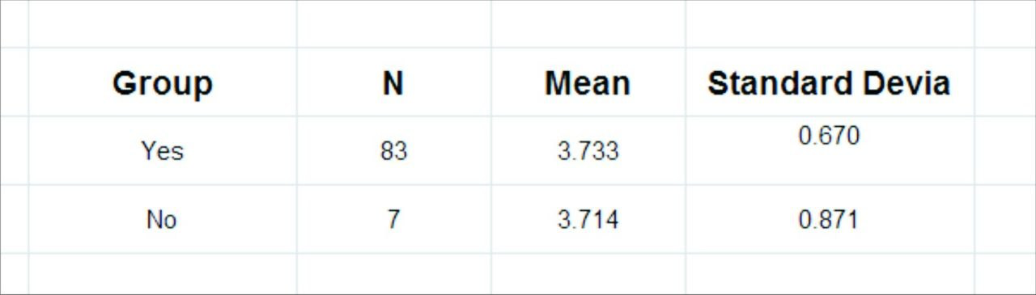

Independent Samples t-test: t (6.613) = 0.054, p = .958.
Note. A significance level of p< .05 was used to determine statistical significance.
Interpretation of the Results
As shown in Table 6, respondents who had previously purchased from SHEIN reported a slightly higher mean purchasing motivation score (M = 3.73) than those who had not (M = 3.71). However, this difference was not statistically significant, t (6.61) = 0.054, p = .958. Therefore, the null hypothesis could not be rejected. These findings suggest that previous purchasing experience with SHEIN was not associated with a statistically significant difference in purchasing motivation among the participants in this study.

5-Discussion, implication, and Future Research
5.1 Introduction
This chapter discusses the findings presented in Chapter 4 and interprets them in relation to the research objectives, hypotheses, and existing literature on consumer behaviour in the fast-fashion e-commerce sector. The discussion focuses on the relationships between customer perception, pricing factors, social media influence, purchasing motivation, and overspending behaviour among SHEIN consumers. The findings are compared with previous studies to identify areas of agreement and disagreement and to provide explanations for the observed results. Furthermore, the chapter highlights the practical implications of the findings, discusses the limitations of the study, and provides recommendations for SHEIN and future research. The chapter concludes by summarising the main findings and contributions of the study.

5.2 Discussion of Findings

5.2.1 Discussion of Hypothesis 1
The findings of this study revealed a significant positive relationship between customer perception and purchasing motivation among SHEIN consumers, thereby supporting Hypothesis 1. This suggests that consumers who hold more favourable perceptions of SHEIN are more likely to exhibit stronger purchasing motivation. One possible explanation is that SHEIN's affordable prices, extensive product range, and convenient digital shopping experience encourage favourable customer evaluations, which subsequently strengthen purchasing motivation.
These findings are consistent with Qu (2024), who argued that SHEIN's rapid growth has been driven by positive consumer perceptions of its affordability, product variety, and convenient digital platform. Similarly, Ramya and Sujith (2025) found that favourable customer perceptions enhance consumers' willingness to purchase, emphasising the importance of positive brand evaluations in influencing purchasing decisions.
The findings also align with Zimand-Sheiner and Lissitsa (2024), who highlighted the significant role of customer perceptions in shaping purchase intentions. However, their study suggested that the influence of these perceptions may weaken as consumers become more aware of environmental and ethical concerns. This indicates that although positive perceptions currently encourage purchasing motivation, their impact may decline as sustainability awareness continues to increase.
Overall, the findings confirm that customer perception is a key factor influencing purchasing motivation among SHEIN consumers. Therefore, maintaining favourable customer perceptions remains essential for strengthening purchasing motivation and supporting SHEIN's long-term competitiveness.

5.2.2 Discussion of Hypothesis 2
The findings of this study revealed a significant positive relationship between pricing factors and purchasing motivation among SHEIN consumers, thereby supporting Hypothesis 2. The strong positive correlation (r = 0.759, p < .001) indicates that competitive prices, promotional discounts, and remarkable offers play a significant role in motivating consumers to purchase from SHEIN. One possible explanation is that attractive pricing reduces consumers' perceived financial risk while increasing the value they associate with their purchases, thereby encouraging purchase decisions.
These findings are consistent with Ramya and Sujith (2025), who found that affordable prices and promotional activities significantly increase consumers' willingness to purchase. Similarly, Arimany Serrat, Arribas-Ibar and Erdoğan (2025) argued that competitive pricing is a defining characteristic of fast-fashion business models, enabling companies such as SHEIN to attract price-sensitive consumers and maintain high sales volumes. Collectively, these studies emphasise the importance of pricing as a critical competitive advantage in the fast-fashion industry.
However, the findings should also be considered alongside the concerns raised by Degli Esposti, Mortara and Roberti (2024), who argued that continuous discounts and low-price strategies may encourage excessive consumption and reinforce unsustainable purchasing patterns. This suggests that while competitive pricing effectively increases purchasing motivation, it may also encourage purchases driven by promotional incentives rather than actual need. Overall, the findings indicate that pricing remains a major determinant of consumers' purchasing motivation. Nevertheless, the long-term effectiveness of pricing strategies may depend on SHEIN's ability to balance competitive pricing with consumers' growing expectations regarding sustainability and responsible consumption.

5.2.3 Discussion of Hypothesis 3
The findings of this study revealed a strong positive relationship between social media influence and purchasing motivation among SHEIN consumers, thereby supporting Hypothesis 3. The correlation coefficient (r = 0.875, p < .001) was the strongest among all the relationships examined in this study, indicating that social media plays a particularly influential role in motivating consumers to purchase from SHEIN. One possible explanation is that frequent exposure to fashion trends, influencer recommendations, and user-generated content increases consumers' interest, encouraging them to purchase from SHEIN.
These findings are consistent with Gabriel et al. (2023), who highlighted the major influence of TikTok in encouraging consumers to engage with SHEIN and increasing their intention to purchase. Similarly, Yee et al. (2026) found that influencer marketing positively affects consumers' purchase intentions by enhancing trust, product awareness, and engagement with fashion brands. Collectively, these studies demonstrate that social media has become one of the most influential marketing tools in shaping consumer purchasing behaviour.
However, Vladimirova et al. (2024) argued that although social media effectively promotes fashion products and increases consumer engagement, it may also encourage higher consumption levels while reducing consumers' awareness of the environmental consequences associated with fast-fashion purchases. Overall, the findings confirm that social media is a major driver of purchasing motivation among SHEIN consumers. Nevertheless, its effectiveness as a marketing tool should be balanced with responsible digital marketing practices that encourage informed purchasing decisions while supporting long-term consumer trust.

5.2.4 Discussion of Hypothesis 4

The findings of this study revealed a significant positive relationship between purchasing motivation and overspending behaviour among SHEIN consumers, thereby supporting Hypothesis 4. The positive correlation (r = 0.706, p < .001) indicates that consumers with stronger purchasing motivation are more likely to engage in overspending when shopping on SHEIN. One possible explanation is that consumers with higher purchasing motivation are more likely to make additional or unplanned purchases, particularly when exposed to attractive promotional offers and marketing activities.
These findings are consistent with Weber and Ritch (2022), who argued that impulse buying is a common characteristic of fast-fashion consumption, with consumers' emotions and purchasing motivation frequently influencing spending behaviour. Similarly, Flachs, Büttner and Serfas (2026) demonstrated that impulsive buying contributes to excessive fast-fashion consumption and suggested that improving consumers' self-control may help reduce unnecessary purchases. Together, these studies indicate that stronger purchasing motivation enhances consumer engagement while increasing the likelihood of overspending.
A similar perspective was reported by Azevedo et al. (2024), who found that SHEIN's pricing strategies, promotional campaigns, and digital marketing activities are designed to encourage purchasing behaviour and strengthen consumer engagement. While these practices may improve business performance, they can also increase repeated purchasing and higher levels of spending, particularly among consumers who respond strongly to promotional incentives. This suggests that overspending cannot be explained solely by individual purchasing motivation but should also be understood within the wider retail environment and the marketing practices that influence consumers' purchasing decisions.
Taken together, these findings indicate that purchasing motivation is an important predictor of overspending behaviour among SHEIN consumers. Although stronger purchasing motivation benefits retailers by increasing customer engagement and sales, it may also encourage excessive consumption when reinforced by persuasive marketing strategies. Consequently, retailers should balance commercial objectives with marketing practices that promote more responsible and sustainable consumption.

5.2.5 Discussion of Hypothesis 5
The findings of this study revealed a significant positive relationship between customer perception and overspending behaviour among SHEIN consumers, thereby supporting Hypothesis 5. Although the relationship was moderate (r = 0.476, p < .001), it indicates that consumers with more favourable perceptions of SHEIN are more likely to engage in overspending behaviour. However, the strength of this relationship suggests that customer perception alone is unlikely to fully explain excessive spending.
These findings are consistent with Zimand-Sheiner and Lissitsa (2024), who argued that favourable perceptions of fast-fashion brands strengthen consumers' purchase intentions, although these perceptions may change as awareness of environmental and ethical concerns increases. Similarly, Talwar et al. (2025) suggested that consumer behaviour in the fast-fashion industry is shaped by a combination of positive brand perceptions, psychological motivations, and ethical considerations rather than by a single influencing factor. This supports the view that customer perception contributes to consumer purchasing behaviour; however, its influence is often reinforced by additional psychological and motivational factors.
Taken together, the findings indicate that customer perception plays a meaningful role in overspending behaviour, although its influence is less substantial than purchasing motivation. This suggests that excessive spending is more likely to result from the combined effects of positive brand perceptions, purchasing motivation, pricing strategies, and marketing activities. Consequently, SHEIN should continue strengthening customer relationships while adopting responsible marketing practices that encourage informed purchasing decisions and support more sustainable consumer behaviour.

5.3 Practical Implications
The findings of this study provide several practical implications for SHEIN and other digital retail platforms. The findings indicate that customer perception, pricing factors, and social media play a significant role in motivating purchases. Therefore, SHEIN and similar online retailers should focus on maintaining a positive brand image, offering competitive value, engaging customers through effective digital marketing strategies, and providing a seamless shopping experience to strengthen customer perceptions.

Second, the positive relationships between purchasing motivation, customer perception, and overspending behaviour suggest that marketing strategies should encourage consumer engagement without promoting excessive or unnecessary purchases. Adopting a more balanced marketing approach may help organisations build stronger long-term customer relationships while reducing the risk of impulsive buying.
Finally, the findings indicate that long-term business success depends not only on attracting customers but also on maintaining their trust through responsible marketing practices and a stronger commitment to sustainability. By balancing commercial objectives with consumer wellbeing, SHEIN can strengthen customer loyalty while encouraging more informed and responsible purchasing decisions.

5.4 Limitations of the Study
This study has several limitations that should be considered when interpreting its findings. First, the research adopted a quantitative approach using a self-administered questionnaire, which relied on participants’ self-reported responses and may therefore be subject to response bias. Second, due to the limited data collection period of approximately two and a half months, the study obtained only 90 valid responses through convenience sampling, which may limit the generalisability of the findings beyond SHEIN consumers and similar online retail settings. The relatively small sample size represents a limitation of the present study. Although 90 valid responses were obtained, a larger sample may have provided a more representative view of consumer behaviour. Future studies could therefore extend the data collection period and recruit participants from a wider population of SHEIN customers.
Third, the study was conducted at a single point in time, preventing the examination of changes in consumer perceptions and purchasing behaviour over time. Future research could adopt longitudinal designs or combine quantitative and qualitative methods to provide a more comprehensive understanding of consumer behaviour and purchasing decisions on digital retail platforms such as SHEIN.

5.5 Recommendations for Future Research
The findings of this study suggest several directions for future research. As the current study involved a specific group of participants, future research could examine more diverse populations
such as university students, working adults, and consumers from different countries, this may help determine whether the findings can be generalised to other consumer groups and retail contexts.
Future longitudinal studies could investigate how customer perceptions, purchasing motivation, and overspending behaviour evolve over time, particularly as consumer awareness of sustainability and ethical consumption continues to increase.
In addition, future researchers may benefit from adopting mixed methods approaches that combine quantitative surveys with qualitative interviews, enabling a deeper exploration of the psychological and contextual factors that influence consumer purchasing decisions. Future studies could incorporate additional variables, such as trust, perceived value, customer satisfaction, or brand loyalty, to develop a more comprehensive understanding of consumer behaviour within digital retail environments.

6-Conclusion
This study examined the relationship between customer perception, pricing factors, social media influence, purchasing motivation, and overspending behaviour among SHEIN consumers. The results supported all five proposed hypotheses, indicating that customer perception, pricing factors, and social media significantly influence purchasing motivation, while purchasing motivation and customer perception contribute to overspending behaviour. Among these variables, social media showed the strongest positive relationship with purchasing motivation, highlighting the increasing role of digital marketing in shaping consumer purchasing behaviour.

Furthermore, the study revealed that purchasing decisions are driven by a combination of interconnected factors rather than a single determinant. Positive customer perceptions and attractive pricing strategies encourage consumer engagement; however, when reinforced by persuasive promotional activities and marketing strategies, they may also increase the likelihood of overspending. These findings underscore the importance of balancing commercial objectives with responsible marketing practices that encourage informed purchasing decisions.
This research contributes to the existing body of knowledge by providing empirical evidence on the determinants of purchasing motivation and overspending behaviour within the context of SHEIN. In addition, it offers practical implications for online retail platforms seeking to enhance customer engagement while encouraging more informed and responsible purchasing decisions. Future research can build on these findings to further explore how digital retail platforms influence consumer purchasing motivation and overspending behaviour in different consumer contexts.

References
. Ajzen, I. (1991) ‘The theory of planned behavior’, Organizational Behavior and Human Decision Processes, 50(2), pp. 179–211. Available at: https://doi.org/10.1016/0749-5978(91)90020-T.

. Arimany Serrat, N., Arribas-Ibar, M. and Erdoğan, G. (2025) ‘Fast fashion sector: business models, supply chains, and European sustainability standards’, Systems, 13(6), article 405. Available at: https://doi.org/10.3390/systems13060405.

. Azevedo, I.M., Alves, T., Pinto Borges, A., Vieira, B., Vieira, E. and Mesquita, S. (2024) ‘Consumer awareness and the ethical footprint of fast fashion with a focus on SHEIN’, New Trends in Contemporary Economics, Business and Management, article bm.2024.1318, pp. 185–192. Available at: https://doi.org/10.3846/bm.2024.1318 (Accessed: 5 July 2026).

. Akoglu, H. (2018) ‘User’s guide to correlation coefficients’, Turkish Journal of Emergency Medicine, 18(3), pp. 91–93. Available at: https://doi.org/10.1016/j.tjem.2018.08.001 (Accessed: 20 May 2026).

. Bos, J. (2020) Research ethics for students in the social sciences. Cham: Springer International Publishing. Available at: https://doi.org/10.1007/978-3-030-48415-6.

. DAM, T.C. (2020) ‘Influence of brand trust, perceived value on brand preference and purchase intention’, The Journal of Asian Finance, Economics and Business, 7(10), pp. 939–947. Available at: https://doi.org/10.13106/jafeb.2020.vol7.no10.939.

. Degli Esposti, P., Mortara, A. and Roberti, G. (2024) ‘Unsustainable fashion: SHEIN and the fast fashion consumption model’, Italian Sociological Review, 14(3), pp. 929–951. Available at: https://doi.org/10.13136/isr.v14i3.822.

. Elshaer, I.A., Alrawad, M., Lutfi, A. and Azazz, A.M.S. (2024) ‘Social commerce and buying intention post COVID-19: evidence from hybrid approach based on SEM–fsQCA’, Journal of Retailing and Consumer Services, 76, article 103548. Available at: https://doi.org/10.1016/j.jretconser.2023.103548 (Accessed: 14 May 2026).

. Escobar-Farfán, M., Veas-González, I., García-Salirrosas, E., Vers-Salinas, K., Veas-Santibañez, V. and Zavala-González, J. (2025) ‘From browsing to buying: determinants of impulse buying behavior in mobile commerce’, Journal of Theoretical and Applied Electronic Commerce Research, 20(4), article 266. Available at: https://doi.org/10.3390/jtaer20040266.

. Farivar, S., Wang, F., and Yuan, Y. (2023) ‘Influencer marketing: a perspective of the elaboration likelihood model of persuasion’, Journal of Electronic Commerce Research, 24(2), pp. 127–145. Available at: http://www.jecr.org/sites/default/files/2023vol24no2_Paper2.pdf (Accessed: 30 April 2026).

. Flachs, S., Büttner, O.B. and Serfas, B.G. (2026) ‘Targeting impulsive buying: reducing fast-fashion consumption with inhibitory control training’, Journal of Environmental Psychology, 110, p. 102914. Available at: https://doi.org/10.1016/j.jenvp.2026.102914 (Accessed: 5 July 2026).

. Gabriel, A., Dantas, Í.J.M., Solino, L.J.S. and Curth, M. (2023) ‘From the screen to the wardrobe: the influence of TikTok on the consumption and use of fashion in SHEIN’, in Academic Research & Reviews in Art, Design, Architecture and Fashion: Breaking Creative Boundaries. pp. 40–51. Available at: https://doi.org/10.59740/academy.58 (Accessed: 30 June 2026).

. Hanaysha, J.R., Ramadan, H.I. and Alhyasat, K.M.K. (2025) ‘Exploring the impact of customer reviews, website quality, perceived service quality, and product assortment on online purchase intention: mediating role of trust’, Telematics and Informatics Reports, 19(100236), p. 100236. Available at: https://doi.org/10.1016/j.teler.2025.100236.

. Hongsuchon, T., Chen, S.-C., and Khan, A. (2025) ‘Applying the S-O-R model to explore impulsive buying behavior driven by influencers on social commerce websites’, PeerJ Computer Science, 11, article e3113. Available at: https://doi.org/10.7717/peerj-cs.3113.

. Jebb, A.T., Ng, V., and Tay, L. (2021) ‘A review of key Likert scale development advances: 1995–2019’, Frontiers in Psychology, 12, pp. 1–14. Available at: https://doi.org/10.3389/fpsyg.2021.637547.

. Koo, M., and Yang, S.-W. (2025) ‘Likert-type scale’, Encyclopedia, 5(1), pp. 18–18. Available at: https://doi.org/10.3390/encyclopedia5010018 (Accessed: 15 May 2026).
. Li, S. (2025) ‘The value and challenges of Maslow hierarchy of needs in contemporary consumer behavior analysis’, Journal of Education, Humanities and Social Sciences, 60(02115), pp. 224–230. Available at: https://doi.org/10.54097/zfm1g851.

. Li, Y., García-de-Frutos, N. and Ortega-Egea, J.M. (2025) ‘Impulse buying in live streaming e-commerce: a systematic literature review and future research agenda’, Computers in Human Behavior Reports, 19(100676), p. 100676. Available at: https://doi.org/10.1016/j.chbr.2025.100676.

. Lim, W.M. (2024) ‘What is quantitative research? An overview and guidelines,’Australasian Marketing Journal (AMJ), 1(1). Available at: https://doi.org/10.1177/14413582241264622.

. Maslow, A. (1943) ‘A theory of human motivation’, Psychological Review. Available at: https://psycnet.apa.org/doi/10.1037/h0054346 (Accessed: 7 May 2026).

. Mathew, M., and Spinelli, R. (2025) ‘Decoding sustainable drivers: a systematic literature review on sustainability-induced consumer behaviour in the fast fashion industry’, Sustainable Production and Consumption, 55, pp. 132–145. Available at: https://doi.org/10.1016/j.spc.2025.02.011.

. Mishra, P., Pandey, C.M., Singh, U., Gupta, A., Sahu, C. and Keshri, A. (2019) ‘Descriptive statistics and normality tests for statistical data’, Annals of Cardiac Anaesthesia, 22(1), pp. 67–72. Available at: https://pmc.ncbi.nlm.nih.gov/articles/PMC6350423 (Accessed: 20 May 2026).

. Narimanfar, S. and Ghafari Ashtiani, P. (2021) ‘A study on investigating the impact of website features on online impulse buying behaviour’, Turkish Journal of Marketing, 6(3), pp. 175–191. Available at: https://doi.org/10.30685/tujom.v6i3.130.

. Ngo, T., Thanh, L., Nguyen, H.P., Mai, A., Huyen, T. and Hoang, P.L. (2024) ‘A comprehensive study on factors influencing online impulse buying behavior: evidence from Shopee video platform’, Heliyon, 10(15), article e35743. Available at: https://doi.org/10.1016/j.heliyon.2024.e35743 (Accessed: 12 May 2026).

. Queirós, A., Faria, D. and Almeida, F. (2017) ‘Strengths and limitations of qualitative and quantitative research methods’, European Journal of Education Studies, 3(9). Available at: https://oapub.org/edu/index.php/ejes/article/view/1017 (Accessed: 15 May 2026).
. Qu, Z. (2024) The rise of SHEIN: navigating the digital era of fast fashion and its comprehensive impacts. EWA Publishing. Available at: https://www.researchgate.net/publication/379918500 (Accessed: 30 June 2026).

. Ramya, S.S. and Sujith, S. (2025) 'Consumer buying behavior towards fast fashion: A study on H&M with special reference to Coimbatore', International Scientific Journal of Engineering and Management, 4(4), pp. 1–7. Available at: https://doi.org/10.55041/ISJEM02695 (Accessed: 30 June 2026).

. Resnik, D. (2020) What is ethics in research & why is it important? National Institute of Environmental Health Sciences. Available at: https://www.niehs.nih.gov/research/resources/bioethics/whatis (Accessed: 20 May 2026).

. Rita, P., Oliveira, T., and Farisa, A. (2019) ‘The impact of e-service quality and customer satisfaction on customer behavior in online shopping’, Heliyon, 5(10), pp. 1–14. Available at: https://doi.org/10.1016/j.heliyon.2019.e02690.

. Saunders, M., Lewis, P., and Thornhill, A. (2019) Research methods for business students. 8th edn. Harlow: Pearson.

. Singh, P., Sharma, B.K., Arora, L., and Bhatt, V. (2023) ‘Measuring social media impact on impulse buying behavior’, Cogent Business & Management, 10(3). Available at: https://doi.org/10.1080/23311975.2023.2262371 (Accessed: 14 May 2026).

. Sun, B., Zhang, Y., and Zheng, L. (2023) ‘Relationship between time pressure and consumers’ impulsive buying—role of perceived value and emotions’, Heliyon, 9(12), article e23185. Available at: https://doi.org/10.1016/j.heliyon.2023.e23185.

. Taherdoost, H. (2017) ‘Determining sample size; how to calculate survey sample size’, International Journal of Economics and Management Systems, 2, pp. 237–239. Available at: SSRN (Accessed: 18 June 2026).

. Tanaporn Hongsuchon, Chen, S.-C., and Khan, A. (2025) ‘Applying the S-O-R Model to Explore Impulsive Buying Behavior Driven by Influencers on Social Commerce Websites’, PeerJ Computer Science, 11(7717), pp. e3113–e3113. Available at: https://doi.org/10.7717/peerj-cs.3113.

. Talwar, S., Alzeiby, E.A., Gupta, B., and Sharma, V.K. (2025) ‘Psychological foundations of fast fashion: managing tensions and paradoxes, and navigating ethical dualities’, Acta Psychological, 261, article 105837. Available at: https://doi.org/10.1016/j.actpsy.2025.105837 (Accessed: 6 July 2026).

. Vladimirova, K., Henninger, C.E., Alosaimi, S., Brydges, T., Choopani, H., Hanlon, M., Iran, S., McCormick, H. and Zhou, S. (2024) ‘Exploring the influence of social media on sustainable fashion consumption: a systematic literature review and future research agenda’, Journal of Global Fashion Marketing, 15(2), pp. 181–202. Available at: https://doi.org/10.1080/20932685.2023.2237978.

. Weber, N., and Ritch, E. (2022) ‘The role of impulse buying on fast fashion consumers’ emotions and behaviours’, in Global Fashion Conference 2022. Global Fashion Conference. Available at: https://doi.org/10.57649/GFC.978-989-54263 (Accessed: 30 June 2026).

. Xiao, L., Guo, Z., D’Ambra, J. and Fu, B. (2023) ‘The role of recommendation systems in shaping online consumer behaviour’, Information & Management, 60(7). Available at: https://doi.org/10.1016/j.im.2023.103774.

. Yee, J.F., Singh, P., Tan, L.H., Yap, J.C., Xiong, X.Y., Xie, Z.Y., Yao, Q.C., V, D. and Kee, D.M.H. (2026) ‘Influencer marketing and consumer purchase intentions in the fast fashion industry’, Journal of the Community Development in Asia, 9(1), pp. 149–165. Available at: https://doi.org/10.32535/jcda.v9i1.4349 (Accessed: 30 June 2026).

. Zhao, Y., Li, Y., Wang, N., Zhou, R., and Luo, X. (2021) ‘A meta-analysis of online impulsive buying and the moderating effect of economic development level’, Information Systems Frontiers, 24(5). Available at: https://doi.org/10.1007/s10796-021-10170-4 (Accessed: 12 May 2026).

. Zhou, Y. (2025) ‘SHEIN’s business model innovation practice and evolution path: from fast fashion to fashion platform’, Frontiers in Business, Economics and Management, 19(1), pp. 126–130. Available at: https://doi.org/10.54097/p5409171.

. Zimand-Sheiner, D. and Lissitsa, S. (2024) ‘Generation Z: factors predicting decline in purchase intentions after receiving negative environmental information: fast fashion brand SHEIN as a case study’, Journal of Retailing and Consumer Services, 81, article 103999. Available at: https://doi.org/10.1016/j.jretconser.2024.103999.

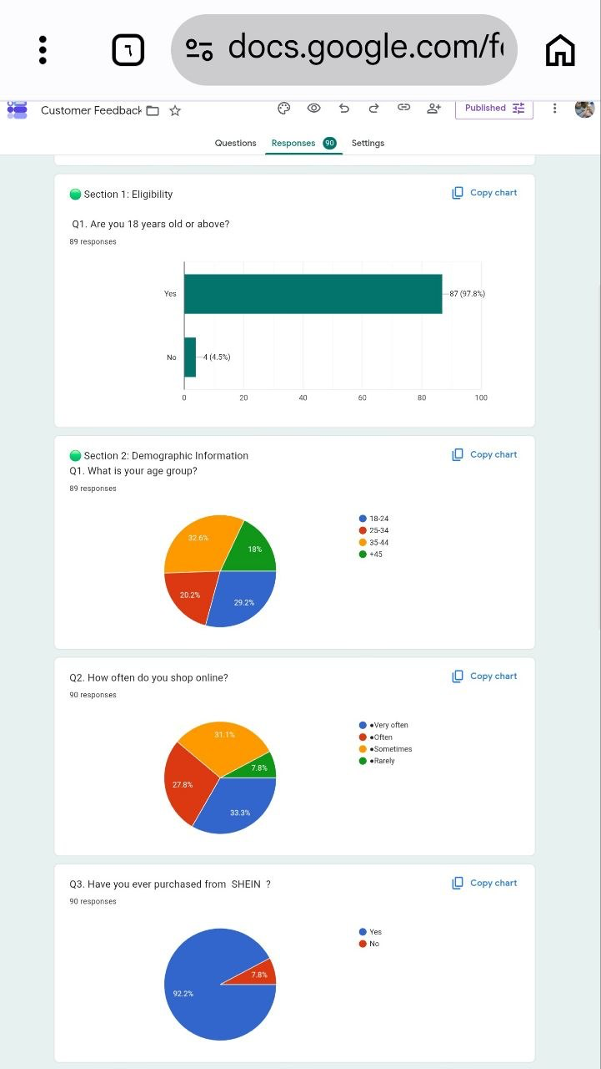
Appendixes
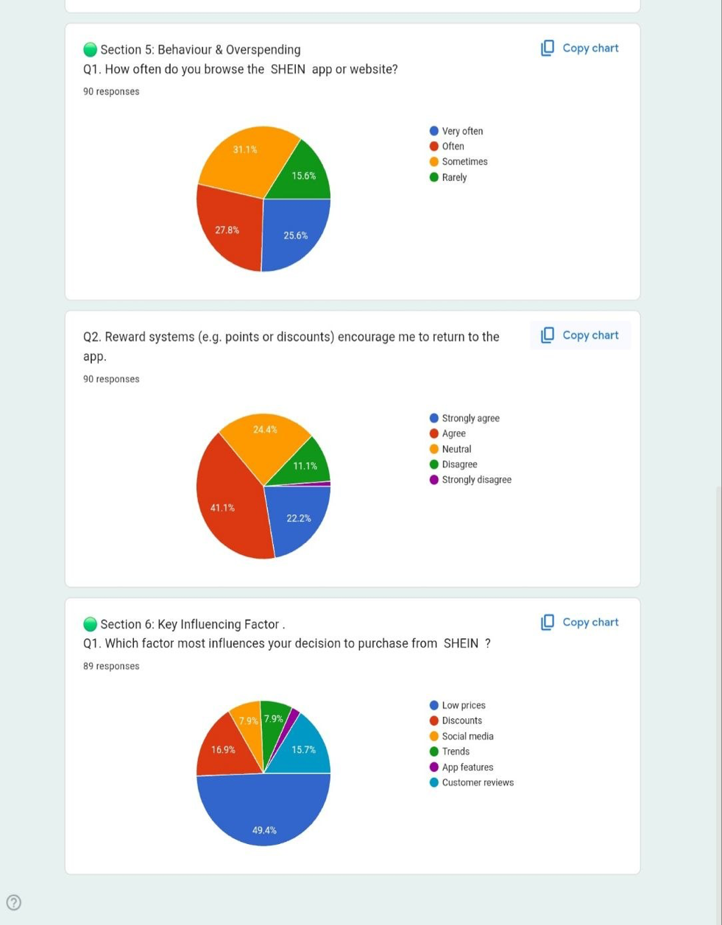
Appendix A:

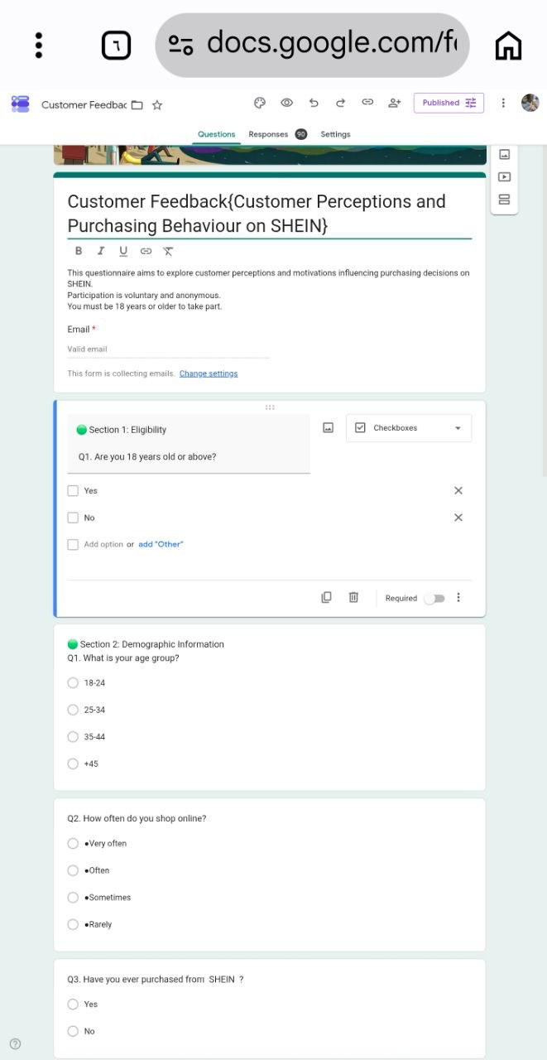
AppendixB:



