INTRODUCTION TO WEB and DATABASE CONCEPTS
HTML & CSS Web Development

  - Shaun Davies (1104018)

University of Wales Trinity Saint David
BSc Computing: Software Engineering

Table of Contents
Introduction 2
Requirements 2
Implementation 2
Home Page 2
About 3
Paintings 3
Self-Portraits 4
Landscapes 4
Flowers 5
Shop 5
Contact 6
HTML Validation 6
CSS Validation 7
Evaluation 8
References 10
Appendices 11
HTML 11
CSS 45

Introduction
This report introduces the website “Van Gogh Universe” a hand coded and custom HTML and CSS based site inspired from a hobby or interest created for educational purposes only, following industry standards on usability, accessibility and search engine optimisation. The site is tested through relevant validation tools and is the evaluated on its quality.

Requirements
“Van Gogh Universe” is an informative website on one of the most celebrated artists in history, Vincent van Gogh. The site aims to inspire its users on the brilliance of the artist by showcasing his work and by telling his story.
The purpose of the website is to:
- Inform visitors on Van Goghs life story and to gain an appreciation of his art.
- To create a revenue through the Shop, where visitors can view products for sale and contact the site owner to make purchases.
- Users can sign up to a monthly newsletter through the enquiry form.
The intended target audience is men and women over 16, creative types, anyone with an appreciation of art.

Implementation

Home Page
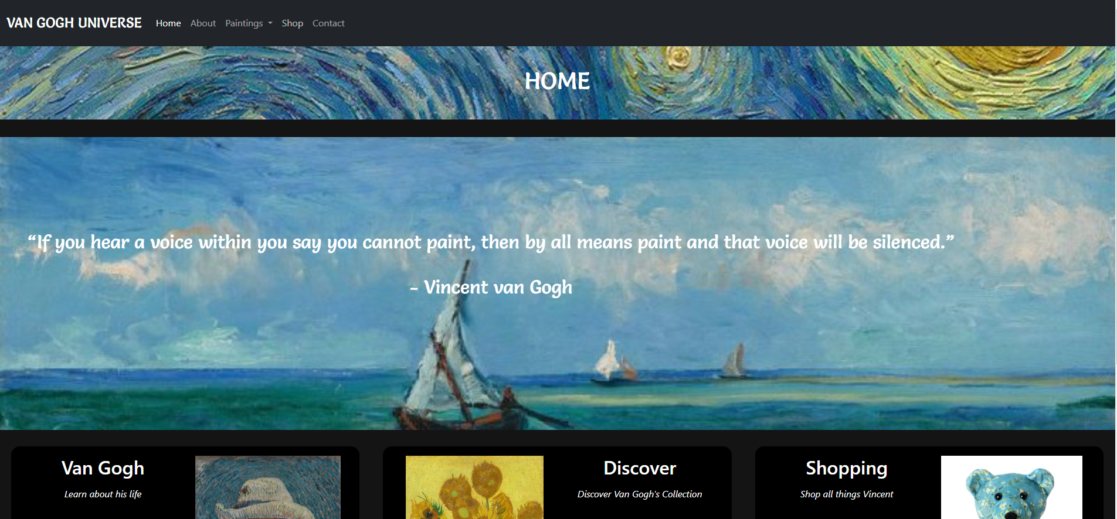

About
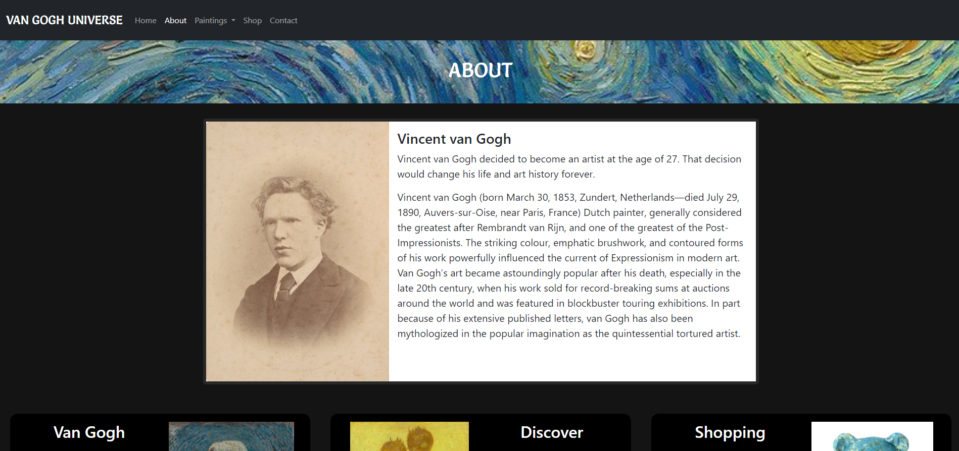

Paintings
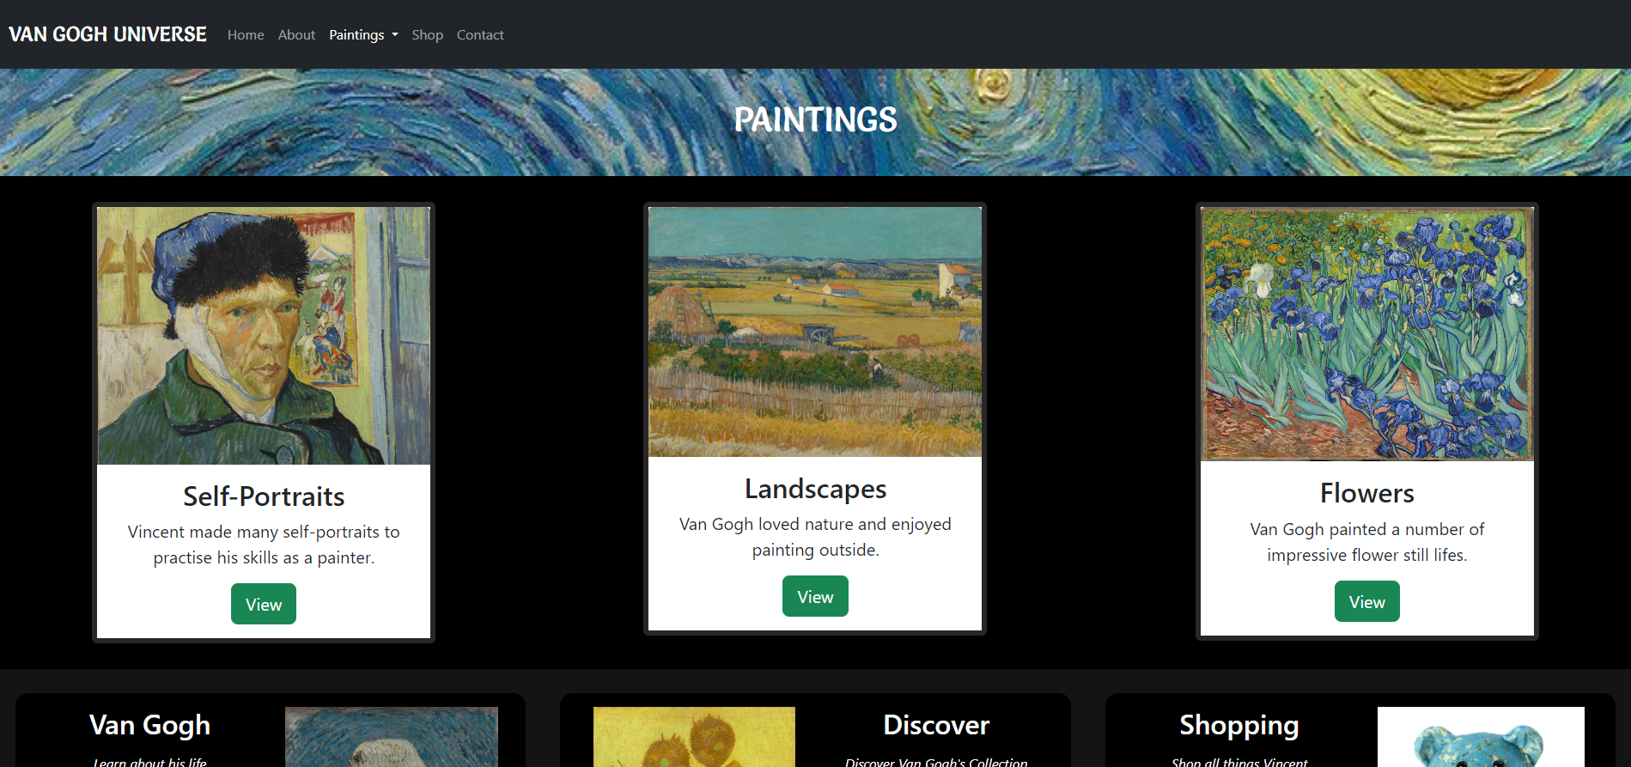

Self-Portraits
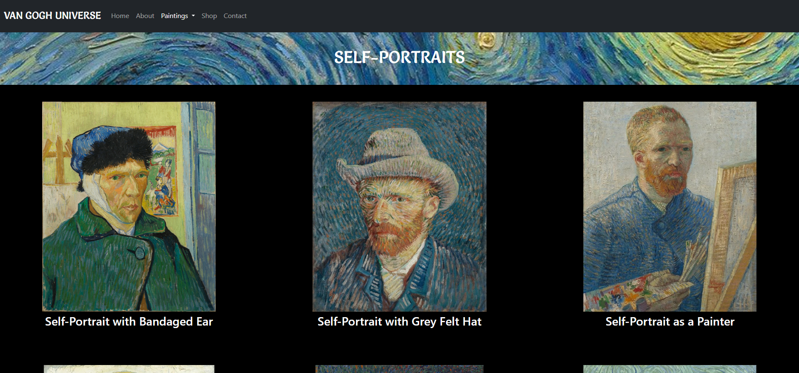

Landscapes
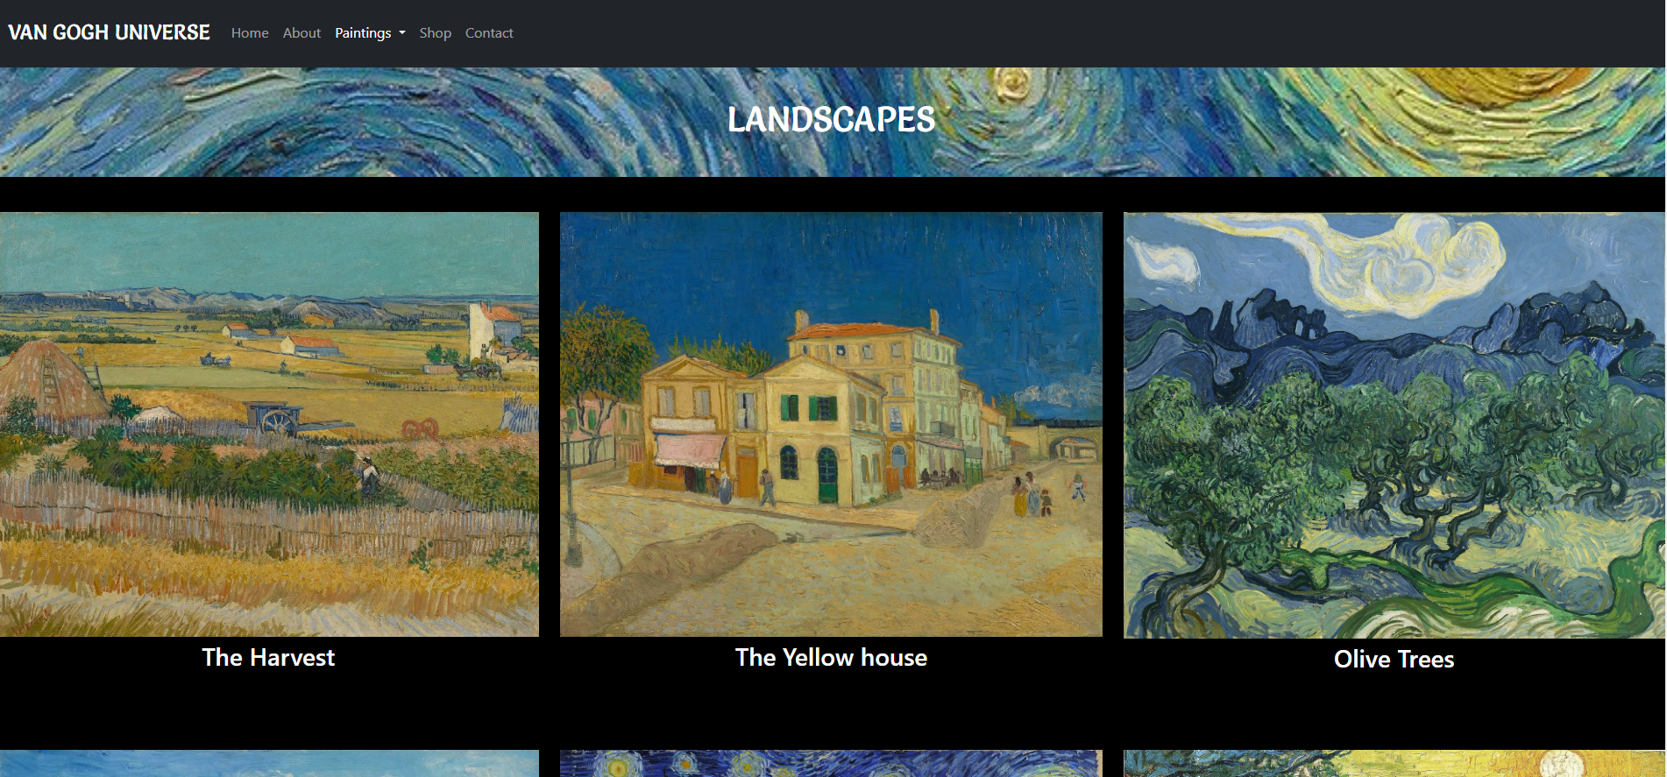

Flowers
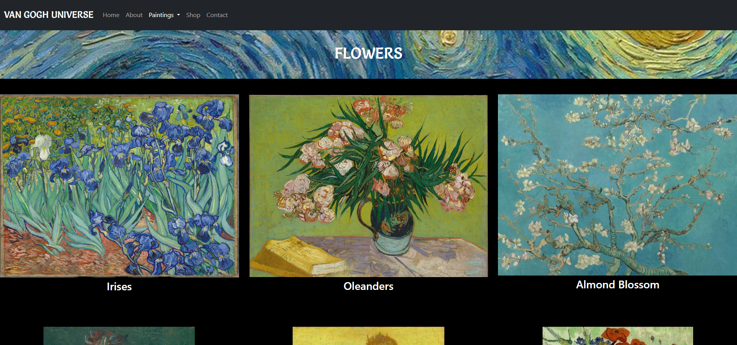

Shop
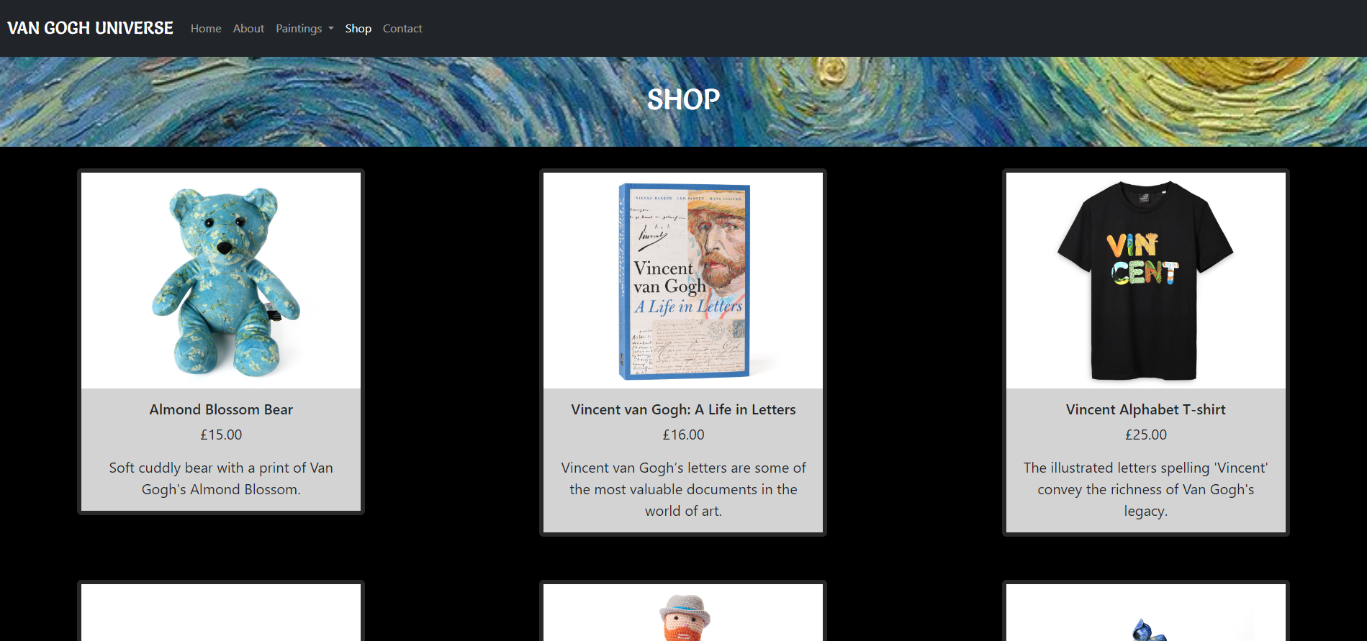

Contact
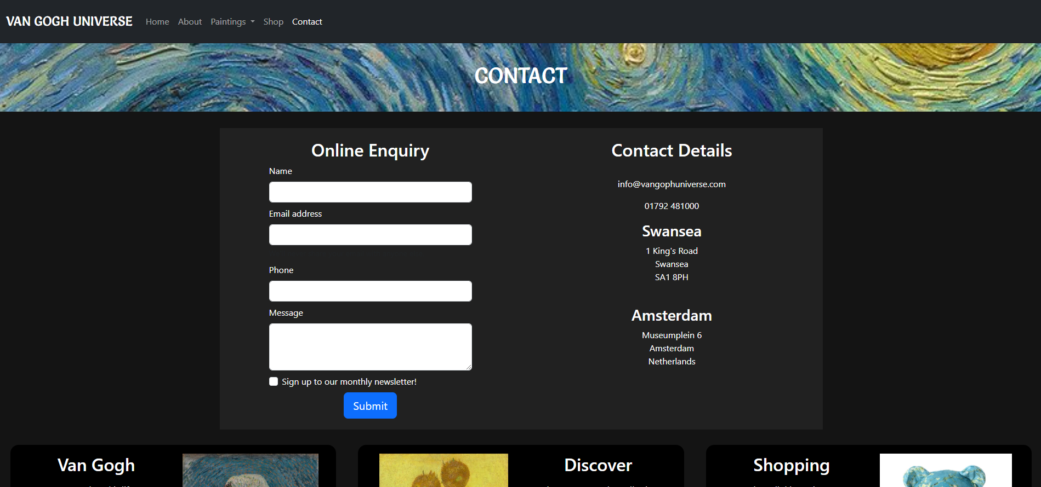

HTML Validation
The following errors were received on the “self-portraits” page:
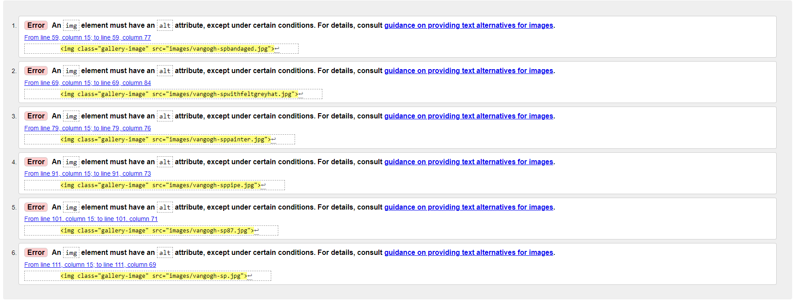
Errors corrected by adding an alt attribute to the images.

All other pages received no errors:
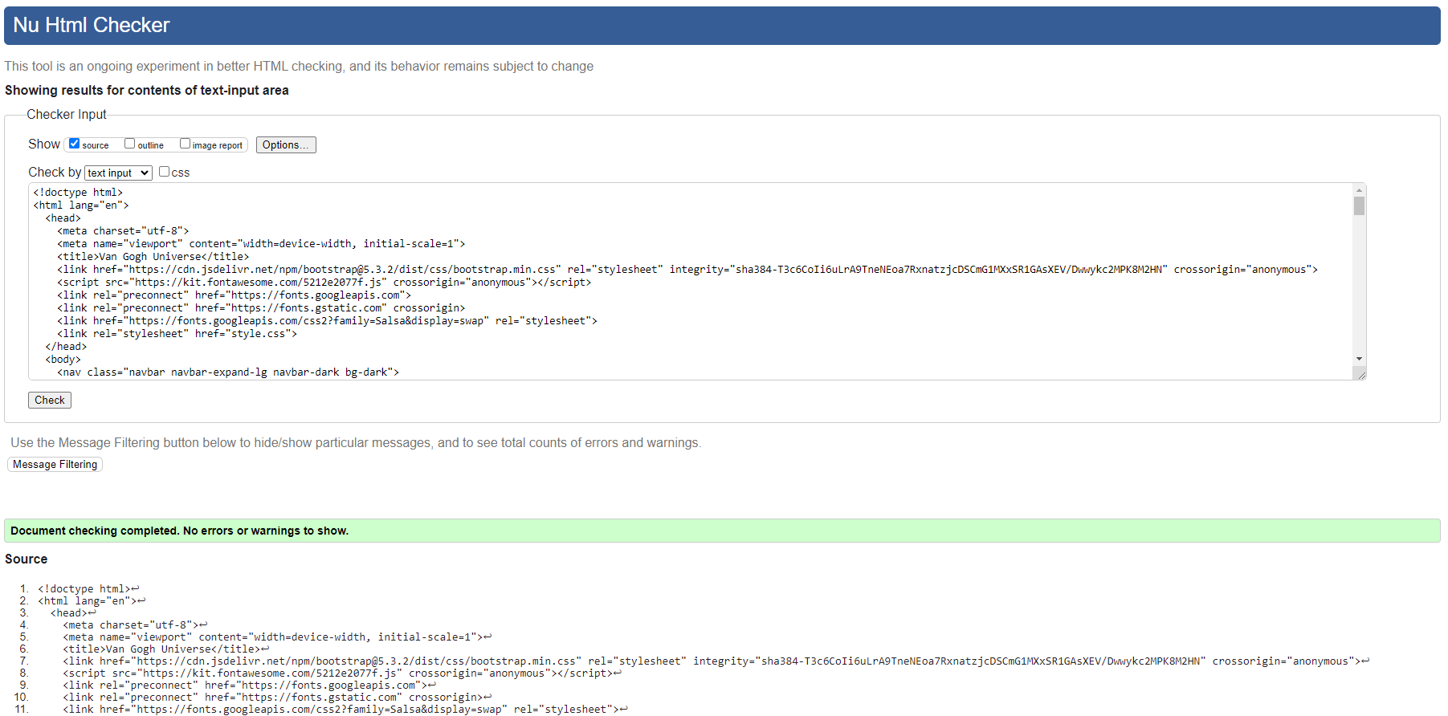

CSS Validation
5 errors found:
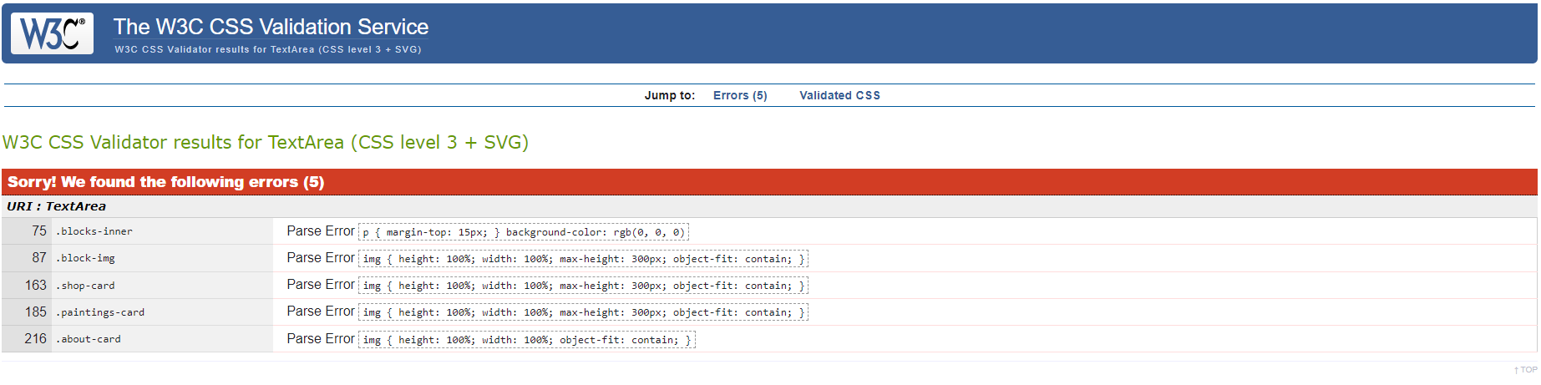
To resolve these errors I created new classes, for example:
.scale-img {
height: 100%;
width: 100%;
max-height: 300px;
object-fit: contain;
}

And formatted correctly when targeting child elements within a class:
.blocks-inner p {
margin-top: 15px;
}

All errors were corrected, and the validation received no further errors:
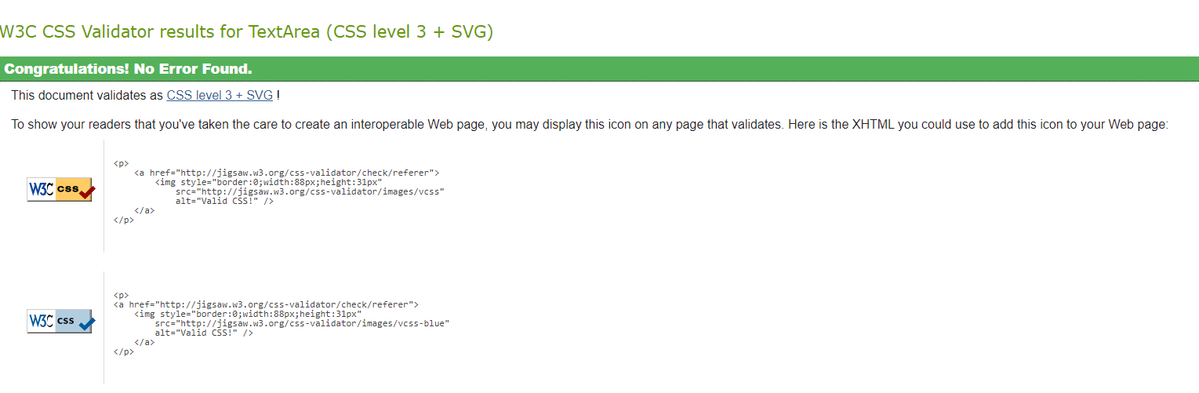

Evaluation
a)
- Website Usability

Website usability is essential for users to interact and navigate a website to achieve their goals effectively and efficiently. A website that prioritizes usability offers a positive user experience which contributes to overall user satisfaction.
Website usability encompasses several factors, as defined by Flavián et al.: (a) the user's ease in comprehending the website's structure, functions, interface, and visible content; (b) the simplicity of using the website during its initial stages; (c) the speed at which users can locate their desired information; (d) the perceived ease of navigating the site, considering the time and actions required to achieve desired outcomes; and (e) the user's ability to control their actions and whereabouts at any given moment. [1] In this study Flavián et al. tested users’ loyalty to websites that they visit based on its perceived usability. Empirical analysis of existing literature, questionnaires and tests on users found to have a positive influence on user satisfaction and in website loyalty when the user perceived that the system was usable, demonstrated through website honesty, benevolence and competence.

- Accessibility
Website Accessibility is important in the inclusion of all disabilities that can affect access to the web, such as auditory, cognitive, neurological and physical disabilities, among many others. Web accessibility ensures inclusivity and equality for those on the web. [2] There are many aspects to web accessibility, and it is essential that these work together to provide the best accessibility for people with disabilities. For example, content; the information on a web page such as text, images and sounds must be compliant with HTML standards by using the correct tags for the content, such as, <img> for images and “alt” for alternative text. These work with and are essential for assistive technology such as screen readers, alternative keyboards and scanning software to work effectively. [3] The W3C Web Accessibility Initiative (WAI) has been established to raise awareness of universal accessibility with the primary goals of developing guidelines to promote accessibility in web technologies, education and outreach and research and development. Published in June 2023 the WCAG 2.1 provides guidance and accessibility guidelines to web designers and developers and teachers and students.[4] The four principles that provide the foundation for web accessibility are: perceivable, operable, understandable and robust (POUR), if any of these ae not true the web will be deemed unusable to users with disabilities. [5] A study by B. Shawar which investigates the accessibility of educational websites in compliance with the WAI, particularly for visually impaired students found that areas for improvement are needed for university websites [6]. Furthermore, a literature review found that educational websites do not meet any version of the WCAG and their conformance levels and calls for educational institutions to carry out web accessibility projects to adhere to WCAG and other web accessibility standards, as well as to comply with the current laws governing educational inclusion [7].

- Search Engine Optimisation
Search Engine Optimisation (SEO) is a marketing tool and it is all about getting a website in the top position of search results. SEO enhances web traffic, increases local sales and enhances the quality of a website to name a few. In development it is done by integrating content with SEO-optimized keywords, metatags, headings and titles. The effectiveness of SEO is influenced by the quality of these factors. This is known as on page SEO. Off-Page SEO occurs when a website is referenced in other articles or on other websites, promoting and prompting users to visit the site. [8] As business owner, SEO is an important tool to success.

b)
- Evaluation of completed website
In respect to the four main principles in WCAG 2.1 the website is Perceivable, Operable, Understandable and Robust. Many manual tests have been carried out on the website and on its responsiveness in Google Chrome DevTools by resizing the screen dimensions and by viewing the site through different mobile screen sizes. The site was fully responsive to these changes from utilising Bootstrap v5.3. Secondly, robustness was tested by clicking every link and button on the website and being able to return to the Home page quickly and efficiently from each scenario. Friends and family members also tested the site by navigating and reporting any issues (none were found).
On-page SEO techniques were used such as descriptive headings:
<div class="row hero-image">
<div class="hero-text">
<h1>Shop</h1>
</div>
</div>
<div class="row hero-image">
<div class="hero-text">
<h1>Contact</h1>
</div>
</div>

H1 headings used to describe and define the pages of the website and subheadings used accordingly.
All images were described by alt tags:
<div>
<a href="images/vangogh-almondblossom.jpg">
<img class="gallery-image" src="images/vangogh-almondblossom.jpg" alt="almond blossom image">
</a>
<div class="caption">
<h3>Almond Blossom</h3>
</div>

Additional tools used include:
- Bootstrap (https://getbootstrap.com/docs/5.3/)
- Google Fonts (https://fonts.google.com/)
- Visual Studio (https://code.visualstudio.com/)
- Contrast Checker (http://contrastchecker.com/)
- Juicy Studio (http://juicystudio.com/services/luminositycontrastratio.php)
- Monsido (https://go.monsido.com/)
All images used on the site are free to use, taken from: https://www.vangoghmuseum.nl/nl

References

[1] C. Flavián et al., "The role played by perceived usability, satisfaction and consumer trust on website loyalty," Information & Management, vol. 43, no. 1, pp. 1-14, Jan. 2006.
[2] S. L. Henry. “Introduction to Web Accessibility”. W3C. Accessed: Jan. 15, 2024. [Online]. Available: https://www.w3.org/WAI/fundamentals/accessibility-intro/
[3] S. L. Henry. “Essential Components to Web Accessibility”. W3C. Accessed: Jan. 15, 2024. [Online]. Available: https://www.w3.org/WAI/fundamentals/components/
[4] “Web Content Accessibility Guidelines (WCAG) 2.1” W3C. Accessed: Jan. 15, 2024. [Online]. Available: https://www.w3.org/TR/WCAG21/
[5] “Introduction to Understanding WCAG” W3C. Accessed: Jan, 15, 2024. [Online]. Available: https://www.w3.org/WAI/WCAG21/Understanding/intro#understanding-the-four-principles-of-accessibility
[6] B. A. Shawar., “Evaluating Web Accessibility of Educational Websites,” International Journal of Emerging Technologies in Learning (Online), vol. 10, no. 4, pp. 4-10, 2015.
[7] M. Campoverde-Molina et al., “Empirical Studies on Web Accessibility of Educational Websites: A Systematic Literature Review,” IEEE Access, vol. 8, pp. 91676-91700, May. 2020.
[8] D. Ó. Tuama, “SEO and Web Development: Why is it important?,” Code Institute, https://codeinstitute.net/blog/seo-and-web-development-why-is-it-important/ (accessed Jan 15, 2024).

Appendices

HTML
Index.html
<!doctype html>
<html lang="en">
<head>
<meta charset="utf-8">
<meta name="viewport" content="width=device-width, initial-scale=1">
<title>Van Gogh Universe</title>
<link href="https://cdn.jsdelivr.net/npm/bootstrap@5.3.2/dist/css/bootstrap.min.css" rel="stylesheet" integrity="sha384-T3c6CoIi6uLrA9TneNEoa7RxnatzjcDSCmG1MXxSR1GAsXEV/Dwwykc2MPK8M2HN" crossorigin="anonymous">
<script src="https://kit.fontawesome.com/5212e2077f.js" crossorigin="anonymous"></script>
<link rel="preconnect" href="https://fonts.googleapis.com">
<link rel="preconnect" href="https://fonts.gstatic.com" crossorigin>
<link href="https://fonts.googleapis.com/css2?family=Salsa&display=swap" rel="stylesheet">
<link rel="stylesheet" href="style.css">
</head>
<body>
<nav class="navbar navbar-expand-lg navbar-dark bg-dark">
<div class="container-fluid">
<a class="navbar-brand" href="index.html">Van Gogh Universe</a>
<button class="navbar-toggler" type="button" data-bs-toggle="collapse" data-bs-target="#navbarNavDropdown" aria-controls="navbarNavDropdown" aria-expanded="false" aria-label="Toggle navigation">
<span class="navbar-toggler-icon"></span>
</button>
<div class="collapse navbar-collapse" id="navbarNavDropdown">
<ul class="navbar-nav">
<li class="nav-item">
<a class="nav-link active" aria-current="page" href="index.html">Home</a>
</li>
<li class="nav-item">
<a class="nav-link" href="about.html">About</a>
</li>
<li class="nav-item dropdown">
<a class="nav-link dropdown-toggle" href="paintings.html" id="navbarDropdownMenuLink" role="button" data-bs-toggle="dropdown" aria-expanded="false">
Paintings
</a>
<ul class="dropdown-menu" aria-labelledby="navbarDropdownMenuLink">
<li><a class="dropdown-item" href="self-portraits.html">Self-Portraits</a></li>
<li><a class="dropdown-item" href="landscapes.html">Landscapes</a></li>
<li><a class="dropdown-item" href="flowers.html">Flowers</a></li>
</ul>
</li>
<li class="nav-item">
<a class="nav-link" href="shop.html">Shop</a>
</li>
<li class="nav-item">
<a class="nav-link" href="contact.html">Contact</a>
</li>
</ul>
</div>
</div>
</nav>

<div class="row hero-image">
<div class="hero-text">
<h1>Home</h1>
</div>
</div>

<div class="container-fluid main my-0 p-0">
<div class="row hero-row">
<div id="carouselExampleSlidesOnly" class="carousel slide" data-bs-ride="carousel">
<div class="carousel-inner banner">
<div class="carousel-item active">
<h2>"Great things are done by a series of small things brought together."</h2>
<img src="images/vangogh-almondblossom.jpg" class="d-block w-100" alt="almond blossom image">
</div>
<div class="carousel-item">
<h2>“There is nothing more truly artistic than to love people.”</h2>
<img src="images/vangogh-thebedroom.jpg" class="d-block w-100" alt="the bedroom image">
</div>
<div class="carousel-item">
<h2>“If you hear a voice within you say you cannot paint, then by all means paint and that voice will be silenced.”</h2>
<img src="images/vangogh-seascape.jpg" class="d-block w-100" alt="Seascape image">
</div>
</div>
</div>
</div>
<div class="row blocks-row justify-content-center">
<div class="col-xl-4 blocks">
<div class="row blocks-inner m-2 p-3">
<div class="col">
<h2>Van Gogh</h2>
<p><i>Learn about his life</i></p>
<a href="about.html" class="btn btn-lg btn-light blocks-btn">View</a>
</div>
<div class="col block-img">
<img src="images/vangogh-spwithfeltgreyhat.jpg" alt="About page image of self portrait">
</div>
</div>
</div>
<div class="col-xl-4 blocks">
<div class="row blocks-inner m-2 p-3">
<div class="col block-img">
<img src="images/vangogh-sunflowers.jpg" alt="Paintings page image of sunflowers">
</div>
<div class="col">
<h2>Discover</h2>
<p><i>Discover Van Gogh's Collection</i></p>
<a href="paintings.html" class="btn btn-lg btn-light blocks-btn">View</a>
</div>

</div>
</div>
<div class="col-xl-4 blocks">
<div class="row blocks-inner m-2 p-3">
<div class="col">
<h2>Shopping</h2>
<p><i>Shop all things Vincent</i></p>
<a href="shop.html" class="btn btn-lg btn-light blocks-btn">View</a>
</div>
<div class="col block-img">
<img src="images/shop-homebear.jpg" alt="Shop page image of teddy bear">
</div>
</div>
</div>
</div>
</div>
<footer class="footer">
<ul class="nav justify-content-center py-2">
<li class="nav-item"><a href="index.html" class="nav-link px-2 text-white">Home</a></li>
<li class="nav-item"><a href="about.html" class="nav-link px-2 text-white">About</a></li>
<li class="nav-item"><a href="paintings.html" class="nav-link px-2 text-white">Paintings</a></li>
<li class="nav-item"><a href="shop.html" class="nav-link px-2 text-white">Shop</a></li>
<li class="nav-item"><a href="contact.html" class="nav-link px-2 text-white">Contact</a></li>
</ul>
<p class="text-center">© 2024 Van Gogh Universe, Inc</p>
<p class="text-center pb-3 mb-0">For educational purposes only</p>
</footer>
<script src="https://cdn.jsdelivr.net/npm/bootstrap@5.3.2/dist/js/bootstrap.bundle.min.js" integrity="sha384-C6RzsynM9kWDrMNeT87bh95OGNyZPhcTNXj1NW7RuBCsyN/o0jlpcV8Qyq46cDfL" crossorigin="anonymous"></script>
</body>

</html>

About.html
<!doctype html>
<html lang="en">
<head>
<meta charset="utf-8">
<meta name="viewport" content="width=device-width, initial-scale=1">
<title>Van Gogh Universe</title>
<link href="https://cdn.jsdelivr.net/npm/bootstrap@5.3.2/dist/css/bootstrap.min.css" rel="stylesheet" integrity="sha384-T3c6CoIi6uLrA9TneNEoa7RxnatzjcDSCmG1MXxSR1GAsXEV/Dwwykc2MPK8M2HN" crossorigin="anonymous">
<script src="https://kit.fontawesome.com/5212e2077f.js" crossorigin="anonymous"></script>
<link rel="preconnect" href="https://fonts.googleapis.com">
<link rel="preconnect" href="https://fonts.gstatic.com" crossorigin>
<link href="https://fonts.googleapis.com/css2?family=Salsa&display=swap" rel="stylesheet">
<link rel="stylesheet" href="style.css">
</head>
<body>
<nav class="navbar navbar-expand-lg navbar-dark bg-dark">
<div class="container-fluid">
<a class="navbar-brand" href="index.html">Van Gogh Universe</a>
<button class="navbar-toggler" type="button" data-bs-toggle="collapse" data-bs-target="#navbarNavDropdown" aria-controls="navbarNavDropdown" aria-expanded="false" aria-label="Toggle navigation">
<span class="navbar-toggler-icon"></span>
</button>
<div class="collapse navbar-collapse" id="navbarNavDropdown">
<ul class="navbar-nav">
<li class="nav-item">
<a class="nav-link" href="index.html">Home</a>
</li>
<li class="nav-item">
<a class="nav-link active" aria-current="page" href="about.html">About</a>
</li>
<li class="nav-item dropdown">
<a class="nav-link dropdown-toggle" href="paintings.html" id="navbarDropdownMenuLink" role="button" data-bs-toggle="dropdown" aria-expanded="false">
Paintings
</a>
<ul class="dropdown-menu" aria-labelledby="navbarDropdownMenuLink">
<li><a class="dropdown-item" href="self-portraits.html">Self-Portraits</a></li>
<li><a class="dropdown-item" href="landscapes.html">Landscapes</a></li>
<li><a class="dropdown-item" href="flowers.html">Flowers</a></li>
</ul>
</li>
<li class="nav-item">
<a class="nav-link" href="shop.html">Shop</a>
</li>
<li class="nav-item">
<a class="nav-link" href="contact.html">Contact</a>
</li>
</ul>
</div>
</div>
</nav>

<div class="row hero-image">
<div class="hero-text">
<h1>About</h1>
</div>
</div>

<div class="container-fluid main my-0 p-0">
<div class="row">
<div class="card about-card p-0">
<div class="row g-0">
<div class="col-md-4">
<img src="images/vangogh-photograph.jpg" class="img-fluid rounded-start" alt="Van Gogh Photograph">
</div>
<div class="col-md-8">
<div class="card-body">
<h3 class="card-title">Vincent van Gogh</h3>
<p class="card-text">Vincent van Gogh decided to become an artist at the age of 27. That decision would change his life and art history forever.</p>
<p>Vincent van Gogh (born March 30, 1853, Zundert, Netherlands—died July 29, 1890, Auvers-sur-Oise, near Paris, France) Dutch painter, generally considered
the greatest after Rembrandt van Rijn, and one of the greatest of the Post-Impressionists. The striking colour, emphatic brushwork, and contoured forms of
his work powerfully influenced the current of Expressionism in modern art. Van Gogh’s art became astoundingly popular after his death, especially in the late
20th century, when his work sold for record-breaking sums at auctions around the world and was featured in blockbuster touring exhibitions. In part because of
his extensive published letters, van Gogh has also been mythologized in the popular imagination as the quintessential tortured artist.</p>
</div>
</div>
</div>
</div>
</div>
<div class="row blocks-row justify-content-center">
<div class="col-xl-4 blocks">
<div class="row blocks-inner m-2 p-3">
<div class="col">
<h2>Van Gogh</h2>
<p><i>Learn about his life</i></p>
<a href="about.html" class="btn btn-lg btn-light blocks-btn">View</a>
</div>
<div class="col block-img">
<img src="images/vangogh-spwithfeltgreyhat.jpg" alt="About page image of self portrait">
</div>
</div>
</div>
<div class="col-xl-4 blocks">
<div class="row blocks-inner m-2 p-3">
<div class="col block-img">
<img src="images/vangogh-sunflowers.jpg" alt="Paintings page image of sunflowers">
</div>
<div class="col">
<h2>Discover</h2>
<p><i>Discover Van Gogh's Collection</i></p>
<a href="paintings.html" class="btn btn-lg btn-light blocks-btn">View</a>
</div>

</div>
</div>
<div class="col-xl-4 blocks">
<div class="row blocks-inner m-2 p-3">
<div class="col">
<h2>Shopping</h2>
<p><i>Shop all things Vincent</i></p>
<a href="shop.html" class="btn btn-lg btn-light blocks-btn">View</a>
</div>
<div class="col block-img">
<img src="images/shop-homebear.jpg" alt="Shop page image of teddy bear">
</div>
</div>
</div>
</div>
</div>
<footer class="footer">
<ul class="nav justify-content-center py-2">
<li class="nav-item"><a href="index.html" class="nav-link px-2 text-white">Home</a></li>
<li class="nav-item"><a href="about.html" class="nav-link px-2 text-white">About</a></li>
<li class="nav-item"><a href="paintings.html" class="nav-link px-2 text-white">Paintings</a></li>
<li class="nav-item"><a href="shop.html" class="nav-link px-2 text-white">Shop</a></li>
<li class="nav-item"><a href="contact.html" class="nav-link px-2 text-white">Contact</a></li>
</ul>
<p class="text-center">© 2024 Van Gogh Universe, Inc</p>
<p class="text-center pb-3 mb-0">For educational purposes only</p>
</footer>
<script src="https://cdn.jsdelivr.net/npm/bootstrap@5.3.2/dist/js/bootstrap.bundle.min.js" integrity="sha384-C6RzsynM9kWDrMNeT87bh95OGNyZPhcTNXj1NW7RuBCsyN/o0jlpcV8Qyq46cDfL" crossorigin="anonymous"></script>
</body>

</html>

Paintings.html
<!doctype html>
<html lang="en">
<head>
<meta charset="utf-8">
<meta name="viewport" content="width=device-width, initial-scale=1">
<title>Van Gogh Universe</title>
<link href="https://cdn.jsdelivr.net/npm/bootstrap@5.3.2/dist/css/bootstrap.min.css" rel="stylesheet" integrity="sha384-T3c6CoIi6uLrA9TneNEoa7RxnatzjcDSCmG1MXxSR1GAsXEV/Dwwykc2MPK8M2HN" crossorigin="anonymous">
<script src="https://kit.fontawesome.com/5212e2077f.js" crossorigin="anonymous"></script>
<link rel="preconnect" href="https://fonts.googleapis.com">
<link rel="preconnect" href="https://fonts.gstatic.com" crossorigin>
<link href="https://fonts.googleapis.com/css2?family=Salsa&display=swap" rel="stylesheet">
<link rel="stylesheet" href="style.css">
</head>
<body>
<nav class="navbar navbar-expand-lg navbar-dark bg-dark">
<div class="container-fluid">
<a class="navbar-brand" href="index.html">Van Gogh Universe</a>
<button class="navbar-toggler" type="button" data-bs-toggle="collapse" data-bs-target="#navbarNavDropdown" aria-controls="navbarNavDropdown" aria-expanded="false" aria-label="Toggle navigation">
<span class="navbar-toggler-icon"></span>
</button>
<div class="collapse navbar-collapse" id="navbarNavDropdown">
<ul class="navbar-nav">
<li class="nav-item">
<a class="nav-link" href="index.html">Home</a>
</li>
<li class="nav-item">
<a class="nav-link" href="about.html">About</a>
</li>
<li class="nav-item dropdown">
<a class="nav-link active dropdown-toggle" aria-current="page" href="paintings.html" id="navbarDropdownMenuLink" role="button" data-bs-toggle="dropdown" aria-expanded="false">
Paintings
</a>
<ul class="dropdown-menu" aria-labelledby="navbarDropdownMenuLink">
<li><a class="dropdown-item" href="self-portraits.html">Self-Portraits</a></li>
<li><a class="dropdown-item" href="landscapes.html">Landscapes</a></li>
<li><a class="dropdown-item" href="flowers.html">Flowers</a></li>
</ul>
</li>
<li class="nav-item">
<a class="nav-link" href="shop.html">Shop</a>
</li>
<li class="nav-item">
<a class="nav-link" href="contact.html">Contact</a>
</li>
</ul>
</div>
</div>
</nav>
<div class="row hero-image">
<div class="hero-text">
<h1>Paintings</h1>
</div>
</div>
<div class="container-fluid main my-0 p-0">
<div class="row">
<div class="col-xl-4 cards-col">
<div class="card paintings-card" style="width: 18rem;">
<img src="images/vangogh-spbandaged-paintings.jpg" class="card-img-top" alt="Van Gogh Self-Portrait">
<div class="card-body">
<h2 class="card-title">Self-Portraits</h2>
<p class="card-text">Vincent made many self-portraits to practise his skills as a painter.</p>
<a href="self-portraits.html" class="btn btn-lg btn-success">View</a>
</div>
</div>
</div>
<div class="col-xl-4 cards-col">
<div class="card paintings-card" style="width: 18rem;">
<img src="images/vangogh-theharvest-paintings.jpg" class="card-img-top" alt="The Harvest">
<div class="card-body">
<h2 class="card-title">Landscapes</h2>
<p class="card-text">Van Gogh loved nature and enjoyed painting outside.</p>
<a href="landscapes.html" class="btn btn-lg btn-success">View</a>
</div>
</div>
</div>
<div class="col-xl-4 cards-col">
<div class="card paintings-card" style="width: 18rem;">
<img src="images/vangogh-irises.jpg" class="card-img-top" alt="Gladioli Painting">
<div class="card-body">
<h2 class="card-title">Flowers</h2>
<p class="card-text">Van Gogh painted a number of impressive flower still lifes, such as <i>Sunflowers</i> and <i>Irises</i>.</p>
<a href="flowers.html" class="btn btn-lg btn-success">View</a>
</div>
</div>
</div>
</div>
<div class="row blocks-row justify-content-center">
<div class="col-xl-4 blocks">
<div class="row blocks-inner m-2 p-3">
<div class="col">
<h2>Van Gogh</h2>
<p><i>Learn about his life</i></p>
<a href="about.html" class="btn btn-lg btn-light blocks-btn">View</a>
</div>
<div class="col block-img">
<img src="images/vangogh-spwithfeltgreyhat.jpg" alt="About page image of self portrait">
</div>
</div>
</div>
<div class="col-xl-4 blocks">
<div class="row blocks-inner m-2 p-3">
<div class="col block-img">
<img src="images/vangogh-sunflowers.jpg" alt="Paintings page image of sunflowers">
</div>
<div class="col">
<h2>Discover</h2>
<p><i>Discover Van Gogh's Collection</i></p>
<a href="paintings.html" class="btn btn-lg btn-light blocks-btn">View</a>
</div>

</div>
</div>
<div class="col-xl-4 blocks">
<div class="row blocks-inner m-2 p-3">
<div class="col">
<h2>Shopping</h2>
<p><i>Shop all things Vincent</i></p>
<a href="shop.html" class="btn btn-lg btn-light blocks-btn">View</a>
</div>
<div class="col block-img">
<img src="images/shop-homebear.jpg" alt="Shop page image of teddy bear">
</div>
</div>
</div>
</div>
</div>
<footer class="footer">
<ul class="nav justify-content-center py-2">
<li class="nav-item"><a href="index.html" class="nav-link px-2 text-white">Home</a></li>
<li class="nav-item"><a href="about.html" class="nav-link px-2 text-white">About</a></li>
<li class="nav-item"><a href="paintings.html" class="nav-link px-2 text-white">Paintings</a></li>
<li class="nav-item"><a href="shop.html" class="nav-link px-2 text-white">Shop</a></li>
<li class="nav-item"><a href="contact.html" class="nav-link px-2 text-white">Contact</a></li>
</ul>
<p class="text-center">© 2024 Van Gogh Universe, Inc</p>
<p class="text-center pb-3 mb-0">For educational purposes only</p>
</footer>
<script src="https://cdn.jsdelivr.net/npm/bootstrap@5.3.2/dist/js/bootstrap.bundle.min.js" integrity="sha384-C6RzsynM9kWDrMNeT87bh95OGNyZPhcTNXj1NW7RuBCsyN/o0jlpcV8Qyq46cDfL" crossorigin="anonymous"></script>
</body>

</html>

Self-portraits.html
<!doctype html>
<html lang="en">
<head>
<meta charset="utf-8">
<meta name="viewport" content="width=device-width, initial-scale=1">
<title>Van Gogh Universe</title>
<link href="https://cdn.jsdelivr.net/npm/bootstrap@5.3.2/dist/css/bootstrap.min.css" rel="stylesheet" integrity="sha384-T3c6CoIi6uLrA9TneNEoa7RxnatzjcDSCmG1MXxSR1GAsXEV/Dwwykc2MPK8M2HN" crossorigin="anonymous">
<script src="https://kit.fontawesome.com/5212e2077f.js" crossorigin="anonymous"></script>
<link rel="preconnect" href="https://fonts.googleapis.com">
<link rel="preconnect" href="https://fonts.gstatic.com" crossorigin>
<link href="https://fonts.googleapis.com/css2?family=Salsa&display=swap" rel="stylesheet">
<link rel="stylesheet" href="style.css">
</head>
<body>
<nav class="navbar navbar-expand-lg navbar-dark bg-dark">
<div class="container-fluid">
<a class="navbar-brand" href="index.html">Van Gogh Universe</a>
<button class="navbar-toggler" type="button" data-bs-toggle="collapse" data-bs-target="#navbarNavDropdown" aria-controls="navbarNavDropdown" aria-expanded="false" aria-label="Toggle navigation">
<span class="navbar-toggler-icon"></span>
</button>
<div class="collapse navbar-collapse" id="navbarNavDropdown">
<ul class="navbar-nav">
<li class="nav-item">
<a class="nav-link" href="index.html">Home</a>
</li>
<li class="nav-item">
<a class="nav-link" href="about.html">About</a>
</li>
<li class="nav-item dropdown">
<a class="nav-link active dropdown-toggle" aria-current="page" href="paintings.html" id="navbarDropdownMenuLink" role="button" data-bs-toggle="dropdown" aria-expanded="false">
Paintings
</a>
<ul class="dropdown-menu" aria-labelledby="navbarDropdownMenuLink">
<li><a class="dropdown-item" href="self-portraits.html">Self-Portraits</a></li>
<li><a class="dropdown-item" href="landscapes.html">Landscapes</a></li>
<li><a class="dropdown-item" href="flowers.html">Flowers</a></li>
</ul>
</li>
<li class="nav-item">
<a class="nav-link" href="shop.html">Shop</a>
</li>
<li class="nav-item">
<a class="nav-link" href="contact.html">Contact</a>
</li>
</ul>
</div>
</div>
</nav>
<div class="row hero-image">
<div class="hero-text">
<h1>Self-Portraits</h1>
</div>
</div>
<div class="container-fluid main my-0 p-0">
<div class="row gallery-row">
<div class="col-md-4">
<div>
<a href="images/vangogh-spbandaged.jpg">
<img class="gallery-image" src="images/vangogh-spbandaged.jpg" alt="Van Gogh portrait">
</a>
<div class="caption">
<h3>Self-Portrait with Bandaged Ear</h3>
</div>
</div>
</div>
<div class="col-md-4">
<div>
<a href="images/vangogh-spwithfeltgreyhat.jpg">
<img class="gallery-image" src="images/vangogh-spwithfeltgreyhat.jpg" alt="Van Gogh portrait with felt grey hat">
</a>
<div class="caption">
<h3>Self-Portrait with Grey Felt Hat</h3>
</div>
</div>
</div>
<div class="col-md-4">
<div>
<a href="images/vangogh-sppainter.jpg">
<img class="gallery-image" src="images/vangogh-sppainter.jpg" alt="Van Gogh portrait painting">
</a>
<div class="caption">
<h3>Self-Portrait as a Painter</h3>
</div>
</div>
</div>
</div>
<div class="row gallery-row">
<div class="col-md-4">
<div>
<a href="images/vangogh-sppipe.jpg">
<img class="gallery-image" src="images/vangogh-sppipe.jpg" alt="Van Gogh portrait with pipe">
</a>
<div class="caption">
<h3>Self-Portrait with Pipe</h3>
</div>
</div>
</div>
<div class="col-md-4">
<div>
<a href="images/vangogh-sp87.jpg">
<img class="gallery-image" src="images/vangogh-sp87.jpg" alt="Van Gogh portrait">
</a>
<div class="caption">
<h3>Self-Portrait</h3>
</div>
</div>
</div>
<div class="col-md-4">
<div>
<a href="images/vangogh-sp.jpg">
<img class="gallery-image" src="images/vangogh-sp.jpg" alt="Van Gogh portrait">
</a>
<div class="caption">
<h3>Self-Portrait</h3>
</div>
</div>
</div>
</div>
<div class="row blocks-row justify-content-center">
<div class="col-xl-4 blocks">
<div class="row blocks-inner m-2 p-3">
<div class="col">
<h2>Van Gogh</h2>
<p><i>Learn about his life</i></p>
<a href="about.html" class="btn btn-lg btn-light blocks-btn">View</a>
</div>
<div class="col block-img">
<img src="images/vangogh-spwithfeltgreyhat.jpg" alt="About page image of self portrait">
</div>
</div>
</div>
<div class="col-xl-4 blocks">
<div class="row blocks-inner m-2 p-3">
<div class="col block-img">
<img src="images/vangogh-sunflowers.jpg" alt="Paintings page image of sunflowers">
</div>
<div class="col">
<h2>Discover</h2>
<p><i>Discover Van Gogh's Collection</i></p>
<a href="paintings.html" class="btn btn-lg btn-light blocks-btn">View</a>
</div>

</div>
</div>
<div class="col-xl-4 blocks">
<div class="row blocks-inner m-2 p-3">
<div class="col">
<h2>Shopping</h2>
<p><i>Shop all things Vincent</i></p>
<a href="shop.html" class="btn btn-lg btn-light blocks-btn">View</a>
</div>
<div class="col block-img">
<img src="images/shop-homebear.jpg" alt="Shop page image of teddy bear">
</div>
</div>
</div>
</div>
</div>
<footer class="footer">
<ul class="nav justify-content-center py-2">
<li class="nav-item"><a href="index.html" class="nav-link px-2 text-white">Home</a></li>
<li class="nav-item"><a href="about.html" class="nav-link px-2 text-white">About</a></li>
<li class="nav-item"><a href="paintings.html" class="nav-link px-2 text-white">Paintings</a></li>
<li class="nav-item"><a href="shop.html" class="nav-link px-2 text-white">Shop</a></li>
<li class="nav-item"><a href="contact.html" class="nav-link px-2 text-white">Contact</a></li>
</ul>
<p class="text-center">© 2024 Van Gogh Universe, Inc</p>
<p class="text-center pb-3 mb-0">For educational purposes only</p>
</footer>
<script src="https://cdn.jsdelivr.net/npm/bootstrap@5.3.2/dist/js/bootstrap.bundle.min.js" integrity="sha384-C6RzsynM9kWDrMNeT87bh95OGNyZPhcTNXj1NW7RuBCsyN/o0jlpcV8Qyq46cDfL" crossorigin="anonymous"></script>
</body>

</html>

Landscapes.html
<!doctype html>
<html lang="en">
<head>
<meta charset="utf-8">
<meta name="viewport" content="width=device-width, initial-scale=1">
<title>Van Gogh Universe</title>
<link href="https://cdn.jsdelivr.net/npm/bootstrap@5.3.2/dist/css/bootstrap.min.css" rel="stylesheet" integrity="sha384-T3c6CoIi6uLrA9TneNEoa7RxnatzjcDSCmG1MXxSR1GAsXEV/Dwwykc2MPK8M2HN" crossorigin="anonymous">
<script src="https://kit.fontawesome.com/5212e2077f.js" crossorigin="anonymous"></script>
<link rel="preconnect" href="https://fonts.googleapis.com">
<link rel="preconnect" href="https://fonts.gstatic.com" crossorigin>
<link href="https://fonts.googleapis.com/css2?family=Salsa&display=swap" rel="stylesheet">
<link rel="stylesheet" href="style.css">
</head>
<body>
<nav class="navbar navbar-expand-lg navbar-dark bg-dark">
<div class="container-fluid">
<a class="navbar-brand" href="index.html">Van Gogh Universe</a>
<button class="navbar-toggler" type="button" data-bs-toggle="collapse" data-bs-target="#navbarNavDropdown" aria-controls="navbarNavDropdown" aria-expanded="false" aria-label="Toggle navigation">
<span class="navbar-toggler-icon"></span>
</button>
<div class="collapse navbar-collapse" id="navbarNavDropdown">
<ul class="navbar-nav">
<li class="nav-item">
<a class="nav-link" href="index.html">Home</a>
</li>
<li class="nav-item">
<a class="nav-link" href="about.html">About</a>
</li>
<li class="nav-item dropdown">
<a class="nav-link active dropdown-toggle" aria-current="page" href="paintings.html" id="navbarDropdownMenuLink" role="button" data-bs-toggle="dropdown" aria-expanded="false">
Paintings
</a>
<ul class="dropdown-menu" aria-labelledby="navbarDropdownMenuLink">
<li><a class="dropdown-item" href="self-portraits.html">Self-Portraits</a></li>
<li><a class="dropdown-item" href="landscapes.html">Landscapes</a></li>
<li><a class="dropdown-item" href="flowers.html">Flowers</a></li>
</ul>
</li>
<li class="nav-item">
<a class="nav-link" href="shop.html">Shop</a>
</li>
<li class="nav-item">
<a class="nav-link" href="contact.html">Contact</a>
</li>
</ul>
</div>
</div>
</nav>
<div class="row hero-image">
<div class="hero-text">
<h1>Landscapes</h1>
</div>
</div>
<div class="container-fluid main my-0 p-0">
<div class="row gallery-row">
<div class="col-md-4">
<div>
<a href="images/vangogh-theharvest.jpg">
<img class="gallery-image" src="images/vangogh-theharvest.jpg" alt="the harvest image">
</a>
<div class="caption">
<h3>The Harvest</h3>
</div>
</div>
</div>
<div class="col-md-4">
<div>
<a href="images/vangogh-theyellowhouse.jpg">
<img class="gallery-image" src="images/vangogh-theyellowhouse.jpg" alt="the yellow house image">
</a>
<div class="caption">
<h3>The Yellow house</h3>
</div>
</div>
</div>
<div class="col-md-4">
<div>
<a href="images/vangogh-olivetrees.jpg">
<img class="gallery-image" src="images/vangogh-olivetrees.jpg" alt="olive trees image">
</a>
<div class="caption">
<h3>Olive Trees</h3>
</div>
</div>
</div>
</div>
<div class="row gallery-row">
<div class="col-md-4">
<div>
<a href="images/vangogh-seascape.jpg">
<img class="gallery-image" src="images/vangogh-seascape.jpg" alt="seascape image">
</a>
<div class="caption">
<h3>Seascape near Les Saintes-Maries-de-la-Mer</h3>
</div>
</div>
</div>
<div class="col-md-4">
<div>
<a href="images/vangogh-starrynight.jpg">
<img class="gallery-image" src="images/vangogh-starrynight.jpg" alt="starry night image">
</a>
<div class="caption">
<h3>The Starry Night</h3>
</div>
</div>
</div>
<div class="col-md-4">
<div>
<a href="images/vangogh-vineyard.jpg">
<img class="gallery-image" src="images/vangogh-vineyard.jpg" alt="vineyard image">
</a>
<div class="caption">
<h3>The Red Vineyard</h3>
</div>
</div>
</div>
</div>
<div class="row blocks-row justify-content-center">
<div class="col-xl-4 blocks">
<div class="row blocks-inner m-2 p-3">
<div class="col">
<h2>Van Gogh</h2>
<p><i>Learn about his life</i></p>
<a href="about.html" class="btn btn-lg btn-light blocks-btn">View</a>
</div>
<div class="col block-img">
<img src="images/vangogh-spwithfeltgreyhat.jpg" alt="About page image of self portrait">
</div>
</div>
</div>
<div class="col-xl-4 blocks">
<div class="row blocks-inner m-2 p-3">
<div class="col block-img">
<img src="images/vangogh-sunflowers.jpg" alt="Paintings page image of sunflowers">
</div>
<div class="col">
<h2>Discover</h2>
<p><i>Discover Van Gogh's Collection</i></p>
<a href="paintings.html" class="btn btn-lg btn-light blocks-btn">View</a>
</div>

</div>
</div>
<div class="col-xl-4 blocks">
<div class="row blocks-inner m-2 p-3">
<div class="col">
<h2>Shopping</h2>
<p><i>Shop all things Vincent</i></p>
<a href="shop.html" class="btn btn-lg btn-light blocks-btn">View</a>
</div>
<div class="col block-img">
<img src="images/shop-homebear.jpg" alt="Shop page image of teddy bear">
</div>
</div>
</div>
</div>
</div>
<footer class="footer">
<ul class="nav justify-content-center py-2">
<li class="nav-item"><a href="index.html" class="nav-link px-2 text-white">Home</a></li>
<li class="nav-item"><a href="about.html" class="nav-link px-2 text-white">About</a></li>
<li class="nav-item"><a href="paintings.html" class="nav-link px-2 text-white">Paintings</a></li>
<li class="nav-item"><a href="shop.html" class="nav-link px-2 text-white">Shop</a></li>
<li class="nav-item"><a href="contact.html" class="nav-link px-2 text-white">Contact</a></li>
</ul>
<p class="text-center">© 2024 Van Gogh Universe, Inc</p>
<p class="text-center pb-3 mb-0">For educational purposes only</p>
</footer>
<script src="https://cdn.jsdelivr.net/npm/bootstrap@5.3.2/dist/js/bootstrap.bundle.min.js" integrity="sha384-C6RzsynM9kWDrMNeT87bh95OGNyZPhcTNXj1NW7RuBCsyN/o0jlpcV8Qyq46cDfL" crossorigin="anonymous"></script>
</body>

</html>

Flowers.html
<!doctype html>
<html lang="en">
<head>
<meta charset="utf-8">
<meta name="viewport" content="width=device-width, initial-scale=1">
<title>Van Gogh Universe</title>
<link href="https://cdn.jsdelivr.net/npm/bootstrap@5.3.2/dist/css/bootstrap.min.css" rel="stylesheet" integrity="sha384-T3c6CoIi6uLrA9TneNEoa7RxnatzjcDSCmG1MXxSR1GAsXEV/Dwwykc2MPK8M2HN" crossorigin="anonymous">
<script src="https://kit.fontawesome.com/5212e2077f.js" crossorigin="anonymous"></script>
<link rel="preconnect" href="https://fonts.googleapis.com">
<link rel="preconnect" href="https://fonts.gstatic.com" crossorigin>
<link href="https://fonts.googleapis.com/css2?family=Salsa&display=swap" rel="stylesheet">
<link rel="stylesheet" href="style.css">
</head>
<body>
<nav class="navbar navbar-expand-lg navbar-dark bg-dark">
<div class="container-fluid">
<a class="navbar-brand" href="index.html">Van Gogh Universe</a>
<button class="navbar-toggler" type="button" data-bs-toggle="collapse" data-bs-target="#navbarNavDropdown" aria-controls="navbarNavDropdown" aria-expanded="false" aria-label="Toggle navigation">
<span class="navbar-toggler-icon"></span>
</button>
<div class="collapse navbar-collapse" id="navbarNavDropdown">
<ul class="navbar-nav">
<li class="nav-item">
<a class="nav-link" href="index.html">Home</a>
</li>
<li class="nav-item">
<a class="nav-link" href="about.html">About</a>
</li>
<li class="nav-item dropdown">
<a class="nav-link active dropdown-toggle" aria-current="page" href="paintings.html" id="navbarDropdownMenuLink" role="button" data-bs-toggle="dropdown" aria-expanded="false">
Paintings
</a>
<ul class="dropdown-menu" aria-labelledby="navbarDropdownMenuLink">
<li><a class="dropdown-item" href="self-portraits.html">Self-Portraits</a></li>
<li><a class="dropdown-item" href="landscapes.html">Landscapes</a></li>
<li><a class="dropdown-item" href="flowers.html">Flowers</a></li>
</ul>
</li>
<li class="nav-item">
<a class="nav-link" href="shop.html">Shop</a>
</li>
<li class="nav-item">
<a class="nav-link" href="contact.html">Contact</a>
</li>
</ul>
</div>
</div>
</nav>
<div class="row hero-image">
<div class="hero-text">
<h1>Flowers</h1>
</div>
</div>
<div class="container-fluid main my-0 p-0">
<div class="row gallery-row">
<div class="col-md-4">
<div>
<a href="images/vangogh-irises.jpg">
<img class="gallery-image" src="images/vangogh-irises.jpg" alt="irises image">
</a>
<div class="caption">
<h3>Irises</h3>
</div>
</div>
</div>
<div class="col-md-4">
<div>
<a href="images/vangogh-oleanders.jpg">
<img class="gallery-image" src="images/vangogh-oleanders.jpg" alt="oleanders image">
</a>
<div class="caption">
<h3>Oleanders</h3>
</div>
</div>
</div>
<div class="col-md-4">
<div>
<a href="images/vangogh-almondblossom.jpg">
<img class="gallery-image" src="images/vangogh-almondblossom.jpg" alt="almond blossom image">
</a>
<div class="caption">
<h3>Almond Blossom</h3>
</div>
</div>
</div>
</div>
<div class="row gallery-row">
<div class="col-md-4">
<div>
<a href="images/vangogh-peoniesanddelphiniums.jpg">
<img class="gallery-image" src="images/vangogh-peoniesanddelphiniums.jpg" alt="peonies and delphiniums image">
</a>
<div class="caption">
<h3>Peonies and Blue Delphiniums</h3>
</div>
</div>
</div>
<div class="col-md-4">
<div>
<a href="images/vangogh-sunflowers.jpg">
<img class="gallery-image" src="images/vangogh-sunflowers.jpg" alt="sunflowers image">
</a>
<div class="caption">
<h3>Sunflowers</h3>
</div>
</div>
</div>
<div class="col-md-4">
<div>
<a href="images/vangogh-daisiesandpoppies.jpg">
<img class="gallery-image" src="images/vangogh-daisiesandpoppies.jpg" alt="daisies and poppies image">
</a>
<div class="caption">
<h3>Vase with Daisies and Poppies</h3>
</div>
</div>
</div>
</div>
<div class="row blocks-row justify-content-center">
<div class="col-xl-4 blocks">
<div class="row blocks-inner m-2 p-3">
<div class="col">
<h2>Van Gogh</h2>
<p><i>Learn about his life</i></p>
<a href="about.html" class="btn btn-lg btn-light blocks-btn">View</a>
</div>
<div class="col block-img">
<img src="images/vangogh-spwithfeltgreyhat.jpg" alt="About page image of self portrait">
</div>
</div>
</div>
<div class="col-xl-4 blocks">
<div class="row blocks-inner m-2 p-3">
<div class="col block-img">
<img src="images/vangogh-sunflowers.jpg" alt="Paintings page image of sunflowers">
</div>
<div class="col">
<h2>Discover</h2>
<p><i>Discover Van Gogh's Collection</i></p>
<a href="paintings.html" class="btn btn-lg btn-light blocks-btn">View</a>
</div>

</div>
</div>
<div class="col-xl-4 blocks">
<div class="row blocks-inner m-2 p-3">
<div class="col">
<h2>Shopping</h2>
<p><i>Shop all things Vincent</i></p>
<a href="shop.html" class="btn btn-lg btn-light blocks-btn">View</a>
</div>
<div class="col block-img">
<img src="images/shop-homebear.jpg" alt="Shop page image of teddy bear">
</div>
</div>
</div>
</div>
</div>
<footer class="footer">
<ul class="nav justify-content-center py-2">
<li class="nav-item"><a href="index.html" class="nav-link px-2 text-white">Home</a></li>
<li class="nav-item"><a href="about.html" class="nav-link px-2 text-white">About</a></li>
<li class="nav-item"><a href="paintings.html" class="nav-link px-2 text-white">Paintings</a></li>
<li class="nav-item"><a href="shop.html" class="nav-link px-2 text-white">Shop</a></li>
<li class="nav-item"><a href="contact.html" class="nav-link px-2 text-white">Contact</a></li>
</ul>
<p class="text-center">© 2024 Van Gogh Universe, Inc</p>
<p class="text-center pb-3 mb-0">For educational purposes only</p>
</footer>
<script src="https://cdn.jsdelivr.net/npm/bootstrap@5.3.2/dist/js/bootstrap.bundle.min.js" integrity="sha384-C6RzsynM9kWDrMNeT87bh95OGNyZPhcTNXj1NW7RuBCsyN/o0jlpcV8Qyq46cDfL" crossorigin="anonymous"></script>
</body>

</html>

Shop.html
<!doctype html>
<html lang="en">
<head>
<meta charset="utf-8">
<meta name="viewport" content="width=device-width, initial-scale=1">
<title>Van Gogh Universe</title>
<link href="https://cdn.jsdelivr.net/npm/bootstrap@5.3.2/dist/css/bootstrap.min.css" rel="stylesheet" integrity="sha384-T3c6CoIi6uLrA9TneNEoa7RxnatzjcDSCmG1MXxSR1GAsXEV/Dwwykc2MPK8M2HN" crossorigin="anonymous">
<script src="https://kit.fontawesome.com/5212e2077f.js" crossorigin="anonymous"></script>
<link rel="preconnect" href="https://fonts.googleapis.com">
<link rel="preconnect" href="https://fonts.gstatic.com" crossorigin>
<link href="https://fonts.googleapis.com/css2?family=Salsa&display=swap" rel="stylesheet">
<link rel="stylesheet" href="style.css">
</head>
<body>
<nav class="navbar navbar-expand-lg navbar-dark bg-dark">
<div class="container-fluid">
<a class="navbar-brand" href="index.html">Van Gogh Universe</a>
<button class="navbar-toggler" type="button" data-bs-toggle="collapse" data-bs-target="#navbarNavDropdown" aria-controls="navbarNavDropdown" aria-expanded="false" aria-label="Toggle navigation">
<span class="navbar-toggler-icon"></span>
</button>
<div class="collapse navbar-collapse" id="navbarNavDropdown">
<ul class="navbar-nav">
<li class="nav-item">
<a class="nav-link" href="index.html">Home</a>
</li>
<li class="nav-item">
<a class="nav-link" href="about.html">About</a>
</li>
<li class="nav-item dropdown">
<a class="nav-link dropdown-toggle" href="paintings.html" id="navbarDropdownMenuLink" role="button" data-bs-toggle="dropdown" aria-expanded="false">
Paintings
</a>
<ul class="dropdown-menu" aria-labelledby="navbarDropdownMenuLink">
<li><a class="dropdown-item" href="self-portraits.html">Self-Portraits</a></li>
<li><a class="dropdown-item" href="lanscapes.html">Landscapes</a></li>
<li><a class="dropdown-item" href="flowers.html">Flowers</a></li>
</ul>
</li>
<li class="nav-item">
<a class="nav-link active" aria-current="page" href="shop.html">Shop</a>
</li>
<li class="nav-item">
<a class="nav-link" href="contact.html">Contact</a>
</li>
</ul>
</div>
</div>
</nav>

<div class="row hero-image">
<div class="hero-text">
<h1>Shop</h1>
</div>
</div>

<div class="container-fluid main my-0 p-0">
<div class="row">
<div class="col-xl-4 cards-col">
<div class="card shop-card" style="width: 18rem;">
<img src="images/shop-bear.jpg" class="card-img-top" alt="Almond Blossom Bear">
<div class="card-body shop-card-body">
<h5 class="card-title">Almond Blossom Bear</h5>
<p>£15.00</p>
<p class="card-text">Soft cuddly bear with a print of Van Gogh's Almond Blossom.</p>
</div>
</div>
</div>
<div class="col-xl-4 cards-col">
<div class="card shop-card" style="width: 18rem;">
<img src="images/shop-alifeinletters.jpg" class="card-img-top" alt="A Life in Letters Book">
<div class="card-body shop-card-body">
<h5 class="card-title">Vincent van Gogh: A Life in Letters</h5>
<p>£16.00</p>
<p class="card-text">Vincent van Gogh’s letters are some of the most valuable documents in the world of art.</p>
</div>
</div>
</div>
<div class="col-xl-4 cards-col">
<div class="card shop-card" style="width: 18rem;">
<img src="images/shop-tshirt.jpg" class="card-img-top" alt="Vincent T-shirt">
<div class="card-body shop-card-body">
<h5 class="card-title">Vincent Alphabet T-shirt</h5>
<p>£25.00</p>
<p class="card-text">The illustrated letters spelling 'Vincent' convey the richness of Van Gogh's legacy.</p>
</div>
</div>
</div>
</div>
<div class="row">
<div class="col-xl-4 cards-col">
<div class="card shop-card" style="width: 18rem;">
<img src="images/shop-sunglasses.jpg" class="card-img-top" alt="Sunflowers Sunglasses">
<div class="card-body shop-card-body">
<h5 class="card-title">Sunflowers Sunglasses</h5>
<p>£8.00</p>
<p class="card-text">Stay protected from the sun and complete your summer look.</p>
</div>
</div>
</div>
<div class="col-xl-4 cards-col">
<div class="card shop-card" style="width: 18rem;">
<img src="images/shop-plush.jpg" class="card-img-top" alt="Vincent Plush Toy">
<div class="card-body shop-card-body">
<h5 class="card-title">Vincent Plush Toy</h5>
<p>£25.00</p>
<p class="card-text">This cheerful cuddly toy from Vincent van Gogh is crocheted by hand.</p>
</div>
</div>
</div>
<div class="col-xl-4 cards-col">
<div class="card shop-card" style="width: 18rem;">
<img src="images/shop-teapot.jpg" class="card-img-top" alt="Porcelain Teapot">
<div class="card-body shop-card-body">
<h5 class="card-title">Irises Porcelain Teapot</h5>
<p>£250.00</p>
<p class="card-text">Carefully crafted from the best clay with a 'secret' glaze recipe. </p>
</div>
</div>
</div>
</div>
<div class="row">
<div class="col-xl-4 cards-col">
<div class="card shop-card" style="width: 18rem;">
<img src="images/shop-memorygame.jpg" class="card-img-top" alt="Memory Game">
<div class="card-body shop-card-body">
<h5 class="card-title">Van Gogh Memory Game</h5>
<p>£10.00</p>
<p class="card-text">Van Gogh Museum memory game. Get to know Van Gogh's works in a playful way with this colorful card game.</p>
</div>
</div>
</div>
<div class="col-xl-4 cards-col">
<div class="card shop-card" style="width: 18rem;">
<img src="images/shop-cushion.jpg" class="card-img-top" alt="Cushion Cover">
<div class="card-body shop-card-body">
<h5 class="card-title">Almond Branch Cushion Cover</h5>
<p>£40.00</p>
<p class="card-text">Velvet cushion cover is printed with a detail from Vincent van Gogh's painting Blossoming Almond Branch in a Glass.</p>
</div>
</div>
</div>
<div class="col-xl-4 cards-col">
<div class="card shop-card" style="width: 18rem;">
<img src="images/shop-coffeecup.jpg" class="card-img-top" alt="...">
<div class="card-body shop-card-body">
<h5 class="card-title">Sunflowers Coffee Cup</h5>
<p>12.00</p>
<p class="card-text">Made from natural fibers, cornstarch and vegetable resin, making it light, clear and beautiful to drink from, with no plastic aftertaste.</p>
</div>
</div>
</div>
</div>
<div class="row blocks-row justify-content-center">
<div class="col-xl-4 blocks">
<div class="row blocks-inner m-2 p-3">
<div class="col">
<h2>Van Gogh</h2>
<p><i>Learn about his life</i></p>
<a href="about.html" class="btn btn-lg btn-light blocks-btn">View</a>
</div>
<div class="col block-img">
<img src="images/vangogh-spwithfeltgreyhat.jpg" alt="About page image of self portrait">
</div>
</div>
</div>
<div class="col-xl-4 blocks">
<div class="row blocks-inner m-2 p-3">
<div class="col block-img">
<img src="images/vangogh-sunflowers.jpg" alt="Paintings page image of sunflowers">
</div>
<div class="col">
<h2>Discover</h2>
<p><i>Discover Van Gogh's Collection</i></p>
<a href="paintings.html" class="btn btn-lg btn-light blocks-btn">View</a>
</div>

</div>
</div>
<div class="col-xl-4 blocks">
<div class="row blocks-inner m-2 p-3">
<div class="col">
<h2>Shopping</h2>
<p><i>Shop all things Vincent</i></p>
<a href="shop.html" class="btn btn-lg btn-light blocks-btn">View</a>
</div>
<div class="col block-img">
<img src="images/shop-homebear.jpg" alt="Shop page image of teddy bear">
</div>
</div>
</div>
</div>
</div>
<footer class="footer">
<ul class="nav justify-content-center py-2">
<li class="nav-item"><a href="index.html" class="nav-link px-2 text-white">Home</a></li>
<li class="nav-item"><a href="about.html" class="nav-link px-2 text-white">About</a></li>
<li class="nav-item"><a href="paintings.html" class="nav-link px-2 text-white">Paintings</a></li>
<li class="nav-item"><a href="shop.html" class="nav-link px-2 text-white">Shop</a></li>
<li class="nav-item"><a href="contact.html" class="nav-link px-2 text-white">Contact</a></li>
</ul>
<p class="text-center">© 2024 Van Gogh Universe, Inc</p>
<p class="text-center pb-3 mb-0">For educational purposes only</p>
</footer>
<script src="https://cdn.jsdelivr.net/npm/bootstrap@5.3.2/dist/js/bootstrap.bundle.min.js" integrity="sha384-C6RzsynM9kWDrMNeT87bh95OGNyZPhcTNXj1NW7RuBCsyN/o0jlpcV8Qyq46cDfL" crossorigin="anonymous"></script>
</body>

</html>

Contact.html
<!doctype html>
<html lang="en">
<head>
<meta charset="utf-8">
<meta name="viewport" content="width=device-width, initial-scale=1">
<title>Van Gogh Universe</title>
<link href="https://cdn.jsdelivr.net/npm/bootstrap@5.3.2/dist/css/bootstrap.min.css" rel="stylesheet" integrity="sha384-T3c6CoIi6uLrA9TneNEoa7RxnatzjcDSCmG1MXxSR1GAsXEV/Dwwykc2MPK8M2HN" crossorigin="anonymous">
<script src="https://kit.fontawesome.com/5212e2077f.js" crossorigin="anonymous"></script>
<link rel="preconnect" href="https://fonts.googleapis.com">
<link rel="preconnect" href="https://fonts.gstatic.com" crossorigin>
<link href="https://fonts.googleapis.com/css2?family=Salsa&display=swap" rel="stylesheet">
<link rel="stylesheet" href="style.css">
</head>
<body>
<nav class="navbar navbar-expand-lg navbar-dark bg-dark">
<div class="container-fluid">
<a class="navbar-brand" href="index.html">Van Gogh Universe</a>
<button class="navbar-toggler" type="button" data-bs-toggle="collapse" data-bs-target="#navbarNavDropdown" aria-controls="navbarNavDropdown" aria-expanded="false" aria-label="Toggle navigation">
<span class="navbar-toggler-icon"></span>
</button>
<div class="collapse navbar-collapse" id="navbarNavDropdown">
<ul class="navbar-nav">
<li class="nav-item">
<a class="nav-link" href="index.html">Home</a>
</li>
<li class="nav-item">
<a class="nav-link" href="about.html">About</a>
</li>
<li class="nav-item dropdown">
<a class="nav-link dropdown-toggle" href="paintings.html" id="navbarDropdownMenuLink" role="button" data-bs-toggle="dropdown" aria-expanded="false">
Paintings
</a>
<ul class="dropdown-menu" aria-labelledby="navbarDropdownMenuLink">
<li><a class="dropdown-item" href="self-portraits.html">Self-Portraits</a></li>
<li><a class="dropdown-item" href="landscapes.html">Landscapes</a></li>
<li><a class="dropdown-item" href="flowers.html">Flowers</a></li>
</ul>
</li>
<li class="nav-item">
<a class="nav-link" href="shop.html">Shop</a>
</li>
<li class="nav-item">
<a class="nav-link active" aria-current="page" href="contact.html">Contact</a>
</li>
</ul>
</div>
</div>
</nav>
<div class="row hero-image">
<div class="hero-text">
<h1>Contact</h1>
</div>
</div>
<div class="container-fluid main my-0 p-0">
<div class="row contact-row">
<div class="contact-form col-lg-6">
<div class="contact-heading">
<h2>Online Enquiry</h2>
</div>
<form>
<div class="mb-2">
<label for="Name" class="form-label">Name</label>
<input type="text" class="form-control" id="Name">
</div>
<div class="mb-2">
<label for="Email" class="form-label">Email address</label>
<input type="email" class="form-control" id="Email">
<div id="emailHelp" class="form-text">We'll never share your email with anyone else.</div>
</div>
<div class="mb-2">
<label for="Phone" class="form-label">Phone</label>
<input type="tel" class="form-control" id="Phone">
</div>
<div class="mb-2">
<label for="exampleFormControlTextarea1" class="form-label">Message</label>
<textarea class="form-control" id="exampleFormControlTextarea1" rows="3"></textarea>
</div>
<div class="mb-2 form-check">
<input type="checkbox" class="form-check-input" id="exampleCheck1">
<label class="form-check-label" for="exampleCheck1">Sign up to our monthly newsletter!</label>
</div>
<div class="contact-btn">
<button type="submit" class="btn btn-lg btn-primary">Submit</button>
</div>
</form>
</div>
<div class="contact-details col-lg-6">
<div class="contact-heading">
<h2>Contact Details</h2>
<br>
<p>info@vangophuniverse.com</p>
<p>01792 481000</p>
<h3>Swansea</h3>
<address>
1 King's Road
<br>
Swansea
<br>
SA1 8PH
</address>
<br>
<h3>Amsterdam</h3>
<address>
Museumplein 6
<br>
Amsterdam
<br>
Netherlands
</address>
</div>
</div>
</div>
<div class="row blocks-row justify-content-center">
<div class="col-xl-4 blocks">
<div class="row blocks-inner m-2 p-3">
<div class="col">
<h2>Van Gogh</h2>
<p><i>Learn about his life</i></p>
<a href="about.html" class="btn btn-lg btn-light blocks-btn">View</a>
</div>
<div class="col block-img">
<img src="images/vangogh-spwithfeltgreyhat.jpg" alt="About page image of self portrait">
</div>
</div>
</div>
<div class="col-xl-4 blocks">
<div class="row blocks-inner m-2 p-3">
<div class="col block-img">
<img src="images/vangogh-sunflowers.jpg" alt="Paintings page image of sunflowers">
</div>
<div class="col">
<h2>Discover</h2>
<p><i>Discover Van Gogh's Collection</i></p>
<a href="paintings.html" class="btn btn-lg btn-light blocks-btn">View</a>
</div>

</div>
</div>
<div class="col-xl-4 blocks">
<div class="row blocks-inner m-2 p-3">
<div class="col">
<h2>Shopping</h2>
<p><i>Shop all things Vincent</i></p>
<a href="shop.html" class="btn btn-lg btn-light blocks-btn">View</a>
</div>
<div class="col block-img">
<img src="images/shop-homebear.jpg" alt="Shop page image of teddy bear">
</div>
</div>
</div>
</div>
</div>
<footer class="footer">
<ul class="nav justify-content-center py-2">
<li class="nav-item"><a href="index.html" class="nav-link px-2 text-white">Home</a></li>
<li class="nav-item"><a href="about.html" class="nav-link px-2 text-white">About</a></li>
<li class="nav-item"><a href="paintings.html" class="nav-link px-2 text-white">Paintings</a></li>
<li class="nav-item"><a href="shop.html" class="nav-link px-2 text-white">Shop</a></li>
<li class="nav-item"><a href="contact.html" class="nav-link px-2 text-white">Contact</a></li>
</ul>
<p class="text-center">© 2024 Van Gogh Universe, Inc</p>
<p class="text-center pb-3 mb-0">For educational purposes only</p>
</footer>
<script src="https://cdn.jsdelivr.net/npm/bootstrap@5.3.2/dist/js/bootstrap.bundle.min.js" integrity="sha384-C6RzsynM9kWDrMNeT87bh95OGNyZPhcTNXj1NW7RuBCsyN/o0jlpcV8Qyq46cDfL" crossorigin="anonymous"></script>
</body>

</html>

CSS
Style.css

.main {
background-color: rgb(20, 20, 20);
}

nav {
z-index: 3;
}

.navbar {
height: 80px;
}

.navbar-brand {
font-family: 'Salsa';
font-size: 24px;
text-transform: uppercase;
}

.hero-image {
background-image: url("images/vangogh-starrydetail.jpg");
height: 125px;
background-position: center;
background-repeat: no-repeat;
background-size: cover;
position: relative;
}

.hero-text {
font-family: 'Salsa';
text-transform: uppercase;
text-align: center;
padding-top: 35px;
color: white;
}

.carousel-item h2 {
position: absolute;
margin-top: 10rem;
margin-left: 3rem;
z-index: 2;
font-family: salsa;
color: white;
}

.slide {
margin-top: 30px;
}

.banner {
max-height: 500px;
}

.hero-row {
text-align: center;
}

.blocks {
color: white;
text-align: center;
max-height: 450px;
max-width: 650px;
min-height: 300px;
padding-top: 20px;
padding-bottom: 30px;
}

.blocks-row {
margin-left: auto;
margin-right: auto;
}

.blocks-inner {

background-color: rgb(0, 0, 0);
border-radius: 15px;
height: 100%;
padding-bottom: 10px;
}

.blocks-inner p {
margin-top: 15px;
}

.scale-img {
height: 100%;
width: 100%;
max-height: 300px;
object-fit: contain;
}

.block-info {
min-height: 190px;
}

.blocks-btn {
margin-top: 20px;
}

footer {
background-color: rgb(0, 0, 0);
color: white;
}

/*CONTACT PAGE*/

.contact-row {
min-height: 200px;
max-width: 1100px;
margin: 0px auto;
}

.contact-heading {
text-align: center;
color: white;
}

form {
color: white;
}

.contact-form {
background-color: rgb(33, 33, 33);
margin-top: 30px;
padding: 20px 90px;
}

.contact-details {
background-color: rgb(33, 33, 33);
margin-top: 30px;
padding-top: 20px;
padding: 20px 80px;
}

@media (max-width: 520px ) {
.contact-form {
padding: 20px 10px;
}

.contact-details {
padding: 20px 10px;
}
}

.contact-btn {
text-align: center;
}

/*SHOP*/

.cards-col {
text-align: center;
background-color: rgb(0, 0, 0);
}

.shop-card {
min-width: 400px;
margin: 30px auto;
border: 6px solid rgb(40, 40, 40);
}

.shop-card-body {
background-color: lightgray;
}

/* PAINTINGS */

.paintings-row {
margin: 20px 100px;
}

.paintings-card {
min-width: 400px;
margin: 30px auto;
border: 6px solid rgb(40, 40, 40);
}

.gallery-row {
background-color: black;
padding: 40px 0;
}

.gallery-image {
height: 100%;
width: 100%;
max-height: 500px;
object-fit: contain;
}

.caption {
color: white;
text-align: center;
padding-top: 5px;
}

/* ABOUT */

.about-card {
max-width: 1100px;
margin: 30px auto;
border: 6px solid rgb(40, 40, 40);
}

.about-img-scale {
height: 100%;
width: 100%;
object-fit: contain;
}

.card-body {
font-size: 20px;
}

