

Future Developments in the Field of Marketing

Name: Natalie Beard
Student Number: 1807949
Module: MBA Marketing Management
Module Code: BMMB7012
June 19, 2022
University of Wales Trinity Saint David

Executive Summary

The purpose of this report is to critically evaluate the marketing activity of Innocent Drinks in regard to a recommendation of improving the CSR of the company through social projects. Innocent Drinks, also known as Innocent, is a fruit drinks company which was established in 1999 with the intention of making it more accessible for people to do good for themselves. The company was taken over by Coca-Cola in 2013, it was established in part 1 of this investigation that Coca-Cola could affect the CSR of Innocent in both a negative and positive way. The report found that CSR-related social projects can have a positive effect on the customer and their attitude towards a company which engages with this type of activity. Innocent has recently suffered reputational damage in regards to its CSR due to greenwashing allegations, the report found that customers are likely to refuse custom with companies which they consider to be greenwashing. It is recommended that Innocent continues to focus on running social projects in order to further boost its CSR while ensuring that all of its marketing is clear and honest in regards to its environmental impact. If Innocent is to improve its CSR and boost its relationship value by using funding and resources received as a result of the Coca-Cola takeover, this may allow Innocent to re-position into a soft drinks market, further increasing its influence and profits.

Table of Contents
Executive Summary 1
1.0 - Introduction 3
2.0- Main Findings 3
2.1 – The Marketing Concept 3
2.2.1 – The Macro Environment 5
2.3 – The Target Market 6
2.3.1 – Segmentation 6
2.3.2 – Targeting 6
2.3.3 – Positioning 7
2.4 – The Marketing Mix 8
2.5 – Marketing Media 8
2.6 – Measuring Success 9
4.– Recommendations 9
References 10
Appendix 14
Appendix 1 – PESTEL Analysis 14
a 14
b 15
Appendix 2 – SWOT Analysis 16
Appendix 3- 7Ps of Marketing 16
Appendix 4 – Value Creation 17
Appendix 6 - Recommendations 18

- - Introduction

The purpose of this report is to critically evaluate the marketing activity of Innocent Drinks. Innocent Drinks, also known as Innocent, is a fruit drinks company which was established in 1999 with the intention of making it more accessible for people to do good for themselves (Innocent Drinks, 2022). The company gives 10% of profits to charity, only uses fresh ingredients and has an ethos based on being responsible and sustainable (Innocent Drinks, 2022). The company was taken over by Coca-Cola in 2013 (Innocent Drinks, 2022), it was established in part 1 of this investigation that the Coca-Cola takeover has the possibility of affecting the corporate social responsibility of Innocent in both a negative and positive way.
This report is part 2 of a 2-part investigation, the first part titled ‘assignment 1' will be referred to as part 1 for the purpose of this report. The report will focus on the recommendation from part 1 to “Launch further social projects to continue to build a positive CSR” (Beard, 2022), (Appendix 6). According to Fahy & Jobber, (2015) corporate social responsibility, which will be referred to in this report as CSR, is a form of self-regulation used by businesses in order to be ethically responsible regarding how their business activities might affect the external environment and general public. According to CIPD (2022), some of the most noticeable CSR activities are related to the support of community activities, examples of this could include supporting community projects with financial measures or offering employees the opportunity to volunteer.

2.0- Main Findings

2.1 – The Marketing Concept

According to Drucker (Fahy & Jobber, 2019),​ the purpose of marketing is to attract and maintain customers whilst acquiring a financial gain. Other marketing experts appear to be in agreeance with this statement, as according to Kotler, Armstrong, Harris and Piercy (2013, p. 2) the aim of marketing is “to create value for customers and to capture value from customers in return”. This can is done by understanding the customer needs and building strong customer relationships in order to receive a financial return (Kotler, Armstrong, Harris and Piercy, 2013). It has been identified that Innocent has created value for customers using various methods, with the primary value being emotional value. Relational value was found to be the area upon which Innocent could improve (Appendix 4). It is thought that by continuing to develop social projects such as the current Big Rewild project (Innocent Drinks, 2022), both emotional and relational value could be strengthened as research has revealed that customers react positively to companies which engage them in social activities (Shetty et al., 2021). In part 1, the SWOT analysis and PESTLE analysis showed that the Coca-Cola investment in Innocent will have enabled for more marketing resources to allow for marketing to be successfully developed. As Coca-Cola is one of the largest drinks companies in the world with a net worth of over 279 billion, it will be able to contribute marketing experts, financial investment and physical resources which should enable Innocent to expand (Statista, 2022), (Macrotrends, 2022).
It has been criticised that companies engaging in CSR could be seen to be implementing social changes as part of a public relations exercise as opposed to having the intention of making a positive impact on the macro environment (Fahy & Jobber, 2015). If honestly implementing CSR, it has been suggested that the companies which do implement a CSR programme, would likely benefit from an enhancement to the reputation of the company (Fatma et al., 2015). However, if companies appear to be greenwashing, it is likely to create a negative perception of the company and deter customers from buying their products or services (Hearn, 2021).
2.2.1 – An evaluation of Innocent and Coca-Cola in regard to the Marketing Concept
Social projects organised by Innocent such as the Big Knit and the Big Rewild have been some of the main focuses of their marketing strategy (Innocent Drinks, 2022). Research has revealed that those who engage their customers in social projects are likely to have a greater effect on the customer’s buying intentions (Shetty et al., 2021).

In 1984, parent company Coca-Cola established The Coca-Cola Foundation in order to support social activities, communities and projects. This charitable branch of the company supports sustainable community initiatives worldwide and has awarded more than $1 billion in grants (The Coca-Cola Company, 2022). However, not all aspects of Coca-Cola’s CSR have been publicised as positive, Coca-Cola is currently one of the world’s biggest plastic polluters and has received negative press coverage in relation to this (Embury-Dennis, 2020). In response to this, Coca-Cola has pledged that it will aim to achieve net-zero carbon emissions by 2050 (The Coca-Cola Company, 2022).
Coca-Cola’s CSR does not entirely focus on the environment they also engage with other social issues such as health, equality and social inclusion (The Coca-Cola Company, 2022). Notable social projects Coco-Cola have initiated within the UK include Park Lives which offers free activities in the community and Designated Driver, which offers free soft drinks to those who select not to drink alcohol and volunteer to drive their friends and family around during the Christmas period (Coca-Cola GB, 2022).
It was critiqued in part 1 that Innocent would need to continue to maintain separate branding in order to steer away from any potentially undesirable engagement in regards to the negative effects that Coca-Cola has on the environment in regards to plastic pollution, however as Coca-Cola has built a strong reputation based upon other positive aspects of its CSR, it is important to also acknowledge that it could be beneficial to expand Innocent’s brand presence by using the finance, influence and marketing expertise of parent company Coca-Cola to help the company to further improve its CSR and create a more impactful brand presence (Bickle, 2011).
As CSR trends are constantly changing and evolving, companies must remain informed of CRS trends and adapt their marketing and social projects accordingly in order to produce effective marketing strategies (Nwagbara & Reid, 2013), trends can be identified by completing a marketing audit (Fahy & Jobber, 2015). By researching external influences using both micro and macro-environment tools the company will be able to identify who the key stakeholders are and identify the outside influences which are important to them (Fahy & Jobber, 2015). Recent CSR trends appear to include issues such as equality, achieving carbon-neutral, supporting employees and global giving (McClimon, 2021), the updated PESTEL analysis appears to concur with these as emerging issues identified include human rights, health and the cost of living. Trends are likely to be influenced by world economics and current news (Moore, 2021).
2.2 – The Macro & Microenvironments

2.2.1 – The Macro Environment

Some of the outside factors of which might influence the marketing strategy of Innocent in relation to CSR have been identified in part 1 of this investigation as climate change trends, financial issues concerning Brexit/Covid-19, health and environment documentaries and legal issues regarding claims of greenwashing on a recent tv commercial (Appendix 1a). Considering these influences, additional trends which were identified through secondary research by analysing predicted future trends and completing a further PESTEL analysis of the issues which might be currently important to the UK public (Appendix 1b), it appears that Innocent should maintain an enthesis on the environment for the primary focus of its CSR. New emerging trends as identified in the main findings and updated PESTEL analysis (Appendix 1b), such as global giving, supporting employees and equality and the rising cost of living, could perhaps be considered as an expansion of current CSR in relation to potential future projects.
2.2.2 – The Microenvironment
In part 1 of this investigation, a SWOT analysis was used to analyse the microenvironment, it was found that the Coca-Cola takeover of Innocent will have given Innocent a financial boost and more opportunities to further expand on social projects it delivers as parent company Coco-Cola is currently one of the leading soft drink sellers in the UK, a market which Innocent has not broken into yet (Statista, 2022). It is thought that by mirroring Coco-Cola’s approach to social projects and building relational connections with customers by creating a feel-good social inclusion connection to the projects, this could enable Innocent to enhance the customer's attitudes towards the CSR delivered by the company (Newman, 2016). In 2012, Coco-Cola launched an open happiness campaign in which it installed gesture-based vending machines that would supply free Coca-Cola to any customers who hugged the machines, intending to spread happiness in a location where signs of affection were at that time discouraged (Kosner, 2012).

2.3 – The Target Market

2.3.1 – Segmentation
It was identified in part 1 of this investigation that the market segmentation is likely to split into three main categories, those who are health-conscious, those who are environmentally conscious and families. By focusing solely on these three segments it is likely that the company potentially misses out on the sales of consumers outside of the target segments. Further investigation into the remainder of the population who are not currently being targeted by Innocent segmentation with a focus on those who do not buy for their family, found that an increasing number of women choosing to remain childless by the age of 30 and almost 12 million over 65s are currently living in the UK. With not all of these newly identified consumers outside of the family segmentation falling within the segmentations of health-conscious or environmental enthusiasts either, the company is potentially missing out on a large volume of sales, by advertising to the wider-public Innocent might be able to reach a larger audience than it does currently by segmenting its audiences for the purpose of marketing (AgeUK, 2019), (Office for National Statistics, 2021). This must be conducted in a manner that the current audience sees to be ethical as the customer loyalty of the current audience has been built upon emotional value and any perceived decline of this might see Innocent breaking the customer relationship life cycle and losing customers (Zendesk UK, 2022). According to Cuellar et al., (2012), the customer value proposition is an important factor for organic growth within consumer-driven businesses and in order to be successful in this. it is important that a company creates a new customer value proposition for any segment of which it does not currently lead.
2.3.2 – Targeting
Innocent currently target their specific segments of their audience using differentiated marketing. For example, Innocent use childlike pictures and fonts in order to attract a family market and uses bold ingredient lists on its packaging to appeal to health-conscious consumers. Parent company Coca-Cola has an undifferentiated approach to marketing, with all advertising being suitable for a wider audience meaning it would appeal to a larger number of people as opposed to specifically targeted segments. Innocent might benefit from introducing an undifferentiated approach to targeting in the same way that Coca-Cola has, this could perhaps help them to break into the soft drinks market. A disadvantage of undifferentiated marketing is it does not cater for personalised marketing and a customer’s growing need to feel like their interaction with the company is personalised to them as undifferentiated marketing would mean that the marketing would not target a specific group of people based on their demographics or interests. (Arora et al., 2022). If unable to deliver the personalised experience through direct marketing, Innocent could perhaps consider using its customer relationship management system to deliver this or ensure that the customer has a personalised experience at its social projects/events. Alternatively, if Innocent were to deliver both differentiated and undifferentiated marketing it would allow for the marketing to be personalised for those who prefer a personalised experience with the rest being targeted through generic campaigns. However, this would likely be more costly to the company.
2.3.3 – Positioning
Innocent is currently the market leader in the on-the-go fruit and vegetable drinks market (Appendix 5), it is thought that the company has been so successful due to the strong brand created by charitable giving, this is one of the reasons that Coca-Cola was attracted to buying the company (Featherstone, 2017). A company can be positioned by focusing on functional, psychological or monetary benefits, in the case of Innocent, the positioning focus is on the quality of ingredients included in the product so it could be suggested that the company positions itself by promoting the psychological benefits by promoting itself as a luxury brand (Chernev & Kotler, 2014). The company is positioned as a high-priced/ high natural ingredient brand as very few companies can compete on the quality of the ingredients within the smoothies, with most other smoothie companies using additives in their drinks and those such as supermarket's own brand smoothie drinks not having a comparable brand appeal or psychological focus. (Appendix 5).
It is possible for the product to remain the same but to re-position the company by targeting a wider audience, this has been particularly effective for Converse which continues to sell shoes but redirected their targeting towards a fashion and lifestyle audience as opposed to athletic as it had done previously (Wijayasinha, 2020). This type of re-positioning would likely be beneficial for Innocent as although it would be valuable to reach a wider market, it would also be detrimental for the company to alienate the current audience segmentations which have already allowed the company to be so successful, by completely changing its product in order to reach new markets. Parent company Coca-Cola is currently the brand leader in the soft-drinks market, it is thought that by re-positioning to this market with a high brand presence and high sales revenue, Innocent could increase profits and further strengthen its branding and reputation. This could potentially be achieved by increasing the CSR reputation of Innocent by combining social events and free samples, helping them to target a wider audience and encouraging the wider public to associate Innocent smoothies as everyday drinks that they might pick up as a part of their weekly shop rather than a luxury brand which might be bought solely for health benefits and other specific reasons as identified in the marketing segmentation.
Parent company Coca-Cola has a successful marketing campaign during the festive period in which customers are given free samples of Coca-Cola drinks when visiting a touring Coca-Cola truck which is heavily advertised on television during the festive period. In 2018, Coca-Cola Australia collaborated with the Salvation Army to create a campaign about feeling good about giving, where Coca-Cola took the festive truck idea and used it to encourage social inclusion by sharing experiences such as Christmas Carols and festive meals. Coca-Cola also donated a large sum of money to the charity. Although it is hard to measure the social impact of this, Coca-Cola has built its brand upon events like this, and so If Innocent is to try to reach the same audiences, it would be beneficial for them to host similar events and to visibly show support of causes in addition to the percentage of profits the company already donates (Coca-Cola Australia, 2018).

2.4 – The Marketing Mix

The marketing mix can be categorised into the 7Ps of marketing which are Product, Price, Promotion, People, Process and Physical Evidence (Jobber & Ellis-Chadwick, 2016). See (Appendix 3 for a breakdown of Innocent’s 7Ps of marketing from part 1. In order to re-position into a soft drinks market, Innocent would need to consider making slight alterations to its marketing mix in order to cater for a wider audience, for example, it might consider using fewer cartoons in order to appeal to those outside of a family audience. With the product remaining the same Innocent would not need to alter the 7ps of marketing too drastically but should consider strengthening emotional value and relational value as part of the value creation process (Appendix 4). Caccavale (2020) suggests that one of the ways a marketing mix can be strengthened is by ensuring all marketing channels are in alignment, it was noted in part 1 that some of the marketing was inconsistent on some platforms, by ensuring all marketing channels are in alignment this will further strengthen the company’s relational value. By strengthening its emotional and relational value it should allow Innocent to create value proposition for new markets it currently does not lead, as mentioned in section 2.3.1.

2.5 – Marketing Media

Innocent is promotes its products to customers through the mediums of TV adverts, social media, emails and its website. Because the audience segmentations all have different wants and likes it is hard to segment the marketing media to tailor it to individual segments, as some of the segments are likely to use the same platforms. For example, families might use the same social media websites as fitness enthusiasts. By using undifferentiated marketing in these cases it would mean that the company could appeal to multiple segments without excluding any by promoting anything that certain segments might find to be inappropriate. Innocent has recently had its tv advert banned by ASA in regard to allegations of greenwashing, it it is to rebuild trust with customers it will need to ensure that advertising does not appear to be greenwashed due to reasons mentioned earlier on in this investigation (ASA, 2022).

2.6 – Measuring Success
Innocent will be able to measure its success by measuring how many people are visiting its website using Google Analytics, how many people are interacting with campaigns on social media and whether direct contact with customers through email and in-person is positive or negative.
3. – Conclusion
Innocent is currently suffering from reputational damage as a result of alleged greenwashing. In order to counter this negative reputational damage, Innocent should concentrate on improving its CSR through social projects, in which case this should also improve the reputation of the company. By improving the relational value of the company it could allow innocent to potentially further expand their business and reposition into a soft drinks market.

4.– Recommendations
Recommendations have been made using a SOSTAC Model, the recommendations can be seen below.
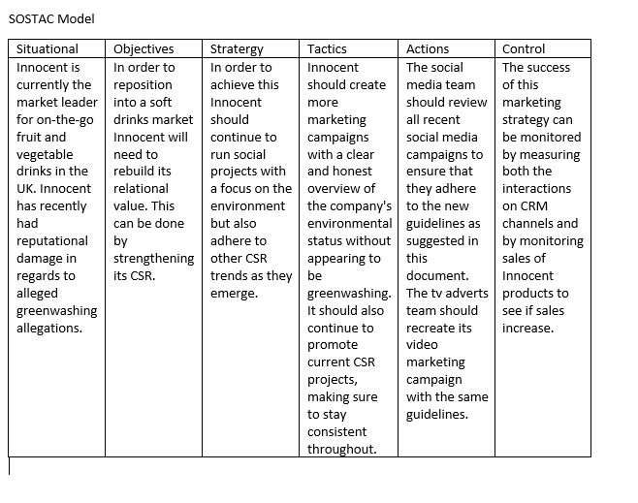

References
AgeUK (2019) Later Life In The United Kingdom 2019, [Online]. Available at https://www.ageuk.org.uk/globalassets/age-uk/documents/reports-and-publications/later_life_uk_factsheet.pdf (Accessed 6 July 2022).

Arora, N., Ensslen, D., Fiedler, L., Liu, W., Robinson, K., Stein, E. and Schüler, G. (2022) The value of getting personalization right—or wrong—is multiplying, Mckinsey & Company, [Online]. Available at https://www.mckinsey.com/business-functions/growth-marketing-and-sales/our-insights/the-value-of-getting-personalization-right-or-wrong-is-multiplying (Accessed 6 July 2021).

ASA (2022) ASA Ruling on Innocent Ltd t/a Innocent, Asa, [Online]. Available at https://www.asa.org.uk/rulings/innocent-ltd-g21-1111827-innocent-ltd.html (Accessed 31 May 2022).
Beard, N. (2022) 'Assignment 1. University of Wales Trinity Saint David. Unpublished essay
Baker, C. and Hutton, G. (2022) Gigabit-broadband in the UK: Government targets and policy, UK Parliament, [Online]. Available at https://commonslibrary.parliament.uk/research-briefings/cbp-8392/ (Accessed 6 July 2022).
Bickle, M. (2011) What Makes Coca-Cola a World-Wide Phenomenon?, Forbes, [Online]. Available at https://www.forbes.com/sites/prospernow/2011/08/01/what-makes-coca-cola-a-world-wide-phenomenon/?sh=355e33b81f08 (Accessed 6 July 2022).

Caccavale, M. (2020) Five Core Tactics To Optimize Your Marketing Mix, Forbes, [Online]. Available at https://www.forbes.com/sites/forbesagencycouncil/2020/07/07/five-core-tactics-to-optimize-your-marketing-mix/?sh=73f594884dc4 (Accessed 6 July 2022).
Casonato, F. (2022) Pride parade returns to London as thousands celebrate 50th anniversary, The Independent, [Online]. Available at https://www.independent.co.uk/tv/lifestyle/pride-london-parade-50th-anniversary-b2114459.html (Accessed 6 July 2022).
Chernev, A. and Kotler, P. (2014) Strategic Marketing Management, 8th ed. Cerebellum Press.

Coca-Cola Australia (2018) "It Feels Good To Give" Christmas campaign with Salvation Army | Coca-Cola Australia, Coca-Cola Company, [Online]. Available at https://www.coca-colacompany.com/au/media-centre/media-releases/coca-cola-partners-with-the-salvation-army-this-christmas-on-festive-campaign (Accessed 6 July 2022).

Cuellar, M., Moeller, L. and Molina, H. (2012) Rethinking the Product Launch, Strategy+Business Magazine, vol. Summer 2012, no. 67, pp. 2-8.

CIPD (2022) Corporate Responsibility an introduction, CIPD, [Online]. Available at https://www.cipd.co.uk/knowledge/strategy/corporate-responsibility/factsheet#gref (Accessed 27 June 2022).

Coca-Cola GB (2022) Does Coca-Cola GB support any charities or community projects?, Coca-Cola GB, [Online]. Available at https://www.coca-cola.co.uk/our-business/faqs/does-coca-cola-support-any-particular-charities-community-projects (Accessed 30 June 2022).

Embury-Dennis, T. (2020) Coca-Cola named world’s worst plastic polluter for third straight year, The Independent, [Online]. Available at https://www.independent.co.uk/climate-change/news/coca-cola-plastic-pollution-nestle-pepsico-b1767370.html (Accessed 29 June 2022).

Fahy, J. and Jobber, D. (2015) Foundations Of Marketing, 5th ed. London, Mc Graw-Hill Education.
Fatma, M., Rahman, Z. and Khan, I. (2015) Building company reputation and brand equity through CSR: the mediating role of trust, International Journal Of Bank Marketing, vol. 33, no. 6, pp. 840-856.
Featherstone, E. (2017) Innocent co-founder: 'everyone told us it wouldn't work', The Guardian, [Online]. Available at https://www.theguardian.com/small-business-network/2017/mar/20/innocent-smoothie-cofounder-investment-worst-moment (Accessed 30 June 2022).

Hearn, A. (2021) UK adults put off brands due to ‘green washing’, The Independent, [Online]. Available at https://www.independent.co.uk/climate-change/uk-adults-green-washing-brands-b1907262.html (Accessed 1 June 2022).

Innocent Drinks (2022) big knit, Innocent Drinks, [Online]. Available at https://www.innocentdrinks.co.uk/big-knit (Accessed 29 June 2022).

Innocent Drinks (2022) everything you need to know about us, Innocent Drinks, [Online]. Available at https://www.innocentdrinks.co.uk/a-bit-about-us (Accessed 27 June 2022).

Innocent Drinks (2022) our owner, Innocent Drinks, [Online]. Available at https://www.innocentdrinks.co.uk/our-owner (Accessed 27 June 2022).

Innocent Drinks (2022) what is the innocent big rewild?, Innocent Drinks, [Online]. Available at https://www.innocentdrinks.co.uk/thebigrewild/all-about (Accessed 29 June 2022).
ITV News (2022) Plymouth protesters march to support American women following Roe v Wade abortion ruling, ITV News, [Online]. Available at https://www.itv.com/news/westcountry/2022-07-03/plymouth-protesters-march-through-city-following-abortion-ruling-in-the-usa (Accessed 6 July 2022).

ITV News (2022) Twelve arrested during M4 fuel price protest for driving ‘too slow’, ITV News, [Online]. Available at https://www.itv.com/news/2022-07-04/serious-disruption-likely-as-motorways-targeted-in-fuel-duty-protest (Accessed 6 July 2022).
Kosner, A. (2012) Hug Me: Coca-Cola Introduces Gesture Based Marketing in Singapore, Forbes, [Online]. Available at https://www.forbes.com/sites/anthonykosner/2012/04/11/hug-me-coca-cola-introduces-gesture-based-marketing-in-singapore/?sh=4c79409626fe (Accessed 6 July 2022).
Macrotrends (2022) CocaCola Net Worth 2010-2022, Macrotrends, [Online]. Available at https://www.macrotrends.net/stocks/charts/KO/cocacola/net-worth#:~:text=CocaCola%20net%20worth%20as%20of%20July%2004%2C%202022%20is%20%24279.09B.&text=The%20Coca%2DCola%20Company's%20strong,sparkling%20water%20and%20sports%20drinks. (Accessed 6 July 2022).
McClimon, T. (2021) 10 CSR Trends To Watch In 2021, Forbes, [Online]. Available at https://www.forbes.com/sites/timothyjmcclimon/2021/01/05/10-csr-trends-to-watch-in-2021/?sh=297d9d45904f (Accessed 29 June 2022).

Moore, K. (2021) How To Predict The Future With Trend Forecaster Laura Saunter Of WGSN Insight, Forbes, [Online]. Available at https://www.forbes.com/sites/karlmoore/2021/05/29/how-to-predict-the-future-with-trend-forecaster-laura-saunter-of-wgsn-insight/?sh=632da22e96f5 (Accessed 6 July 2022).
Newman, D. (2016) Connecting With Your Customer Is What Drives Relationship Marketing, Entrepreneur, [Online]. Available at https://www.entrepreneur.com/article/283594 (Accessed 6 July 2022).
Nwagbara, U. and Reid, P. (2013) Corporate Social Responsibility (CSR) and Management Trends: Changing Times and Changing Strategies, Economic Insights – Trends And Challenges, vol. 2, no. 2, pp. 12-19 [Online]. Available at https://www.researchgate.net/profile/Charles-Fombrun/publication/233662267_A_World_of_Reputation_Research_Analysis_and_Thinking_-_Building_Corporate_Reputation_Through_CSR_Initiatives_Evolving_Standards/links/54d8dd790cf25013d0405d74/A-World-of-Reputation-Research-Analysis-and-Thinking-Building-Corporate-Reputation-Through-CSR-Initiatives-Evolving-Standards.pdf.

Office for National Statistics (2021) Conception and fertility rates - Office for National Statistics, Office For National Statistics, [Online]. Available at https://www.ons.gov.uk/peoplepopulationandcommunity/birthsdeathsandmarriages/conceptionandfertilityrates (Accessed 6 July 2022).
Rowlett, K. (2022) Bristol protesters march to support American women following Roe v Wade abortion ruling, ITV News, [Online]. Available at https://www.itv.com/news/westcountry/2022-07-03/hundreds-march-in-bristol-following-roe-v-wade-abortion-ruling (Accessed 6 July 2022).

Shetty, S., Chaudhuri, M. and Shetty, A. (2021) The Influence of Cause-Related Marketing on Millennials’ Purchase Intentions: Evidence of CSR from an Emerging Economy, Gadjah Mada International Journal Of Business, vol. 23, no. 2, pp. 137-154.
Siddique, H. (2022) What would a British bill of rights look like?, The Guardian, [Online]. Available at https://www.theguardian.com/law/2022/jun/21/what-would-a-british-bill-of-rights-look-like (Accessed 6 July 2022).
Statista (2022) Leading beverage companies worldwide based on sales 2020, Statista, [Online]. Available at https://www.statista.com/statistics/307963/leading-beverage-companies-worldwide-based-on-net-sales/ (Accessed 6 July 2022).
Statista (2022) Top UK soft drink brands, by c-store sales 2021, Statista, [Online]. Available at https://www.statista.com/statistics/629118/soft-drink-brand-ranking-in-the-united-kingdom-uk-by-convenience-sales-value/ (Accessed 6 July 2022).
The Coca-Cola Company (2022) Climate Sustainability, The Coca-Cola Company, [Online]. Available at https://www.coca-colacompany.com/sustainability/climate (Accessed 29 June 2022).
The Coca-Cola Company (2022) SOCIAL IMPACT, The Coca-Cola Company, [Online]. Available at https://www.coca-colacompany.com/social-impact (Accessed 6 July 2022).

The Coca-Cola Company (2022) The Coca-Cola Foundation, The Coca-Cola Company, [Online]. Available at https://www.coca-colacompany.com/social-impact/coca-cola-foundation (Accessed 29 June 2022).
Webb, S. (2022) Coca-Cola, Ikea, and Kim Kardashian’s fashion brand accused of ‘greenwashing’, The Independent, [Online]. Available at https://www.independent.co.uk/climate-change/news/coca-cola-ikea-tesco-kim-kardashian-s-greenwashing-b2112805.html (Accessed 6 July 2022).

Wijayasinha, R. (2020) Council Post: What To Do When You Have To Reposition Your Company, Forbes, [Online]. Available at https://www.forbes.com/sites/forbescommunicationscouncil/2020/06/22/what-to-do-when-you-have-to-reposition-your-company/?sh=67b8a20d7651 (Accessed 6 July 2022).
Zendesk UK (2022) What is the CRM process? - Zendesk UK, Zendesk UK, [Online]. Available at https://www.zendesk.co.uk/blog/crm-process/ (Accessed 6 July 2022).

Appendix

Appendix 1 – PESTEL Analysis
a
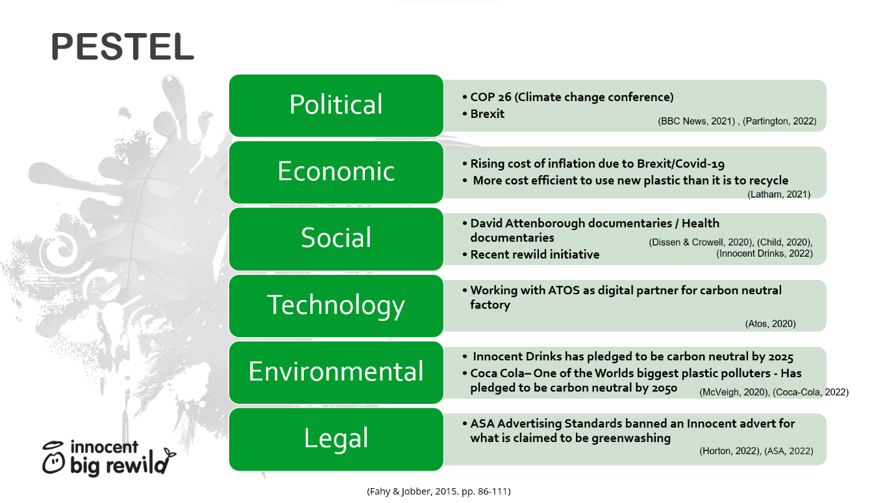

b
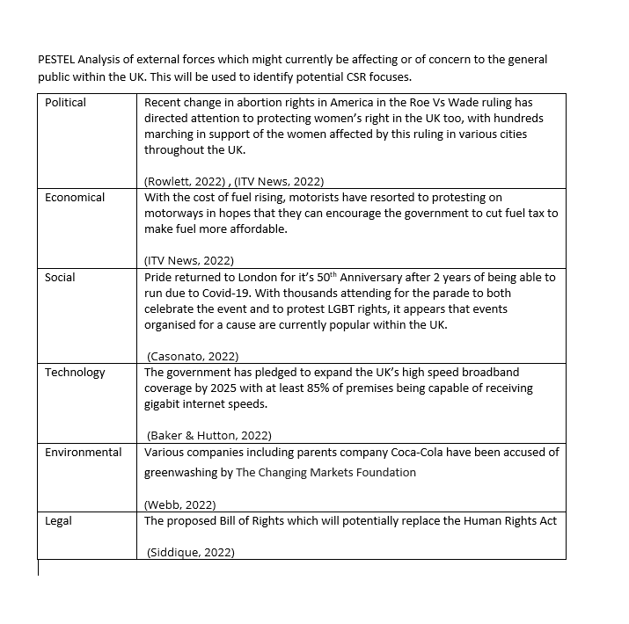

Appendix 2 – SWOT Analysis

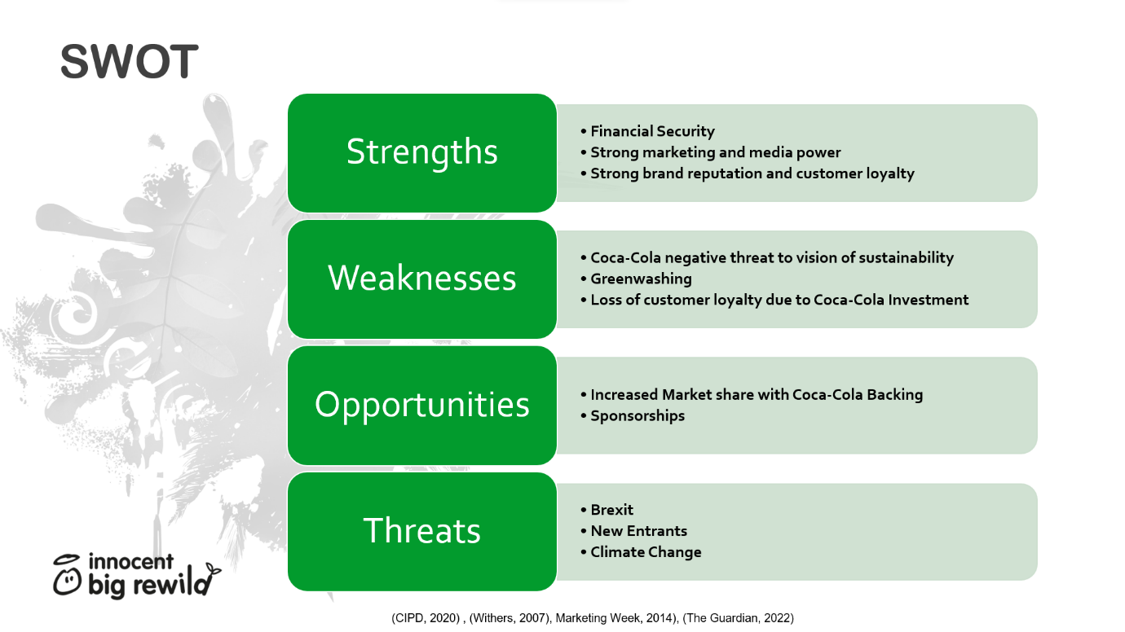
Appendix 3- 7Ps of Marketing

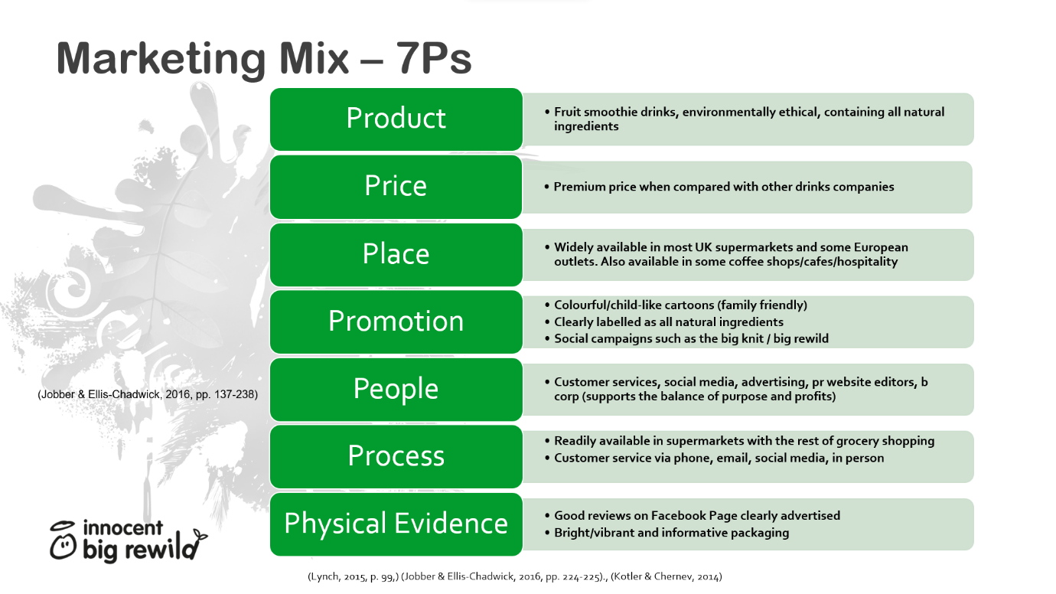

Appendix 4 – Value Creation

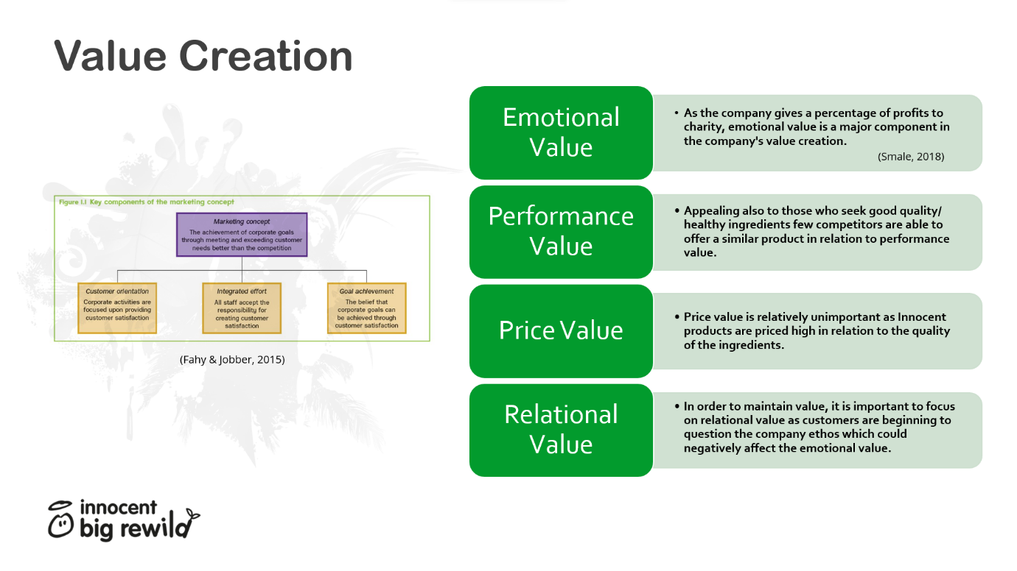
Appendix 5- Positioning

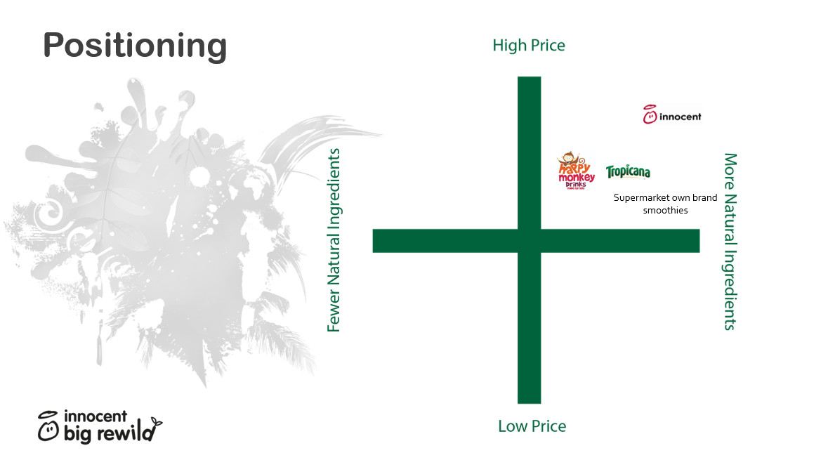

Appendix 6 - Recommendations



