Data Mining Project: Report





July 2019

MODULE NAME: Data Handling and business information m5x00842
Project Name: Data mining project
Name: Kate Oliver
Student Number: 1702582

Assignment 2
1 Executative summary 32
2 Introduction 42
3 Excel Analysis 42
4 IF Function 42
5 LOOKUP Function 62
6 Pivot Tables 72
7 Charts & Graphs 82
8 Strengths of Excel 92
9 Weka Data Mining 92
10 Classify 102
11 Cluster 112
12 Recommendations 112
13 Conclusion 122
14 References 132

Executative summary
This report works to help Sarn Helen identify where they are losing money and help them to understand the importance of data and how analysing it properly can be of great benefit to the business as a whole. It also explains how software such as Excel and Weka are essential tools when it comes to analysing data and data mining.
It begins by explaining the ways in which Excel can help a company such as Sarn Helen office supplies. Highlighting its ability to provide structure to a vast amount of data, and when used correctly, it can be very influential when it comes to businesses making informed decisions. The report then goes on to explain the importance of functions such as;
- if function
- lookup function
- pivot tables
- charts and graphs
Highlighting how each has a different purpose yet are all vital to analysing data and providing the best answers. After establishing the extent of what Excel can do as a program, it then goes on to confirm and establish Excel’s vast strengths proving it is a vital piece of software to any business looking to succeed in data analysis.
Next, it went on to explain what the difference is between data mining and data processing. Introducing Weka and how its inbuilt algorithms help identify patterns in different ways. Such as the cluster tool helps to group different parts of the data that have a common theme highlighting to the user potential themes as well as defining re-occurrences that could be either potential issues or possible successes that once addressed could become critical components to Sarn Helen success.
Finally, it discusses potential recommendations to help improve Sarn Helen’s current situation; it highlights the areas of which problems have been found. For example, specific regions or products that are not creating enough profits to be sustainable and providing Sarn Helen office supplies with the potential options they need to consider to minimise their percentage of loss and maximise their potential profit.

introduction
This report has been created to help show Sarn Helen Supplies how to analyse their data and explain that using software such as Excel and Weka can help better inform the way in which they make business decisions. It also explains how to utilise the systems that they already have in place. It will walk through the positives of excel and a detailed explanation of the different functions and how they can turn a vast amount of unorganised data into the tools to help them make the right decision as well helping to identify potential issues or pitfalls. Understanding how the software works in its entirety helps its user to get the best out of it. This report is a guide to help Sarn Helen Supplies understand how helpful data can be in the business and transform how decisions are made.

Excel Analysis
A spreadsheet is a format where data is arranged in rows and columns, providing structure for huge amounts of data. A spreadsheet can be used for a variety of different things such as; creating budgets, producing graphs and charts as well as storing and sorting data. It helps translate data into meaningful information that can be extremely useful to businesses such as Sarn Helen Office Supplies. Businesses all over the world are beginning to realise how influential data can be when it comes to making informed decisions. Instead of making decisions based on HIPPO (highest paid person’s opinion) and their intuition formed after years of experience, companies are opening their minds to using data to help formulate the best course of action. By gathering all relevant information on the topic, it removes personal bias and gives people the whole picture (McAfee & Brynjolfsson, 2012). Research shows that data-driven businesses are 23 times more likely to gain more customers, six times more likely to keep them and 19 times more likely to be profitable as a result (Harshdeep, 2018).

IF Function
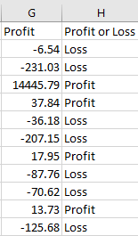
The IF Function, begins with inputting a rule and then it analyses the data based on where it fits the statement or not. For example, with Sarn Helen, using the IF function identifies whether and order is making a profit or a loss.
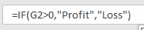

By implementing this function, it helps give organisations a clear distinction as to whether orders are making a profit or a loss, saving them time, stopping them from having to analyse each cell they can now use the profit or loss column as a clear indicator. It also automatically updates if any of the data changes in the profit column the IF function will update the profit or loss column keeping it up to date as factors change thus, minimising the possibility of error.

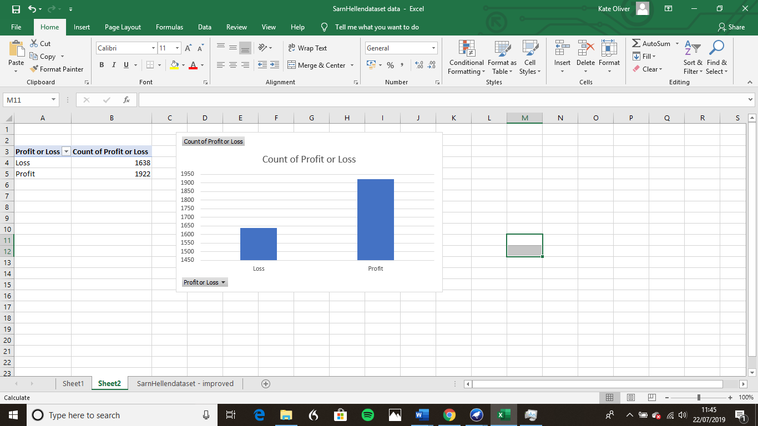

This chart shows that out of 3560 cases only 1922 made profit and 1638 ended up with a loss. That woks out at 46% operating at a loss, this is an issue that needs to be rectified. Using the other functions, it will help identify some of the issues and which areas are the root of the problem, thus helping to make the right decisions to help Sarn Helen move forward.

LOOKUP Function
The lookup function is used to search through extensive amounts of data and allows users easier access to information.
This equation, provides a search cell which in this case is “Q2”, and when a cell from column A is typed in to the search cell the formula would sift through column H and find out whether that order number is provided a profit or a loss and displays it in “R2”.
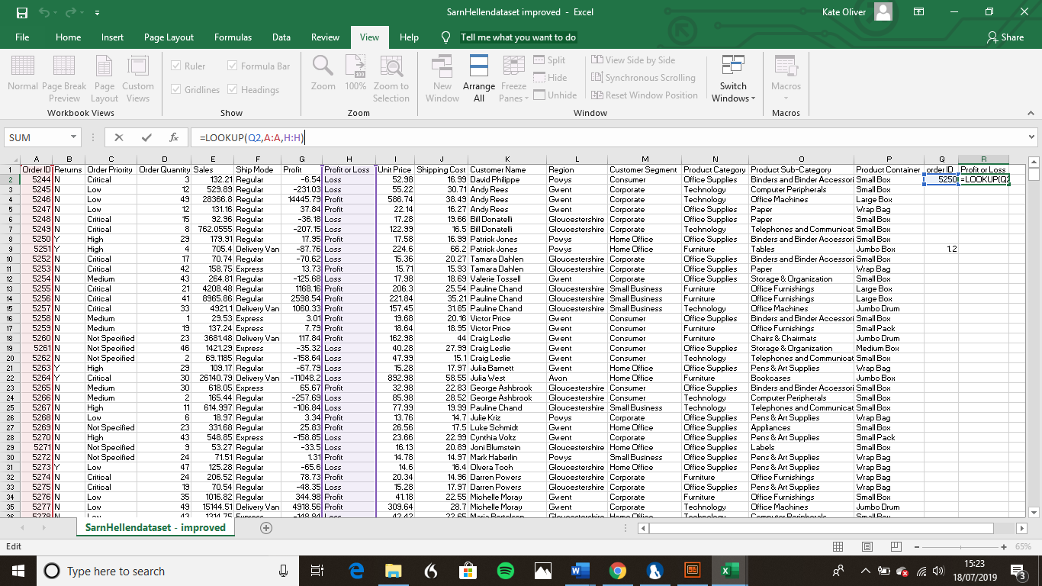
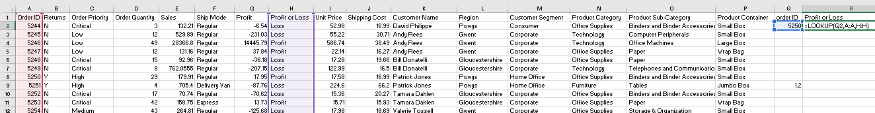

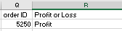

This function creates a short cut for users, the LOOKUP function has excel pinpoints the information needed to answer the question asked of it. In the case of Sarn Helen it has highlighted the order ID 5250 came as a profit and if order ID 5251 was search it would show that order operated at a loss.

Pivot Tables
A PivotTable is a function built into Excel, where a table is created to help organise and summarise data. The user can decide which areas to analyse by picking the categories that are used helping to identify specific trends.
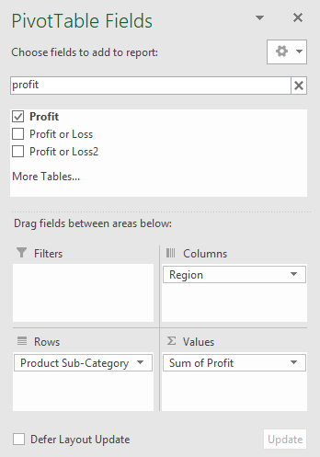
Using the formatting table, it provides the list of different categories to choose from, and allows the user to decide what goes in the columns and rows, thus tailoring it to the specific question being asked of the data.

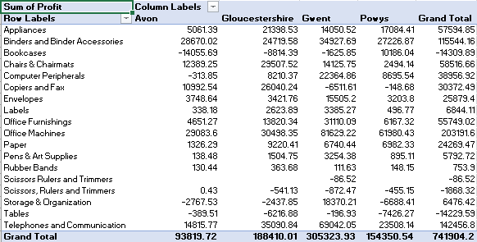
For example, the PivotTable created has the sub categories of the different products sold by Sarn Helen on the rows and the regions they are sold in across the columns. This means that it highlights how much profit each product makes in each region, as well as the overall profit each region makes.

It shows that Gwent is the region with the most profit made and the product that created the most profit was office machines yet they lost 6511.61 on Copiers and Fax. Avon also made their profit on office machines however they lost 14055.69 on bookcases. This PivotTable helps Sarn Helen to identify which products to sell in which region to create the highest profit.

This PivotTable has already identified an issue with the data input. The Sub-category “Scissors, Rulers and Trimmers” is repeated twice this is due to the fact that when it was typed out the comma was missed between scissors and rulers thus causing the error. Even a small issue like this can affect the results because it splits information and to first glance it comes across as if Scissors etc. are only be sold in Gwent.

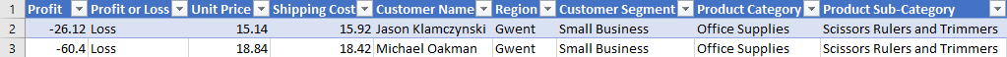
After identifying the data with the errors above and adding the required commas the PivotTable reconfigured with the data and changed accordingly. As seen below there is no longer the extra row within the PivotTable.

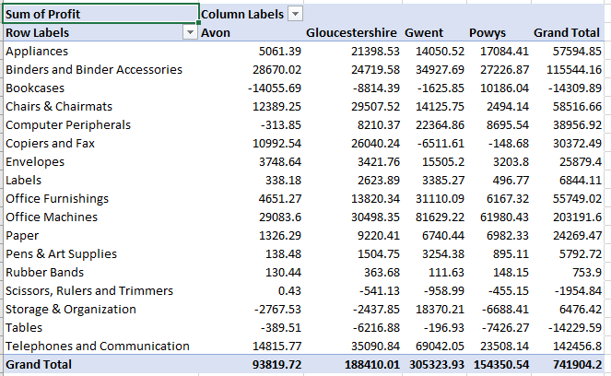

Charts & Graphs
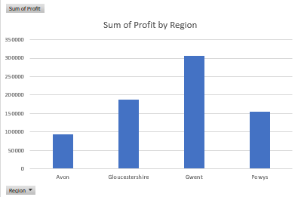
Charts and Graphs help to display data in a visual way that is much easier to understand and translate patterns and trends from within the data. They are used mostly in meetings and other forms of business discussions as they can be customized to display only the relevant information to the question asked of it. For example, this bar chart
Answers the question; Which region made the most profit?
This shows very distinctly that Gwent is the most profitable and Avon is struggling considerably. This helps identify problem areas as well as the greater success that they can learn from.

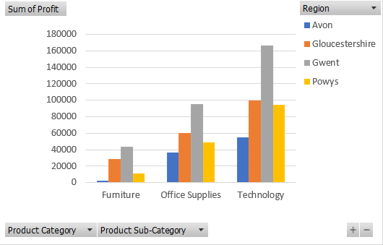
It can then be taken further analysed and this second graph highlights which categories of product work best in which region. This indicates that all regions sell technology more than any other product.
Tools such as graphs and charts can be helpful to management as well, it is a quick and distinctive way of showing progress and highlighting specific areas that are struggling. For example, after being presented with this graph management would then discuss with the furniture department how they should improve and work on ways to improve profit figures.

Strengths of Excel
Excel is the "world's most widely-used program" (Walkenbach, 2007). Excel can organise the data with formula and functions. Excel is a piece of software that most businesses use to analyse large amounts of data, and it helps businesses to identify trends and patterns. With the selection of tools and applications, it comes with, the data can be separated and manipulated to help make decisions for the future of the company. By identifying the patterns, management can deduce what is the best step to ensure the highest level of profit is achieved and the business is run as efficiently as possible. Data has become key to the success of a business; it helps to inform decisions with information that would not be obtained any other way. It provides structure and a platform to hold a high volume of data.

Weka Data Mining
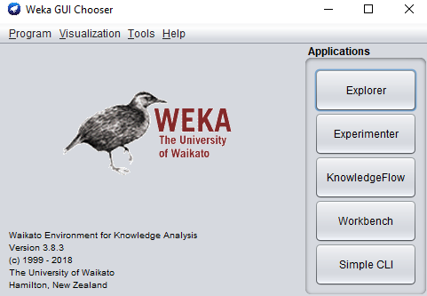
Data mining is the process of identifying patterns from within data, it uses algorithms and forms of artificial learning techniques to identify patterns and extract vital information from data.
Weka is a piece of software that enables data mining it holds tools such as;
- classification
- clustering
- association
as well as a selection of others helping identify different things from within data.

Classify
Classify is a data mining algorithm which is used to figure out the potential output of the data being processed through Weka. Then there is the decision tree, where it highlights the different layers of decisions. This algorithm and model help to give structure to unorganised data.
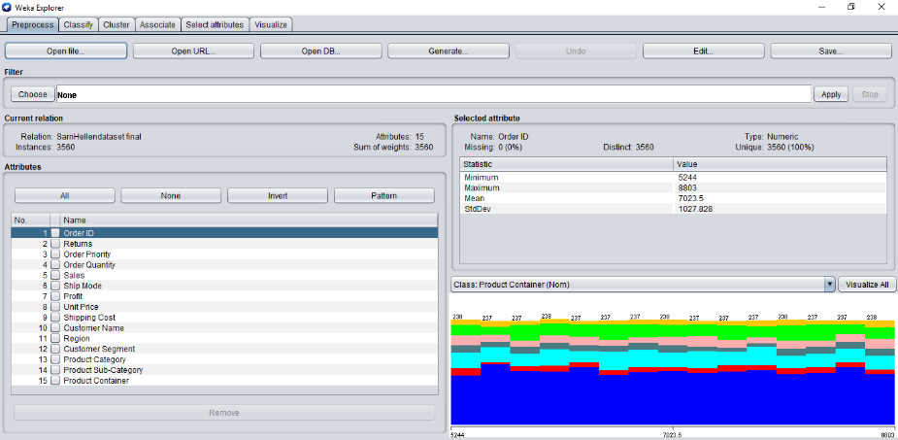
Once the data is put into Weka, there are a variety of different options for how to process the data depending on what the users wishes to get out of the data.

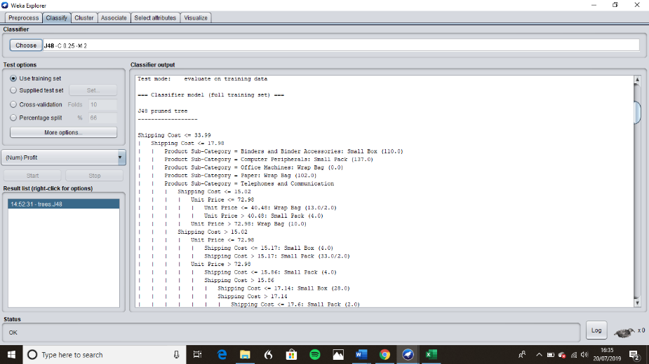
One of the aspects of the classify function is highlighting false positives and false negatives, which indicate a problem in the model, and some of the data has been miss classified. Which does help signal the user to potential issues with the data and a certain amount of error can be expected, but it needs to be monitored because if the percentage grows too high, then the data will miss inform the user thus tainting any decisions made due to its findings.

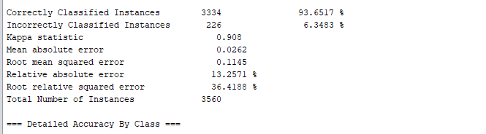
Sarn Helens Data when classified has a 93.65% of correct classification and only 6.34% incorrect showing this is a strong and trustworthy source of information for the business. This shows us initially that this is a good, strong model so far.

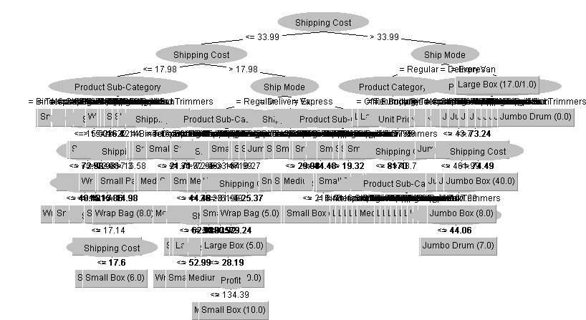
The next step is to transform this model into a decision tree, which is used to help understand the different layers of the data and how each bit is connected. However, it is more effective and helpful when a smaller amount of data is applied. Otherwise, it becomes unfollowable and defeats the objective of the decision tree of making data easier to understand. It is best used when the user identifies a specific area it wishes to analyse and then put through classification. Creating a PivotTable in excel and then converting that data to Weka would be much more effective.

cluster
Clustering is a function that makes group out of the data to help identify patterns in the information. Clustering can be considered to be one of the more useful functions within Weka as it can quickly turn a considerable amount of data into organised groups enabling the user to make conclusions quickly yet precisely. It is most commonly used when a pattern needs to be determined from a batch of data. It identifies aspects that data have in common, for example, the demographic that is most attracted to Sarn Helen’s product in each region. There are disadvantages to this function as the user needs to know exactly how many groups, if the user does not have a deep understanding of the data, they are analysing they will be unable to utilise the cluster function’s full potential.

reccomendations
After analysing the data Sarn Helen provided, there are a few different areas that need improving and will help with the issue of diminishing profit margins. Firstly, the data shows that the Technology sector is its most profitable sector, meaning if the business could focus on it and enhance its sell-ability, then its profit margin could potentially grow. Next, the areas where Sarn Helen are operating at a loss are;
- Scissors, Rulers and Trimmers
- Tables
- Bookcases
It seems that the best option moving forward would either be to remove them from their product list as they are areas that are losing Sarn Helen a high amount of money or if Sarn Helen wishes to continue selling them, then they need to establish the right market for selling them and figure out ways to make them more appealing to the customer and establish a competitive edge. Moving forward to the next area, which is the furniture department, they are the least profitable out of all areas, as seen in the graphs and charts section above. Compared to the other two categories, there is a substantial difference in the money it is bringing in. Concerning the regions, it is evident from the data gathered that Gwent is the area bringing the most money for Sarn Helen, whereas Avon is struggling in comparison. The recommendation would be to analyse both regions and see if there are any differences between the two or key attributes of Gwent that could be transferred to Avon to help bring it up to par. another aspect that Sarn Helen has to understand is the issue of human error, as seen from the pivot tables the slightest incorrect input of data can alter the outcome of the function meaning that Sarn Helen need to put together a process that helps to eliminate as much human error as possible enabling them to have the strongest most trustworthy data to help inform them on how the company is progressing as well as when it comes to helping make an informed decision.

conclusion
In conclusion, Excel and Weka are software's that are vital to businesses that wish to analyse data to help inform their decision-making as well as identifying potential solutions. Sarn Helen office supplies have been struggling with a decrease in their profit, from the information gathered from the data the problem areas have been identified, and these are the furniture department, the region of Avon as well as the products; tables, bookcases and scissors etc. This shows that when data is analysed and mined correctly, it can become obvious the specific areas where productivity is lacking and needs to be worked on as well as recognising the areas that Sarn Helen is succeeding. It could be seen from this report that excel has the tools to help organise Sarn Helen's data and that the available functions can help work with data effectively and is a piece of software that is easy to use yet meets most of the demands of working with data. Weka has more specific functions of mining through data to help find patterns that the human eye may not detect and is a great tool to have and use. It can be hard to get to grips with to a certain extent, but when someone with the right skills and abilities uses it, the results are incredibly useful.

References
Harshdeep, S., 2018. Using Analytics for Better Decision-Making. [Online]
Available at: https://towardsdatascience.com/using-analytics-for-better-decision-making-ce4f92c4a025
[Accessed 18 July 2019].
McAfee, A. & Brynjolfsson, E., 2012. Big Data: The Management Revolution. Harvard Business Review, 90(10), pp. 60-68.
walkenbach, j., 2007. Excel 2007 Bible. Indianapolis: Wiley.
Walkenbach, J., 2007. Excel 2007 Bible. Indianapolis: Wiley.

