Internet Protocols assessment.

For this Universities , we will use 172.16.0.0/19 major network , which is private IP address and a class B address . The total amount of subnets will be 7.
We will have 8190 Hosts and we will need only 1620 , rest of them could be used for a future expansion of the University.
Available IP addresses in allocated subnets are 2570.

Network Bits | Subnet Mask | Numbers of Subnets | Numbers of Host
/16 | 255.255.0.0 | 0 | 65534
/17 | 255.255.128.0 | 2 (0) | 32766
/18 | 255.255.192.0 | 4 (2) | 16382
/19 | 255.255.224.0 | 8 (6) | 8190
/20 | 255.255.240.0 | 16 (14) | 4094
/21 | 255.255.248.0 | 32 (30) | 2046
/22 | 255.255.252.0 | 64 (62) | 1022
/23 | 255.255.254.0 | 128 (126) | 510
/24 | 255.255.255.0 | 256 (254) | 254
/25 | 255.255.255.128 | 512 (510) | 126
/26 | 255.255.255.192 | 1024 (1022) | 62
/27 | 255.255.255.224 | 2048 (2046) | 30
/28 | 255.255.255.240 | 4096 (4094) | 14
/29 | 255.255.255.248 | 8192 (8190) | 6
/30 | 255.255.255.252 | 16384 (16386) | 2

Subnet Name | Needed Size | Allocated Size | Address | Mask | Dec Mask | Assignable Range | Broadcast
A | 708 | 1022 | 172.16.0.0 | /22 | 255.255.252.0 | 172.16.0.1-  172.16.3.254 | 172.16.3.25
C | 338 | 510 | 172.16.4.0 | /23 | 255.255.254.0 | 172.16.4.1-172.16.5.254 | 172.16.5.255
B | 286 | 510 | 172.16.6.0 | /23 | 255.255.254.0 | 172.16.6.1-172.16.7.254 | 172.16.7.255
D | 279 | 510 | 172.16.8.0 | /23 | 255.255.254.0 | 172.16.8.1-172.16.9.254 | 172.16.9.255
RA | 4 | 6 | 172.16.10.0 | /29 | 255.255.255.248 | 172.16.10.1-  172.16.10.6 | 172.16.10.7
RC | 4 | 6 | 172.16.10.8 | /29 | 255.255.255.248 | 172.16.10.9 –  172.16.10.14 | 172.16.10.15
RB | 4 | 6 | 172.16.10.16 | /29 | 255.255.255.248 | 172.16.10.17 –  172.16.10.22 | 172.16.10.23
RD | 4 | 6 | 172.16.10.24 | /29 | 255.255.255.248 | 172.16.10.25 –  172.16.10.30 | 172.16.10.31
School of Applied Computing – A – RA -Router name (MP)
School of Architecture , Built Natural Environment – C – RC – Router name
School of Automotive Engineering- B – RB- Router name
School of Engineering , Manufacturing and Logistics -D – RD- Router name

School of Applied Computing
Lab No | Network address | First IP | Last IP | Broadcast address | Subnet mask
Staff 25pcs | 172.16.0.0 | 172.16.0.1 | 172.16.0.30 | 172.16.0.31 | /27
Lab 301-50pcs | 172.16.0.32 | 172.16.0.33 | 172.16.0.94 | 172.16.0.95 | /26
Lab 302 – 30pcs | 172.16.0.96 | 172.16.0.97 | 172.16.0.126 | 172.16.0.127 | /27
Lab 303 – 30pcs | 172.16.0.128 | 172.16.0.129 | 172.16.0.158 | 172.16.0.159 | /27
Lab 305 – 20pcs | 172.16.0.160 | 172.16.0.161 | 172.16.0.190 | 172.16.0.191 | /27
Lab 306 – 40pcs | 172.16.0.192 | 172.16.0.193 | 172.16.0.254 | 172.16.0.255 | /26
Lab 308 – 120 pcs | 172.16.1.0 | 172.16.1.1 | 172.16.1.126 | 172.16.1.127 | /25
Lab 411 – 30pcs | 172.16.1.128 | 172.16.1.129 | 172.16.1.158 | 172.16.1.159 | /27
Lab 410 – 60 pcs | 172.16.1.160 | 172.16.1.161 | 172.16.1.222 | 172.16.1.223 | /26
Lab 412 – 36 pcs | 172.16.1.224 | 172.16.1.225 | 172.16.2.30 | 172.16.2.31 | /26
Router A (for connection of all above) | 172.16.2.32 | 172.16.2.33 | 172.16.2.34 | 172.16.2.35 | /30
Test Centre – 15pcs | 172.16.2.36 | 172.16.2.37 | 172.16.2.66 | 172.16.2.67 | /27
Ip Phone | 172.16.2.68 | 172.16.2.69 | 172.16.2.70 | 172.16.2.71 | /30
Printer -1- | 172.16.2.72 | 172.16.2.73 | 172.16.2.74 | 172.16.2.75 | /30
Video – 1- | 172.16.2.76 | 172.16.2.77 | 172.16.2.78 | 172.16.2.79 | /30
Router – Test centre- | 172.16.2.80 | 172.16.2.81 | 172.16.2.82 | 172.16.2.83 | /30
Access Lab 5 printers | 172.16.2.84 | 172.16.2.85 | 172.16.2.90 | 172.16.2.91 | /29
Access Lab – 240 pcs | 172.16.2.92 | 172.16.2.93 | 172.16.3.162 | 172.16.3.163 | /24
Router Access Lab | 172.16.3.164 | 172.16.3.165 | 172.16.3.166 | 172.16.3.167 | /30

School of Architecture , Built Natural Environment
Lab no | Network address | First Ip | Last Ip | Broadcast address | Subnet mask
Staff – 32 pcs | 172.16.4.0 | 172.16.4.1 | 172.16.4.62 | 172.16.4.63 | /26
Lab 201 – 54 pcs | 172.16.4.64 | 172.16.4.65 | 172.16.4.126 | 172.16.4.127 | /26
Lab 202 – 25pcs | 172.16.4.128 | 172.16.4.129 | 172.16.4.158 | 172.16.4.159 | /27
Lab 203 – 30pcs | 172.16.4.160 | 172.16.4.161 | 172.16.4.190 | 172.16.4.191 | /27
Lab 205 – 28 pcs | 172.16.4.192 | 172.16.4.193 | 172.16.4.222 | 172.16.4.223 | /27
Lab 404 – 35 pcs | 172.16.4.224 | 172.16.5.225 | 172.16.5.30 | 172.16.5.31 | /26
Lab 408 – 28 pcs | 172.16.5.32 | 172.16.5.33 | 172.16.5.62 | 172.16.5.63 | /27
Lab 409 – 60 pcs | 172.16.5.64 | 172.16.5.65 | 172.16.5.126 | 172.16.5.127 | /26
Lab 410 – 45 pcs | 172.16.5.128 | 172.16.5.129 | 172.16.5.190 | 172.16.5.191 | /26
Router C | 172.16.5.192 | 172.16.5.193 | 172.16.5.194 | 172.16.5.195 | /30

School of Automotive Engineering
Lab no | Network Address | First IP | Last IP | Broadcast | Subnet mask
Staff – 20 pcs | 172.16.6.0 | 172.16.6.1 | 172.16.6.30 | 172.16.6.31 | /27
Lab 101 – 25 pcs | 172.16.6.32 | 172.16.6.33 | 172.16.6.62 | 172.16.6.63 | /27
Lab 102 – 35 pcs | 172.16.6.64 | 172.16.6.65 | 172.16.6.126 | 172.16.6.127 | /26
Lab 103 – 30 pcs | 172.16.6.128 | 172.16.6.129 | 172.16.6.158 | 172.16.6.159 | /27
Lab 205 – 20 pcs | 172.16.6.160 | 172.16.6.161 | 172.16.6.190 | 172.16.6.191 | /27
Lab 206 – 55 pcs | 172.16.6.192 | 172.16.6.193 | 172.16.6.254 | 172.16.6.255 | /26
CAD Lab – 20pcs | 172.16.7.0 | 172.16.7.1 | 172.16.7.30 | 172.16.7.31 | /27
Lab 301 – 80 pcs | 172.16.7.32 | 172.16.7.33 | 172.16.7.158 | 172.16.7.159 | /25
Router C | 172.16.7.160 | 172.16.7.161 | 172.16.7.162 | 172.16.7.163 | /30

School of Engineering , Manufacturing and Logistics
Lab no | Network address | First IP | Last IP | Broadcast | Subnet mask
Staff – 18 pcs | 172.16.8.0 | 172.16.8.1 | 172.16.8.30 | 172.16.8.31 | /27
Lab 101 – 35 pcs | 172.16.8.32 | 172.16.8.33 | 172.16.8.94 | 172.16.8.95 | /26
Lab 102 – 30 pcs | 172.16.8.96 | 172.16.8.97 | 172.16.8.126 | 172.16.8127 | /27
Lab 103 – 30 pcs | 172.16.8.128 | 172.16.8.129 | 172.16.8.158 | 172.16.8.160 | /27
Lab 105 – 25 pcs | 172.16.8.160 | 172.16.8.161 | 172.16.8.190 | 172.16.8.191 | /27
Lab 206 – 50 pcs | 172.16.8.192 | 172.16.8.193 | 172.16.8.254 | 172.16.8.255 | /26
Lab 208 – 90 pcs | 172.16.9.0 | 172.16.9.1 | 172.16.9.126 | 172.16.9.127 | /25
Router D | 172.16.9.128 | 172.16.9.129 | 172.16.9.130 | 172.16.9.131 | /30

Router Connection between Schools
Router | Network address | First IP | Last IP | Broadcast | Subnet mask
RA-RB | 172.16.10.0 | 172.16.10.1 | 172.16.10.2 | 172.16.10.3 | /30
RA-RC | 172.16.10.8 | 172.16.10.9 | 172.16.10.10 | 172.16.10.13 | /30
RA-RD | 172.16.10.16 | 172.16.10.17 | 172.16.10.18 | 172.16.10.19 | /30

IPv6.
For the servers and the MP connection to ISP – the router which connects all the servers to the MP , we will convert the IPv4 into IPv6 ( dual stack method) with anycast command from the routers CLI.
So if the IPv4 is 172.16.10.5 conversion to IPv6 will be 0:0:0:0:0:ffff:ac10:a05 . (MP to ISP connection).

Internet protocol version. 6 – Ipv6

Andrei-Daniel Mihai
Student no. 1912494
Cloud Computing

“One day, IPv6 will become the norm rather than the exception.”

“Posted September 24, 2019 | byValentin Bajrami (Red Hat Accelerator)”

The reason why IPv6 was created is to overcome the IPv4 problem , and that is the “address draining”. Soon IPv4 addresses will come to an end and IPv6 will overtake from there.
IPv4 uses a 32-bit address space which means a total of 4,294,967,296 addresses that hosts can have. There are a few special blocks of private network addresses around 18 million and around 200 millions of multicast addresses. Ipv4 use a decimal notation, each octet being separated by dot “.” For example (1.1.0.0).
Because the world is rapidly grown and the businesses are expanding and now we have more gadgets that can be connected to internet (phone, tablets, fridge, TV
, coffee machine etc.). With all those machines that requires an IP address around us, we had to find a solution for all of them. So, here is IPv6!
If we compare it with his predecessor (IPv4), IPv6 use 128-bits allowing us to have 340 trillion trillion trillion IP addresses. And that is a lot of addresses. The notation for this one is different from IPv4; IPv6 use an hexadecimal notation, each separated into 8 groups of 16 bits by a colon “:” . For example (“2001:0db8:85a3:0000:0000:8a2e:0370:7334”) .
This can be configurated manually by using Stateless Address Auto Configuration (SLAAC) or DHCPv6 and is supported by majority of operating systems, like Linux, macOS, Windows, etc.
Now, that we had an introduction let’s see how we calculate IPv6.
As we know, comparative with IPv4, IPv6 addresses has 128 bits. To create a border between the host number and network number, those bits are separated by creating borders between them. To be more precise, 128 bits is divided in two parts, 64 bits each.
Those 64 bits represents global routing prefix and the subnet ID.
As per Figure 1, we can see how all 128 bits are divided to create an address. First 3 bits are set to 001 for any globally address. Then the following 16 bits represents the subnet ID. The las remaining of 64 bits are reserved for the interface ID.

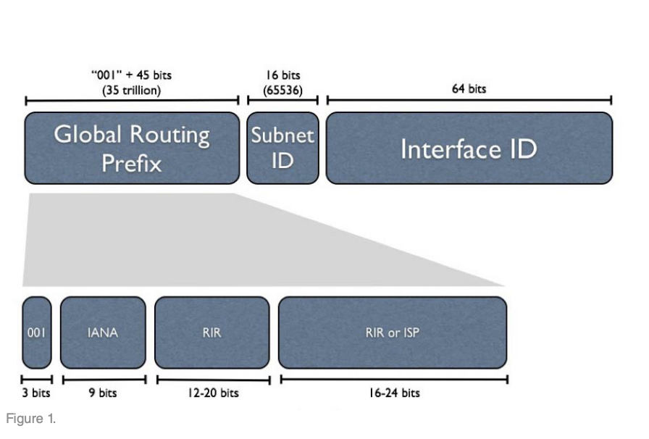

How many IP addresses do we need?
As per IPv6 Addressing Plan Book, first thing we have to determine a size allocation before requesting a/48 (or 1.2*1024 addresses). If the company don’t plan a future expansion, this addressing should be enough. However, a big company with multiple site will get a larger allocation based on an overall number, as per Figure 1, where is shown the number of /48-sized.
Next step will be to assign a subnet and an address to a site.
As you’ve been shown a few upper paragraphs, one single company site is allocated /48 bits standard. Also, this is the only prefix that IPS will allow.
Another subnet that is obtained from the primary site allocation it shouldn’t be smaller than the interface allocation IPv6 of /64.
As is shown in Figure 2, the subnet group /48 with the resulting number of /64 subnet.

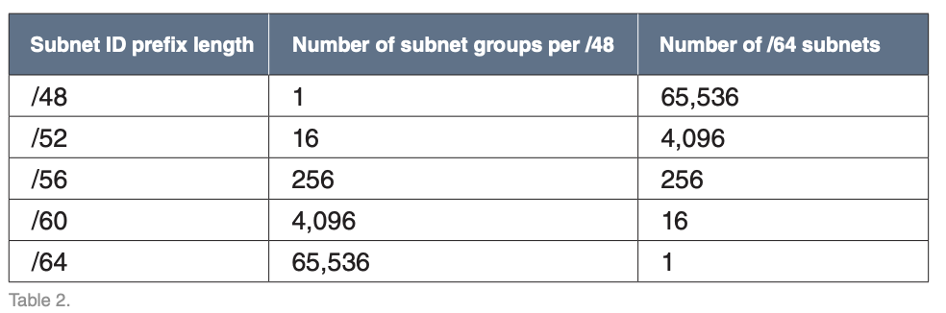
The values that are shown in the table above can be helpful to us, by showing how many groups of subnets are needed for our one location.
Among throw companies are unexpected to use more then 4096/64 subnets for one branch.
The way we establish how many groups of subnets we might need should take in consideration the ongoing production but also the possibility of a expansion of the company.
Now that we know how to establish, how many IPv6 addresses we need, in the following part we will see, how and from where we get the IPv6 address location.
The company will have to call for IPv6 space from ISP (Internet Service Provider) or from RIR (Regional internet Registries). The company will choose from one of those two (ISP or RIR) depending of their needs; provider assigned (for the ISP) or provider independent (for the RIR).

In the following part we will discuss about Pros and Cons of IPv6 but also about benefits and deployment issues.
As we know, with the IPv6 we can interconnect everything, from telephones and desktops, to automobiles and even your home.
When it comes to Pros, we have some characteristics like:
1.Efficient Routing
2.Multi Routing
3.Directed Local Address
4.Increase Capacity and Network Configuration
5.More Mobility

Starting with efficient routing (our first Pros characteristic), means that IPv6 put a limit to the growth of routing tables and makes them more efficient by allowing hierarchical address allocation. Is using the MTU (maximum transmission unit) protocol to allocate the path.
Multi Routing. Ipv6 can use multicast addressing and that means it can stretch all over the internet and makes it simple for the delivery process.
According to Jason Hoffman IPv6 can “also gives devise mobility and covers the configuration aspects in the protocol designing. It also handles the end to the end connectivity, which enables error detection by providing more transport layers.”
Direct Local Address. Gives well-structured data flow between multimedia streams.
Increased Capacity and Network Configuration. All resources are effectively grant, another web addresses can be accommodate.
More Mobility. According to Jason Hoffman “ IPv6 avoids , triangular routing , which is a forma of the path which sends a connection to a proxy system before transferring to the destination. This allows entire subnets to move to a new router point without any renumbering.” (Jason Hoffman – blog pros and cons ipv6)

Of course that everything on this world specially influenced by human factor has Pros and Cons characteristics. Now that we saw some of the Pros characteristics of IPv6, is time to see which are the Cons one.
1.System issues. The IP address needs to be memorised all the time if there is a problem with the network and you have to introduce it manual. Don’t forget, IPv6 is formed by numbers and letters.
2.Complexity in the Network Topology Drawings. If we remember that in IPv4 case , the IP was formed only from numbers, which was easy to added in the topology table and scheme, comparative with IPv6 which is more longer and we can have issues reading the topology drawing, the text being untraceable
3.Upgrading the service. The majority of the companies, needs to upgrade their network devices because there are not design for IPv6. This mean a costly upgrade because the companies needs the advice of a network specialist so he can do the transition more easily.
4.Local Network Changes
5.Confusion in the IP Schemes

There are some benefits for using IPv4 and Ipv6 together. Numerous companies still use IPv4 devices but in the same time, they want to grow their network using IPv6. To do so , there are three options available for transiting to IPv6.

- Dual-Stack Network. Can run both network hardware (IPv4 and IPv6) together. This type of approach is supported by major network trade.
- Tunneling. By tunnelling means you can one protocol is mined inside by shortening the other. You have the advantage to work with a new protocol without disturbing the other one. The only down side of tunnelling is that two users cannot communicate between them if they don’t use the same protocol without having a dual-stack host.
- Network Address Translation-Protocol Translation (NAT-PT) aka RFC-2766. According to Jason Hoffman “This is done by placing a mechanism on the network which interprets traffic going back and forth between both the IP version. It translates the IPv6 packets into IPv4 packets.” (Jason Hoffman – Blog Pros-Cons IPv6).

Conclusion.
In the past 20 years, the technology evolved more and more. In our day most of common households that use to be simple object became “smart” where you can use them remotely, or program them from your mobile phone on your way home.
And then the growth of population, increased the numbers of internet users where it was obviously that IPv4 will come to an end and people start to develop a new IP to satisfy the need of technology for the users. IPv6 not only satisfy the need of using the internet but also helps businesses and industry to grow and develop.

References :
https://www.infoblox.com/wp-content/uploads/2016/04/infoblox-whitepaper-ipv6-addressing-plan-basics_1.pdf
https://wisdomplexus.com/blogs/pros-cons-ipv6/
https://www.6net.org/publications/presentations/edwards-ipv6-benefits.pdf
Jason Hoffman https://wisdomplexus.com/blogs/pros-cons-ipv6/
https://www.redhat.com/sysadmin/what-you-need-know-about-ipv6
https://www.cisco.com/c/en/us/td/docs/ios-xml/ios/ipv6_basic/configuration/xe-3s/ip6b-xe-3s-book/ip6-add-basic-conn-xe.html
https://www.cisco.com/c/en/us/td/docs/interfaces_modules/services_modules/ace/vA5_1_0/configuration/rtg_brdg/guide/rtbrgdgd/ipv6.html

