  KNOWLEDGE and information management  AMAZON.COM | Mirela Urzica  KNOWLEDGE AND INFORMATION MANAGEMENT SKILLS FOR THE WORKPLACE BMSW5106



Knowledge and Information Management Skills for the Workplace
BMSW 5106
Student Name: Mirela Mihaela Urzica
Student ID: 1922003
Lecturer Name: Mohamad Kalam

Knowledge and Information Management of Amazon.com

EXECUTIVE SUMMARY
This report will address the relevant information regarding Amazon.com. In this report, various management theories are associated with Amazon. com will be described briefly. In this report, an effective presentation of the management development practices at Amazon.com will also be described briefly. Further in this report, various aspects regarding the process of maintaining good customers relationship will also be discussed briefly. Further in this report, the potential knowledge regarding the management challenges at Amazon will also be discussed briefly.

TABLE OF CONTENTS
TABLE OF FIGURES…………………………………………………………………………………….4
INTRODUCTION 5
KNOWLEDGE MANAGEMENT THEORIES 6,7
IMPORTANCE OF UNDERSTANDING OF GOOD KNOWLEDGE MANAGEMENT DEVELOPMENTAL PRACTICES……………………………………………………………………………………………8,9
IMPORTANCE OF INFORMATION MANAGEMENT SYSTEMS AND INFORMATION MANAGEMENT MODELS IMPLEMENTED BY AMAZON 10
SIGNIFICANCE OF INFORMATION SYSTEM IN AMAZON 10
INFORMATION SYSTEM IMPLEMENTED BY AMAZON 10
KNOWLEDGE MANAGEMENT CHALLENGES AND RECOMMENDATIONS 16
RECOMMENDATIONS FOR MANAGING KNOWLEDGE MANAGEMENT CHALLENGES WITHIN THE ORGANISATION 18
CONCLUSIONS 20
REFERENCE LIST 21,22
APPENDIX……………………………………………………………………………………………….22

TABLE OF FIGURES
FIGURE 1 AMAZON 6
FIGURE 2 WIIG KNOWLEDGE MANAGEMENT MODEL 12
FIGURE 3 SECI MODEL 13
FIGURE 4 MEYER AND ZACK MODEL OF KNOWLEDGE MANAGEMENT 15
FIGURE 5 THE INUKSHUK MODEL 16
FIGURE 6 KNOWLEDGE MANAGEMENT CYCLE 17
FIGURE 7 KNOWLEDGE MANAGEMENT CHALLENGES 18

INTRODUCTION
In the corporate world, work life has been faced multiple changes through Covid-19 pandemic situation along with another external environment. Therefore, people behaviour change and new rules appeared. This new change in every organisation has significant potential in online shopping, and with electronic devices used, the shopping was easy and secure.
In this report several aspects related to knowledge management within the multinational organisation, Amazon will be described extensively. Knowledge management can be defined as the processes to share, create, and use the knowledge and the information regarding the operations of the organisation. This report will cover the information management theories implemented within Amazon. In this report, several theories related to the knowledge management system will be described briefly. These theories include the discussion of the Wiig model of knowledge management, knowledge management cycle, SECI model, inukshuk model and Meyer & Zack model of knowledge management.
Amazon.com is the largest American multinational technology-based company. This company provides its services in e-commerce, digital streaming, and artificial intelligence. This is one of the five largest information technology industries providing services all over the world. Amazon is being founded by Jeff Bezos in Washington. Amazon counts among the largest employer in the United States (Amazon.com, 2021). Amazon also provides streaming content like video and music with the help of various online platforms. Amazon.com is an online platform that provides various services through online platforms in various sectors. Amazon has various separate websites for providing different and relevant services to consumers. Amazon headquarters are in Washington USA. There are around 1335000 employees all over the world (Amazon.com, 2021).


FIGURE 1 AMAZON
SOURCE: (Amazon.com, 2021).

KNOWLEDGE MANAGEMENT THEORIES
Knowledge management theories can be defined as the processes to share, create, and use the knowledge and the information regarding Amazon with the help of several theories. The knowledge management theories are associated with the collection of efforts to improve the Organisation’s performance by gaining the competitive advantages and innovation methods associated with the respective organisation (Hislop et al., 2018). Knowledge management at Amazon focuses mainly on achieving the organisational objectives with the help of the several management practices involve within Amazon. In these types of theories, the major focuses on the management of the knowledge regarding Amazon.com.
There are three types of knowledge management theories like Organisational knowledge management theories, ecological knowledge management theories and techno-centric knowledge management theories.
In the Amazon, knowledge management theories the major focus is on the organisational structure involved within the Amazon, in this type of theories the major focus will be upon the hierarchical management of the knowledge within the Amazon (Barão et al., 2017)
The next most important theory of knowledge management is the theory of environmental management in the Amazon. This theory focuses on the management of the relationships between the individuals and the Amazons. This approach focuses on the relations between the internal and external individuals associated with Amazon. This approach focuses on bringing the individuals with the help of the knowledge of the management in the Amazon (Raudeliūnienė et al., 2018).
Techno centric knowledge management process is associated with the focus on the use of the technology and the designing of the technology for the facilitation of the knowledge within the Amazon. This process also deals with the flow of knowledge with the help of information technology (Bolisani and Bratianu, 2017).
The knowledge management theories are being used in Amazon like the Wiig theory, knowledge management cycle, inukshuk knowledge management theory, SECI knowledge management theory and Meyer & Zack theory.

IMPORTANCE OF UNDERSTANDING OF GOOD KNOWLEDGE MANAGEMENT DEVELOPMENTAL PRACTICES
There are various practices involved in the development of the knowledge management practices at any Amazon. With the inculcation of all these knowledge management practices in the Amazon, the development of the Amazon can easily be assessed (GIVA, 2018). The robust implementation of all these knowledge management practices within Amazon can easily reap the great reward for Amazon in the long term for attaining the Amazon goals. Amazon enhance value of 64% by using KM principle. This organisation uses the ability of its customers to find very quick and easy what customer want, when they want, and this led to success in organisation. (Rosenberg, 2014)
By understanding the Amazon culture of the company:
Before deciding the appropriate Amazon knowledge management approach the Amazon culture of the company must also be known so that the knowledge management approach can easily be implemented within Amazon (GIVA, 2018). The main task of identifying the Amazon culture is to inculcate the approach of finding the behaviour of the people associated with Amazon. By identifying the Amazon culture, the capabilities of the people associated with the Amazon can easily be determined.
By appropriately implementing the knowledge management:
Before the implementation of the knowledge management approach within Amazon, an adequate consensus regarding the knowledge of Amazon must also be discussed. Before the implementation of the knowledge management approach into Amazon, the employees' behaviour regarding the adaptation of the changes in the Amazon must also be assessed appropriately.
By inspiring the employees by appreciation and rewards:
There are various practices associated with the implementation of knowledge management in Amazon. A better implementation of the knowledge management approach includes the approach of motivating the individuals associated with Amazon (GIVA, 2018). This motivation is in the form of external motivation with the help of the rewards and the appreciation for the employees. These appreciation and rewards show the value of the work of the employees associated with Amazon.
By implementing the approach of knowledge ownership:
This approach helps the company in motivating their employees so that the Amazon growth of the company can be assured. With the help of this approach, the employees within Amazon feel much more associated with the works and, feel much more responsible towards their work.
By assigning a knowledge management executive within Amazon:
With the implementation of the knowledge management processes in Amazon, changes can be assured in Amazon (GIVA, 2018). To cope with these changes a knowledge management executive must be associated with Amazon. This individual must be very well experienced in the field of knowledge management within Amazon. With the help of this individual in Amazon, the change in Amazon can easily be managed.
Briefing after important projects and the environment:
Briefing after the important projects and the presentation in the Amazon will lead to the increment in the positive outcomes within the Amazon(GIVA, 2018). With the help of the briefing, the company can create a wide scope for the expansion of the business horizons.
By implementing knowledge exchange policy:
With the help of the implementation of the knowledge exchange policy in Amazon, the vital and crucial knowledge of Amazon is continuously being supplemented to the employees of Amazon (GIVA, 2018).

IMPORTANCE OF INFORMATION MANAGEMENT SYSTEMS AND INFORMATION MANAGEMENT MODELS IMPLEMENTED BY AMAZON
Information management systems can be elaborated as the system through which the information regarding the operations of the company is being stored appropriately (Pozdniakov et al., 2018).

SIGNIFICANCE OF INFORMATION SYSTEM IN AMAZON
The business of any Amazon can only be successful when the operations within the business are being appropriately managed. The information system within any business Amazon helps in storing the record of several business documents. The effective information system within Amazon helps in making adequate decisions and planning regarding the business operations. With the help of the information systems in Amazon, a competitive advantage can easily be gained. With the help of the robust information systems within Amazon, several tasks regarding the selling of the products with the minimum cost price can also be assured. With the help of the information systems, innovation in the products and the related services can also be assured. These innovations in the products lead to the Amazon growth of the company in the market.
Amazon has been using the IT and the IS services within the products and the services that it provides to its customers so that appropriate management regarding the products and services can also be assured.

INFORMATION SYSTEM IMPLEMENTED BY AMAZON
WIIG MODEL OF KNOWLEDGE MANAGEMENT
Amazon is using Wiig model for managing the knowledge, so that the previous knowledge and the new knowledge can easily be stored and implemented in the future times. This model is consisting of the four steps for managing the knowledge (Venkatraman and Venkatraman, 2018).
The first step involves in managing the knowledge within the Amazon is to build the knowledge from personal experience, training and education, media, and all the other book sources.
The next step involved is to hold the knowledge that has been built in the first step. The knowledge can easily behold with the help of the people and other tangible sources (Venkatraman and Venkatraman, 2018).
This is the third step involved in knowledge management of the Amazon in this step several systems like intranet and other knowledge base system are being used for the management of the knowledge management within Amazon. In this step, the pooling regarding the knowledge attained is being done by people and cross groups.
In this step, the knowledge that has been gathered through various sources in the Amazon is finally being used in the Amazon (Venkatraman and Venkatraman, 2018).
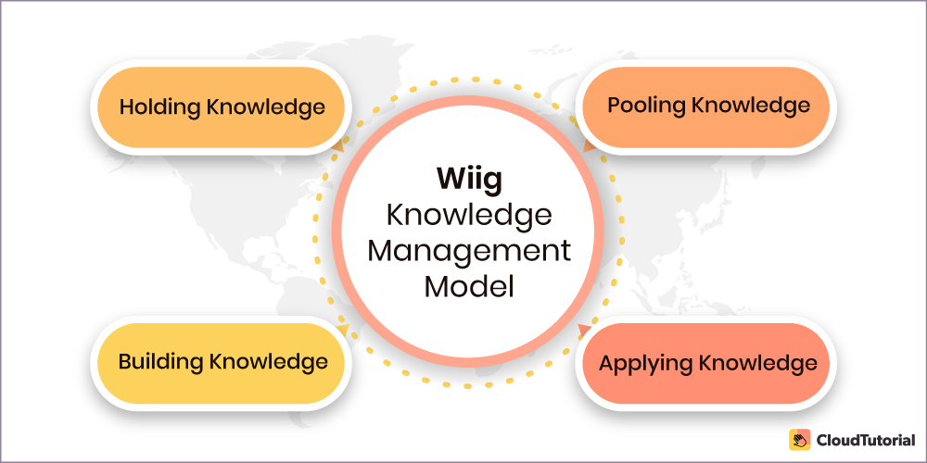
FIGURE 2 WIIG KNOWLEDGE MANAGEMENT MODEL
SOURCE: (Venkatraman and Venkatraman, 2018).

SECI MODEL OF KNOWLEDGE MANAGEMENT
This model is being used extensively for the implementation of knowledge management within Amazon. This model is being proposed by Nonaka in the year 1991. This model consists of four conversion methods like socialization, externalization, combination, and internalization (Adesina and Ocholla, 2019).
Socialization is the process in which the tacit knowledge is being shared by initiation., observation, practice, and participation. In this step, Amazon gets interacted with various people on the social level to understand their demands.
In the externalization process, tacit knowledge is being articulated through explicit concepts. In this process Amazon shares and creates knowledge in Amazon (Adesina and Ocholla, 2019).
In the combination, process Amazon accumulates the concepts in the knowledge management cycle.
In the internalization process, the explicit and the tacit knowledge is being combined.
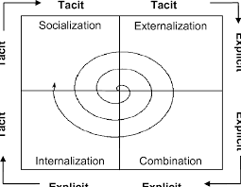
FIGURE 3 SECI MODEL
SOURCE: (Adesina and Ocholla, 2019)

MEYER AND ZACK MODEL OF KNOWLEDGE MANAGEMENT
This model is also known as the cycle of the refinery. This model deals with the management of the knowledge management cycle in Amazon this model five steps are being involved for the inculcation of the knowledge management cycle within Amazon.
Acquisition of knowledge is the first step of this model. In this step, the knowledge has been addressed through various raw sources like, credibility, relevance, accuracy, cost, control, and timeliness of the implementation of the knowledge (Rashid et al., 2021). The most important principle here is to focus on the garbage in and garbage out of the knowledge which is useful and not useful for the implementation of the knowledge within various sectors.
The next important step involves in this cycle is to refine the knowledge through various sources for future use. In this step, the knowledge available to Amazon regarding any operation will be tested on physical and logical aspects. In the physical aspect, the knowledge of any operation will be migrated from one phase to another and then the knowledge is being restructured and relabelled again for the implementation of the knowledge. At the end of this step, the knowledge of any operation will be standardised and tests on the statistical analysis (Rashid et al., 2021).
The acquisition and the refinement process of the model help in the management of the internal knowledge and external knowledge.
At this step, the knowledge is being stored within Amazon by making a bridge between the acquisition and the refinement processes of the knowledge management in Amazon (Rashid et al., 2021).
In the distribution process, the knowledge regarding any operation of Amazon will be delivered to the end-users. In this process, the delivery of any product will be made by analysing the time-bound, frequency and form of the products. All these aspects will be completed based on the copyright, attribution, and confidentiality of the products of Amazon.
At the end of this step Amazon will evaluate the efficacy of the products that are being launched.

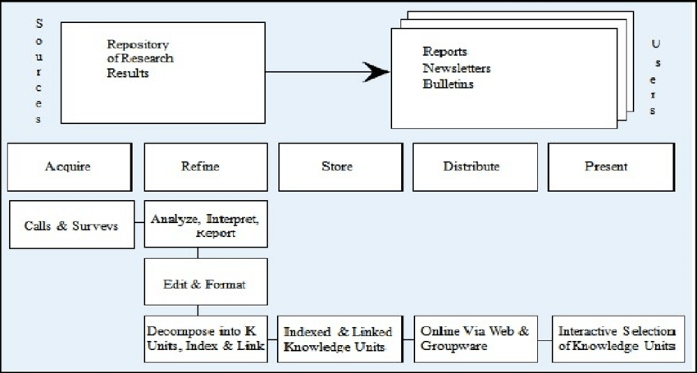
FIGURE 4 MEYER AND ZACK MODEL OF KNOWLEDGE MANAGEMENT
SOURCE: (Rashid et al., 2021)
INUKSHUK KNOWLEDGE MANAGEMENT MODEL
The Inukshuk knowledge management model consists of five elements like technology, leadership, process, management, and culture. This model is the extension of the SECI model of knowledge management. This model provides both the tacit and the explicit knowledge of Amazon (Yusril and Nurmiati, 2021).
In the leadership process of this model explicit knowledge regarding the operations of the model must be known. In this step, the leader associated with any operation decides with the employees' involvement on the Amazon.
For creating a motivating culture within Amazon several rewards and appreciation are being provided to the employees associated with Amazon. In this step, the employees who are not working appropriately are also being punished (Yusril and Nurmiati, 2021).
In the technology step of this model, Amazon clarifies the use of the computer technology that is being used in Amazon.

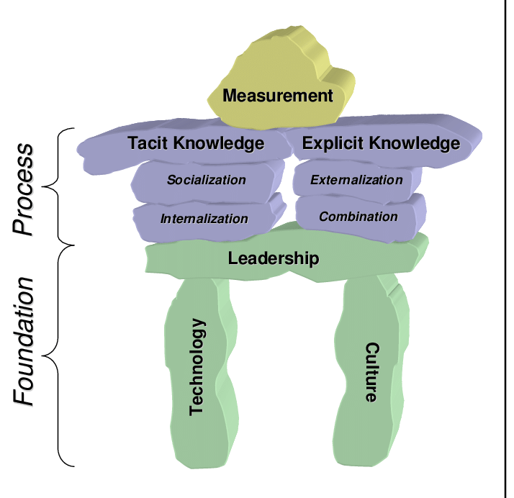
FIGURE 5 THE INUKSHUK MODEL
SOURCE: (Yusril and Nurmiati, 2021).
KNOWLEDGE MANAGEMENT CYCLE:
The knowledge management cycle is the process of managing the information related to various operations within Amazon through several steps involved. A knowledge management cycle is followed by six steps. These steps involve the creation of the knowledge, capturing of knowledge, refining of knowledge, storing of knowledge, management and disseminating of the knowledge.
In the creation of the knowledge new ways of doing the works has been explored. In the next process of the knowledge regarding all the operations within the Amazon is being captured, the new knowledge that has been captured will then use in the adequate context so that appropriate action regarding the achievement of the knowledge can be made, the new knowledge is then being stored through various mediums and manage for the use in the various relevant processes within the Amazon. At the end of the cycle, the knowledge has been made available to the Amazon (Husain and Ermine, 2021).
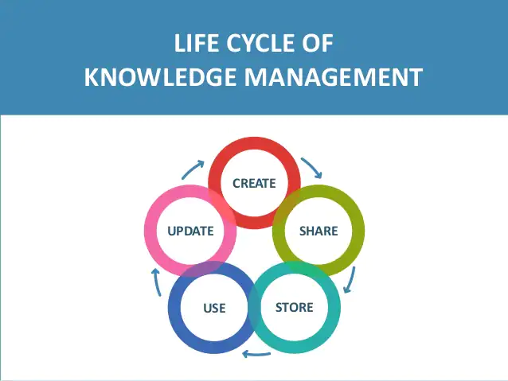
FIGURE 6 KNOWLEDGE MANAGEMENT CYCLE
SOURCE: (Husain and Ermine, 2021)

KNOWLEDGE MANAGEMENT CHALLENGES AND RECOMMENDATIONS
Knowledge management challenges are being faced by Amazon like, security of the information of the operations of the organisation, motivating the people for organisational challenges, measuring knowledge regarding the operations of the organisation, overpowering the leadership within the organisation and storing the appropriate data regarding the information within the organisation (Farris,2019).
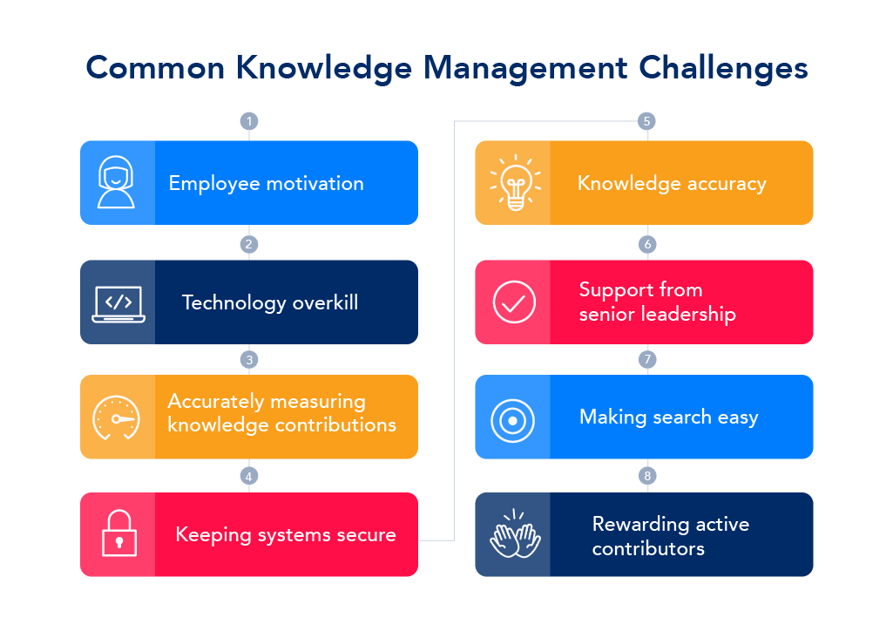
FIGURE 7 KNOWLEDGE MANAGEMENT CHALLENGES
SOURCE: (Farris,2019).
SECURITY OF THE INFORMATION:
By accumulating adequate security level of knowledge management of the information regarding the operations of the company, Amazon has to provide the appropriate level of information to the people dealing with the information management tasks in the organisation (Ferreira et al., 2018).
MOTIVATING THE PEOPLE:
Amazon has the challenge to keep the people motivated within the organisation by overpowering the organisational culture in the organisation. This overpowering process can be completed by embracing the sharing, improving, and changing the level of the knowledge.
REGULATING WITH THE TECHNOLOGY:
Amazon has a great challenge to regulate the knowledge and transfer the knowledge appropriately. Due to the incessant changes in the organisational structure of the organisation has the challenge to regulate the information of the operations as per the changes (Ferreira et al., 2018).
MEASUREMENT OF KNOWLEDGE:
Amazon has a great challenge to manage the flow of information as per the changing organisational culture.
OVERPOWERING OF SHARED LEADERSHIP:
Due to the continuous changes in the organisational structure Amazon has the challenge to overpower the leadership within the organisation. This overpower of the leadership required the changes in the leadership knowledge as per the demands of the organisational challenges in the organisation (Ferreira et al., 2018).
STORING RELEVANT DATA OF THE INFORMATION SYSTEMS:
Due to the continuous changes in the organisational structure of the organisation, Amazon has a vast challenge of storing the relevant data regarding the changes that have been occurred due to various processes including the external and the internal factors.
OVERSKILL RELATED TO TECHNOLOGY:
Due to the continuous amendments in the flow of technology within the organisation, Amazon has a great challenge to update the level of the technology as per the requirement of the technological changes within the organisation (Ferreira et al., 2018).
ACCURACY OF THE KNOWLEDGE:
Amazon has to deal with various changes within the organisation like the changes related to technology and organisational management. As out of date knowledge has no use within the organisation and therefore Amazon has to deal with the complex process of measuring the accuracy level of the knowledge management within the organisation (Ferreira et al., 2018).

RECOMMENDATIONS FOR MANAGING KNOWLEDGE MANAGEMENT CHALLENGES WITHIN THE ORGANISATION
There are several challenges regarding the management of knowledge in the organisation. Without managing these changes in the organisation, the growth of the organisation cannot be achieved. By managing these challenges within the organisation, a robust organisational structure can be created. Managing the challenges related to the knowledge management productivity, efficiency and agility of the employees and the leaders can easily be maintained within the organisation (Areed et al., 2021).
BY IMPLEMENTING REWARD STRUCTURE TO ENCOURAGE EMPLOYEES: Knowledge retention within the organisation is a complex process and therefore Amazon must implement the reward providing a structure within the organisation (Areed et al., 2021). This structure helps in retaining talented employees within the organisation for a longer time.
BY ANALYSING THE RISK FACTOR TO THE ORGANISATION: Amazon must implement the strategy to analyse the risk factor to the organisation.
BY ESTABLISHING AND PROMOTING KNOWLEDGE SHARING CULTURE: The senior leaders at Amazon must promote a knowledge sharing culture within the organisation so that adequate and important knowledge can easily be retained and be stored within the organisation (Areed et al., 2021). This process is occurred at the top level of the organisation and then reach the bottom levels of the knowledge sharing processes.
BY ESTABLISHING KNOWLEDGE SHARING CULTURE THROUGH THE BEGINNING OF THE EMPLOYEES’ CAREER: If Amazon promotes the knowledge sharing culture at the beginning of the employees’ career, then appropriate and relevant knowledge regarding several operations within the organisation can be established easily.
BY GIVING TOP PRIORITY TO KNOWLEDGE CREATION: Amazon can develop robust knowledge management skills within the organisation by giving priority to the creation of knowledge related to the operations of the organisation (Areed et al., 2021). Also, Amazon should take strict action regarding the employees who are not following the process of knowledge creation within the organisation.
BY EFFECTIVELY TRAINING THE STAFF FOR KNOWLEDGE SHARING CULTURE: Amazon should train the employees effectively for the process of sharing knowledge within the organisation. As, per the organisational changes within the organisation, Amazon should provide respective pieces of training to the related staff so that the changes within the organisation can be dealt with easily.
DEVELOPMENT OF METHODS RELATED TO TACIT KNOWLEDGE: Development of the methods related to tacit knowledge is a complex process. This complex process is full of extracting and expressing the knowledge related to the changes in the organisation (Areed et al., 2021). Amazon must need to develop methods related to the implementation of tacit knowledge skills within the employees. For developing this method, the senior specialist of knowledge management within the organisation have to work closely with the senior departments in the organisation.
BY ACQUISITION OF KNOWLEDGE: Amazon can develop the culture of acquisition of knowledge related to operations within the organisations. Knowledge acquisition is the process of gathering knowledge from different sources. This knowledge can be gathered from different theoretical aspects as well as through different human experts. Amazon can also inculcate several approaches related to knowledge acquisition within the organisation. These knowledge acquisition processes involve the discussion of the problem associated with the organisation, analysis of the problem occurs within the organisation (Santos et al., 2021).

CONCLUSIONS
In this report several aspects related to knowledge management within the multinational organisation, Amazon has been described extensively. This report covered a brief introduction of Amazon. Further, this report also covered the information management theories implemented within Amazon. In this report, several theories related to the knowledge management system has been described briefly. These theories include the discussion of the Wiig model of knowledge management, knowledge management cycle, SECI model, inukshuk model and Meyer & Zack model of knowledge management. This report has also covered certain points regarding the good level of development of knowledge management practices within the organisation. At the end of the report, certain challenges related to the knowledge management practices within Amazon have been covered extensively. Also, this report has covered certain recommendations related to the development of knowledge management practices within the organisation.

REFERENCE LIST
Adesina, A.O. and Ocholla, D.N. (2019). The SECI Model in Knowledge Management Practices: Past, Present and Future. Mousaion, 37(3).
Amazon.com, (2021). Who We Are Online available at: https://www.aboutamazon.com/about-us [Last accessed on: 2 November 2021].
Areed, S., Salloum, S.A. and Shaalan, K. (2021). The role of knowledge management processes for enhancing and supporting innovative organizations: a systematic review. Recent Advances in Intelligent Systems and Smart Applications, pp.143-161.
Barão, A., de Vasconcelos, J.B., Rocha, Á. and Pereira, R. (2017). A knowledge management approach to capture organizational learning networks. International Journal of Information Management, 37(6), pp.735-740.
Bolisani, E. and Bratianu, C. (2017). Emergent knowledge strategies: Strategic thinking in knowledge management (Vol. 4). Springer.
Farris, C. (2019). Knowledge Management Challenges Online available at: https://capacity.com/knowledge-management/knowledge-management-challenges/ [Last accessed on: 05 November 2021].
Ferreira, J., Mueller, J. and Papa, A. (2018). Strategic knowledge management: theory, practice and future challenges. Journal of Knowledge Management.
GIVA, (2018). 7 Best Practices for Knowledge Management Organizational Culture Online available at: https://www.givainc.com/blog/index.cfm/2018/5/25/7-best-practices-for-knowledge-management-organizational-culture [Last accessed on: 2 November 2021]
Hislop, D., Bosua, R. and Helms, R. (2018). Knowledge management in organizations: A critical introduction. Oxford university press.
Husain, S. and Ermine, J.L. (2021). The Virtuous KM Cycle, a Global Approach to Managing Knowledge. In Knowledge Management Systems. Emerald Publishing Limited.
Pozdniakov, S., Kuzmin, O., Kiiko, V. and Korenets, Y. (2018). Definition of the role of business modelling in the building of a management information system.
Rashid, A.S., Tout, K. and Yakan, A. (2021). The critical human behaviour factors and their impact on knowledge management system–cycles. Business Process Management Journal.
Raudeliūnienė, J., Davidavičienė, V. and Jakubavičius, A. (2018). Knowledge management process model. Entrepreneurship and Sustainability Issues, 5(3), pp.542-554.
Rosenberg, M., (2014), Enhancing value by using KM principle, (online) Available at:https://learningsolutionsmag.com/article1-480/the-knowledge-management-genius-of-amazoncom.( Last accessed 28 December 2021)
Santos, G.M.C., Marques, C.S., Ratten, V. and Ferreira, J.J. (2021). The impact of knowledge creation and acquisition on innovation, coopetition, and international opportunity development. European Journal of International Management, 16(3), pp.450-472.
Venkatraman, S. and Venkatraman, R. (2018). Communities of practice approach for knowledge management systems. Systems, 6(4), p.36.
Yusril, A.N. and Nurmiati, E. (2021). SYSTEMATIC LITERATURE REVIEW: IMPLEMENTATION OF KNOWLEDGE MANAGEMENT IN THE ORGANIZATION. JITK (Jurnal Ilmu Pengetahuan dan Teknologi Komputer), 6(2), pp.227-232.

APPENDIX
TASK 2
POSTER- PRACTICAL EVALUATION OF THE PROPOSAL KNOWLEDGE MANAGEMENT FRAMEWORK FOR AMAZON

