Day one:
The first day I went into placement, I had to bring along my DBS so that the school could have a copy for themselves. After this was done, I had to fill in a form providing all my information and contact details encase of any emergencies. Once, this was all done the receptionist took me to the class I would be in, which was the nursery class and introduced me to the teacher.
The teacher then went over all the health and safety with me including things such as; fire assembly point, where the first aid kit is placed, accident/incident forms, and also told me about the children that had any allergies and food requirements. For example, there was a child who could only have soya milk and another child was vegetarian.
Day two:
For my second day, the teacher gave me an activity to do on the interactive white board with the children one at a time, and it was them being able to decorate/design their own island and this was the children using their fine motor skills, I was not able to finish the activity as there was not enough time. Around, 10:15 the children have their snacks and I was asked to prepare the snacks alongside another teacher and the snacks were fruit along with milk or water.
After preparing the snacks, I was asked to get out the bikes, cars and scooters in the hall due to it raining outside the children were still able to play but just indoors in the hall, and still being able to release any built up energy and for them to concentrate afterwards. The bikes, cars and scooters were helping the children with their fine gross motor skills and with their, visual stimulation and attention.
For the afternoon class, I was also doing the same activity but was able to finish as there wasn’t many children in and this time the children in the afternoon class were able to go outdoors and play because it was not raining.

Day three:
I was mainly doing photocopying, printing and sticking in activity sheets that were done by the children in their books, as there was some backlog. However, I was also supervising the children at the same time when the teacher or the teacher assistant had to go into the other room.
During the end of the day I was called out by the reception teacher as there was a parent who didn’t speak English and the teacher needed someone to translate, as the other teacher assistant who could speak Bangla wasn’t in and I was the only one available.
Day four:
Today was mainly a catchup day as well, so any activities that children missed because they were not in, the teacher would catch up with those children. Before the children came into class I had to put out some activities and some of these were drawing table alongside cutting and sticking, playdough, water/sand area, jigsaws and role play area.
I noticed that the playdough area and water/sand area were the most popular but there could only be a few children around that area, so I had to make sure that there was only five to six children there and that they need to take turns, and whilst also doing that I had to ensure the floor wasn’t wet because otherwise a child could fall and hurt themselves.
Whilst observing I also noticed that a few children enjoyed the drawing table and some were cutting and sticking, this helped the children with their coordination, fine and gross motor skills, and their control.
Furthermore, when observing the role play area I saw the children playing doctors and with this they were developing empathy, some children were coming out of their shells a little more when playing in the role play area and improving their communication skills.
Day five:
During the morning I was mainly up in the library printing out activity sheets for the children, doing a new sign in sheet (as the other one was getting a bit old and ruined) the sign in sheet was basically having the children’s name on the side and then printing out their pictures so that they can stick their picture near their names when they come into class. Once, this was done I then had to laminate them and cut their pictures into circles.
The children also had name tags which they could use to sign in when they come into nursery, and by doing this it is allowing the child to get familiar with their own name, how it sounds and the letters used.
Day six:
I was asked if I could go into the reception class as one of the teacher assistants we’re not in for the morning class and they were short on staff for the morning. Whilst, I was there the children in reception were doing some problem solving with numicons and how many ways they could use it to fill in the shape. With the children using numicons it is helping them with their numbers and giving the child to have an image of what a number can look like, and also it is sensory because they are able to touch them. I also noticed some children were in the book area reading by themselves or with the teacher.

Day seven:
As the main nursery teacher was not in due to being in meetings, the teacher did not want to start anything new for the children so it was more free play in the classroom but if there was anything that needed to be finished then the teachers assistants and I could finish it.
The children were playing in the sand and water area, colouring, jigsaws, role play area, train tracks and logos, some children were in the reading area.
The same thing took place during the afternoon as the teacher was in and out, which meant the children were able to play with what was given out, they had their snacks and went outdoors to play. The TA brought out chalk and showed them that they can draw, write their name, and some were also tracing their friends with the chalk and whilst observing this I saw that this is developing their fine motor skills, they were building friendships, and even just playing outdoors the children were taking risks by going on the climbing frame, the fire pole etc.
Day eight:
The children were focusing on healthy eating and overall just being healthy, staying active.
There was one activity that I was doing with the children, I had four children at a time so two of the children were sticking pictures onto a laminated sheet that had a section for healthy food and one for unhealthy food, and the other two children were looking at different fruits and then matching them to the word that they was right. By observing this I noticed that some didn’t know what is healthy and what isn’t which is fine because as they get older they will learn more and more about it.
Some children in groups with another teacher assistant went out in the hall to do some exercise and use the apparatus, and others went outdoor to play, and then it swapped. Not everyone got to all the activities.
This was also happening within the afternoon nursery and I noticed that when doing the activities the children enjoyed it, it was allowing them to blow off any steam they had and just being able to use all their muscles whilst being in the hall or outdoors.
Day nine:
This was carrying on from yesterday and what the children were doing, which was learning about healthy eating, well-being and overall just staying healthy.
When I was observing the children who were doing exercise in the hall with the apparatus, there was one child who was a little hesitant but another child showed them what to do, and I think by the child showing them what to do it gave them a little more encouragement. The children were doing an activity that they may not always do or have never done before, and it was something new as a child told me “they would want to do it again.” And I asked why and the child replied with “it was fun.”

Day ten:
Both morning and afternoon nursery class spent the day outdoors and in the outdoor class area as the day was much better compared to the others and the teacher wanted to take advantage of it.
By the children spending their time outdoors, it is allowing them to get the fresh they need and might not always get when they are home due to parents working, feeling unsafe or not having the space around them, and they also were able to have their snacks outside and some of the children thought this as a “little picnic.”
Before, the children went home they had story time and I was able to read to them so I picked a story stack and the book was “the very hungry caterpillar” which seemed like the children liked, I also added a little caterpillar toy just to make it more interesting for them and for the children to engage as they were counting along with me to how many food it ate, and this can link in with them learning their numbers.

Other relevant aspects
As I was in university on Mondays, I know on most Mondays the teachers will have a small meeting before the school day starts, and this where they can talk about what is happening throughout the week, months, any upcoming events or announcements that need to be made they will be delivered within that meeting.
I also know sometimes the nursery teacher would have meetings with the head teacher during the afternoons alongside other teachers from other classes.

On my third day, I was called to help translate to a parent because English wasn’t their first language and they did not understand much, so I had to sit in the classroom (this was done in privately and at the end of the day) and explain what the teacher was saying along with the teacher and teacher assistant with me and it was about the child’s behaviour and what they did because it has happened a few times before but nothing like this.
I noticed that the teacher had a good relationship with the parent and this made it a bit more easier to talk to them, and even though the teacher was talking about their behaviour, they also spoke about the positive things the child has done.

During one of the lunch times the teacher, the teacher assistants, and including myself all stayed in the classroom just to finish up all the work that needed to be done, tidy up the classroom ready for the afternoon nursery class and the teacher was also planning lessons for the weeks to come.
I was also able to learn how to fill in an accident/incident form as I have never done one before, so the teacher was kind enough to show me how to do one encase I ever needed to fill one in.
There was also a child in my class who has autism and they had a meltdown due to things changing such as their routine, and I learnt alongside the TA who stays with the child on how to calm the child down and this was them taking the child to a safe space which is in another room, and its known as safe place and if they need to go somewhere when they are feeling overwhelmed with blankets, pillows, calming toys and it is also important for the teacher to stay calm. The child also has a book where the TA or teacher can write down what they did throughout the day, any meltdowns and then that book will then go home with the child so that their parents can have a look at it and if something needs to be changed the parents and teacher can sit down and talk to try and overcome the barriers.

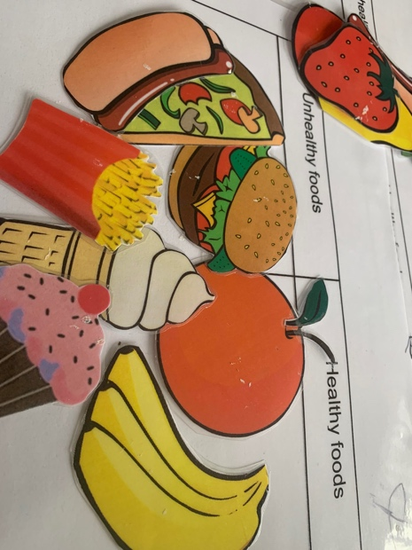
Pictures:

The children putting the foods in the healthy and unhealthy box

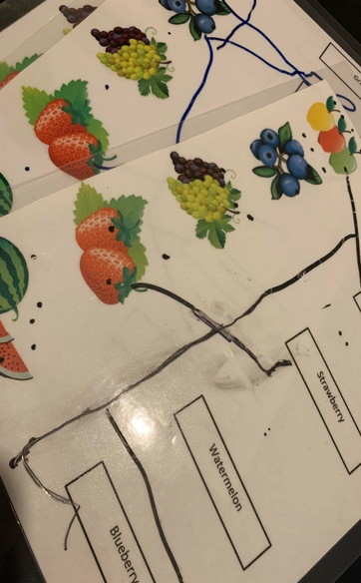

The children trying to join up and match the word that goes with the picture. (some children helped each other and worked as a team).

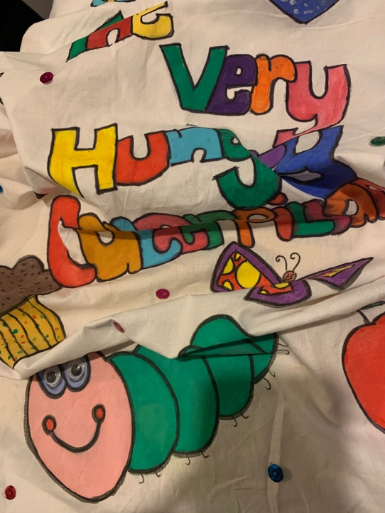

The story bag I picked and the book I read to the children was “the very hungry caterpillar.”

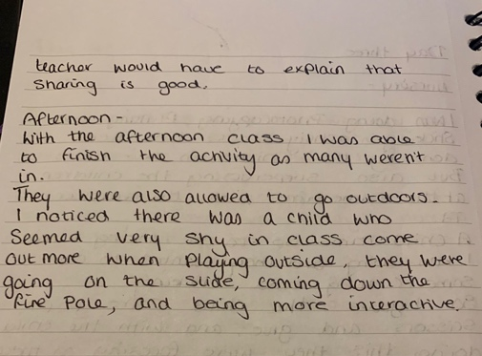
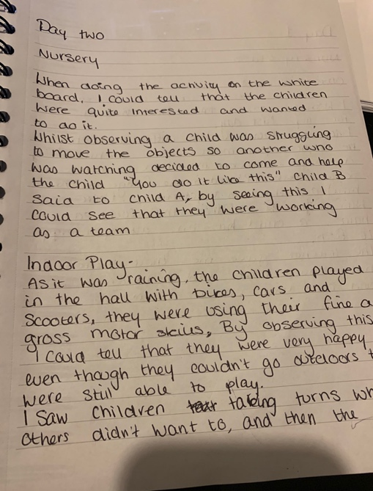
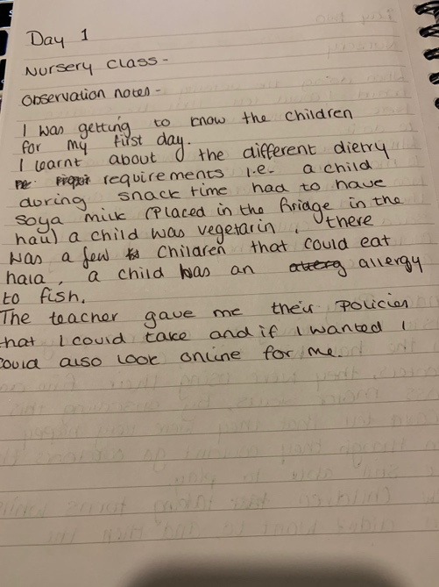
Observation notes:
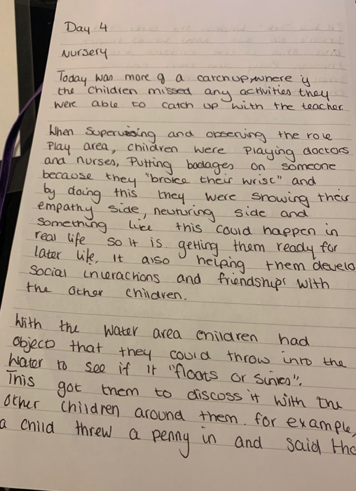
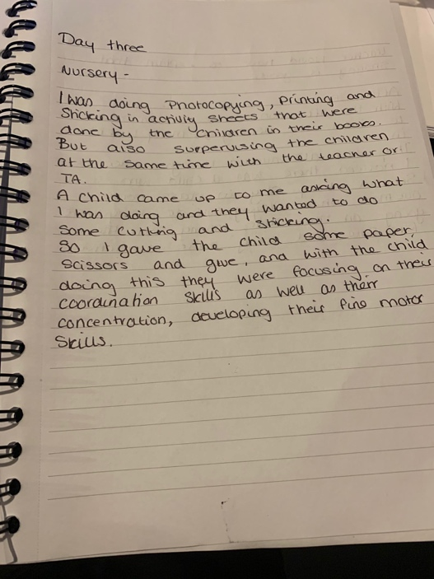
Both day two

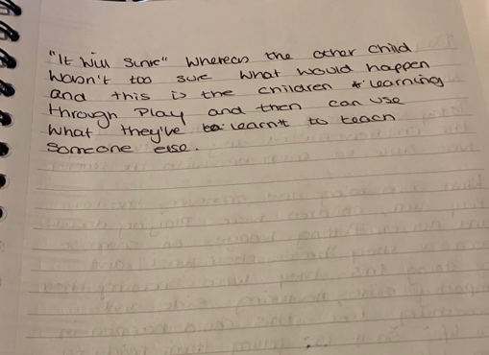

Both day four



