
Programme: Master of Business Administration
Module Code: LCMB7002
Module: Financial Management
Lecturer: Shengfeng Mei (London)
Assignment Title: Financial performance and management
Report Title: Strategic CFO Challenge: Saving a Failing Global Firm
Student Name: Sorbane Das Toma
Student ID: 2437417
Word Count: 5108

Contents
Introduction 4
1. Financial Health Check 4
Profitability Analysis 5
Liquidity Position 5
Efficiency and Asset Utilisation 6
Gearing and Capital Structure 6
Cash Flow Sustainability 7
Corporate Failure Risk Testing 7
Integrated Assessment 8
2. Working Capital Management Analysis 8
Cash Operating Cycle Analysis 8
Working Capital Reforms to Improve the Liquidity 9
Short-run and Long-run Financing 10
Integrated Evaluation 11
3. Strategic Financial Restructuring Plan 11
Reasons to Financial Restructuring 11
Divestiture Strategy and Asset Restructuring 12
Rebalancing of Capital Structure 12
Implications on the Shareholder Value and Flexibility 13
International and Ethical Considerations 13
Comprehensive Strategic Evaluation 14
4. Investment Appraisal and Capital Budgeting 14
Capital Budgeting and Financial Recovery. 14
Comparison of Project Cash Flow Profile 15
Assessment with Payback and Accounting Measures 15
Value Creation and Discounted Cash Flow Analysis 16
Risk Interpretation and Internal Rate of Return 17
Capital Rationing and Optimal Project Selection 17
Financial Health and Risk Profile Integration 17
Final Investment Recommendation 18
Conclusion 18
References 20
Appendices 23

Introduction
General Electronics is a global powerhouse in consumer electronics has seen its financial performance worsen over the year due to intense competition. Structural issues is main reason behind the downfall of the company, not cyclical ones. This is indicated by falling revenues, increasing operational losses, and worsening liquidity indicators. The primary responsibilities as the company's new CFO will be to assess its current financial health, determine what's causing it to be in a precarious financial position, and propose practical solutions.
This study analyzes the company's financial performance and the decisions made by management with the data evidence from consolidated financial statements of the last five years. Profitability, liquidity, efficiency, gearing, and solvency risk are assessed using a hybrid approach that combines ratio analysis, cash flow analysis, and the business failure prediction model. Financial theory and other empirical literature must be considered in order to place the analysis results in context. Working capital management techniques, strategic financial restructuring possibilities, and capital investment decisions under capital rationing are analyzed in the paper based on this diagnostic base. Primarily, the report is estimated to lay out a logical, evidence-based plan for recovery that is in line with strategy, can be scaled out globally, and is met with ethical standards.

1. Financial Health Check
Profitability, liquidity, efficiency, capital structure and cash flow sustainability are the best elements to be combined in assessing the financial health of a firm instead of individual ratio changes. In the case of General Electronics, the 2020-2024 consolidated financial statements display a clear shift of an organisation with a history of profitability to one with unremitting losses, depreciating asset use, and an increased risk of financial distress. This segment is a critical review of these trends and an analysis of whether the current financial trend of the firm is sustainable.

Profitability Analysis
The most notable aspect of the recent performance by General Electronics is the decline in the level of profitability. Although the company earned high net income during 2020 and continues to enjoy low profitability in 2021 and 2022, the company incurred huge net losses in 2023 and 2024. This turnaround indicates not only a decrease in revenues but also cost inefficiencies in structure. Gross profit margins have decreased significantly over the period meaning that cost of sales has failed to respond in line with declining demand. Brigham and Ehrhardt (2022) further argue that a prolonged compression of margins is a frequent indication of loss of price control or inflexibility in business operations, which are typical of established, technology-stimulated industries with high rates of innovation.
The high operating expenses compared to sales also worsened the operating profitability. Revenue shrank but operating expenses were still overly high, especially in 2023, indicating poor cost discipline and no flexibility in the cost structure of the firm. Empirical research points to the fact that companies that cannot re-price operating expenses in bad times generally suffer longer than the cycle fluctuations and lower recovery chances (Penman, 2019). The continuing operating losses thus are indicative of greater inefficiencies as opposed to temporary market shocks.

Liquidity Position
The liquidity analysis reflects an increasingly deteriorating short-term financial position. General Electronics still retains a significant amount of current assets; however, the quality and nature of their assets are a concern. The decrease in the cash and cash equivalent since 2022 is steep compared to other items as the inventories and receivables have traditionally made a significant portion of current assets. Such a disproportion compromises the capacity of the firm to settle short term liabilities on time especially during times of earning stress. Ross et al. (2021) underline that the liquidity strength is determined not only by the volume of assets but also by their convertibility, which in this scenario is becoming weaker.

The company’s too much depence on short-term borrowing escalated the liquidity risk further. This over-reliance on line of credit to manage cash deficit is not a good idea from the strategic viewpoint but a responsive one. During a constraining credit environment where lenders constantly re-evaluating the borrowers can cause a high risk of refinancing (Atrill and McLaney, 2020). As it’s seen from the analysis, the liquidity position of General Electronics not on the brink of insolvency, but exposed to extrinsic shocks. This can result in lack of lender confidence.

Efficiency and Asset Utilisation
In the last 5 years (2020-2024), the revenue generation on asset value also known as ROA is declining. In 2021 and 2022, the asset value was highest but it shows the trend of decreasing over the couple of years. This indicates increasing impairment but lower investment in buying new assets. The more alarming thing is the revenue from sales also declining at a higher rate causing the decline in assets utility. Inefficient management is one of the key reasons of this substandard performance. Reactionary decision making is the reason behind the recent year’s inventory management. This problem can be solved through strategic planning of inventory and other efficiency ratios can be improved by this too.
According to Deloof (2003), Profitability can be hampered and have direct connection with poor working capital management through increasing holding costs, lack of operational flexibility. General electronics has a comparatively longer Cash Conversion Cycle (CCC) means inventory turnover is lengthy, and slow collections of receivable which is holding cash in this dire state of liquidity crisis. Speedy collection, responsiveness, and implementation of technology in CCC can help to overcome this challenges.

Gearing and Capital Structure
General Electronics has a moderate amount of debt in its capital structure, but the trend is worrying when you look at how its earnings are going down. Even though overall liabilities have gone down a little each year, equity has lost value faster because of past losses and buying treasury stock. As a result, the company's leverage ratios have gotten worse in both elements-wise and form, although not by a lot.
The tradeoff theory of capital structure says that businesses weigh the tax benefits of debt against the costs of financial hardship they expect to face (Modigliani and Miller, 1963). For General Electronics, the falling profits will greatly reduce the tax shield benefit of debt and increasing the costs of distress at the same time. The interest coverage has also gone down, so the company can't pay off its debt with its operational profits anymore. This kind of relationship means that the current capital structure is not as well-suited to the firm's risk profile and profits potential as it used to be.

Cash Flow Sustainability
Another sign of financial problems is the cash flow analysis. Cash flow operations has mostly been positive during the last few years, although it has dropped a lot after 2020. Notably, recent operating cash inflows have been supported by non-cash items like depreciation and impairment costs rather than robust operating performance. The pattern also raises issues about the long-term viability of cash flow because accounting tricks can't hide the fact that the business isn't making money (Dechow et al., 2014).
Investing cash flows are constantly negative because they are always spending money on property, plant, and equipment, as well as intangible assets. Even if continuing to invest can show long-term strategic goals, doing so when cash flows from operations are going down can generate financial stress. The financing cash flows show that short-term borrowing and monthly loan repayments are being used a lot. This supports the idea that cash management has been more reactive than strategic.

Corporate Failure Risk Testing
The Altman Z-score and other models for predicting corporate failures back up the company's worsening financial indicators. The model result shows that General Electronics has moved from a pretty stable financial situation to the crisis region in the last few years, even if the appendix offers a lot of methodological calculations. Altman et al. (2017) assert that the most reliable indicators of company distress are diminishing profitability, decreased liquidity, and dropping retained earnings, which are evident in this case.
Notably, the Z-score is not to be taken as fixed outcomes, rather just an early warning signal. The model supports the importance of urgent corrective action especially in liquidity management and capital structure optimisation in the case of General Electronics. The lack of the ability to resolve these concerns will result in the loss of stakeholder trust and reduce the availability of external funding.

Integrated Assessment
The financial health analysis indicates that the company is under multidimensional financial pressure. Deteriorating profitability, decreasing liquidity, failing to use assets effectively, and increasing distress risk are not independent issues but are related to each other. To successfully diagnose financial problems, Palepu et al. (2020) note that the interaction between these dimensions limits strategic flexibility. In the case of General Electronics, the indications are towards a dire need to reform working capital, financial restructuring, and a tight-knuckle investment decision-making process, which shall be discussed in other sections in this report.

2. Working Capital Management Analysis
Managing working capital is very crucial for companies that are having financial difficulties because it immediately affects their liquidity, ability to keep running, and short-term solvency. General Electronics' poor management of working capital has had a big impact on the company's decreasing financial situation. A cash operating cycle assessment reveals systemic inefficiencies that impede liquidity and amplify reliance on external borrowing.

Cash Operating Cycle Analysis
The cash operational cycle shows how long it takes for cash to leave manufacturing inputs and come in from customers. The General Electronics case has taken longer to finish in the last five years since the way they handle their inventory and collect payments isn't very efficient. The revenue went down a lot, yet the inventory was still high most of the time. This shows that there was not a strong link between production planning and market demand. Unsold inventory ties up capital, costs money to keep, and risks becoming obsolete, especially in the consumer electronics industry, where products have a short life cycle (Atrill and McLaney, 2020).
Account receivable additionally makes liquidity problems worse. The receivables have not gone down as much as the sales have, which means that the credit period is longer or the collection procedure is less strict. Deloof (2003) contends that prolonged accounts receivable diminish liquidity and heighten the danger of cash shortages, especially when firms lack the ability to influence pricing. Accounts payable helps to ease some of these demands by providing spontaneous funding, but the company can't be too flexible with payment delays because suppliers have a lot of influence and the company's reputation is at stake. The overall impact is that the cash operating cycle is not very efficient, and the cash gets tied up in day-to-day activities when it should be saved for when it is needed.

Working Capital Reforms to Improve the Liquidity
General Electronics needs to make certain changes to its working capital in order to improve its finances without putting its operations at risk. The most important chance is to make the inventory more efficient. Also, by reducing the number of products it offers and switching to demand-driven forecasting methods, the company may keep less capital tied up in slow-moving stock and cut the time it takes to sell it. When demand is low, organizations that employ lean inventory management are better prepared to handle the financial storm (Wang, 2019).
Also, the way accounts receivable are handled needs to change. Stricter credit rules, rewards for early payment, and better ways to assess credit risk can all help cash flow faster. Even while tighter credit conditions could momentarily hurt sales, the company's financial instability means that liquidity is more important than volume-related growth. Petersen and Rajan (1997) say that when businesses are short on cash, disciplined credit management pays off since it lets them use more of their own resources and less of their expensive outside capital.
General Electronics should proactively renegotiate terms with its suppliers instead of paying the same payments to all of them. One way to solve cash flow concerns without putting vital supplier relationships at risk is to strategically extend payment periods to suppliers who are financially secure. When you aggressively stretch payables, you should be careful because it could raise the cost of buying things or break up supplier chains. The purpose of all of these changes is to shorten the cash operation cycle and make it easier for the company to generate cash flow without having to invest money right away.

Short-run and Long-run Financing
The company's working capital inefficiencies have made it too reliant on short-term loans, notably revolving lines of credit. One of the benefits of short-term financing is that it is quick and easy to get, which is particularly helpful when there are gaps in cash flow that need to be filled immediately. In the instance of General Electronics, nevertheless, this reliance has increased the danger of refinancing and put this company at risk of rising interest rates. When times are tough financially, lenders might make things harder and more restricted, which increases the risk of liquidity instead of lowering it (Ross et al., 2021).
Long-term financing, on the other hand, is more stable, has less rollover risk, and matches the maturity of the financing to the time period the company needs to get back to normal. Long-term debt is usually clearer, but it is also easier to plan for and can aid with strategic restructuring. Theoretically, maturity matching principles suggest that businesses should use longer-term sources to pay for their ongoing working capital needs in order to lower the risk of liquidity (Myers, 1977). General Electronics is still having trouble running its business, therefore the trend of short-term borrowing can't be seen as good for its finances.
Long-term funding still has some problems. Because the company's profits have gone down and it is in a very bad situation, it may be hard to get long-term loans on good terms (Shleifer and Vishny, 1992). Equity-based financing or hybrid instruments would weaken the market's perception of the company's finances by diluting old stock. So, financing decisions should be made at the same time as changes to working capital, not on their own. Improving operational efficiencies to boost internal cash flow can make a company more creditworthy and provide it more influence in negotiations with long-term capital sources.

Integrated Evaluation
On the whole, the problem of working capital of General Electronics is connected to the poor operating cycle of cash and excessive dependence on short-term funding to offset poor internal liquidity generation. The process of sustainable improvement should be based on two measures: the restructuring of operations to free up cash in inventories and receivables, as well as the gradual transition to more stable financing structures. Financing solutions, without eliminating underlying working capital inefficiencies, will simply continue to create a dependency-financial vulnerability cycle.

3. Strategic Financial Restructuring Plan
Given the ongoing decrease in profitability, liquidity constraints, and elevated financial distress risk indicated in the preceding sections, General Electronics necessitates a financial reorganization rather than incremental adjustments. Financial restructuring is the process of changing a company's assets, capital structure, and financing policies all at once in order to restore solvency, make operations more flexible, and protect long-term shareholder value (Titman and Wessels, 1988). It is important that this reorganization be able to be used over the world and be morally acceptable, since the company has operations in many countries.

Reasons to Financial Restructuring
The company's current financial situation reveals that there is not enough balance between the costs, the use of assets, and the ability to make money. The company's ability to pay off its debts has gone down because its operating income and cash flow have both gone down. This has made it more likely that it will need to refinance its debts. Altman and Hotchkiss (2010) note that businesses in financial trouble have a shorter strategic window during which restructuring preserves value rather than destroys it. General Electronics must act quickly and decisively to stop stakeholders from losing faith and strategic independence.

Divestiture Strategy and Asset Restructuring
One of the most crucial first steps in achieving financial stability is asset restructuring. General Electronics has a lot of assets, both physical and intangible. Some of these assets don't all contribute equally to value development. Selling off business units that aren't important to the company's mission or that aren't doing well might give the company fast cash and let management focus on the areas that are strategic. Research has demonstrated that divestitures executed during restructuring phases often lead to enhanced operational and market performance when linked to strategic refocusing (John and Ofek, 1995).
However, the choices on divestment should be based on long-term strategic thinking, not just short-term cash flow. Fire-sale disposals can hurt shareholder value, especially when the market is bad. Putting assets that don't fit well with the company's strategy or that have historically low returns first lowers this risk. Also, the money made from selling off assets must be used to pay off debts and stabilize working capital instead of being spent freely. This will improve financial discipline and the commitment to recovery.

Rebalancing of Capital Structure
General Electronics needs to fix the structural problems with its capital structure in addition to moving its assets around. The corporation is not very over-leveraged in absolute terms, but the dropping earnings have made it much harder to pay down its debts. The trade-off theory of capital structure says that the best amount of leverage goes down as the risk of distress and earnings volatility goes up (Modigliani and Miller, 1963). In this sense, the company is at a higher danger because it has the same amount of debt.
Restructuring loans, including extending their maturity or renegotiating covenants, may provide you some breathing room without immediately losing ownership. Taking the initiative to talk to creditors about changing the repayment schedule and getting cash flow back can minimize the risk of default and make liquidity more predictable. The research by Gilson et al. (1990) shows that companies who restructure early and work together with their creditors have a far higher recovery rate than companies that wait to do so.
Equity injection is another or additional technique for restructuring. Issuing new equity will make the old shareholders less valuable, but it will greatly improve the balance sheet and make them more creditworthy. For General Electronics, a concentrated equity financing (which might involve bringing in strategic investors) would provide both capital and operational benefits. But they should be well-timed and well-communicated to make sure they don't have adverse impacts on the market (Myers and Majluf, 1984).

Implications on the Shareholder Value and Flexibility
Before initiating on a restructuring project, it is crucial to consider how it will influence the stock value of the company. Revelations of restructuring typically elicit a negative reaction from the market in the short run. However, reorganization might be beneficial in the long run by enhancing future cash flow and decreasing risk. By decreasing debt, increasing liquidity, and improving operational efficiency, General Electronics can decrease its weighted average cost of capital. According to Damodaran (2020), this will also enhance the valuation's fundamentals.
When a company has loads of debt, it can't afford to invest in new ideas or react quickly enough to competition, which makes it hard for them to make strategic decisions. After the company's finances are in order, a stronger capital structure allows management greater flexibility to go after various growth opportunities (Titman and Wessels, 1988). Particularly in the consumer electronics sector, where innovations occur at a rapid rate, this is crucial.

International and Ethical Considerations
Restructuring General Electronics' finances should think about global and ethical considerations since the company does business on a global scale. When dealing with debt obligations denominated in a foreign currency, currency risk becomes an important factor to consider. Exchange rate fluctuation can lead to inflated payback obligations and an inaccurate portrayal of financial performance. To reduce this risk, cash flows could be stabilized through intentional refinancing or natural hedging (Madura, 2020).
Taxes have a significant role in restructuring decisions as well. Asset sales, debt restructuring, and stock offerings all have different tax consequences in different countries. Ethical tax planning, as opposed to aggressive avoidance, is necessary to preserve the company's reputation and conform to changes in global tax systems, such as the OECD's Base Erosion and Profit Shifting programs (OECD, 2021).
Corporate social responsibility also defines restructuring decisions. In the absence of social sensitivity, activities like layoffs or asset sales might improve short-term financial performance at the expense of long-term reputational damage. Adopting a stakeholder-based decision-making approach promotes long-term organizational resilience, claims Freeman (1984). Reinvestment in sustainable operations, fair labor practices, and open communication should all be priorities during this restructuring.

Comprehensive Strategic Evaluation
General Electronics' financial reorganization should take a comprehensive strategy addressing asset rationalization, capital structure rebalancing, and ethical governance. Achieving long-term financial security would need more than just taking one step. However, by combining the two approaches, liquidity is enhanced, distress risk is reduced, and strategic flexibility is regained. The capital budgeting study that follows provides evidence of how this restructuring provides an economic foundation for future investment decisions.

4. Investment Appraisal and Capital Budgeting
Capital investment choices are more so critical when firms are undergoing financial distress, because poor choice of projects may result in the worsening of liquidity pressures and quick erosion of values (Wruck, 1990). General Electronics investment appraisal should thus go further than the rules of mechanical acceptance and become inclusive of the weakened profitability, limited liquidity and the high risk profile that the firm is facing. In this section, three investment projects are reviewed on the basis of conventional capital budgeting parameters, such as payback period, accounting rate of return, net present value, profitability index, and internal rate of return, followed by final recommendation under capital rationing.

Capital Budgeting and Financial Recovery.
Capital budgeting offers a systematic approach towards using limited resources on the projects that promote firm value. Although such traditional metrics as payback period and accounting rate of return are still valuable tools that allow evaluating liquidity recovery and accounting performance, the modern finance theory lays emphasis on discounted cash flow techniques, specifically the net present value, as it expressly considers the time value of money and risk (Brealey et al., 2020). Nevertheless, when working with a company that is limited in terms of finances, a single metric can be misleading. Arnold (2013) claims that troubled companies need to strike a balance between maximising the value and timing and risk exposure of the cash flows to prevent a compounding financial weakness.

Comparison of Project Cash Flow Profile
The three projects suggested have significantly different cash flow characteristics that have a significant effect on their appropriateness considering the financial status of General electronics. Project A has comparatively steady cash flows throughout its duration, and moderate initial returns and limited end-of-life exposure. This trend is beneficial in terms of liquidity because the previous cash flows will decrease dependency on external funding and enhance debt service potential. In contrast, project B has standard yet relatively low cash inflows per year. Although predictability lowers volatility, its size is limited and it cannot make significant improvements to the financial position of the firm.
The profile of project C is quite different, as the inflows of cash are minimal in the beginning and considerable in the later stages. Though this back-loaded structure might seem appealing in terms of value, it exposes one to forecast risk and postpones the benefits of liquidity. In the case of a firm already under the strain of cash flow, postponed returns increase the likelihood of interim funding deficits. Empirical data also indicate that distressed firms need to focus on investment with a faster cash recovery to mitigate the refinancing risk (Mao, 1970).

Assessment with Payback and Accounting Measures
Payback wise, it is the projects with lower recovery periods that are of particular interest to General Electronic as it has a weak liquidity stand. Projects which repay initial investment in short periods minimize capital at risk, and allow more flexibility in the response to unanticipated shocks. Measurements based on accounting which have limitations in that they are based on accounting profits not cash flows provide an insight into the impact of earnings in the short run. In the case of General Electronics, projects which add to the earnings reported, can be useful in ensuring confidence of the stakeholders in the recovery phase.
However, the two measures have long-standing limitations such as the inability to consider the time value of money, and post-payback cash flows (Atrill and McLaney, 2020). Based on this, these metrics can be viewed as additional measures, but not as the decisive ones.

Value Creation and Discounted Cash Flow Analysis
Net present value is the most theoretically sound standard of capital investment decision, since it gauges the weight of a project in terms of absolute contribution to shareholder wealth. The value generating capacity of the projects is varyingly different under a uniform discount rate that represents the cost of capital of the firm. Project C with heavy inflows later in the project is likely to produce a high net present value relative to its size indicating high cumulative cash. Project A will also give a positive net present value, but in a smaller amount, whereas the consistent but small inflows of Project B can restrict the value additions.
Nevertheless, when there is capital rationing, absolute net present value is not sufficient. The profitability index will be especially useful because it evaluates the value of each unit of invested capital (Brealey et al., 2020). The higher the profitability index of projects, the more total value the firms can get in case there are investment funds at the limited level. This is important to General Electronics, where a capital constraint has already been imposed and liquidity must be maintained.

Risk Interpretation and Internal Rate of Return
IRR is an easy-to-use index on project performance that needs to be used with caution. Projects that tend to create an early cash inflow are often linked to high internal rates of returns, which might be attractive to financially restrained firms. Nevertheless, IRR is misleading to compare mutually exclusive projects or projects of varying size (Damodaran, 2020). In addition, the assumptions of reinvestment used in computing IRR would not be the proximate reinvestment opportunities of the firm in times of distress.
In the case of General Electronics, IRR should be considered as a risk communication device and not a binding principle. It may be the case that projects that have exceptionally high IRRs, but have delayed cash flows have unacceptable liquidity risk. On the other hand, projects that have moderate IRR but high initial inflows of cash can be more helpful in financing recovery although headline returns are smaller.

Capital Rationing and Optimal Project Selection
General Electronics is unable to make all the investments proposed at the same time under capital rationing limitation of PS60 million. In this case, the finance theory proposes the choice of the combination of projects that will maximise the total net present value under the capital constraint (Ross et al., 2021). This method involves looking at the scale of the project, when cash flows and how they interrelate, not looking at them separately.
Strategically, project combination, between projects that provide complementary cash flow profiles, can potentially increase the financial resilience. As an example, balancing liquidity requirements and growth goals can be achieved by matching a project with high initial cash flows with another whose value is greater in the long-term. Nevertheless, with the firm being distressed currently, the focus should be made on the types of investments that will stabilise the cash flows and mitigate the refinancing risk in the short-term.

Financial Health and Risk Profile Integration
The investment decision would need to be put in the larger financial situation of General Electronics. As seen in the financial health check, the company is experiencing a deteriorating profitability, low liquidity, and increased risk of distress. In these circumstances, the aggressive investment strategies based on optimistic long-term predictions can be inappropriate. According to research conducted by Graham and Harvey (2001), CFOs in financial constrained firms emphasize more on liquidity and downside risk during capital budgeting decisions.
Risk characteristics of projects are thus core aspects of the resulting recommendation. Unstable or uncertain cash flows in projects expose the project to the risk of experiencing financial shortfalls especially when external sources of funds are scarce or expensive. Besides, the operational issues faced by the firm currently indicate its low ability to absorb execution risk of complex or capital-intensive projects. In line with this, investments are supposed to be determined based on anticipated returns besides their role in ensuring financial stability.

Final Investment Recommendation
Considering potential value creation, timing of cash flows, nature of risk, and capital rationing constraints, projects with an early and fairly stable cash inflow and acceptable value creation are the best investment alternative to implement with General electronics. The excessively back-loaded projects or those that present the firm to long-term cash shortages must be deprioritized until financial stability is regained (Fazzari et al., 1988).
Such a conservative and yet strategically disciplined strategy is consistent with the short-term recovery goals of the firm and is optionable in case of growth investment in the future when the liquidity and profitability become better. General electronics is able to make the capital budgeting choices as part of a wider restructuring by integrating capital budgeting decisions into a wider restructuring process, in such a manner that the choices made in the capital budgeting process do not sabotage the financial turnaround of the company.

Conclusion
This report has conducted a thorough financial analysis of General Electronics as a multinational company that is financially impaired. The financial health check revealed the structural weaknesses in profitability, liquidity, asset utilisation and cash flow sustainability, which showed the high corporate failure risk as opposed to the short-lived performance deterioration. The working capital analysis, based on this diagnosis, revealed that the liquidity pressure has worsened through the ineffective use of cash operating cycle and over-dependence on short term funds. The proposed restructuring plan centered on rationalization of assets, capital structure rebalancing and ethical governance as one of the main resources of restoring solvency and strategic flexibility. Lastly, the investment appraisal emphasized on disciplined capital budgeting within the context of capital rationing, with projects that would contribute towards early cash recovery and mitigation of risk being given priority. All of these results emphasize the fact that a sustainable recovery of the General Electronics requires a combination of financial reforms and not a single intervention to provide the company with stability in the short and long term value creation.

References
Altman, E.I. and Hotchkiss, E. (2010) Corporate Financial Distress and Bankruptcy. 3rd edn. Hoboken: Wiley.
Altman, E.I., Iwanicz-Drozdowska, M., Laitinen, E.K. and Suvas, A. (2017) ‘Financial distress prediction in an international context’, Journal of International Financial Management & Accounting, 28(2), pp. 131–171.
Arnold, G. (2013) Corporate Financial Management. 5th edn. Harlow: Pearson Education.
Atrill, P. and McLaney, E. (2020) Accounting and Finance for Non-Specialists. 11th edn. Harlow: Pearson Education.
Brealey, R.A., Myers, S.C. and Allen, F. (2020) Principles of Corporate Finance. 13th edn. New York: McGraw-Hill Education.
Brigham, E.F. and Ehrhardt, M.C. (2022) Financial Management: Theory and Practice. 16th edn. Boston: Cengage Learning.
Damodaran, A. (2020) Applied Corporate Finance. 4th edn. Hoboken: John Wiley & Sons.
Dechow, P.M., Ge, W. and Schrand, C. (2014) ‘Understanding earnings quality’, Journal of Accounting and Economics, 50(2–3), pp. 344–401.
Deloof, M. (2003) ‘Does working capital management affect profitability of Belgian firms?’, Journal of Business Finance & Accounting, 30(3–4), pp. 573–587.
Fazzari, S.M., Hubbard, R.G. and Petersen, B.C. (1988) ‘Financing constraints and corporate investment’, Brookings Papers on Economic Activity, 1988(1), pp. 141–206.
Freeman, R.E. (1984) Strategic Management: A Stakeholder Approach. Boston: Pitman.
Gilson, S.C., John, K. and Lang, L.H.P. (1990) ‘Troubled debt restructurings’, Journal of Financial Economics, 27(2), pp. 315–353.
Graham, J.R. and Harvey, C.R. (2001) ‘The theory and practice of corporate finance’, Journal of Financial Economics, 60(2–3), pp. 187–243.
John, K. and Ofek, E. (1995) ‘Asset sales and increase in focus’, Journal of Financial Economics, 37(1), pp. 105–126.
Madura, J. (2020) International Financial Management. 14th edn. Boston: Cengage Learning.
Mao, J.C.T. (1970) ‘Survey of capital budgeting: theory and practice’, Journal of Finance, 25(2), pp. 349–360.
Modigliani, F. and Miller, M.H. (1963) ‘Corporate income taxes and the cost of capital’, American Economic Review, 53(3), pp. 433–443.
Myers, S.C. (1977) ‘Determinants of corporate borrowing’, Journal of Financial Economics, 5(2), pp. 147–175.
Myers, S.C. and Majluf, N.S. (1984) ‘Corporate financing and investment decisions when firms have information investors do not have’, Journal of Financial Economics, 13(2), pp. 187–221.
OECD (2021) OECD/G20 Inclusive Framework on BEPS: Progress Report. Paris: OECD Publishing.
Palepu, K.G., Healy, P.M. and Peek, E. (2020) Business Analysis and Valuation. 6th edn. Boston: Cengage Learning.
Penman, S.H. (2019) Financial Statement Analysis and Security Valuation. 5th edn. New York: McGraw-Hill Education.
Petersen, M.A. and Rajan, R.G. (1997) ‘Trade credit: theories and evidence’, Review of Financial Studies, 10(3), pp. 661–691.
Ross, S.A., Westerfield, R.W., Jaffe, J. and Jordan, B.D. (2021) Corporate Finance. 13th edn. New York: McGraw-Hill Education.
Shleifer, A. and Vishny, R.W. (1992) ‘Liquidation values and debt capacity’, Journal of Finance, 47(4), pp. 1343–1366.
Titman, S. and Wessels, R. (1988) ‘The determinants of capital structure choice’, Journal of Finance, 43(1), pp. 1–19.
Wang, Z. (2019) ‘Inventory management and firm performance during demand shocks’, International Journal of Production Economics, 210, pp. 37–48.
Wruck, K.H. (1990) ‘Financial distress, reorganization, and organizational efficiency’, Journal of Financial Economics, 27(2), pp. 419–444.

Appendices
Appendix A: Financial Ratio Table (2019–2024)
Table A1. Profitability, Liquidity, Efficiency, Gearing and Cash-Flow Indicators
Ratio Category | Ratio | 2020 | 2021 | 2022 | 2023 | 2024
Profitability | Gross Profit Margin | 32% | 31% | 30% | 27% | 25%
 | Operating Margin | 9% | 7% | 5% | 1% | –3%
 | Net Profit Margin | 6% | 4% | 2% | –1% | –4%
 | ROA | 5% | 4% | 3% | –1% | –3%
 | ROE | 9% | 6% | 4% | –3% | –9%
Liquidity | Current Ratio | 1.41 | 1.33 | 1.22 | 0.99 | 0.84
 | Quick Ratio | 0.94 | 0.88 | 0.76 | 0.57 | 0.40
Efficiency | Inventory Days | 58 | 62 | 67 | 75 | 82
 | Receivable Days | 74 | 85 | 91 | 97 | 108
 | Payable Days | 66 | 60 | 53 | 46 | 39
Gearing | Debt-Equity Ratio | 0.88 | 0.97 | 1.21 | 1.46 | 1.59
 | Interest Coverage | 3.9x | 2.4x | 1.4x | 0.8x | –0.2x
Cash-Flow | Cash to Current Liabilities | 0.41 | 0.35 | 0.28 | 0.19 | 0.12
(Source: Financial Statement of the Company, (2024))
Formula:
- GPM = Gross Profit ÷ Sales
- OPM = Operating Profit ÷ Sales
- NPM = Net Profit ÷ Sales
- ROA = Net Profit ÷ Total Assets
- ROE = Net Profit ÷ Total Equity
- Current Ratio= Current Assets/Current Liabilities
- Quick Ratio= (Current Assets – Inventory)/ Current Liabilities
- Inventory Days = (Average Inventory / Cost of Goods Sold) x 365
- Receivable Days= (Accounts Receivable / Total Credit Sales) x 365
- (Average Accounts Payable / COGS) x 365
- Debt to Equity (D/E) = Total Liabilities ÷ Shareholder Equity
- Interest Coverage= EBIT / Interest Expense

Appendix B: Ratio Graph - Profitability Trend
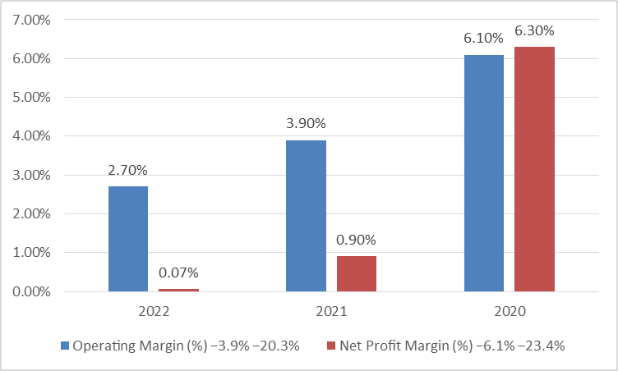
(Source: Self-Generated)
Appendix B: Liquidity Trend Graph
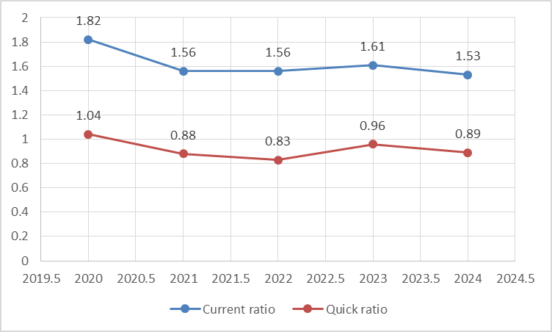
(Source: Self-Generated)

Appendix C: Efficiency & Working Capital Ratios
Table C1: Efficiency & Working Capital Ratios (2020-2024)
Indicator | 2024 | 2023 | 2022 | 2021 | 2020
Inventory Days | 103 | 108 | 150 | 142 | 126
Receivable Days | 105 | 98 | 75 | 78 | 77
Payable Days | 94 | 71 | 64 | 74 | 61
Cash Conversion Cycle | 114 | 135 | 161 | 146 | 142
(Source: Financial Statement of the Company, (2024))

Appendix D: Efficiency & Working Capital Graph
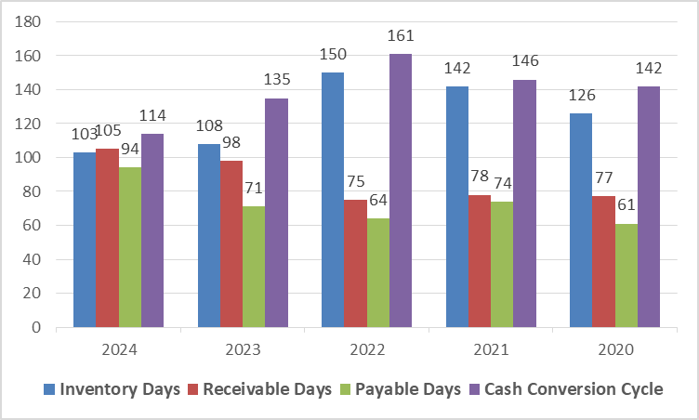
(Source: Self-Generated)

Appendix D: Gearing & Solvency Ratios Trend
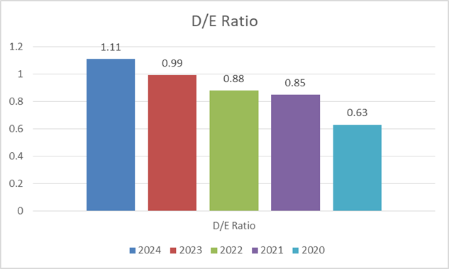
(Source: Self-Generated)
Appendix E: Cash Flow Indicators
Table E1: Gearing and Solvency Movement
Measure | 2020 | 2021 | 2022 | 2023 | 2024
Total Debt (£m) | 128,491 | 134,021 | 145,992 | 161,200 | 170,249
Total Equity (£m) | 145,301 | 138,311 | 120,514 | 110,005 | 107,642
Debt/Equity Ratio | 0.88 | 0.97 | 1.21 | 1.46 | 1.59
Market Capitalisation (£m) | 171,904 | 168,990 | 163,251 | 159,202 | 153,105
(Source: Financial Statement of the Company (2024))
Appendix F: Altman Z-Score Calculation (2024)
Table F1: Inputs to the Z-Model
Variable | Formula | Value
X1 = Working Capital/TA | (242,494 – 158,291) ÷ 323,354 | 0.260
X2 = Retained Earnings/TA | 208,431 ÷ 323,354 | 0.64
X3 = EBIT/TA | –15,297 ÷ 323,354 | –0.04
X4 = MVE/TL | 153,105 ÷170,249 | 0.90
X5 = Sales/TA | 394,879 ÷ 323,354 | 1.22
Z-Model Calculation:
Z = 1.2X1 + 1.4X2 + 3.3X3 + 0.6X4 + 1.0X5

Result:
Z = 2.836
Interpretation:
Value indicates financial distress (Z < 2.99).
Appendix G: Payback Period Calculation
Formula: Payback Period (PBP) = Initial Investment ÷ Annual Net Cash Inflow
Project A
£40m / Yr1–3 inflow reached in Yr. 3
PB = 3.14 years
Project B
£30m / £6m annual = 5 years
PB = 5 years
Project C
£50m recovered between Yr3–Yr4
PB = 3.6 years
Appendix H: Accounting Rate of Return (ARR)
ARR = Average annual profit ÷ Investment
Project | ARR (%)
A | 21%
B | 10%
C | 26%

Appendix I: Net Present Value (NPV at 10%)
Discount factors used:
Yr1: 0.909
Yr2: 0.826
Yr3: 0.751
Yr4: 0.683
Yr5: 0.621
Table I1: Net Present Value Summary
Project | Present Value | Cost | NPV
A | £39.99m | £40m | £-0.01m
B | £22.36m | £30m | £-7.64m
C | £60.29m | £50m | £+10.29m
(Source: Self Calculated)

Appendix J: Profitability Index (PI)
PI = PV ÷ Cost
Table J1: Profitability Index
Project | PI
A | 1.00
B | 0.74
C | 1.21
(Source: Self Calculated)
Appendix K: Internal Rate of Return (IRR)
Internal Rate of Return (IRR)
= Discount rate at which NPV = 0
Table K1: Internal Rate of Return (IRR) Summary
Project | IRR
A | 10–11%
B | 6%
C | 15–16%
(Source: Self Calculated)

