Marketing Function at Saudi Arabian Packaging Industry W.L.L (SAPIN)

ASSIGNMENT 2

3rd AUGUST, 2018

Module: |  | Marketing Management (SBMA7102D)
From: |  | Saeed Ahmed (Student ID: 1705946)
To: |  | Dr. Huw Thomas

TABLE OF CONTENTS

- INTRODUCTION 1
- ROLE OF MARKETING 2
- MARKETING STRATEGY 3
- MARKETING RESEARCH 3
- MARKETING MIX 4
- BRANDING 5
- CORPORATE SOCIAL RESPONSIBILITY 6
- SEGMENTATION AND TARGETING 6
- MEDIA CHANNELS 7
- METRICS 8
- COST PER LEAD 8
- TOTAL VISITS ON WEBSITE 8
- BOUNCE RATE 8
- CUSTOMER ATTRITION AND RETENTION 9
- BRAND AWARENESS 9
- NET PROMOTER SCORE 9
- TOTAL CONVERSIONS 10
- APPENDIX A 11
- REFERENCES 12

- INTRODUCTION

Saudi Arabian Packaging Industry W.L.L. (hereafter referred to as SAPIN) is a metal and plastic packaging company situated in the city of Dammam, Eastern Province of Saudi Arabia. It is one of the subsidiaries for Al-Suhaimi Holding Company where I work at as a Senior Internal Auditor. SAPIN started its operation in 1976 starting from manufacturing can components towards become a leading can manufacturing company in the Middle Eastern region throughout the years. The company’s vision is to be the leading packaging solutions provider with the highest quality and ethical standards while serving chosen markets whereas their detailed mission states to focus on meeting evolving customer’s needs by delivering quality and timely products in the metal and plastic packaging domain while ensuring sustainable profit and environment.⁽¹⁾ The company supplies packaging for products of household and industrial use, mainly ranging from milk powder and baby food to coffee, nuts and juices and air fresheners, insecticides, lubricants and paints.⁽²⁾ Below is an illustration taken from SAPIN’s company portfolio from its inception till its major milestones through its history.⁽³⁾

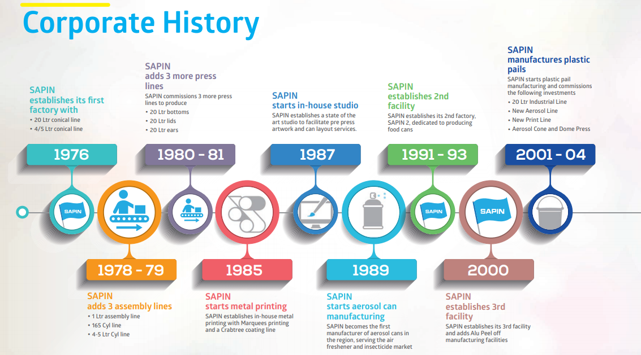
SAPIN’s corporate history ⁽³⁾

- ROLE OF MARKETING

“Marketing is the distinguishing, unique function of the business.” – Peter F. Drucker ⁽⁴⁾
The above statement clearly indicates how marketing is vital for any business. As per Kotler P. (2016), marketing is a social and managerial process by which individuals and groups obtain what they want and need through creating and exchanging products and value with others.⁽⁵⁾ Whereas, as per the American Marketing Association (1985) definition, marketing is the process of planning and executing the conception, pricing, promotion and distribution of ideas, goods and services to create exchanges that satisfy individual and organizational objectives.⁽⁶⁾
SAPIN’s marketing function operates in a Business to Business (B2B) business setup where its customers are normally other companies who are looking for quality and sustainable packaging solutions. Prior to 2010, the marketing function at SAPIN was only carrying out basic outdoor advertising activities, overseen by a single marketing co-coordinator. However, in 2010, the management identified the need for a proper marketing function to deal with rising competition and further maintain a stronghold in the Middle East and North Africa (MENA) region, hence they decided to bring in a team of dedicated marketing function. The marketing function, as seen in SAPIN’s organizational structure (refer to Appendix A) comprises of “Head of Sales & Marketing”, “Marketing & Communication Manager” and “Marketing Coordinator”. As it can be noted, the organization effectively utilizing the Marketing function to carry out cross functional activities where the Head of the department is overseeing both Sales and Marketing function and ensuring that these two functions are properly aligned. The Marketing and Communications Manager is responsible for conducting marketing research and feasibility studies, manage the content marketing activity, carry out basic search Engine optimization techniques to boost up search results for SAPIN’s web presence and creating brand awareness social media platforms. The marketing function had been working in a holistic fashion with relevant departments (especially Operations, Finance, Supply chain, Quality, IT and Sales) where the input from such departments help them understand from production to delivery and further they gain information to improve their marketing activities in serving customer needs.

It was not until 2013, where they moved towards a strong brand campaign through their slogan “LEADER OF THE PACK” highlighting their strength as a trusted and premier packaging solution. Furthermore, the marketing division focused more on ‘Relationship Marketing (RM)’ rather than its transactional or marketing mix approach (Zolkiewski, 2004) where (i) this relationship marketing is based on interactions within networks of relationships (Gummesson, 2002), (ii) creates and maintain long term relationships which are mutually rewarding (Rapp & Collins, 1990), (iii) is based upon dialogues and interactions (Blomqvist, Dahl & Haeger, 1993). But the most important aspect is highlighted by Hunt and Morgan (1994) who explains how the process of RM develops trust and commitment among business partners to maintain a valued relation with the alignment of shared values.⁽⁷⁾

- MARKETING STRATEGY

The strategic plan defines the company’s overall mission and objectives. The first goal for marketing is to create value for customers and build profitable customer relationships whereas the next step is to devise the marketing strategy which is the marketing logic by which the company hopes to create this customer value and achieve these profitable relationships. Guided by marketing strategy, the company designs an integrated marketing mix made up of factors under its control—product, price, place, and promotion (the four Ps).⁽⁵⁾ Below are some of the activities carried out by the marketing function:
- Marketing Research :
The marketing research carried out is one of the starting points by the marketing function that helps in assessing the taste of B2B customers, identifies value propositions along with current and upcoming customer requirements and this research plays an important role in product development. This research also informs management about the market trends, enabling them to make fully informed decision related to their overall business strategy. Two broad research techniques as highlighted by Groucutt J. (2005) used by the marketing function at SAPIN can be classified into primary (customer questionnaires, in-depth interviews, observations) and secondary (internal and external information) sources. ⁽⁷⁾

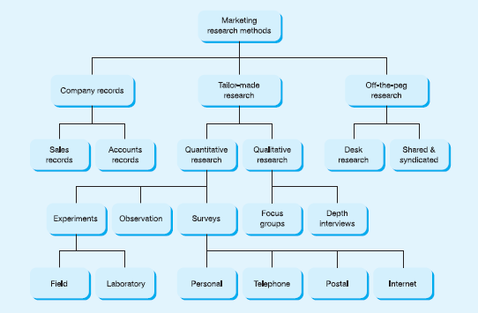

Marketing research methods ⁽⁸⁾

The marketing function conducts periodic surveys, interviews, and receives customer feedbacks to ensure such data delivers valuable marketing insights. Other secondary sources used for marketing research purposes are either external or internal information based. Information gathered from external data (such as trade/industry publications, independent market research reports, etc) covering the B2B industries are often used. Internal information includes data from business divisions (such as Finance, Sales, Operations, Supply Chain and Quality) different perspectives how marketing can use effectively use this data in their overall strategy, for instance, the inventory report issued by the Operations/Supply Chain Management or the sales team monthly report helps marketing to identify how customer demand or supply is being taken in the market. Below is an illustration on the types of marketing research methods:
- Marketing Mix:
SAPIN utilizes the marketing mix of the 4 P’s (Product, Place, Promotion, Price) which is the part of the marketing strategy and focuses on developing a set of tactical marketing tools that organizations blend to produce the response it wants in the target market. ⁽⁵⁾

- Product:
SAPIN offers the below products to its B2B customers:
- Aerosol cans
- Food cans
- Paint cans
- Plastic Pails
- Can components
These products are processed at their facilities situated at Dammam (Saudi Arabia) and Dubai (United Arab Emirates). Currently, SAPIN is planning to expand its product mix by extending to other modes of packaging such as flexible packaging to gain entrance into new markets. Below is an illustration of the products being offered:

- Place:
The Place/Distribution mix indicates the locations where the products can be offered from. SAPIN has a total of 4 factories (3 in Dammam, Saudi Arabia and 1 in Dubai, UAE) where the whole can manufacturing process is carried out. Each production facility has its own warehouse to stock finished inventory where the UAE branch primarily is focused dealing with consumers from UAE and Oman while the Saudi region cover the remaining Middle Eastern region (Kuwait, Qatar, Iraq, Syria, etc). This element of marketing mix supports SAPIN’s growth strategy in meeting their segmented market and helps in further market penetration due to their geographical outreach.
- Promotion:
SAPIN promotes its products through various marketing tactics such as:
- Trade and Professional Magazines
- Events/Trade fairs
- Social Media
- Direct Selling
Videos of manufacturing processes are posted on LinkedIn, social media whereas the Marketing department submits articles in professional journals about SAPIN’s history and milestones achieved.
- Price:
SAPIN pricing strategy is based on differential pricing where there is a margin for price negotiation albeit there is a threshold/bottom cost to ensure the sales are profitable. The prices also take consideration of the prevailing tin and aluminum prices listed on the London Metal Exchange (LME) and since the prices are usually customer oriented, it also revolves around other variables such as quantity ordered, delivery time, payment time, demographics.

- Branding:
SAPIN has been focusing on building a better brand presence in the B2B industry as it has realized that a powerful brand leads to higher brand equity, creating a differential effect for customers with respect to products and marketing activities. Such brand equity enables the company to capture consumer preference and loyalty, hence providing a long term competitive advantage. ⁽⁵⁾

One important component of the brand strategy is the brand positioning in which the marketing function tries to positions the desired brand image in the mind of its customers. Out of the known 3 brand level positions i.e. ‘product attributes (low)’ ‘desired benefits (moderate)’ and ‘belief and values (high)’, SAPIN has been able to elevate its brand position from ‘product attributes’ to a ‘desired benefit’ level where the focus has been on providing additional benefits to customers such as ‘convenience’ in their packaging solutions. ⁽⁵⁾ For example, the marketing function’s recent dialogue with one of their B2B customer had helped them in identifying and further discussion with the technical and operations team to resolve the issue for the ‘powder scoop’ falling into the tin container. This led to some modification to the lid design of the tin can and hence, an additional ‘scoop’ holder was designed at the lid of the tin can which reduced the risk of the spoon falling into the powder where it could be contaminate when touched with bare hands. Currently, the marketing division is working on SAPIN’s brand strategy by moving from the “LEADER OF THE PACK” brand tagline to “COMPLETE PACKAGING SOLUTION” as the company is working on feasibility studies to expand its product line toward other modes of packaging, such as flexible packaging.

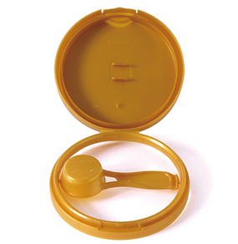

Infant formula powder can lid with scoop holder
- Corporate Social Responsibility (CSR):

To further promote its brand as socially responsible, SAPIN has been active on serving the social welfare for the general public. Since 2008, SAPIN has been campaigning to raise the awareness for ‘breast cancer’ by endorsing the ‘Think Pink’ campaign in Saudi Arabia and Bahrain. Later in 2016, SAPIN was the first company in Saudi Arabia to participate and contribute to the World Wildlife Fund. This became one of the company’s core values i.e. contribute towards positive environmentalism and the need for manufacturing companies to focus on sustainable green practices as due to the increasing trend of awareness about the impact of packaging on the environment. Other initiatives taken by the company for reduce carbon footprint and greener future is the usage of forklifts on ‘CNG’ which is a cleaner fuel when compared with LNG and other alternative fuels, proper disposal of scrap through transparent recycling framework and usage of LED lights in their facilities to reduce electricity consumption. This all leads to a stronger responsible brand image while aligning with ethical standards and customer values.⁽⁹⁾

- SEGMENTATION AND TARGETING
The segmentation process involves establishing criteria by which groups of consumers with similar needs can be identified and the marketing function gains a a clear understanding of the market. The segmentation process is central to the marketing strategy and can be broken into three distinct elements: segmentation, targeting and positioning.⁽¹⁰⁾

As per Doyle (1994), segmentation helps in:
- Meeting consumer needs more precisely
- Increase profits
- Segment leadership
- Retain customers
- Focus marketing communications ⁽¹⁰⁾
Moreover, Wright (2004) indicates B2B businesses such as SAPIN require segmentation to:
- To identify new opportunities within existing markets, especially identifying gaps within existing product or evolving market needs changing over time.
- Spreading knowledge throughout the company employees about segmented markets and raising competitiveness.⁽⁷⁾

The target customer market of SAPIN is geographically based (focused on the MENA region) where it strives to offer premier can packaging solutions. SAPIN has access to markets operating in North African countries (Egypt, Morocco, Sudan, Tunisia, etc) and Middle Eastern countries (UAE, Kuwait, Oman, Syria, Jordan, etc). Therefore, the marketing function utilizes a single-market strategy focusing on a specific geographical location though differentiated/segmented marketing approach due to its various packaging solutions with differentiated/customized specifications.⁽⁵⁾ This is especially the case where standard packaging may not be the best solution at certain occasions and the marketing team, along with the other functions (Technical, Operations) needs to work in partnership with the customer to develop specific product by serving as a turnkey consultant/advisor for the product. ⁽¹¹⁾ Due to such collaboration, SAPIN was able to innovate its product offering and became the first global company to launch the 2 piece aluminum cheese can with easy release technology for its major customer, Kraft foods in 2013 and was awarded the ‘can of the year’ award in 2014 by the “Can Maker” magazine (UK) respectively. ⁽¹²⁾

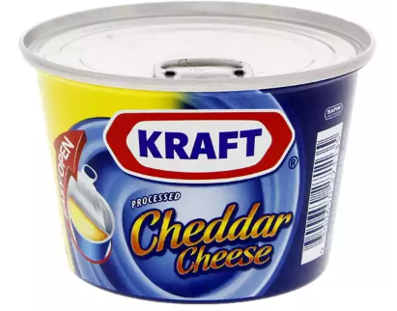
2 piece aluminum cheese can for Kraft Foods ⁽¹²⁾

- MEDIA CHANNELS
The type of marketing and advertising media used by SAPIN is majorly in professional and trade magazines (such as Can-Maker magazine, UK) and while other major channel is e-marketing channel such as email, social media (Twitter, Facebook, LinkedIn, etc) and websites. As highlighted by Groucutt, J. (2005), trade and professional magazines covers two areas i.e. (i) B2B magazines which markets products and services to industrial customers while (ii) other magazines produced by professional organizations or trade bodies as means of communicating issues with their members. Since these magazines are easily available on the web in softcopy format (PDF), they can be easily downloaded and viewed on websites rather than printing conventional hard copies. ⁽⁷⁾
The other channel is digital marketing which is the most cost effective and provides a strong digital presence where content focused marketing helps in catching the attention of customers. An instance can be seen where the marketing function has recorded videos of the SAPIN manufacturing facilities showing the complete can manufacturing process on the social media/website. This helps the customer to have an inside view of the types of modern equipment used, the professionalism of the workers operating such equipment/machinery and the required safety and quality standards followed while preparing the products. ⁽¹³⁾
- MARKETING METRICS
The marketing function at SAPIN has jotted down key metrics for their function in alignment with the short term and long term business goals of the organization. One of the key KPI frameworks being followed by SAPIN throughout its organizational units is the SMART (specific, measurable, attainable, relevant, time-bound) approach which also applies to the marketing function. Some of the main metrics used for measuring marketing performance are as below:
- Cost per lead:
One of the most important metric to measure the effectiveness by the marketing function is the ‘cost per lead acquisition’. This effort by marketing also helps the sales department to secure a potential customer into a successful conversion by focusing on the right audience and at the same time, reduce sales efforts and costs. Moreover, the marketing function also benchmark its result with not by its past history and performance, but with industry benchmarks to ensure that their lead acquisition cost is reasonable. ⁽¹⁴⁾

- Total Visits on website:
The complete content displayed on the company’s website is being managed by the Marketing function, from the design outlay till the description on each webpage. Besides their presence on social media and industry journals, the marketing function uses the traffic on the website to get a picture of their marketing campaign, where the rising or decreasing trend of average monthly visits indicates whether their marketing campaign is heading into the right direction.⁽¹⁴⁾

- Bounce rate:
The bounce rate shows what percentage of visitors leave your website before they further exploring your website. This helps the marketers to focus on the root-cause as to what content helps in attracting potential leads and look into improvement areas on the website where it had been unable to garner customer attention. ⁽¹⁴⁾

- Customer Attrition and retention rate:
Another key metric of measuring SAPIN’S marketing campaign effectiveness is to measure if the needs of existing customers are being met or further efforts needs to be undertaken to identify their current and future demands. In order to ensure the risk of customer attrition or churn, the marketing function (in collaboration with Sales) ensure that they are in constant communication with their customers in case of a complex requirement or an issue that needs to be resolved. The marketer in his individual capacity has maintained positive and closer relationship with customers and steps in to resolve any other issue that may prove to be a nuisance to the customer (such as delay in shipping or a product defect). The marketing function also utilizes customer feedback, especially with its major customers on a more frequent basis to get their input and how they can further help in meeting their needs and provide a satisfactory product and customer experience.⁽¹⁴⁾

- Brand awareness:
Although measuring brand awareness has been traditionally difficult to measure, the marketing function uses social media (such as twitter and LinkedIn) and surveys visits to gauge what other companies are saying about their brand.⁽¹⁵⁾
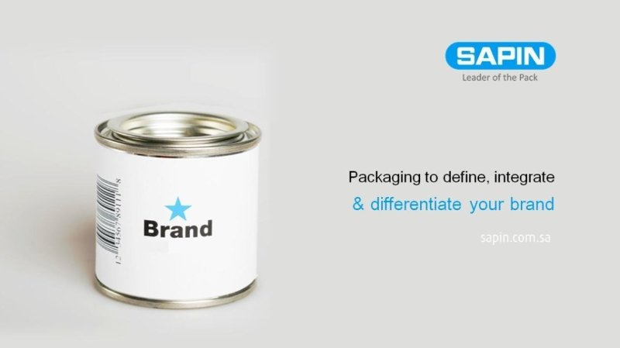
SAPIN digital advertising focusing on brand awareness
- Net Promoter Score (NPS):
NPS is a customer loyalty metric which can gauge the loyalty of a customer’s relationship and how likely is that such customer’s would refer SAPIN to other businesses, normally from a rating scale of 0 – 10 where the scale of 0-6 are ‘detractors’, 7-8 are ‘passives’ and ‘9-10’ are actual promoters. These promoters serve as brand advocates.⁽¹⁶⁾

- Total conversions:
This metrics measures the overall profitability of SAPIN’s overall marketing efforts which is usually traced when a prospective lead turns into a successful conversion. This metric can be quantified by the marketing function and identify whether the conversion numbers through the website or referrals or other methods are showing a healthy trend or not.⁽¹⁴⁾

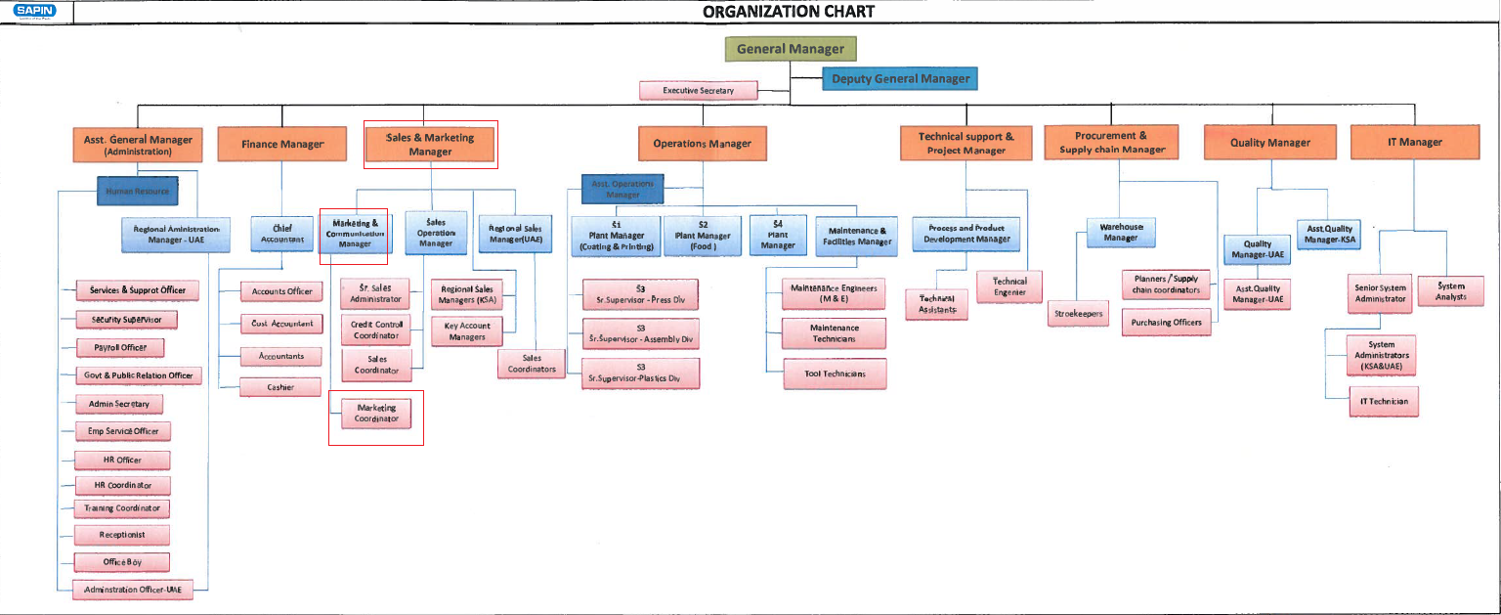
APPENDIX A

APPENDIX 3

REFERENCES:
⁽¹⁾ SAPIN website (2018). “Mission and Vision statement”. from SAPIN: http://www.sapin.com.sa/mission&vision.php
⁽²⁾ SAPIN website (2018). “History”, from SAPIN: http://www.sapin.com.sa/history.php
⁽³⁾ SAPIN website (2018). “Company Brochure”, from SAPIN http://www.sapin.com.sa/upload/projects/images/6/SAPIN%20Brochure_NEW.pdf
⁽⁴⁾ Drucker, P. F. (1954). The Practice of Management. New York: Harper-Collins Publishers.
⁽⁵⁾ Kotler, P. & Armstrong, G. (2016). Principles of Marketing: Global Edition (16th Edition). Harlow: Pearson Education Limited.

⁽⁶⁾ AMA Publishing (2007). Marketing's Evolving Identity: Defining Our Future, from American Marketing Association: https://archive.ama.org/Archive/AboutAMA/Pages/AMA%20Publications/AMA%20Journals/Journal%20of%20Public%20Policy%20Marketing/TOCS/summary%20fall%2007/MarketingsEvolvingjppmfall07.aspx
⁽⁷⁾ Groucutt, J. (2005). Foundation of Marketing. Palgrave Macmillan.
⁽⁸⁾ Hooley, G., Piercey, N. F. & Nicoulaud, B. (2008). Marketing strategy and competitive positioning (4th Edition). Harlow: Pearson Education Limited.
⁽⁹⁾ Trade Arabia (2016). “SAPIN takes the green route”. from Trade Arabia website: http://www.tradearabia.com/news/IND_300439.html
⁽¹⁰⁾ Ferrell O.C., & Hartline, M. D. (2011). Marketing Strategy (5th Edition). South- Western, Cengage Learning.
⁽¹¹⁾ SAPIN website (2018). “Services”. from SAPIN: http://www.sapin.com.sa/content.php?pageid=17
⁽¹²⁾ Gulf Industry (2015). “Awards spur SAPIN to innovate more”. from Gulf Industry Arabian Business Community: http://www.gulfindustryonline.com/news/12917_Award-spurs-Sapin-to-innovate-more.html
⁽¹³⁾ SAPIN website (2018). “Videos”. from SAPIN: http://www.sapin.com.sa/videos.php
⁽¹⁴⁾ DeMers, J. (2014), 10 Online Marketing Metrics You Need To Be Measuring, from Forbes:
https://www.forbes.com/sites/jaysondemers/2014/08/15/10-online-marketing-metrics-you-need-to-be-measuring/
⁽¹⁵⁾ Smith, K. (2014), How to Measure brand awareness, from Brand Watch: https://www.brandwatch.com/blog/marketing-how-to-measure-brand-awareness/

⁽¹⁶⁾ DeMere, N. E. (2017), Interesting Ways Real Companies Use Net Promoter Score Results, from Hubspot: https://blog.hubspot.com/service/net-promoter-score-results

