
Department of Criminology and Policing
Submitted in part fulfilment for the degree of BSc
Are Serious Organised Crime Gangs Targeting Young People to be in their Criminal Activity and How?

James Ellis Dick
(2103999@student.uwtsd.ac.uk)
Independent Project [BMPS6012]

Abstract
This research represents an analysis and evaluation of whether serious organised crime organisations target young people, and if so, how they are able to exploit and force young people to commit crime for these gangs, and what are the issues faced by victims and support agencies. Within the last few years, anti-serious organised crime agencies have managed to develop their strategy to safeguard young people from exploitation. Due to this, anti-serious organised crime agencies have managed to increase the number of young people safeguarded over the last few years. However, the increase could mean that there has been an increase of young people being exploited in the UK.
This research used questionnaires which included both closed and open questions to understand the views of respondents about the reasons for child criminal exploitation, in particular county lines. The primary research showed that respondents believed the biggest risk factor for a young person to go into gangs was wanting a sense of belonging and being protected by those gangs. The most common preventative measure given by the participants was to report their concerns to either the UK police or local authorities.
Recommendations made by respondents which could help prevent child criminal exploitation from happening included that the UK public can rely on other first responder organisations to tackle child criminal exploitation rather than primarily trusting the UK police to handle it, and education of the young in education before they get approached by these criminal gangs.

Acknowledgements

I would like to thank the university for my three academic years, the first studying Public Services and this last year changing to Criminology, I have learnt a few areas within the crime department, whether learning about serious organised crime, or learning the different types of law such as criminal, or domestic law or even how to properly conduct a crime scene.
I would also like to thank my lecturers who have lectured since my first year, they have been amazing throughout the years.
To my learning support tutor, who has been helped supported me since day one, whether looking at essay’s, presentations or even this research, making sure that my assignments are to the best of its ability, without you I would not be typing this dissertation today.
I would like to thank the participants who took part in my survey and look at all your different responses to see your views on child criminal exploitation today. I was astounded by the number of participants who took part in the survey from all over the country as well as the different age gaps too. Without the support of you guys I would not have written a thorough analysis.
Lastly, my family who have helped supported me and cheered me on from Kent and other places in the UK. It has been a long three years away from home but thank you all for supporting through difficult times from when I first moved to Wales and nervous to start a new chapter.

Declarations
This work has not previously been accepted in substance for any degree and is not being concurrently submitted in candidature for any degree.

STATEMENT 1
This dissertation is being submitted in partial fulfilment of the requirements for the degree of BA/BSc.

STATEMENT 2
This dissertation is the result of my own independent work/investigation, except where otherwise stated.
Other sources are acknowledged in the Reference Section.

STATEMENT 3
I hereby give consent for my dissertation, if accepted, to be available for photocopying and for interlibrary loan, and for the title and summary to be made available to outside organisations.

STATEMENT 4
I hereby give consent for my dissertation, if accepted, to be available on the university’s IT system to those who have consent to use the system.

Student’s Name
James Ellis Dick
Signed: James Ellis Dick
Date: 07/05/2024

Contents page

Chapter 1: Introduction 1
1.1 Background 1
1.2 Objectives 3
1.3 Scope 4
Chapter 2: Literature Review 6
2.1 To understand and investigate the nature of serious organised crime in the UK (Objective 1) 6
2.2 To analyse the level and scope of the child criminal exploitation of children and young people by serious organised crime groups in England and Wales (Objective 2) 9
2.3 To examine the methods used and the risk factors for young people becoming involved with organised crime (Objective 3) 11
Chapter 3: Methodology 14
3.1 Research Onion 15
3.1.2 Research Philosophy 15
3.1.3 Research Approach 16
3.1.4 Methodological Choice 17
3.1.5 Research Strategy 18
3.1.6 Time Horizon 18
3.1.7 Procedures and Techniques 19
3.2 Sampling 19
3.2.1 Pilot Study 20
3.3 Limitations 20
Chapter 4: Findings 21
4.1 Are Serious Organised Crime Gangs Targeting Young People in their Criminal Activity and How? 21
4.2 Introduction 21
4.3 Findings: Description of Data Analysis and Results 21
4.4 Synthesis of findings with literature review 34
4.5 Summary 35
Chapter 5: Conclusion 37
5.1 Introduction 37
5.2 Research objectives: summary of findings and conclusions 37
5.2.1 To understand and investigate the nature of serious organised crime in the UK (Objective 1) 38
5.2.2 To analyse the level and scope of the child criminal exploitation of children and young people by serious organised crime groups in England and Wales (Objective 2) 38
5.2.3 To examine the methods used and the risk factors for young people becoming involved with organised crime (Objective 3) 39
5.3 Recommendations 40
References 41
Appendix 48

Chapter 1: Introduction

1.1 Background
The topic for this dissertation is to explore the nature of serious organised crime and how this involves forced crime exploitation and child exploitation. Serious organised crime (SOC) according to Crime Stoppers (2023a) is when individuals or groups of people have planned and coordinated to conduct serious crime, and these individuals are motivated to commit these crimes for financial gain. According to the Home Office (2023a), their assessment uncovered that SOC is estimated to cost the UK economy £47 billion a year, with the cost increasing year after year. There is evidence from Haenlein (2023), that there is “growth in serious organised crime … since the 2018 Strategy’s publication.” The National Crime Agency (NCA) (2023) says serious organised crime (SOC) continues to grow and they are developing new methods to improve the threat of SOC within the UK. The latest data from the NCA (2023) estimated that in the years 2021 and 2022, there were around 59,000 individuals who were involved with SOC. It is very difficult to measure precisely how many people are involved with SOC, however according to Haenlein (2023) there is little doubt that there continues to be an increase in SOC.
The different criminal activities that SOC gangs commit include drugs and county lines, child sexual exploitation, modern slavery, financial fraud, business crime, cybercrime and car crime (Crime Stoppers, 2023a; GCHQ, 2023). For this dissertation, county lines will be one of the main focuses of research. County lines (Crime Stoppers, 2023b) is a term used to identify organised illegal drug dealing networks. This organised crime is usually managed by a person using a ‘deal line’ to communicate with the people who are exporting the drugs and money. SOC gangs mostly recruit or hire young vulnerable people, children and adults, from rural and suburban areas linked to big cities, as ‘runners’ to export drugs and cash all over the UK. Their main transportation is using the rail network, or taxis and other private hire vehicles.
When it comes to exploitation, there are six major different forms of exploitation; labour, organ harvesting, forced crime, sexual, domestic servitude and forced marriage (Stop the Traffik, 2022). For this research, forced criminal exploitation will be one of the main focuses for the dissertation. Forced criminal exploitation, according to Safer Communities Wales (2023), is the abuse of power and control of another person. This means to take advantage of another person or situation for criminal purposes. These crimes tend to be begging, shoplifting, and crimes related to SOC, such as county lines (Stop the Traffik, 2022). Child Criminal Exploitation (CCE) occurs, according to HM Government (2018, p.48), “where an individual or group takes advantage of an imbalance of power to coerce, control, manipulate or deceive a child or young person under the age of 18 into criminal activity”. The gang members manipulate the young people by exchanging gifts, money or drugs to the young victim, or a more coercive way is by the use of violence or the threat of violence.
In terms of up-to-date UK academic literature to suggest the threats of a young person being criminally exploited, there are articles that have documented interviews with young people, who have worked under gangs to transport drugs across the country (Robinson, et al., 2019, pp. 700-706), as well as interviews with youth practitioners who have worked alongside young people who have been coerced into committing crimes for SOC gangs (James, 2021, pp. 13-14). In terms of UK government departments tackling the issue of young people involved with CCE or any type of exploitation, there are at least 27,000 young people who are identified as county line gang members in the UK (UK Parliament, 2023). However, there is not an accurate number within recent years to suggest whether exploiting young people have increased or decreased making it very difficult to analyse.
The main aim of this research is to identify whether SOC gangs encourage and bribe young and vulnerable people to work county line operations, and what coercive methods gangs use to exploit these young people. To see whether this is true or not, it is important to identify if there are links in the research to contributary factors such as exclusion from education, school status, or areas of deprivation (Office for National Statistics, 2023), for example young people who in live in areas of deprivation and poverty might be more at risk of being involved or being exploited (James, 2021, pp. 13-14).
  - Objectives
There are three main objectives of this research. The first objective is to understand and investigate the nature of serious organised crime in the UK. The purpose of this objective is to examine the nature of SOC, by looking at how the UK government first started tackling SOC in the country. Furthermore, if SOC areas such as county lines have developed a change in strategy when it comes to exploiting young people, whether there has been an increase in county lines over the last few years and if there is an increase in safeguarding those who are most at risk.
The second objective is to analyse the level and scope of the exploitation of children and young people by serious organised crime groups in England and Wales. This objective focuses more on the statistics level of CCE within the UK and analyses quantitative data on how young people are exploited through SOC gangs.
The third objective is to examine the methods used and the risk factors for young people becoming involved with organised crime. This objective will evaluate the qualitative data on how young people are at risk or what methods these gangs implement to convince or exploit young people to carry out forced criminal activities such as county lines. Risk factors such as gender and cultural background will be explored (McCluskey, et al., 2019), along with coming from a low-income background where they are victims of poverty or wanting a sense of belonging and wanting to be around the criminal gang for protection.
  - Scope
The timescale for this dissertation has been split into five chapters. Each chapter throughout the dissertation is to make sure that everything is structured well. The first chapter of the dissertation is the introduction. This chapter sets the scene for the dissertation question which is “Are serious organised crime gangs targeting young people in their criminal activity and how?” The Second Chapter is the Literature review, which will provide an overview and analysis of current literature in line with the objectives of this research. Chapter three is the Methodology, which explains the data collection and analysis method used in the research, which is mostly quantitative data as most of the questions asked will be multiple choice, and some qualitative data to see if any new information which might not be discussed before emerges, for example how could the community prevent CCE happening in their area. This research will use an online questionnaire using google forms.
Chapter four of the dissertation is the Findings of the qualitative and quantitative analysis which will be conducted. Finally, chapter five is the conclusion which is the summary of the main findings of the dissertation and includes recommendations for practice and further research.
The literature review will start by exploring the history of when SOC first became an issue in the UK, as well as evaluating how the government has tackled SOC within the last two decades. Afterwards, the research will analyse the scope of young people being exploited to commit forced crime in the UK. The research will identify the methods used by SOC gangs and evaluate how gangs exploit children and young people in the UK, including expert perceptions from Barnardo’s practitioners (James, 2021, p. 12). The research will also evaluate articles which have interviewed young offenders involved with going across the country delivering the drugs, and what methods were used to persuade the young person into committing the crime (Robinson, et al., 2019, pp. 700-706). This dissertation will also review some literature on whether youth offenders are victims of child criminal exploitation.

Chapter 2: Literature Review

2.1 To understand and investigate the nature of serious organised crime in the UK (Objective 1)
As established in the introduction, serious organised crime (SOC) is increasing in the UK, with recruitment of individuals increasing year after year, along with the cost of providing victim support for those who have been exploited by SOC gangs (NCA, 2023). Lavorgna, et al. (2013, p.7), explain that the UK government did not tackle organised crime (OC) as a separate offence until 1994, when the House of Commons assigned the Home Affairs Committee to assess the nature of OC. The reason why the UK decided to tackle to OC in 1994, was due to the fall of the Soviet Union, which throughout Europe resulted in “moral panic” (Hobbs & Hobbs, 2011, p. 254). The fear was that Eastern European and Russian criminals were moving to the Western side of Europe. Ten years later, in 2004-05, the UK established the first anti-organised crime agency called the Serious Organised Crime Agency (SOCA) (Home Office, 2004). According to Lavorgna et al. (2013, p.7) this was a “watershed moment in the government’s effort against SOC”. However, the SOCA was not as effective as the UK government thought it would be, and as a result there was a reorganisation. In 2013, the agency known today as the NCA replaced the SOCA, and the UK government made the decision that organised crime intelligence should be shared with local police forces to improve strategic policing of SOC (Home Office, 2011).
The different criminal activities that SOC gangs commit include drugs and county lines, child sexual exploitation, modern slavery, financial fraud, business crime, cybercrime, and car crime (Crime Stoppers, 2023; GCHQ, 2023). The NCA (2023) has devised a table of all the crimes related to SOC and researched the different crimes to see if those crimes had increased or stayed the same in the year 2022. Crimes such as drugs, fraud, modern slavery and human trafficking, money laundering, organised acquisitive crime and organised immigration crime all showed an increase within England and Wales. Crimes such as Child Sexual Abuse, Cyber Crime and Firearms showed no change, however, these threats are still at large within the UK.
An emerging issue within the UK that has become an increasing threat is county lines drug trafficking. According to Robinson, et al. (2019, p.694) county lines drug dealing is a “rapidly evolving illicit drug supply model”, with drug gangs and organised criminals crossing the “police borders” into rural towns. The county lines origin is suggested to be between 2015 and 2017 (Caluori, et al., 2022), however some argue that the crime has been around since the 1990’s as the term back then was referred as “going to country” (White, 2021). County lines has become more of a challenge for agencies such as the County Line Programme taskforce, which in recent years has added to the complexity of the challenge, as they are already tackling an existing illicit drug market (
The Home Office (2023b) has released a document showing statistics for the county lines data. The data includes the line closures, both type 1 and 2. Type 1 line closure is the closure of a county line through the arrest and charge of a line holder, type 2-line closure is the closure of a county line through the deactivation of a phone line associated with the line. The data also shows how many arrests were made and how many people were safeguarded from November 2019 to June 2023. The County Lines Programme Taskforce recorded from April 2020 to March 2021 that there were 703 type-one line closures and no line closures for type 2. There is no evidence as to why this was the case, as in April 2021 to March 2022 there were 531 lines closed for type 2, which could suggest that type 2 county lines were discovered in that year, or the UK government was not aware of the type 2 county lines until April 2021 to March 2022. The individuals arrested between April 2020 and March 2021 were 2,597, with 687 people referred for safeguarding. In April 2022 to March 2023, there were 1,364 lines closed for type 1 and 53 lines closed for type 2, with 2,661 arrests and 3,235 individuals referred for safeguarding. The data presented from the Home Office (2023c) shows there have been more arrests and people safeguarded in recent years, however, it does not mean that county lines have risen or decreased since it was established in 2019. Also, in terms of safeguarding individuals, there has been an increase, which could suggest that the NCA, the county line taskforce and the police have come to terms with the fact that individuals who are runners are victims not perpetrators (CITE) . This may be due to how young these runners commonly are, as different literature outlines different common ages of children being exploited, with some experts giving a broad range between 14-17 years old (Crown Prosecution Service, 2022; The Children's Society, 2024), whilst other experts argue and give a more specific age range of between 15-16 (NSPCC Learning, 2023; Safeguarding Hub, 2023). This is important to identify so that agencies can focus their attention on the age range that specifically is more vulnerable than others.
The County Lines programme taskforce is a joint agency which helps tackle county line disruption. The taskforce is combined with different police services around England and Wales such as the Metropolitan Police Service, Merseyside Police, West Midlands Police and British Transport Police as well as the Greater Manchester Police.

2.2 To analyse the level and scope of the child criminal exploitation of children and young people by serious organised crime groups in England and Wales (Objective 2)
A Barnardo’s report; ‘Exploited and Criminalised’ (James, 2021, p.4) outlines in its key findings that there is a lack of data collection on Child Criminal Exploitation (CCE) by the UK police forces, as well as very little understanding amongst relevant professionals such as the police, social care and health related organisations, of what CCE is, and a low understanding of what crimes could be related to CCE. The UK Parliament (2023) has estimated that in England there are 120,000 children or one in every 25 teens who are at high risk of gang exploitation. Furthermore, only 24% of children who were involved in gang violence are known to children’s services (Longfield, 2019, p. 3; James, 2021, pp. 4-5). In April 2020, a survey of 1,000 Barnardo’s frontline workers, who’s responsibility it was to help children through mental health support, found that one in four (24%) had supported a child or young person they thought was being coerced, deceived, or manipulated into criminal activity (Barnardo's, 2020). In the survey, Barnardo’s practitioners, were asked in which way children and young people are being criminally exploited, and Barnardo’s compared this with data they recently collected in 2021 with 276 participants, to data collected in 2019 with 182 participants. Barnardo’s found within the data that ‘selling drugs’ had increased by 13%; in 2019 it was recorded that 62% of the participants stated that was what young people were exploited for, but in 2021 that percentage jumped to 75%. Another crime that increased was ‘violence’, which in 2019 was at 43%, but in 2021 went up by 11% to 54%. However, not all exploitation related crimes had risen. ‘County lines’ in 2019 was recorded as 41% of young people going into county lines, meanwhile in 2021, the percentage went down to 38% making ‘county lines’ decrease by 3% (James, 2021, p. 12). In the practitioners’ findings, they found that social deprivation and poverty is one of the main reasons children and young people go into CCE. The practitioners suggested that young people who are on social media want to “fulfil an image presented on social media”, which is unaffordable to them as they are living in poverty, and this increases the risk that young people will join a gang, as they perceive this is an easy route to making money (James, 2021, pp. 13-14)
Barlow, et al. (2022) suggest that child criminal exploitation (CCE) is a “complex interplay” which emerges from three key areas between the potential target, the motivated perpetrator, and the conducive environment. They also argue that the UK government today have “strong and sophisticated” civil and criminal legislation, such as the Modern Slavery Act 2015, which states what must happen for an individual to commit modern slavery and human trafficking. The Act also shows the penalties and sentencing for the perpetrators and the different safeguarding measures to be put in place for victims. The Social Services and Well-being (Wales) Act 2014 part 7, is another act for safeguarding young victims who are at risk of exploitation from SOC in Wales, however, Broad (2018) suggests that these legislations lack clear definitions which may have affected the decision making of the prosecution of the perpetrators involved with exploitation, making it harder to prosecute. Also, Longfield (2019, p.10) and The Children's Society (2019, p.4) suggest that the responses from the UK Government about CCE have been inconsistent and sometimes contradictory, which may be because there is no statutory definition of child criminal exploitation in the UK, which as a result, according to The Children’s Society (2019, p.4), means that “too many children are falling through gaps in support” in England and Wales.
Barlow et al. (2022, p.159) state that CCE has “proliferated” in recent years, which is becoming an increasing concern in terms of children’s safety and welfare. CCE, is not identified as a “single event crime” by which victims can be identified by the risk factors, however, CCE is more to do with the pattern of behaviour that comes from interactions between the victim, the perpetrator and the environment that they share over time (Beckett & Warrington, 2014).
According to Robinson, et al. (2019, p.697), there has been an increased number of children and young people who have been arrested or picked up by the police in counties hundreds of miles away from their homes (NCA, 2017). The issue for the county lines agencies such as NCA, County Lines Programme taskforce, and victim support agencies, such as Barnardo’s, is that even though the young people who had unauthorized absences from home and school were brief, the acts committed by the young people represented a serious safeguarding concern for the protection of the young people (Sturrock & Holmes, 2015, p. 67). Robinson, et al. (2019, p.706) also concluded that unlike Child Sexual Exploitation (CSE), CCE victims were mostly male. When the males were asked whether they felt they were the victims, they had declined the victim label to say that drug dealing was their own rational choice.

2.3 To examine the methods used and the risk factors for young people becoming involved with organised crime (Objective 3)
Robinson, et al. (2019, pp.700-706) collected data from young people from Merseyside and Glasgow who have been “runners” for county lines gangs. In their study they were concerned with how young people get exploited into committing this crime, and within their studies they found three key themes: “Going Country”, “Working the Lines” and Exploitation.
One of the Merseyside participants called Smurf, explained his situation and how he was treated by the people who organised the county lines operations. The runner explained that his task in the operation was to go from Sefton to Cardiff for two weeks to sell drugs such as cocaine and heroin, and he was promised that he would get paid £1000 a week. However, the participant was not paid, and he was arrested by an undercover police officer posing as a drug user. Later on when he was released from a jail in Liverpool, his “elder”, someone who makes the decisions on “generating sales” and “building an active customer base” who helps to develop the gang organisation (Densley, 2012), used the mobile phone “line” to communicate with Smurf, only for the elder to tell Smurf that they would not pay him a fair wage, however, making sure Smurf was well looked after and that his immediate needs were met.
Another runner from Liverpool by the name of Elliot described his encounter with county lines gangs where, one of the older kids asked him if he wanted to make “some proper money” which Elliot agreed to, so they sent him all over the country, and every few days the older kids would supply him with drugs, new clothes, and shower gel. After, conducting all the interviews with the participants, it was clear that there was a pattern used by criminal gangs, to entice young people into selling drugs on their behalf. They found in their interviews that young people did not go into county lines to get “free drugs”, however, the majority of the participants were doing the job to “pay off drug debts that dealers had allowed them to accrue over a long period of time”, in other words a form of indentured servitude. A participant from Merseyside explained that there was a process called “strapping” or “on tick”, where young people were allowed to get drugs upfront without paying for them, which was equivalent to a buy now and pay later scheme (Robinson, et al., 2019, pp. 701-702).
Arnez and Rachel (2021) examined the risk factor of school exclusion in the UK and how it can lead to youth offending. They suggested that the severing of links and ties with school is such a huge challenge for young people, with some professionals taking a punitive attitude to challenging behaviour, and schools often exclude young people without any thought as to where they might end up next. They suggest that school exclusion could leave young people in a state of vulnerability and at risk of exploitation, which could lead criminal gangs to exploit young people to offend. Arnez and Rachel (2021) also consider criminological research on how school exclusion can lead to youth offending. In criminology, school exclusion is suggested to be viewed as a risk factor to youth offending and uses the term ‘school-to-prison-pipeline’. The US term according to Hemez et al. (2019) refers to the young people who have experienced ‘punitive punishment’ in education and are more likely to be involved in crime. McCluskey et al. (2019) have identified that young people with certain characteristics are more at risk of exclusion from school such as being a male, of African-Caribbean origin, in local authority care, of lower socio-economic background, having a special educational need (SEN) and having a mental health condition.
Windle et al. (2020, p. 67) suggests an important reason as to why young people may be exploited, is because they are considered disposable to OC gangs and can likely be replaced by other young vulnerable people. They are cheap to employ as they receive low amounts of cash per week, and gangs accept the risks that might happen relating to street-level sales, where the young dealer might be assaulted by a rival gang and the drugs and money that the young person had in their possession might be stolen.

Chapter 3: Methodology
The literature review aimed to address whether serious organised crime (SOC) groups specifically target young people into carrying out forced criminal activities, such as theft from small shops, pickpocketing or crime that is more major such as county lines. The research used for the literature review came from secondary research. The objectives for this dissertation are to understand and investigate the nature of SOC in the UK, to analyse the level and scope of the criminal exploitation of children and young people by SOC gangs in England and Wales, and to examine the methods used and the risk factors for young people becoming involved with organised crime.
The purpose of chapter three is to outline the methods that were used to carry out primary research into these issues, in order to further develop knowledge in this field and to gain insights into the public’s views of child criminal exploitation (Saunders, et al., 2023, p. 131). Furthermore, the methodology is designed to identify whether there is a link between current literature, and the public’s perception of this issue.

3.1 Research Onion
To assist with the primary research, Saunders et al. (2023) proposed the ‘Research Onion’ model to help plan research and data collection methods for a research project. The model’s purpose is to help build a structure to create a suitable research project. Figure 3.1.1, shows that within the model there are six layers which will assist the correct methodological approach to be chosen for this research, starting from the research philosophy to then choosing the procedures and techniques which are best suited for this research project.
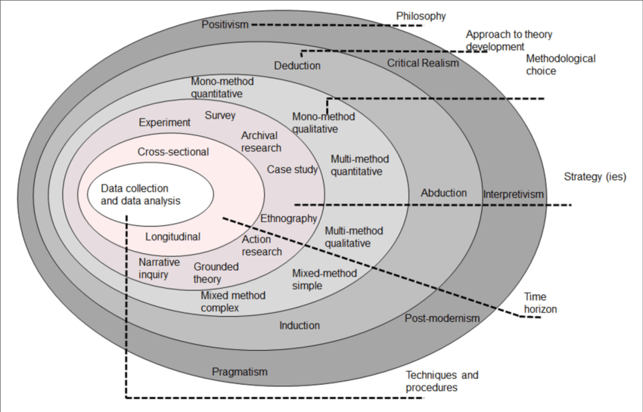
Figure 3.1.1 - The ‘research onion’ (Saunders et al, 2023)

3.1.2 Research Philosophy
‘Research philosophy’ is the term that sets out the ‘beliefs’ and ‘assumptions’ that will help develop the research study (Tamminen & Poucher, 2020; Saunders, et al., 2023). It is important to select the correct research philosophy approach as it will enhance the understanding in the approach to the particular field of study that is chosen (Saunders, et al., 2009).
There are various research philosophies within Saunders et al.’s (2023) research onion model, but for the purpose of this research, the interpretivism research perspective will be the most helpful in order to further develop the research. The Interpretivism perspective “adopts a philosophical perspective that individuals create and develop their own subjective knowledge and meanings of their own social realities” (Alborough & Hansen, 2022, p.3). Within the primary research, the responses from the participants within the research survey may be variable as different individuals may have a different perspective. Alborough & Hansen (2022, p.2) suggest that the interpretivism approach allows the engagement to be deeper and more critical, which is important when asking the public ‘why are children being exploited?’ for example.

3.1.3 Research Approach
After selecting the interpretivism perspective which is the research philosophy that will be the most beneficial for this research, the inductive research approach is believed to be the best when associated with researching qualitative data (Gabriel, 2013; Saunders, et al., 2023, p. 157). Inductive reasoning, according to Saunders, et al. (2023, p. 53), develops a theory during the research. They also state that unlike a deductive approach in which the research questions are drafted in advance and formulated into a theory against which the research will be tested, an inductive approach “is intended to allow meanings to emerge from primary data when collected in order to identify patterns and relationships to develop a theory”. However, the inductive approach still allows the research to use an existing theory to come up with the appropriate research questions and to develop concepts. For the purpose of this research, finding themes and patterns is important, to understand how criminal gangs use different methods to exploit young people into committing crime; for example, is it because the young person wants to earn money and valuable items or maybe they want respect.

3.1.4 Methodological Choice
The methodological choices, according to Saunders et al. (2023, pp.181-182), are to use either and quantitative, qualitative or a mixed methods approach. Quantitative research refers to any data collection procedures, which collect numerical data and uses statistical analysis and graphs to analyse and represent findings. Data can be collected using experiments and surveys (Sheard, 2018). Quantitative data, according to Saunders et al. (2023, p.184), could be linked to the inductive approach, which uses the data collected to introduce a theory, for example, research could use quantitative data to create a hypothesis which could be tested using further research. The benefit of quantitative research is that it is “very well suited to establishing cause and effect relationships, to testing hypotheses and to determining the opinions, attitudes and practices of a large population” (Verhoef & Casebeer, 1997, p. 65). Qualitative research refers to any data collection procedures, such as interviews or observations, which collect non-numerical data, such as views, opinions and feelings as well as observations by the researcher (Aspers & Corte, 2019, p. 146). This type of data is analysed using words, images, audio recordings, video clips and other similar material (Saunders et al, 2023, pp.181-182). The purpose for qualitative data is to examine and find themes to develop categories as well as looking for similarities or differences (Wong, 2008). The Mixed methods approach combines both data collection of quantitative and qualitative data (Adu, et al., 2022). The benefit of combining both quantitative and qualitative data is it can provide stronger evidence from gathering both types of data (Office for Health Improvement and Disparities , 2020).
This research will use a mixed methods approach using the quantitative data from the online survey analysing the closed questions responses, and the research will be analysing qualitative data from the open question asked at the end of the online survey.

3.1.5 Research Strategy
The next layer of the research onion is the research strategy; how the primary research will be conducted, for example online survey, case study, interviews (Phair & Warren , 2021). For this research project, an online survey will be used to collect quantitative and qualitative data from the participants’ responses. The majority of the questions will be closed questions with one open question at the end. According to Saunders et al. (2023, p. 506) and De Vaus (2014), questionnaires permit all participants to answer to the same set of questions, closed or open, in a predetermined order, to then be stored for data collection. Furthermore, the purpose of online questionnaires is to provide an effective way to gather data from a lot of people. With the assistance of modern technology, the online questionnaire enable the response rate to be faster and more cost effective compared to a face-to-face survey (Saloniki, et al., 2019, p. 2208). See Appendix A. The online survey.

3.1.6 Time Horizon
The time horizon is outlined by Melnikovas (2018, p.34) as the time frame for the research. When considering the time horizon for the primary research, according to the research onion (Saunders et al., 2019), there are two different time scales, cross sectional and longitudinal. Cross sectional, otherwise known as a short term study, involves collecting primary data at a specific time, whereas longitudinal is collecting data for a long period of time (Melnikovas, 2018, p. 34). The cross-sectional time frame is used for this research, as the online survey will only be available to the public for two weeks.

3.1.7 Procedures and Techniques
When collecting the primary data, the research will include an online survey from google forms, with nine closed questions and one open ended question at the end to identify the public’s thought’s on CCE and develop any themes along the way. The use of closed questions will find the quantitative data and the open question will discover the qualitative data.
Saunders et al. (2023, p.664) suggest that when it comes to finding themes and patterns, the correct data analysis for this research is referred as thematic analysis. Thematic analysis identifies the patterns from within the qualitative data for further analysis related to the research question. The benefit of thematic analysis is it provides an orderly and logical way to analyse results into rich descriptions, explanations, and theorising.

3.2 Sampling
According to Andrade (2020, p. 102), studies are conducted through samples, because it is not possible to collect primary data from the entire population, so a sample of the population is appropriate. The type of sampling used for this research is probability cluster (multistage) sampling, which means, the participants from the online survey are divided into geographic locations and are selected randomly (Elfil & Negida, 2017, p. 2). The primary survey asked to the public, will be shared to individuals from different parts of the UK, including in Wales, specifically Swansea, in Kent, and in Edinburgh, in order to get different perspectives, not only from geographical groups but from different age and gender categories, as some people from the younger generations might know more than groups of people from older generations. In addition, the link to the survey will be available publicly online.

3.2.1 Pilot Study
A pilot study is crucial as it could help identify the potential problems with the online survey before sending it out to all the participants, for example problems such as incorrect wording or unclear questions (Ullah, et al., 2023, p. 1091). A pilot has been sent out to close family and a Learning Support Specialist from the University of Wales Trinity St David (UWTSD), to identify if the questions are clear and to make sure that the spelling is correct.

3.3 Limitations
Limitations means the weaknesses of the study and the factors that have occurred when designing the primary research (Jansen, 2022). The Limitations for this primary research were, potentially biased questions being asked when designing the online survey. For example, the question about whether young county lines runners are victims, may be seen as a leading question. Furthermore, there might be more participants in the southeast than other regions within the UK as the survey was distributed to friends and family in the Southeast of England. This could mean analysing geographical data could be difficult as the majority of the participants are from one area.

Chapter 4: Findings

4.1 Are Serious Organised Crime Gangs Targeting Young People in their Criminal Activity and How?

4.2 Introduction
Chapter four of this research shows the findings from the primary data collected using the survey method. The survey was created using Google Forms to enable easy accessibility to the participants on social media, which allowed them to click on the link to arrive at the survey. Throughout the survey there were 15 questions, with 195 responses being relayed back to the survey. Before being asked the demographic questions, there was an introductory briefing which stated that the survey was being conducted for research by an undergraduate at the University of Wales Trinity St David, that the information would be gathered anonymously, in order to minimize privacy considerations (Information and Privacy Commissioner of Ontario, 2015, p. 5) and that if they wished to do so the participants could withdraw from the study at any time. After the participants had read the statement, they could tick the box stating that they consented and agreed that their answers would be used for primary research (See Appendix A. for the survey in its entirety).
The purpose of this chapter is to analyse and examine the data from the online survey to evaluate the public’s perception on CCE. The data from the survey will show the thoughts and opinions of respondents and will compare these thoughts to the secondary data within the literature review.

4.3 Findings: Description of Data Analysis and Results
As mentioned previously, the first part of the online survey was whether the participants were giving their consent to fill out the form to achieve the research. The purpose of this section was to make sure that the research was done ethically to allow the participants to have a choice about whether they wanted to give consent or not. Figure 4.3.1 shows all 195 participants have read the introductory statement and agreed to take part.
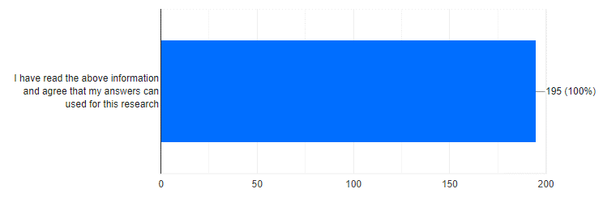
Figure 4.3.1
The first demographic question the participants were asked, was their age category. The purpose of this question was to understand whether different ages had different knowledge and understanding of what SOC or CCE is. The age categories provided were ranged from 18 to 66+ with the majority of the participants being 46-55 (27.2%). On the contrary, there was one participant that was under the age of 18, however the participant has been identified as a sibling (see Figure 4.3.2).

Figure 4.3.2

The second demographic question asked what gender the participants identify as. This was to see whether different genders had different opinions of young people involved with county lines, specifically whether they would identify the young people involved with CCE as victims. The results from the survey showed that the majority of the participants were female with 57.9% compared to the male participants with 41.5%, and with 1 (0.5%) participant not wanting to state their gender (see figure 4.3.3.).
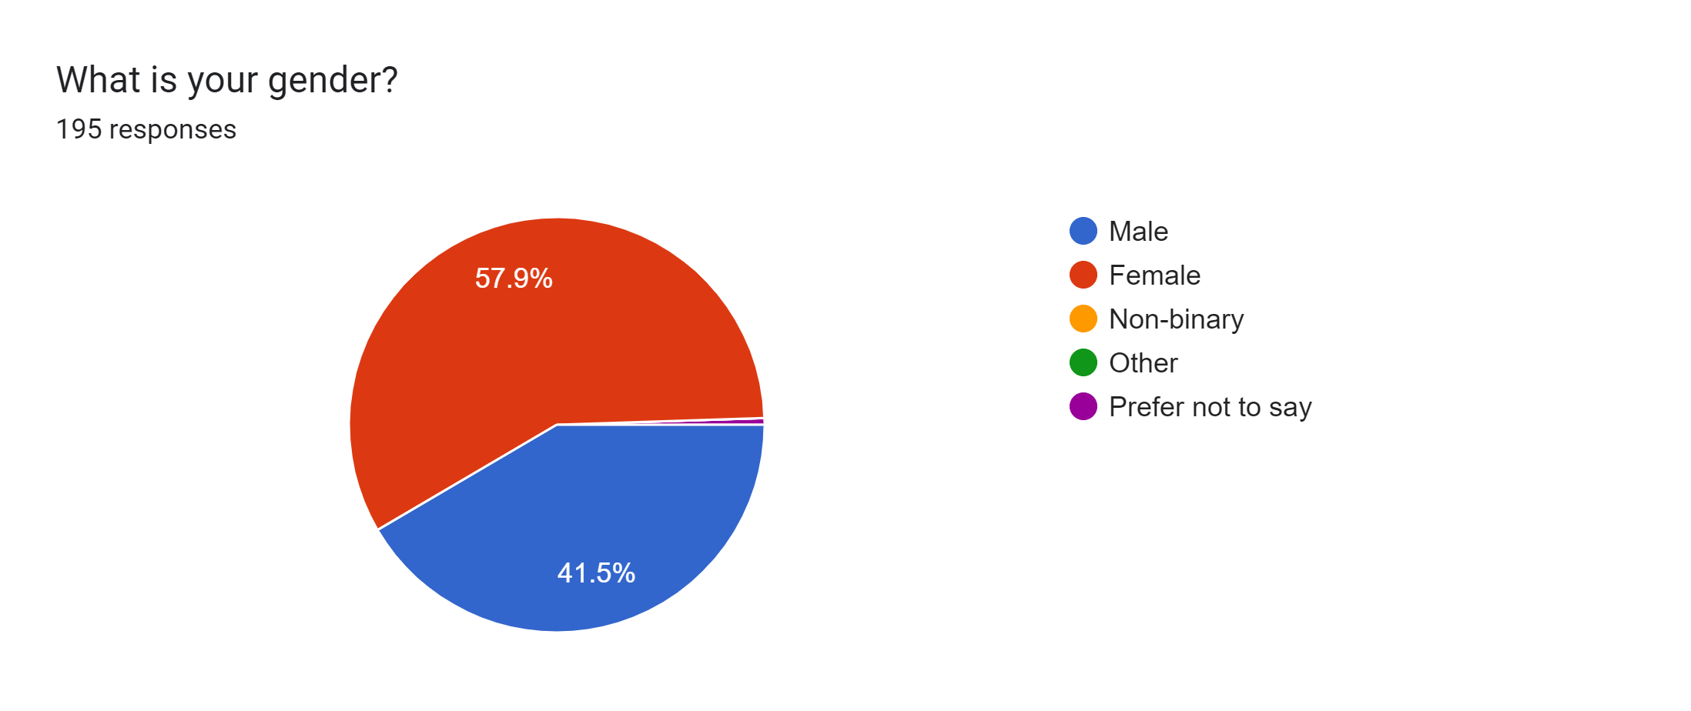
Figure 4.3.3

The third question of the survey was to identify which region of the UK the participant currently lived in. The south-east of the UK took over with 62.6% of the overall participants, with the other regions being shared fractionally (see figure 4.3.4). The purpose of this question was to understand whether individuals around the UK understand more of the dangers of county lines and CCE due to the area that they live in.
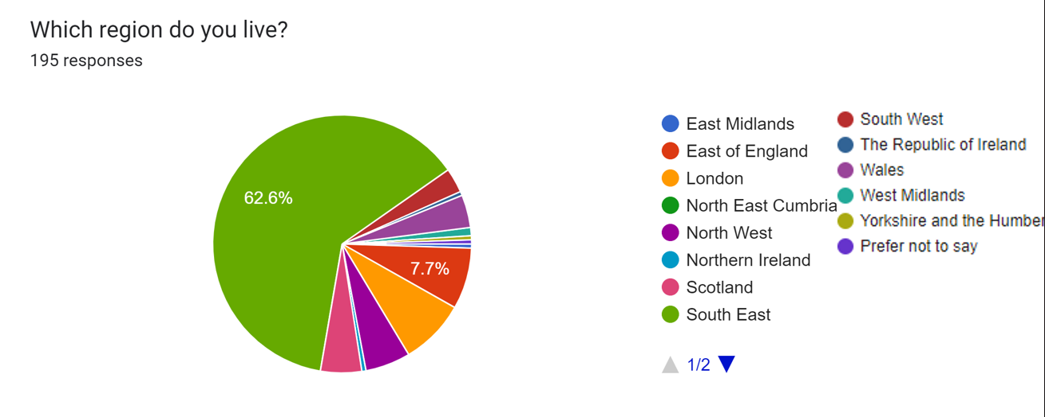
Figure 4.3.4

The Last demographic question asked was the type of area the participants live in. The majority of the participants lived in a suburban area with 42.6% leaving the other areas split almost evenly (see figure 4.3.5.). As with the previous question, the purpose of this question is to notice if different areas have different outcomes.
Figure 4.3.5.

The purpose of the first three questions of the second section of the survey was to show how much the public knew about SOC, County Lines and CCE. The majority of the participants did know what all those terms mean. 188 (96.4%) participants knew the term Child Criminal Exploitation (CCE) (figure 4.3.6.), 185 (94.9%) participants stated they understood the term SOC (figure 4.3.7.) and 173 (88.7%) respondents knew what the term county lines means (figure 4.3.8.). Most of the participants who did not know what either of these terms’ means were aged between 18-25.
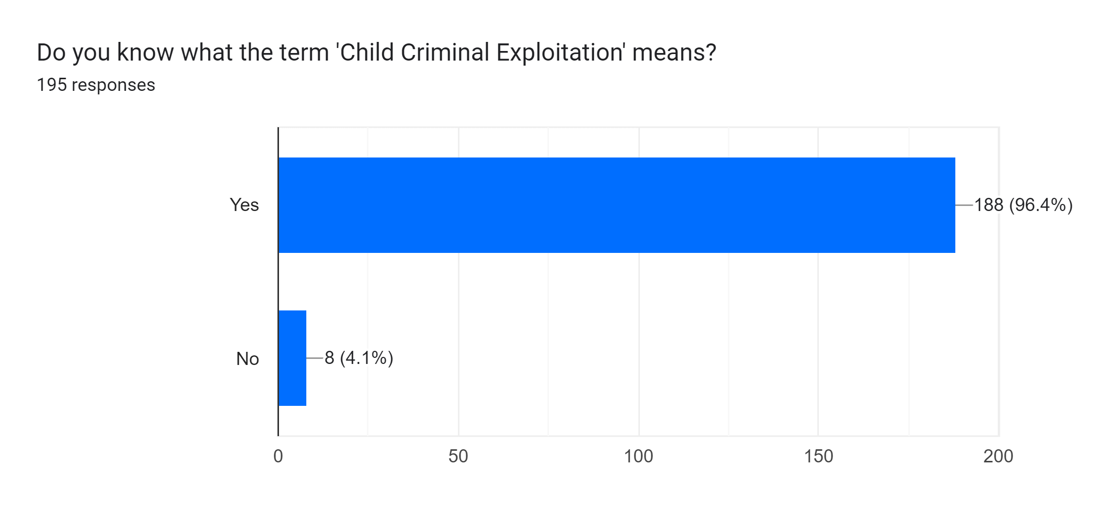

Figure 4.3.6.

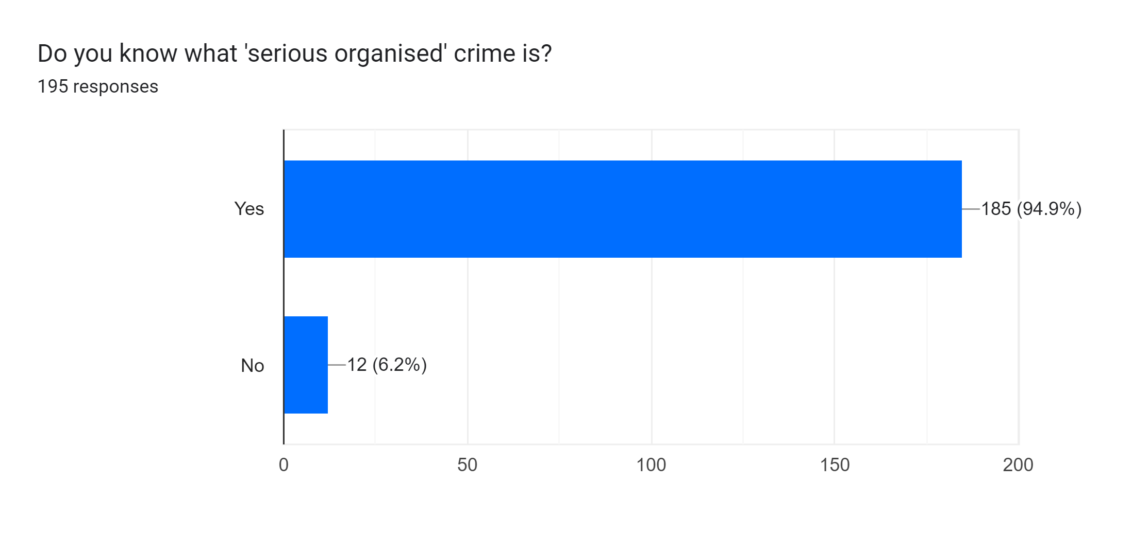

Figure 4.3.7.

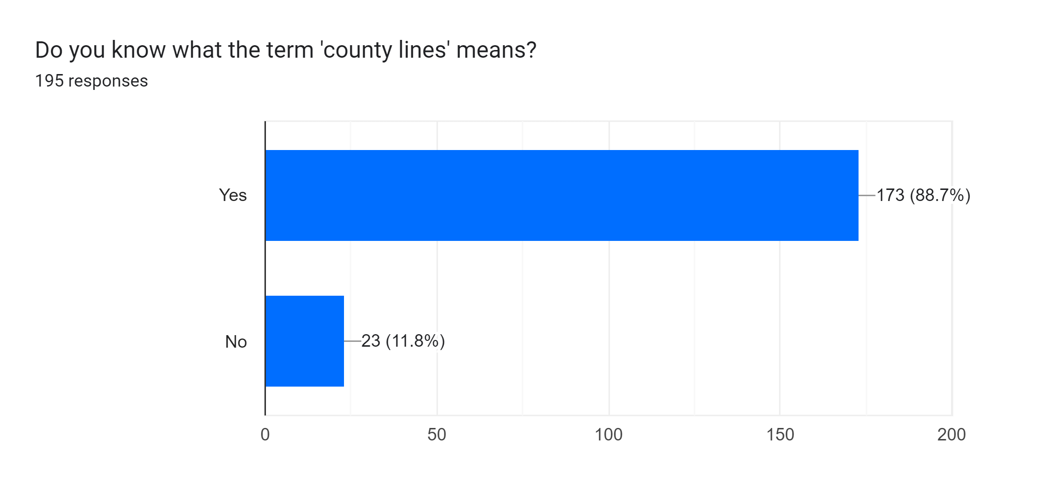

Figure 4.3.8.

Having mentioned the participant knowledge on all three areas, when asked whether they knew the age range of the young people who help deliver the drugs and money across the country, i.e. runners, the majority of the participants (44.6%) thought it was between 13-14 (figure 4.3.9.), however, according to the Safeguarding Hub (2023) and NSPCC Learning (2023) the common age range is between 15-16 years old. However, there have been experts stating that the age range is 14-17 years old (Crown Prosecution Service, 2022; The Children's Society, 2024).
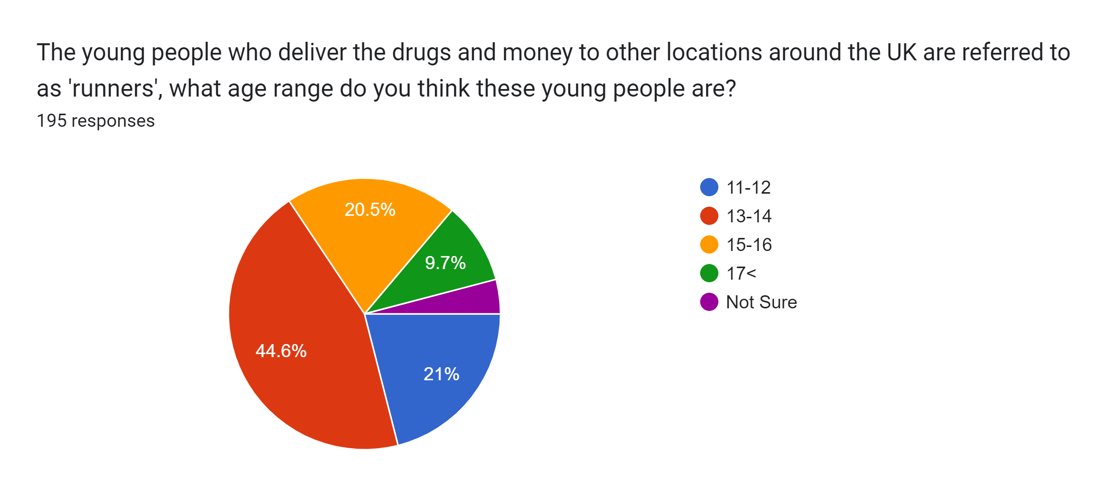
Figure 4.3.9.
The following question, which is linked to the previous question, asked whether these young runners are considered to be victims rather than perpetrators. In total 58.5% of the participants strongly agreed and 34.9% agreed that these young people are victims, however 3.6% either disagreed or strongly disagreed with that statement (see figure 4.3.10).
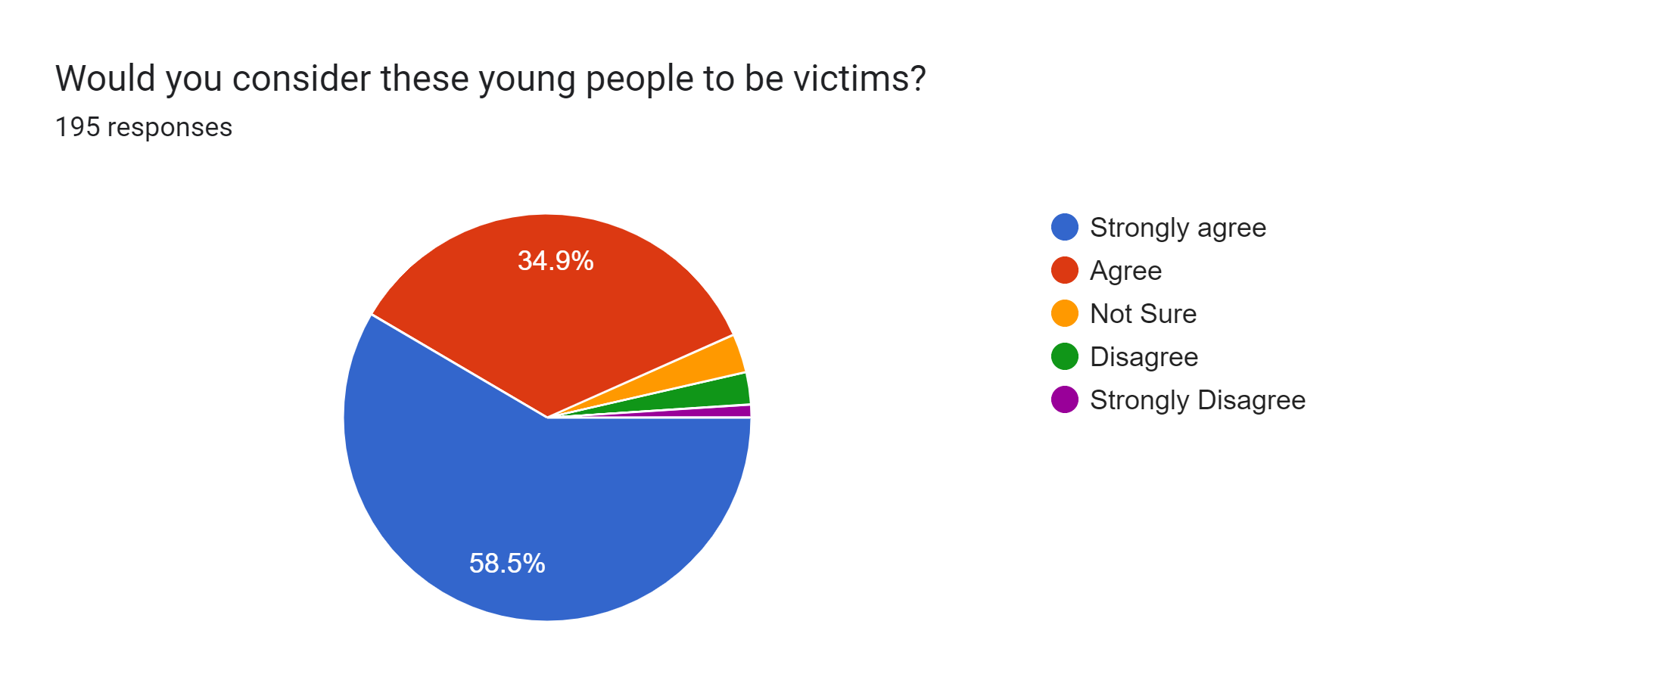
Figure 4.3.10
While analysing this question two different themes emerged within the data. The first theme was that the participants who ‘strongly agreed’ with young people being victims to CCE were more often between the ages 46-55 and 36-45 (see figure 4.3.11.), whereas the four out seven who either selected ‘disagree’ or ‘strongly disagree’ were mostly from the age ranges >18 and 18-25. Furthermore, those who either ‘disagreed’ or ‘strongly disagreed’ were 100% male. According to Andrews, et al., (2021) women and girls generally show more empathy than men and boys which could account for these results. However, a study from Pang et, al. (2023, p. 13), suggests that whether women are more empathetic and caring than men remains an open question as research that was conducted, where when given an open-questionnaire (subjective test) the women showed more empathy than the men, however, according to the electroencephalography (EEG) (objective test), the women and men had the same brain response when given the same scenario, so even though in this primary research question, it appears that the male gender shows less empathy than the female participants, further research using a EEG could show different results given the subjective and objective data.

Figure 4.3.11.
The next two questions are related to young and vulnerable people being exploited to commit crime. The first question asks the participants if they were confident in spotting the signs of a young person being exploited (see figure 4.3.12.). In summary 54.4% of the participants were undecided, whereas 32.8% said they were confident in spotting the signs. There was no clear link between these answers and the age, gender or location of the participants when analysing the data.
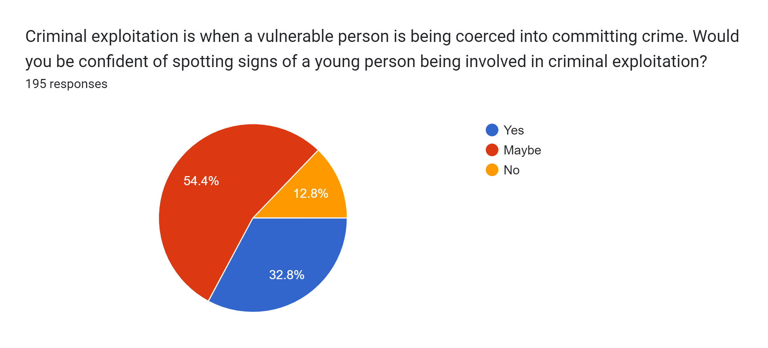
Figure 4.3.12.

The following question asked if the participants knew where to report this type of crime if they saw a young person involved with county lines. 57.4% said yes they would know where and how to report it, whilst participants who did not or were unsure were split in half according to figure 4.3.13.
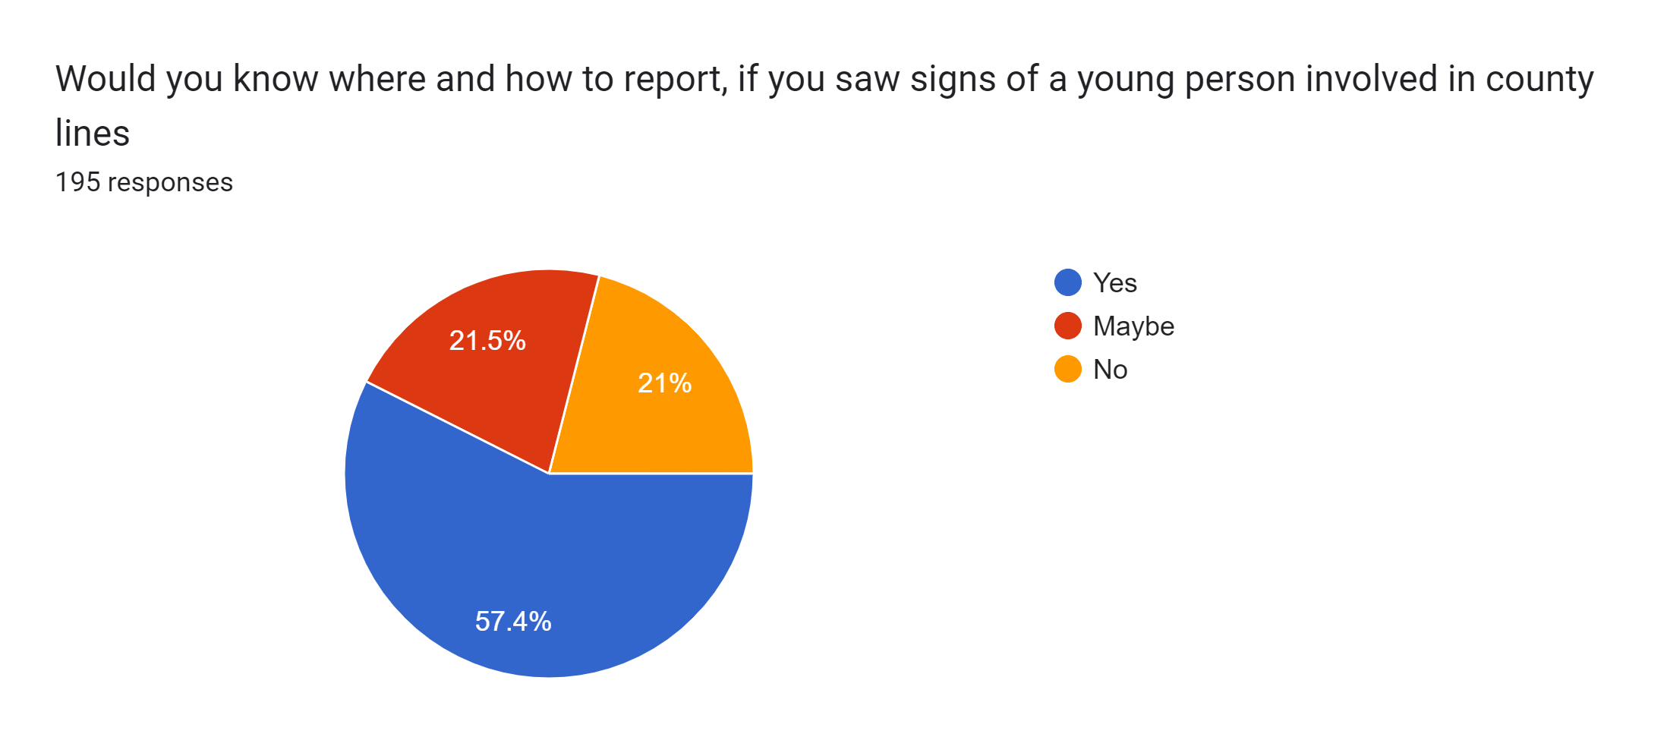
Figure 4.3.13
Figure 4.3.14 shows that the people with the least amount of knowledge to know where to report this issue were between 18-25 years. This could suggest that young people are not being taught or educated enough about county lines to know how to report their concerns to a specific agency, or it could raise other issues which could be explored with further research.
Figure 4.3.14
Figure 4.3.15 aimed to get the thoughts of the participants about what the best way would be to prevent CCE if the government where to give more resources to anti-serious organised crime agencies. The options given to participants were suggestions taken from the literature. For example, Brewster, et al. (2023, p. 164) suggested getting more practitioners involved with the frontline service provision which falls under charitable organisations such as Barnardo’s, as they have practitioners helping young people with their lives by building trusting relationships and asking the young people at risk to help find other young people involved with CCE (Barnardos, 2024). Increasing awareness through education was another suggestion as training youth workers to go into schools could help increase awareness of crime and criminal exploitation, however, this method seems to have a flaw as in order to spread the message and get it across to the young people, the staff must have confidence in themselves to hold these types of discussions (Walsh, 2022, pp. 31-32). Lastly, providing more youth services was suggested by Axford (2023), but only if the youth services are co-designed by the young people, as according to the data the service will be more engaging if it is personalised.
The top two answers that were chosen were ‘increasing awareness through education’ with 45.6%, and ‘providing more for youth services’ with 40.5% (see figure 4.3.15). However, despite the fact that in the literature review, UK charities such as Barnardo’s, the NSPCC and Crimestoppers help young people who have been involved with CCE, only 3.1% of the participants chose this outcome, which could mean that these organisations are not given the recognition they deserve.
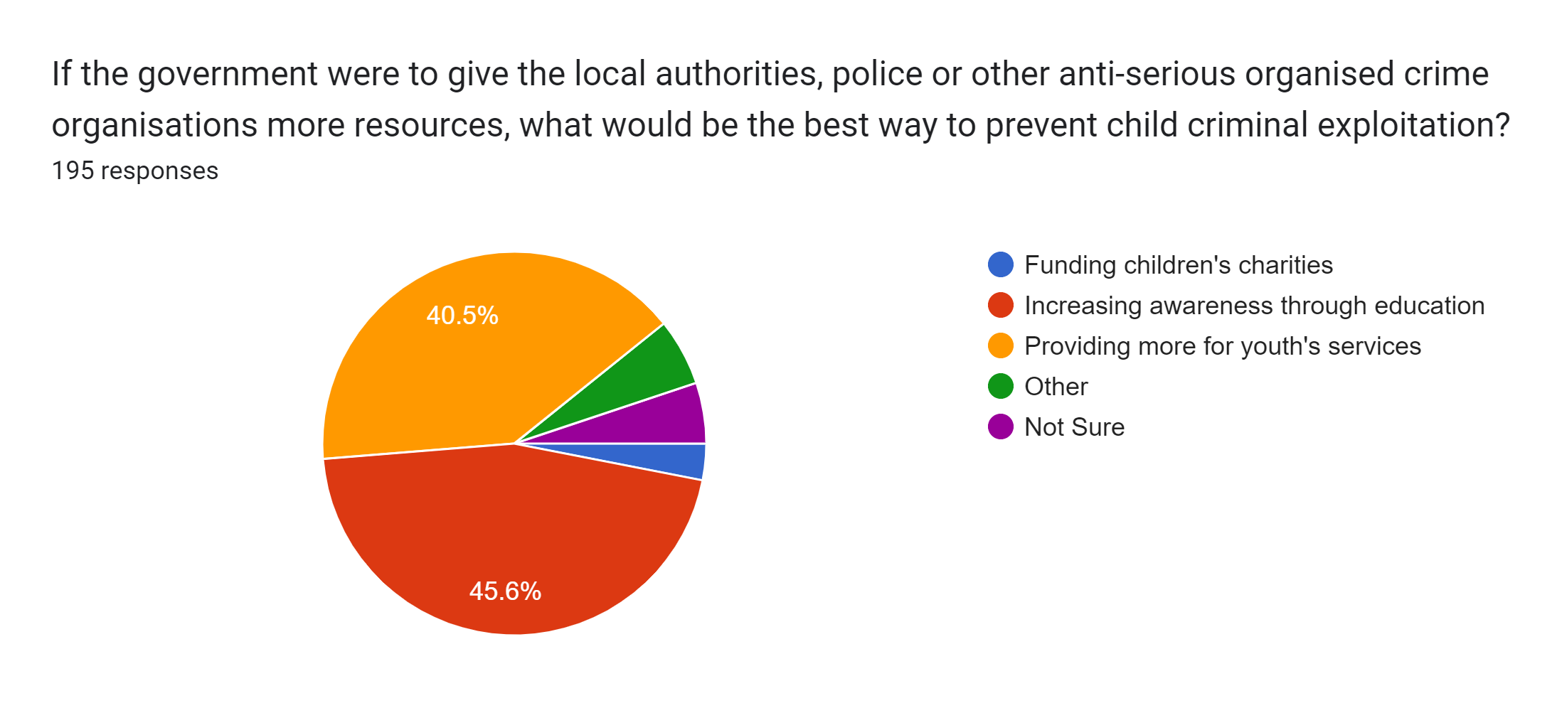
Figure 4.3.15.
A study from Office for National Statistics (2023) that showed students from secondary schools with differing Ofsted ratings, showed the various percentages of the likelihood a young person being imprisoned or in a custodial sentence. Young people who attend a lower-rated school have a 9% chance of getting imprisoned, compared with those who attend a good or outstanding school who have only a 6% change of imprisonment. Pupils with Special Educational Needs (SEN), also have a higher percentage of being imprisoned, with 2.5% of Children with a statement of SEN in immediate custodial sentences as compared with 0.7% of those who do not have SEN. The secondary data clearly shows that awareness needs to be focused towards pupils who attend a lower-rated school as well as students with SEN as these young people are more at risk of crime and imprisonment.
The last quantitative question asked the participants how gangs are able to exploit young people into becoming runners for operations such as county lines (see figure 4.3.16). The options given were again the most common answers given by experts as to why young people are more likely to get exploited (NSPCC, 2023; James, 2021). The most common answer selected was ‘wanting a sense of belonging and being protected by these criminal gangs’ with 45.6% of the participants agreeing with that statement. Within the analysis of data, there were no themes of gender, age or location emerging when searching for any similarities. The reason why these answers were presented to the participants was that charitable organisations such as the NSPCC (2023) and Barnardo’s (James, 2021) give these reasons as to why a young people are more likely to be exploited.
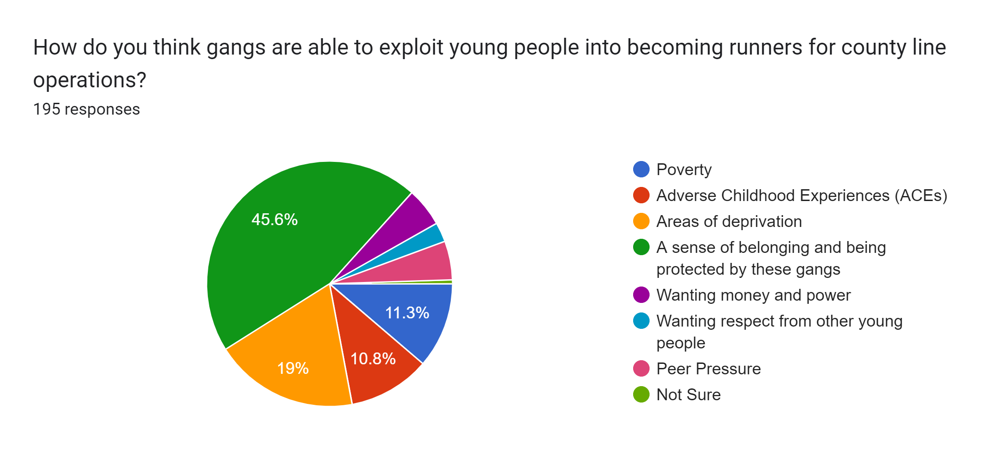
Figure 4.3.16
The final ‘open’ question the participants were asked was:
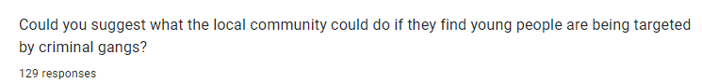
In summary, the most common answer which was suggested by the public was to report it to the police or local authorities (35.66% of respondents). As this answer was the most common recommendation, this could suggest that many people do have confidence in the police or local authorities to try to stop CCE from happening. From the participants who suggested reporting or informing their concerns to the police, 72% (27 out of 38) of the participants were female, however, neither the age or geographical location showed any similarities. Of the participants who suggested informing the local authorities, 82% were male (9 out of 11). In an article from Novich et al. (2018, p. 7), they suggest women have more favourable opinions about the police compared to men, due to women having fewer negative face-to-face encounters with law enforcement.
A few participants describe using youth clubs or church groups or any other activity-based group. They recommended the use of mentorship within those clubs to teach the young people the dangers of criminal activity. There is evidence to show that mentoring programs for youth have shown behavioural benefits for young people who are being mentored. Potential benefits include social-emotional development, as well as improving youth perceptions of parental relationships, enabling the youth to further develop their education and in some cases fewer incidents of assault, drug misuse and alcohol misuse (Merriam, 2014, p. 87). However, a report from Townsend (2023) claimed that due to the cost-of-living crisis which has led to families being unable function properly, six in ten parents will struggle to afford to pay for these clubs, which could mean that the young people are at greater risk of exploitation due to a lack of adult supervision. According to Gaffney, et al. (2022, p. 28) issues with mentorship include the need for an effective recruitment strategy in order to recruit mentees with the right demographic background, the question of what works better, the use of structured or unstructured approaches, and how to manage the ending of a mentoring relationship.
Out of all the participants, only 5% suggested charities as a solution to preventing CCE. This is surprising as these charities help not only protect young people but also help find them too before they are exploited. 2% recommended reporting their issues to Crime Stoppers whilst the other 2% suggested the NSPCC, and 1% mentioned about funding UK charities. Ironically, when answering the question in figure 4.3.15, none of the participants selected ‘funding children’s charities’ as their answer, instead most of them selected ‘providing more for youth services’ instead. However, this could suggest that the participants thought that youth services meant organisations such as the NSPCC or Crime Stoppers.
A response which was surprising was having a direct referral route to a local Violence Reduction Unit (VRU). A VRU, according to the Association of Police and Crime Commissioners (APCC) (2024), is experts from police, health, local government, probation and community organisations who come together to tackle violent crime. The VRUs aim is to intervene early and to provide young people the skills and the resilience to have a productive life without violence (HM Government, 2018, p. 5). There is a link between county line drug dealing and serious violence according to Havard (2022, p. 9), due to the infrastructure of the county lines model fuelling serious violence within street level drugs supplies. In terms of how effective the VRUs are, according to the Home Office (2023d), they have proven to be effective in reducing injuries due to violent crime.
Another answer was education. This did not just mean educating the young people through schools but also educating the families too, so if an issue ever occurred, they could call services like Crime Stoppers to prevent any exploitation within the community.

4.4 Synthesis of findings with literature review
Figure 4.3.9 of the primary survey was to establish what the most common age participants thought ‘runners’ are. The primary survey showed that the majority of the participants selected the age gap 13-14, whilst the Crown Prosecution Service (2022) and The Children’s Society (2024) believe that the age range is broadly around 14-17, and other organisations such as NSPCC Learning (2023) and Safeguarding Hub (2023) suggest the range is between 15-16. As mentioned in the literature review, it is important to identify the most common age so that anti-child criminal exploitation agencies can focus their attention on that problem, and go into schools to intervene early before the young people get exploited. As there are not sufficient statistics on government websites indicating the most common age range, further research is possibly required.a
When discussing how young people go into county lines and are criminally exploited, figure 4.3.15. clearly shows that the majority of the participants selected ‘a sense of belonging and being protected’ by the criminal gangs with 45.6%. Comparing this research with the literature review, however, shows that practitioners who work at Barnardo’s suggest that social deprivation and poverty are the main concerns driving young people (James, 2021, pp. 13-14). Another suggestion which was not given to the participants, is that young people want to have the rich lifestyle that is presented on their social media page. It has been found that young people who have social media and are living in poverty, are at an increased risk of joining gangs because the young person believes this is the easy route to making money (James, 2021, pp. 13-14). This is backed up in the current research as ’areas of deprivation and poverty’ were the other top answers selected by the participants.

4.5 Summary
In conclusion, most of the participants do know what the terms SOC, CCE and county lines mean, and those participants who did not understand the term were mostly from younger age brackets. When analysing the primary research to find correlations between age, gender and location with all the questions, there was some correlation between ages and gender but not the location of where the participants currently live.
Some new methods of approach when dealing with young people being vulnerable to CCE, are to introduce them to church groups for mentoring and learning the dangers of becoming involved with CCE. According to Townsend (2023) however, due to the cost-of-living crisis, parents or carers are struggling to pay for these clubs, meaning that young people who cannot attend are more vulnerable and more at risk to CCE due to a lack of adult supervision. Furthermore, for the mentoring to be effective to the young person, there needs to be an effective recruitment strategy, whether the mentoring needs to be structured or unstructured and lastly, having to terminate the mentoring sessions without worrying the young person re-offend in the future (Gaffney, et al., 2022, p. 28).
Other answers given by participants involved getting charity organisations to help safeguard young people as they help get the young person’s life back on track and make that young person less vulnerable when approached by gangs in the future. Even though there is no evidence to back up the claim that charity organisations have increased safeguarding for young people against exploitation, in terms of organisations who are first responders to victims of any modern slavery, organisations such as Barnardo’s, Salvation Army and the NSPCC are some of the organisations who co-operate with other government agencies to prevent exploitation and safeguard victims (Home Office, 2023c).
In terms of the primary survey, there was no statistical analysis when conducting this investigation, which meant the information presented was less valid due to having just graphs rather than having equations to validate findings. When distributing the survey online, the questionnaire was publicly available and was promoted on social media, meaning that the majority of respondents were recruited through friends and family. This resulted in more than half of the participants being from the southeast of England, which created a potential bias, furthermore, this research focuses on England and Wales, so only having a few participants from Wales is unfortunate because unique perspectives may have been missed.
Some of the research questions that were given to the participants could have been better. For example, for some questions, when presented with the option ‘other’, participants could have written an open response to those questions, however that option was not given to the participants as it was not on the primary survey. Two questions that should have been in the survey which could have helped further the analysis were whether if the different genders and individuals within the BAME community are more likely to be exploited by gangs (McCluskey, et al., 2019)
************************************************************************************************

Chapter 5: Conclusion

5.1 Introduction
The overall aim for this research was to find out if young people within the UK get exploited by organised crime gangs, and if so, how do they get exploited into committing the crimes. The research was to understand and advance the methods used by these gangs to get better knowledge on how to reduce more young people from being exploited.

5.2 Research objectives: summary of findings and conclusions
This research concludes that young people are primarily targeted and exploited by organised crime gangs to commit crime specifically county lines due to young people being represented as cheap and disposable (Windle, et al., 2020, p. 67). The young people who are predominantly targeted live in poverty or social deprivation (James, 2021, pp. 13-14). This could be because young people want to live a rich lifestyle and believe that crime is the easy solution to gaining money. However, within the findings of this research, many respondents agreed that another major factor could be young people wanting a sense of belonging and protection from those gangs. This information is not new. The NSPCC (2023), already suggest that young people want protection from gangs, however, it is interesting to note that 89 out of 195 participants selected this option, making it the most common choice amongst participants.
Furthermore, as shown in the literature review, another reason that criminal gangs target young people is because they are easy to exploit. The young person is promised money and other essentials according to Robinson, et al (2019, pp. 700-706) however often payment is withheld. On many cases the reason young people need that money is to be able to pay of previous drug debts, where the young person is able to get drugs for free but in return the young person must work for the criminal gang and deliver drugs, in other words indentured servitude for the gang. However, as discovered from the literature review, the gang does not fulfil their end of the bargain and only gives the young person a portion of the promised money or the gang sends them personal gifts instead such as jewellery.

5.2.1 To understand and investigate the nature of serious organised crime in the UK (Objective 1)
From looking at the survey, it appears that more respondents knew the term ‘Child Criminal Exploitation (CCE), with 96.4% of the participants stating yes. Followed by ‘serious organised crime (SOC) with 94.9%. Then the term ‘county lines’ with a drop to 88.7%. Most of the participants who did not know the term ‘county lines’ were from ages of 18-25. The reason the term ‘county lines’ may be less well known to the participants than the other two terms, is because county lines had only become a threat to the UK between the years 2015 and 2017 when it first came to police attention, whilst terms like CCE and SOC, are commonly used when mentioning Modern Slavery and furthermore the UK government have been tackling SOC since 1994 (Lavorgna, et al., 2013, p. 7). As young people are more at risk of being exploited by gangs, they need to be taught the dangers of county lines otherwise it might be too late, and gangs could end up exploiting young people and forcing them to work for the gang.

5.2.2 To analyse the level and scope of the child criminal exploitation of children and young people by serious organised crime groups in England and Wales (Objective 2)
Within the findings to analyse how old the average young person would be to be exploited into doing county lines, the 45% of the participants agreed that they were 13-14 years old, so some of them were aware that young people as young as this could be going on trains or other private hire vehicles to deliver drugs across the country. Furthermore, when asked whether these young people were victims rather than offenders, 59% strongly agreed and 35% agreed that young people were indeed victims, the other 3.6% who either disagreed or strongly disagreed that they were victims were male participants as well as most of them being between the ages of 18-25 and 26-35. Organisations label young people as victims to who are forced to do crime for gangs, due to gangs either forcing or threatening the young person to commit the crime, however

5.2.3 To examine the methods used and the risk factors for young people becoming involved with organised crime (Objective 3)
As mentioned before, when discussing the methods used to exploit young people into doing county lines, the majority of the participants had chosen ‘a sense of belonging and being protected by the criminal gangs’, there were no themes however, that had emerged when analysing the participants demographic, so no demographic correlation could be suggested for further research.
In terms of how to try and prevent the young people from being exploited, figure 4.3.15 shows that either people wanted to give more resources to education and spread awareness from education or providing more resources for youth services. To determine whether these types of solutions are effective, remains an open question as youth services need to have an environment co-designed by young people for the service to be engaging and awareness through education could increase spreading information on the dangers of crime and exploitation, however to be effective for young people, the staff who hold these talks need to have confidence themselves to have these discussions with young people (Walsh, 2022).

5.3 Recommendations
There are some areas within the findings that need further research, such as if male and female either share the same or different perspective when mentioning whether young offenders are victims or not using an EEG to get objective data. Another area that needs further inquiry is why young people understand the least where and how to report a crime where a young person is visible being exploited. Lastly, to identify what the common age range is for a young person to be exploited as secondary research suggest different answers from broad range of 14-17 (Crown Prosecution Service, 2022; The Children's Society, 2024).
The primary research itself would need some changes, if completed again. The first area I would make sure that the result’s had more variety, such as asking for more participants in Wales and trying to spread the demographic more evenly and have fewer participants from the southeast. This would make the research fairer by getting different perspectives from other regions around the country rather than most of them being from the southeast.
Furthermore, in terms of the questions asked to the participants, maybe discussing the topics on ‘social media’ and even ‘violence’ could have developed the research as they play a role in increasing the likelihood of young people being exploited, as well mentioning whether young males from the BAME community are more at risk (McCluskey, et al., 2019), rather than mentioning to the participants, if they knew where and how to report the signs of CCE, it is important information to know but not for this research as there is not much relevance to it.

References
Adu, J. et al., (2022) A discussion of some controversies in mixed methods research for emerging researchers. Methodological Innovations, 15(3), pp. 321-330.
Alborough, L. & Hansen, R. K., (2022) Reframing fundraising research: The challenges and opportunities of interpretivist research practices and practitioner researchers in fundraising studies. Journal of Philanthrophy and Marketing, 28(1), pp. 1-11.
Andrade, C., (2020) Sample Size and its Importance in Research. Indian Journal of Psychological Medicine , 42(1), pp. 102-103.
Andrews, K., Lariccia, L., Talwar, V. & Bosacki, S., (2021) Empathetic Concern in Emerging Adolescents: The Role of Theory of Mind and Gender Roles. The Journal of Early Adolescence, 41(9), pp. 1394-1424.
Arnez, J. & Condry, R., (2021) Criminological perspectives on school exclusion and youth offending. Emotional and Behavioural Difficulties, 26(1), pp. 87-100.
Aspers, P. & Corte, U., (2019) What is Qualitative in Qualitative Research. Qualitative Sociology, 42(2), pp. 139-160.
Association of Police and Crime Commissioners, (2024) Home Office Violence Reduction Unit Workshop.
Available at: https://www.apccs.police.uk/videos/home-office-violence-reduction-unit-workshop/#:~:text=VRUs%20bring%20together%20specialists%20from,violent%20crime%20its%20underlying%20causes.
[Accessed 19 April 2024].
Axford, N. et al., (2023) Engaging youth at risk of violence in services: Messages from research. Children ad Youth Services Review, Volume 144.
Barlow, C., Kidd, A., Green, S. T. & Darby, B., (2022) Circle of analysis: a systemic model of child criminal exploitation. Journal of Children's Services, 17(3), pp. 158-174.
Barnardo's, (2020) Generation lockdown: a third of children and young people experience increased mental health difficulties.
Available at: https://www.barnardos.org.uk/news/generation-lockdown-third-children-and-young-people-experience-increased-mental-health
[Accessed 3rd December 2023].
Barnardo's, (2024) Criminal exploitatation of children.
Available at: https://www.barnardos.org.uk/get-support/support-for-parents-and-carers/child-abuse-and-harm/criminal-exploitation-children#:~:text=Barnardo's%20hosts%20the%20Centre%20of,professionals%20to%20spot%20the%20signs
[Accessed 15 April 2024].
Beckett, H. & Warrington, C., (2014) Suffering in silence: children and unreported crime, Luton: University of Bedfordshire.
Braun, V. & Clarke, V., (2022) Thematic Analysis: A Practical Guide. London: Sage.
Brewster, B., Robinson, G., Silverman, B. W. & Walsh, D., (2023) Covid-19 and child criminal exploitation in the UK: implications of the pandemic for county lines. Trends Organ Crime, 26(2), pp. 156-179.
Broad, R., (2018) Assessing Convicted Traffickers: Negotiating Migration, Employment and Opportunity through Restricted Networks. The Howard Journal of Crime and Justice, 57(1), pp. 37-56.
Caluori, J., Mooney, B. & Kirk, E., (2022) Running out of credit: Mobile phone tech and the birth of county lines.
Available at: https://www.crestadvisory.com/post/running-out-of-credit-mobile-phone-tech-and-the-birth-of-county-lines
[Accessed 5 May 2024].
Crime Stoppers, (2023a) Serious and organised crime.
Available at: https://crimestoppers-uk.org/keeping-safe/community-family/serious-and-organised-crime
[Accessed 1 November 2023].
Crime Stoppers, (2023b) County Lines.
Available at: https://crimestoppers-uk.org/keeping-safe/community-family/county-lines
[Accessed 1 November 2023].
Crown Prosecution Service, (2022) County Lines Offending.
Available at: https://www.cps.gov.uk/legal-guidance/county-lines-offending
[Accessed 27 March 2024].
De Vaus, D. A., (2014) Surveys in Social Research. 6th ed. Abingdon: Routledge.
Densley, J. A., (2012) It’s Gang Life, But Not As We Know It: The Evolution of Gang Business. Crime and Delinquency, 60(4), pp. 517-546.
Elfil, M. & Negida, A., (2017) Sampling methods in Clinical Research; and Educational Review. Archives of Academic Emergency Medicine, 5(1), pp. 1-3.
Gabriel, D., (2013)Inductive and deductive approach to research.
Available at: https://deborahgabriel.com/2013/03/17/inductive-and-deductive-approaches-to-research/
[Accessed 4th February 2024].
Gaffney, H., Jolliffe, D. & White, H., (2022) Mentoring: Toolkit technical report.
Available at: https://youthendowmentfund.org.uk/wp-content/uploads/2022/10/Mentoring-Technical-Report_Final.pdf
[Accessed 10 May 2024].
GCHQ, (2023) Serious and Organised Crime.
Available at: https://www.gchq.gov.uk/section/mission/serious-crime
[Accessed 1 November 2023].
Haenlein, C., (2023) A Boundless Threat? The Rise of Organised Crime in the UK.
Available at: https://www.rusi.org/explore-our-research/publications/commentary/boundless-threat-rise-organised-crime-uk#:~:text=Though%20difficult%20to%20measure%20precisely,(excluding%20child%20sexual%20abuse).
[Accessed 3 May 2024].
Havard, T., (2022) Serious youth violence: County lines drug dealing and the Government response.
Available at: https://researchbriefings.files.parliament.uk/documents/CBP-9264/CBP-9264.pdf
[Accessed 4 May 2024].
Hemez, P., Brent, J. J. & Mowen, T. J., (2019) Exploring the School-to-Prison Pipeline: How School Suspensios Influence Incarceration During Young Adulthood. Youth Violence Juv Justice, 18(3), pp. 235-255.
HM Government, (2018) Serious Violence Strategy.
Available at: https://assets.publishing.service.gov.uk/media/5acb21d140f0b64fed0afd55/serious-violence-strategy.pdf
[Accessed 19 April 2024].
Hobbs, D. & Hobbs, S., (2011) A Bog of Conspiracy: the institutional evolution of organized crime in the UK. In: F. Allum & S. Gilmour, eds. Routledge Handbook of Transnational Organized Crime. London: Routledge, pp. 250-262.
Home Office, (2004) One Step ahead: a 21 centruy strategy to defeat organized crime.
Available at: https://assets.publishing.service.gov.uk/media/5a7c0c4fe5274a7202e19393/6167.pdf
[Accessed 20th November 2023].
Home Office, (2011) National Crime Agency - a plan for the creation of a national crime fighting capability.
Available at: https://assets.publishing.service.gov.uk/media/5a78e615e5274a277e690553/nca-creation-plan.pdf
[Accessed 22nd November 2023].
Home Office, (2023a) New strategy to tackle organised crime.
Available at: https://www.gov.uk/government/news/new-strategy-to-tackle-organised-crime#:~:text=The%20National%20Crime%20Agency%20(NCA,affordable%20homes%20outside%20of%20London.
[Accessed 12 May 2024].
Home Office, (2023b) County Lines Programme data.
Available at: https://www.gov.uk/government/publications/home-offices-county-lines-programme-data/county-lines-programme-data
[Accessed 18th October 2023].
Home Office, (2023c) National referral mechanism guidance: adult (England and Wales). [Online]
Available at: https://www.gov.uk/government/publications/human-trafficking-victims-referral-and-assessment-forms/guidance-on-the-national-referral-mechanism-for-potential-adult-victims-of-modern-slavery-england-and-wales
[Accessed 4 May 2024].
Home Office, (2023d) Violence Reduction Units 2022 to 2023.
Available at: https://www.gov.uk/government/publications/violence-reduction-units-year-ending-march-2023-evaluation-report/violence-reduction-units-2022-to-2023#:~:text=The%20Home%20Office%20has%20funded,financial%20year%202022%20to%202023
[Accessed 19 April 2024].
Information and Privacy Commissioner of Ontario, (2015) Best Practices for Protecting Individual Privacy in Conducting Survey Research.
Available at: https://www.ipc.on.ca/wp-content/uploads/2015/04/best-practices-for-protecting-individual-privacy-in-conducting-survey-research.pdf
[Accessed 10 March 2024].
James, E., (2021) Exploited and Criminalised: What can the Police, Crime , Sentencing and Courts Bill do to enure that children who are criminally exploited receive the care and support they need?.
Available at: https://www.barnardos.org.uk/sites/default/files/2021-10/Exploited%20and%20Criminalised%20report.pdf
[Accessed 3rd December 2023].
Jansen, D., (2022) Research Limitations and Delimitations.
Available at: https://gradcoach.com/research-limitations-vs-delimitations/#:~:text=Research%20limitations%20are%2C%20at%20the,%2C%20equipment%2C%20data%20or%20participants.
[Accessed 11 February 2024].
Lavorgna, A., Lombardo, R. & Sergi, A., 2013. Organized crime in three regions: comparing the Veneto, Liverpool, and Chicago.. Trends in Organized Crime, 16(3), pp. 265-285.
Longfield, A., 2019. Keeping kids safe: improving safeguarding responses to gang violence and criminal exploitation. [Online]
Available at: https://assets.childrenscommissioner.gov.uk/wpuploads/2019/02/CCO-Gangs.pdf
[Accessed 1st December 2023].
McCluskey, G. et al., 2019. Exclusion from school in Scotland and across the UK: Contrasts and questions. British Educational Research Journal, 45(6), pp. 1140-1159.
Melnikovas, A., 2018. Towards and Explict Research Methodology: Adapting Research Onion Model for Futures Studies. Journal of Futures Studies, 23(2), pp. 29-44.
Merriam, M., 2014. Does Mentoring Work in Rehabilitating Offenders?, Birmingham : University of Birmingham.
Modern Slavery Act 2015, c.30, n.d. [Online]
Available at: https://www.legislation.gov.uk/ukpga/2015/30/contents/enacted
[Accessed 2nd December 2023].
NCA, 2017. County Lines Violence, Exploitation and Drug Supply. [Online]
Available at: https://nationalcrimeagency.gov.uk/who-we-are/publications/234-county-lines-violen-ce-exploitation-drug-supply-2017/file
[Accessed 24th November 2023].
NCA, 2023. Overview of SOC in the UK. [Online]
Available at: https://nationalcrimeagency.gov.uk/nsa-overview-of-soc
[Accessed 28 October 2023].
Novich, M., Kringen, A. L. & Hunt, G., 2018. “They Can’t Search Her”: How Gender Imbalances in the Police Force Contribute to Perceptions of Procedural Unfairness. Fem Criminal, 13(3), pp. 260-286.
NSPCC Learning, 2023. Protecting children from county lines. [Online]
Available at: https://learning.nspcc.org.uk/child-abuse-and-neglect/county-lines/
[Accessed 27 March 2024].
NSPCC, 2023. Criminal exploitation and gangs. [Online]
Available at: https://www.nspcc.org.uk/what-is-child-abuse/types-of-abuse/gangs-criminal-exploitation/
[Accessed 1 October 2023].
Office for Health Improvement and Disparities , 2020. Mixed methods study:How to use a combination of quantitative and qualitative data to evaluate your digital health product.. [Online]
Available at: https://www.gov.uk/guidance/mixed-methods-study
[Accessed 8th February 2024].
Office for National Statistics, 2023. The links between young people being imprisoned, pupil background and school quality. [Online]
Available at: https://www.ons.gov.uk/peoplepopulationandcommunity/educationandchildcare/articles/thelinksbetweenyoungpeoplebeingimprisonedpupilbackgroundandschoolquality/2023-01-27
[Accessed 6 May 2024].
Pang, C. et al., 2023. Are women more emplathic than men? Questionnaire and electroencephalography estimations of sex/gender differences in empathic ability. Social Cognitive and Affective Neuroscience, 18(1), pp. 1-16.
Phair, D. & Warren , K., 2021. Saunders’ Research Onion: Explained Simply: Peeling the onion, layer by layer (with examples). [Online]
Available at: https://gradcoach.com/saunders-research-onion/#:~:text=Research%20strategies%20%E2%80%93%20how%20you'll,(cross%2Dsectional%20or%20longitudinal)
[Accessed 4th February 2024].
Robinson, G., McLean, R. & Densley, J., 2019. Working County Lines: Child Criminal Exploitation and Illicit Drug Dealing in Glasgow and Merseyside. International Journal of Offender Therapy and Comparative Criminology, 63(5), pp. 663-814.
Safeguarding Hub, 2023. County Lines - how gangs recruit children. [Online]
Available at: https://safeguardinghub.co.uk/county-lines-part-2/
[Accessed 27 March 2024].
Safer Communities Wales, 2023. Criminal Exploitation. [Online]
Available at: https://safercommunities.wales/modern-slavery-exploitation/criminal-exploitation/#:~:text=Criminal%20exploitation%20is%20the%20deliberate,a%20person%20or%20a%20group.
[Accessed 1 November 2023].
Saloniki, E. C. et al., 2019. Comparing internet and face-to-face surveys as methods for eliciting preferences for social care-related quality of life: evidence from England using the ASCOT service user measure. Quality of Life Research, 28(8), pp. 2207-2220.
Saunders, M., Lewis, P. & Thornhill, A., 2023. Research methods for business students. ninth edition ed. Harlow, England: Pearson .
Saunders, M. N., Lewis, P. & Thornhill, A., 2009. Research methods for business students. fifth edition ed. Harlow, England: Pearson Education.
Sheard, J., 2018. Chapter 18 - Quantitative data analysis. In: K. Williamson & G. Johanson, eds. Research methods: Information, Systems and Contexts. Monash: Chando Publishing, pp. 429-452.
Social Services and Well-being (Wales) Act 2014, n.d. Part 7: Safeguarding. [Online]
Available at: https://www.legislation.gov.uk/anaw/2014/4/part/7
[Accessed 12 May 2024].
Stop the Traffik, 2022. Types of Exploitation. [Online]
Available at: https://www.stopthetraffik.org/what-is-human-trafficking/types-of-exploitation/
[Accessed 1 November 2023].
Sturrock, R. & Holmes, L., 2015. Running the Risks: The links between gang involvement and young people going missing, London: Catch 22.
Tamminen, K. A. & Poucher, Z. A., 2020. Research philosophies. In: D. Hackfort & R. Schinke, eds. The Routledge International Encyclopedia of Sport and Exercise Psychology. London: Routledge, p. 15.
The Children's Society, 2019. Counting Lives: Responding to children who are criminally exploited. [Online]
Available at: https://www.childrenssociety.org.uk/sites/default/files/2020-10/counting-lives-report.pdf
[Accessed 1st December 2023].
The Children's Society, 2024. What is county lines?. [Online]
Available at: https://www.childrenssociety.org.uk/what-we-do/our-work/child-criminal-exploitation-and-county-lines/what-is-county-lines
[Accessed 27 March 2024].
Townsend, M., 2023. Record number of young in the UK 'at risk of exploitation' this summer. [Online]
Available at: https://www.theguardian.com/society/2023/jun/04/record-number-of-young-in-the-uk-at-risk-of-exploitation-this-summer#:~:text=The%20UK's%20largest%20children's%20charity,the%20six%2Dweek%20school%20break.
[Accessed 10 May 2024].
UK Parliament, 2023. 4 July 2023 - Child exploitation and county lines - Oral evidence. [Online]
Available at: https://committees.parliament.uk/event/18861/formal-meeting-oral-evidence-session/
[Accessed 7 May 2024].
Ullah, I. et al., 2023. Objective to conduct a pilot study in research. Journal of Positive School Psychology, 7(1), pp. 1091-1100.
Verhoef, M. V. & Casebeer, A. L., 1997. Broadening horizons: Integrating quantitative and qualitative research. The Canadian Journal of Infectious Diseases, 8(2), pp. 65-66.
Walsh, C., 2022. From Contextual to Criminal Harm: Young People's Perceptions and Experiences of Child Criminal Exploitation (CCE) in Northern Ireland. [Online]
Available at: https://www.endingtheharm.com/wp-content/uploads/2023/03/Criminal-harms-report-final.pdf
[Accessed 10th December 2023].
White, N., 2021. Explained: What 'County Lines' is and How it works. [Online]
Available at: https://www.huffingtonpost.co.uk/entry/county-lines-how-drug-dealing-works-in-uk_uk_6033d072c5b66da5dba32b2c
[Accessed 5 May 2024].
Windle, J., Moyle, L. & Coomber, R., 2020. 'Vulnerable' Kids Going Country: Children and Young People's Involvement in County Lines Drug Dealing. Youth Justice, 20(1-2), pp. 64-78.
Wong, L. P., 2008. Data analysis in Qualitative Research: A brief Guide to Unsing Nvivo. Malaysian Family Physician, 3(1), pp. 14-20.

Appendix

The Questionnaire and Literature Review Matrix
Questions | Association with Chapter 2
Q1) This survey is being conducted as research for an undergraduate dissertation at UWTSD. All the information gathered will be Anonymous. Your participation is confidential and voluntary, and you are free to withdraw at any time without giving any reason. By completing the survey you agree to your information being used for this research, lease confirm that you have read this information | The first five questions are demographic questions which help support the research in identifying any themes emerging in regards of the quantitative questions
Q2) How old are you?
Q3) What is your gender?
Q4) Which region do you live?
Q5) What type of are do you live in?
Q6) Do you know what ‘serious organised’ crime is?  - Yes  - No | Q6/7/8) This is to get the basic understanding if the participants know what SOC, county lines and CCE is.
Q7) Do you know what the term ‘county lines’ mean?
- Yes
- No
Q8) Do you know what the term ‘Child Criminal Exploitation’ means
- Yes
- No
Q9) The young people who deliver the drugs and money to other locations around the UK are referred to as ‘runners’, what age range do you think these young people are?  - 11-12  - 13-14  - 15-16  - <17  - Not sure | Q9) There have be severely arguments from different literature, trying to identify the most common age that a young person gets exploited, as the Crown Prosecution Service (2022), and The Children's Society (2024) suggest 14-17, however other literature such as NSPCC learning (2023) and Safeguarding Hub (2023), give a specific age between 15-16. This is important to identify, so organisations can focus their efforts before the young people get exploited
Q10) Would you consider these young people to be victims?  - Strongly agree  - Agree  - Not Sure  - Disagree  - Strongly Disagree | Q10) To get clarity from the participants that they either agree or disagree that young are victims when being involved in forced criminal activity, furthermore, to evaluate if one demographic have different views than another.
Q11) Criminal exploitation is when a vulnerable person is being coerced into committing crime. Would you be confident of spotting signs of a young person being involved in criminal exploitation?  - Yes  - Maybe  - No | Q11/12) was to get a general understanding if the participants knew if they saw the signs of young person being exploited, they knew who to report their concerns too, such as the first responder organisations (Home Office, 2023c).
Q12) Would you know where and how to report, if you saw signs of a young person involved in county lines?
- Yes
- Maybe
- No
Q13) If the government were to give the local authorities, police or other anti-serious organised crime organisations more resources, what would be the best way to prevent child criminal exploitation?  - Funding children’s charities  - Increasing awareness through education  - Providing more for youth’s services  - Other  - Not Sure | Q13) These options given were suggestions taken from the literature. For example, Brewster, et al. (2023, p. 164) suggested getting more practitioners involved with the frontline service provision which falls under charitable organisations such as Barnardo’s, as they have practitioners helping young people with their lives by building trusting relationships and asking the young people at risk to help find other young people involved with CCE (Barnardos, 2024). Increasing awareness through education was another suggestion as training youth workers to go into schools could help increase awareness of crime and criminal exploitation, however, this method seems to have a flaw as in order to spread the message and get it across to the young people, the staff must have confidence in themselves to hold these types of discussions (Walsh, 2022, pp. 31-32). Lastly, providing more youth services was suggested by Axford (2023) but only if the youth services are co-designed by the young people, as according to the data the service will be more engaging if it is personalised.
Q14) How do you think gangs are able to exploit young people into becoming runners for county line operations?  - Poverty  - Adverse Childhood Experiences (ACEs)  - Areas of deprivation  - A sense of belonging and being protected by these gangs  - Wanting money and power  - Wanting respect from other young people  - Peer Pressure  - Not Sure | Q14) There is evidence from James (2021, p.12) when interviewing practitioners from Barnardo’s to get their expert opinion as to why young are more likely to be exploited. The most common answers given were ‘poverty’ and ‘social deprivation’. However, upon looking at interviews to young people who have been involved in exploitation other methods used by gangs include being promised to be paid, in order to pay off drug debts (Robinson, et al., 2019, pp. 700-706)
Q15) Could you suggest what the local community could do if they find young people are being targeted by criminal gangs? (open question) | Q15) This open question was to allow the participants any suggestions they could think of, when identifying any preventions for exploitation.

