

BMSW4008
Digital Skills for Personal and Professional Growth

Evidence of learning (E- portfolio)

Student Name: Eugenia Mihaela Racaceanu
Student ID: 2326833
Word Count: 2700
Lecturer: Philippa Fitzgerald
Date: 06/12/2024

Task 1 Questionary analysis 1
Introduction 2
Key Findings 2
Conclusion 6
Task 2 Website and marketing materials 7
Introduction 8
Segmentation Analysis 8
Website Design Using Weebly 8
Marketing Materials Design Using Canva 12
SEO Strategy 14
Conclusion 15
Task 3: Microsoft excel 15
Setting up the Spreadsheet 16
Entering Sample Data 16
Use of Formulas 17
Apply formatting 17
Chart Comparison 18
Introduction 18
Data Organization and Management 19
Data Analysis 19
Financial Planning and Control 19
Collaboration and Accessibility 19
Integration with Other Tools 20
Conclusion 20
Task 4 Advertising video 20
References 21

Task 1 Questionary analysis

Introduction
This paper aims to assess the outcomes obtained from a market research questionnaire that consists of questions aimed at assessing customer preference and behaviour towards a particular type of product/service. Some of the items included demographic characteristics, their buying behaviour and their impressions about the specified brand. In total, twenty-five responses were gathered to give an understanding of consumers’ concerns and enabling of an appropriate business approach based on these concerns.

Key Findings

Demographics and Target Customers
Age Distribution: Huge numbers of respondents are also within the ages of 18-24 years, 52% of the respondents while 32% of the respondents are within the ages of 25-34 years. This is an indication that the largest market audience is the young people hence making a conclusion that the trend in the market today is towards the young people in need of the products or services in the niche (Evans et al., 2021).
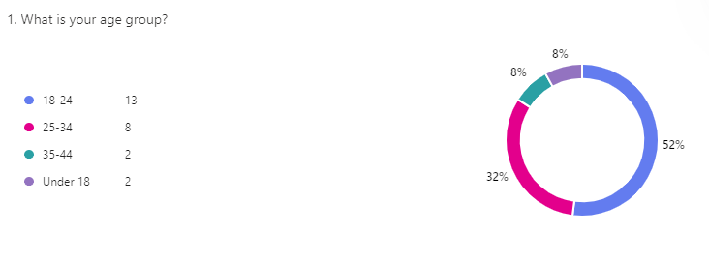
Figure 1. Survey Graph 1
Gender: The sample also has more male participants (60%) than female (32%), and participants who identified as ‘Other’ (non-binary) (4%). These gender distributions suggest that, while marketing campaigns may require a larger appeal to male interests, it should not overemphasize these interests to be more expansive (Li et al., 2021).
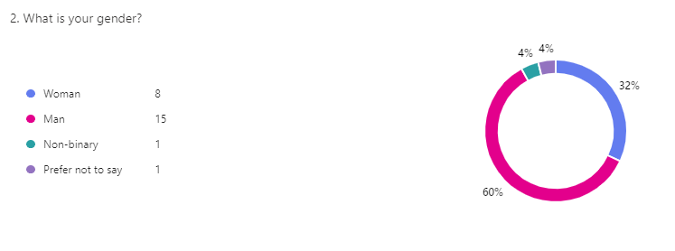
Figure 2. Survey Graph 2
The demographic analysis indicates that the aim at consumers in the 18-34 age range, with slightly more male consumers. Marketing materials should therefore be able to consider issues of age and gender.
Purchase Frequency and Purchase Motive
Frequency of Purchase: The majority of the respondents commonly use the product/service within a period of one month (40%) or one week (28%) confirming steady market requirement. A much smaller number purchase daily or seasonally, but this proves that the product/service does not necessarily have to be a daily necessity but is frequently used.
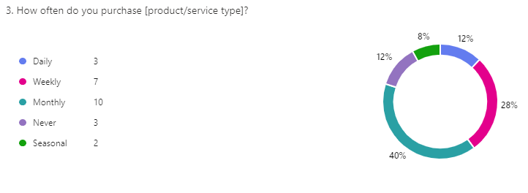
Figure 3. Survey Graph 3
Factors Influencing Purchase: According to respondents, quality is the leading criterion by which they make their choice, which is mentioned by 52% of them, while brand reputation and price are of equal importance – 24% and 20%, respectively. Only a limited number of respondents viewed environmental concerns or customer service as their issue of most concern; there was an outstanding preference for quality (Kingsnorth, 2022).
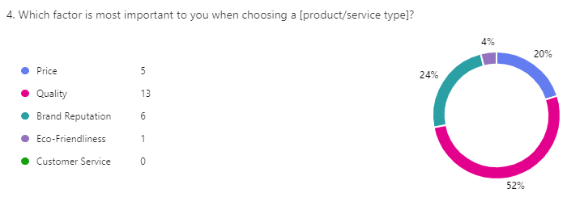
Figure 4. Survey Graph 4
Because the feature of quality is considered the most critical, its focus in advertisements and product specifications may boost the products’ demand. Evaluating monthly sales showcases that there is a consistent consumer clientele whose shopping habits, optimized for subscription/loyalty program need analysis.
Most e-commerce shoppers have a preferred platform from which they make their purchases, and how much they are willing to spend on their purchases
Shopping Platform: From the results below, it is evident that respondents source their products online through marketplaces 36% and social media 28% more so than physical stores 15%. As the trend moves more towards the utilisation of online platforms, there is the need to engage the target group through a good online platform and social media marketing strategy.
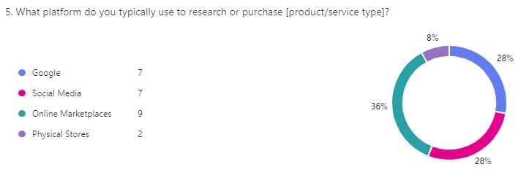
Figure 5. Survey Graph 5
Spending Habits: The largest part of the respondents (60%) uses £50-£100 as a monthly budget for this product/service, and only a few of them are ready to spend more than £200. This moderate spending implies that positioning of the product or service should be put in a reachable price range that will get the attention of the target population (Veleva and Tsvetanova, 2020).
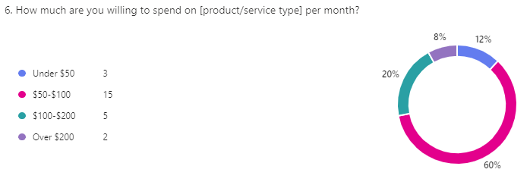
Figure 6. Survey Graph 6
For such a group an online-first strategy with price point around £50-£100 would probably be quite appealing. There will be a need to lend our presence on social media and online marketplaces due to the high usage (Puspaningrum, 2020 ).
The study is Brand Loyalty and Satisfaction
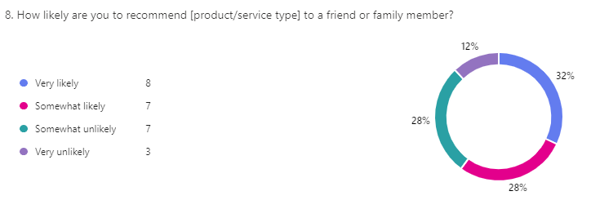
Figure 7. Survey Graph 7
Likelihood to Recommend: An astonishing 32% of the respondents said they would very likely recommend the product/service and an additional 28% stating that they are somewhat likely to do so. Another part of the audience is somewhat or very unlikely to recommend, which shows that there is potential for improving customer satisfaction (Pride and Ferrell, 2022).
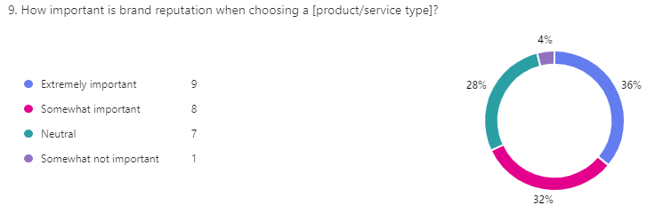
Figure 8. Survey Graph 8
Importance of Brand Reputation: Brand reputation for 36% of the respondents is of extreme significance. This puts into perspective the importance of creating and sustaining the right brand image that will pull in and retain customers.
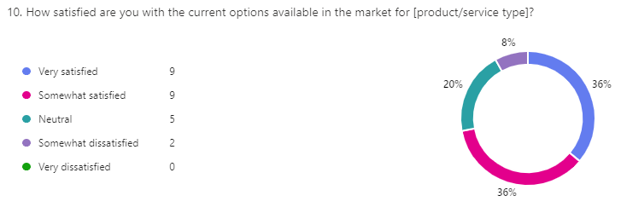
Figure 9. Survey Graph 9
Customer Satisfaction: Many respondents are very satisfied (36%) or somewhat satisfied (36%) with current market options and a small percent somewhat dissatisfied. This relatively high satisfaction means that the market is already moderately competitive, there may appear certain niches to occupy that are missing in the existing options.
Emphasis on a positive brand image and satisfaction level will ensure that potential customers will recommend the product and will remain loyal customers in the future when the company begins expansion (Aaker and Moorman, 2023).

Conclusion
In conclusion the analysis there are several points focused like the target visitor group of any of the sites is young, and 18-34 years of age, predominantly male. Consumers value a product by stressing the importance of quality, therefore marketing should market quality. Such a clear focus on the online purchasing channels will be vital, as most of them buy clothes via the Internet. A cost-sensitive positioning at £50-£100 price points should be the best fit to start. Building a good company image and satisfying customers gives recommendations and renewal decisions.
These ideas provide a platform in which to modify the marketing strategies, improve product portfolios, and create a specialized business model that perfectly fits the customer’s needs. This means that the business can now invest its time and resources on issues that create better quality messages that capture this target segment by allowing it to create better online presence and engage in more targeted and strategic brand-building marketing programs to secure this crowd.

Task 2 Website and marketing materials

Introduction
The following analysis of design and content of a two-page website and connected marketing materials is the result of the questionnaire conducted with potential consumers: Specifically, the results of the questionnaire have been used to determine audience demographics, content topics, and SEO to positively align marketing communications with the intended target market for the website.

Segmentation Analysis
The questionnaire results provide valuable demographic and behavioral data to guide audience segmentation:
Age and Gender: The core consumer demographic is from 18 to 34 years with a bit more male domination among users. Thus, the website and the advertisement will have a more polished look to appeal to younger audiences more. Clean and relatively ‘sexless’ shades and action will be employed to appeal to as many distinct categories of viewers.
Customer Preferences: When choosing between quality and other factors like price or environmental impact, respondents gave their vote to quality as an important criterion proving that there is an audience ready to pay for well-produced products or services. Therefore, on the website, there will be significant calls for quality including quality testimonial messages, quality product images, and quality assurance (Drummond et al., 2020).
Application: The content of the website is designed in a way that follows these audience attributes with selection of pictorial content, choice of words and layout of the website that targets young and quality conscious customers.

Website Design Using Weebly
Page 1: Home Page
The home page serves as the initial touchpoint for visitors, reflecting the brand’s identity and providing quick access to essential information:
Hero Section: A clean image, high-quality picture of the product/service with tagline stating quality. Since quality was identified as the most valued from among all the offered tags, the tagline could be “Experience Excellence – For Quality Driven Lives” (Puspaningrum, 2020 ).
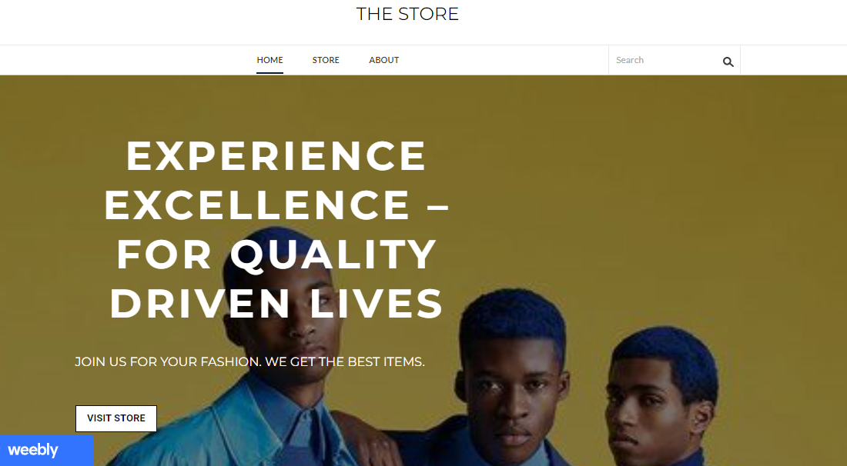
Figure 10. Home Page
About Section: It highlights the brief brand description and how the brand maintains the quality and trust of the consumers at the initial stage of visiting the site. This section will contain brief yet effective as far as influencing young consumers are concerned.
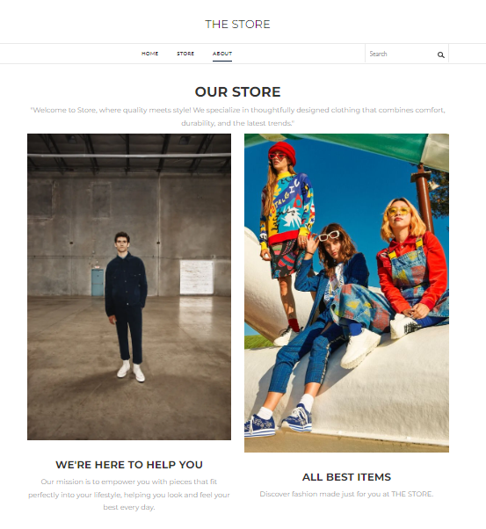
Figure 11. About Section
Key Features and Benefits: A segment that informs and persuades the target consumer on the reliability, durability and attractiveness of the product/service and how it differs from similar existing products/services. Each feature is also followed by an icon related to the feature to make the layout appealing as well as easy to understand.

Figure 12. Feature Section
Page 2: Items information and testimonials about the product/service
Detailed Product/Service Descriptions: Scenario descriptions that illustrate core details and that do not lose communication at the same time. According to the foregoing average price sensitivity, this section will provide clear and understandable information regarding prices and stress on the balance between quality and price.

Figure 13. Product Description
Call to Action (CTA): There will be a bright united CTA that will say for example, “Join the Quality Movement – Shop Now!” at the bottom of the page so that they can be encouraged to purchase products from the site or browse through it.

Figure 14. CTA Button

Marketing Materials Design Using Canva
The social media graphics and digital flyers produced and distributed for advertising those services likewise have a similar branding and style. The following materials are developed to present to the specific audience as a result of the selected questionnaire-based segments.
Social Media Graphics:
- Target Platforms: Since a part of audience uses social media for gathering the information (28%) and online shops (36%), the materials will be shared in Instagram, Facebook, and Pinterest cooperate (Infante and Mardikaningsih, 2022 ).
- Design Style: Communications will contain clear written messages that are specific to quality and longevity, and the visuals will support the brand image. Posts will include tagline “Crafted for Quality” to reiterate brand message and will post high quality images of products/services.

Figure 15. Social Media Post
Digital Flyers:
Key Information: Signages will be in the flyers, and they include description of the product or service, reviews and comments, promotions. High contrast and uncomplicated fonts together with high resolution graphics will make the audience take a second look at the brand’s credentials and expertise.
Application: These materials provide SEO/Engagement help in having inclusion of search friendly keywords regarding quality and durability to enhance the website visibility at search engines as well as in social networks (Jung et al., 2022).

Figure 16. Digital Flyers

SEO Strategy
Having a good SEO is essential for the most part since the audience tends to search online (Google and social media). This way the website as well as the different marketing materials needed to create the brand have been most effectively positioned to target selected keywords to guarantee them the best positions in the search engine results.
Keyword Selection:
Primary Keywords: Keywords that evoke “high-quality [product/service]”, “young professionals’ best [product/service]”, and “affordable quality [product/service]” are present in the survey results and used on the website (Appel et al., 2020).
Long-Tail Keywords: These include everyday phrases such as ‘how to buy a [quality product/service]’ or ‘what is the best [long-lasting product or service] for under £100’, because these are more indicative of the audiences’ worries regarding product and service quality and its affordability.
On-Page SEO Elements:
Page Titles and Meta Descriptions: Such taglines as the main keywords are “Quality [Product/Service] for Modern Living,” while meta descriptions briefly state the brand’s path to quality and reliability.
Image Alt Text: All the images are supplied by appropriate descriptions (for instance, the ‘keyworded’ statement such as ‘quality [product/service] image’) for increased availability and better audience exposure.
Internal Linking: The navigation is provided with the links between the home and product pages, which means that the visitor will spend more time on the site.
Application: This SEO strategy provides the website and contents with a proper place in the search engines so that the intended web users can be reached properly (Haudi et al., 2022).

Conclusion
As per questionnaire it influences the whole content and style of web and marketing as well as the structure and the performance to attract clients. The concern for the quality of service and product correlates with the main issue of concern of the target audience; the pricing also caters for budget consciousness and SEO strategies capture the essence of online search behaviour. This scientific approach makes it right for the brand to reach its targeted audience hence promote the product/service in a competitive world. The result is a set of images that outline the overall image of a brand to directly address the audience of young, select and perceptive consumers and accentuate the company’s position as a reputable, powerful brand of choice in the niche.

Task 3: Microsoft excel

Setting up the Spreadsheet
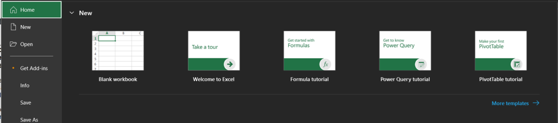
Figure 17: Excel Interface
Open the Excel in the system and it will open an interface like this.
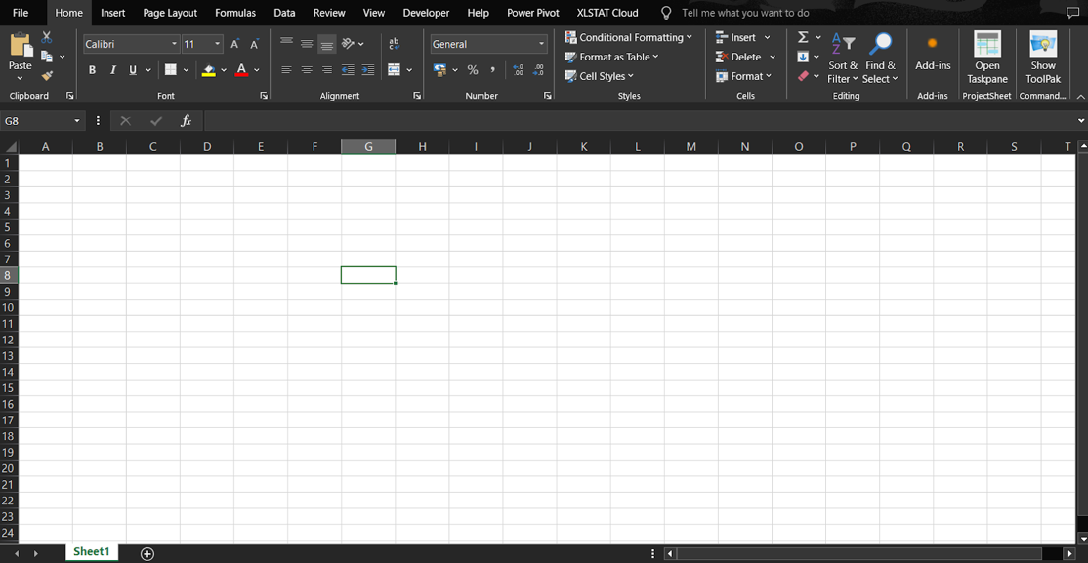
Figure 18: Blank Workbook
Click on “Blank Workbook” to open a workbook to write all the finances of the business.
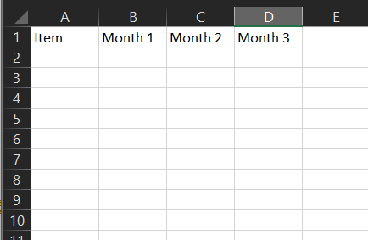
Figure 19: Adding Headers to Workbook
Write the headers in the first row of the workbook, with Item, Month 1, Month 2 and Month 3

Entering Sample Data
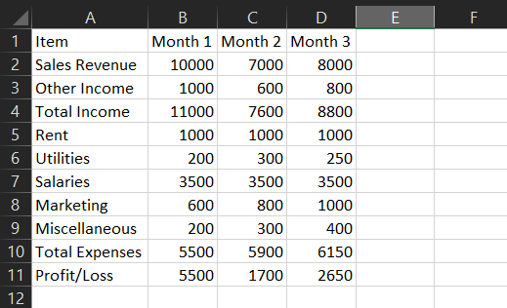
Figure 20: Sample Data
Added some sample values in the workbook, in different categories like sales revenue, salaries.

Use of Formulas
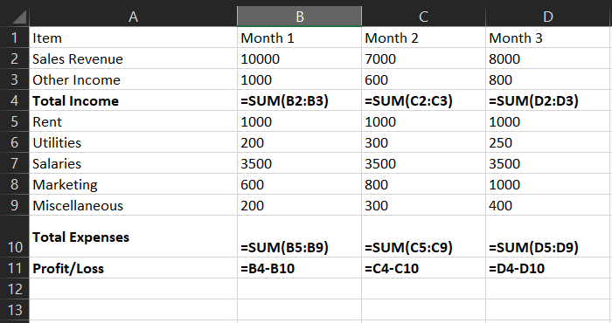
Figure 21: Adding Formulas.
Adding formulas to the cells of Total Income, Total Expenses and Profit/Loss.

Apply formatting
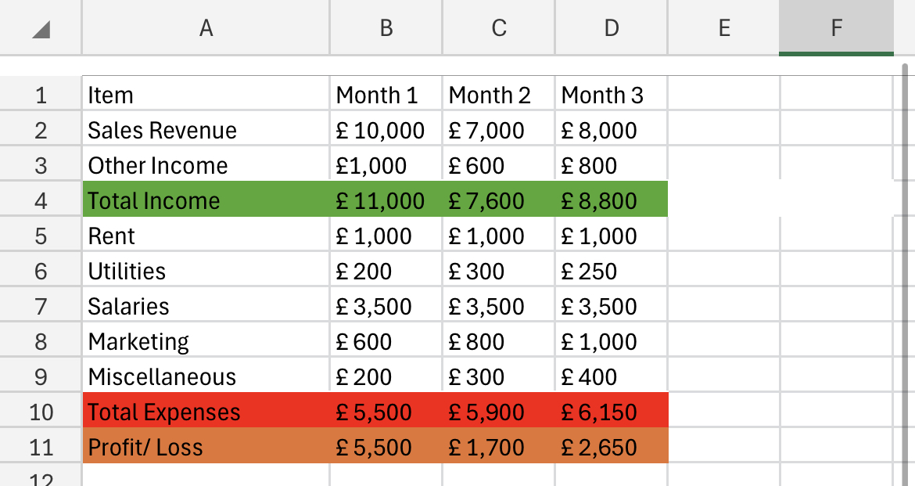
Figure 22: Adding Colours to Cells
Adding colours to distinguish cells like income and expenses.

Chart Comparison
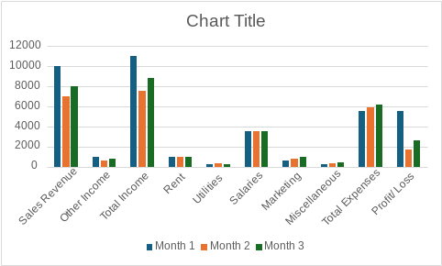

Fig
Figure 23: Income vs Expenses.
This is the bar chart representation to compare the income and expenses across three months.

Introduction
In today’s world organizations have begun to depend more and more on data in their decision-making and rising productivity. Microsoft Excel has cropped up as one of the influential tools in this environment that enables users to manipulate, analyse and present data. In this report, the importance of Excel is discussed with special emphasis on its capabilities, its uses and its contribution to the process of knowledge-based decision-making.

Data Organization and Management
The first and strongest argument which can be provided in favour of using Excel in one’s activity is its capacity to process large amounts of information. Structured tables can be constructed by the users for categorizing data so users can easily search them and alter them if needed. This capability is of great importance to any organisation that deals with customer details, sales data or even inventory information (Afif and Nawirah, 2020). Sorting and filtering options of Excel facilitate searching particular data and exclude time waste. For example, companies can quickly arrange sales figures according to date or choose which customers meet particular criteria, for example, geographic location or purchasing frequency (Rangkuti and Harahap, 2020).
Excel shows conventions for putting in data well. This means it will prompt the users to place related items in one column and never leave empty rows or columns within a range of data. Adherence to these guidelines improves readability while also having positive impacts on the Excel environment for processing the data for analysis and reporting. By paying priority to these organizational principles, efficient flows of operations can be achieved with little space for mistakes (Rebman et al., 2023).

Data Analysis
The great number of analytical tools in Excel allows for constructing complicated calculations and analysing tendencies. End-user operations like SUM, AVERAGE, and VLOOKIP are important for the analysing of data and producing value-added reports (Kalwar and Khan, 2021). For example, companies can employ Excel in sales analysis across certain periods and determine e.g. seasonal variations and potential future performance. The use of graphs and charts to represent data adds to comprehension and simplifies presentation when presenting information to the stakeholders (Yang and Cheng, 2020).

Financial Planning and Control
Financial forecasting is fundamental in the case of small businesses and new ventures, as this will enable the business to survive and expand. Excel support services that help in drafting and making budgets and projections. By entering past values in various formats laid down in advance, the possible future revenues and costs can be estimated. It also helps them come up with correct estimations on the best investments to make and the right resources to apply.

Collaboration and Accessibility
As the world becomes ‘digested’ collaboration is key. Several users can collaborate on an Excel document thus improving on group work and efficiency. Components, such as comments and track changes or suggestions, allow interacting members, and other participants, to give responses and input changes instantly. Considering current possibilities in using OneDrive and SharePoint as cloud tools, a user can easily access files created in spreadsheet software at any location with an internet connection. Using this flexibility means that distance does not matter since people can work in their teams and communicate effortlessly (Ajiva, Ejike and Abhulimen, 2024).

Integration with Other Tools
Excel’s compatibility with other software enhances its functionality in ways includes, Companies use excel with other software such as Customer Relationship Management (CRM), Accountancy, and data analysing tools to minimize data hand entrance (Khan, Kalwar and Chaudhry, 2021). This integration is very important especially when organizations are concerned with data-driven decisions; as it allows the possibility of sourcing data from various tools in a very easy manner (Daff, 2021).

Conclusion
In conclusion, the application of Microsoft Excel cannot be exaggerated in today’s Information and Communication Technology society as it provides core tools for efficient data management, analysis, sharing and integration with other applications. Due to flexibility, it can be useful to different industries allowing companies to build efficient strategies based on data collection. Today, with the new developments of the digital world emerging continuously, Excel also holds its ground as the BI tool. It empowers organizations with relevant forms that may be used in the assurance of competitive advantage since the management of the organization makes informed decisions based on the data collected.

Task 4 Advertising video
Link video: https://youtu.be/GY0iKO9uioI?si=bpWhem-lz_OjPzgL


References

Aaker, D.A. and Moorman, C. (2023). Strategic market management. John Wiley & Sons. https://books.google.com/books?hl=en&lr=&id=_TDaEAAAQBAJ&oi=fnd&pg=IA2&dq=marketing+strategy+process&ots=uEjwwwTafL&sig=8ijEDmqGuIbS5f_CO5OSxw60CG8
Afif, I.R. and Nawirah, N. (2020). Design of financial statement preparation based on SAK EMKM using microsoft excel. Journal of Islamic Accounting and Finance Research, 2(1), p.141. doi: https://doi.org/10.21580/jiafr.2020.2.1.5156.
Appel, G., Grewal, L., Hadi, R. and Stephen, A.T. (2020). The future of social media in marketing. Journal of the Academy of Marketing science, 48(1), pp.79-95. https://link.springer.com/article/10.1007/s11747-019-00695-1?error=cookies_not_support
Daff, L. (2021). Employers’ perspectives of accounting graduates and their world of work: software use and ICT competencies. Accounting Education, 30(5), pp.495–524. doi: https://doi.org/10.1080/09639284.2021.1935282.
Drummond, C., O'Toole, T. and McGrath, H. (2020). Digital engagement strategies and tactics in social media marketing. European Journal of Marketing, 54(6), pp.1247-1280. https://www.emerald.com/insight/content/doi/10.1108/EJM-02-2019-0183/full/html
Evans, D., Bratton, S. and McKee, J. (2021). Social media marketing. AG Printing & Publishing. https://books.google.com/books?hl=en&lr=&id=7lgkEAAAQBAJ&oi=fnd&pg=PT7&dq=social+media+marketing&ots=UYXmvp7cfW&sig=7itQ2i0VtC2YMso9bLJ5mXVXEfw
Haudi, H., Handayani, W., Musnaini, M., Suyoto, Y., Prasetio, T., Pitaloka, E., Wijoyo, H., Yonata, H., Koho, I. and Cahyon, Y. (2022). The effect of social media marketing on brand trust, brand equity and brand loyalty. International Journal of Data and Network Science, 6(3), pp.961-972. http://growingscience.com/beta/ijds/5384-the-effect-of-social-media-marketing-on-brand-trust-brand-equity-and-brand-loyalty.html
Infante, A. and Mardikaningsih, R. (2022). The Potential of social media as a Means of Online Business Promotion. Journal of Social Science Studies (JOS3), 2(2), pp.45-49. https://ejournal.metromedia.education/index.php/jos3/article/view/26
Jung, J., Kim, S.J. and Kim, K.H. (2020). Sustainable marketing activities of traditional fashion market and brand loyalty. Journal of Business Research, 120, pp.294-301. https://www.sciencedirect.com/science/article/pii/S0148296320302356
Kalwar, M. and Khan, M. (2021). Optimization of Procurement & Purchase Order Process in Foot Wear Industry by Using VBA in Ms Excel. [online] Available at: https://www.researchgate.net/profile/Muhammad-Kalwar/publication/356786418_Optimization_of_Procurement_Purchase_Order_Process_in_Foot_Wear_Industry_by_Using_VBA_in_Ms_Excel/links/61ac945350e22929cd4a5eb8/Optimization-of-Procurement-Purchase-Order-Process-in-Foot-Wear-Industry-by-Using-VBA-in-Ms-Excel.pdf [Accessed 28 Oct. 2024].
Khairunnisa Rangkuti and Mailina Harahap (2020). Development Of Business Analysis Learning Model Using The Microsoft Excel Application. JASc (Journal of Agribusiness Sciences), [online] 3(2), pp.77–84. Available at: https://jurnal.umsu.ac.id/index.php/JASc/article/view/4609/pdf_51 [Accessed 28 Oct. 2024].
Khan, M.A., Muhammad Ahmed Kalwar and Chaudhry, A.K. (2021). Optimization of material delivery time analysis by using Visual Basic for applications in Excel. Journal of Applied Research in Technology & Engineering, [online] 2(2), pp.89–89. doi: https://doi.org/10.4995/jarte.2021.14786.
Kingsnorth, S. (2022). Digital marketing strategy: an integrated approach to online marketing. Kogan Page Publishers. https://books.google.com/books?hl=en&lr=&id=acdsEAAAQBAJ&oi=fnd&pg=PP1&dq=marketing+strategy+process&ots=Zudj23KAsR&sig=pX1_eQnjp4sMdJMGFaV7ssV0OSA
Li, F., Larimo, J. and Leonidou, L.C. (2021). Social media marketing strategy: definition, conceptualization, taxonomy, validation, and future agenda. Journal of the Academy of Marketing Science, 49, pp.51-70. https://link.springer.com/article/10.1007/s11747-020-00733-3
Mowar, A. (2022). Marketing management. Blue Rose Publishers. https://books.google.com/books?hl=en&lr=&id=lOyZEAAAQBAJ&oi=fnd&pg=PA54&dq=marketing+strategy+process&ots=4IofSGwJR6&sig=wgov6qCyfwR11lE0tgoWi4gplMg
Oluwaseun Abiola Ajiva, Onyinye Gift Ejike and Angela Omozele Abhulimen (2024). Advances in communication tools and techniques for enhancing collaboration among creative professionals. International Journal of Frontiers in Science and Technology Research, [online] 7(1), pp.066–075. doi: https://doi.org/10.53294/ijfstr.2024.7.1.0049.
Pride, W.M. and Ferrell, O.C. (2022). Foundations of marketing. Cengage Learning, Inc.. https://thuvienso.hoasen.edu.vn/handle/123456789/13215
Puspaningrum, A. (2020). Market orientation, competitive advantage and marketing performance of small medium enterprises (SMEs). Journal of Economics, Business, and Accountancy Ventura, 23(1), pp.19-27. https://register-jobfair.perbanas.ac.id/index.php/jebav/article/view/1847
Puspaningrum, A. (2020). Social media marketing and brand loyalty: The role of brand trust. The Journal of Asian Finance, Economics and Business, 7(12), pp.951-958. https://koreascience.kr/article/JAKO202034651879491.page
Rebman, C.M., Booker, Q.E., Wimmer, H., Levkoff, S., McMurtrey, M. and Powell, L.M. (2023). An Industry Survey of Analytics Spreadsheet Tools Adoption: Microsoft Excel vs Google Sheets. Information Systems Education Journal, [online] 21(5), pp.29–42. Available at: https://eric.ed.gov/?id=EJ1409034 [Accessed 28 Oct. 2024].
Veleva, S.S. and Tsvetanova, A.I. (2020), September. Characteristics of the digital marketing advantages and disadvantages. In IOP Conference Series: Materials Science and Engineering (Vol. 940, No. 1, p. 012065). IOP Publishing. https://iopscience.iop.org/article/10.1088/1757-899X/940/1/012065/meta
Yang, P. and Cheng, T.C. (2020), June. Understanding Data Analysis Workflows on Spreadsheets: Roadblocks and Opportunities. In Proceedings of Workshop on Human-In-the-Loop Data Analytics (HILDA’20). https://par.nsf.gov/servlets/purl/10161749

‌

