Name: Rebecca Cowley
Student Number: 1708411
BA Course Title: Illustration
Tutor(s): Sarah Tombs, Louise Burston
Word Count: 1939

2. Within a given time period, select examples of what could be considered high and low cultural artefacts. Discuss these, taking into consideration the surrounding social, political and historical context.

High/Low Culture Artefacts From 1950 to 1970

For many centuries before now, the terms ‘High Culture’ and ‘Low Culture’ have played a large role not only socially but also within the art world. Visual arts such as architecture, painting and sculpture were only received by the most powerful and wealthy individuals around Europe and so art was considered an entertainment source for the most elite of society. In this essay, we will examine a selection of artefacts that are associated with both high and low culture between the given time period of 1950 to 1970. We will also take into consideration the surrounding social, political and historical factors within this time frame.

When we refer to the term ‘high culture’, we associate it with pieces of work that are deemed “the best that has been thought and written in the world”. (Raymond Williams,1974). More traditionally, we relate it with being that of a higher class. ‘High art’ or works considered that of high culture, are expected to be the most elite and genius, created by artists of great skill and therefore, only a small minority of the population were deemed worthy of viewing it.

As the world slowly began recovering from the turbulent times of the second world war, new art movements began to develop from the mid-1940s to the 1950s. Artists at the start of this period struggled to find appropriate artistic voice and language after the war and would debate over the future of modern art. Due to resulting mass migration at the time, Areas such as New York, in turn, became a fertile ground for artists across the globe to congregate, exhibit and exchange their work. This led the decade to discover the breakthrough of art movements such as abstract expressionism, pop art, modern sculpture and new figurative painting. Abstract expressionism at the time could roughly be divided into two subgenres, Action Painting and Colour Theory Painting.

Jackson Pollock was a major influential American artist at this time. He was what many people call a mastermind and leader behind this art movement, dominated the art world with his action paintings and influencing many artists to this day. In the height of his career, Pollock created an infamous set of three large wall paintings in the summer and autumn of 1950. Here we will discuss, one of those paintings, ‘One: Number 31’,1950.
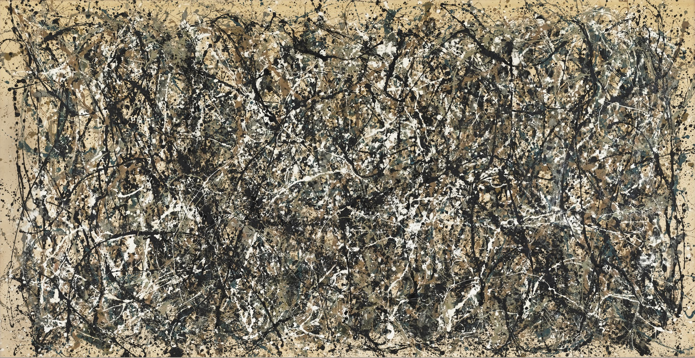
Jackson Pollock, 1950, ‘One: Number 31’

Like many abstract artists at the time, Pollock directly translated his emotions, thoughts and mood onto the canvas. As Harold Rosenburg explains in ‘The American Action Painters’ (1952 pg. 22), ‘The canvas began to appear to one American painter after another as an arena in which to act. … What was to go on canvas was not a picture but an event’. Rather than using traditional methods and equipment such as brushes and easel, his process consisted of laying the canvas on the floor, where he then dripped, splashed, poured enamel paint onto the surface, usually straight from the can. He would then continue by adding depth to the painting by using tools such as knives, towels and sticks. We can certainly see this in ‘One: Number 31, 1950’ with the rather strong and expressive movements that can be seen in the painting. With its sheer size and scale, the viewer is confronted with the volume of energy the piece gives off.

“My painting does not come from the easel…I prefer to tack the unstretched canvas to the hard wall or floor. On the floor, I am more at ease. I feel nearer, more a part of the painting, since this way I can walk around it, work from the four sides and literally be in the painting. I prefer sticks, trowels, knives, and dripping fluid paint…. When I am in my painting, I’m not aware of what I’m doing….there is pure harmony, an easy give and take, and the painting comes out well.”- Jackson Pollock, "My Painting," Possibilities I (Winter 1947–48), 78–83

Pollock’s work featured in Vogue as well as art galleries in New York, As this was in the face of the mass media, it inevitably triggered public acceptance. By the 1960s, The art world viewed Pollock as one of the most important and influential figures, and would then go onto being one of the leaders of the avant-garde movement. His work today continues to be compared to that of the literature by William Shakespeare.

The works of another infamous artist at the time, Lucian Freud can also be considered of high culture. Here we will discuss the piece ‘Girl With A White Dog, 1951-1952’. Fraud approached this painting with echoes from nineteenth-century portraiture, with smooth lines and soft colours, which also gives it a slightly ghostly, or rather sinister effect. Perhaps the tension felt in this painting could reflect upon the possible emotions of the artist at the time this was painted.
“The sense that Freud gives of human existence as essentially lonely, and spiritually if not physically painful, is something shared by his great contemporaries, Francis Bacon and the sculptor Alberto Giacometti”. Gallery label, April 2005

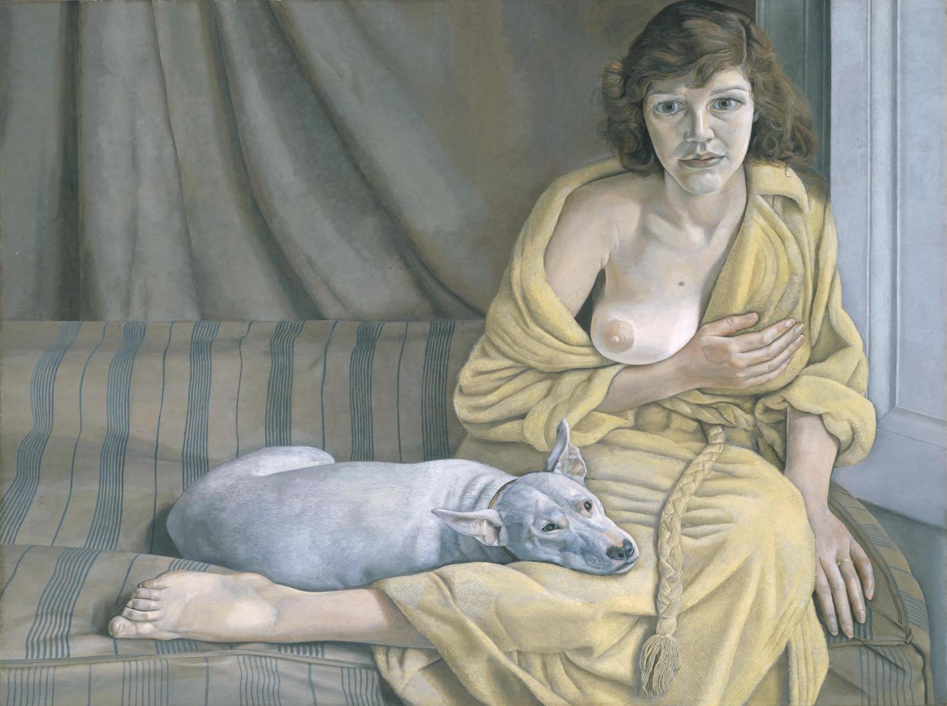
Lucian Freud, 1951-1952, ‘Girl With A White Dog’

As we observe this painting, we are reminded of the seriousness that comes from works such as Jackson Pollock’s action art. Although action art conveyed no clear shape, presenting us with drips, splashes and strokes of paint. We are reminded of the similar underlying emotions behind the piece.
In this next section, we will be exploring artefacts considered to be that of low culture. We commonly associate term ‘low culture’ with popular culture and mass media. Characteristics of artefacts from this genre of art are typically cheap, can be mass produced and are easily accessible. Another typical characteristic is that the use of machines such as cameras, printers/printing presses and computers. Unlike high culture art, the typical goal when creating art deemed of low culture is to reach as many people as possible, as John. A. Walker, (1998, p. 9) explains, “success is often measured in quantitative rather than qualitative terms”.

By 1960’s the world was introduced to ‘Pop Art’, one of the many and most well-known art movements of the 20th century. Pop art challenged the attitudes and characteristics of traditional art, confronting its audience with a new way of receiving art by including imagery taken from magazines, newspapers and objects from popular and mass culture. The
movement was detached, lacked emotion and was very impersonal compared to the earlier movement of abstract expressionism. Many artists of this movement grew up in lower class backgrounds, and so access to art school was not quite realistic and so as a result, the contrast in style varied to that of an artist coming from a higher social class who studied at colleges. This is where perhaps pop art had to become witty, and ironic so it could reach its mass audience.

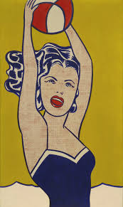
Roy Lichtenstein, 1961, ‘Girl With A Ball’

As an example, we will discuss Roy Lichtenstein’s ‘Girl With A Ball’,1961. This oil painting by Lichtenstein depicts an image of a woman holding a ball with block colour, with bold lines and smooth brushstrokes which contrasts earlier decades work quite distinctly where these qualities were more traditionally expressive and emotional depending on the artist’s thoughts and mood at the time. As John. A. Walker states in his book ‘Art In The Age Of Mass Media, (1994, pp. 35):

“Lichtenstein’s strategy was to translate the ‘language’ of abstract expressionism into the ‘language’ of graphic design.’Non-commercial’ fine art appears to have become commercial applied art.”

In another example of Lichtenstein’s work, ‘Little Big Painting’,1965 we are presented with a reference to action painting, from the earlier and dominant art movement, abstract expressionism. The blown-up and flat brushstrokes of this painting parody the earlier style’s characteristics of being emotional, personal and eventful by being rather ironic, playful and detached from the subject matter. In this painting, we are confronted with static, solid lines which lack spontaneity resulting in a more of a mechanically produced effect, opposed to the work of Jackson Pollock for example.

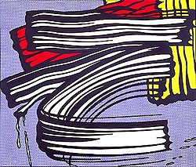
Roy Lichtenstein, 1965, ‘Little Big Painting’

Another iconic artist in the pop art movement was Andy Warhol. Following the idea of his earlier piece, ‘Campbell Soup Cans’,1962 Warhol went onto produce one of his more renowned sculptures, ‘Brillo Boxes’,1970. With this sculpture, Warhol challenged the traditional and formal layout of the gallery space by introducing an artefact of mass commercial culture and everyday life, that simply being an industrial box for commercial steel wool.

“The Brillo Boxes comment on the commercial framework behind the pristine spaces of the art gallery and art museum, while rubbing the nose of high culture in the mundane disorder of the supermarket stockroom”. (Walsh, P,1998)

Warhol recognised that objects such as soup cans, industrial boxes and other commercial items were never going to be seen in the same respect as fine art, and so he referred to his studio as ‘The Factory’ and made the term ‘Industrial art/ Business art’ known. Adopting the technique of silk-screen printing, Warhol believed in speed and efficiency, in turn turning his studio into a production line. With this technique, Warhol was able to quickly produce work, achieving a significant amount of output as he would reproduce a single piece over and over, rather than creating a ‘one-off’ like classic/high culture artists.

“Business art is the step that comes after art. I started as a commercial artist and I want to finish as a business artist … Being good in business is the most fascinating kind of art … making money is art and working is art and good business is the best art”. (Warhol, A, 1976,
p. 88)

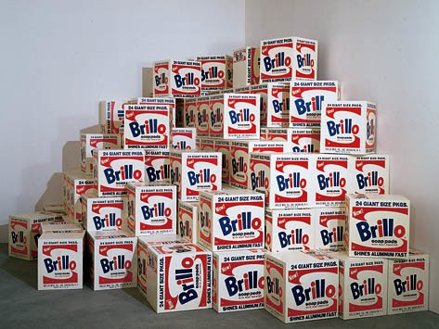
Andy Warhol, 1970, ‘Brillo Boxes’

When we look at the politics behind pop art, we can see critics at the time deemed the style as superficial, theft and inauthentic compared to earlier styles such as abstract expressionism. “They have accused it of mindlessly reproducing and celebrating the worst aspects of capitalism and consumerism” (John A Walker,1994, pp.38).

At first glance, we can assume that these pieces are a form of plagiarism, with artists taking existing work and passing it as their own, however, this can be argued. 'Recontextualisation’ is a term we refer to when an image’s context is changed determined on where it is placed/cropped etc. This was a common technique used by artists such as Lichtenstein and Warhol. This form of appropriation was firstly introduced with ‘Dada’ artists such as Marcel Duchamp and his series of ‘Ready-mades’. An example from this series would be Duchamp’s ‘Bicycle Wheel’,1913.

In conclusion, The distinctions between high culture art and low culture art were very different in comparison to one another between 1950 and 1970. High art dominated the 1950’s, with the movement of abstract expressionism, and the sub-genres that followed such as action painting and colour theory painting. However, this then changed with the trend of mass production and mass media. As many of the artists' environment became more media-saturated, we notice that pop art become the new dominant art movement, abandoning the serious, personal and autobiographical art style of using movement in art to express emotion to opt for a more distant approach. Pop art introduced irony, wittiness a sense of playfulness to the art world. Artists started using objects in their environment as their subject-matter. Most commonly more commercial objects, such as newspaper/magazine clippings, advertisements, comics and references to celebrities. As the decades progressed, art became more business orientated where art became more industrial and commercially themed. Artists started to mass produce work rather than creating pieces of art that were original and the rate of success was determined more on how many people saw/bought the art rather than the quality/ emotions behind the work.

Bibliography

Rosenburg, H. (1952) ‘The American Action Painters’. Art News 51/8, Dec. 1952, p. 22

Williams, R. (1974) ‘On High and Popular Culture’. The New Republic. November 22, 1974. Available at: https://newrepublic.com/article/79269/high-and-popular-culture Accessed on: 9/12/18

Pollock, J, (Winter 1947–48), ‘“My Painting", Possibilities I’ p.78–83. Available at:https://www.moma.org/learn/moma_learning/jackson-pollock-one-number-31-1950-1950/
Accessed on: 9/12/18

Gallery label, April 2005. Available at: https://www.tate.org.uk/art/artworks/freud-girl-with-a-white-dog-n06039 Accessed on: 9/12/18

(Walker, A.J, 1994, pp. 9)
Walker, A.J. (1994) ‘Art In The Age Of Mass Media’. Revised edn. London: Pluto Press.

(Walker, A.J, 1994, pp. 35)
Walker, A.J. (1994) ‘Art In The Age Of Mass Media’. Revised edn. London: Pluto Press.

Walsh, P. (1998) ‘Index of Selected Artists in the Collection’ Andy Warhol Foundation for the Visual Arts/ARS, New York. Available at:http://www2.oberlin.edu/amam/Warhol_BrilloBoxes.htm Accessed on: 9/12/18

(Walker, A.J, 1994, pp. 38)
Walker, A.J. (1994) ‘Art In The Age Of Mass Media’. Revised edn. London: Pluto Press.

Warhol, A, ‘A to B and Back Again: The Philosophy of Andy Warhol’, (London: Pan Books, 1976, p. 88)

