Creating and Handling a Data File on SPSS

Index

Page
Creating and Handling a Data File on SPSS

1) Loading SPSS for Windows 3

2) Defining Variables 4

3) Entering the Data 8

4) Saving, Opening and Printing a Data File 9

5) Sorting the Data File 10

6) Inserting or Deleting Cases 10

7) Inserting or Deleting Variables 11

8) Searching for Data Items and Selecting Cases 11

Descriptive Statistics with SPSS

9) Frequency Tables and Percentages 15

10) Charts 16

11) Cross-tabulations 21

12) Histograms 22

13) Averages and Measures of Spread 24

14) Comparison of Means 25

15) Reporting a Statistical Output 27

Creating a Data File

- Loading SPSS

Load SPSS from the Start menu

Click on Type in data then OK.
The following screen display should be visible:
Tool
Bar
Menu
Bar

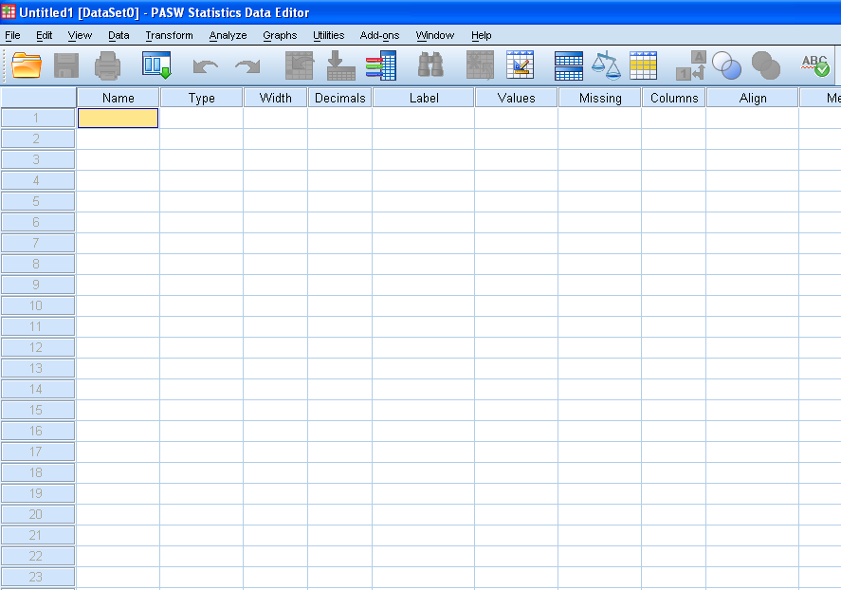

Menu bar
This is a drop-down menu system.
Tool Bar
These are short cuts for using the menu bar.

Go to Variable Select Cases Spell Check
Open Data Undo Redo Find Insert Variable Value Labels
Document

Go to Case Insert Cases Weight Cases Show All Variables
Save Print Variables Split File Use Variable Sets
Recall Dialog

The purpose of each Tool icon is displayed when the mouse arrow is held for a few seconds above the icon.
3) Defining Variables

Download the data file “week1_data.csv” from the moodle. It contains data for a sample of 30 employees, 15 male and 15 female, of a large organisation, between the ages of 20 and 50. Open the data file to view the variables and cases (observations).

Refno | Gender | Jobhappy | Agegroup | Age | Salary | Prodbsal
002 | 1 | 2 | 1 | 20 | 18.8 | 19.4
004 | 1 | 1 | 3 | 48 | 27.2 | 26.4
006 | 1 | 3 | 3 | 45 | 30.8 | 30.2
011 | 2 | 3 | 2 | 36 | 27.2 | 27.0
016 | 2 | 1 | 1 | 25 | 19.8 | 20.2
019 | 1 | 1 | 2 | 39 | 22.3 | 22.7
022 | 1 | 1 | 2 | 39 | 19.3 | 19.4
023 | 2 | 3 | 3 | 42 | 25.3 | 25.6
026 | 1 | 2 | 1 | 27 | 17.1 | 17.6
035 | 2 | 2 | 3 | 41 | 32.3 | 33.4
037 | 2 | 3 | 3 | 47 | 21.3 | 21.4
044 | 2 | 2 | 1 | 28 | 21.7 | 22.0
045 | 1 | 2 | 2 | 37 | 22.1 | 22.1
050 | 2 | 2 | 2 | 34 | 19.2 | 19.2
055 | 1 | 1 | 1 | 23 | 17.3 | 18.1
057 | 2 | 3 | 2 | 30 | 20.9 | 20.9
061 | 2 | 3 | 2 | 34 | 19.4 | 19.4
076 | 2 | 3 | 1 | 22 | 14.9 | 15.6
082 | 1 | 1 | 2 | 31 | 23.3 | 23.6
088 | 2 | 3 | 2 | 38 | 16.7 | 17.2
090 | 1 | 1 | 2 | 32 | 22.3 | 22.4
097 | 1 | 2 | 2 | 34 | 22.2 | 21.8
099 | 2 | 2 | 3 | 40 | 25.1 | 25.9
101 | 1 | 3 | 1 | 21 | 24.9 | 25.2
103 | 2 | 3 | 1 | 21 | 19.4 | 19.8
132 | 1 | 1 | 3 | 44 | 21.2 | 21.1
148 | 1 | 2 | 3 | 41 | 29.4 | 30.3
164 | 1 | 3 | 1 | 29 | 14.9 | 15.1
171 | 2 | 3 | 3 | 47 | 27.2 | 28.1
172 | 2 | 3 | 1 | 22 | 21.7 | 22.6

Refno is a 3-digit reference code, unique for each employee.

Gender is categorical Nominal variables i.e. male or female are names of unordered categories and are coded:
gender: 1 = male, 2 = female

Agegroup and Jobhappy are categorical Ordinal variables i.e. its values are categories which can be ordered:
agegroup: 1 = 20 - 29 years old, 2 = 30 - 39 years old, 3 = 40 - 50 years old.
jobhappy: 1 = no, 2 = not sure, 3 = yes
Age, Salary and Prodbsal are quantitative Scale variables i.e. their values are measurements on a proper scale. Salary is the actual salary in £1000’s whereas
Prodbsal is the proposed salary in £1000’s under a new productivity-based incentive scheme.

Entering Variable Descriptions

Variables are the column headings.
Each variable must be given a name, the format of the data described e.g. whole numbers or text, and any codes explained e.g. 1= 20-29 years old.
The case numbers 1, 2, 3, 4, 5, etc. are automatically inserted by SPSS.

a) Define Refno Variable

Cursor should be at the top of column 1 as shown:

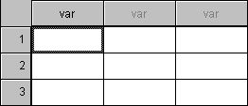

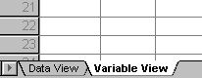 Click on Variable View in the bottom left hand corner of the screen:

The following column headings now appear:
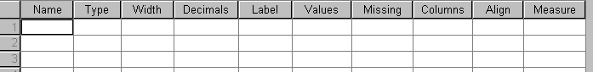
Type Refno for Name then press the Enter key.
(Other columns will automatically be filled in but some will need to be changed.)

Under Type, click on then on String (i.e. non-digits).

Note: Refno is defined a string variable so that the 0’s of such values as 002 are
displayed. Otherwise 002 would be displayed as 2.
Type 3 for Characters to accommodate the three digits of the reference number, then click on OK. This value appears under Width.
Under Label, type Reference number (shows the meaning of ‘refno’)
Under Columns, enter 5 for to accommodate the variable name refno. Note that the default column width is set at 8 and it is not essential to change this value to 5 except to make the data file smaller ie. Fit more on the screen.
The other columns should be correct.

b) Define Gender Variable

Move to row 2 under Name using arrow keys or mouse.
Under Name, type Gender.
Under Type, select Numeric.
Type 1 for Width and 0 for decimal places, then click on OK.
There is no need to enter a Label.
Click in the Values column then on
For Value type 1, click in the Label box, type male, click on Add.

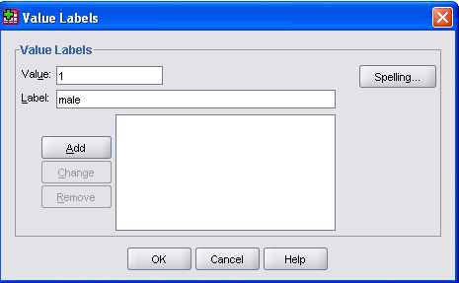

In the Value box, type 2, in the Label box, type female, click on Add.
Click on OK.
Select Left under Align and select Nominal under Measure.
(Text eg. male/female is usually aligned to the left of a column, whereas scale data eg. 30.4 is usually aligned to the right of a column)

c) Define Jobhappy variable

Move to row 3 under Name and type Jobhappy.
Under Type, select Numeric.
Type 1 for Width and 0 for decimal places, then click on OK.
Under label, type Are you happy in your job?

Click in the Values column and then on

In the Value box, type 1, in the Label box, type no, click on Add.
In the Value box, type 2, in the Label box, type not sure, click on Add.
In the Value box, type 3, in the Label box, type yes, click on Add.
Click on OK.
Select Left under Align and select Ordinal under Measure.

d) Define Agegroup Variable

Move to row 4 under Name and type Agegroup.
Under Type, select Numeric.
Type 1 for Width and 0 for Decimal Places, and click on OK.
Click on Values and then on

In the Value (Box), type 1, click on Label (Box), type 20-29, click on Add.
In the Value (Box), type 2, click on Label (Box), type 30-39, click on Add.
In the Value (Box), type 3, click on Label (Box), type 40-50, click on Add.
Select Left under Align and select Ordinal under Measure.

e) Define Age Variable

Move to row 5 under Name and type Age.
Under Type, select Numeric.
Type 2 for Width and 0 for Decimal Places, and click on OK.
The other columns should be correct ie. Right under Align and Scale under Measure.

f) Define Salary Variable

Move to row 6 under Name and type Salary.
Under Type, select Numeric.
Type 3 for Width and 1 for Decimal Places, and click on OK.
Under Label, type Present salary (£000).
Under Columns, enter 6 to accommodate the variable name salary.
The other columns should be correct ie. Right under Align and Scale under Measure.

g) Define Prodbsal Variable

Move to row 7 under Name and type Prodbsal.
Under Type, select Numeric.
Type 3 for Width and 1 for Decimal Places, and click on OK.
Under Label, type Productivity-based salary (£000).
Select Right under Align and Scale under Measure.
The other columns should be correct ie. Right under Align and Scale under Measure.

The completed Variable View table should appear as:

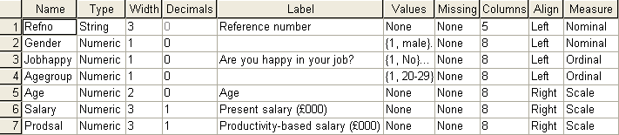
3) Entering the Data
Click on Data View

a) Enter Data for Case 1
i.e. 002 1 2 1 20 18.8 19.4

Use arrow keys to move to the top of the refno column.
Type 002, then use right arrow key to move across to the gender column.
Type 1 then move across to the jobhappy column etc.
Note: to correct errors, click on the cell and re-enter the value for that cell position.

b) Validation tests

After defining variables, SPSS will automatically detect some types of invalid data

e.g. i) More characters than variable length

If the data item for a variable has more characters than the stipulated variable length then only the stipulated number of characters will be accepted.
e.g. for case 2, try typing 1234 under refno, or woman under gender

ii) Wrong type of data

If a non-digit is entered for a numeric variable then a bleep will sound and the data rejected.

c) Load the Complete File (OR Enter Data for Cases 2 to 30)

Go to moodle and download the file “Week1_data.sav” and save the file in your desktop. In SPSS click File, Open, Data.

Alternatively, the data for cases 2 to 30 can be entered manually using arrow keys to move the cursor to correct cell positions and repeating the procedure as for case 1 using data from the sample data listing.

d) Display Value Labels

Value Labels for agegroup can be displayed as data on the screen instead of the codes 1, 2, 3 etc.
Click on the Display value labels icon 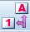 (or Utilities, Value Labels) to give:

Case Refno Gender Jobhappy Agegroup Age
1 002 male not sure 20 - 29 20
2 004 male no 40 - 50 48
3 006 male yes 40 - 50 45
4 011 female yes 30 - 39 36
etc.
Click on the Display value labels icon to return to the codes.

4) Saving, Opening and Printing a Data File

- Saving a file

If you wish to save the file or any other file in your own directory click on File and Save As

- Opening a file

To open this file or any other you will need to use a similar procedure to that for saving as shown above. Click on File, Open.
Now click on the filename and on Open.

- Printing a file

Click on File and Print.
Make sure that the selected printer is the one which you require then OK.

5) Sorting the Data File

The sample data file is in refno order. You may wish to sort the cases into a different order e.g. ascending age order.
Click on Data and Sort Cases to give:

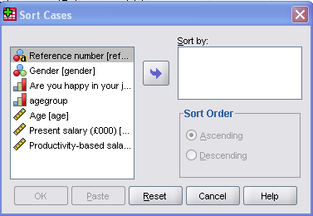

Click on Age and on the right arrow then OK.
(The arrow is or depending on which side of it has a highlighted variable.)

Change the data back to refno order by clicking on Data and Sort Cases. Deselect Age by clicking on Age and , then select Refno by clicking on Refno and , OK.

6) Inserting or Deleting cases

New cases can be inserted anywhere in the file.
If the file is sorted then new cases can be added to the end and the file re-sorted.
To insert a new case in a particular position in the file, click on the required case number position then click on the Insert case icon .
A blank case will now appear and the case data can be entered.

To delete a case just click on the case number then on Edit and Cut.
Now try i) inserting a new case (blank row) at any position
ii) then deleting it.

7) Inserting or Deleting Variables

To insert a new variable click in the column where the new variable is to be inserted then click on the Insert variable icon 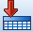 (or Edit, Insert Variable).
(The variable name and format can now be entered by clicking on the Variable View tab at the bottom of the screen.)
To delete a variable just click on the variable name then on Edit and Cut.

Now try i) inserting a new variable (blank column) at any position
ii) then deleting it.

8) Searching for Data Items and Selecting Cases

a) Searching for a particular data item

To search the file for a particular data item click on the variable column containing the required data item, then click on the Find icon
(or Edit, Find).
To find a case with salary 25.1 click in the salary column then on
Type 25.1 in the Find box.
The search window should appear as:

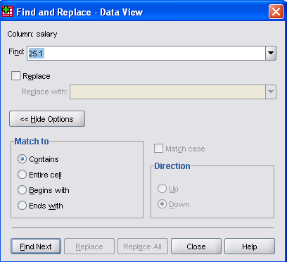

Click on Find Next. The search should stop at the case with salary 25.1. Now click on Close to view the case. If the data cannot be found, or the search is in the wrong direction then the message “Not Found” is displayed.
If a data item occurs more than once then you need to click on Find Next again after the first data item is found.

Now try searching for i) a 25 year old employee
ii) any 21 year olds.
b) Selecting Cases

The file can be searched for cases satisfying a particular condition e.g. Agegroup =3, and the selected cases printed, saved as a separate file, or used in a statistical analysis.
Cases are selected using Data, Select Cases to give:

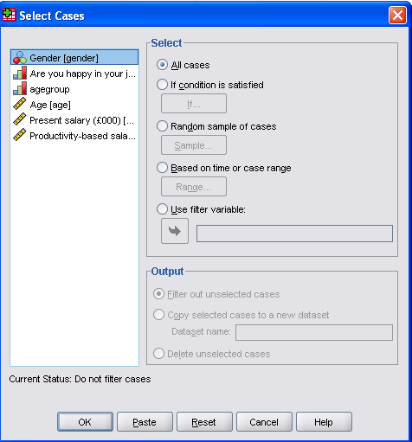

Now select If condition is satisfied and then click on If to give:

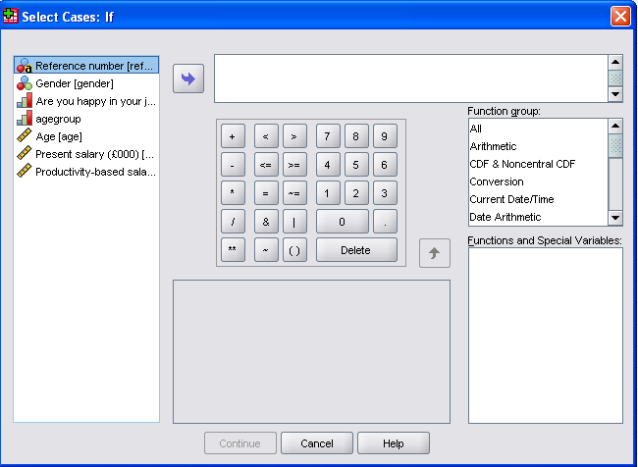

Click on Agegroup then . Now click on and type 3.
Click on Continue then OK.

The unselected cases can be seen in the data file with a line through their case numbers.
An extra variable filter_$ is also created with value 0 for unselected cases and value 1 for selected cases.

The data file appears as:
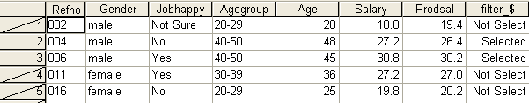

c) Output of selected cases

Selected cases can be displayed as output, and can be printed if required.
Select Analyse, Reports and Case Summaries to give:

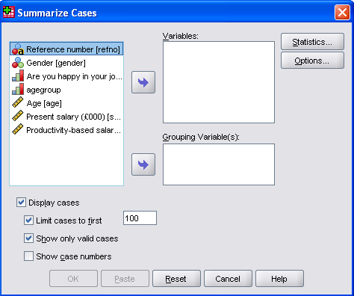

We can select any combination of variables to be included in the listing. All the cases should be Agegroup = 3, and so Agegroup and Age can be omitted.
Select Refno., Gender, Jobhappy, Salary, Prodbsal then OK.

The following output should be displayed:
The Case Summaries will be:

- Printing the Output

This table can be printed by clicking on it then on File, Print and Selected Output.

- Editing the Output

Any part of the output can be edited by double-clicking on the required table and double-clicking a second time on the required item to allow editing. Click anywhere outside the table the output to end the editing.

Ex: Change the heading to Case Summaries for agegroup = 3.

d) Changing the selection

Return to the data editor by clicking on
Undo the selection by clicking on Data, Select Cases, Reset and OK.

Now try selecting all females using Gender = 2, and display only the variables Refno., Jobhappy and Age in the output.
Then reset.

Now try selecting the following employees, displaying all variables in the output.
i) those over 45 years old. (then reset)
ii) those who are male and jobhappy (and is & ) (then reset)
iii) those who are either over 45 or have salaries over 25.0 (or is ⏐) (then reset).
Descriptive Statistics with SPSS

We will now consider a selection of ways of analysing the data and displaying
the results. This first section does not involve any significance testing.

9) Frequency table and Percentages

a) Obtain a frequency table for the agegroup variable.

Click on Analyse, Descriptive Statistics and Frequencies to give:

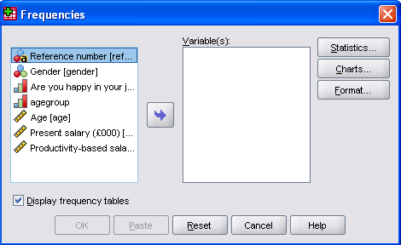

Click on Agegroup and the right-arrow .
Click on Charts, Bar charts and Continue, OK.
(Obtaining a bar-chart is normally optional)
The following output is displayed in the output window:

Note: i) The output shows value labels 20-29 etc. (if any).
- The valid percentage is the same as the percentage in this case. However if there was a blank cell i.e. a value missing in the data, the valid percentages would be calculated out of 29 not 30.
iii) The cumulative percentages show the percentage up to and
including that value e.g. there are 70% up to 39 years old.
b) Bar-chart Option

The chart should appear as:

10) Charts (without obtaining frequencies)

In SPSS v 17 there are a number of different ways to generate graphs which
can be seen by clicking on the menu bar.
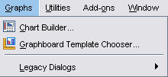

The option Legacy Dialogs is consistent with procedures available in earlier versions of SPSS, but more experienced users may choose to experiment
with the alternative approaches to producing more interactive graphs.

a) Obtain a pie-chart for the jobhappy variable

Click on Graphs, Legacy Dialogs and Pie.

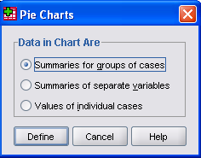

Select Summaries for groups of cases and click on Define to give:

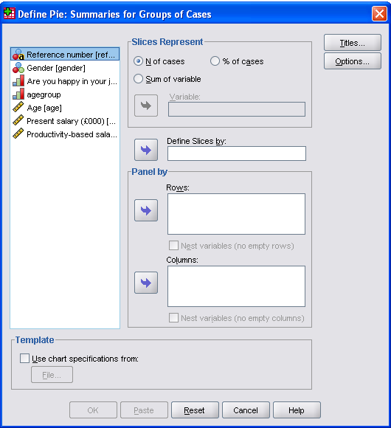

Click on Jobhappy and on the “Define Slices by” arrow ..
N (umber) of cases should already be selected for Slices Represent.
Click on Titles, type in Happy Employees?, and click on Continue, OK.

Editing the Chart (Add labels)
Click and then double-click on the Chart and the SPSS Chart Editor window should appear.

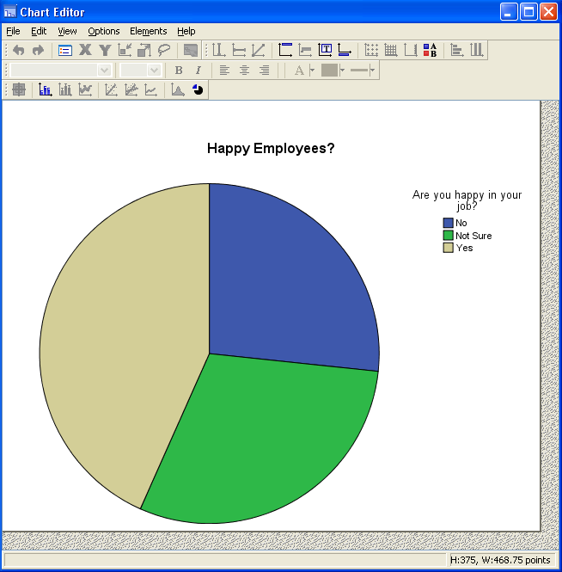
Click on the pie chart and it should then be highlighted with a blue border.
Click on Elements, Show Data Labels and the Properties window automatically appears for further editing. At this stage it is possible to change the labels, colours, titles or chart type. Close the Properties window to show the following chart.

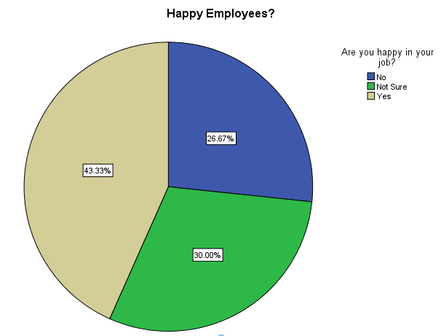

Changing the chart type

Double click on the pie chart in the Chart Editor to highlight again with a blue border. In the Properties window, click on the Variables tab and change the Element type from Pie to Bar from the drop-down menu, Apply, Close.

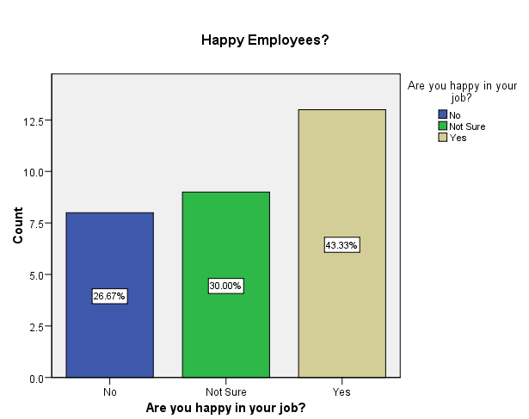

Editing the Bar Chart

Change bar colour to white:
Double click on the bars and the Properties window should appear. Alternatively the Properties window can be opened with a right click over the selected bars.
Click on the Fill & Border tab, select each bar in turn, click on Fill and change the colour to white by clicking on the white rectangle, Apply.

Change bar style to drop shadow
Click on the Depth & Angle tab and click on Shadow under Effect, Apply, Close.

Remove the Legend
Double click on the legend and press delete on the keyboard

Change position of bar labels
Double click on the bar labels in the centre of the bars.
In the Properties window click on the Data Value Labels tab.
Click on Custom under Label Position and click on the Above Center icon.
Apply, Close.

Edit the Axis Label
Click on the vertical axis label and then click on it again to change it to Percentage of Employees.
The edited chart should now appear as:

Close the Chart Editor window when editing has been completed

b) Cluster Bar Chart for gender and agegroup

Select Graphs, Legacy Dialogs, Bar, Clustered, Define to give:

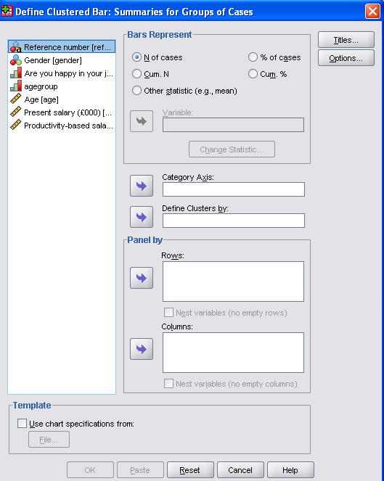

Select Agegroup for the Category Axis, Gender for Define Clusters by.
Add a Title, Continue, OK. The following chart appears, displaying a bar for each combination of Agegroup and Gender:

The frequencies and percentages represented by each bar can be displayed using cross-tabulations as shown in the next examples.
11) Cross-tabulations

a) Cross-tabulation of gender and agegroup

Produce a cross-tabulation between gender and agegroup to show the frequencies in each possible combination of the gender and agegroup values.

Click on Analyse, Descriptive Statistics and Crosstabs.
Select Gender for the row variable and Agegroup for the column variable, OK.

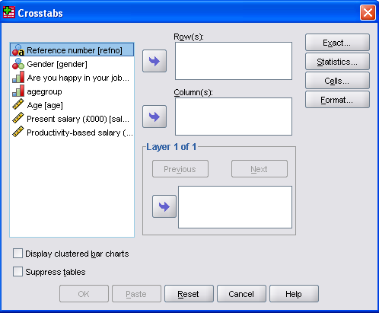

The output includes:
Now click on the Go to Data Editor icon to return to the data.

b) Cross-tabulation of Gender and Jobhappy

Row, column or total percentages can be obtained together with frequencies.
Click on Analyse, Descriptive Statistics and Crosstabs.
Select Gender for the Row variable and Jobhappy for the Column variable.
Click on Cells and select Row under Percentages, Continue and OK, to give the following:

This shows that 10 out of 15 or 66.7% of females are happy with their jobs, whereas 3 out of 15 or 20% of males are happy with their jobs.

12) Histograms

A histogram is used with quantitative variables to show the frequencies within a number of class intervals.

Histogram of salary

Click on Graphs, Legacy Dialogs, Histogram, select Salary for the variable.
Click on Titles and type Histogram of Present Salary
Click on Continue, OK, to give:

SPSS has used 8 intervals in the construction of the histogram.
The mean salary, standard deviation and number of values are also displayed.

Editing the Histogram

Double-click on the Histogram to view the SPSS Chart Editor.

To change the Bars to White

Double click on the bars and click on the Fill & Border tab in the Properties window. Click on Fill and then change the colour of the bars to white by clicking on the white rectangle, Apply, Close.

To improve the labelling

Double click on the Salary Axis to open the Properties window.
Click on the Scale tab.
For Major Increment deselect Auto and enter 2.5 under Custom, Apply, Close.
Click on the Frequency Axis Title, and then click again to edit the title. Change the title to Number of Employees.
Close the Chart Editor window.

Note that the boundary values of the intervals are labelled on the histogram.
In some cases SPSS labels the mid-points of the intervals.
This is dependent on the convenience of the data.
13) Averages and Measures of Spread

The mean, number of values and standard deviation are automatically displayed with a Histogram.

Frequencies (Analyse, Descriptive Statistics, Frequencies) has a Statistics option which will display such things as mean, median, mode, sum, standard deviation, maximum, minimum, range, variance, percentiles, etc.

Descriptives (Analyse, Descriptive Statistics, Descriptives) will give a number of measures of average and spread under Options. Although there are fewer options than with Frequencies, the Frequencies tool is not always appropriate.

Descriptives for salary and prodbsal

Return to the data editor then select Analyse, Descriptive Statistics, Descriptives.
Select both Present salary and Productivity-based salary for the variables and click on Options to give:

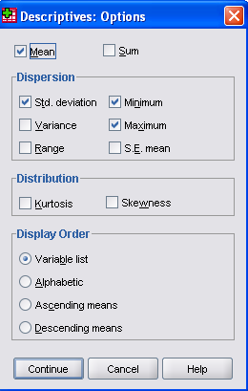

Select Mean, Std. deviation, Maximum and Minimum, Continue and OK.
The output should be:

14) Comparison of Means

Summarising data for different groups of people can be displayed using a table of means and a bar chart of means.

a) Table of Mean Salaries for Gender and Jobhappy

Select Analyze, Tables, Custom Tables. Click OK to the dialogue box which provides advices on the use of variables within Custom Tables.

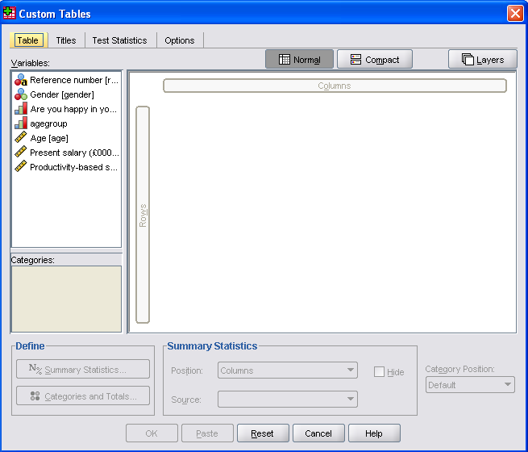

‘Click and drag’ the variables with Jobhappy for Columns and Gender for Rows.
The following table will be generated.

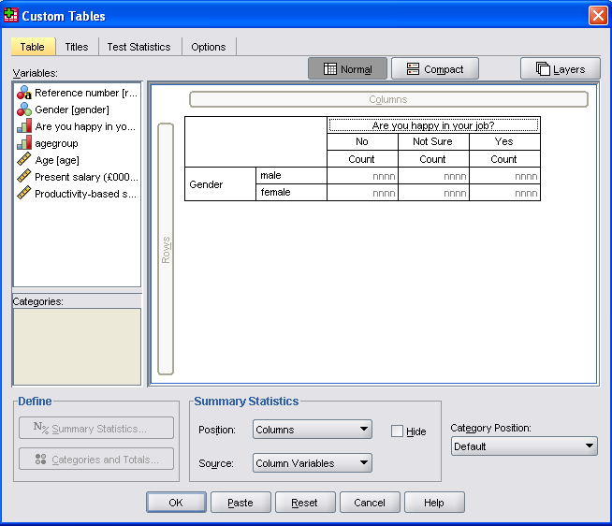

Click and drag Salary to replace the Count for the cells of the table and the Mean will automatically be generated.

Click on the Titles tab and type Mean Salaries of Employees under Title. Continue, OK.

b) Bar Chart of Mean Salaries for Gender and Jobhappy

Select Graphs, Legacy Dialogs, Bar, Clustered, Define.
Click on Other statistic under Bars Represent.
Select Salary for Variable.
(Note that the mean score is selected as the default, but other statistics could be selected by clicking on Change statistic).
Select Jobhappy for the Category Axis and Gender for Define Clusters by.
Click on Titles and type Mean Salaries of Employees, Continue, OK.

15) Reporting a Statistical Output

It is useful to be able to insert relevant tables or charts into a word processed
document as part of a report on statistical analysis.

To transfer SPSS output to a WORD document:
Use the output created from the Comparison of Means in the last analysis.

Click on the table of means from the output and this should now be surrounded by a border with a red arrow on the left-hand side.
Select Edit, Copy.
Minimise SPSS by clicking on the minus sign in the top right-hand corner of the screen. Similarly, it may be necessary to minimise the data editor, by clicking on the minus sign in the top right-hand corner of the screen.

Load WORD and type in:
The results below show the analysis of the mean salaries for gender and jobhappy.
Press the return key twice on the keyboard.
Then select Edit, Paste Special, click on Picture, OK.
(Note that Edit, Paste does not always produce the best results for inserting SPSS output into WORD documents and hence Paste Special is a preferable alternative, especially for tables).

The selected output should now be pasted into the WORD document.
Press the return key twice on the keyboard before minimising WORD and returning to the SPSS output (this should be seen as an icon at the bottom of the screen).

Click on the Bar Chart of Mean Salaries of Employees and repeat the process:
Edit, Copy, minimise SPSS.
Return to WORD and select Edit, Paste, OK.
(Note that this time there is no Picture option in the Paste Special, and Paste gives the best results).

Notes

(i) The size of the output table can be changed by clicking and dragging the small squares on the sides of the border of a selected table.

- The titles of the tables have to be copied and pasted separately, but it may be preferable to type these directly into the WORD document as an alternative.

(iii) Insert, New Text can be used as an alternative to add text to the SPSS output.

