Student name: | Husain Younis Adam Arman | Student P number: | 2024676
Programme: | Built Environment Programmes – Level 4. BSc (Hons) Construction Management; BSc (Hons) Quantity Surveying; BSc (Hons) Building Surveying; BSc (Hons) Civil Engineering. HNC and HND pathways.
Module: | Construction Technology - Past and Present | Module Level (4, 5, 6): | 4
Module code: | ACBA4010 | Contribution to Overall  Module Assessment (%): | 100%
Lecturer: | Dr Jamiu Dauda & Sheila Holmes | Internal Verifier: | Dr Deborah Hughes
Assignment Title: | Domestic Building Components and their Functional Requirements | Assignment No (x of x): | 1of 1
Hand Out Date: | Week Commencing 15th March, 2021 | Submission deadline: | 7th May, 2021

1.Functional Requirements of Walls in Building Construction

I. Strength requirements of walls
The strength of the material used to make the divider, just as the way in which the materials are assembled, decide the divider's solidarity needs. Materials' compressive and rigidity, which might be confirmed through testing, decide their solidarity. To register admissible material strength, extreme qualities at disappointment are gathered from testing tests and a strength decrease factor is added to a definitive strength. This element is utilized to represent changes in material strength just as their response to stressors. Materials that might be utilized to construct dividers incorporate stone, block, steel, and cement. In most unobtrusive structures, for example, abodes, the total compressive strength of blocks and stones isn't utilized to guarantee the practical solidness of the construction.
II. Stability requirements of walls
The establishment's solidness, load capriciousness, temperature impacts, parallel loads, for example, seismic tremor and wind burdens, and dampness changes all play a part in divider security. The divider's tendency to topple is brought about by loads that don't follow up on the divider's center, like burdens from rooftops and floors, just as sidelong loads. At the point when both sidelong and flighty burdens rise, divider twisting happens, making the divider unsteady. Construction laws indicate the tallness and broadness of dividers to keep loads from causing flimsiness. Besides, even limitations, for example, the association among dividers and rooftops and the intersection of dividers and docks forestall horizontal burden bending. At the point when both sidelong and unconventional burdens rise, divider twisting happens, making the divider shaky. Construction laws determine the stature and expansiveness of dividers to keep loads from causing precariousness. Besides, level limitations, for example, the association among dividers and rooftops and the intersection of dividers and wharfs forestall horizontal burden mutilation. Moreover, in light of the fact that brace activities are initiated in the previous, dividers with unpredictable setups, for example, those portrayed in Figure-1, are more steady than ordinary straight dividers.
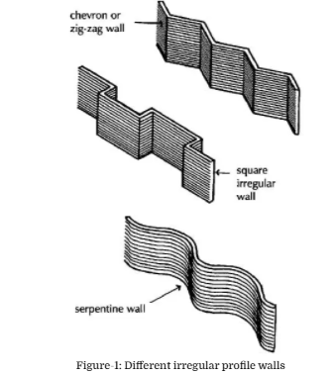
III. Weather and ground moisture resistance of walls
Dampness (water fume and fluid water) that might penetrate establishment dividers by retaining water from the beginning precipitation falling on the dividers ought to be very much ensured. For all establishment dividers over the ground level, a clammy resistant layer with a thickness of 150 mm can be utilized. This might thwart water assimilation from the earth, which may have adverse results if not tended to properly. How much water that might penetrate dividers is controlled by various elements, including the nature of the materials utilized, how those parts are collected, and the overarching winds. There are various answers for situations, for example, utilizing thicker dividers, developing two skins of block, stone, or square dividers with a 50 mm space between them, cladding or putting the outside substance of the divider, and utilizing a glass sheet as a shade divider. Besides, natural components like slopes, trees, or other assembled structures close by ought to be viewed as when setting up proper arrangements, as these might modify the seriousness of openness conditions to winning breezes that immediate downpour on the dividers.
IV. Durability requirements of walls
The recurrence and amount of work important to cause a divider to fulfill the insignificant useful and tastefully satisfactory rules decides the divider's strength. The limit of the divider to oppose downpour and its warm characteristics are instances of practical necessities. It's hard to characterize a standard satisfactory divider look, especially when extraordinary materials like glass and plastic sheets are utilized. This is because of the way that the base satisfactory look changes from one individual to another. This isn't true, be that as it may, when conspicuous materials are utilized, for example, top notch blocks or stones picked with care. On the off chance that great consumed blocks and excellent mortars are utilized, adequate consideration is paid to divider openings, and openness conditions are tended to, a block facade will be sturdy and require no fixes during its lifetime. At the point when lime mortar is utilized to assemble block facades, it should be repointed to forestall dampness entrance and reestablish a satisfying look.
V.Fire safety requirements of walls
The first and most critical protect against fire is to give a simple method for getting away from it, in light of the fact that the tenants' lives will be in hazard because of gases and smokes in the beginning phases of the fire. The subsequent component is fire security, which incorporates restricting coating, primary, and outside fire spread, just as giving admittance to firemen. The cutoff points are implemented by requiring imperviousness to fire for dividers and determining the combustibility of the materials used to cover inside dividers and ground surface.
VI. Resistance to heat passage
Containing heat and forestalling its misfortune is basic since it permits structures to accomplish financially savvy, alluring, and lovely warm conditions. To limit inordinate hotness misfortune, it is exhorted that a thermally protected divider be developed. The utilization of light weight, low conductivity materials can assist decline with warming misfortune. Besides, when contrasted with lightweight materials with helpless conductivity, thick high conductive materials have a more prominent potential for heat stockpiling. On the off chance that a construction has a steady wellspring of hotness, it's smart to use low-thickness materials on the outside and high-thickness materials on the inside of the divider. Utilizing light-weight materials, then again, is helpful when the design is warmed irregularly.
VII.Sound resistance of walls
The two strategies for sound transmission are sway and airborne. The last option is brought about by repeating air aggravations from a source like a radio, though the previous is brought about by an effect on strong surfaces, for example, footfall, which make floor vibration, which causes the air encompassing it to vibrate and be heard as solid. Substantial dividers, empty dividers, and strong dividers are instances of high-thickness materials that can be used to close off airborne commotion. In any case, since sway commotions travel quickly through thick materials, materials that can pad or stop the effect sound's course ought to be utilized.
2.Durability requirements of walls
Numerous homegrown and worldwide offices have researched the utilization and life span of huge board structures raised a very long while back [1,2,3]. While surveying the drawn-out suitability of different enormous board frameworks, it's critical to assess the most common way of developing outside dividers, in addition to other things. They are quite possibly the most basic parts of a design, deciding its reliability by bearing impressive loads from climate effect. Rather than the heap bearing layer, the outside layer of an outer divider concentrated in this work is described by extreme, variable working conditions. The outside layer is a warm protection and burden bearing layer that secures steel associations as holders and pins from consumption [4]. It additionally ensures steel connectors as holders and pins from mechanical and climate impacts. It straightforwardly affects the primary layer's constancy. That is the reason, furthest degree attainable, the outside layer's substantial should be of superb quality and impervious to carbonisation. A very long while of activity, gathering flaws, creation disregard [5, 6], and an absence of proceeding with support [7] have prompted the end that the shade dividers need fitting security and address a risk to people and property.
I. Characteristics of the building
The plant being scrutinized was placed into administration in 1986. It was assembled utilizing the enormous board technique and the R-76 interaction framework, which has been modernized. It is a variety of the PLP – Rataje framework, which was created after the 1974 arrival of the Design Technical Standard (in Polish: Normatyw Techniczny Projektowania) and the mid 1980s presentation of another hotness standard [11]. As per the material specialized models [12], the structure has 13 overground levels (2 help and business and 11 private), and accordingly ought to be named "high" (in Polish "wysoki" signifies "high") structures.
II. Survey of the external layer's condition
The investigation of the façade and resulting testing were facilitated with the continuous work on working on warm productivity. Therefore, the review region was restricted to a segment of a divider with extra loggias and an end divider with two columns of boards on the front facing façade.
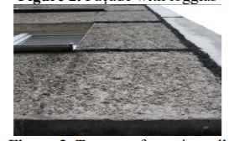
III. Thickness of carbonisation, SEM and EDS analyses of the external layer
The phenolphthalein strategy was utilized to check the scope of carbonation in the relieved cement of the outside layer - the standard [15] clarifies the tests' system. The estimations were gathered utilizing cored boreholes bored into the structure's façade. The measurement of the example is around 44 mm, and the length is dictated by the thickness of the outside layer. A water powered press was utilized to isolate the boreholes. Under packed air, the split surfaces were cleaned of free particles.
Photographs of the difference in shading in specific separated segments were taken after a 2 percent arrangement of phenolphthalein was applied and a slip by of c. 30 seconds.
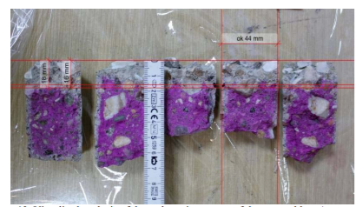
Miniature region of the outside layer for substantial corruption because of destructive impacts of the climate for more than 30 years were examined utilizing SEM and EDS. Figure A depicts a micrograph of the substantial surface, while Figure portrays the stage structure of the substantial as far as connection with the climate and in a layer 9 cm beneath the surface.
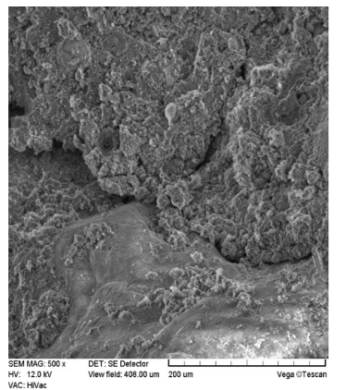
The diagrams portray the corruption of cement. Figure portrays the maturing of the surface layer, which incorporates the draining of Ca and Si (substantial's essential constituents) and an ascent in the amount of C, S, and K. (carbonation, corrosive downpours).
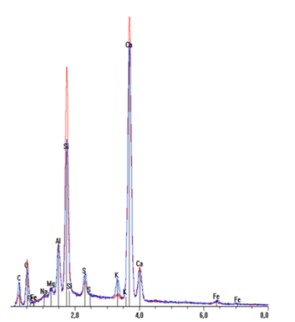
IV. Concrete hardness
Strength estimates like as hardness and compressive strength should be utilized to evaluate the condition of the substantial of the outside layers. The main boundary, just as, in a roundabout way, the other, still up in the air using non-disastrous sclerometric testing with a Schmidt sclerometer. A N type gadget was utilized in the analysis, and the strategic standard [16] was kept. The temperature during activity was 20-25 degrees Celsius, and the tried cement of the outside layer was air-dry. Each time the part was estimated, the surface layer of coarseness was broken and the surface was ground and smoothed with a wire end. A mallet was put opposite to the testing surface each time. 9-12 estimations were taken at 6 areas on every part, bringing about the registered ordinary strength fck for 13 tried boards of the outside layer. The discoveries were acquired utilizing the program "Motek Schmidta N [in Polish: N Schmidt hammer] EU PRO v.3.80" from Motek Schmidta. Directing the test on a part that was not firm enough may bring about critical errors in the estimation. The part's base thickness ought to be 100 mm, as per the rules. Besides, the outside layer's attributes incorporate its suspension from the loadbearing layer, which lessens firmness significantly further. Therefore, part vibrations got a piece of the smash's energy.
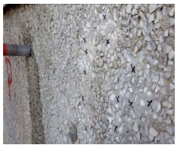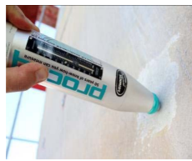
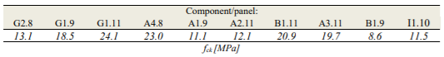
V.Compressive strength
The design's cored boreholes were utilized to exactly decide the compressive strength of the outside layer concrete. For the test, five façade boards were picked. Every one yielded three boreholes with a breadth of c. 43-44 mm. A nonimpact drill was utilized to penetrate the boreholes. In the wake of introducing the K2-type steel substance secures, the examples were slashed to diminish a risk presented by the primary debilitating (by the Inwestbud organization). Inside the performed warm effectiveness redesign, the structure the executives arranged the gathering of the supporting associations.
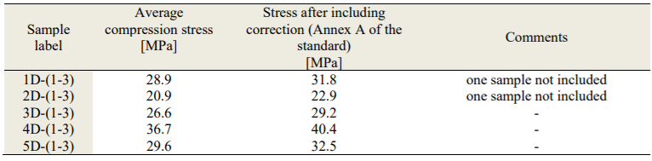
VI. Reinforcement location
An expected position, a measurement, and a covering of the outside layer's support (Figure) were characterized using Hilti's Ferroscan PS200 ferromagnetic gadget. The estimations were completed in accordance with the client guidelines for the gear [18]. Three 180x180 cm blocks (Figure 18) and ten 60x60 cm pictures were examined altogether to set up the support's particular spots, including the steel holder's situating and securing (Figure). The investigation of the checked pictures uncovers the utilization of a support network (in the outside layer) with even two-side dividing of 20 to 22 cm and rebar widths of 6-8 mm.
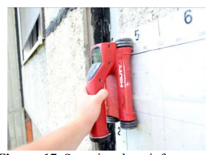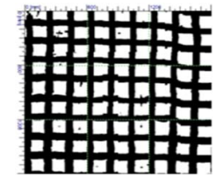
VII. Adopted repair method
The hidden reason of the speculations is to further develop client solace by upgrading warm protection of outside dividers and working on the presence of the façade. The significance of primary support and upkeep was likewise stressed. The accompanying procedures of fix and modernization were picked:
- The slacking process – the "ETICS" gentle wet methodology
- K2 steel associations are utilized to synthetically fix specific layers of triple-layer outside dividers.
- Filling the creases of pre-assembled parts with polyurethane sealant as an optional advance
- fixing breaks and scratches in the harmed overhang loggias' boards utilizing PCC II/III sort fix mortar
- A steel stem and a tension screw are built of erosion safe steel, ideally A4 grade. Vinyl-ester or epoxy-acrylic sap should be utilized to append the associations. The made anchors have a greatest length of 210 mm and a width of 20 mm.
References
- Ching, F.D., 2020. Building construction illustrated. John Wiley & Sons.
- Addis, W., 2007. Building: 3000 years of design engineering and construction (Vol. 601). London, UK: Phaidon.
- Stone, P.A., 1983. Building economy.
- Chudley, R. and Greeno, R., 2006. Building construction handbook. Routledge.
- Assaf, S.A., Al-Khalil, M. and Al-Hazmi, M., 1995. Causes of delay in large building construction projects. Journal of management in engineering, 11(2), pp.45-50.
- Allen, E. and Iano, J., 2019. Fundamentals of building construction: materials and methods. John Wiley & Sons.
- Zavadskas, E.K., Antucheviciene, J., Vilutiene, T. and Adeli, H., 2018. Sustainable decision-making in civil engineering, construction and building technology. Sustainability, 10(1), p.14.

