University of Wales Trinity Saint David.London.Winchester House.11CranmerRoad.Vassal Sw9 6EJ. Business and management . The global business investment.(lCBB4005) Assessment1.October21.Weekend Study.Group2 Dobri Hristev Kachulev (2113193).

Environmental Analysis of Automobile Industry

Executive Summary
The report discussed the concept of the global business environment along with its key aspects to sustain the business in the international market. The ideas of internal and external factors that are responsible for influencing the company operation were analysed. Moreover, this area has been identified through PESTEL and SWOT analyses. Within this report, a summarised viewpoint of Porter's five forces of Aston Martin company has also been depicted for evaluating the factors affecting Aston Martin. The value chain model along with the VRIO framework was also implemented for better analysis of sustainability factors.

Table of Contents
Introduction 4
Findings 5
Conclusion 14
Reference List 15
Appendices 18
Appendix 1: PESTEL ANALYSIS 18
Appendix 2: SWOT Analysis 19

Introduction
The global business environment reflects the worldwide factors that are beyond the control of the organisation and are responsible for influencing the decision-making process. The major importance of having a business in the international market is that it strategically improves the brand value among the consumers. Along with that, it assists in the contribution of advanced technology and also acquires investment capital for the organisation. In the assignment, the concept related to operating a business globally along with the challenges is framed in a scrutinising manner. To analyse the internal and the external factors of growing a business globally, SWOT and PESTEL analysis has been performed here. In addition to that, essential aspects like Porter's five factors along with the value chain model and VRIO analytical aspects will also be implemented for evaluating company potential.
Aston Martin
Aston Martin is a well-known and highly recognised luxury sports car brand. The products belonging to Aston martin is popular for their elegance, beauty, innovation and others which glorifies its brand image in the automobile industry (astonmartinlagonda, 2021). It was founded in the year 1913 by Lionel Martin and Robert Bamford and its head office is located in England, UK. With its exclusive business model, the brand has successfully sold 1,455 cars in the UK market and has made a profit of around £ 1.1 billion (statista.com, 2020).

Findings
Concept of International Market
The market of a company located beyond its geographical location has been called as International market (Watson et al., 2018). To operate the functions in the international market, the companies need to make sophisticated plans that will suit the operations that also empowers the concept of international business. Along with that, international business refers to the import and export of goods and services across the national borders at a global level (Buckley et al., 2018). The main importance of operating a business in the international market is that, with this, trade relations of the companies get improved and it moreover enhances the brand value of the organisation. The key benefits of international business are that it helps in improving the selling of the products to specific nations to achieve organisational objectives.
Challenges faced while operating international business
During the operation of international business, organisations face several challenges which are grouped into internal and external factors. The external challenges are being considered as the macro factors which are out of the control of the company and are playing a major role in influencing the functions of the organisation. Apart from this, the internal factors refer to the conditions that are been caused due to the internal matters consisting of operating performance, employees matter and all. The external and the micro aspects determining the changes in the company are explained with the help of the following PESTEL analysis.
PESTEL Analysis
PESTEL analysis refers to the evaluation of the external macro factors that are responsible for a huge impact on businesses. (Refer to appendix 1)
Factors | Effects on the Automobile industry
Political | - The government of different country operates their trade barriers on a variant scale which directly influence the profit margin of the company (bbc.co.uk, 2021).  - The political aspect also guides the business by fluctuating VAT on the products.  - With the major decisions of the company, the export and import of the businesses might also affect which moreover impacts the trade values.
Economical | - Due to the impacts of the pandemic, global GDP gets lowered down to 84.54 trillion dollars which are considered three times lower when it gets compared to 2019 (Neill, 2021).  - With the downfall of the GDP, automobile production reduced by 44.6% (smmt.co.uk, 2020).  - With the impacts of Covid-19, the inflation rate decreased to 3.2% in the year 2020 which then improves to 3.5% in the 2021 post-pandemic period (Neill, A., 2021).
Social | - Impacts of a pandemic have caused shortages of staff along with the rise in the demand for petrol, which directly affects the livelihood of the people.  - Due to the rise in the cases of Covid-19, the lifestyle of people also changes. People are switching their concerns to essential products like health factors, food than the non-essential ones (bbc.co.uk, 2021).  - This has suppressed the market of the automobile industry.
Technological | - Pandemic issues have forced businesses to operate remotely.  - Due to the imposition of lockdown, people around the globe have embraced internet solutions.  - Social media usage has increased among people. It has been found that 2.81 billion active users have social media accounts (statista.com, 2021).  - Moreover, it has accelerated the digital marketing aspects of the companies.
Environmental | - In the contemporary world, the business needs to empanel its operations with environmental legislation.  - As per the UN rule, the companies have to focus on climatic issues like declining carbon content and also have to consider sustainable trends (Plummer and Timmins, 2021).
Legal | - Every business has to inculcate employment legislation laws which are mending to attain the prosperity of the workers of the organisation.  - For trading in the international market, the corporation must have to encompass the trade rules and tariffs that are regulated by the world trade organisation (wto.org, 2021).
Table 01: PESTEL Analysis for the global business environment for the automobile industry
(Source: Created by the learner)
SWOT Analysis
SWOT Analysis is considered as a technique that helps in the identification of the four major aspects of the businesses like Strengths, Weaknesses, Opportunities and Threats (GURL, 2017). This plays a major role in identifying internal factors of the companies which are essential for the development of the business.
(Refer to appendix 2)
Strengths | Weaknesses
- Highly experienced and well-qualified leaders in the team empower the leadership aspects of the corporation (astonmartinlagonda.com, 2021).  - Tactical tax strategies have been implemented by the company to manage the tax affairs along with the maintenance of relations with tax authorities (astonmartinlagonda.com, 2021). | - The high horsepower engines such as AMG V8 and the DB11 V8 are used in Aston MARTIN CARS (topgear.com, 2021). This is very expensive in terms of fuels and thus, this factor influences customer behaviour.  - The manufacturing of Aston Martin vehicles is facing liquidity issues.
Opportunities | Threats
- It has been proclaimed that the automobile sector will hike with 205 million Units by 2028 at a rise of 4.5% CAGR (globenewswire.com, 2021).  - With an emerging sale of 88 million units of light vehicles, the automobile industry is recovering (Carlier, 2021). | - Due to the accumulation of large brands in the automobile industry, competitors have evolved in this sector.  - Owing to considerations of sustainability, people are shifting their views on electric vehicles that are less polluting.  - As a result of Covid-19, markets shifts are now unpredictable.
Table 02: SWOT Analysis
(Source: Created by the learner)

Porter’s Five Forces
Porter’s Five Forces refers to a scalable framework that assists the companies to analyses of its competitors that eventually helps in upgrading its operation (Varelas and Georgopoulos, 2017). It moreover analyses the actions of sustaining rivals and newcomers. Through the components of it, the analysis for Aston Martin is depicted following.
(Refer to appendix 3)
Competition in the industry
At present, the competition in the automobile industry has hiked due to the arrival of various companies. The sole rivals for Aston Martin are BMW, Porsche, and others. Moreover, with strategic approaches, the key rival of Aston Martin which is BMW has sold its 2.3 million cars in the global market, 2020 (Carlier, 2021). Considering this aspect, it has been marked that, the competition in the industry for Aston Martin is high.
Potential of new entrants into the industry
In the contemporary automobile market, there are already a lot of companies sustaining and among that, some of the companies have made their renowned image. Moreover, Aston Martin is popular across the world for its luxury and elegance (astonmartinlagonda, 2021). In addition to that, there are other well-known competitors like BMW, Porsche, and others who have also capitalised on the market. Thus, the threat of a new entrant for Aston Martin has been considered as low.
Power of Suppliers
The products of Aston Martin are well known for their super designed engines. The brand has framed its products with AMG V8 and DB11 V8, top-class engines and for that; they have established partnerships with Daimler AG (dw.com, 2021). Moreover, the company also has options of other engine manufacturers but due to top class recognition, Aston Martin has empanelled to Daimler AG. This has conceptualized that the power of sellers is Moderate.
Power of Customers
The increase in demand for vehicles has led to higher competition in the automobile industry. Also, the power of the customers has always been high as the customer behaviour rules the market and according to the perspective of the customers, the companies designed their products. With the increase in competition, people have the choice to buy the ultimate range of products.
Threat of Substitutes
Due to an increase in awareness among the people about sustainable products, people are more focusing on the electric vehicle over the petrol and diesel polluting cars. Apart from that, due to exclusive potential, people still have a preference for petrol vehicles over electric vehicles. This has made the threats of Substitutes for Aston Martin to fall in the Moderate section.
Value Chain
Value chain refers to a business model that assists the organisations by identifying the activities that are required to design the products that are suited for satisfying the customers. This also helps out the organisations in orienting the concepts of consumer behaviour which are needed for the better sustenance of the product. This value chain model will be essential for Aston Martin Corporation and are further been explained below.
Primary Activities
Inbound Logistics: Logistics depicts the concept of transporting and receiving the raw materials from the stakeholders for managing the resources. Considering this, Aston Martin has established key partnerships with Daimler AG for its advanced engine, AMG V8 which they used as a primary source in their car (dw.com, 2021).
Operations: Operation processes refers to the activities with the help of which, raw materials are being changed into the finished and the stabilised product. Relating with this concept, Aston Martin plays very well in proving elegance and luxurious products to the customers after processing out all the resources (astonmartinlagonda, 2021).
Outbound Logistics: In this stage, the products are ready to deliver to the customers by encompassing them with packaging, labelling and other factors. Aston Martin provides a high-quality product to the customers by managing all the outbound logistics like effective packaging and others.
Marketing and Sales: Sales and marketing are being considered vital factors for the companies to showcase the details of the products to the customers. Considering this aspect, Aston Martin has empanelled its vehicles in the sports race and also have collaborated with popular brands like Red bull for better marketing (redbullracing.com, 2021).
Service: Better service to the products helps in retaining customers. Acknowledging this concept, Aston Martin has located its body shops for great service value. Along with that, the brand has also empanelled key servicing offers for its customers (hrowen.co.uk, 2021).
Supporting Activities
Firm Infrastructure: It refers to the structure of the organisation where the company operates its missions and also manufactures its products. Procuring this standard, Aston Martin has developed its well-framed operating infrastructure in Warwickshire, England (astonmartinaustin.com, 2021).
Human Resource Management: HR officials play a major part in the organisation in terms of recruiting and hiring potential candidates for the firm. At Aston Martin, the HRM plays an efficient function to hire the right candidates for the effective functioning of the corporation.
Development of Technology: In this section, the technical information and the innovations are collaborated to design scalable products. At Aston Martin, Managers and leaders are having their prior attention to developing a technology that will be much efficient for the customers.
Procurement: It is the stage, where the companies are associated with the stakeholders to obtain key resources. Considering this stage, Aston Martin has developed a partnership with Daimler to obtain high engines at nominal cost, which eventually helps the company by improving its profit margins (dw.com, 2021).

Competence / Resource | Valuable | Rare | Inimitable | Organized | Competitive Status
Inbound Logistics | YES  It is valuable as this is important to prepare the products of Aston Martin. | NO  It is not rare as this is available to all the other brands. | NO  It is not inimitable as it is not rare. | NO  It is not organised because the same things are used by other organisations. | COMPETITIVE PARITY
Technology | YES  Technology is valuable to develop a new and innovative product. | NO  The technology is also used by other companies. | NO  It is not inimitable as this technology is not rare. | NO  This is not called organised as this technology is used by others also. | COMPETITIVE PARITY
Marketing and Sales | YES  It is valuable as Marketing and sales help in the selling of products. | NO  All the companies are using approximately the same marketing tactics to sell their products. | NO  The marketing strategy can be used by every company thus it is not inimitable | NO  These strategic approaches are not called organised as it is not inimitable. | COMPETITIVE PARITY
Human Resource Management | YES  It is called valuable as it helps in providing valuable employees to the companies. | YES  Yes, it is rare as the HRM strategy used in Aston Martin is different from every organisation. | YES  It is rare; thus it is inimitable. | YES  The aspects of HRM are called as organised as it adds specific values to the organisation. | SUSTAINABILITY COMPETITIVE ADVANTAGE
Table 03: VRIO Table
(Source: Created by Learner)
All the above-discussed factors in the VRIO table are very much essential in contributing their potential to the Sustainable core values of the company. The Inbound logistics are much important as maintaining key partnerships with the stakeholders could eventually provide the sustainable and desired parts which moreover uplifts the manufacturing values of the Aston Martin Products. The effective maintenance of technology could lead the company to innovate sustainable products which will attract customers more. Marketing and Sales help in effective selling of the products of the Aston Martin brand to the consumers by depicting its key features. In addition to that, with the assistance of Human Resource Management, more potential employees get empanelled to the operation of the company. Summing it all up, all the aspects are playing a vital role in sustaining the core values of Aston Martin Company.

Conclusion
The overall report conceptualises the concept of the Global business environment and the challenges faced by the organisations while operating their functions in the global market. In this assignment, with the help of PESTEL and SWOT analysis, the evaluation of the external and the internal challenges was covered. In addition to that, Porter's five forces framework has been implemented in this report to highlight the major and the key aspects of the Aston Martin Company. The elements of the Value chain model along with the VRIO model has been also discussed to identify the potential components of the company and also evaluate their sustainability to the core values of the companies.

Reference List

astonmartinaustin.com, 2021. WHERE ARE ASTON MARTINS MADE? [Online] Available at: https://www.astonmartinaustin.com/where-are-aston-martins-made/ [Accessed 22 December 2021]
astonmartinlagonda, 2021. ABOUT US [Online] Available at: https://www.astonmartinlagonda.com/about-us [Accessed 21 December 2021]
astonmartinlagonda.com, 2021. LEADERSHIP [Online] Available at: https://www.astonmartinlagonda.com/about-us/governance/leadership [Accessed 22 December 2021]
astonmartinlagonda.com, 2021. TAX STRATEGY [Online] Available at: https://www.astonmartinlagonda.com/investors/corporate-governance/tax-strategy [Accessed 22 December 2021]
bbc.co.uk, 2021. External factors [Online] Available at: https://www.bbc.co.uk/bitesize/guides/zgfrpbk/revision/2 [Accessed 21 December 2021]
bbc.co.uk, 2021. External factors [Online] Available at: https://www.bbc.co.uk/bitesize/guides/zgfrpbk/revision/4 [Accessed 22 December 2021]
Buckley, P.J., Enderwick, P. and Cross, A.R. eds., 2018. International business. Oxford University Press.
Carlier, M., 2021. Automotive industry worldwide - statistics & facts [Online] Available at: https://www.statista.com/topics/1487/automotive-industry/ [Accessed 22 December 2021]
Carlier, M., 2021. BMW Group's global automobile deliveries from 2007 to 2020 [Online] Available at: https://www.statista.com/statistics/264342/global-sales-volume-of-automobiles-of-bmw-group/ [Accessed 22 December 2021]
dw.com, 2021. Daimler plans larger stake in James Bond carmaker Aston Martin [Online] Available at: https://www.dw.com/en/daimler-plans-larger-stake-in-james-bond-carmaker-aston-martin/a-55415475 [Accessed 22 December 2021]
globenewswire.com, 2021. Automotive Industry to grow 205 Million Units by 2028, registering a CAGR of 4.5% - Report by Market Research Future (MRFR) [Online] Available at: https://www.globenewswire.com/news-release/2021/10/07/2310152/0/en/Automotive-Industry-to-grow-205-Million-Units-by-2028-registering-a-CAGR-of-4-5-Report-by-Market-Research-Future-MRFR.html [Accessed 22 December 2021]
GURL, Emet. "SWOT analysis: A theoretical review." (2017).
hrowen.co.uk, 2021. ASTON MARTIN SERVICING AND AFTERCARE [Online] Available at: https://www.hrowen.co.uk/aston-martin/aftersales/ [Accessed 22 December 2021]
Neill, A., 2021. Global gross domestic product (GDP) at current prices from 1985 to 2026 [Online] Available at: https://www.statista.com/statistics/268750/global-gross-domestic-product-gdp/ [Accessed 22 December 2021]
Neill, A., 2021. Global inflation rate from 2016 to 2026 [Online] Available at: https://www.statista.com/statistics/256598/global-inflation-rate-compared-to-previous-year/ [Accessed 22 December 2021]
Pan, W., Chen, L. and Zhan, W., 2019. PESTEL analysis of construction productivity enhancement strategies: A case study of three economies. Journal of Management in Engineering, 35(1), p.05018013.
Plummer, A., and Timmins, B., 2021. COP26: UK firms forced to show how they will hit net zero [Online] Available at: https://www.bbc.com/news/business-59136214 [Accessed 22 December 2021]
redbullracing.com, 2021. Aston Martin Partnership [Online] Available at: https://www.redbullracing.com/int-en/driving-future-innovation [Accessed 22 December 2021]
smmt.co.uk, 2020. UK car manufacturing falls -44.6% in August as coronavirus bites again [Online] Available at: https://www.smmt.co.uk/2020/09/uk-car-manufacturing-falls-44-6-in-august-as-coronavirus-bites-again/ [Accessed 22 December 2021]
statista.com, 2020. Aston Martin car sales in the United Kingdom (UK) from January 2016 to December 2018 [Online] Available at: https://www.statista.com/statistics/385338/aston-martin-car-sales-in-the-united-kingdom/ [Accessed 21 December 2021]
statista.com, 2021. Most popular social networks worldwide as of October 2021, ranked by number of active users [Online] Available at: https://www.statista.com/statistics/272014/global-social-networks-ranked-by-number-of-users/ [Accessed 22 December 2021]
topgear.com, 2021. The boss of AMG is now running Aston Martin [Online] Available at: https://www.topgear.com/car-news/boss-amg-now-running-aston-martin-0 [Accessed 22 December 2021]
Varelas, S. and Georgopoulos, N., 2017. Porter’s competitive forces in the modern globalized hospitality sector–the case of a Greek tourism destination. J Tour Res, 18, pp.121-131.
Watson IV, G.F., Weaven, S., Perkins, H., Sardana, D. and Palmatier, R.W., 2018. International market entry strategies: Relational, digital, and hybrid approaches. Journal of International Marketing, 26(1), pp.30-60.
wto.org, 2021. Tariffs [Online] Available at: https://www.wto.org/english/tratop_e/tariffs_e/tariffs_e.htm [Accessed 22 December 2021]

Appendices

Appendix 1: PESTEL ANALYSIS

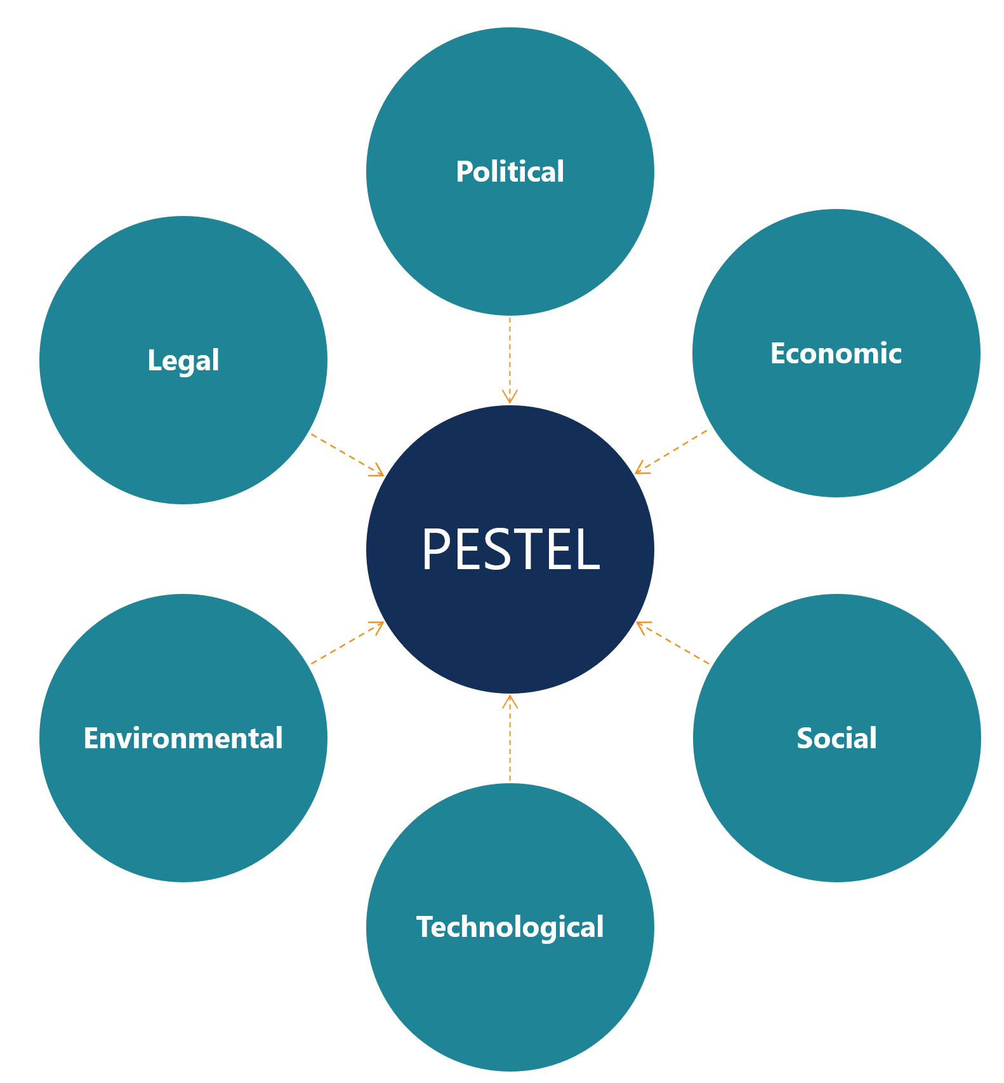

(Source: Inspired by Pan et al., 2019)

Appendix 2: SWOT Analysis
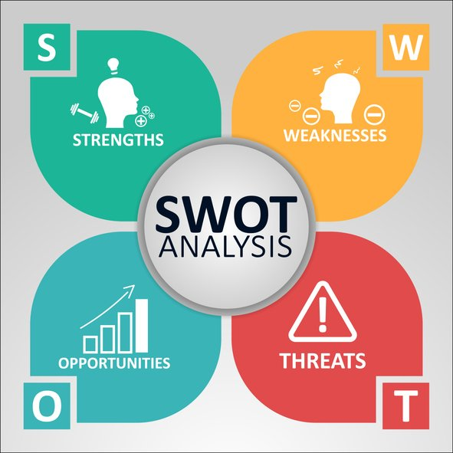

(Source: Inspired by GURL, 2017)

