Hilton Hotel Chain Audit Report

BMIH5004
Management and Organisational Behaviour
Lecturer: Jaliya de Silva

Student: Anamaria Gabriela Tocila
Student ID: 2120101

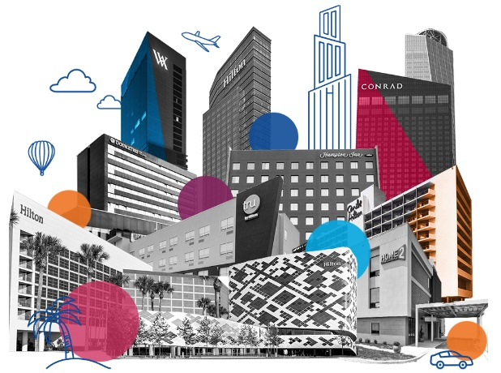
Executive Summary
Structure, culture, strategic goals, and financial results are all investigated as part of this in-depth analysis of the Hilton Hotel Group. Hilton's implementation of a matrix organizational structure improves its global operations by allowing the company to better adapt to the needs of its many markets. The company's culture, rooted in innovation and inclusivity, is a testament to its commitment to employee engagement and exceptional guest experiences. Strategic initiatives, particularly in digital transformation and luxury market expansion, demonstrate Hilton's agility and foresight in the competitive hospitality industry. The analysis of Hilton's business performance, using tools like SWOT, highlights its strengths in brand equity and global presence, while also identifying areas for growth and improvement. The report concludes with recommendations aimed at enhancing Hilton's market position, focusing on geographic diversification, organizational agility, sustainability, data-driven personalization, employee development, and strategic partnerships. These suggestions are meant to help Hilton thrive and evolve whitin this ever-changing industry.
Table of Contents

Executive Summary 2
Introduction 4
Organisation Structure, Culture, and Goals of Hilton Hotel Group 5
Recent Change Initiatives at Hilton Hotel Group 9
Strategic Direction and Business Performance of Hilton Hotel Group 12
Conclusion 14
Recommendations for Hilton Hotel Group 15
Reference List 17


Introduction
Reputable for its opulent lodgings and first-rate service, the Hilton Hotel Group is a major player in the world of hospitality. Hilton, a long-standing company, has become a prominent industry leader with a widespread global presence and diverse portfolio of brands. This report examines an organisational audit of Hilton, with a specific focus on its structure, culture, strategic initiatives, and overall business performance. The audit seeks to analyse the interplay of these elements in establishing Hilton as a leader in the competitive hospitality industry. This paper examines Hilton's matrix organisational structure, its distinctive culture centred on innovation and inclusivity, recent digital transformations and adaptations in response to COVID-19, and strategic directions such as expansion into luxury markets and emphasis on sustainability.



Organisation Structure, Culture, and Goals of Hilton Hotel Group
Organisational Structure
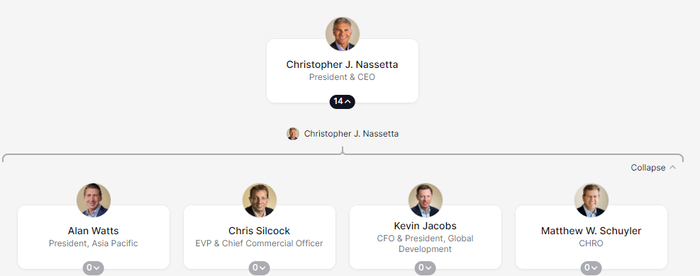
Matrix Structure Enhanced by Hierarchical Elements

The Hilton Hotel Group exhibits a primarily matrix organisational structure, integrating both functional and divisional frameworks. This structure, essential for large businesses like Hilton with 18 brands serving millions of guests, combines hierarchical elements due to its size (Dudovskiy, 2016), (Hilton Report, 2022)​​. It ensures effective resource allocation and expertise sharing across various departments and geographic locations. Hilton's matrix structure, which includes a mix of ownership, management, franchise, and timeshare divisions, enables coordinated global hotel operations and corporate functions, enhancing market responsiveness and flexibility (Miranda, 2021).

Functional Departments and Geographic Divisions
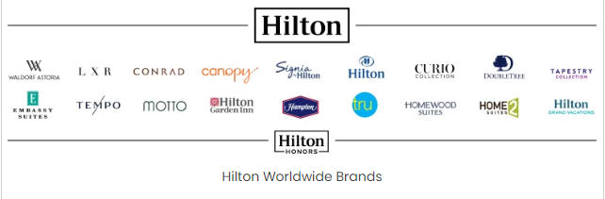
Hilton's matrix structure centralises control over core functions like marketing, finance, human resources, and operations. Suri (2023) argues that centralization ensures uniformity in standards and policies across all Hilton properties. Geographic divisions are designed to meet local market demands and ensure that Hilton's services are aligned with diverse customer preferences and local relevance, while also maintaining a global brand identity (Niemelä, 2019).

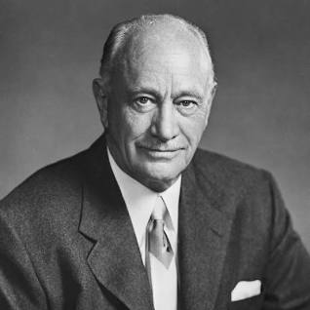
Organisational Culture
Culture Defined by Conrad Hilton’s Vision
Conrad Hilton, the founder of Hilton, had a strong confidence in the ability of travel to promote harmony and understanding, which has a profound impact on the organization's culture. The culture has gained global recognition, as indicated by various awards for workplace excellence and diversity (Maclean, Harvey, & Suddaby, 2022).

Thrive at Hilton: A Comprehensive Approach
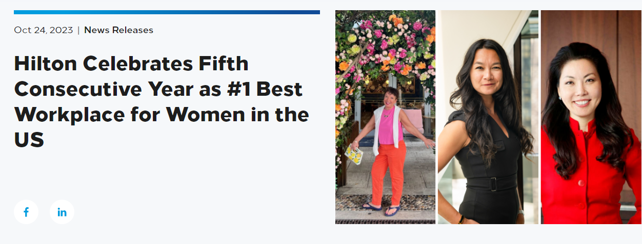 The 'Thrive at Hilton' initiative demonstrates Hilton's dedication to the welfare of its employees, which subsequently impacts its service quality and operational efficiency (Kim and Jung, 2022). This initiative showcases Hilton's inclusive culture, which values diversity of ideas and backgrounds. It aligns with Handy's 'Role Culture' while also incorporating aspects of 'Power Culture' and 'Task Culture' (Heckroodt and Al Hashmi, 2023).

Goals and Alignment with Culture and Structure
 Focus on Environmental Sustainability and Community Engagement
According to Abdou, Hassan, and El Dief (2020) Hilton’s strategic goals include a significant emphasis on environmental sustainability and community impact. The company has set ambitious targets for reducing carbon emissions, water usage, and waste, demonstrating its commitment to sustainable practices​​.
Supporting Goals through Organizational Dynamics
The matrix structure of Hilton facilitates efficient resource allocation and encourages innovation. Culture plays a crucial role in the company's commitment to maintaining high service standards. Additionally, the power and task culture components enable the company to make agile decisions and adapt to market changes effectively (Kim and Lin, 2021).

Innovative Customer Experiences and Digital Transformation
Hilton's dedication to customer satisfaction is demonstrated by its innovative service improvements. Investments in digital keys and smart room technologies demonstrate a dedication to enhancing the guest experience through modernization (Lukanova & Ilieva, 2019). Cocchi, NDosi, and Vignoli (2021) found that these initiatives, facilitated by the matrix structure, enable flexible development and adoption of technological solutions to meet changing customer demands.Employee Development and Diversity
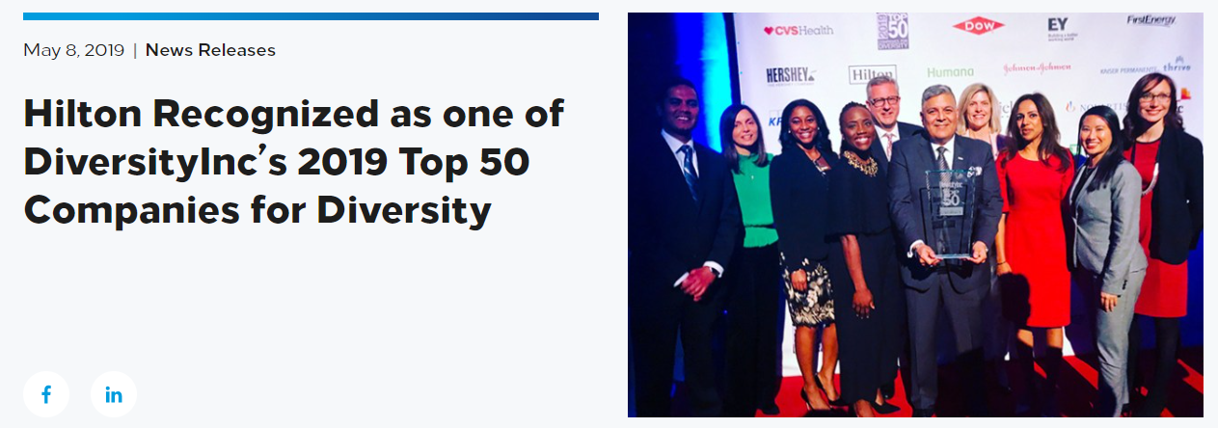 The focus placed on staff development through initiatives like "Thrive at Hilton," as noted by Kim and Jung (2022), is consistent with the company's culture of placing a high priority on the welfare of team members. Hilton improves service quality and operational efficiency by promoting the holistic development of its workforce (Hassanein & Özgit, 2022). The company's dedication to diversity and inclusivity, acknowledged by multiple awards, enhances a dynamic and innovative workplace, promoting a culture where diverse viewpoints lead to business achievements.
Global Brand Identity and Local Market Adaptability
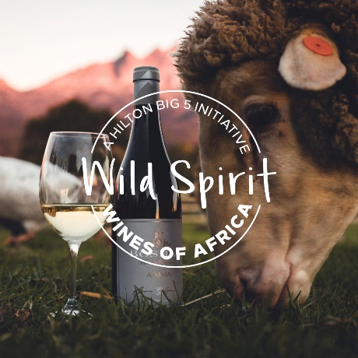
Hilton uses geographic divisions within its matrix structure to tailor services to local preferences while upholding a consistent global brand identity (Eschenbrenne et al., 2023). This approach is essential for Hilton to accommodate a diverse customer base, showcasing adaptability and responsiveness to various market dynamics.
In summary, Hilton's organisational structure, culture, and strategic goals work together to form a strong framework that contributes to its success in the hospitality industry. Hilton's strong structure, inclusive culture, and focus on innovation and sustainability make it a global leader in a diverse and changing industry.

Recent Change Initiatives at Hilton Hotel Group
Digital Transformation
Innovation and Agility in the Digital Sphere

Hilton's digital transformation has significantly improved guest interaction and operational efficiency. Hilton implemented a digital experience for its 300,000 employees, demonstrating its dedication to innovation and employee engagement (Credera Website, 2023). Dutta and Pathak (2022) state that the transformation involved creating a mobile app for global workforce engagement and exploring strategies to improve guest and employee interaction. Hilton's adoption of an agile digital strategy, along with the establishment of an in-house innovation lab, has enabled the company to swiftly address market demands and maintain competitiveness within the dynamic hospitality sector. ​
Adapting to Competitive Market Dynamics
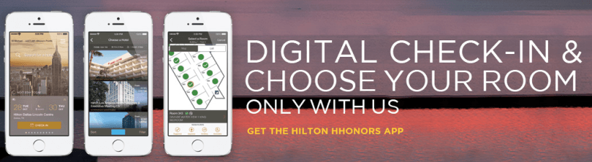
The emergence of rivals such as Airbnb and changing consumer demands have highlighted the necessity for Hilton to accelerate product delivery and improve digital capabilities. Hilton's adoption of agile practices was crucial in addressing these challenges, enabling the company to enhance its speed and efficiency in product delivery (Credera Website, 2023).

COVID-19 Adaptations
Responsive Measures during the Pandemic

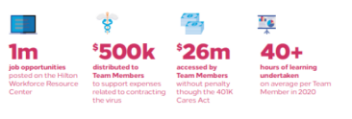
Hilton took swift action in the face of the epidemic to safeguard the company's key operations and provide assistance to employees who were impacted. This included suspending operations in many hotels, reducing services, and implementing cost-saving measures such as salary reductions for senior executives and furloughs for corporate team members. These measures were integral to preserving liquidity and ensuring the company's stability during the crisis​​ (Shin et al., 2021)
Supporting Team Members and Communities
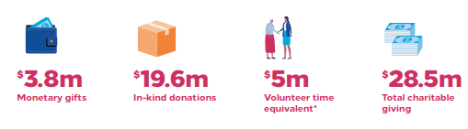
According to Shin et al. (2021), Hilton activated resources like the Hilton Workforce Resource Center, offering access to temporary jobs for furloughed team members, and the Team Member Assistance Fund to support those impacted by COVID-19. Additionally, Hilton extended its hospitality to aid communities, donating food to local pantries and providing housing for first responders and healthcare workers​​.

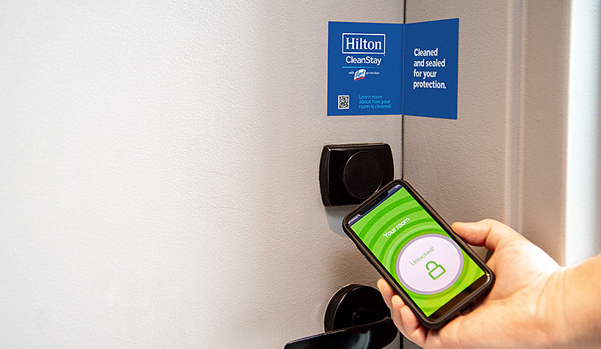
Flexibility and Safety for Guests
Hilton prioritized guest safety and flexibility, offering full refunds for all reservations before June 30, 2020, and implementing safety protocols to protect guests and team members. These measures demonstrated Hilton's commitment to guest well-being and adaptability in the face of unprecedented challenges​​ (Fachada, 2023)

Evaluation and Management of Change Initiatives
Implementing Lewin's Change Model
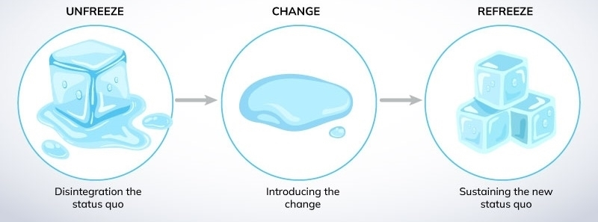 Hilton's approach to change can be framed using Lewin's Change Model:
Unfreezing: Recognizing the need for digital innovation and COVID-19 adaptations.
Changing: Implementing digital tools, the CleanStay program, and operational adjustments.
Refreezing: Integrating these changes into Hilton's new operational norm (Clemons, 2021).


Effective Leadership and Continuous Improvement
Hilton's leadership was instrumental in effectively managing these changes through transparent communication, employee training, and customer education. Hilton (2020) states that the company's emphasis on continuous improvement and frequent updates to its digital offerings and health protocols has maintained the significance and efficacy of these modifications.
Hilton's recent change initiatives in digital transformation and COVID-19 adaptations demonstrate its ability to quickly adapt to external challenges and utilise technology for improved customer experience and operational efficiency. Hilton's change management strategies and resilience in the hospitality industry are evident in these efforts.

Strategic Direction and Business Performance of Hilton Hotel Group
Strategic Direction
Differentiation through Luxury and Global Expansion
Hilton Hotel Group's strategic direction aligns with Porter's Generic Strategies, emphasising differentiation through luxury branding and service excellence (Hotel Business Website, 2022). Hilton intends to expand its luxury portfolio in 2023, with notable growth in Waldorf Astoria Hotels & Resorts, Conrad Hotels & Resorts, and LXR Hotels & Resorts. The expansion consists of 10 new openings in highly sought-after global locations, following a prosperous period of growth in the next years.

Waldorf Astoria's International Presence
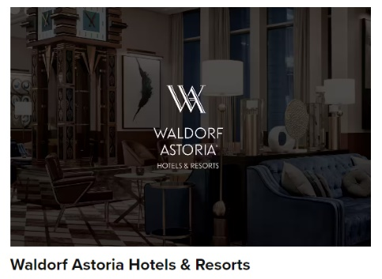
Key international markets like Egypt present exciting opportunities for Waldorf Astoria Hotels & Resorts to enter new regions and grow their existing ones in North Africa and the Middle East. The company plans to expand its present portfolio of 32 hotels in 16 different locations with the establishment of 26 more in the coming years (Hotel Business, 2022).
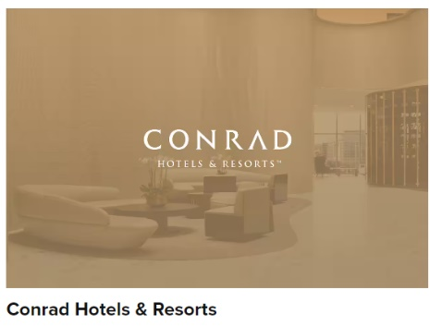
Conrad Hotels & Resorts Market Penetration
As the most extensive collection of Hilton Luxury Hotels, Conrad Hotels & Resorts is actively expanding into new regions like North Africa, the Americas, and Asia and the Pacific. With these four new hotels set to open in 2023, Hilton is demonstrating its dedication to expanding its premium options in a variety of popular travel destinations (Hotel Business, 2022).

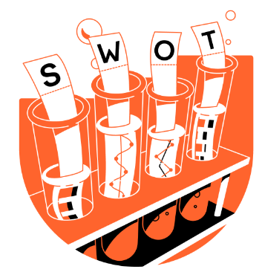
Business Performance
SWOT Analysis: A Comprehensive View
Strengths: Hilton's brand equity and global presence are its core strengths. The expansion of luxury brands and the continuous introduction of high-quality services solidify its market position (Rocha, 2022).
Weaknesses: A high dependency on certain markets, like North America, poses risks related to economic fluctuations and changing consumer preferences (Trung, 2019).
Opportunities: The expansion into new luxury markets and the rising trend of experiential travel offer Hilton opportunities to diversify and cater to evolving customer demands (HB, 2020).
Threats: Intense competition and the impact of global events like the COVID-19 pandemic present ongoing challenges (Clemons, 2021).
Hilton's focus on quality and innovation has helped it establish a strong position in the global hospitality industry. The importance of geographic diversification and adaptability to market changes and external uncertainties is clear. The company's proactive strategy in expanding its luxury portfolio and entering new markets showcases its dedication to staying competitive and meeting the diverse needs of customers. Continuous analysis and strategic adjustments are essential for effectively navigating the ever-changing hospitality industry.

Conclusion
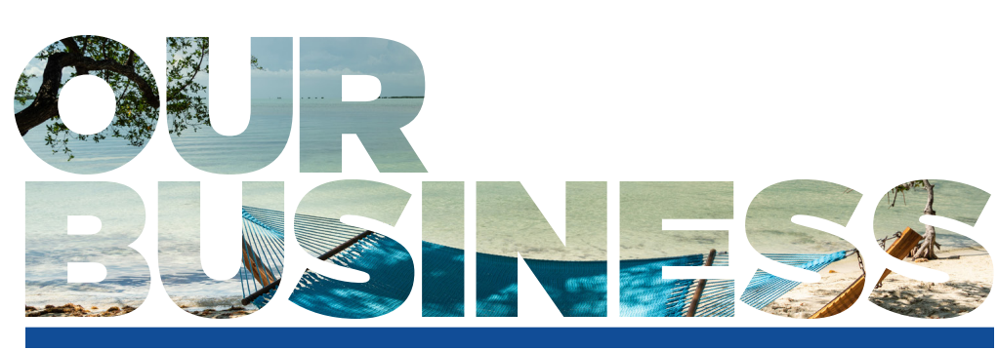With a focus on sustainability, luxury branding, and innovation, Hilton Hotel Group's strategic approach has solidified its leadership position in the worldwide hospitality industry. The audit uncovers Hilton's strong organisational structure, characterised by a balance between adaptability and a strong emphasis on excellence and customer satisfaction. Hilton's culture prioritises employee engagement and diversity, which supports its strategic objectives and promotes a flexible and responsive business atmosphere. Hilton has shown resilience and adaptability despite market challenges and the COVID-19 pandemic, highlighting the importance of ongoing strategic evaluation and agility. Hilton's future success relies on its efforts to expand into new markets, improve organisational agility, strengthen sustainability initiatives, utilise data analytics, invest in employee development, and establish strategic partnerships.


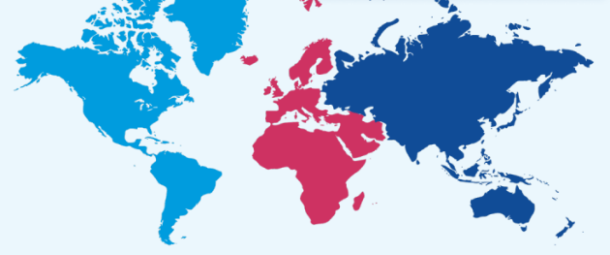
Recommendations for Hilton Hotel Group
Accelerate Global Market Expansion:
Consistent with its strategic development into new premium markets, Hilton should continue diversifying geographically, especially in growing economies in the Asia-Pacific region, Africa, and the Middle East. Expanding can decrease dependence on the North American market and take advantage of the increasing tourism sectors worldwide (Safaeva et al., 2022).
Enhance Organizational Agility:
Hilton should improve its agility by building on its current matrix structure. Delegating authority to local managers and improving decision-making processes can facilitate prompt adjustments to both local market dynamics and global trends (Darvishmotevali et al., 2020).
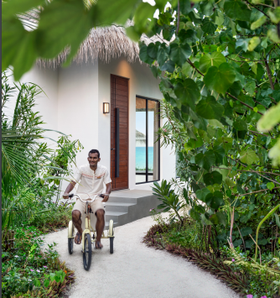
Deepen Commitment to Sustainability:
Hilton ought to enhance its sustainability efforts to align with its existing environmental objectives. This may involve the wider implementation of renewable energy, sustainable construction methods, and increased focus on waste reduction, targeting the growing population of environmentally aware travellers (Shah and Khan, 2020).
Utilize Advanced Data Analytics:
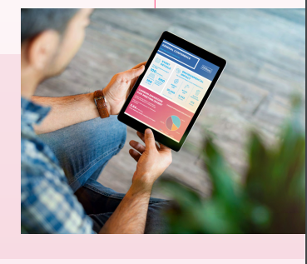
Using data analytics to personalise guest services can improve customer experiences and foster loyalty. Stylos et al. (2021) suggest that analysing preferences and behaviours can lead to the development of more tailored offerings.
Focus on Employee Development:
Ongoing investment in employee training, specifically in leadership, customer service, and digital skills, is crucial. This is consistent with Hilton's focus on employee engagement and development, which aims to maintain high service standards (Hitka et al., 2019).
Cultivate Strategic Partnerships:
Establishing collaborations with technology firms and local entities has the potential to generate distinctive guest experiences and introduce fresh sources of revenue. Collaborations can enhance Hilton's market position and reach (Raub & Martin-Rios, 2019).
Implementing these recommendations may increase Hilton's competitive advantage, foster sustainable growth, and ensure adaptability in the dynamic hospitality sector.
Reference List
- Abdou, A.H., Hassan, T.H. and El Dief, M.M., 2020. A description of green hotel practices and their role in achieving sustainable development. Sustainability, 12(22), p.9624. https://www.mdpi.com/2071-1050/12/22/9624/pdf
- Clemons, C., 2021. Best Practice from Black Manager’s Perceptions and Lived Experiences Before and after Implementation of Diversity Management Programs (Doctoral dissertation, Northcentral University). https://search.proquest.com/openview/7f0e2d6cea93f48c45f796bdb2261ca1/1?pq-origsite=gscholar&cbl=18750&diss=y
- Cocchi, N., Dosi, C. and Vignoli, M., 2021. The Hybrid Model MatrixEnhancing Stage-Gate with Design Thinking, Lean Startup, and Agile: Managers can use the Hybrid Model Matrix to decide when to use design thinking, Lean Startup, or Agile with Stage-Gate to boost new product development. Research-Technology Management, 64(5), pp.18-30.
- Credera Website, 2023. Hilton engages employees with digital transformation. https://www.credera.com/case-studies/hilton-digital-transformation
- Darvishmotevali, M., Altinay, L. and Köseoglu, M.A., 2020. The link between environmental uncertainty, organizational agility, and organizational creativity in the hotel industry. International journal of hospitality management, 87, p.102499. https://www.academia.edu/download/62310400/Altinay7320200308-71936-1x1q6j.pdf
- Dudovskiy, J. 2016. Hilton Organizational Structure. Business Research Methodology. https://research-methodology.net/hilton-organizational-structure/
- Dutta, H. and Pathak, P., 2022, October. Enabling digital transformation with cloud native architecture. In AIP Conference Proceedings (Vol. 2519, No. 1). AIP Publishing.
- Eschenbrenner, B., Zlatic, A., Bechtel, M., Collins, B., Straley, C. and Gubbels, G., 2023. Marriott International: A Managerial Strategic Audit. https://digitalcommons.unl.edu/cgi/viewcontent.cgi?article=1647&context=honorstheses
- Fachada, B.C., 2023. Business adaptive strategies in crisis: the case of Hilton Hotels Worldwide (Doctoral dissertation). https://repositorio.ucp.pt/bitstream/10400.14/41371/1/203278844.pdf
- Hassanein, F. and Özgit, H., 2022. Sustaining human resources through talent management strategies and employee engagement in the Middle East hotel industry. Sustainability, 14(22), p.15365. https://www.mdpi.com/2071-1050/14/22/15365/pdf
- Heckroodt, S. and Al Hashmi, W.S.G., 2023. Cultural Competence: The Intrinsic Strategic Advantage. Taylor & Francis.
- Hitka, M., Kucharčíková, A., Štarchoň, P., Balážová, Ž., Lukáč, M. and Stacho, Z., 2019. Knowledge and human capital as sustainable competitive advantage in human resource management. Sustainability, 11(18), p.4985.
- Hotel Business Website, 2022. Hilton to grow luxury portfolio in 2023. https://hotelbusiness.com/hilton-to-grow-luxury-portfolio-in-2023/
- Kim, J. and Jung, H.S., 2022. The effect of employee competency and organizational culture on employees’ perceived stress for better workplace. International Journal of Environmental Research and Public Health, 19(8), p.4428. https://www.mdpi.com/1660-4601/19/8/4428
- Kim, J. and Jung, H.S., 2022. The effect of employee competency and organizational culture on employees’ perceived stress for better workplace. International Journal of Environmental Research and Public Health, 19(8), p.4428. https://www.mdpi.com/1660-4601/19/8/4428
- Kim, Y.R. and Lin, S.C., 2021. The non-linear relationship between brand diversification and hotel owner performance: The roles of ownership structure and location as moderators. Journal of Hospitality and Tourism Management, 49, pp.235-243. https://www.sciencedirect.com/science/article/pii/S1447677021001650
- Lukanova, G. and Ilieva, G., 2019. Robots, artificial intelligence, and service automation in hotels. In Robots, artificial intelligence, and service automation in travel, tourism and hospitality (pp. 157-183). Emerald Publishing Limited. https://www.researchgate.net/profile/Georgina-Lukanova-2/publication/337022595_Robots_Artificial_Intelligence_and_Service_Automation_in_Hotels/links/5dc147a44585151435e992f9/Robots-Artificial-Intelligence-and-Service-Automation-in-Hotels.pdf
- Maclean, M., Harvey, C. and Suddaby, R., 2022. Institutional biography and the institutionalization of a new organizational template: Building the global branded hotel chain. Business History, pp.1-29. https://www.tandfonline.com/doi/pdf/10.1080/00076791.2022.2031988
- Miranda, C. A., 2021. MULTINATIONAL FIRMS IN THE TOURISM SECTOR: ACCOR HOTELS https://dspace.uib.es/xmlui/bitstream/handle/11201/158933/Abellanet_Miranda_Coloma.pdf?sequence=1
- Niemelä, M., 2019. Brand management strategies of hotel chain sub-brands Sheraton Marriott and DoubleTree by Hilton. https://www.theseus.fi/bitstream/handle/10024/180205/Brand%20Management%20Strategies_Miia%20Niemel%C3%A4.pdf?sequence=2
- Raub, S.P. and Martin-Rios, C., 2019. “Think sustainable, act local”–a stakeholder-filter-model for translating SDGs into sustainability initiatives with local impact. International Journal of Contemporary Hospitality Management, 31(6), pp.2428-2447. https://arodes.hes-so.ch/record/4318/files/Author%20postprint.pdf
- Rocha, R.A., 2022. Hilton equity research-the value under Hilton´ s strong brand portfolio (Doctoral dissertation). https://run.unl.pt/handle/10362/140002
- Safaeva, S.R., Alieva, M.T., Abdukhalilova, L.T., Alimkhodjaeva, N.E. and Konovalova, E.E., 2020. Organizational and economic aspects of the development of the international tourism and hospitality industry. Journal of Environmental Management and Tourism, 11(4), pp.913-919. https://journals.aserspublishing.eu/jemt/article/download/5218/2801
- Shah, S.S.A. and Khan, Z., 2020. Corporate social responsibility: a pathway to sustainable competitive advantage?. International Journal of Bank Marketing, 38(1), pp.159-174.
- Shin, H., Sharma, A., Nicolau, J.L. and Kang, J., 2021. The impact of hotel CSR for strategic philanthropy on booking behavior and hotel performance during the COVID-19 pandemic. Tourism Management, 85, p.104322. https://www.ncbi.nlm.nih.gov/pmc/articles/PMC8602938/
- Stylos, N., Zwiegelaar, J. and Buhalis, D., 2021. Big data empowered agility for dynamic, volatile, and time-sensitive service industries: the case of tourism sector. International Journal of Contemporary Hospitality Management, 33(3), pp.1015-1036. https://eprints.bournemouth.ac.uk/35221/1/Big%20data%20and%20Agility%20Volatile%20sensitive%20industries_Stylos%2C%20Zwiegelaar%2C%20Buhalis%202021.pdf
- Suri, V.K., 2023. Assessing Business Health of Shared Services. Dorrance Publishing.
- Trung, N.B., 2019. The spillover effects of US economic policy uncertainty on the global economy: A global VAR approach. The North American Journal of Economics and Finance, 48, pp.90-110. https://www.sciencedirect.com/science/article/abs/pii/S1062940818302523

