

EFFECTIVE IMPLEMENTATION OF STRATEGY BY MANAGERS: A COMPARISON OF JOLLIBEE FOOD CORP AND MCDONALD
LCMB7020

NAME : ANSIF ANSARY
STUDENT ID : 2215082
MODULE TITLE : DISSERTATION
MODULE CODE : 7020
COURSE : MBA HUMAN RESOURCE MANAGEMENT
LECTURER : OGOCHUKWU AGUNENYE

University of Wales: Trinity Saint David
E-Thesis Deposit Agreement

Details of the Work
I would like to deposit the following item in the digital repository maintained by the University, and/or in any other repository authorized for use by the University:

Title
…………EFFECTIVE IMPLEMENTATION OF STRATEGY BY MANAGERS:
A COMPARISON OF JOLLIBEE FOOD CORP AND MCDONALD…………….

This item is a product of my own research endeavours and is covered by the agreement below in which the item is referred to as “the Work”. It is identical in content to that deposited in the Learning Resources Centre, subject to point 4 below.

I agree that the University of Wales: Trinity Saint David may electronically store, copy or translate the Work to any approved medium or format for the purpose of future preservation and accessibility. The University is not under any obligation to reproduce or display the Work in the same formats or resolutions in which it was originally deposited.

UW: TSD Digital Repository
I understand that work deposited in the digital repository will be accessible to a wide variety of people and institutions, including automated agents and search engines via the World Wide Web.

I understand that once the Work is deposited, the item and its metadata may be incorporated into public access catalogues or services, such as national databases of electronic theses.

I agree as follows:
- That I am the author or have the authority of the author/s to make this agreement and do hereby give the University of Wales: Trinity Saint David the right to make available the Work in the way described above.
- That the electronic copy of the Work deposited in the digital repository and covered by this agreement, is identical in content to the paper copy of the Work.
- That I have exercised reasonable care to ensure that the Work is original, and to the best of my knowledge, does not breach any laws including those relating to defamation, libel and copyright.
- That I have, in instances where the intellectual property of other authors or copyright holders is included in the Work, gained explicit permission for the inclusion of that material in the Work, and in the electronic form of the Work as accessed through the open access digital repository, or that I have identified and removed that material for which adequate permission has not been obtained and which will be inaccessible via the digital repository
- That University of Wales: Trinity Saint David does not hold any obligation to take legal action on behalf of the Depositor, or other rights holders, in the event of a breach of intellectual property rights, or any other right, in the material deposited.
- That I undertake to indemnify the University of Wales: Trinity Saint David against all actions, suits, proceedings, claims, demands and costs occasioned by the University in consequence of any breach of this agreement

Signature ……………………………………………………….

Date …12/02/2024……………


Master’s Degrees by Examination and Dissertation Declaration Form.
- This work has not previously been accepted in substance for any degree and is not being concurrently submitted in candidature for any degree.
Signed……ANSIF ANSARY.………
Date 12/02/2024

- This dissertation is being submitted in partial fulfilment of the requirements for the degree of Master in Business Administration.
Signed : ANSIF ANSARY
Date : 12/02/2024
- This dissertation is the result of my own independent work/investigation, except where otherwise stated.
Other sources are acknowledged by footnotes giving explicit references.
A bibliography is appended.
Signed candidate: ……ANSIF ANSARY…
Date: :12/02/2024

4. I hereby give consent for my dissertation, if accepted, to be available for photocopying, inter- library loan, and for deposit in the University’s digital repository
Signed (candidate)…ANSIF ANSARY..
Date………12/02/2024
Supervisor’s Declaration.
I am satisfied that this work is the result of the student’s own efforts.
Signed: …OGOCHUKWU AGUNENYE
Date: 12/02/2024

Acknowledgement
I, Ansif Ansary, acknowledge that, my mentor has assisted me throughout the investigation and in the process of data analysis in this research I had very little idea about the process I should use for investigation; assistance of the mentor and fellow researchers has shown me the path to successfully complete in research within a timeframe.

Declaration
I, hereby confirm that the submitted work is the result of my own effort. The literature and the materials that have been authored by others and have been used in the present dissertation have been acknowledged duly. No part of the dissertation has been used for obtaining any other previous degree in the present institutions or any other institutions.

Abstract
The study aims at McDonald's and Jollibee Food Corp's management styles and their effectiveness in business operations. The importance of strategic management in an organisation can be learned after the introduction of such an effective study. Objectives of the research also help in gaining an insight into the managers with helpful insights and suggestions that could be used in enhancing the market game of each company. The significance of the study assists in learning about the effectiveness of strategic planning and administration in proper organisational management. The structure of the dissertation helps in having an idea about the possible structure of the whole investigation.

Methodology
The methodology has significant value that helps the researcher to design and conduct the study successfully. For the enhancement of the research interpretivism philosophy has been considered the most suitable philosophy. An inductive approach has been regarded as the most suitable approach. In addition to this, the researcher has preferred to choose a case study as the best-suited research strategy. This study has considered the mono-method as the research choice, also this study has taken the cross-sectional process for managing the step of the Time-horizons. Additionally, this study has developed search strategies for identifying suitable sources for collecting the data in this study. Moreover, this study has taken primary qualitative method to collect the data and analyse the data for this study, moreover, this study also maintains the research ethics.

Findings
Profitability and reputation management in a business provides growth and value enhancement of a business. It can be stated that in comparison to McDonald’s, Jollibee Food Corp has demonstrated value because of the effective customer needs assessment process. Similarly, it has also been witnessed that this company has showcased efficiency in terms of employee as well as environment management process leading them towards sustainable operation management process successfully. The findings of this study indicate that the managers of McDonald’s and Jollibee use religious beliefs, dietary and taste preferences to offset the international standards with local preferences. Moreover, training, benefits and rewards have been used by managers to empower the spirit of development among employees. The findings and discussion deals with the analysis of interview transcripts made based on the answers revealed by managers of McDonalds and Jollibee Food Corp. This sheds light on the recommended strategies adopted by managers to excel in the new market. However, the theme reveals critical success factors of food sector which, further develop the idea of providing business opportunities for both the organisations concerned. Corporate culture has been the basic norm for performing a business operation and the expansion of businesses on the global ground has been entirely associated with the fruitfulness of corporate culture. However, both the discussed companies have been performing effectively to gain a positive cultural ambience regarding corporate perspectives. Jollibee has been found to prioritise consumer satisfaction and, in this aspect, it has mainly supported its employees to provide a quality contribution to the consumer market. On the other hand, McDonald's has performed with cost leadership to enhance its preference in the competitive environment of the fast-food industry.

Table of Contents
Chapter 1: Introduction 10
1.1 Background 10
1.2 Aim & Objectives 12
1.3 Research Question 13
1.4 Rationale of research 13
1.5 Dissertation structure 14
1.6 Significance of the study 14
1.7 Summary 15
Chapter 2: Literature Review 16
2.1 Introduction 16
2.2 Main body 16
2.2.1 Strategic management techniques used by managers 16
2.2.2 Impact of Strategic Management Models 18
2.2.3 Different cultural and commercial environments food sector businesses 19
2.2.4 Challenges in the implementation of strategies by managers 20
2.2.5 Current practices in enhancing market game of food businesses 20
2.2.6 McDonald's and Jollibee Food Corp's respective corporate cultures influence the companies' capacity to go with long-term strategic choices 22
2.2.7 Various social settings by offsetting worldwide standards with local preferences 23
2.2.9 Theoretical application 27
2.2.7 Literature gap 28
2.3 Hypothesis 29
2.4 Proposed methodology 29
2.5 Summary 29
Chapter 3: Methodology 30
3.1 Introduction 30
3.2 Research Onion 30
3.3 Research Philosophy 31
3.4 Research approach 32
3.5 Research Strategy 33
3.6 Research Choice 34
3.7 Time horizon 34
3.8 Search Strategy 34
3.9 Data collection method 38
3.10 Data Analysis Method 38
3.11 Ethical Consideration 39
3.12 Summary 39
Chapter 4 Findings, analysis and discussion 40
4.1 Introduction 40
4.2 Findings 40
Primary data depiction and analysis 40
4.3 Descriptive Statistics Analysis 59
4.4 Summary 71
Chapter 5: Discussion 72
5.1 Introduction 72
5.2 Discussion of a derived result 72
5.4 Summary 80
Chapter 6: Conclusion 80
6.1 Conclusion 80
6.3 Recommendation 83
6.3 Future scope 84
6.4 Study limitation 85
References 86

List of Figures
Figure 1.1: Business success of Jollibee Food Corp. 10
Figure 1.2: Telephone order frequency from the customers in the case of each organisation 11
Figure 1.3: Structure of the study 14
Figure 2.1: Stages of the strategic formulation 17
Figure 2.2: Strategic management process 18
Figure 2.3: Hofstede’s cultural model 19
Figure 2.4: Various marketing growth practices 21
Figure 2.5: Ethics and value development in employees through the business process by use of proper corporate culture 22
Figure 2.6: Revenue growth of McDonald’s from 2005 to 2022 26
Figure 2.7: Aspects related to resource-based theory 27
Figure 2.8: Aspects related to theory of planned behaviour 28
Figure 3.1: Research onion 30
Figure 3.2: Research philosophy 32
Figure 3.3: Research approaches 33
Figure 4.1: Gender of the participants 40
Figure 4.2: Age of the participants 41
Figure 4.3: Occupation of the participants 42
Figure 4.4: Managers from Jollibee Food Corp and McDonald’s 43
Figure 4.5: Manager’s work experiences from Jollibee Food Corp and McDonald’s 44
Figure 4.6: Profitability management is effective for Jollibee Food Corp and McDonald’s 45
Figure 4.7: Reputation management for Jollibee Food Corp and McDonald’s 46
Figure 4.8: The strategic management techniques can be effective for managing different cultural and commercial environments for Jollibee Food Corp and McDonald’s 47
Figure 4.9: Successful implementations of strategic management techniques in Context to Cross-Cultural Management for Jollibee Food Corp and McDonald’s 48
Figure 4.10: The influential managerial techniques for Jollibee Food Corp and McDonald’s 49
Figure 4.11: Employees' behaviour appropriate to maintain a cultural and commercial for Jollibee Food Corp and McDonald’s 50
Figure 4.12: Jollibee Food Corp and McDonald’s promote a unique experience to the consumers 51
Figure 4.13: Importance of developing an emotional connection with customers for both companies 52
Figure 4.14: Adaptation of technology is a critical success factor 53
Figure 4.15: Customer satisfaction is a long-term strategic choice 54
Figure 4.16: Cost-leadership as a long-term strategic choice 55
Figure 4.17: Strategies to offset worldwide standards to local preferences 56
Figure 4.18: Rewards and recognition to empower employee spirit development 57
Figure 4.19: Training programmes and career growth opportunities create a spirit of development 58
Figure 4.20: Employee spirit development helps in strategic administration practices 59
Figure 4.21: Descriptive statistics for question No. 6 60
Figure 4.22: Descriptive statistics for question No. 7 60
Figure 4.23: Descriptive statistics for question No. 8 61
Figure 4.25: Descriptive statistics for question No. 10 62
Figure 4.26: Descriptive statistics for question No. 11 63
Figure 4.27: Descriptive statistics for question No. 12 64
Figure 4.28: Descriptive statistics for question No. 13 64
Figure 4.28: Descriptive statistics for question No. 14 65
Figure 4.29: Descriptive statistics for question No. 15 66
Figure 4.30: Descriptive statistics for question No. 16 67
Figure 4.31: Descriptive statistics for question No. 17 68
Figure 4.32: Descriptive statistics for question No. 18 69
Figure 4.32: Descriptive statistics for question No. 19 70
Figure 4.33: Descriptive statistics for question No. 20 71
Figure 6.1: Recommendations 84

List of Tables
Table 3.1: Different search engines to collect a database 36
Table 3.2: Boolean operator 37

Chapter 1: Introduction

1.1 Background
The strategic administration of an organisation has a direct impact on the operational management process of an organisation. The market performance and profit-gaining possibility partially depend on the strategic administration of the organisation (Zolloet al., 2023). Application of proper market research for the fast-food industry has helped the growth of well-known organisations like McDonald’s and Jollibee Food Corp. Development of products that will be preferred by the customers and selection of thoughtful marketing techniques in the process of work has helped the organisations to flourish in the global market.
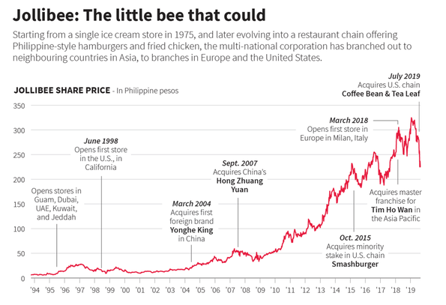

Figure 1.1: Business success of Jollibee Food Corp.
(Source: Bscapitalmarkets.com, 2020)
Maintaining proper communication among marketing teams and administration in both organisations has benefited both companies in providing preferable products to the customers. Development of a better idea about the customer's demand in the market and making business development decisions has been maintained by both the selected organisations. However, the strategic management difference in both organisations has left minor changes in the overall performance of the business for McDonald's and Jollibee. As opined by Raubet al., (2021), introducing new employees in the organisation with effective management techniques also helps in reducing the conflict among employees. Such a process of work also helps in maintaining an alignment in the communication development with customers in the competitive market. Increasing the level of customer service and sustaining customers in a market filled with competitors has been possible by both McDonald's and Jollibee through such an effective management style. Both McDonald's and Jollibee are making an effort to remain in the best position in the fast-food market through service quality development by adopting a customer-centric approach in the business (Moret, 2020). The method of social adaptability and process of standardisation helps in making the process of work more effective in the case of Jollibee Food Corp.
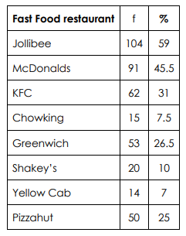

Figure 1.2: Telephone order frequency from the customers in the case of each organisation
(Source: Moret, 2020)
Such an innovative market strategy and business management practice has benefited Jollibee to remain in a better position in the market as compared to that of McDonald’s. Customers across different regions prefer ordering from Jollibee as compared to McDonald’s as the telephonic order percentage of Jollibee has reached 59% as compared to 45.5% of McDonald’s (Moret, 2020). The development of a better idea about possible shifts in the market and changes in the preferences of customers has been effective for Jollibee by applying the chosen methodology in the overall process of work.
Development of an idea about the management practices that each of the organisations in the overall industry of fast-food can help in the assessment of the issues that each of the organisations is using in the market. Acknowledging the effectiveness of the process of work and knowing about the validity of the actions that are being made for market development has been easier in the organisation (Raubet al., 2021). The process of advertisement to gain the attention of a diverse group of customers in the business is also worth studying. The decisions of organisational management in both McDonald's and Jollibee regarding the introduction of various products in the market that will help sustain customers from all age groups and socio-economic backgrounds have been effective in achieving business success (Moret, 2020). Evaluation of the system of customer attraction applied by both organisations has helped in gaining an idea about the major success of Jollibee in the global fast-food market.
Management of the organisation has taken active participation in the survey of the market, and such knowledge has helped the management of Jollibee in making faster changes to the plan of customer service. The application of effective processes has helped them achieve market supremacy by increasing customer satisfaction in the global market.

1.2 Aim & Objectives
Aim
The purpose of this research is to look at McDonald's and Jollibee Food Corp's management styles about the plans they set in motion. The study's general objective is to realize what these fast-food giants are doing to stay at the top through a similar assessment.
Objective
- To analyze the strategic management techniques used by Jollibee Food Corp. and McDonald's to stay at the top in the fast-food industry.
- To analyze how well each company's management strategies adapt to different cultural and commercial environments.
- To identify the key factors influencing the successful implementation of various strategies in the fast-food sector.
- To provide managers with helpful insights and suggestions that could be used in enhancing the market game of each company based on a comparison of the strategic approaches of McDonald's and Jollibee Food Corp.

1.3 Research Question
Q1. How do Jollibee Food Crop and McDonald's differ in their strategic management practices within the fast-food industry?
Q2. To what extent do market-specific factors and cultural factors influence the managerial techniques that are employed by each company?
Q3. How can the insights be gained through the comparison of the mentioned organization’s strategies and how the particular insights could be recommended for the managers in the broader business landscape?
Q4. What are the critical success factors contributing to the effective implementation of the strategies in the highly competitive fast-food sectors?
Q5. In the fast-food sector, how do McDonald's and Jollibee Food Corp's. respective corporate cultures influence the companies' capacity to go with long-term strategic choices?
Q6. How in all actuality do fast-food chains like McDonald's and Jollibee Food Corp. figure out how to speak to customers in various social settings by offsetting worldwide standards with local preferences?
Q7. How do Jollibee Food Corp. and McDonald's empower a spirit of development among their employees and which part does development play in their strategic administration practices?

1.4 Rationale of research
Applying managerial strategies for the development of business and customer service in the market is necessary in any industry.

Hypothesis
is, that a lack of managerial techniques and practices in the fast-food market can result in a reduction of customer satisfaction. Massive reductions in the rate of profitability and loss of customers in the market can be a common factor in this kind of situation. Failure in proper strategic management in well-known companies like McDonald's and Jollibee Food Corp can result in a reduction of organisational goodwill in the fast-food market across the world.
The rationale of this study helps to prove the effectiveness of strategic management practices and techniques in the fast-food business for increasing the satisfaction level of customers. Better decision-making by keeping in mind the choice of customers has benefited McDonald's and Jollibee Food Corp in gaining market supremacy (Moret, 2020). The development of better service for the customers has further benefited Jollibee to remain in the top position of the market. Business development and boosting customer satisfaction levels have been easier for the organisation after the development of proper strategic control on the business. The leaders and managers in both McDonald's and Jollibee Food Corp have played a crucial role in the business development and increase of service quality.

1.5 Dissertation structure
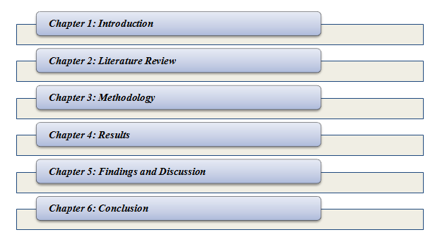

Figure 1.3: Structure of the study
(Source: Developed by the researcher)

1.6 Significance of the study
Effectiveness of the managerial strategies and practices in business has been extracted by introducing this research. Evaluation of each key factor in the managerial decision-making process that helps boost business and increase customer satisfaction in the market has been evaluated in detail through this research. The study also helps in assessing the factors that are necessary for maintaining market supremacy and customer satisfaction (Raubet al., 2021). The effectiveness of marketing and product development practices that have been applied by both McDonald's and Jollibee in the process of business has been analysed in detail for each of the business's success. Having an idea about the system of work in each of the organisations and the key factors of business decisions that are helping both companies in sustaining customers throughout each of the business crises is necessary. According to Alvarez (2020), the adoption of better marketing strategies in the business and the development of an idea about the working process becomes easier in an organisation through effective administration in the business. Based on this factor, the current study has helped in gaining an overview of the effectiveness of organisational administration in the process of business. Significance of quality employee management in an organisation to boost customer service in the market is important in business. The effectiveness of such an approach in sustaining customers can also be found in this study.

1.7 Summary
It can be summarised that the background of the study has helped in gaining an overview of the following evaluation and knowledge. The aim and objectives help to showcase the direction of the investigation in this study. Assessment of the key research factors can be made through selected research questions in this study. The rationale and problem statement help in gaining an idea about the effectiveness of managerial administration. The study of the dissertation helps to recognise each of the following chapters in this study.

Chapter 2: Literature Review

2.1 Introduction
Study has been trying to generate information that are related to implementation processes that are being incorporated by managers for effective development in business operations. However, this study has been trying to come up with information by gaining data from various authors' perspectives regarding the challenges that are being encountered while incorporating strategies.

2.2 Main body

2.2.1 Strategic management techniques used by managers
Profitability along with creating a reputation which helps in retaining customers have become the main priorities of managers. Fuertes et al., (2020), stated that strategy is described as a long-term goal taken by a company, approach of actions, and allocate significant resources in achieving the purpose successfully. Businesses start with a SWOT analysis in order to identify the strengths, weaknesses, opportunities, and threats of the restaurants. Identification of strengths starts with an angle which helps the food businesses deal with other market competition. Weakness, on the other hand, started with an inability to interpret, extract, and use the information at the fingertips. In addition, opportunity includes visibility of the business and threats, on the other hand, involving nearby competitors facing the business.
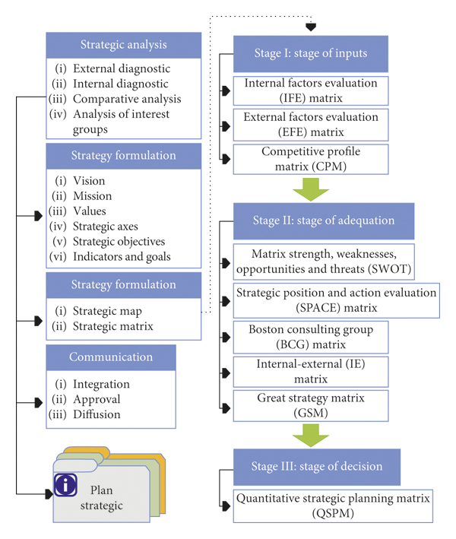

Figure 2.1: Stages of the strategic formulation
(Source: Fuertes et al., 2020)
Figure 1 shows the phases of strategic formulation, the ability of the businesses, and strategies connected with the operations which need to be referred to. On the other hand, Bulturbayevichet al., (2021), stated that the focus of strategic management strategies or techniques is on competitor analysis. After that, the redevelopment of the marketing strategy comes along with the minimisation of the labour cost of the restaurant. For example, McDonald's uses "Cost leadership," "Ansoff Matrix," and "Broadcast promotion," as strategic management techniques. JFC or "Jollibee Foods Corporation" has been using a collaboration of “cost leadership" and "differentiation" as strategic management techniques in order to achieve success in their development. Advertising, global enlargement, limited-time offers and promotions, and other strategic management techniques are used by the managers of JFC.

2.2.2 Impact of Strategic Management Models
Preferable planning, marketing and implementation of tools are boons for restaurant owners. Lanzolla and Markides, (2021), stated that outcomes generated from SWOT analysis help businesses to identify the challenges and areas to improve in initiating business improvements. This refers to creating a timeline along with checkpoints, purposes, and plans to implement those. On the other hand, Caputo et al., (2021), stated that findings from competitive analysis help to identify competitors who were not adept at it, and then businesses use certain ideas and implement those in their businesses. This helps businesses in feng more domains in restaurants that require development (Gomez-Zavagliaet al., 2020),). This has helped nature in the surroundings in comparison to turning a blind eye to those doing business around the other businesses.
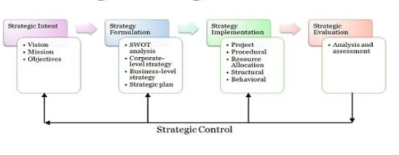

Figure 2.2: Strategic management process
(Source: Caputo et al., 2021)
Figure 2 shows the overall strategic management process including the stages such as strategic intent, strategy formulation, and strategy implementation, and the last one is strategic evaluation. As per the view of Lanzolla and Markides, (2021), it has been seen that the "definition of physical constraints" is included in the strategic management processing in food businesses. Strategic management frameworks or strategies have a direct effect on the decisions of the business. "Porter's Five Forces" framework has been taken into consideration here, due to its accompanying items such as, "the probability of new entrants," "the bartering force of suppliers and buyers," "the strength of serious contention," and others (Ritter and Pedersen, 2020). For example, "The Porter's Five Forces" model on food chains such as McDonald’s, and Jollibee, received more definite searching the cutthroat area related to these businesses and the issues facing these companies.

2.2.3 Different cultural and commercial environments food sector businesses
"Cross-cultural management" is a type of management from the context of cross-cultural. This engages a study of the encouragement of management practice, managers along cultural orientations related to individual managers and organisational employees. On the other hand, Boussebaa, (2021), stated that cultural context in management needs to be located, multiple roles in global management and the encouragement of culture on organisational outline and system and management around cultures, and nations.
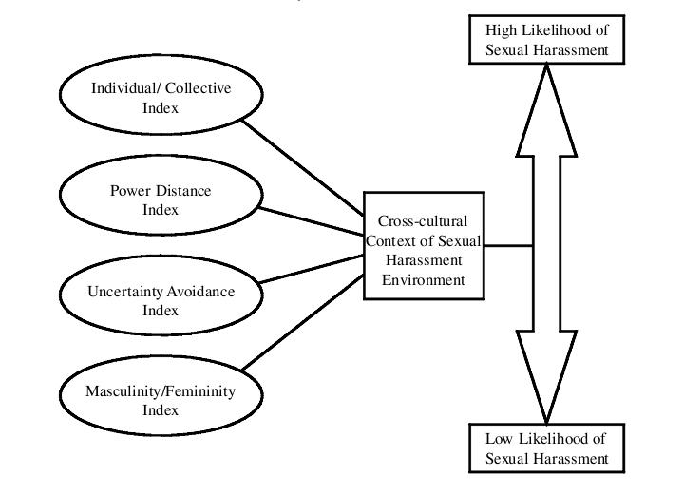

Figure 2.3: Hofstede’s cultural model
(Source: Ermasova, 2021)
Figure 3 shows cross-cultural context referring to items such as the collective index, power distance index, uncertainty avoidance index, and femininity index. Based on the context of the culture in businesses, an upgraded framework is order to describe how culture describes customers' behaviour. This shows that social, personal items, psychological, and cultural impacts two significant elements in the market such as marketing mix, and customer attitude(Mykhailichenkoet al., 2021). Kotlter has created for example, McDonald's has a developed strategy that offers global-standardised items insight into their menu. When they were entering new markets, managers claimed that McDonald's was not willing to do any type of modification to their menu in foreign markets. On the other hand, Boussebaa, (2021), refers to the framework created by Strodbeck, and Luckhohn. This debate shows that modifications in culture have particular practice in leadership. Thus, the primary nature of humans has become a significant area related to culture.

2.2.4 Challenges in the implementation of strategies by managers
The primary issue faced by managers while implementing strategies in an organisation was a "lack of commitment to the strategy." The linkage of strategy along with organisational outline. This connection of this strategy is there with organisational culture. Alzoubi and Yanamandra, (2020), identified issues in setting goals from the end of managers in their organisation. Strategic aims or goals are complex and due to this nature, those goals demand multiple resources scattered around multiple departments and placements in order to achieve them(Chen et al., 2020). Creating clear goals around teams’ benefits from more transparency on commitments, and priorities.
As per the view of Aquilaniet al., (2020), it has been identified that, “Lack of alignment”wasidentified as another issue in the implementation of strategic management strategies by managers. Lack of skills to track progress, less connection to the strategy, and no measurements in leading indicators are highlighted as some other issues faced by meaning in their implementations.

2.2.5 Current practices in enhancing market game of food businesses
Market enhancement is an effective tool that a business needs to incorporate so that they are able to attain success eventually. Okumus (2021) stated that lack of effective market enhancement reduces the scope of growing opportunities for a company. Food businesses need to incorporate strong marketing practices because a massive amount of competition is present globally. Borsellino et al. (2020) contradicted that lack of incorporation of effective marketing strategies reduces chances of development which as result impact their brand presence in the market.
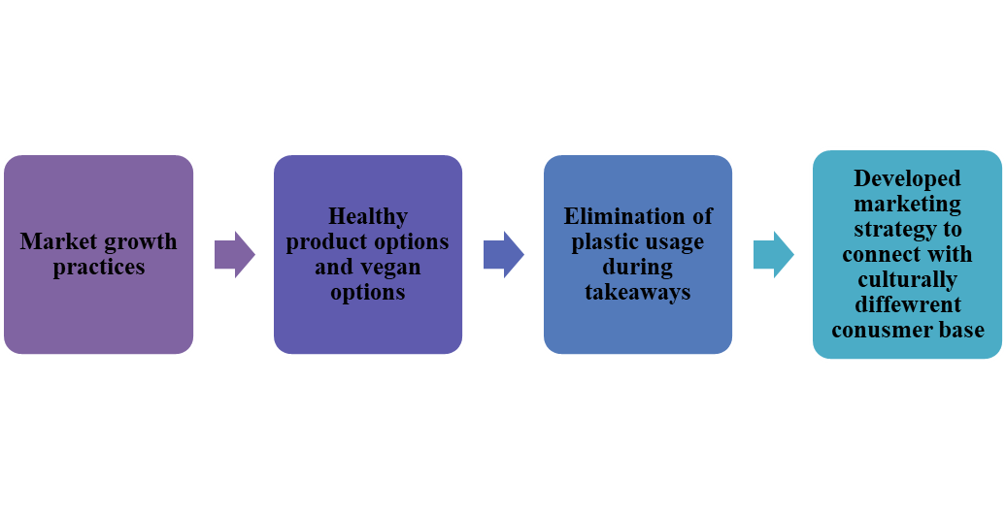

Figure 2.4: Various marketing growth practices
(Source: Created by author)
Presently, one major practice that is incorporated for increasing market game is to come up with product options that are vegan and are completely plant based. As supported by Costello et al. (2020), the majority of time consumers look up to big food businesses and their actions that they are taking for introducing plant-based products and introducing vegan options. Reque and Brandelli (2021) stated that incorporation of a food menu for vegan people and also including food options that are made from healthy substances are going to help in increasing sales of a company (Bulturbayevich, 2021). For instance, companies like McDonalds, Jollibee provide fried chicken, burgers to their consumers.
Both of these companies need to include burger breads that are made from wheat flour, ragi flour, and bajra flour which are beneficial for health (Aboelmaged, 2021). On the other hand, changing bread quality is not enough, it is also important to make changes in the oil that is used for frying the chicken (Rejeb et al. 2020). Another major practice that has been considered recently is related to packaging processes that are being used by a company to deliver its products. Li et al. (2021) opined thatthe majority of consumers recently due to their busy schedule have adopted the process of takeaway option and hence wants sustainable packaging. On other hand, incorporation of recycled plastic can also be used but taking actions for building a sustainable environment is required so that effective market growth can be reached (Wakefield and Axon, 2020). Effective product packaging makes the company termed as sustainable which as a result is going to improve overall business presence. Both companies McDonalds and Jollibee need to incorporate actions so that they are able to improvise their business aspects and improve their brand presence.

2.2.6 McDonald's and Jollibee Food Corp's respective corporate cultures influence the companies' capacity to go with long-term strategic choices
Application of effective corporate culture helps better management of the employees in each of the multinational organisations. Employees working in each of the companies become acquainted with the process of customer communication development to gain information about the choice of customers. Any kind of shift in the preferences of customers can be acknowledged by the employees after the adoption of such an effective process of work (Graham et al., 2022). Boosting business ethics and values in the employees also becomes possible after the introduction of an effective corporate culture.
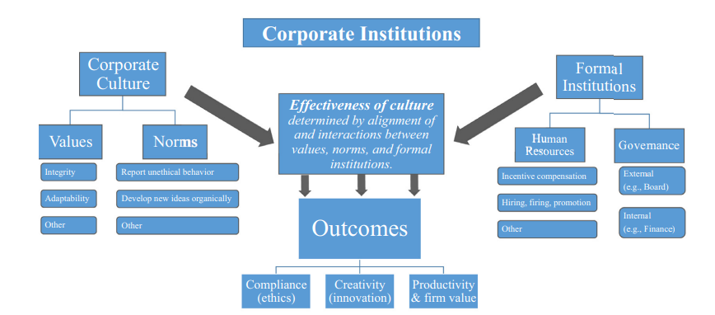

Figure 2.5: Ethics and value development in employees through the business process by use of proper corporate culture
(Source: Graham et al., 2022)
Introducing the rules and regulations of each of the organisations in the business to the employees becomes possible by application of the value development process. It has helped both organisations in the development of strategic choices of the company with better market information (Rajawatet al., 2020). Having an idea about the choices of customers in the business and assessing the possibility regarding future shifts in the market has helped McDonald's and Jollibee in faster achieving faster business progress. Providing customers with quality products at a nominal price range has helped companies like McDonald’s and Jollibee in the management of market effectiveness by increasing satisfaction in the customer's has helped in faster business development (Aporbo, 2022). Faster development of the business and following the corporate values of the organisation is a part of the training process of employees in both organisations. Management of a diverse group of employees in both organisations becomes possible after the introduction of effective administration techniques in the company.
Evaluation of the skills of employees and faster management of business also becomes possible after introducing each of the factors. The development of a proper code of conduct in the process of employee management in the business has helped both McDonald’s and Jollibee in achieving long-term business goals (Rajawatet al., 2020). The application of effective taglines in the advertisement helps in gaining customers' attention in the global market. According to Aporbo (2022), the use of effective taglines like ‘“Ditosa Jollibee Beedaangsarap’, has helped Jollibee in the development of better customer attention in the market. Application of the same type of tagline by McDonalds such as “I am loving it”, has also helped the organisation boost the attention of customers towards their products. The development of an idea about the choices of customers in the overall business process is necessary for faster business progress in the market. Ethics in the process of business has helped these organisations in the systematic development of both organisations’ performance in the market.

2.2.7 Various social settings by offsetting worldwide standards with local preferences
Local preference for food products has a significant role in maintaining worldwide standards for a company that deals with food products. In different countries throughout the world, the companies that provide food products introduce various types of food items according to cultural differences (Siddiquiet al., 2022). Due to the influence of cultural traditions, and religious differences the types of food products vary in different nations. Companies of food products such as McDonald's and Jollibee Food Corp provide different food items in several countries in order to penetrate in diverse cultures and markets. Localization is a significant factor in the food industry as it allows companies to grow in the local markets by providing sustainable and diverse food products according to traditional cultures.
McDonald's has a secret ingredient that enables the company to achieve global success. The company follows the localization process in order to meet the preferences and needs of a specific market. As per the view of Anyanwuet al., (2022), McDonald's has made key alterations to its menu that caters to a country's religious beliefs and dietary preferences. For example, the majority population of India does not consume beef due to religious beliefs. In response to this, McDonald's has introduced Maharaja Mac which is another version of Big Mac that contains chicken instead of beef (Economictimes.indiatimes.com, 2021). Apart from this, the company has also introduced a vegetarian option named McAlooTikki Burger to meet the needs and preferences of the vegetarian population of India. The strategy of tailoring the menu according to the dietary preferences and tastes of consumers in different nations has helped the company to the global growth with increasing sales.
Jollibee Food Corporation is another significant company that deals with food items throughout the different nations of the world. In order to satisfy the consumers, the company provides various types of food products in different countries. Jollibee is famous for its signature fried chicken named Chickenjoy (Jollibee.com, 2022). The company has its twist in using local spices that satisfy the taste preferences of local markets. In terms of satisfaction of consumers, the company provides quality products and maintains cultural traditions in the food products. Apart from this, Jollibee has placed their outlets in the populated areas. The strategic plan of placing the outlets in populated areas has helped the company to grab more consumers by satisfying them by providing mouth-watering food items.
2.2.8 Employee Spirit Development as a part of Strategic Management Practice at Jollibee Food Corp. and McDonald's
Employees are a core part of an organisation as they are responsible for promoting their best performance so that maximum efficiency can be reached. As stated by Dachneret al., (2021), major companies across the globe always emphasise the creation of employee motivation as their work contributes to the development of business operations. Strategies are developed so that effective employee motivation can be generated and necessary development can be incorporated. Big firms like McDonald's and Jollibee Food Corporation come up with proper strategic approaches so that effective employee motivation can be provided. Insufficient development of employee-related approaches can decrease the motivation within the workers which as a result can lower their spirit of working. On the contrary, a lack of spirit among the workers can easily diminish the performance level of an organisation because employees are unable to put their best potential for the organisational benefit (Noviani, 2021). Hence, it is crucial to take employee motivation methods as a part of strategy formation so that employees remain motivated to provide their maximum performance.
Employee spirit development is necessary because an increased employee spirit helps in meeting organisational goals. As contradicted by Usmanet al., (2021), decreased employee motivation creates a scope of misconduct within the workplace as they are unable to provide their best performance. Based on this aspect, it is important to come up with strong employee motivational aspects like providing rewards, and increased incentives so that maximum developments can be reached in the employee spirit up-liftmen. Big organisations like Jollibee and McDonald's are promoting rewards, and incentive-based systems so that they can improve their employee-based satisfaction. As stated by Khuonget al., (2020), it is also equally important to interact with employees to know their needs as well as any type of issues that they are facing while conducting work. This type of interaction also acts as a potential strategy to improve employee motivation. Employees' issues are resolved and thus it leads to the development of employee spirit.
Motivating employees to develop better customer service in the global market has helped both McDonald's and Jollibee sustain customers through the highly competitive fast-food industry. Training employees in the process of boosting organisational values helps make the system of work more effective in the business (Graham et al., 2022). Development of business in both McDonald's and Jollibee by maintaining proper food quality competition with companies like Burger King, Starbucks, and Taco Bell has been possible after the introduction of such effective business techniques.
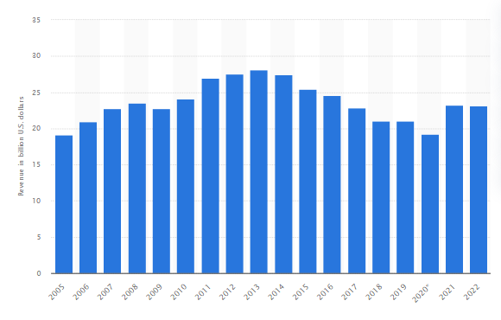

Figure 2.6: Revenue growth of McDonald’s from 2005 to 2022
(Source: Statista.com, 2022)
Passing motivation to the employees for the development of quality customer service has helped Jollibee in gaining a better position in the market in terms of receiving online orders (Jollibee.com.ph, 2024). Better training and guidance from the organisational leaders also help in the development of an idea regarding the service of customers, and employees become capable of delivering quality service. The application of technologies like online orders and payment systems has benefited in development of the business in a better way. The motivation and training process of employees helps them better cope with the changes in global business situations.
Research Gap
From the literature review part of the research, the researcher has developed ideas on the different strategic management that can be used by the managers of the food companies. Apart from this, the researcher has understood the impact of different strategic methods for managing purposes. In addition to this, the study contains different commercial and cultural environments associated with food sector business. The study provides an in-depth idea of the challenges in the implementation process of the strategies and current practices that can enhance the market game of food companies. Still, there is a gap in the research regarding the comparison of strategies of the two companies that can be mitigated through this informative study.

2.2.9 Theoretical application
Resource-based theory
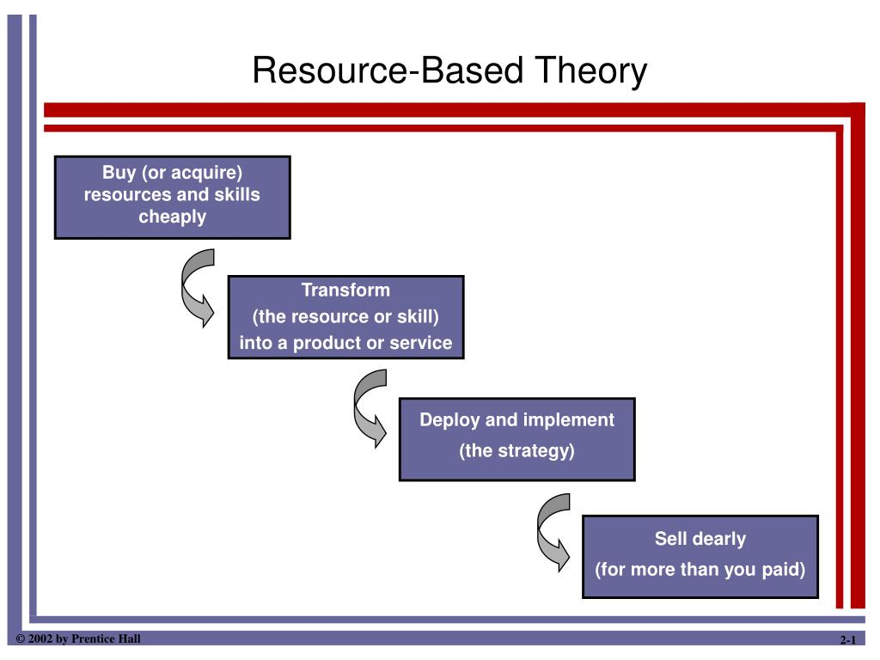

Figure 2.7: Aspects related to resource-based theory
(Source: Influenced by Stoelhorst, 2021)
According to this theory, it is stated that a company is able to conduct competitive growth through properly analysing their internal resources that are present and incorporating those resources to improve overall business operations. Based on this theory’s overview it can be stated that a company’s manager has to incorporate market strategy based on the resources that are available in the internal market (Stoelhorst, 2021). Big company managers while incorporating marketing strategy need to analyse the key internal resources that are going to help the company to attain effective business success in the long run (Barney et al. 2021). McDonalds and Jollibee both of these firms have to look into their capabilities, resources, and competences so that their managers are able to make use of their ultimate capabilities to place their place in the market.
Theory of planned behaviour
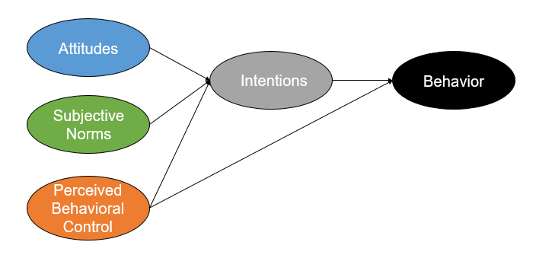

Figure 2.8: Aspects related to theory of planned behaviour
(Source: Influenced by Soket al.2021)
According to this theory it is mentioned that a company needs to formulate their market growth strategies through analysing the behaviour of their consumers. Soket al. (2021) mentions incorporation of this theory effectively helps to come up with business operations that are going to serve the customer requirements after analysis of their behaviour. McDonalds and Jollibee both are able to make necessary improvements in their way of action through incorporation of strategy formulation that serves the business needs. On the other hand, theory of planned behaviour helps in making the strategies that aligns with customer or market needs (Abbasiet al. 2021). First theory helps in looking into internal aspects of a firm and the second one helps in looking into external aspects of a firm while implementation of strategy by a manager.

2.2.7 Literature gap
Overall study has been conducted to analyse the marketing strategy formulation that is being used by a manager to conduct business operations. However, in the study of Okumus (2021), the majority of information has been incorporated related to challenges that are being encountered by managers while formulating business strategies. However, fewer information has been incorporated regarding the recommended strategies that can be used.

2.3 Hypothesis
H1: The managers of Jollibee Food Corporation implement better strategy than McDonald
H2: The managers of McDonaldimplement better strategy than Jollibee Food Corporation

2.4 Proposed methodology
It can be proposed within this study that based on literature gaps that are being identified it can be analysed that incorporation of methodology is required for gathering of information. A primary data collection process has been used for gathering of information from a wide variety of sources. Articles, journals have been made so that reliable data associated with topics are extracted successfully. It is also found that thematic analysis is going to be conducted for effective interpretation of information that is being extracted from study. Incorporation of these method can effectively help in development of necessary information associated with topic.

2.5 Summary
It can be summarised from this section that a manager needs to look after various aspects of an organisation while formulating a strategy. Similarly, incorporation of that formulae strategy also needs to be done based on certain factors that are impacting the performance of the implemented strategy.

Chapter 3: Methodology

3.1 Introduction
The methodology is a significant part of research that allows the researcher to provide descriptions of the techniques and procedures that are used to identify the pieces of information relevant to the research topic and to analyze them. Through the help of the methodology part, the process of conducting the research becomes more effective and manageable. The methodology of a study allows the researcher to design the study in a smooth way that helps in achieving the objectives through the selected instrument appropriately. The methodology section of the research enables the readers to evaluate the reliability and validity of the overall study critically.

3.2 Research Onion
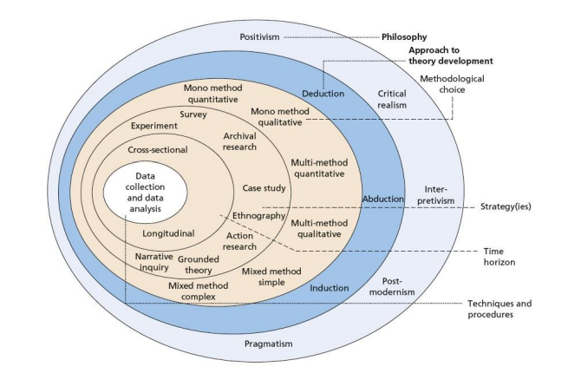

Figure 3.1: Research onion
(Source: Mardiana, 2020)
The onion model of Saunders is a framework that helps the researcher to organize the study design. The framework of the onion model comprises six different layers. Each of the layers helps to make a significant choice of the methods that can provide a proper shape throughout the phases of the research. Different instrument of the onion model of Saunders helps in conducting the study in an effective manner.

3.3 Research Philosophy
The philosophy of research is based on the beliefs regarding the way through which information about a specific phenomenon can be gathered, analyzed, and finally utilized. The philosophy of research deals with the nature, sources, and development of knowledge. As per the findings of Morgan and Nica (2020), the research philosophy involves reflecting on the beliefs and assumptions regarding data collection for developing, analyzing, challenging, and evaluating them. In order to develop the methodology of a study, the research can be designed and executed through various forms of philosophy of research such as “pragmatism”, “interpretivism”, “realism” and “positivism”. Variations in the forms of philosophies of research help in distinguishing the works of different researchers. The different forms of philosophy also aid by providing shape to the research that leads the researcher to conduct the study successfully. The positivist philosophy depends on reality whereas the interpretivist philosophy depends on the information gathered from authentic sources of data, existing journals, and past knowledge (Siponen and Klaavuniemi, 2021). The pragmatist philosophy focuses on facts and fixed principles. Finally, the realistic philosophy is based on “interpretivism” and “positivism” philosophy.
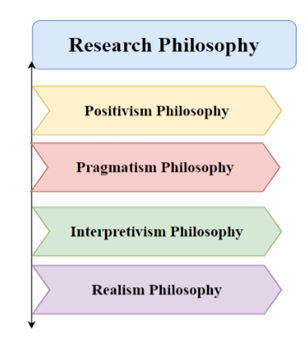

Figure 3.2: Research philosophy
(Source: Created by the author)
In order to enhance the productivity of the study, the researcher has chosen “positivism philosophy” to analyse the factual findings of the data. Positivism is a research philosophy that utilises scientific methodologies from the natural sciences to analyze social troubles. Positivist research seeks to affirm hypotheses and provide information that can be implemented broadly by way of the use of impartial dimension and quantitative analysis. This is regular with the studies technique used in the research that compares the approach execution of Jollibee and McDonald's. The reason is to impartially evaluate the efficacy of managers from exceptional groups in enforcing commercial enterprise techniques. This situation relates to the sector of social technological know-how and goals to explain the reason-and-impact links between management practices and the overall performance of a corporation.

3.4 Research approach
Concerning the process and plan of the research, the researcher explains the approach. The approach section of a research methodology aids with the collection of information, identifying them, and analyzing and interpreting those data in order to specify the understanding of the provided topic. It is one of the most significant parts of research as it helps the readers to understand the background of the research and the establishment of the subject area. Similarly, the approach of research narrows down the broader procedure of the method into specific conduct (Alvesson and Sandberg, 2022). The methodological choice of the approach of research can be categorized into three different sections which are “deductive”, “abductive”, and “inductive”. According to the research of Xu and Zammit (2020), an inductive approach to research methodology is the process through which the researcher shows the pattern of data, and depending on the observation, the information is collected for the enhancement of the ideas relevant to the topic, whereas the deductive approach helps in developing hypotheses and tests with the help of specific observations.
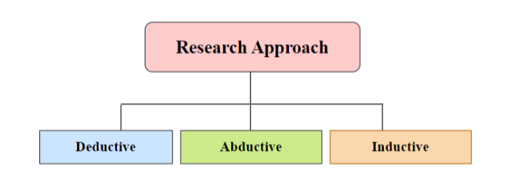

Figure 3.3: Research approaches
(Source: Created by the author)
In response to choosing an appropriate approach for the advancement of the research, the research used a deductive method to research the correlation between managerial practices and the a success execution of strategies. Deductive studies entails formulating hypotheses derived from established theories after which devising an empirical has a look at to validate those assumptions. Hypotheses are derived from method execution frameworks, which propose that sure control practices bring about powerful implementation. Subsequently, those assumptions are tested via the gathering of quantitative information approximately the managerial implementation moves at Jollibee and McDonald’s. The statistics is examined in order to decide if the speculation linking managerial behaviours to implementation effectiveness has to be commonplace or rejected.

3.5 Research Strategy
The scheme or plan that assists the researcher in making directions of the study and concluding the study in a successful way is considered the strategy of research. According to the view of Oxholm and Glaser (2023), research strategy helps the researcher by providing an in-depth analysis regarding a particular event, person, or group. The research can be conducted with various strategies that are categorized into several sections such as grounded theory, case study, narrative strategy, survey, experimental strategy archival strategy, ethnography, and action strategy. The researcher has preferred to choose “survey” as the most suitable strategy for the research. According to the research of (Ferriet al., 2020), the case study allows the researcher to accumulate information as much as possible relevant to the provided topic. The research strategy is based on conducting a survey among managers from McDonalds and Jollibee Food to bring out the effective implementation of marketing strategies in the food sector. This entails the collection of adequate data from managers’ responses while considering the need for effectively implement strategies by managers from both companies. This reveals the idea of enhancing business performance based on proper collection of data from managers. However, the focus is given to collecting primary data in response to survey statistics gathered from responses.

3.6 Research Choice
This study has chosen the qualitative method for collecting the data for this study, which is important for observing the situation and making decisions for identifying the findings of this study. Therefore, considering the research choice, this has been followed by the Mono method which refers to taking one method for the research. As mentioned by Papariniet al., (2021), the qualitative method is important for identifying the complexities of the research, analysing the contexts of the phenomena and making decisions. Therefore, through this process, the study can identify the implementation process of the different findings of the research. Here, in this study, this method has been chosen for observing the social situation by considering only one method, identifying the complexities and making suitable decisions for the companies of Jollibee Food Corp and McDonald's. The challenges that have been found for these companies are a lack of marketing strategies, a lack of market enhancement and others; therefore, after analysis of these situations, the decisions can be taken for this study. On the other hand, the quantitative method has not been used in this study because the quantitative method mainly focuses on the statistical analysis of the study and the numerical analysis of the data. Therefore, this has been excluded in this study to identify the findings of this study (Hennink and Kaiser, 2022). On the other hand, the mixed method includes considering two types of methods and the multi method includes considering multiple types of methods. Therefore, these methods excluded in this study.

3.7 Time horizon
This refers to the two factors which are cross-sectional and longitudinal. As mentioned by Doeringet al., (2020), cross-sectional refers to all observations from a specific point in time, in contrast, longitudinal refers to considering particular variables and managing observations from different years, months and others. Here, in the study, the survey responses have been gathered from managers frommanagers for the observations for this study. Therefore, through this process, a specific time frame can be considered to complete the overall research process.

3.8 Search Strategy
There are various types of search strategies which are important for collecting the data for this study and analysing the data of the collated data. There are three types of search strategies those are keyword search, database search and Boolean search. The search strategies are also considered as the searching the suitable sources in collecting the data for this study. Therefore, by identifying the credible sources of the data the data of this study can be collected and proper findings can be identified. The keyword search includes the identification of the different keywords that are effective for searching the articles. The keywords are:
- Implementation strategies
- Managers Strategies
- Managers' Techniques and Practices
- Implementation Strategies of Jollibee Food Corp
- Implementation Strategies of McDonald's
- Strategic management practices
- Market-specific factors
- Cultural factors
- Competitive markets
- Market profitability
Therefore, these keywords are effective for searching the articles considering these terms also this can give authentic sources for analysing the findings of this study. There is another process for searching the sources which is the database search.
S.No. | Database | Description | Explanation
1 | Google Scholar | This is the authentic database that provides the free sources of the articles. Through this process, researchers can consider authentic sources of the databases for collecting the data considering the research topic. Moreover, researchers can consider the past five years' new journals for collecting the data. | This is the primary source of this study to collect the data and meet the research objectives.
2 | ProQuest | This database also provides authentic sources that can be used in the research process. Therefore, this can be used in this research to identify suitable data for this study. | This is the secondary source for collecting the data after the Google Scholar

Table 3.1: Different search engines to collect a database
(Source: Self-made)
There is another type of search strategy which is the Boolean search, which can give better utilisation of the different keywords for this study. This includes the utilisation of the AND and OR gate for identifying suitable articles for the research.
Search term | Quantity
Implementation strategies of Jollibee Food Corp AND McDonald's | 150
Managers' Techniques and Practices of Jollibee Food Corp AND McDonald's | 130
Market-specific factors OR Cultural factors | 120
Competitive Markets OR Market profitability | 80
Strategic management practices of Jollibee Food Corp AND McDonald's | 120

Table 3.2: Boolean operator
(Source: Self-made)
This table shows the usage of the Boolean operators in collecting the data for this study, moreover, the utilisation of the AND and OR gate have been identified. This gives the proper implementation of the techniques and collection of suitable resources for this study.

3.9 Data collection method
The data collection method includes considering the interview process and collecting the data from the managers of the company. This study has considered the six respondents three managers from both the companies of Jollibee and McDonald’s. The study employs quantitative survey information accumulated directly from management at Jollibee and McDonald’s as its essential information of statistics on method implementation behaviours. The survey facts allows for quantitative observe of management techniques using described metrics. Two separate surveys for two separate companies have been conducted. For each survey, 30 managers have been included. A total of 60 managers from two companies (30 each) have been taken for conducting the survey process. In this context it is worth mentioning that among these 60total participants, 29 participants are from managerial post from each company and rest 1% was not from managerial post. However, we have followed random sampling technique, where total 58 respondents were from managerial post from both the companies and rest 2 respondents were not from managers.The survey employs predetermined measures to evaluate variables together with communication fashion, monitoring systems, and alignment techniques. The survey answers are assigned numerical ratings and then blended to provide statistical information on management strategies. Statistical tests are used to examine facts so as to research the relationships among approaches and performance(Caligiuriet al., 2024). These questions can be effective for gathering knowledge from managers and making future decisions for this company. The goal of the findings is to perceive the tactics which might be most beneficial for accomplishing a success implementation in a wide sense. The use of primary quantitative survey facts is regular with the positivist deductive methodology employed inside the research. Although qualitative facts may additionally provide more detailed descriptions, quantitative surveys allow for quantifiable evaluation to evaluate theories on the management elements that have an impact on implementation success.

3.10 Data Analysis Method
Considering the data analysis method, this study has taken the thematic analysis process for analysing the collected data in this study, this is the primaryprocess. This process includes making some survey questions considering the literature analysis and the interview analysis process (Caligiuriet al., 2024). Therefore, through this process, the objectives of this study can be met and the purpose of developing this study can be achieved. The research usually employs quantitative analysis of survey facts on managerial execution behaviours at Jollibee and McDonald's. This includes the usage of statistical evaluation to examine hypotheses on the practices which are associated with effective approach implementation. Metrics such as means and general deviations condense the patterns of responses within the survey data. This pertains to the managerial tendencies shown with the aid of every employer. This experiment examines the theories about efficient methodologies while the statistical observe pursuits to objectively compare the behaviours of managerial execution between the two businesses which will find any noteworthy discrepancies.

3.11 Ethical Consideration
This study has followed the ethical guidelines for managing the safety of the researchers and managing safety of the participants.The research guarantees that managers who participate in surveys are safely knowledgeable about the aim, risks, and rewards earlier than giving their voluntary assent to take part. Consent refers back to the voluntary settlement that is not stimulated via pressure or deceit. Although the survey acknowledges acquiring ethical clearance, it lacks sufficient statistics about the particular strategies used in studies design, information gathering, and analysis. However, the researcher has conducted two different surveys for two different company groups to highlight the comparison related to strategic implementation. Also in order to maintain the ethics and confidentiality principle,the researcher has conducted two different surveys.Moreover, researchers have developed suitable communication to follow different steps of the research and maintain the ethics of the research.

3.12 Summary
This study has followed the overall structure taken from the research onion, and the effectiveness of the different steps of the research onion has been considered in this study. Moreover, this study followed the search strategies for collecting the data and ethical considerations for maintaining authentication in collecting the data in this study.

Chapter 4 Findings, analysis and discussion

4.1 Introduction
This section intends to present the primary findings and its analysis in the form of pie chart and descriptive data. The primary data presented in this chapter is from the survey conducted for 60 managers (30 each from McDonald's, employee attitude at Jollibee Food Corp. respectively, however only 29 were from the managerial post for both companies). Therefore, based on the following analysis and secondary findings the discussion is intended to be carried out.

4.2 Findings

Primary data depiction and analysis
Demographic Questions
Q1. What is your gender?
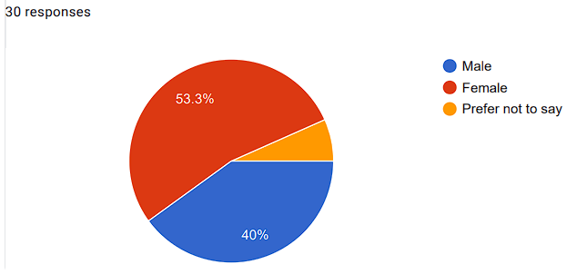(Jollibee Food Corp)
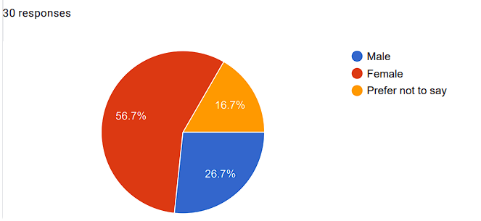 (McDonald’s)

Figure 4.1: Gender of the participants
(Source: Derived from Google form)
Considering the data of the 30 members of Jollibee Food Corp, 53.3% were female whereas 40% were male, however, the rest percentage preferred not to disclose their gender. In contrast, it has been seen that 30 managers from McDonald’s also participated in the survey, whereby, 56.7% were females, 26.7% were male and 16.7% preferred not to disclose their gender. Nevertheless, in the opinion of Mukucha et al., (2024), stated that within the fast-food industry, males hold most of the managerial posts. However, in the case of this survey female managers from McDonald’s and Jollibee Food Corp have shown active participation.
Q2. What is your age?
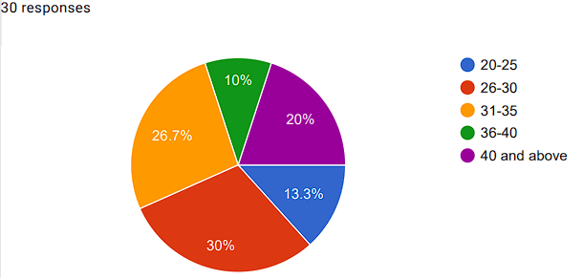(Jollibee Food Corp)
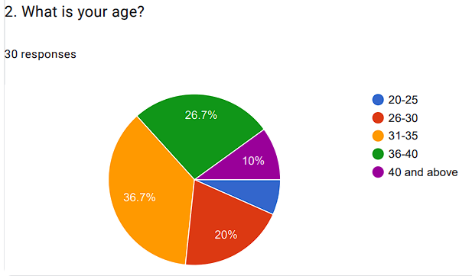(McDonald’s)

Figure 4.2: Age of the participants
(Source: Derived from Google form)
Among the two companies, it has been noted that most of the participants fall under the 26-35 (30% and 26.7% for Jollibee Food Corp whereas 20% and 36.7% for McDonald’s) age group, thus considered to be in their early and middle adulthood. In the views of Mukucha et al., (2024), most of the managerial staff holding the manager post are below 40 years of age in the fast-food industry.
Q3. What is your occupation?
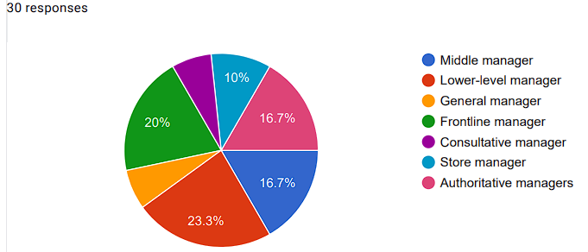(Jollibee Food Corp)
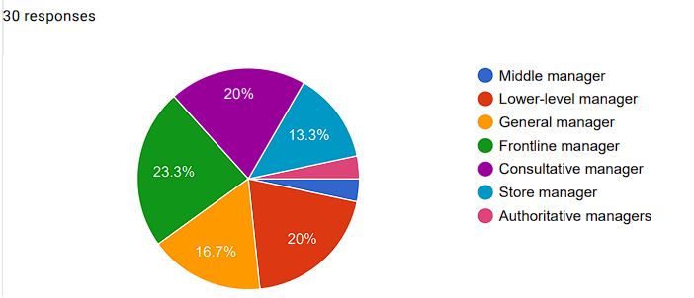(McDonald’s)

Figure 4.3: Occupation of the participants
(Source: Derived from Google form)
In accordance with the data provided, the fast-food industry has several managerial posts, wherein, low-level managers and frontline managers are the most serving managers within Jollibee Food Corp and McDonald’s with 23.3% and 23.3% respectively. However, in the opinion of Mares and Minkoff-Zern (2024), within the fast-food industry, managers play an important role in the aspect of customer satisfaction via different job responsibilities.
Q4. Are you a Manager at Jollibee Food Corp?
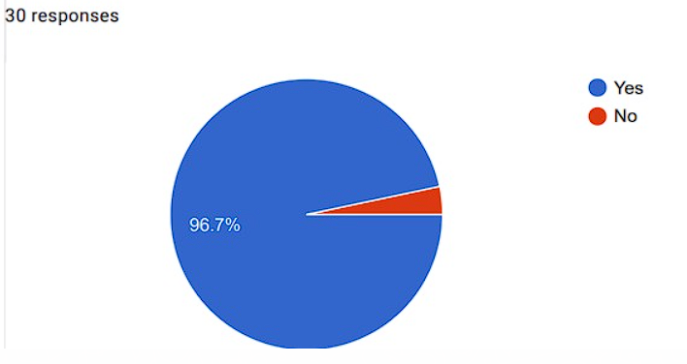(Jollibee Food Corp)
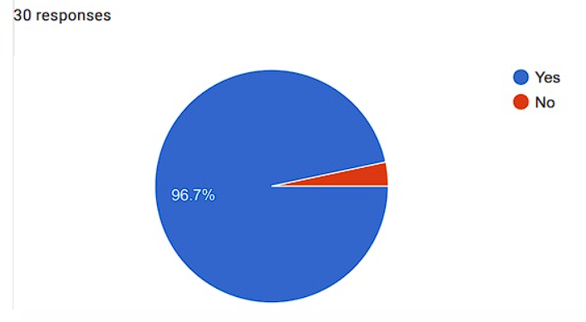(McDonald’s)

Figure 4.4: Managers from Jollibee Food Corp and McDonald’s
(Source: Derived from Google form)
In consideration of the data, there were 30 respondents each from the fast-food companies Jollibee Food Corp and McDonald’s. However, among the 30 survey respondents, 29 members (96.7%) were managers from different departments and only 1 member (3.3%) respondent was not at any managerial post for both the companies. In the opinion of Steele et al., (2024), survey dependability is based on the views of the majority of respondents. Therefore, in this survey analysis, out of 60 total survey respondents, the viewpoint of 58 survey respondents has been considered.
Q5. How many years of experience do you have in your managerial designation?
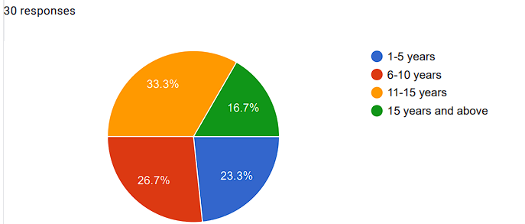(Jollibee Food Corp)
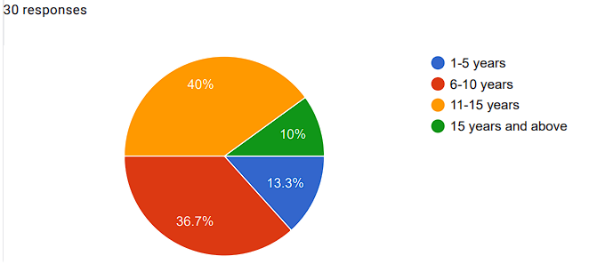(McDonald’s)

Figure 4.5: Manager’s work experiences from Jollibee Food Corp and McDonald’s
(Source: Derived from Google form)
It is noted that among all kinds of managers at different departments of Jollibee Food Corp and McDonald’s, most of the managers have working experience under the range of 11-15 years. It was noted that for Jollibee Food Corp’s managers, it was 33.3% whereas for McDonald’s managers, it was 40%, respectively. From the perspective of Mares and Minkoff-Zern (2024), managers could have worked for an initial period of 3 years and a maximum of 11 years within leadership positions.

Contextual Questions
Q6. Do you think that profitability management is effective for Jollibee company and McDonald’s?
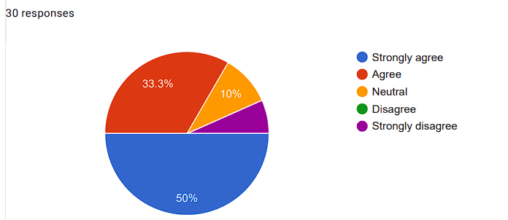(Jollibee Food Corp)
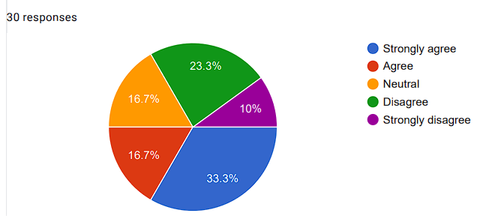(McDonald’s)

Figure 4.6: Profitability management is effective for Jollibee Food Corp and McDonald’s
(Source: Derived from Google form)
As per data both Jollibee Food Corp and McDonald’s seek profitability management whereby it leads to effectiveness. Moreover, inside Jollibee Food Corp’s management, 50% show strong agreement and inside McDonald’s management, 33.3% show strong agreement to profitability management. As per Ejechi and Okoro (2023), the profit percentage for fast food businesses is typically between 6 and 9%. There are various reasons why this is greater than the sector's average.
Q7. Would Reputation management be fruitful for your company?
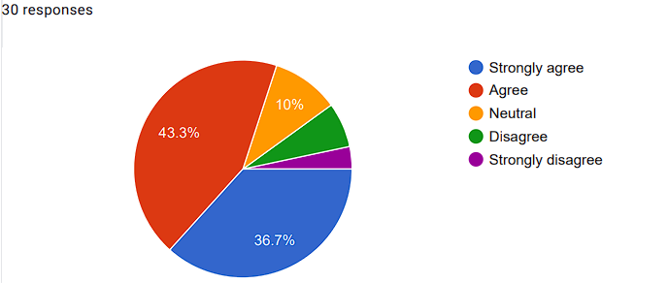(Jollibee Food Corp)
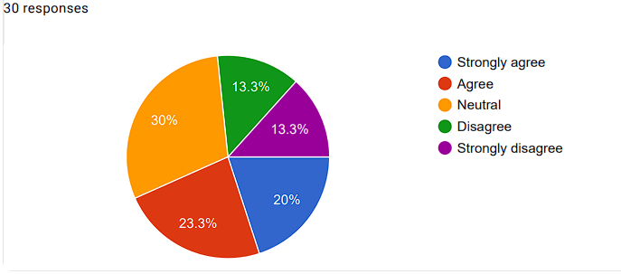(McDonald’s)

Figure 4.7: Reputation management for Jollibee Food Corp and McDonald’s
(Source: Derived from Google form)
Considering the data, Jollibee Food Corp and McDonald’s are engaged in reputation management whereby 43.3 % of managers agree with Jollibee Food Corp and 23.3% agree with McDonald’s. As per Reshi et al., (2023), in the fast-food sector, managing one's reputation is crucial to operating a profitable dining establishment in a market that is extremely competitive.
Q8. Do you think, strategic management techniques can be effective for managing different cultural and commercial environments of the company?
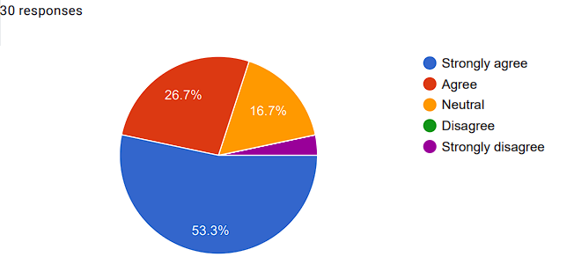(Jollibee Food Corp)
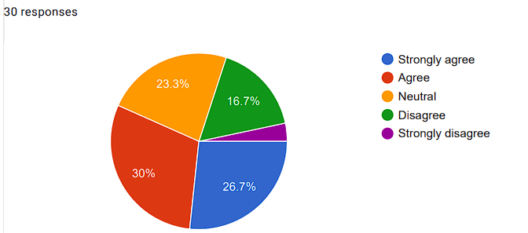(McDonald’s)

Figure 4.8: The strategic management techniques can be effective for managing different cultural and commercial environments for Jollibee Food Corp and McDonald’s
(Source: Derived from Google form)
For Jollibee Food Corp. (53.3% of managers strongly agree) and McDonald's (30% of managers agree), strategic management strategies can be helpful when managing diverse cultural as well as commercial settings. Considering the perspective of Halim (2023), only by using localised marketing mix techniques can international fast-food chains succeed within their new markets.
Q9. Do you think, successful implementations of strategic management techniques can be effective for the Cross-Cultural Management of the company?
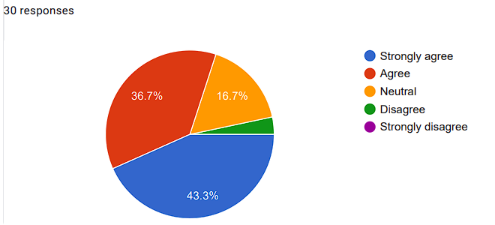(Jollibee Food Corp)
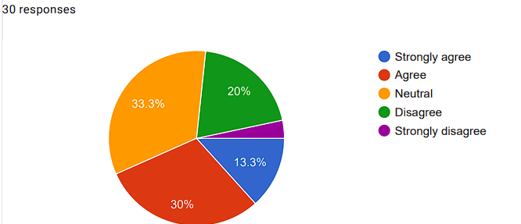(McDonald’s)

Figure 4.9: Successful implementations of strategic management techniques in Context to Cross-Cultural Management for Jollibee Food Corp and McDonald’s
(Source: Derived from Google form)
In accordance with the data, Jollibee Food Corp. managers (43.3% Strongly agree) and McDonald's managers (30% agree) have successfully implemented strategic management approaches in the framework of cross-cultural management. As per Ullah et al., (2024), Competent strategic management continually prepares, monitors, alongside evaluates an organization's operations in contrast to static strategies with the goal of increasing efficiency in operations, competitiveness, and revenue.
Q10. Do you agree that influential managerial techniques are effective for cross-cultural management?
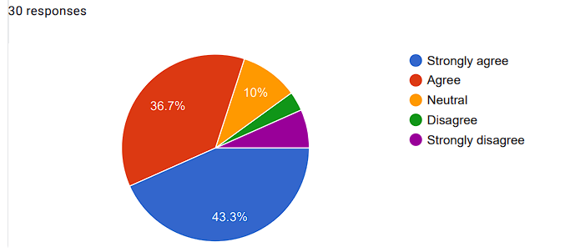(Jollibee Food Corp)
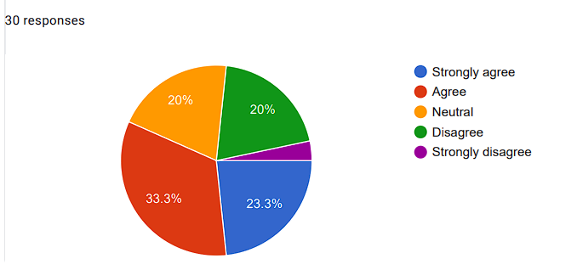(McDonald’s)

Figure 4.10: The influential managerial techniques for Jollibee Food Corp and McDonald’s
(Source: Derived from Google form)
Influential management strategies used by McDonald’s (33.3% agree) and Jollibee Food Corp. (43.3% strongly agree) demonstrate the significance of management across cultures. According to Abdelhakim et al., (2023), through the promotion of awareness and respect for different ways of speaking and intercultural quirks, cross-cultural management improves communication within international corporations.
Q11. Is your organisational employees' behaviour appropriate to maintain a cultural and commercial environment?
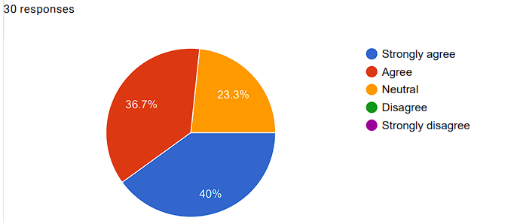(Jollibee Food Corp)
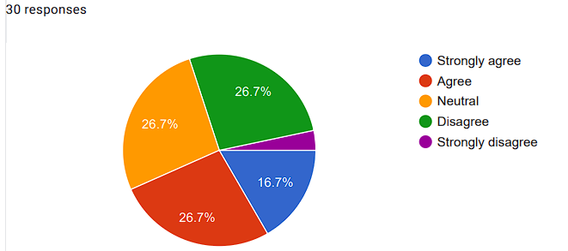(McDonald’s)

Figure 4.11: Employees' behaviour appropriate to maintain a cultural and commercial for Jollibee Food Corp and McDonald’s
(Source: Derived from Google form)
Employee conduct is suitable to preserve McDonald's (26.7% of managers show agreement) and Jollibee Food Corp.'s (40 % of managers show strong agreement) business culture. Considering the notion of Chico et al., (2023), organisations with strong organisational cultures typically outperform less structured ones due to the mechanisms they put into effect to encourage employee involvement, efficiency, and effectiveness.
Q12. Do you agree that your organisation promote a unique experience to the consumers?
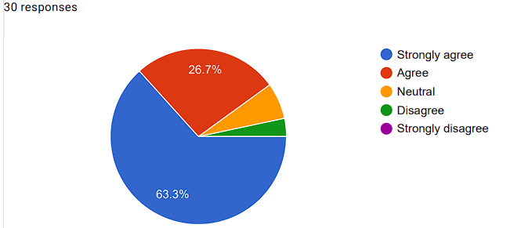(Jollibee Food Corp)
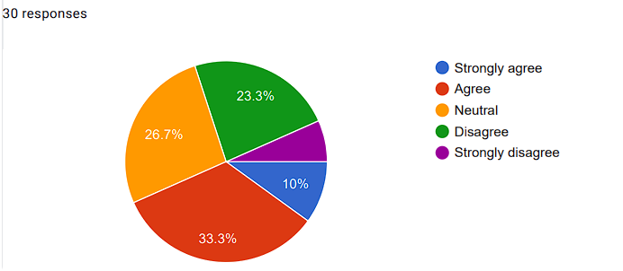(McDonald’s)

Figure 4.12: Jollibee Food Corp and McDonald’s promote a unique experience to the consumers
(Source: Derived from Google form)
Both McDonald's managers show 33.3% agreement and Jollibee Food Corp. managers show 63.3% strong agreement towards pushing for customers to have a distinctive experience. According to Dandiset al. (2023), fast-food businesses use tales, images, and animations to produce interesting content that connects with consumers. Additionally, businesses organise freebies, and competitions, while promoting on social networking channels in addition to introducing new goods and services.

Q13. Would you agree that building an emotional connection with the consumers is necessary for being competitive?
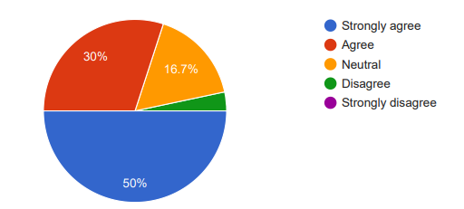(Jollibee Food Corp)
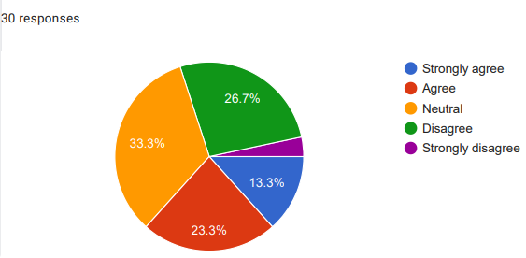(McDonald’s)

Figure 4.13: Importance of developing an emotional connection with customers for both companies
(Source: Derived from Google form)
Considering the techniques and practices implemented by managers of both popular fast-food chains the researcher has set this question. In order to obtain the answer to the fourth research question the researcher has gathered the survey responses from different managers of both fast food companies. The responses to this question enable the researcher to understand the practices used by managers of fast-food companies to manage competitive advantages. Among 30 managers of Jollibee Food Corp, almost 80% of managers have agreed that an emotional connection with customers is crucial to being competitive in the market. Khan et al., (2022) have also mentioned that an emotional connection with customers helps a company to better understand the demand of customers and assists in increasing customer satisfaction and brand awareness. In contrast, only 36% of managers from McDonald's have agreed with this question.
Q14. Do you agree that adaptation of technology is a critical success factor to implement strategies developed by managers in highly competitive fast food sectors?
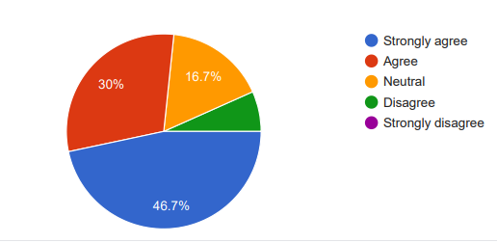(Jollibee Food Corp)
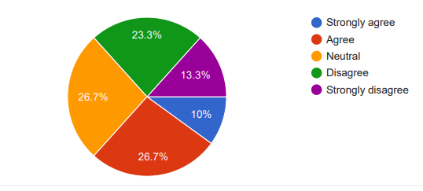(McDonald’s)

Figure 4.14: Adaptation of technology is a critical success factor
(Source: Derived from Google form)
In order to understand the managerial practices and techniques used by managers of McDonald’s and Jollibee Food Corp the researcher this question. In order to understand the way managers of large fast-food companies are managing their competitiveness in the market this question has been asked to respondents. The responses from managers have helped the researcher to understand the critical success factor behind the implementation of strategies by managers. The responses from the survey reveal that more than 70% of respondents from Jollibee Food Corp have agreed that technology adaptation is the critical success factor for the implementation of strategies by managers. Butt (2020) has mentioned that in recent days, technology is crucial to sustain digital transformation that helps businesses automate business operations, bring innovation and enhance business efficiency. Thus, technology adaptation is a critical success factor that provides competitive advantages. On the other hand, it has been obtained from the survey that only 36% of managers from McDonald’s have agreed with this question.
Q15. Would you agree that customer satisfaction is a long-term strategic choice to improve organisational capacity?
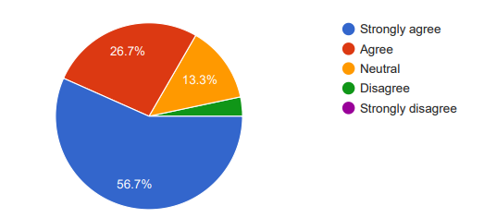(Jollibee Food Corp)
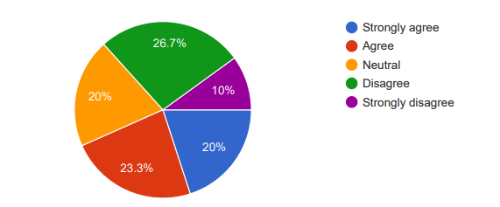(McDonald’s)

Figure 4.15: Customer satisfaction is a long-term strategic choice
(Source: Derived from Google form)
One of the crucial responsibilities of managers is to develop strategies that help other employees maintain a positive relationship with customers. In order to run a successful business it is crucial to develop a corporate culture that influences the capacity of the company to make long-term strategic choices. Albderiet al.,(2023) have claimed that quality management and timely delivery are managerial approaches to gaining long-term success through customer satisfaction. Whether the managers of Mcdonald's and Jollibee are using this approach or not has been analysed through this question. It can be compared to the responses obtained from managers of both companies that more than 80% of managers from Jollibee and almost 50% of managers from McDonald's have agreed that customer satisfaction is a long-term strategic choice for fast-food businesses.
Q16. Do you think cost leadership is a long-term strategic choice to enhance organisational capacity?
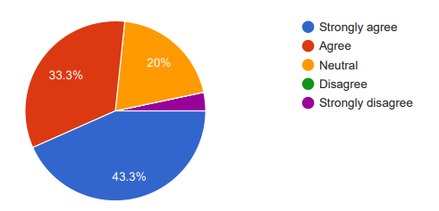(Jollibee Food Corp)
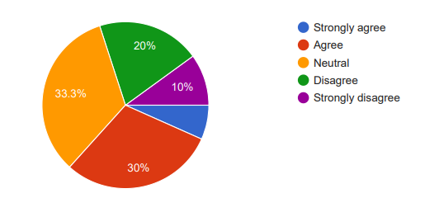(McDonald’s)

Figure 4.16: Cost-leadership as a long-term strategic choice
(Source: Derived from Google form)
In order to understand other corporate culture that influences the company’s capabilities to run a long-term business the researcher has designed this question. Ali and Anwar (2021) have defined cost leadership as a strategy that is applied by businesses to become a leader in low-pricing. This strategic choice assists a business in achieving profitability through high sales volume. By offering a low price products businesses can run a long-term business. Therefore, cost leadership is a managerial approach that goes with long-term strategic choices. The primary survey responses reveal that almost 40% of managers of McDonald’s and more than 70% of managers from the Jollibee group have agreed with this question.
Q17. Do you think that taste, dietary preferences and religious beliefs can help fast food chains offset worldwide standards with local preferences?
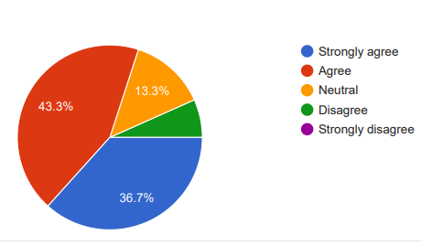(Jollibee Food Corp)
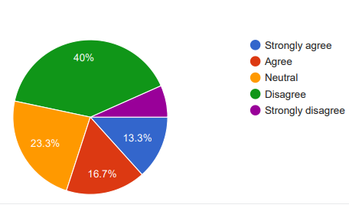(McDonald’s)

Figure 4.17: Strategies to offset worldwide standards to local preferences
(Source: Derived from Google form)
Jollibee Food Corp and McDonald’s both are international fast-food chains that are popular among cross-cultural customers. In order to manage the cross-cultural customers in foreign countries it is crucial for managers to develop appropriate strategies in different social settings to balance local preferences with worldwide standards. Chun and Nyam-Ochir (2020) have identified that different global fast-food chains have altered their menu considering the taste and dietary preferences of local people. Moreover, companies have also considered the religious beliefs of local people to managing business in a particular country. More than 70% of survey responses from Jollibee’s managers indicate that they follow this strategy during global business.
Q18. Do you agree that rewards, recognition and benefits can empower a spirit of development among employees?
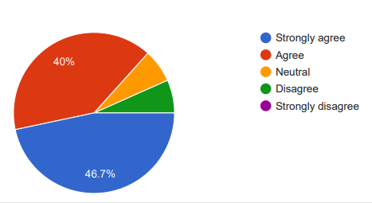(Jollibee Food Corp)
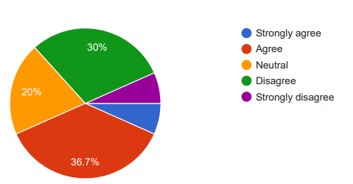(McDonald’s)

Figure 4.18: Rewards and recognition to empower employee spirit development
(Source: Derived from Google form)
Along with managing long-term success, customer and business profitability managers are also responsible for employee satisfaction and engagement. The increasing engagement and satisfaction of employees are directly linked with improving the productivity and profitability of the business (Ghlichlee and Bayat, 2021). It has been observed from the survey responses that more than 40% of managers from McDonald’s and almost 80% of managers from Jollibee Group have agreed that benefits, rewards and recognition from managers can empower the spiritual development of employees.
Q19. Do you agree that training programmes and career growth opportunities can create a spirit of development among employees?
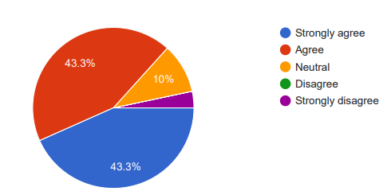(Jollibee Food Corp)
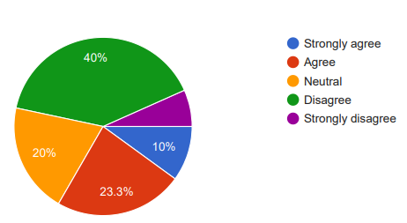(McDonald’s)

Figure 4.19: Training programmes and career growth opportunities create a spirit of development
(Source: Derived from Google form)
In the context of employee spiritual development, the researcher has asked managers about the importance of career growth opportunities and training programs. Gabriel and Aguinis (2022) have mentioned that the appropriate training programme and carer growth opportunities motivate employees which in turn improves employee performance and engagement with the company. The survey responses also indicate that more than 80% of managers from Jollibee and almost 30% of managers from McDonald's have agreed with this question.
Q20. Do you agree the development of employee spirit assists in strategic administration practices?
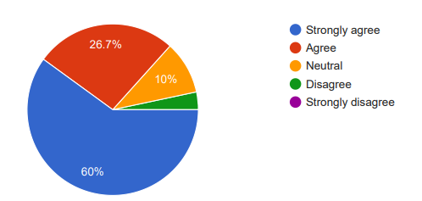(Jollibee Food Corp)
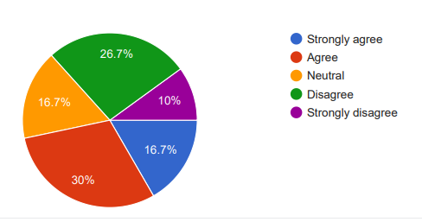(McDonald’s)

Figure 4.20: Employee spirit development helps in strategic administration practices
(Source: Derived from Google form)
Lastly, the researcher has asked this question to managers to understand the importance of employee spirit development for strategic administration practices for the business. van Tuin et al., (2020) have stated that motivated employees indicate increased employee engagement and improved profitability of the company. The survey responses also indicate that more than 80% of managers from Jollibee Group and almost 46% of managers from McDonald's have agreed with this question.

4.3 Descriptive Statistics Analysis
Question 6
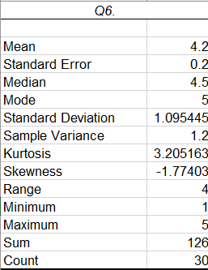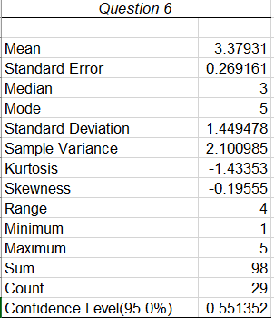
(Jollibee) (McDonald’s)

Figure 4.21: Descriptive statistics for question No. 6
(Source: Created by the researcher)
It can be noted that McDonald's and Jollibee earned mean values of 3.3 and 4.2 for the query, respectively. Moreover, the standard deviation shows that 1.09 for McDonald's and 1.44 for Jollibee. Thus, it is appropriate to ask how profitability management McDonalds and Jollibee Company.
Question 7
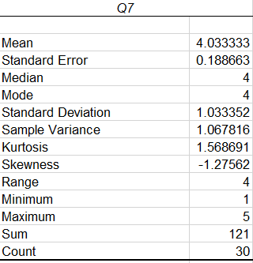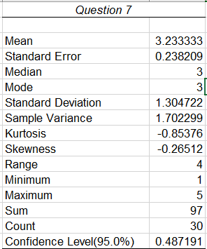
(Jollibee) (McDonald’s)

Figure 4.22: Descriptive statistics for question No. 7
(Source: Created by the researcher)
It may be noted that both Jollibee and McDonald's earned mean values of 3.2 and 4.0 regarding the question at hand, respectively. Additionally, the standard deviation shows that Jollibee's as well as McDonald's have 1.03 and 1.30, respectively. Thus, it is reasonable to ask how reputation management might benefit McDonald's and Jollibee Company.
Question 8
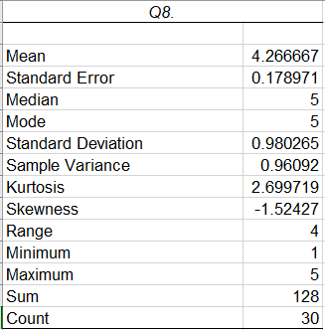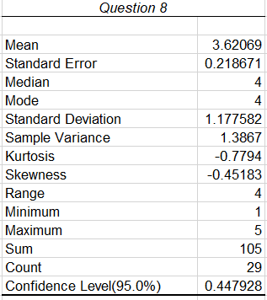
(Jollibee) (McDonald’s)

Figure 4.23: Descriptive statistics for question No. 8
(Source: Created by the researcher)
The prediction has been noted that McDonald's received a mean score of 3.6 while Jollibee received a mean score of 4.2 for this question. Additionally, the standard deviation shows that Jollibee's is 0.98 and McDonald's is 1.17. Thus, it is reasonable to ask how strategic management approaches might help Jollibee Food Corp. handle its many cultural as well as commercial surroundings with greater proficiency than McDonald's.
Question 9
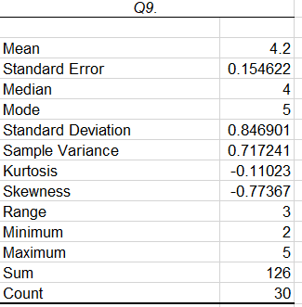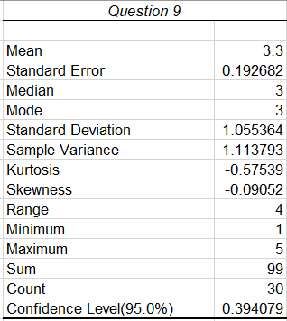
(Jollibee) (McDonald’s)
Figure 4.24: Descriptive statistics for question No. 9
(Source: Created by the researcher)
Subsequently, was additionally noted that McDonald's and Jollibee earned mean values of 3.3 and 4.2 for this question, respectively. Additionally, the standard deviation shows that Jollibee's is 0.84 and McDonald's is 1.05. Consequently, Jollibee Food Corp. along with McDonald's have successfully used strategic management approaches in an environment of management across cultures.
Question 10
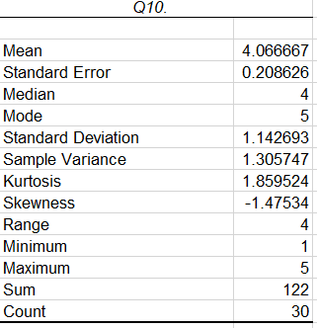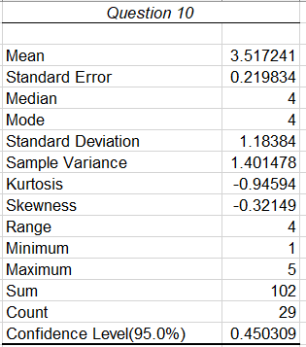
(Jollibee) (McDonald’s)

Figure 4.25: Descriptive statistics for question No. 10
(Source: Created by the researcher)
It is to be mentioned that McDonald's received a mean score of 3.5 while Jollibee received a mean score of 4.0 for this particular query. Additionally, the standard deviation shows 1.14 for McDonald's and 1.18 for Jollibee. Consequently, Jollibee Food Corp. finds that influential managerial practices are more successful regarding multicultural leadership than McDonald's.
Question 11
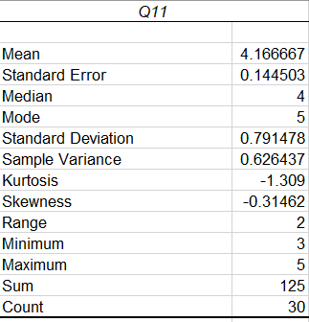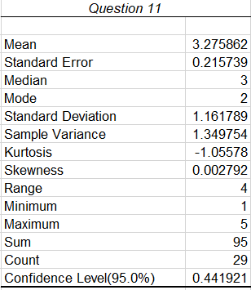
(Jollibee) (McDonald’s)

Figure 4.26: Descriptive statistics for question No. 11
(Source: Created by the researcher)
The subject has pointed out that McDonald's and Jollibee earned mean values of 3.2 and 4.1 regarding this question, respectively. Additionally, the standard deviation indicates that Jollibee's is 0.79 whereas McDonald's is 1.16. As a result, Jollibee Food Corp. offers customers a different experience than McDonald's.
Question 12
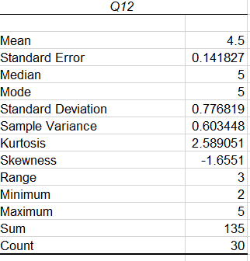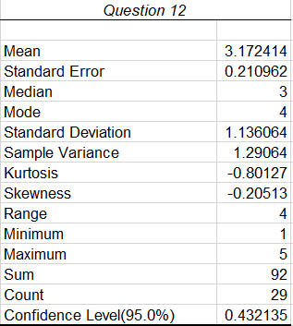
(Jollibee) (McDonald’s)

Figure 4.27: Descriptive statistics for question No. 12
(Source: Created by the researcher)
The prediction needs to be noted that McDonald's received a mean score of 3.1 while Jollibee received a mean score of 4.5 for this query. Additionally, the standard deviation shows that Jollibee's is 0.77 whereas McDonald's is 1.13. In contrast to McDonald's, employee attitude at Jollibee Food Corp. is proper to preserve the company's culture.
Question 13
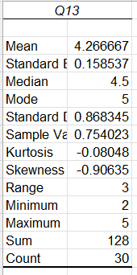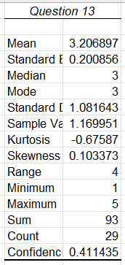
(Jollibee) (McDonald’s)

Figure 4.28: Descriptive statistics for question No. 13
(Source: Created by the researcher)
It has been observed that the mean value obtained for this question for Jollibee is 4.2 and for McDonald's is 3.2. The standard deviation also reveals 0.15 for Jollibee and 0.20 for McDonald's. Therefore the question is acceptable and Jollibee is more emotionally connected with customers than McDonald's.
Question 14
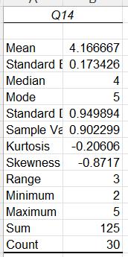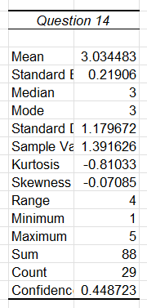
(Jollibee) (McDonald’s)

Figure 4.28: Descriptive statistics for question No. 14
(Source: Created by the researcher)
The mean value between 3-5 for both companies indicates that technology adoption is a critical success factor.
Question 15
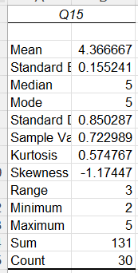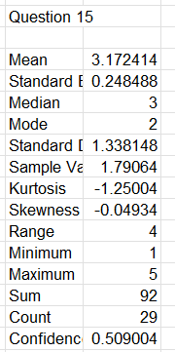
(Jollibee) (McDonald’s)

Figure 4.29: Descriptive statistics for question No. 15
(Source: Created by the researcher)
The mean and SD values for McDonald's and Jollibee are 3.17 and 4.36 and 0.24 and 0.15 respectively. These values indicate the question is acceptable and Jollibee follows customer satisfaction as a long-term strategy.
Question 16
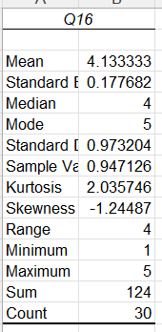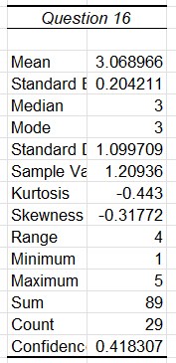
(Jollibee) (McDonald’s)

Figure 4.30: Descriptive statistics for question No. 16
(Source: Created by the researcher)
The highest mean and low standard deviation value of the Jollibee group in compared to McDonald's indicates the question is acceptable and Jollibee follows a cost-leadership strategy as long-term strategic choices.
Question 17
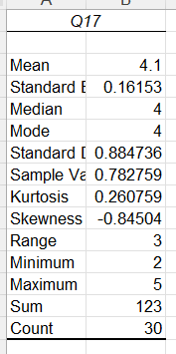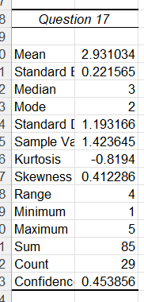
(Jollibee) (McDonald’s)

Figure 4.31: Descriptive statistics for question No. 17
(Source: Created by the researcher)
The 4.1 and 2.93 mean values for both companies indicate that the question is acceptable. The SD values 0.16 and 0.22 for both companies indicate that taste and dietary preferences help to balance global standards with local preferences.
Question 18
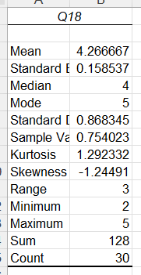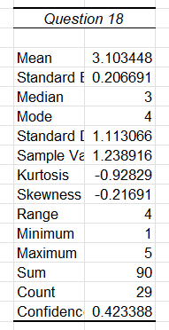
(Jollibee) (McDonald’s)

Figure 4.32: Descriptive statistics for question No. 18
(Source: Created by the researcher)
The positive mean and SD values indicate that recognition, rewards and benefits are important for empowering the spiritual development of employees.
Question 19
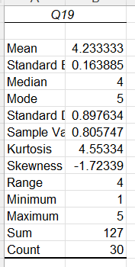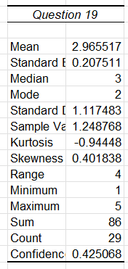
(Jollibee) (McDonald’s)

Figure 4.32: Descriptive statistics for question No. 19
(Source: Created by the researcher)
The SD value between 0-1 indicates that training and career development opportunities are important for employees' spiritual development.
Question 20
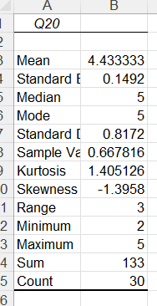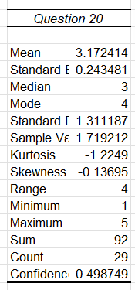
(Jollibee) (McDonald’s)

Figure 4.33: Descriptive statistics for question No. 20
(Source: Created by the researcher)
The positive mean and standard value indicate that the question is acceptable and that employee spiritual development plays a part in strategic administration practices.

4.4 Summary
It can be summarised from this chapter that both pie graphs and descriptive statistics have indicated that managers of both fast-food chains have applied various managerial techniques and strategies to increase employee engagement, business profitability and long-term success of the business.

Chapter 5: Discussion

5.1 Introduction
This part has discussed the primary result of the study which has been associated with the survey method and analysis of the study with descriptive statistics. The discussion has been presented for deriving a concrete decision about the performed investigation. In this aspect, the decision has been made according to the proposed research questions as well as objectives.Findings and discussion in a study is a phase that assists in developing decisions based on gathered data-oriented evidence. This study on managers' effectiveness in terms of strategic implementation emphasising data-based analysis has been emphasising drawing a sufficient conclusion. Undertaking a comparison between Jollibee Food Corp and McDonald’s, the successful strategic implementation process and its efficiency have been evaluated through an interview process based on which themes have been developed.

5.2 Discussion of a derived result
This study has considered the survey process and developed 20 questions to identify suitable findings from the survey. In the first section, the demographic questions have been identified which are valuable for identifying the characteristics of the managers of both the companies of Jollibee Food Corp and McDonald’s. The first question of the survey focuses on the genders of the managers where this can be seen that McDonald’s has a high level of female managers that handle the business process, Jollibee Food Corp also has a higher number of female employees however, this is less than McDonald’s. However, Mukucha et al., (2024), state that fast food companies have a higher level of male managerial positions. Considering the second question, this has been identified that, both companies have members of all types of age groups. Considering the third question, McDonald’s has a higher level of Frontline managers, while the Jollibee Food Corp, has a higher level of Lower-level managers. However, both companies have various types of managers including the Middle manager, Lower-level manager, General manager, Frontline manager, Consultative manager, Store manager and Authoritative manager (Mares and Minkoff-Zern, 2024). After that, these demographic questions also include the experiences of the managers as this survey only covers the perspectives of the different managers of both the company. This can be seen that most of the managers in McDonald’s have 11 to 15 years of experience, additionally, Jollibee Food Corp also has a higher level of managers having experience of 11 to 15 years.
After that, the survey includes the contextual questions that are important for meeting the objectives of this research. For example, the sixth question shows that profitability management is needed for the companies, and most of the respondents strongly agree with this question for both of the companies, and 50% of the respondents of the Jollibee Food Corp strongly agreed with this question. Moreover, from the literature section, this can be analysed that Jollibee Foods Corp focuses on customer behaviours. Based on the observation of Dalay and Yap (2021), Jollibee Foods Corp always emphasises customers' behaviours and their decisions regarding organisational improvement.Dalay and Yap (2021) have further explained that by emphasising CSR principles, Jollibee Foods Corp has been engaging with customers as well as their needs developing cost-effective management practices. It has also been identified that because of strategic management practice, managers of Jollibee Foods Corp have successfully been able to address customers purchasing patterns (Dalay and Yap, 2021).On the other hand, McDonald’s mainly focuses on the employees' behaviours management.On the contrary aspect Tien et al., (2020) have found out that McDonald’s has been facing complexities in terms of providing rent for organisational stores.On the contrary aspect, Godfrey et al., (2020) have identified that often McDonald's fails to provide sufficient wages in terms of supporting employees within the organisation.On the contrary aspect, Alexander (2023) has demonstrated that despite demonstrating a sustainable working condition, employees in McDonald’s have been working in a multi-layered structure constantly.Therefore, this can be said that both companies have taken different strategic management techniques for managing the profitability of the company.
On the other hand, the seventh question stated that reputation management for the company can be also improved by considering the strategic management techniques for the companies. From the responses, this has been analysed that approximately 43% of the people from the Jollibee Food Corp have agreed to this question however for McDonald’s most of the respondents provided a neutral response. Therefore, this can be said that most of the managers of both companies consider strategic management techniques to enhance profits and reputations, and this is higher in the Jollibee Food Corp. Through this process, the first objective of this study has been met after identifying that both the company values the strategies management techniques for the profit development and reputation management and this is higher for the Jollibee Food Corp.On the contrary aspect, Ge (2020) has demonstrated that McDonald’s demonstrates a terrible reputation management with organisational stakeholders affecting business growth management.
On the other hand, considering eight questions of the survey this stated that the strategic management techniques are effective for managing the cultural aspects and commercial environments of the company. The responses show that for McDonald’s 30% of the employees agreed to this question while for the Jollibee Food Corp, 53% of the managers agreed to this question. Therefore, this can be said that the management strategies of different companies adapt strategies differently to different cultures and commercial environments. Moreover, these strategies further influence the cultural aspects and commercial environments of the company.Environmental factor management is an important attribute that has been managed efficiently with strategies developed by Jollibee Foods Corp. As per Wen et al., (2020), Jollibee Foods Corp has been providing its employees with effective training regarding climate change and issues because of it. Henceforth, by reducing the rate of waste generation and implementing CSR strategies, the management of this company has been providing a significant amount of contribution towards the value and efficiency management process.Wen et al., (2020) have also demonstrated that with an initiative of the AAA model, the management of Jollibee Foods Corp has been incorporating high-quality materials within organisational offerings by preserving environmental aspects.Therefore, this can be said that the cultural aspects of the company and the environmental aspects of the company are interrelated with taking changes in the strategic management techniques in the business process. Through this process, the second objective is to study can be met and states that the company's commercial environmental approaches and cultural aspects are important for managing the strategic decisions of the company, that influence the overall performance of the company.
In addition to that, considering the ninth question which includes successful implementations of strategic management techniques that can be effective for managing the Cross-Cultural Management of the company. From the respondents, this has been found that for McDonald’s higher percentages of the respondents considered the neutral option and for the Jollibee Food Corp, 43% of the respondents strongly agreed with this question. Moreover, from the literature section, this has been found that "Cross-cultural management" has different indexes including the femininity index, power distance index, collective index, femininity index and others. These indexes determine the influence of the implementation of strategic management techniques of the company. Further, implementing the Cross-Cultural Management approaches in the company can be also helpful for implementing various strategic options in the business process. Therefore, this can be said that, through this process, the third objective of this research which is the successful implementation of various strategies in the fast-food sector has been fulfilled properly.On the other hand, As reported by Gutierrez, (2021), Jollibee’s localization method has enabled it to surpass McDonalds in its very own market, commanding a 60% marketplace share inside the Philippines, while McDonalds has a 40% percentage. In the opinion of Mina and Campos, (2020), Jollibee has cultivated sturdy patron loyalty by tailoring its services to match the particular tastes of the neighbourhood marketplace.This is agreed by Dsouza and Sharma, (2021) who makes sure that the revamping of the marketing method coincides with reducing the restaurant’s labor prices.In the analysis of Wen et al., (2020), the managers of JFC use advertising, worldwide enlargement, time-restrained offers, promotions, and different strategic control techniques. Expanding the selection of rice bowls, red bean pies, or halo-halo may beautify its competitive function versus Jollibee of their local market (Le et al., 2023).In phrases of operations, it is far recommended for Jollibee to keep its hands-on franchise model in Southeast Asia, while also taking into consideration greater adaptability for worldwide franchisees (Keasberryet al., 2022).Therefore, this can be said that both companies have taken different methods for managing strategic decisions for the company and managing the overall performance of both companies.
Additionally, the tenth question includes influential managerial techniques that are also effective for developing the Cross-Cultural Management of the company. Considering the responses from McDonald’s, this has been found that 33% of the people agree with this statement and the Jollibee Food Corp, 43% of the people strongly agreed with this question. Therefore, this can be said that Jollibee Food Corp has taken a vital step in managing the Cross-Cultural Management of the company, this company also focuses more on influential managerial techniques.As per the views of Andriyanty et al., (2021), a company’s corporate culture has been directly related to employees' performance and productivity. Narayanamurthy and Tortorella (2021) have found that the highly connected employees have been realising value for the company and they have been trying to contribute their most for performance enhancement. Jollibee Food Corp has utilised this approach by promoting a strong positive experience among the existing employees (Jollibee.com.ph, 2024).Through this process, the cultures of the company as well as employee satisfaction can be managed through this process and the overall performance of the company can be enhanced.
On the other hand, the eleventh question shows organisational employees' behaviour which is effective for maintaining the cultural and commercial environment of the company. The managers of the Jollibee Food Corp provided 40% of the strongly agreed responses whereas the managers of McDonald’s showed only 16% of the strongly agreed responses. Therefore, this can be said that employees' behaviour can be effectively managed by the Jollibee Food Corp, however, McDonald’s also considered the employees' values in managing the works of the company. Therefore, through this process, the cultural and commercial environment of the company can be managed and the efficient performance of the company can be developed. From the literature review, this can be identified that Employee Spirit Development can be the Strategic Management Practice for both of the companies (Dachneret al., 2021). In this process, the importance of the employee's behaviours in managing the strategic decisions has been identified in this study, therefore, this can say that this also influences the cultural and commercial environment aspects of the company. Through managing this question, the second objective of this research has been met.
On the other hand, the twelfth question shows the organisational promotions for managing unique experiences for consumers. This can be considered a strategic management approach for the company to provide unique experiences for consumers. Through this process, the successful implementation of various strategies in the fast-food sector can be managed and companies develop their overall performance. However, considering both companies, Jollibee Food Corp performed better in managing the unique experiences for consumers than McDonald’s. On the other hand, the literature section states that companies provide services considering the choice of customers and meeting the values of the customers and employees (Graham et al., 2022). Therefore, through this process, the implementation of the strategic decisions for both companies can be managed.
The investigation has been done to analyse the significance of emotional relations with the employees. Moreover, in their analysis,it has been found from the survey that both of the discussed organisations have given importance to building strong relationships with the target consumer market. However, Jollibee has been found to perform better than McDonald's in this aspect. On the other hand, it has been found from the literature review section that a strategic management process is essential to perform in the fast-food industry and gain success in the global market (Khan et al., 2022). Therefore, the previously evaluated information has been strongly supported by the current conduction to understand the managerial technique for achieving good support from the consumer market.Tacubanzaet al., (2023) report that Jollibee embodies the ideas of the circle of relatives and entertainment, while McDonalds is the epitome of a convenient and fast dining enjoy. Mobile packages and social media systems provide energetic participation and interplay (Casero-Ripollés, 2020).From the primary research work, it has been found that expressing a strong emotional relationship with the consumer market has a high impact on business success and it has been fully concern by business managers. However, as reported by Tajvidi and Tajvidi, (2021), advancements in the food era, health-orientated alternatives, sustainability, and automation facilitate the customization and enhancement of food merchandise.
On the other hand, the implementation of advanced technology in the fast food sector has been greatly accepted by Jollibee Food Corp, whereas the managers of McDonald's have not been sure about this matter. However, Keasberryet al., (2022) ensure that a constant brand identity is vital, as it enables to setting up of a sturdy and particular role for the emblem globally, along with the localization efforts. Ensuring accessibility for busy, budget-aware clients entails developing outlets and strategies, along with force-through and transport, even as also preserving fees (Rawat et al., 2020).The information has been shared in the survey process. In contrast, the review of precious literature has represented that the integration of digital technology for online orders and payment systems has a better influence over the consumer market. The reason is the integration of technology boosts the performance speed of the company and reduces the total timing of product purchases. Therefore, the adoption of advanced technology in relevant sections has been considered an effective strategy management in this industry and Jollibee has been perfectly accommodating with this approach.
Simultaneously, performing with satisfied customers has been fund-effective for business management in the international aspect. The previous literary work has represented that desired product quality and high user experience have been considered to satisfy one consumer in the fast-food industry. However, both Jollibee Food Corp and McDonald’s have emphasised quality and service over the pricing strategy. On the other hand, Yamin (2020) has identified that increased employee retention leads to increased productivity and business profitability. The company report of Jollibee reveals that the company has developed a positive relationship with strong support for employees and their happiness is the prosperity of the business (Jollibee.com.ph, 2024).However, the primary data has represented that Jollibee Food Corp has prioritised customer satisfaction as a long-term strategic choice whereas McDonald’s has not given much concern for satisfying the consumers like the others. As a result, it has been found that Jollibee has a brand reputation in the global fast-food industry and McDonald's is still progressing in this aspect. The managers of these brands have identified this gap regarding proposing effective operational strategies.
The long-term strategic choice has been accounted for with cost leadership has been considered an effective part to manage the consumer market and achieve growth. The previous literature has identified that McDonald's has used "Cost leadership," "Ansoff Matrix," and "Broadcast promotion," for strategic management. This company also enhances the Systemwide sales by $20 billion by focusing on the stakeholders' engagement and brand management (Corporate. McDonalds, 2022). As opined by Hanga et al., (2022) localisation is a method of integrating the service or product that meets the preferences and requirements of a particular market. Regarding this Bernal-Merino (2020) has agreed that McDonald's is the expert in localisation.Similarly, JFC has used a combination of “cost leadership" and "differentiation" as an efficient technique for managing the corporation strategically. The survey result has depicted a slightly different projection. The managers have stated that the incorporation of a cost leadership strategy is not very effective for the company to achieve long-term success (Ali and Anwar, 2021). In contrast, the other discussed organisation, as well as its managers, have highly agreed that cost leadership is most beneficial for strategic management in a long-term approach. Thus, the investigation has been done to achieve objective 2 through primary research concern and it has been supported and argued with previous literary work to justify the relentless.
The fast food industry has been changing itself and this process has been found with rapid inclining during the post-COVID era. However, Parthasarathi et al., (2022) have identified that 31% of the vegetarian population in India is from the sattvic vegetarian category, who cannot consume the food products offered by fast-food shops.Global consumers have shifted their food habits towards green consumption and healthy dieting.Chen and Zhang (2022) have cited in their research that in China, McDonald's has used chicken breast pieces instead of chicken fillets as per the meat preferences of Chinese people. In contrast, Utama et al., (2020) have argued that due to the diverse food, flavor and dietary preferences of people fast-food chains like McDonald's face challenges.This priority has induced the sector to introduce different food products with healthy food content and taste (Siddiqui et al., 2022). On the other hand, health-conscious people have been showing less interest towards fast food consumption than before. In a similar context, Tien (2020) has argued that appropriate training for employees to develop skills can motivate them and develop their spirits. The training program helps employees learn various life skills that assist them in managing various situations (Mcdonalds.com, 2024). One of the training programs of Jollibee namely "JFC Coaching Culture" has performed that has created significant improvement in the capability of managers (Ccl.org, 2024).As a result, the companies have prioritised consumer demand by alluring their exciting taste, dietary preferences and religious beliefs. Therefore the majority of JFC’s managers have agreed with that concern but most of the managers of McDonald's have not agreed. Therefore, they thought that prioritising the choice of consumers could reduce their unique business approach.
On the other hand, increasing the positive impact of strategic managerial concerns can be achieved by satisfying the employees. The previously published work on similar grounds has represented that employees are a vital part of both the organisation because the business operation and industrial success have been entirely based on their professional contribution this has been supported through the primary research aspect and the manager of both of the company has agreed that they have been thinking deeply for the betterment of the staff. Therefore, they have promoted spirit development as well as motivated them by providing rewards, benefits and recognition according to their performance. On the other hand, Jollibee offers unique local taste in their food to meet the requirements of customers (Prasetyoet al., 2021). A report indicates that in North and East India McDonald's has launched a "McDonald's for Youth" community campaign to offer employment to local people (Indiatimes.com, 2024). The net promoter score of Jollibee is higher than McDonald's (Comparably.com, 2024).
A similar application has been done through the arrangements of skill development and knowledge increment programs for the employees. The decrease in organisational growth can result from the misrepresentation of the company goals and it is entirely the responsibility of the employees (Usman et al., 2021). The managers of Jollibee Food Corp have fully agreed with this process for the spirit development of the employees and they have been concerned about employees' self-development to gain organisational success indirectly. In contrast, the Mcdonalds' have shown completely opposite thoughts for its staff. It has been relied upon this strategy for organisational performance increment. This organisation has recruited talent and appreciates their contribution to encourage them to self-development on their own.Uygun and Gupta (2020) have stated that the spirit development of individuals influences their behavioural change and leads to the modification in organisational function. Zhang (2021) has claimed that spirit development is related to various organisational benefits including improved work relations, increased communication and employee retention.
Motivated employees have a high contribution towards the achievement of the company's objectives. Employees' motivation can be increased by both mitigating their needs and appreciating their contribution simultaneously (Khuong et al., 2020). It has further increased the feeling of value among the employees and they have been thinking deeply about organisational development. Considering spirit development, Manzoor et al.,(2021) have argued that rewards and recognition from managers can motivate employees.Therefore, administrative conduction by the higher level employees has been improved through spirit enhancement and it has been completely supported in Jollibee Food Corp. The situation is confusing at McDonald's because the managers have not shown proper support for motivational concerns for the employees. In contrast, Biriowu and Ofurum (2020) have cited that benefits and team-building programmers can motivate employee morale and their engagement with the organisation. Jollibee Food Corp provides health insurance, free meal allowance, educational support and other government-mandate benefits to its employees (Prosple.com, 2024).
Thus, the fourth and last objectives of this study have been met and it has been found that employee betterment has been also focused by the manager to achieve complete betterment of the organisation and achieve a competitive edge in the international fast-food sector.

5.4 Summary
This section has done to discusses the derived results from the survey and compares them with the previously published data about the influence of strategic managerial techniques and business practice. The discussion part has properly demonstrated every single proposed objective of this study with the required justification.

Chapter 6: Conclusion

6.1 Conclusion
The food industry is expanding at high speed nowadays and rapid progress is noticed in the fast-food market. The study is developed focusing on data associated with two renowned organisations of the industry that are Jollibee Food Corp. and McDonald’s. Application of strategic administration in these two organisations is discussed including the impacts of the administrative strategies on the business process of these entities. From the discussion of the study, it can be concluded that Jollibee Food Corp. is better than McDonald's in the matter of strategic administration. Hence, the entity is comparatively more successful in the business purpose of the fast-food market. The strategic management techniques of both entities are strong enough that they are useful in increasing the stability of the entities in the market. These techniques aid the organisations to stay in the top positions in the fast-food industry. The study also enlightens the several cultural and commercial environments that affect the company’s management strategies. The strategies of McDonald’s are not as effective as those of Jollibee Food Corp. This is effective on the outcomes received by the entities of the business process.
The study is developed including the main parameters involved in the business that are influential on successful implications of the management strategies in the mentioned business sector. Highlighting the factors helps understand the essential aspects that are required to be focused on by the other organisations of the fast-food sector. Helpful insights and suggestions are provided and their effects are elaborated that are useful for the managers for the enhancement of the matter game to each company involved in the study based on the strategic approach’s comparison. This investigation has been entirely based on the primary data collection method which has been done through the survey method. In this aspect, 30 managers form each organisation have been chosen to know their though regarding proposed dimensions. The data from practical field has demonstrated that Jollibee Food Corp has implementing managerial administration for satisfying both employees and consumers. On the other hand, the manager of McDonalds have majorly disagreed with the potential influencing factors for achieving sustainable position in the international business aspect. On the other hand, descriptive statistics has supported this information with necessary numeral logic. It has bene finally found that Jollibee Food Corp is more rational for achieving required success in the fast food sector by servicing the consumer and mitigating the needs of the employees simultaneously.The conclusion of the study is made depending on the outputs of the analysis as they are the primary proof of the decisions. The study is developed focusing on four objectives that are helpful in enlightening the edges of the strategic management techniques of Food Corp. and McDonald’s. The implication of the techniques is another essential factor that is explained in the study.
6.2 Linking with Objectives
The study is constructed based on objectives that are constructed focusing on essential parameters associated with the subject of the study. Data from Jollibee Food Corp. and McDonald's are focused on in the development of the study. Questions included in the questionnaires of the survey are also developed depending on the key factors of the objectives.
Objective 1: To analyse the strategic management techniques used by Jollibee Food Corp. and McDonald's in order to stay at the top in the fast-food industry.
The first objective of the study is dependent on the analysis of strategic management techniques implemented by Jollibee Food Corp. and McDonald's. The techniques are influential in the matter of sustainability of the entities in the fast-food market. Data used in the description of these concern are effective in the matter of understanding the objective included in the study. The first question of the questionnaire is effective in understanding the strategies applied in the entities.
Objective 2: To analyse how well each company's management strategies adapt to different cultural and commercial environments.
The cultural and commercial environments in a business entity are salient as well as influential. Hence the environments are needed to be enlightened in the business process of the organisations. The second objective of the study is associated with the matter. The environment and its factors are effective on the performance of the employees of organisations. Hence the included entities in the study focus on the key to the environments and involve these in its management strategies. The strategic management in the study includes the Cross-Cultural Management and Environmental Factor Maintenance that influences the Managerial Techniques of Jollibee Foods and McDonald’s. The data that are enlightened in the development of the survey questions are helpful in highlighting the purpose of the objective of the study. The objective is adequately linked with the study. The effects of the environments and their parameters on the outcomes of the business of the included entities are discussed approachesthat are helpful to understand the causes of focusing on the environments in the matter of business management strategies. The answers of the questions are useful in explaining the objective.
Objective 3: To identify the key factors influencing the successful implementation of various strategies in the fast-food sector.
The implementation of strategies is as important as its identification. The third objective of the study focuses on the implementation of the strategies that are selected by Jollibee Food Corp. and McDonald's. Managers are responsible for the implementation of the selected strategies in the business procedure of the entities. The survey questions of the paper involves gaining insights from the strategies made by managers of Jollibee Food Corp and McDonald's as a part of recommendations for both organisations in the broader business landscape. The discussion of the survey and literature revieware also helpful in understanding the effects of the implication of the chosen strategies in the business purpose of the entities. Survey question 13,14,15 and 16 are related to the objective and data collected by asking the questions are helpful in describing the objective.
Objective 4: To provide managers with helpful insights and suggestions that could be used in enhancing the market game of each company based on a comparison of the strategic approaches of McDonald's and Jollibee Food Corp.
The above objective is the fourth objective of the study that enlightens helpful insights and suggestions to the managers of McDonald's and Jollibee Food Corp. for the enhancement of the market game of the entities. The discussion the study focuses on the critical success factors of the implementation of strategies that are made by managers of highly competitive fast-food sectors. The survey questionnaries is related to the mentioned objective and helps study the insights that are effective in providing proper suggestions to the organisations to achieve desired goals in the business procedure. The last four questions of the survey transcript ask for suggestions that are based on the objective.

6.3 Recommendation
Suggestions that are helpful in the improvement of the strategic management administration are provided below. These recommendations can be adopted by each of the entities involved in the study.
Recommendations for Jollibee Food Corp.:
- Bringing in additional value in terms of managing customers by providing them with 24*7 supports (Mina and Campos, 2020).
- Incorporating more eco-friendly strategies while engaging with society and social causes.
Recommendations for McDonald's:
- Focusing on Cost Effectiveness and Finance Management rather than Innovation (Kawamoto and McDonald, 2020).
- Addressing employee's needs in the cross-cultural engagement process as well as bringing in improvement in environmental policy within the organisation (Gladstone et al., 2022).

Figure 6.1: Recommendations
(Source: Self-created)
The above figure reflects recommendations for the entities. These recommendations can be applied by organisations as strategies to improve their current situation in the fast-food business sector. The sustainability of the entities is increased with the implication of the strategies. Managers of the entities are the most responsible individuals who are engaged with the implication purpose of the strategies.

6.3 Future scope
The study has a high future scope as the direct involvement of the managers in the survey of the study is effective in the efficiency of the data used in the study. These are helpful in the execution of further research work associated with the study subject as their opinions are useful in enlightening various edges of strategic management techniques that are required to be focused on by the entities of the fast-food market. The techniques and their effects are essential for the stable progress of the entities. The opinions of the six managers that are surveyed give their opinions in an adequate manner. This has increased the effectiveness of the study in the future research process. On the other hand, the thematic explanation of the study highlights the necessity of strategic management administration in the business process and its influences on the increment of the competitive advantages of the business organisations.

6.4 Study limitation
The factors that are not properly focused on in the study are the collection of the quantitative data associated with the research subject, and the number of managers involved in the study. These are counted as the limitations of the study. The involvement of the statistical data aids in increasing the efficiency of the parameters of strategic management techniques included in the business of Jollibee Food Corp. and McDonald's. The inclusion of more managers in the survey process helps understand the edges of the techniques in a more appropriate manner. Hence, these limitations adversely affect the efficiency of the study. Development and explanation regarding the proposed objectives with survey method only in the study is considered as another limitation of the study. The limitations decrease the effectiveness of the study. These need to be focused on in future studies to increase their efficiency.

References
Abbasi, G.A., Kumaravelu, J., Goh, Y.N. and Singh, K.S.D., (2021). Understanding the intention to revisit a destination by expanding the theory of planned behaviour (TPB).Spanish Journal of Marketing-ESIC, 25(2), pp.282-311.
Abdelhakim, A.S., Abou-Shouk, M., Ab Rahman, N.A.F.W. and Farooq, A., (2023). The fast-food employees' usage intention of robots: A cross-cultural study. Tourism Management Perspectives, 45, p.101049.
Aboelmaged, M., (2021). E-waste recycling behaviour: An integration of recycling habits into the theory of planned behaviour. Journal of Cleaner Production, 278, p.124182.`
Agostini, M. and van Zomeren, M., (2021). Toward a comprehensive and potentially cross-cultural model of why people engage in collective action: A quantitative research synthesis of four motivations and structural constraints. Psychological Bulletin, 147(7), p.667.
Albderi, A.J.T., Hasan, M.F. and Flayyih, H.H., (2023). Measuring the level of banking performance according to the requirements of comprehensive quality management: an application study. Ishtar journal of economics and business studies, 4(1), pp.1-18.
Alexander, T., (2023).Unwrapping the McDonald's model: An introduction to dynamic social theory. The Journal of American Culture, 46(3), pp.232-241.
Ali, B.J. and Anwar, G., (2021). Porter’s Generic Competitive Strategies and its influence on the Competitive Advantage. Ali, BJ, & Anwar, G.(2021). Porter’s Generic Competitive Strategies and its influence on the Competitive Advantage. International Journal of Advanced Engineering, Management and Science, 7(6), pp.42-51.
Alvarez, M.T.S., (2020). Marketing Strategies of Food Service Industry in the Province of Isabela, Philippines, pp.1736-1749.
Alvesson, M. and Sandberg, J., (2022). Pre-understanding: An interpretation-enhancer and horizon-expander in research. Organization Studies, 43(3), pp.395-412.
Alzoubi, H. and Yanamandra, R., (2020). Investigating the mediating role of information sharing strategy on agile supply chain. Uncertain Supply Chain Management, 8(2), pp.273-284.
Andriyanty, R., Komalasari, F. and Rambe, D., (2021).The effect of work from home on corporate culture mediated by motivation, work behavior, and performance.JurnalAplikasiManajemen, 19(3), pp.522-534.
Annosi, M.C., Brunetta, F., Bimbo, F. and Kostoula, M., (2021). Digitalization within food supply chains to prevent food waste. Drivers, barriers and collaboration practices.Industrial Marketing Management, 93, pp.208-220.
Anyanwu, O.A., Naumova, E.N., Chomitz, V.R., Zhang, F.F., Chui, K., Kartasurya, M.I. and Folta, S.C., (2022). The Socio-Ecological Context of the Nutrition Transition in Indonesia: A Qualitative Investigation of Perspectives from Multi-Disciplinary Stakeholders. Nutrients, 15(1), p.25.
Aporbo, R., (2022). A discourse analysis of fast-food advertisements. Discourse analysis of fast-food advertisements, 111(1), pp.18-18.
Aquilani, B., Piccarozzi, M., Abbate, T. and Codini, A., (2020). The role of open innovation and value co-creation in the challenging transition from industry 4.0 to society 5.0: Toward a theoretical framework. Sustainability, 12(21), p.8943.
Barney, J.B., KetchenJr, D.J. and Wright, M., (2021). Bold voices and new opportunities: an expanded research agenda for the resource-based view. Journal of Management, 47(7), pp.1677-1683.
Bernal-Merino, M.Á., (2020).Key concepts in game localisation quality. The Palgrave handbook of audiovisual translation and media accessibility, pp.297-314.
Biriowu, C.S. and Ofurum, U.A., (2020). Employee engagement and organizational survival. World Journal of Innovative Research, 9(5), pp.79-92.
Borsellino, V., Schimmenti, E. and El Bilali, H., (2020).Agri-food markets towards sustainable patterns. Sustainability, 12(6), p.2193.
Boussebaa, M., (2021). From cultural differences to cultural globalization: towards a new research agenda in cross-cultural management studies. critical perspectives on international business, 17(3), pp.381-398.
Bscapitalmarkets.com (2020),Jollibee’s business growth. Available at: https://www.bscapitalmarkets.com/jollibeersquos-us-gamble-costs-29-billion-in-market-value.html [Accessed on: 5th February 2024]
Bulturbayevich, M.B., (2021), February. Improving the mechanisms of strategic management of innovation processes in enterprises. In Archive of Conferences (Vol. 15, No. 1, pp. 130-136).Chen, T.L., Kim, H., Pan, S.Y., Tseng, P.C., Lin, Y.P. and Chiang, P.C., (2020). Implementation of green chemistry principles in circular economy system towards sustainable development goals: Challenges and perspectives. Science of the Total Environment, 716, p.136998.
Butt, J., (2020). A conceptual framework to support digital transformation in manufacturing using an integrated business process management approach. Designs, 4(3), p.17.
Caligiuri, P.M., Collings, D.G., De Cieri, H. and Lazarova, M.B., (2024). Global Talent Management: A Critical Review and Research Agenda for the New Organizational Reality. Annual Review of Organizational Psychology and Organizational Behavior, 11, pp.393-421.
Casero-Ripollés, A., (2020).Impact of Covid-19 on the media system.Communicative and democratic consequences of news consumption during the outbreak.Casero-Ripollés, Andreu (2020).“Impact of Covid-19 on the media system.Communicative and democratic consequences of news consumption during the outbreak”.Elprofesional de la información, 29(2), p.e290223.
Ccl.org (2024) Jollibee coaching culture Available at: https://www.ccl.org/wp-content/uploads/2023/10/case-study-jollibee-foods-center-for-creative-leadership.pdf [Accessed on 23-01-2024]
Chen, Y. and Zhang, Z., (2022). Exploring public perceptions on alternative meat in China from social media data using transfer learning method. Food Quality and Preference, 98, p.104530.
Chico, A.L., Lopena Jr, N.P., Esmero, R.B. and Gatchalian, J.K.R., (2023). Organizational Culture and Employees Performance Among Selected Employees in Fast Food Chain.
Chun, S.H. and Nyam-Ochir, A., (2020). The effects of fast food restaurant attributes on customer satisfaction, revisit intention, and recommendation using DINESERV scale. Sustainability, 12(18), p.7435.
Comparably.com (2024) NPS of fast-food companyAvailable at: https://www.comparably.com/brands/jollibee-foods [Accessed on 23-01-2024]
Corporate.McDonalds, (2022).Dear Shareholders, the Global McFamily and our Customers. Available at: https://corporate.mcdonalds.com/content/dam/sites/corp/nfl/pdf/MCD_2023_Annual_Report.pdf[Accessed on: 05/02/2024]
Costello, C., Cao, L., Gelcich, S., Cisneros-Mata, M.Á., Free, C.M., Froehlich, H.E., Golden, C.D., Ishimura, G., Maier, J., Macadam-Somer, I. and Mangin, T., (2020). The future of food from the sea.Nature, 588(7836), pp.95-100.
Dachner, A.M., Ellingson, J.E., Noe, R.A. and Saxton, B.M., (2021).The future of employee development.Human Resource Management Review, 31(2), p.100732.
Dalay, J.B. and Yap, F.D., (2021). Consumers’ awareness on Jollibee Foods Corporation’s corporate social responsibility programs and their buying behavior towards a strategic corporate social responsibility.International Journal of Engineering Technologies and Management Research, 8(4), pp.25-39.
Dandis, A.O., Al Haj Eid, M., Griffin, D., Robin, R. and Ni, A.K., (2023). Customer lifetime value: the effect of relational benefits, brand experiences, quality, satisfaction, trust and commitment in the fast-food restaurants. The TQM Journal.
Doering, T., Suresh, N.C. and Krumwiede, D., (2020).Measuring the effects of time: repeated cross-sectional research in operations and supply chain management. Supply Chain Management: An International Journal, 25(1), pp.122-138.
Dsouza, D. and Sharma, D., (2021). Online food delivery portals during COVID-19 times: an analysis of changing consumer behavior and expectations. International Journal of Innovation Science, 13(2), pp.218-232.
Economictimes.indiatimes.com, (2021).What can a Maharaja Mac tell us about the economy? A lot.Available at: https://economictimes.indiatimes.com/markets/stocks/news/what-can-a-maharaja-mac-tell-us-about-the-economy-a-lot/articleshow/85449881.cms?from=mdr [Accessed on 5th February, 2024]
Ejechi, I. and Okoro, G.O., (2023). PRODUCTION PLANNING AND ORGANISATIONAL PERFORMANCE OF FAST FOOD AND RESTUARANTS, PORT HARCOURT. BW Academic Journal, pp.18-18.
Ferri, F., Grifoni, P. and Guzzo, T., (2020). Online learning and emergency remote teaching: Opportunities and challenges in emergency situations. Societies, 10(4), p.86.
Fuertes, G., Alfaro, M., Vargas, M., Gutierrez, S., Ternero, R. and Sabattin, J., (2020). Conceptual framework for the strategic management: a literature review—descriptive. Journal of Engineering, 2020, pp.1-21.
Gabriel, K.P. and Aguinis, H., (2022). How to prevent and combat employee burnout and create healthier workplaces during crises and beyond. Business Horizons, 65(2), pp.183-192.
Ge, L., (2020). Report on Critical Analysis on Operation Management for McDonalds. International Core Journal of Engineering, 6(11), pp.386-392.
Ghlichlee, B. and Bayat, F., (2021). Frontline employees’ engagement and business performance: the mediating role of customer-oriented behaviors. Management Research Review, 44(2), pp.290-317.
Gladstone, D.J., Lindsay, M.P., Douketis, J., Smith, E.E., Dowlatshahi, D., Wein, T., Bourgoin, A., Cox, J., Falconer, J.B., Graham, B.R. and Labrie, M., (2022). Canadian stroke best practice recommendations: secondary prevention of stroke update 2020. Canadian Journal of Neurological Sciences, 49(3), pp.315-337.
Godfrey, J., Wearing, S.L., Schulenkorf, N. and Grabowski, S., (2020). The ‘volunteer tourist gaze’: commercial volunteer tourists’ interactions with, and perceptions of, the host community in Cusco, Peru. Current Issues in Tourism, 23(20), pp.2555-2571.
Gomez-Zavaglia, A., Mejuto, J.C. and Simal-Gandara, J., (2020).Mitigation of emerging implications of climate change on food production systems. Food Research International, 134, p.109256.
Graham, J.R., Grennan, J., Harvey, C.R. and Rajgopal, S., (2022). Corporate culture: Evidence from the field. Journal of Financial Economics, 146(2), pp.552-593.
Gutierrez, B.P.B., (2021). Jollibee Foods Corporation.
Halim, P.A., (2023). STRATEGIC MANAGEMENT ANALYSIS OF FAST FOOD BURGER KINGS FRANCISE COMPANY DURING THE PANDEMIC. Jurnal Ekonomi, 12(01), pp.1780-1785.
Hanga, K.M., Kovalchuk, Y. and Gaber, M.M., (2022). PGraphD*: methods for drift detection and localisation using deep learning modelling of business processes. Entropy, 24(7), p.910.
Hennink, M. and Kaiser, B.N., (2022). Sample sizes for saturation in qualitative research: A systematic review of empirical tests. Social science & medicine, 292, p.114523.
Indiatimes.com (2024) McDonald’s for youth Available at: https://hospitality.economictimes.indiatimes.com/news/restaurants/mcdonalds-india-north-and-east-aims-to-hire-1500-employees-from-ngos-by-2025-through-its-community-campaign/98361665 [Accessed on 23-01-2024]
Jollibee.com, (2022).About Jollibee. Available at: https://www.jollibee.com.ph/about/#:~:text=With%20a%20strict%20adherence%20to,Spaghetti%20among%20other%20delicious%20products. [Accessed on 5th February, 2024]
Jollibee.com.ph (2024) Training in organisation Available at: https://www.jollibee.com.ph/careers/#:~:text=In%20Jollibee%2C%20employees%20experience%20strong,are%20happy%20in%20their%20workplace. [Accessed on 23-01-2024]
Jollibee.com.ph, (2024).Beelong and Care.Beelong to Excel.Beelong with Pride.Beelong with Jollibee.Available at https://www.jollibee.com.ph/careers/#:~:text=In%20Jollibee%2C%20employees%20experience%20strong,are%20happy%20in%20their%20workplace. [accessed on 5-2-2024]
Kawamoto, K. and McDonald, C.J., (2020). Designing, conducting, and reporting clinical decision support studies: recommendations and call to action. Annals of internal medicine, 172(11_Supplement), pp.S101-S109.
Keasberry, C., Le Ha, P. and Alas, Y., (2022).6 Tales of Filipinos in Brunei Darussalam.The Sociolinguistics of Global Asias.
Khan, R.U., Salamzadeh, Y., Iqbal, Q. and Yang, S., (2022). The impact of customer relationship management and company reputation on customer loyalty: The mediating role of customer satisfaction. Journal of Relationship Marketing, 21(1), pp.1-26.
Khuong, M., Mai, T. and Phuong, N., (2020).The impacts of human resource management practices on employees’ motivation and loyalty.Management Science Letters, 10(11), pp.2673-2682.
Lanzolla, G. and Markides, C., (2021). A business model view of strategy. Journal of Management Studies, 58(2), pp.540-553.
Le, T.M.H., Nguyen, V.K.L., Le, T.T.H., Nguyen, T.T.H. and Vu, K.N., (2023). Customer satisfaction and fast-food restaurants: an empirical study on undergraduate students. Journal of Foodservice Business Research, 26(6), pp.771-792.
Li, C., Zhu, H., Li, C., Qian, H., Yao, W. and Guo, Y., (2021).The present situation of pesticide residues in China and their removal and transformation during food processing.Food Chemistry, 354, p.129552.
Manzoor, F., Wei, L. and Asif, M., (2021).Intrinsic rewards and employee's performance with the mediating mechanism of employee's motivation. Frontiers in psychology, 12, p.563070.
Mardiana, S., (2020).Modifying Research Onion for Information Systems Research.Solid State Technology, 63(4), pp.5304-5313.
Mares, T.M. and Minkoff-Zern, L.A., (2024). The essential work of feeding others: connecting food labor in public and private spaces. Agriculture and Human Values, pp.1-8.
Mares, T.M. and Minkoff-Zern, L.A., (2024). The essential work of feeding others: connecting food labor in public and private spaces. Agriculture and Human Values, pp.1-8.
Mcdonalds.com (2024) Training programme Available at: https://mcdonalds.com.hk/en/careers/training-and-benefits/ [Accessed on 23-01-2024]
Mina, J.C. and Campos, R.B., (2020). Promotional Mix and Industry Practices of Leading Fast–food Industry in the Philippines: A Case of NE Pacific Mall, Cabanatuan City, Nueva Ecija. American International Journal of Business Management (AIJBM), 3(12), pp.08-18.
Mina, J.C. and Campos, R.B., (2020). Promotional Mix and Industry Practices of Leading Fast–food Industry in the Philippines: A Case of NE Pacific Mall, Cabanatuan City, Nueva Ecija. American International Journal of Business Management (AIJBM), 3(12), pp.08-18.
Moret, J.D.S., (2020). Service quality and satisfaction level on delivery services of fast-food restaurants in manila as perceived by millennial. ASIAN TOURISM RESEARCH, p.95.
Morgan, D.L. and Nica, A., (2020). Iterative thematic inquiry: A new method for analyzing qualitative data. International Journal of Qualitative Methods, 19, p.1609406920955118.
Morley, A., (2021). Procuring for change: An exploration of the innovation potential of sustainable food procurement.Journal of Cleaner Production, 279, p.123410.
Mukucha, P., Tsekea, S., Jaravaza, D.C. and Jaravaza, N., (2024). Contract farming: a comparison of production and marketing contracts as sourcing strategies in the fast food restaurant industry. Journal of Foodservice Business Research, pp.1-18.
Mykhailichenko, M., Lozhachevska, O., Smagin, V., Krasnoshtan, O., Zos-Kior, M. and Hnatenko, I., (2021). Competitive strategies of personnel management in business processes of agricultural enterprises focused on digitalization. Management Theory and Studies for Rural Business and Infrastructure Development, 43(3), pp.403-414.
Narayanamurthy, G. and Tortorella, G., (2021). Impact of COVID-19 outbreak on employee performance–moderating role of industry 4.0 base technologies. International Journal of Production Economics, 234, p.108075.
Noviani, E., (2021). The Importance Of Providing Motivation To Bring Work Spirit That Impact On Increasing PERFORMANCE. AKADEMIK: JurnalMahasiswaEkonomi&Bisnis, 1(2), pp.49-58.
Okumus, B., (2021). Food tourism research: a perspective article. Tourism Review, 76(1), pp.38-42.
Oxholm, P.D. and Glaser, J., (2023). Goals and outcomes of police officer communication: Evidence from in-depth interviews. Group Processes & Intergroup Relations, 26(4), pp.875-890.
Paparini, S., Papoutsi, C., Murdoch, J., Green, J., Petticrew, M., Greenhalgh, T. and Shaw, S.E., (2021). Evaluating complex interventions in context: systematic, meta-narrative review of case study approaches. BMC medical research methodology, 21(1), pp.1-22.
Parthasarathi, S.K., Hebbani, A.V. and Dharmavaram Desai, P.P., (2022). Vegetarian ethnic foods of South India: review on the influence of traditional knowledge. Journal of Ethnic Foods, 9(1), pp.1-19.
Prasetyo, Y.T., Castillo, A.M., Salonga, L.J., Sia, J.A., Chuenyindee, T., Young, M.N., Persada, S.F., Miraja, B.A. and Redi, A.A.N.P., (2021). Factors influencing repurchase intention in drive-through Fast-food : A structural equation modeling approach. Foods, 10(6), p.1205.
Prosple.com (2024) Employee benefits of Jollibee Group Available at: https://ph.prosple.com/graduate-employers/jollibee-foods-corporation [Accessed on 23-01-2024]
Rajawat, A., Kee, D.M.H., Malik, M.Z.B.A., Yassin, M.A.Q.B.M., Shaffie, M.S.I.B.A., Fuaat, M.H.B., AlDosari, N. and Santoso, M.E.J., (2020). Factors: Responsible for McDonald's performance. Journal of the community development in Asia, 3(2), pp.11-17.
Raub, S., Borzillo, S., Perretten, G. and Schmitt, A., (2021). New employee orientation, role-related stressors and conflict at work: Consequences for work attitudes and performance of hospitality employees. International journal of hospitality management, 94, p.102857.
Rawat, P.S., Dimri, P., Kanrar, S. and Saroha, G.P., (2020). Optimize task allocation in cloud environment based on big-bang big-crunch. Wireless Personal Communications, 115, pp.1711-1754.
Rejeb, A., Keogh, J.G., Zailani, S., Treiblmaier, H. and Rejeb, K., (2020). Blockchain technology in the food industry: A review of potentials, challenges and future research directions. Logistics, 4(4), p.27.
Reque, P.M. and Brandelli, A., (2021). Encapsulation of probiotics and nutraceuticals: Applications in functional food industry. Trends in Food Science & Technology, 114, pp.1-10.
Reshi, I.A., Dar, S.A. and Ansar, S.S., (2023). An empirical study on the factors affecting consumer behavior in the fast-food industry. Journal of Accounting Research, Utility Finance and Digital Assets, 1(4), pp.376-381.
Ritter, T. and Pedersen, C.L., (2020).Analyzing the impact of the coronavirus crisis on business models. Industrial Marketing Management, 88, pp.214-224.
Siddiqui, S.A., Zannou, O., Karim, I., Kasmiati, Awad, N.M., Gołaszewski, J., Heinz, V. and Smetana, S., (2022).Avoiding food neophobia and increasing consumer acceptance of new food trends—A decade of research.Sustainability, 14(16), p.10391.
Siponen, M. and Klaavuniemi, T., (2021).Demystifying beliefs about the natural sciences in information system.Journal of Information Technology, 36(1), pp.56-68.
Sok, J., Borges, J.R., Schmidt, P. and Ajzen, I., (2021). Farmer behaviour as reasoned action: a critical review of research with the theory of planned behaviour. Journal of Agricultural Economics, 72(2), pp.388-412.
Statista.com (2022), Revenue growth of McDonald’s from 2005 to 2022. Available at: https://www.statista.com/statistics/208917/revenue-of-the-mcdonalds-corporation-since-2005/ [Accessed on: 5th February 2024]
Steele, B., Neelakantan, L., Jochim, J., Davies, L.M., Boyes, M., Franchino-Olsen, H., Dunne, M. and Meinck, F., (2024). Measuring violence against children: A COSMIN systematic review of the psychometric and administrative properties of adult retrospective self-report instruments on child abuse and neglect. Trauma, Violence, & Abuse, 25(1), pp.183-196.
Stoelhorst, J.W., (2021). Value, rent, and profit: A stakeholder resource‐based theory. Strategic Management Journal.
Tacubanza, E., Barreiro, E., Abrina, T. and Capacio, J.L., (2023).Resilience of Organic Rice and Supermarket Value Chains during the COVID-19 Pandemic.
Tajvidi, R. and Tajvidi, M., (2021). The growth of cyber entrepreneurship in the food industry: Virtual community engagement in the COVID-19 era. British Food Journal, 123(10), pp.3309-3325.
Tien, N.H., (2020). Staff motivation policy of foreign companies in Vietnam. International journal of financial management and economics, 3(1), pp.1-4.
Tien, N.H., Dana, L.P., Jose, R.J.S., Van Dat, N. and Duc, P.M., (2020).Analysis of McDonalds’ entry strategy into Vietnam market.International journal of advanced research and development, 5(3), pp.23-29.
Ullah, S., Bano, S., Zehri, A.W., Khawajakhail, S. and Baloch, M.S., (2024). FLAVORS OF SUSTAINABILITY: INVESTIGATING THE IMPACT OF GREEN SUPPLY CHAIN PRACTICES ON FAST-FOOD BUSINESSES IN QUETTA. Remittances Review, 9(1).
Usman, M., Ali, M., Ogbonnaya, C. and Babalola, M.T., (2021).Fueling the intrapreneurial spirit: A closer look at how spiritual leadership motivates employee intrapreneurialbehaviors.Tourism Management, 83, p.104227.
Utama, A.G.S., Kumar, N., Wen, S.J., Kee, D.M.H., Er, T.M., Xin, T.P., Yuan, Y.J., Yadav, V., Nair, R.K., Khanum, W.R. and Shukla, K., (2020). Factors influencing consumer behaviour: A case of McDonald’s. Advances in Global Economics and Business Journal, 1(2), pp.55-64.
Uygun, S.V. and Gupta, S.K., (2020). Leadership and accountability for social development: intellectual leadership and rectors. International Journal of Indian Culture and Business Management, 21(2), pp.171-180.
van Tuin, L., Schaufeli, W.B., Van den Broeck, A. and van Rhenen, W., (2020). A corporate purpose as an antecedent to employee motivation and work engagement. Frontiers in Psychology, 11, p.572343.
Wakefield, A. and Axon, S., (2020). “I’ma bit of a waster”: Identifying the enablers of, and barriers to, sustainable food waste practices. Journal of Cleaner Production, 275, p.122803.
Wen, X.W., Sun, S.L. and Yang, Z.H., (2020). A social innovation perspective on business model improvement in food related industries. International Food and Agribusiness Management Review, 23(5), pp.767-772.
Wen, X.W., Sun, S.L. and Yang, Z.H., (2020). A social innovation perspective on business model improvement in food related industries. International Food and Agribusiness Management Review, 23(5), pp.767-772.
Xu, W. and Zammit, K., (2020).Applying thematic analysis to education: A hybrid approach to interpreting data in practitioner research. International Journal of Qualitative Methods, 19, p.1609406920918810.
Yamin, M., (2020).Examining the role of transformational leadership and entrepreneurial orientation on employee retention with moderating role of competitive advantage. Management Science Letters, 10(2), pp.313-326.
Zhang, J., (2021), February. Research on employee relationship management innovation of SMEs in China.In 5th Asia-Pacific Conference on Economic Research and Management Innovation (ERMI 2021) (pp. 94-99).Atlantis Press.
Zollo, L., Pellegrini, M.M., Faldetta, G. and Rialti, R., (2023). How to combine multiple identities and gaining stakeholders legitimacy in hybrid organizations? An organizational design response. Journal of Management and Governance, 27(4), pp.1189-1222.

