  professional career and development | report  Veronica Bono (2011627)  Lecturer: Lloyd Beharry  BMSW4005

Table of Contents
INTRODUCTION 1
THE EMPLOYMENT RELATIONSHIP 2
THE RECRUITMENT PROCESS 4
REFLECTION ON THE ROLE PLAY 5
CAREER DEVELOPMENT 6
SWOT ANALYSIS 7
PERSONAL DEVELOPMENT PLAN 8
CONCLUSION 9
REFERENCES 10
APPENDIX 11
Application form 11

INTRODUCTION

Employability is a term that groups personal skills and qualities that make the individual more likely to be hired in a work environment.

In the recruitment process, it is essential for the employer to have an overview of the qualities of those who are proposing to determine if they can be a potential candidate.

Certain skills are more important than others depending on the various jobs, but in general all employers prefer people with good time management, able to organize their own tasks during working hours; good problem-solving skills regardless of the employee's role, it is preferable to have a person who knows how to find a solution to any problem that arises at work.
Communication and interpersonal skills are highly sought after: finding people who are sociable, friendly and honest, especially in jobs where you are in contact with the public, makes the difference. Even in more solitary work environments, having good skills with people allows to develop good relationships at work and consequently work in a peaceful atmosphere.
Being employable means bringing and offering value to the company. If the candidate is valuable, the employer will be willing to hire him, because the more he brings value, the more the company grows.

In the following paragraphs I discuss the employment relationship and the main laws that govern it
Then I will look at the stages in the recruitment process to better understand how important it is in order to select the right person. I reported a reflection about the role play performed as task 1 with my classmate. The last paragraph is dedicated to Career Development and my position on it, my self-assessment and plan for my career development.

THE EMPLOYMENT RELATIONSHIP

There are laws of different nature that regulate the relationship between employer and employee.
The employment relationship is mainly regulated by common law, developed by judges and tribunals, and Acts of parliament, that are legislation created by the parliament and approved by the society.
These laws cover every aspect involved in the employment relationship.

RECRUITMENT: the main law governing the recruitment process is the Equality Act 2010. This legislation protects categories of people with certain characteristics, from discrimination and unfair treatment. The act covers different places and situations: medical and health services, hospitality services and work contexts. An individual may be subject to discrimination in the workplace or at the time of application for a job for several aspects: Age, Race, Sex, Gender reassignment, Disability, Religion or belief, Sexual orientation, Marriage or civil partnership, Pregnancy and maternity.

EMPOLYMENT CONTRACT: The contract is a formalization of the employment relationship between worker and employees in which the details of employment are defined. Although it is an agreement between the two parties, the legislation defines standard terms and conditions that support the rights of the worker: The Employment Rights Act 1996 is the main law in force.
ERA states that the job details must be formalized, and the worker has the right to have the details in writing.
It also defines the terms of the cessation of the employment relationship, both parties must give a reasonable notice. Under ERA employees are protected from unfair dismissal and are also defined the details in case of redundancy payment or insolvency.

DATA PROTECTION: General Data Protection Regulation (GDPR) 2018
Employers who need to process personal data must follow data protection principles to ensure that they are treated correctly and used securely. The employees have the right to know the use that will be made of their personal data.

PAY AND HOLIDAY ENTITLMENT AND WORKING TIME: Working Time Regulations 1998.
The legislation takes care of the workers protecting them from overwork. The law states that the worker can work a limit of 48 hours per week, on average 8 hours per day, unless a greater number of hours has been previously agreed by both parties.The worker is entitled to a 28-day holyday during the year if employed full time.
This law defines other employee rights, such as breaks and special leaves.

HEALTH AND SAFETY AT WORK: the Health and Safety at Work Act 1974 (HSWA).
The law imposes rules on employers in order to make the workplace safe and healthy for employees. The employer must therefore provide a safe work system, machinery and equipment that are safe and in good standing. Carrying out risk assessment is appropriate in order to minimize any danger and train staff to adopt prevention rules.

These are some of the main laws in force that regulate the employment relationship.
Now let's see the responsibilities that both parties must assume to maintain correct behaviour.

As we already mentioned, the employer is responsible for hiring people through a fair and correct procedure and then formalizing all the details in a written statement (employment contract). It must ensure a reasonable salary proportionate to the work that the employee performs. It must provide a safe environment and the necessary and appropriate equipment.
Organize working hours in compliance with the Working Time Regulations. As in the recruitment phase, termination of the contract must also be fair and reasonable.
Employees also have responsibilities and obligations, more on an ethical level.
In exchange for work and pay opportunities, the worker must comply with rules and policies and take care of workplace and equipment that the employer makes available. He must be honest, not steal, and not put the employer in a problematic condition, working for competitors or not respecting the confidentiality of the workplace.

THE RECRUITMENT PROCESS

Recruitment is the process in which a network of potential candidates is created to be hired for a job position. This process can be divided into stages, each of which requires careful analysis.

JOB ANALYSYS
Before advertising a job offer, it is necessary to evaluate what the company needs, what responsibilities and duties the new employee must cover, what characteristics and peculiarities are sought in the employee.

JOB DESCRIPTION
The job description clearly explains tasks and responsibilities regarding the advertised role. Includes basic job-related information to attract a large number of candidates.

PERSON SPECIFICATION
This is a statement that refers to the qualities that are required from the candidate. This section includes levels of experience, qualifications, personal qualities, employability skills.
Person specification is a very important stage in the recruitment phase, because after having attracted the attention of many candidates with the job description, the same candidates can self-assess whether they meet the requirements of the requested person. It is a way to make a first short list.

ADVERTISMENT
After having developed a complete description of the role and the candidate, it is time to create the advertisement that informs the people of the open position.
In addition to the descriptions, it is appropriate to enter the place, the benefit and salary range, and application methods for the job.
Given the considerable technological growth in recent years, advertisements are nowadays made online, through special platforms, social media, newsletters and paid ads.

APPLICATION FORMS
It is a pre-structured document template by the company that the candidate must fill out. It is a very efficient tool as the company is able to identify information more quickly and above all those relevant to the position.
SHORT LISTING
Among the many candidates for the open position, there is a selection based on the criteria that best meet those of the company and then enter the next phase: the interview, the moment when candidate and employer can have a direct confrontation.

REFLECTION ON THE ROLE PLAY
In week 9 we carried out a role play as the first task simulating a job interview.
I played the role play with my classmate Shaila. The session was divided into two parts: the first in which we played the role of interviewer and the second the role of candidate.
In the weeks leading up to the exam, Shaila and I had to organize and prepare the play team. Although we were both very busy, we worked very well, there was excellent communication, interaction, clarity and understanding. We both prepared our application from and the questions to ask during the interview. We organized two meetings to try out the entire play and here too the work was very productive, honest feedback and useful advice to improve
Preparing for the interview as a candidate, I realized how many interviews I had in the past were really poor. To the questions that were asked to me, I have always given answers that were very insignificant in content and not valuing. For the exam, I thoroughly analyzed the questions that would be asked of me and I tried to elaborate more exhaustive and straight to the point answers.

Even more relevant for me was taking the interview role. I really impersonalized myself in the part, thinking like an employer. Putting myself in the shoes of a manager, I understood what is really important and relevant to observe during a job interview.
I really enjoyed the whole task especially interviewing the potential candidate, which made me feel particularly at ease and I would like to be able to do it often in a future job. The task overall I think it went well. From my point of view I could have been more relaxed; the fact of not being very confident in English and a bit nervous about the situation led me to make the tension visible. This work has allowed me to reflect on this very important stage when applying for a job. Certainly when the time comes to change jobs I will be much more prepared to face the interview in the best possible way.

CAREER DEVELOPMENT

Career development is a process of managing learning, new skills and abilities in order to reach a better position.
The Personal Development Plan is a tool that supports the development process, in which an effective action plan is created to achieve the set goal
The first step in creating a PDP is self-assessment. It is necessary to be aware of one's own qualities, interests, characteristics and weaknesses. Knowing ourselves and doing a self-analysis is important to then choose the right job that reflects and adapts to the person's personality.
Having a PDP helps to focus on the activities to be completed, to analyze them and to prioritize them. It allows us to use our resources such as money, time and energy more effectively,
I have created my PDP depending on the goal that I have set for my career.
Within 2 years I want to work in the beauty Spa of the Corinthia Hotel in the position of manager, so to have more responsibility. In order to set the activities that will build my PDP, I used the Swot Analysis as a tool for self-reflection on my strengths and weaknesses.

SWOT ANALYSIS

STRENGHT  Being empathic  Friendly person  Good in relation with people  Resourcefulness  New ideas, creative  I easily spot problems  5 year experience in beauty industry  Already have experience in 5 star hotel | WEAKNESSES  English  Money  too emotionally attached which makes change difficult  Lack of confidence due to my difficulties in English  Procrastination  Spending too much time thinking and less time acting
OPPORTUNITIES  Being a good communicator.  Learn a proper and professional English  Earn more money  Have many contacts  Become a confident and exemplary spa manager | THREATS  Lack of money makes my growth slower (I can't take courses).  If I do not learn English well I will never be a spa manager.  Little preparation.  .

PERSONAL DEVELOPMENT PLAN

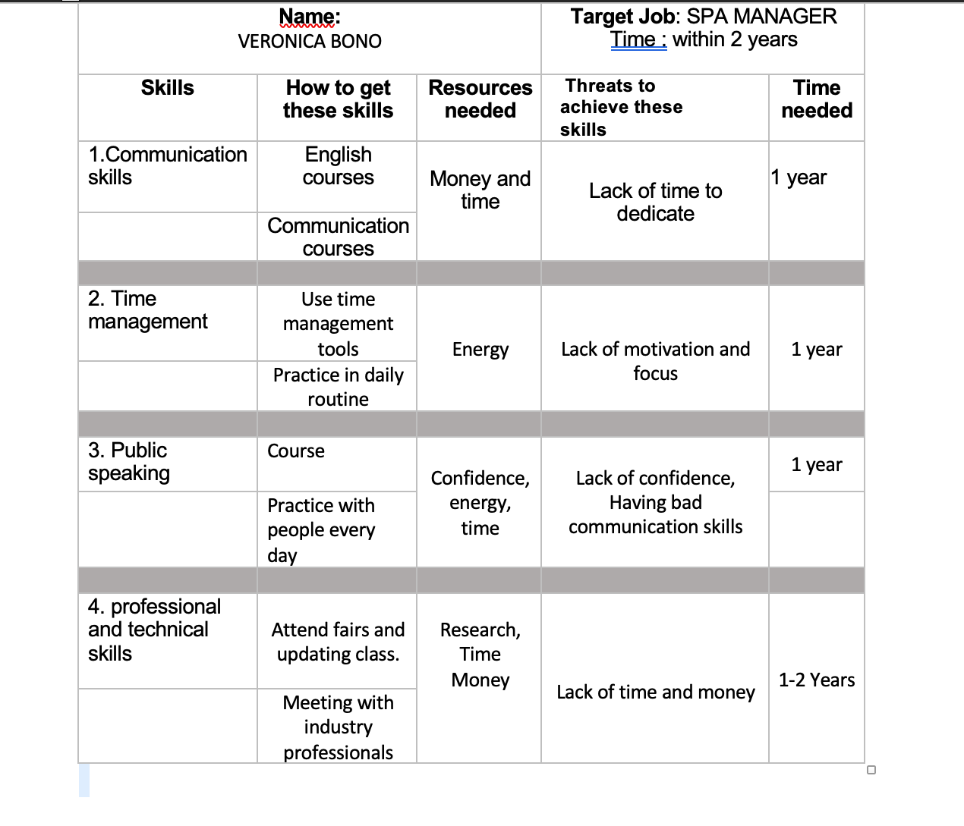

CONCLUSION

I have developed valid tools to develop my career, reflecting on myself first of all and then the skills and abilities i need to achieve my work goal.I have created a plan that allows me to focus my resources on my career path.
Being employable means having so many values ​​that make us more desirable by employers.
Knowing the recruitment process, the values ​​and skills that are required is important in order to be successful.
Now I have the foundations and tools needed to grow and develop in my professional career.

REFERENCES

CIPD (2020) Recruitment: an introduction. Available at:
https://www.cipd.co.uk/knowledge/fundamentals/people/recruitment/factsheet#gref. (Accessed: 27 August 2021).

CIPD (2021) Working hours and time off work. Available at:
https://www.cipd.co.uk/knowledge/fundamentals/emp-law/working-time/factsheet. (Accessed: 26 August 2021)

Data Protection Act 2018. Available at: https://www.gov.uk/data-protection.
(Accessed: 27 August 2021)

Equality Act 2010. Available at: https://www.gov.uk/guidance/equality-act-2010-guidance.
(Accessed: 26 August 2021)

MS Solicitors (n.d) Employer Rights & Responsibilities. Available at:
https://www.ms-solicitors.co.uk/employer/employer-responsibilities/. (Accessed: 25 August 2021)

Murray J. (2020) Employer Responsibilities to Employees. Available at:
https://www.thebalancesmb.com/what-are-my-responsibilities-to-employees-as-an-employer-397923#employee-responsibilities-to-employers. (Accessed: 25 August 2021)

NetLawman (2020) Employment Rights Act 1996. Available at:
https://www.netlawman.co.uk/ia/era-1996. (Accessed: 28 August 2021)

TalentLyft (n.d) What is Job Advertisement?. Available at:
https://www.talentlyft.com/en/resources/what-is-job-advertisement. (Accessed: 22 August 2021)

WORKSMART (n.d) What are my employer's duties under the Health and Safety at Work Act?
Available at: https://worksmart.org.uk/health-advice/health-and-safety/employer-duties/what-are-my-employers-duties-under-health-and-safety. (Accessed: 28 August 2021)

UK Government (2020) Career Development Plan. Available at:
https://www.gov.uk/government/publications/hr-career-frameworks/career-development-plan. (Accessed 25 August 2021).

APPENDIX

Application form

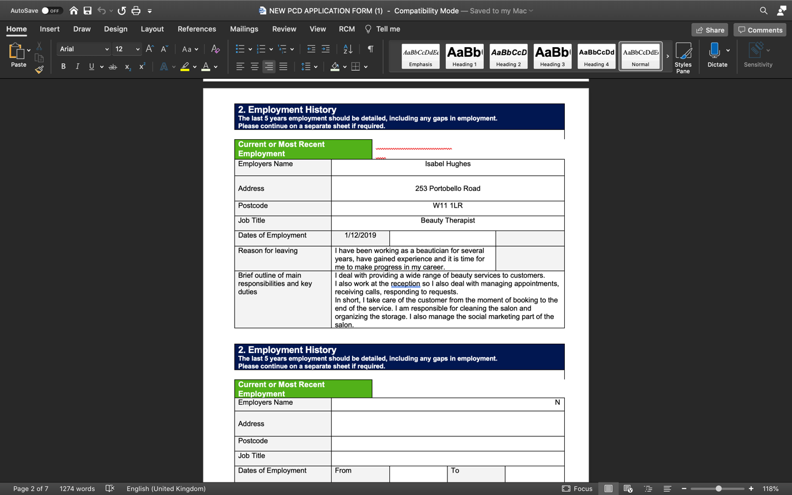
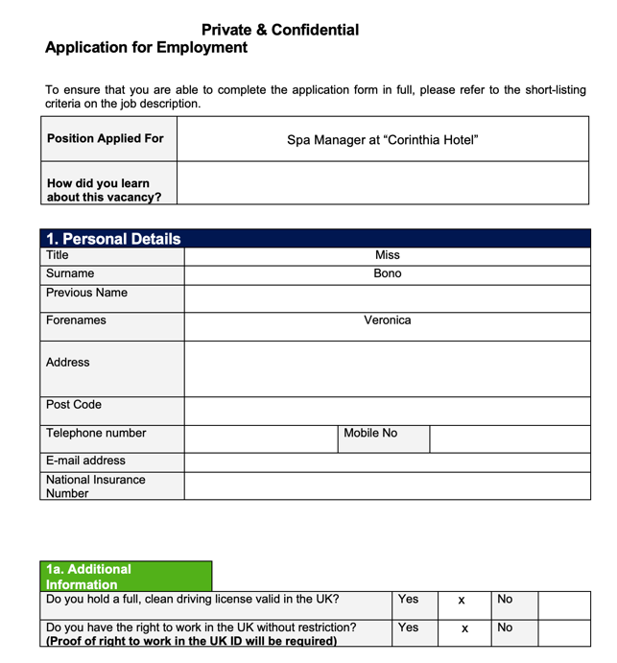

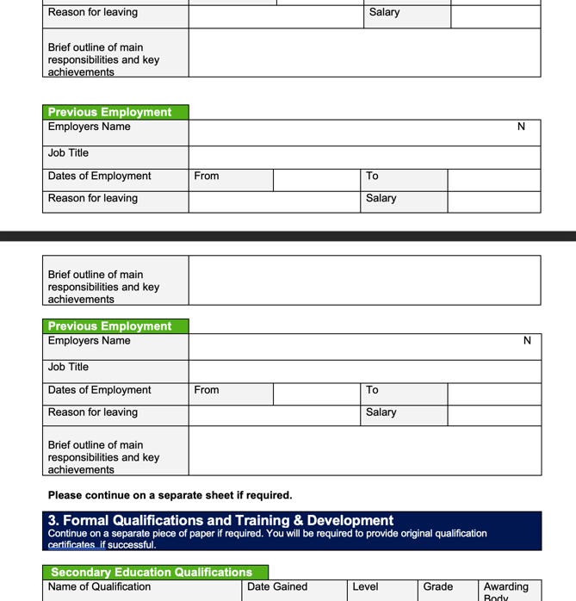

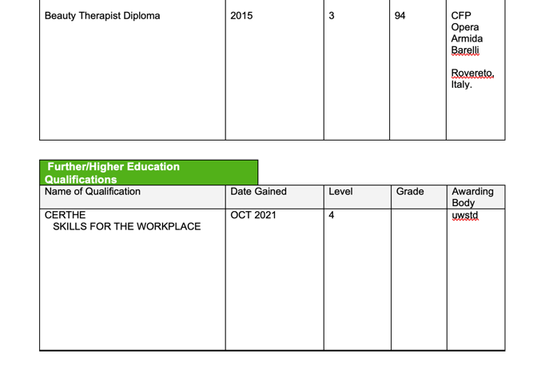

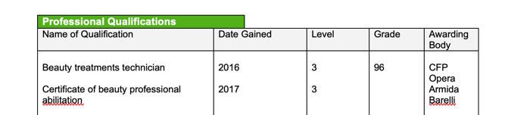

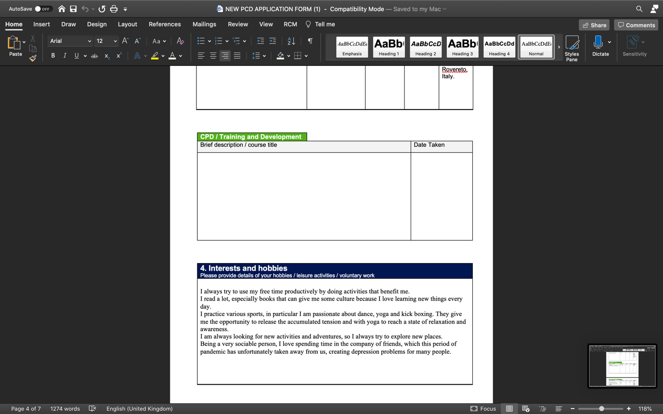

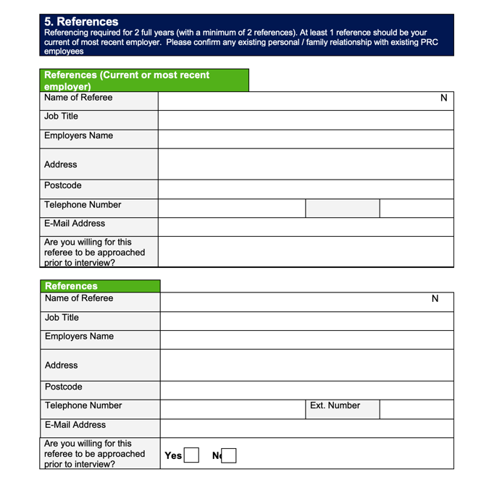

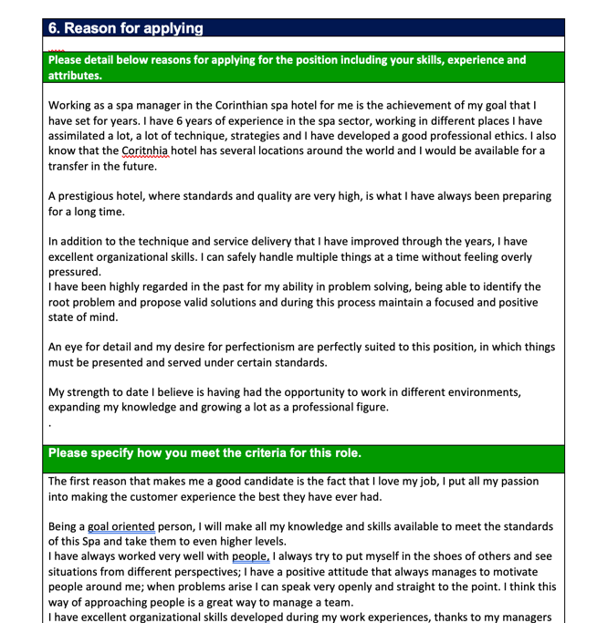

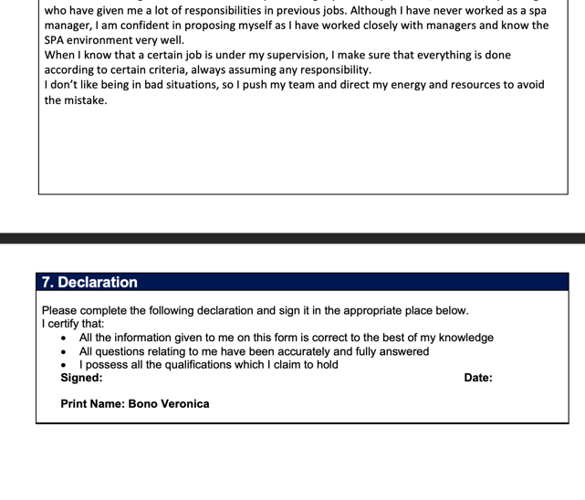


Interview questions

