Foreign languages and Cultural Awareness

Produce an Aide Memoire for hotel staff to help manage guest service experiences for the international visitor

Module code :MX501923 LON
LECTURE : DALE CLARKE
STUDENT NAME : MADALINA- ANDREEA POPA
STUDENT NUMBER: 1815001
STUDENT ID : 1815001@STUDENT.UTWSD.AC.UK
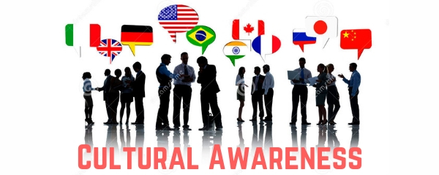

Contents
INTRODUCTION 3
Cultural Awareness 3
Common issues that hotel staff face in dealing with diverse culture 3
Measures taken by Marriot International to deal with diverse cultural of it visitors 6
List of countries Marriott International is operating and the culture norms of those 8
countries: 8
Issues Faced By Marriot International facing in the countries and its solution 9
Do’s and Don’ts for Marriot staffs 10
Conclusion 11
References: 12

INTRODUCTION

The purpose of this report was to produce an Aide Memoire for hotel staff to help manage guest service experiences for the international visitor. Using Marriot Hotel on this study case will help to identify common issues faced by staff with diverse culture, what measures are be taking by Marriot to deal and solution .

Cultural Awareness

Cultural awareness plays a crucial role in the operation of hospitality organisations as they offer services people from various locations (Holland, 2017). Marriott International is well known for its quality services that it offers to its customers. However, the employees of the organisation must know several aspects regarding cultural awareness and issues related to it so that the demands of the customers are catered effectively. It is required that the employees of the hotel have proper knowledge regarding the various aspects of culture so that the customers of the organisation can be satisfied.

Common issues that hotel staff face in dealing with diverse culture

Since people from various geographical locations flock to the hospitality organisations, it is necessary that the staffs of hotels are able to manage the visitors effectively. The increased rate of growth of tourism industry has led to the emergence of various issues in the hospitality organisations that has affected the quality of the services offered by the organisations to the customers. The primary issues that Marriott International is facing in terms of dealing with diverse culture are as follows:

- Language problem: The staffs of Marriott International fail to deal with the visitors speaking different languages because the staffs fail to comprehend languages spoken by visitors belonging to varying to different countries (Whittaker and Chee, 2015). Lack of knowledge of varying languages adversely affects the quality of services offered by the organisation to its guests (Mok & Armstrong, 1998).


- Cuisines: Varying countries have varying cuisines. However, Marriott International fails to offer cuisines of the varying kinds to its visitors based on their geographic location. Therefore, it becomes a big hindrance for Marriott International in terms of offering quality provisions to its visitors.


- Human Resource: Marriott International is lagging behind other organisations because it fails to recruit and retain employees ready to relocate to international countries. Therefore, it creates a big issue for the organisation to offer services to its visitors such that their expectations are met (So et al., 2016). As a result, issues pertaining to cuisine and language differences take place in the organisation thereby affecting the worth of the provisions offered by the organisation to its guests.

- Ambience: The hotel fails to offer an ambience of home to its guests that in several cases adversely affect its customer base. Thus, it is required that the hotel works so that its visitors get a proper ambience in the hotel that can increase their level of satisfaction they derive thereby aiding the hotel to increase its number of visitors, get positive reviews, and increase its profitability (Mattila, 1999).


Measures taken by Marriot International to deal with diverse cultural of it visitors

It is required that Marriott International takes proper measures so that the issues it is facing can be resolved effectively to ensure that the worth of the services it provides to the visitors is enhanced. The steps that the organisation is taking in order to deal with the issues it is facing are as follows:
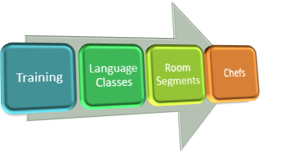
- Training: Marriott International organises a number of training sessions so that it can be ensured that the worth of its facilities and provisions meet customer expectations. It has been observed that the visitors of a hotel are satisfied if the hotel staffs are confident and humble in their approach even if they cannot communicate due to language issue (Marriott.com, 2020).

- Language Classes: The hotel has focussed on organising language classes for its managers so that the issue of language barrier can be eradicated. The organisation has focussed on organising free language classes so that it can be ensured that people visiting the hotel from varying locations peaking different languages can be easily communicated.
- Room Segments: The organisation is focussing on having different segments of varying countries based on which the rooms of the organisation will be designed so that its visitors can feel at home. The step will further enhance the quality of its provisions to the customers thereby leveraging its reputation in the industry (Ayeh et al., 2016).
- Chefs: The organisation has focussed on recruiting chefs who have proper knowledge of cuisines from various parts of the world to ensure that its guests are satisfied. Further, the organisation has also focussed on proper training of its chefs to enhance their performance further (Gonçalves, 2014).

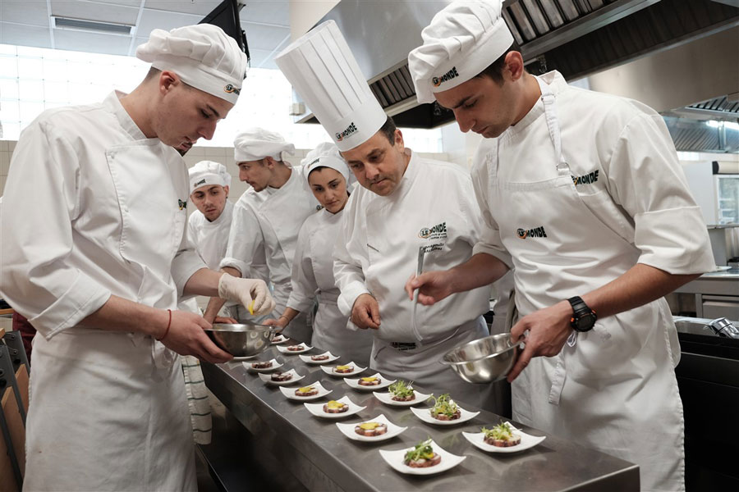

List of countries Marriott International is operating and the culture norms of those

countries:

Marriott International has its operations in several countries. The organisation operates in countries like UK, China, India, USA, and several others. The organisation also has its presence in several African nations like Zambia, Tunisia, Uganda, South Africa, Rwanda, Mauritius, and several others. The organisation has its operation in a number of countries. The operation of the hotel in varying locations is affected by the norms and legislation of the corresponding nation. A few examples of the effect of country norms on the organisation have been provided below:

India
Marriott has to operate as per varying cultures of India because India is a multicultural country. Therefore, Marriott has to ensure that the expectations of Indians belonging to varying cultures are met. However, along with it the organisation has to ensure that the expectations of international visitors are met as well.

UK
UK has a rich history in terms of culture therefore Marriott International has to ensure in such a situation that its services are able to satisfy local as well as international visitors.

Issues Faced By Marriot International facing in the countries and its solution

Marriott International faces several issues while operating within the different countries (Marriott.com, 2020). Marriott International operates in the market of USA, UK, China and India to name a few. Different issues are encountered by the popular hotel to carry out the operations successfully. Solutions exist in solving the different issues faced by Marriott International while providing services in the various markets.
For instance, in the market of UK, poor service provided to the customers was an issue that was faced by Marriott International. The customer queries that reached the authorities went unanswered and this problem had to be addressed in a systematic manner (Beckford, 2019).
In the market of USA, the customers who avail the proper facilities of Marriott International get confused with the rates offered by the competitors (Gonçalves, 2014). Sometimes, it happens that the customers avail the facilities of lower price rates provided by the market competitors of Marriott in the USA. To address this problem and provide solutions to it, the hotel company devises newer and efficient marketing strategies that prove to be beneficial for the management to maintain a direct relationship with the employees to accomplish the specific tasks related to the organisation.
In the market of China, Marriott International faced problems as their websites and mobile applications were closed by the political authorities as they alleged that the Company had negatively impacted the sovereignty linked with the nation by naming Hong Kong and Macau in their holiday destination list. The problem is resolved with the help of keeping in mind the different strategic dictates and policies framed by the Communist Party of China. The company apologised to the Chinese government to help in performing the different tasks and provide smooth and quality services to their customers (Seo, 2012).

Growing worker strike faced by Marriot International
Sources :How Big a Problem Are the Growing Strikes for Marriot (2018)

In the market of India, Marriott encountered problems that had a negative impact upon designing the different categories of services to be provided to the customers in the open market. The high rates of interest and the expenses of the land create problems for Marriott International in expanding their business operations and developing the relevant marketing operations within the market of India. The rates of interest are enhanced by the economic policies laid down by the governmental authorities and this creates problems for the company to carry out their operations smoothly. Marriott International can remove this obstacle by devising the appropriate strategy of observing and studying the condition of the market. After that, they can devise the beneficial strategies to ensure that the different operations and customer services can be provided by them adhering to the policies. Marriott develops their own marketing strategy to adapt to the market situations of India and this helps them to achieve the numerous goals designed by the management to meet the requirements of the customers.
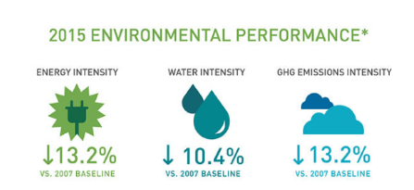
Lack of reservation for environmental sustainability
Source: Technology and Operations Management ,2020

Do’s and Don’ts for Marriot staffs

Having efficient staff is prerequisite in all organisations as it is directly linked to its productivity and success. It plays one of the most important factors in enhancing customer experience in hotels and ensures that their loyalty is retained in the future. It is crucial for Marriott International to ensure that the staffs is trained appropriately so that they remain effective in their roles and responsibilities. Various Do’s and Don’ts may be identified which need to be followed by all the staff in Marriott International in order to ensure that the collective goals of the organisation are met in the best possible manner. These do’s and don’ts have been illustrated in a tabular format below:

Do’s for Marriott International staff | Don’ts for Marriott International staff
Do use all equipment’s efficiently: It is crucial that all staff of the hotel is aware of the entire functionality and operations of the system. They must be sure of the method of operation before usage as this reduces chances of accidents and untoward situations within the premises. | Don’t forget small details: Guests are often very particular regarding their experience in the hotels. In order to ensure that they are not offended, the staff must see to it that even the smallest detail is taken into consideration.
Do be courteous and polite to all guests: According to Ehlert (2016), it is important that the staffs in a hotel is polite and friendly with their guests so that they are not offended. This imparts a positive reputation for the staff as well as for the entire organisation and boosts customer retention. | Don’t be intolerant towards customer enquiries: The staff in Marriott must never be intolerant towards the questions of their guests. As has been stated by Espellita and Maravilla Jr. (2019), the employees must be patient and try to solve their queries in the best possible manner. They must never exhibit rudeness or impatience while dealing with guests and their diverse enquiries.
Do prioritise guests: Following the literary underpinnings of Mok & Armstrong (1998), it is important for the staff to prioritise their guests and ensure that all their needs and preferences are met in the best possible manner. | Don’t argue with guests: It is important that the staffs never argue with the guests in Marriott International. Though some guests may be unruly and problematic, they must be respected. Recurring problems with certain customers need to be resolved peacefully with due respect to everyone.
Do know the task before starting: In order to avoid any unnecessary mistakes, the staff in Marriott must ensure to understand the task properly and ask questions in case of any doubt. | Don’t compromise on work ethics: It is necessary for Marriott International to ensure that their staffs do not compromise on their work ethics under any situation. They must not fall prey to any kind of corruption and disloyalty. These will ensure that guests view the hotel positively and are attracted to avail its services time and again.

Conclusion

An Aide Memoire was done in this study case for Marriot hotel helping to identify issues face by staff with the international visitors how to deal with. In the same time Marriot Hotel has been taking some actions so everything can be resolved efficiently and guest are worth it for the service and enhanced as well.

References:

Armourcollege.org. 2020. course PS – Cultural Awareness – Armour College. [online] Available at: http://armourcollege.org/course-ps-cultural-awareness/ [Accessed 10 Jan. 2020].
Ayeh, J.K.; Au, N.; Law, R. Investigating cross-national heterogeneity in the adoption of online hotel reviews. Int. J. Hosp. Manag. 2016, 55, 142–153.
Gonçalves, A., 2014. The Journey not the Arrival Matters: Developing Intercultural Awareness and
Communication Skills in Tourism Education. ENCATC Journal of Cultural and Policy, 4(1) 2014/ISSN
Beckford, J., 2019. The Intelligent Organisation: Realising the value of information. Routledge.
Ehlert, A., 2016. Be Our Guest: A Hotel's Guide to Guest Service Hospitality Training.
Espellita, S. and MaravillaJr, V.S., 2019.Employable Skills for Hospitality Graduates as Perceived Among Hotel Supervisors in Cebu City. Journal of Economics and Business, 2(2).
Food-management.com. 2017. SNA survey: International dishes, customization surge in K-12 dining. [online] Food Management.Available at: https://www.food-management.com/news-trends/sna-survey-international-dishes-customization-surge-k-12-dining [Accessed 10 Jan. 2020].
Gonçalves, A. 2014.The Journey not the Arrival Matters: Developing Intercultural Awareness and Communication Skills in Tourism Education. ENCATC Journal of Cultural and Policy, 4(1) 2014/ISSN 2224-2554.
Holland, K., 2017. Cultural awareness in nursing and health care: an introductory text. Routledge.

How Big a Problem Are the Growing Worker Strikes for Marriott? 2018. Available at: https://skift.com/2018/10/16/how-big-a-problem-are-the-growing-worker-strikes-for-marriott/ (Accessed: 10 January 2020).
Hub.theasap.org.uk. 2017. UNWTO: Tourism demand remains strong despite challenges – Serviced Apartment Industry News. [online] Hub.theasap.org.uk. Available at: https://hub.theasap.org.uk/unwto-tourism-demand-remains-strong-despite-challenges/ [Accessed 10 Jan. 2020].
I1.wp.com. 2020. [online] Available at: https://i1.wp.com/www.mancrates.com/blog/wp-content/uploads/2016/11/chefs.jpg?fit=900%2C600&ssl=1 [Accessed 10 Jan. 2020].
Iaea.org. 2020. Call for Papers: Abstracts for Conference on Human Resource Development for Nuclear Power Programmes Due 31 January 2018. [online] Available at: https://www.iaea.org/newscenter/news/call-for-papers-abstracts-for-conference-on-human-resource-development-for-nuclear-power-programmes-due-31-january-2018 [Accessed 10 Jan. 2020].
Jimice.org. 2020. [online] Available at: http://jimice.org/wp-content/uploads/2014/12/instructional-training.png [Accessed 10 Jan. 2020].

Marriott international: no reservations about climate change – Technology and Operations Management. 2020. Available at: https://digital.hbs.edu/platform-rctom/submission/marriott-international-no-reservations-about-climate-change/ (Accessed: 10 January 2020).
Marriott.com. 2020. [online] Available at: https://www.marriott.com/diversity/diversity-and-inclusion.mi [Accessed 10 Jan. 2020].
Marriott.com. 2020 Available at: https://www.marriott.com/marriott/aboutmarriott.mi (Accessed: 10 January 2020).
Mattila, A. S., 1999. The Role of Culture in the Service Evaluation Processes. Journal of Service Research, 1 (3), 250-61.
Mok, C., & Armstrong, W. R., 1998. Expectations for Hotel Service Quality: Do they differ from Culture to Culture? Journal of VacationMarketing,4(4), 381–391.
Seo, Y., 2012. Cultural Impact on Customer Satisfaction and Service Quality Evaluation in Hotels. UNLV Theses, Dissertations, Professional Papers, and Capstones. 1370.
So, K.K.F., Liu, W., Wang, Y. and Sparks, B., 2016. Service expectations of Chinese outbound tourists.In Chinese outbound tourism 2.0 (pp. 223-236). Oakville: Apple Academic Press.
Tenoblog.com. 2020. [online] Available at: https://tenoblog.com/wp-content/uploads/2018/10/language-problems.jpg [Accessed 10 Jan. 2020].
Whittaker, A. and Chee, H.L., 2015. Perceptions of an ‘international hospital’in Thailand by medical travel patients: Cross-cultural tensions in a transnational space. Social Science & Medicine, 124, pp.290-297.

