

Assessment Component 2

Written Essay

Student name: Ivelina Succaria
Student ID: 2010919

Module name: Children, Young People and Families
Module code: (BMHP5004_LON)
Lecturer name: Bianca Sanfilippo
Word count: 2,735

Introduction

We presume that we know and understand both quite well when thinking about children and childhood. Once we go deeper and try to define them, we suddenly realise that it is not that easy. Knowing what something is, does not necessarily mean that you can explain it. The definition of child and childhood has changed throughout human history, either adding something more or crossing out the previous one and giving an entirely new explanation and point of view. However vast and numerous cultural commitments we can find to the nature of the child, what remains an essential part of all the concepts is that it differs and changes with the changes in society and its understanding of children. (Jenks, 2013)
Cunningham (1998) believes that the concepts of our world shape childhood. More than any other branch of history, its development is tracing the evolution of society. Nowadays, the western world is more considerate and anxious about bringing up their children and the responsibilities that come with this. Such demand for knowledge urges society to look back to the historical and social factors that changed children's perspectives and childhood and shaped their existence and understanding (Cunningham, 1998). According to Cunningham (2021), we should be able to make a clear differentiation between child and childhood. He says that a child is a human being, while childhood is a set of ideas that can shift through time and social circumstances.

Child and Childhood

Definition

When trying to find a definition of a child, one may stumble into a few different perspectives. The popular dictionaries define ‘child’ as a young human who has not reached the age of an adult and is a person between birth and puberty or between infancy and puberty. (Merriam Webster, 2019; Oxford Dictionary, 2022). This definition covers fully the biological perspective of a child, which considers the level of maturity of a human being.
In the Convention of the Rights of the Child (2010), the definition describes the child as a person under the age of 18 or more minor if the law applicable to them does not state that the majority is attained earlier. The Convention is ratified by 192 countries, which makes it relevant to their understanding of a child and makes it a global agreement.
On the other hand, the law has another definition of a child – it is someone who is at an age below the legally defined age to be responsible for your acts in front of the law. According to UK law, a child is every individual at 18 and below. It is also an individual who has is 16 and lives independently, studies at the University, is serving the army or is in custody in a secure estate, is legally considered a child, and should receive the protection any other child receives (NSPCC, 2021).
Childhood is closely connected with children, and it is impossible to define or describe it without having the child in its centre. During the historical development of humans, the definition of childhood changed together with a child's understanding. James and Prout (2018) define childhood as when a child needs to become an adult and outline its key features as a social construction variable in its social representation and needs to be recognised in society (UK Essay, 2018).

Family as a significant influencer of child and childhood

The first and most crucial environment a child enters is their family. The circle is where the child receives guidance, safety, and education. The family is the one that provides basic knowledge, creates norms, and teaches ethics. Nowadays, parents are aware of their role in children's upbringing and show significant efforts to develop a cognitive learning environment at home. A family is a social group of two or more people connected either by blood, marriage or adoption. It could be described as a small social group that has a significant effect on the socialisation of children. From a sociological point of view, the family is the first institution in human society and the place where children acquire their first social skills, values, emotions and interest through direct relations and interactions with their parents and following their roles in the union (Roostin, 2018). As a significant part of society, family, and its definition, changes with the development of humanity itself. These changes could result from the evolution of the number of populations, understanding of marriage, and acceptance of divorce as a standard change process in a family. Today we have different types of families, which would be unimaginable in the past.
Now we distinguish a family household, where at least two members are related by blood, e.g., they are a parent and a child. We also have a nuclear family consisting of parents and children only, a same-sex family with both parents of the same sex, and an extended family in which, besides the mother and father, other relatives are living in the same family. There are also step, and blended families which appear after remarriages and the children share one or no parents (Pasley and Petren, 2015). Whatever the kind of family it is, the experiences that it gives to the child are unique and significant for their development. Immediately after the birth, the child is already considered a member of the family and has an individual role. The family members will set many values and habits and create language codes that will make the child unique and different from the children outside the family. Bronfenbrenner describes the role of the child in the family as both passive and active. He speaks about the importance of the relationship between the member of the family and the way it changes the environment and subsequently the qualitative changes and, finally, the children.
An example of this could be a divorce in the family, and it will immediately change the environment and thus bring sudden qualitative changes. Bronfenbrenner calls this a theory of ecological system and divides the development of a child as a dependent of four structures embedded in each other.
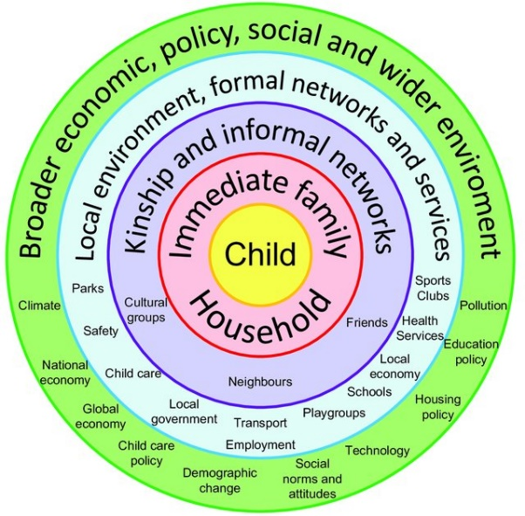
Figure 1: Bronfenbrenner's ecological model (Scott, 2016).
The first structure is the micro-system, which refers to the child's immediate environment and becomes more complex with the child's growth. All the things in this structure directly influence the child's development. The second is the mesosystem which describes the interaction between the child’s micro-systems. It could be a connection with peers, school, grandparents, or neighbours. The Exosystem includes other formal and informal social structures, which do not have the child as a part but indirectly influence them, affecting the microsystems. The fourth system in this model is the macrosystem. It refers to the already established society and culture in which the child is developing. This context includes ethnicity, culture and geographical location, beliefs, and ideology. Following this system, we could see that children raised in different countries will experience other influences and will have further development (Guy-Evans, 2020). Bronfenbrenner’s model is widely accepted by psychologists, sociologists and teachers and has become a framework for studying a child’s development. Bronfenbrenner puts the family in the first and closest system, which proves its importance for a child’s development.

Changes in children and family since history to the present times

Today child and childhood are a matter of constant interest and research, and children have a central role in the family and society. The Law and Government specially protect them. This interest of historians and scholars in children and childhood flourished at the beginning of the last century. It results from the historical interest in family, education, and human development. It is clear that children were important in old societies, but they did not accept them in the way we do today. They were seen as different from adults or a minor copy of them, but they did not understand their needs and psychological development. It does not necessarily mean that they were ill-treated or neglected, but there was no understanding of their development needs. The ancient societies like Egyptians, Greeks, Spartans understood the need for physical training and discipline, but their concerns about children's development stopped there. In her book Forgotten children: Parent-child relationship from 1500 to 1900, Linda Pollock (1983) cites Philippe Aries, who states that in the Middle Ages, there was still no clear understanding or concept of childhood. He discusses that a child merely did not exist in that period, and it was not even considered an object of interest. There were no pictures of children at that age, and they were not an object of importance.
In the 16th and 17th centuries, the child’s image started to improve slowly, but parents were still unsure how to treat them – as good or as evil, and when to include them in their society as adults. The progress in accepting and recognising children continued slowly. Still, in the 19th century, there were different points of view of children from the upper class and children from low-income families. Society and parents stayed ignorant about child labour and the exploitation it brought. It was challenging to overcome these two and establish legal rights and protection for children (Pollock, 1983). However, late in the 17th-century, children were described as playing with toys, and the first attempts at children's literature appeared (Wikipedia, 2022). In the 19th century, the understanding of children developed how families rediscovered education as an essential part of human development, which led to the moment in which children were made a vital part of everyday life. The compulsory education stopped child labour and made the difference between child and adult recognisable. Schools helped extend the childhood period and slowly created a child word, separated and very different from the adult one. The changes in family and adults relationship in the 18th and 19th centuries led to the birth of the modern family in which there was love and romantic feelings. The connection between the mother and the baby became solid and vital. The well-being of the children in the family became an essential part of it.

Factors contributing to the change in children’s life

There were few factors in the Moder times society, especially in England, which helped reduce the inequalities between children and changed their lives tremendously.
The first one was the Elementary education Act, published in 1870 and made elementary education compulsory for children aged 5 to 12 years old. This Act practically finished child labour and released them from the industrial and agricultural labour duties, and answered the demand of the Reform Act of 1867, which needed an educated society and citizens who could vote wisely. Special education authorities and boards were responsible for managing the schools and their functioning. Between 1870 and 1880, the school boards opened between 3,000 to 4,000 schools, and by 1890, there were gymnastics, art and crafts facilities, and subjects like domestic science were successfully taught at school (Elementary Education Act 1870).
The Factory Act of 1883 was the next step in recognising children as an essential part of society. The Act lowered the number of working children. In the 1840s, the percentage of 10 to 14-year-old working boys was 5.1%, but in the 1890s, the rate was 2.4% (Rose, 2016).
Another important factor for changing the attitude and understanding of children and childhood is the vast development in psychology and science. It started in the 20th century and created a severe theoretical child and adolescent development models. The contribution of Erickson, Freud and Piaget is undoubtful. They made a completely new understanding of child and childhood as a period of great importance for individuals' psychological and emotional development. Together with neuroscience and the new knowledge of the human brain, their studies put childhood in the centre of human existence and being and marked a whole new era in child understanding. Bronfenbrenner's theory discussed previously is an example of the new attitude and point of view of 20th-century society. Maslow’s hierarchy of needs, published in 1943, puts children’s understanding on a brand-new basis. It gave a new look to the child’s needs and stated that the basic human needs should be addressed to children too, and any lack leads to distortion of the development.
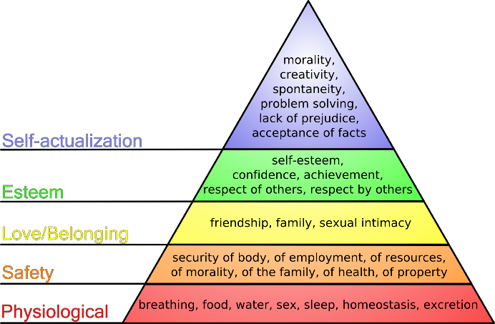
Fig.2 Maslow’s hierarchy of needs (The art of autism, 2013).

Approaches to support children, young adults, and families

Legislation and Policies

The existing legislation in the UK nowadays results from all the changes in society’s perspective of children and childhood. The ages of change and understanding have made the government and law, and today the aims that stay in front of them are to keep children safe and protected. The law has to ensure that the children’s voices are heard. They have the right to access education, safety, freedom to choose their activities. It is suitable to decide to get a job and be safe at it or even support them if they need to leave their home and keep their personal information confidential (NSPCC, 2021). The policy towards children in the UK is oriented to the child's best interest and follows the global legalisation of children. The UK has ratified the United Nations Convention on the Rights of the Child (UNCRC) since 1989. It strictly follows its idea of placing the child in the centre of the legislation process, ensuring that their rights will be put in the context of human rights. The legislation concerning children is s set of legally bound principles designed to protect children, their health, education, safety, and family. The UNCRC understands and acknowledges the vulnerability of children and discusses them concerning the so-called “four Ps” – protection, prevention, provision, and participation (Kehily, 2004). The Children Act 1989 is the document that states that all the responsible authorities should work together and with the family and the child (if it is of understanding) and will not jeopardise the safety and wellbeing of the child (Ryan, 2019). Children Act 2004 focuses on the wellbeing of children, but it also discusses that in cases of maltreatment of a child, there are relevant authorities that should be immediately informed. It also deals with Children’s Trusts – many independently set up bodies that will cooperate with health and Social Services and ensure relations with teachers, parents, guardians, and necessary outside sources. The Act also sets up a fund to help beat poverty and overcome the financial disadvantages for families, but its primary purpose is to ensure childcare and protection (iHasco, 2020). The Care Act 2014 and The Children and Families Act 2014 stress young carers, disabled children, and carers (Clements, 2015).

Effectiveness of legislation and conclusion

The effectiveness of legislation is something that we do not usually hesitate about. We consider that its primary duty is to solve problems once put into practice. In a way, it is accurate, and it usually makes a positive impact and improves the problems in the country and society. The legislation has its measures and can identify the needs and react promptly. The system knows what is “ a child in need”. It can assess it following Section 17 of the Children Act 1989, Universal service provision,’ Early Family Support Threshold Guidance’ and ‘Trafford Safeguarding Children Procedures’.
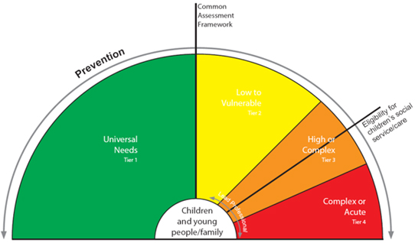
Fig.3: Levels of needs (Trafford Council, 2021).
Following the above diagram, the local authorities should safeguard and protect children and their families if they are defined as “High need of support”. It is to consider their duty to help families bring up their children, providing them with appropriate services for fulfilling their children’s needs (Trafford Council, 2021).
This said and explained, everything is under control, and all the issues are seen and solved. However, one crucial point still exists – the problem with the invisible children. Why do we have such a vast number of “invisible” children if we have legislation and policies?
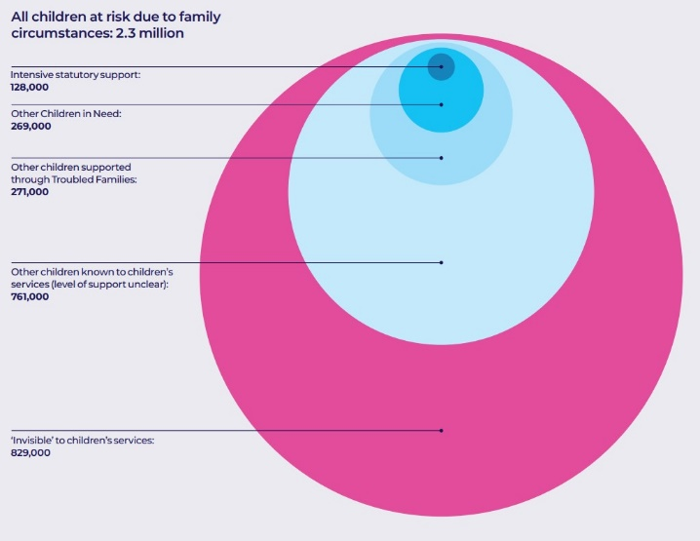
Fig.3: All children at risk (Children’s Commissioner)
The reasons could be found in the breakdowns in communication between professionals and agencies, the bureaucracy, the tight deadlines for completing a case, the overloaded social workers. They fail to comply with procedures and management incompetence (Ferguson, 2017). In a video of Real Stories from 2016, several children from impoverished backgrounds were interviewed. What becomes strikingly shocking in all the cases is that the system is doing its job from one side, and the parents take child benefits, live in council houses, and are considered to be noticed and helped adequately. On the other side, it is clear that children have no normal childhood and clearly understand that they are different. One of the girls says: “We are different because we can’t do much in our house”. The understanding of poverty that a boy give is “…that goes on what we need and not on what we want.” And another one -” I go without dinner when I am at home, but when I am at school, I get dinner.” (Real Stories, 2016) The striking fact in these examples is that legislation is a mighty tool. Still, it is not almighty, and without the personal involvement of each member of the society, the percentage of invisible children will not get lower.

References

- "Convention on the Rights of the Child" (PDF). The Policy Press, Office of the United Nations High Commissioner for Human Rights. Archived from the original (PDF) on 31 October 2010.
- Children’s Commissioner (n.d.). Childhood vulnerability in numbers Need, spend, and the millions of children in England miss out. [online] Available at: https://www.childrenscommissioner.gov.uk/wp-content/uploads/2019/07/cco-vulnerability-2019-infographic.pdf (Accessed 26 March 2022).
- Clements, L. (2015). The Care Act 2014 overview. Care Act Overview (revised, [online] 12, p.1. Available at: https://www.podstelford.org/wp-content/uploads/2019/02/0-care-act-notes-updated-2015-march.pdf (Accessed 27 March 2022).
- Cunningham, H. (1998). Histories of Childhood. The American Historical Review, [online] 103(4), p.1195. Available at: https://www.jstor.org/stable/2651207?msclkid=669c1ddcacfc11ec9394f60ef9b615be (Accessed 26 March 2022).
- Cunningham, H. (2021). Children and Childhood in Western Society Since 1500. [online] Routledge & CRC Press. Available at: https://www.routledge.com/Children-and-Childhood-in-Western-Society-Since-1500/Cunningham/p/book/9780367470623?msclkid=6ebc2636ad0211ec8e77665370199a36 (Accessed 26 March 2022).
- Elementary Education Act 1870. [online] Available at: https://be.in.edu.vn/en/Elementary_Education_Act_1870-4088462860 (Accessed 27 March 2022).
- Ferguson, H. (2017). How Children Become Invisible in Child Protection Work: Findings from Research into Day-to-Day Social Work Practice. The British Journal of Social Work, [online] 47(4), pp.1007–1023. Available at: https://academic.oup.com/bjsw/article/47/4/1007/2622323 (Accessed 27 March 2022).
- Guy-Evans, O. (2020). Bronfenbrenner’s Ecological Systems Theory. [online] www.simplypsychology.org. Available at: https://www.simplypsychology.org/Bronfenbrenner.html (Accessed 26 March 2022).
- iHasco (2020). What is the Children Act 2004? iHasco Blog, News and Updates. Available at: https://www.ihasco.co.uk/blog/entry/2508/what-is-the-childrens-act-2004?msclkid=9ff68604add411ec84870348b69dd30c (Accessed 27 March 2022).
- James, A. and Prout, A. (2018). James and Prout: Constructing and Reconstructing Childhood. [online] www.ukessays.com. Available at: https://www.ukessays.com/essays/education/nature-of-childhood-construction-and-reconstruction-of-childhood-education-essay.php?msclkid=9d162762ad3411ec8ed810584579008a (Accessed 26 March 2022).
- Jenks, C. (2013). Childhood. [online] Routledge. Available at: https://doi.org/10.4324/9780203023488 (Accessed 24 March 2022).
- Kehily, M.J. (2004). Understanding childhood: An introduction to some key themes and issues. MJ Kehily (red.), An introduction to childhood studies. [online] Available at: https://www.academia.edu/2112372/Understanding_childhood_An_introduction_to_some_key_themes_and_issues?from=cover_page (Accessed 26 March 2022).
- Merriam Webster (2019). Definition of CHILD. [online] Merriam-webster.com. Available at: https://www.merriam-webster.com/dictionary/child (Accessed 25 March 2022).
- NSPCC (2021). Children and the law. [online] NSPCC Learning. Available at: https://learning.nspcc.org.uk/child-protection-system/children-the-law?msclkid=2dd176edad3f11ec906280323c0d1336 (Accessed 26 March 2022).
- Oxford Dictionary (n.d.). child noun - Definition, pictures, pronunciation and usage notes | Oxford Advanced Learner’s Dictionary at OxfordLearnersDictionaries.com. [online] www.oxfordlearnersdictionaries.com. Available at: https://www.oxfordlearnersdictionaries.com/definition/english/child?q=child (Accessed 25 March 2020).
- Pasley, K. and Petren, R.E. (2015). Family Structure. Encyclopedia of Family Studies, pp.1–4.
- Pollock, L.A. (1983). Forgotten children: parent-child relations from 1500 to 1900. Cambridge Cambridgeshire; New York: Cambridge University Press.
- Real Stories (2016). poverty and children - Bing video. [online] www.bing.com. Available at: https://www.bing.com/videos/search?q=poverty+and+children&view=detail&mid=73A5CAF099F10BE0EFFF73A5CAF099F10BE0EFFF&FORM=VIRE&msclkid=153bb722add811ecabd7b8586703c29e (Accessed 27 March 2022).
- Roostin, E. (2018). FAMILY INFLUENCE ON THE DEVELOPMENT OF CHILDREN. PrimaryEdu - Journal of Primary Education, [online] 2(1), p.1. Available at: https://www.researchgate.net/publication/332618364_FAMILY_INFLUENCE_ON_THE_DEVELOPMENT_OF_CHILDREN (Accessed 26 March 2022).
- Rose, L. (2016). Erosion of childhood: childhood in Britain 1860 -1918. Routledge.
- Ryan, M. (2019). The Children Act 1989: Putting it into Practice. [online] Google Books. Routledge. Available at: https://www.google.co.uk/books/edition/The_Children_Act_1989/sWClDwAAQBAJ?hl=en&gbpv=1&dq=Children+act+1989&pg=PT8&printsec=frontcover (Accessed 27 March 2022).
- Scott, K. (2016). (PDF) Housing Children: South Auckland, The Housing Pathways Longitudinal Study. [online] ResearchGate. Available at: https://www.researchgate.net/publication/311843438_Housing_Children_South_Auckland_The_Housing_Pathways_Longitudinal_Study (Accessed 27 March 2022).
- The art of autism (2013). Special Education is not about funding. It’s about the people. [online] The Art of Autism. Available at: http://the-art-of-autism.com/special-education-is-not-about-funding-its-about-the-people/ (Accessed 27 March 2022).
- Trafford Council (2021). 1.2.2 Children in Need Framework/Thresholds for Children’s Social Care Intervention. [online] www.proceduresonline.com. Available at: https://www.proceduresonline.com/trafford/cs/chapters/p_framework_thresholds.html (Accessed 28 March 2022).
- Wikipedia (2022). Child. [online] Wikipedia. Available at: https://en.wikipedia.org/wiki/Child?msclkid=22ed8e3bad0411ec85cffd6d16dfab95 (Accessed 26 March 2022).
- UKEssays. November 2018. James and Prout: Constructing and Reconstructing Childhood. [online]. Available from: https://www.ukessays.com/essays/education/nature-of-childhood-construction-and-reconstruction-of-childhood-education-essay.php?vref=1 [Accessed 26 March 2022].

