University of Wales
Trinity Saint David
Research report

Module Title: Digital Skills and Research Methods
Module Code: LCHS4002
Academic year: 2022

Students information
Student ID: 2128699 Jubli Aktar
Course: Health Studies
Wordcount: 2000
Submission date: 7th August 2022

Declaration of Originality: I hereby declare that this work is my own and that no part has been copied from any other author, student or individual. I also state that this work has not formed any other significant part of academic assessment submission.

Contents
1. Introduction 3
2. Research Design 4
2.1. Research Objective 4
2.2. Research Questions 4
2.3. Method 4
2.4. Ethical Considerations 7
3. Results 8
4. Discussion 13
5. Conclusions 15
6. Reference list 16
7. Appendix 17

Introduction
The name of the research is ‘The Impact and Importance of Digital Skills in Job and Business: A Case Study in Unilever PLC’. The reason behind choosing this topic is very simple. The world is getting digitalized rapidly. Scientists are discovering new ideas, technicians and engineers are inventing new technologies and businesses and others are using technologies to improve their performance (White, 2019). Besides, the use of technology and digital skills make people’s life convenient. In this research report, different digital skills are required, the importance of those skills in the company and the impact of digital skills have done in the company are analyzed. The research is conducted at Unilever PLC. So, all the impact and analysis are based on this specific company. The research aims to identify which digital skills companies prefer most in the potential job candidates and the employees in the company. Also, how the company utilisesdigital skills in different functions of the companyfor improved performance.

Research Design
The way the research has been designed is explained below.

Research Objective
The objective of the research is to identify the digital skills that have put a positive impact on the performance development of the company.

Research Questions
The research questions are the questions that would answer after the completion of the research project(Chandra and Harindran, 2017). The research focuses on three research questions. They are mentioned below.
- What are the digital skills required to sustain in the competitive market?
- Why the digital skills are important for the company?
- How the digital skills impact the performance of the company?

Method
Research Method:The research has applied the deductive research method. Because this method priorities the previous research findings and includes new information (Chandra and Harindran, 2017). Compared to the inductive research method, the deductive research method is also easier. That is why this research method is followed.
Research Type:Quantitative research is applied. The reason behind it is that quantitative research analyses and measures the numerical data. For data collection or to get results, numerical data is considered (Chandra and Harindran, 2017). Besides, the use of numbers makes the thing very strong and justified. People believe in numbers rather than opinions. So, quantitative research is a good choice for this study.
Time:The research started on June 1st 2022 and ended on July 31st 2022. It took two months to complete the research appropriately.
Sampling Method: The probability sampling method is applied. It provides an opportunity for all of the respondent groups to be counted (Ayan, 2018). In the probability sampling method, a simple random sampling technique is applied. The reason behind it is to randomly provide respondents with a chance to get involved in the research. In addition, the simple random sampling technique is one of the most common techniques and most researchers validate this technique for proper research(Ayan, 2018).
Study Area:The study area is Unilever PLC’s offices situated in the United Kingdom.
Respondent Type:The employers and employees of Unilever PLC are the respondents of the research.
Population Size: Around 6,000 employees work at Unilever PLC in the United Kingdom. So, the population size of this research is 6,000.
Sample Size:To calculate the sample size of the research, the confidence margin is 95% and the confidence interval is 5% considered. So, the result of the sample size came out to 361. To be 95% sure of the results of the study, 361 amounts of data should be collected and analysed.
Data Collection:Primary data is collected through the survey. Secondary data is collected from different journals, books and authentic resources related to the topic of the research. Data has been collected virtually. Due to the coronavirus pandemic, employees of Unilever PLC did not allow to survey persons. The company had permitted to collect data and conduct the survey virtually. So, the survey questionnaire has been prepared on Google Forms and sent via email. The employees of Unilever PLC. have submitted the survey after completing to answer all the questions.
Survey Questionnaire: The survey questionnaire is given below.
No. | Question
1 | Can you name some of the digital skills that are mandatory for an employee?
2 | On a scale of 1-5, do you agree that digital skills are very important for an employee to work at the company? (1 = Strongly disagree and 5 = Strongly agree)
3 | On a scale of 1-5, do you agree that digital skills are becoming employability skills? (1 = Strongly disagree and 5 = Strongly agree)
4 | On a scale of 1-5, to what extent, do the digital skills impact the profitability of the company? (1 = Not at all and 5 = Very much)
5 | On a scale of 1-5, to what extent, the digital skills impact the productivity of the company? (1 = Not at all and 5 = Very much)
6 | On a scale of 1-5, to what extent, do the digital skills impact the overall performance of the company? (1 = Not at all and 5 = Very much)
7 | On a scale of 1-5, do the company provide training to their employees with digital skills? (1 = Never and 5 = Of course)
8 | On a scale of 1-5, do the company interested in investing in more new digital technologies? (1 = Not at all and 5 = Very much)

Budget:The budget for the research is very low since it is small research. Also, the cost is low because the research has been conducted online. The budget for the research is given below.
Name | Amount
Internet Connection | £30.00
Stationaries | £30.00
Printing Cost | £25.00
Conveyance Cost (University Library and Unilever Office) | £20.00
Miscellaneous | £20.00
Total Cost | £125.00

Resources:The resources required to conduct the research are listed below.
Physical Resources | Technical Resources
Pen | Laptop
Pencil | Internet Connection
Pendrive | Google Forms
Eraser | Google Sheets
Sharpner | Google Docs
Stapler | Google Scholar
Marker | Journal Articles
Highlighter | Research Papers
File | University Library Resources
Notebook

Ethical Considerations
Ethics is one of the issues in research. When people provide different opinions, sometimes it becomes biased. But in this research, no biased information is provided. All the data collected from primary and secondary resources are authentic. Data has been double-checked before submission. All the references are listed at the end of the research report. Any kind of plagiarism is also strictly avoided.

Results
Before showcasing the results of the research report, one thing should be clear, all of the employees of Unilever PLC were not comfortable participating in the survey. Only a few employees participated in the survey. So, the discussion and the results of the research have failed to collect a sample amount of data. It is one of the limitations of the research. The results of the survey questionnaire are given below.
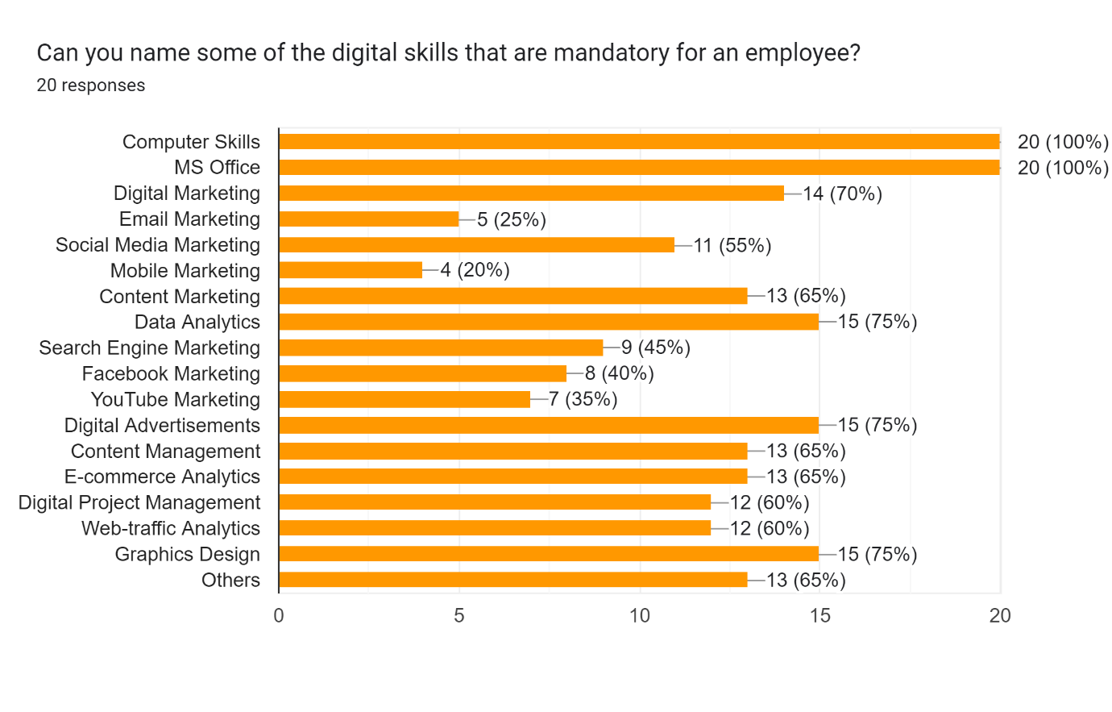
The most required digital skills are computer skills, MS office, digital advertisements, data analytics, graphic design and social media marketing.
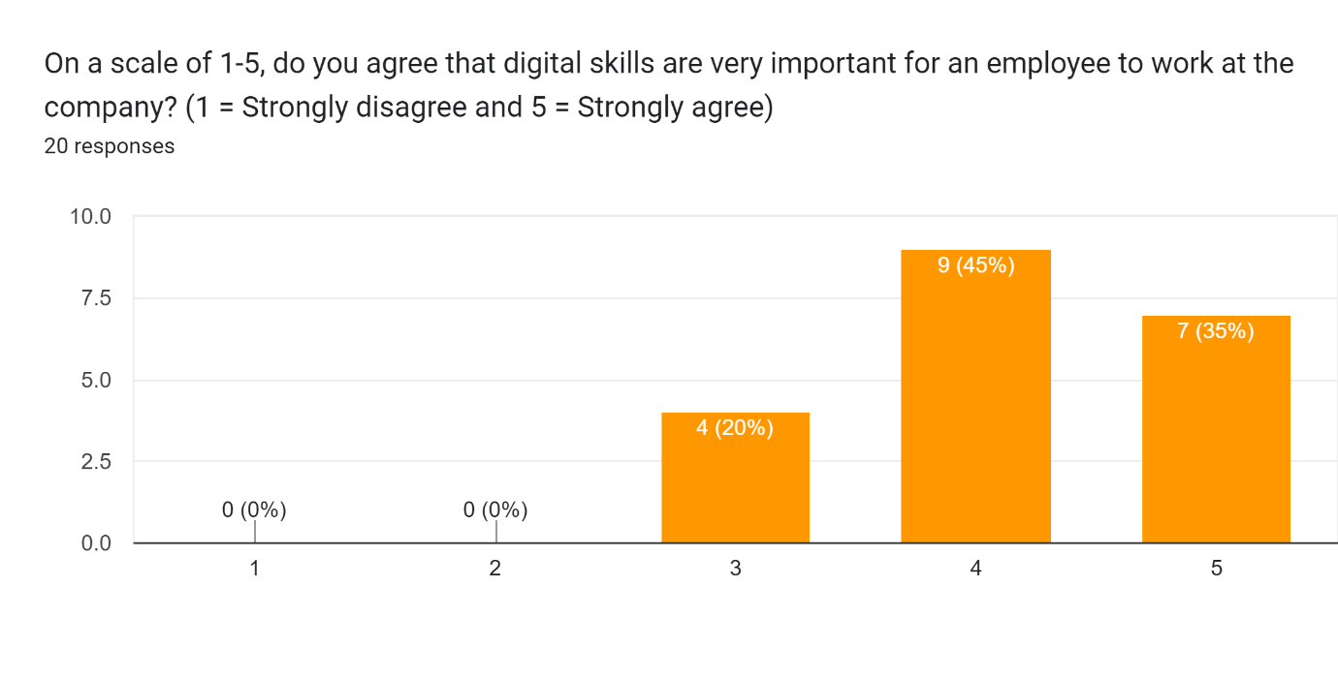
45% of the respondents agreed that digital skills are mandatory and 35% strongly agreed.
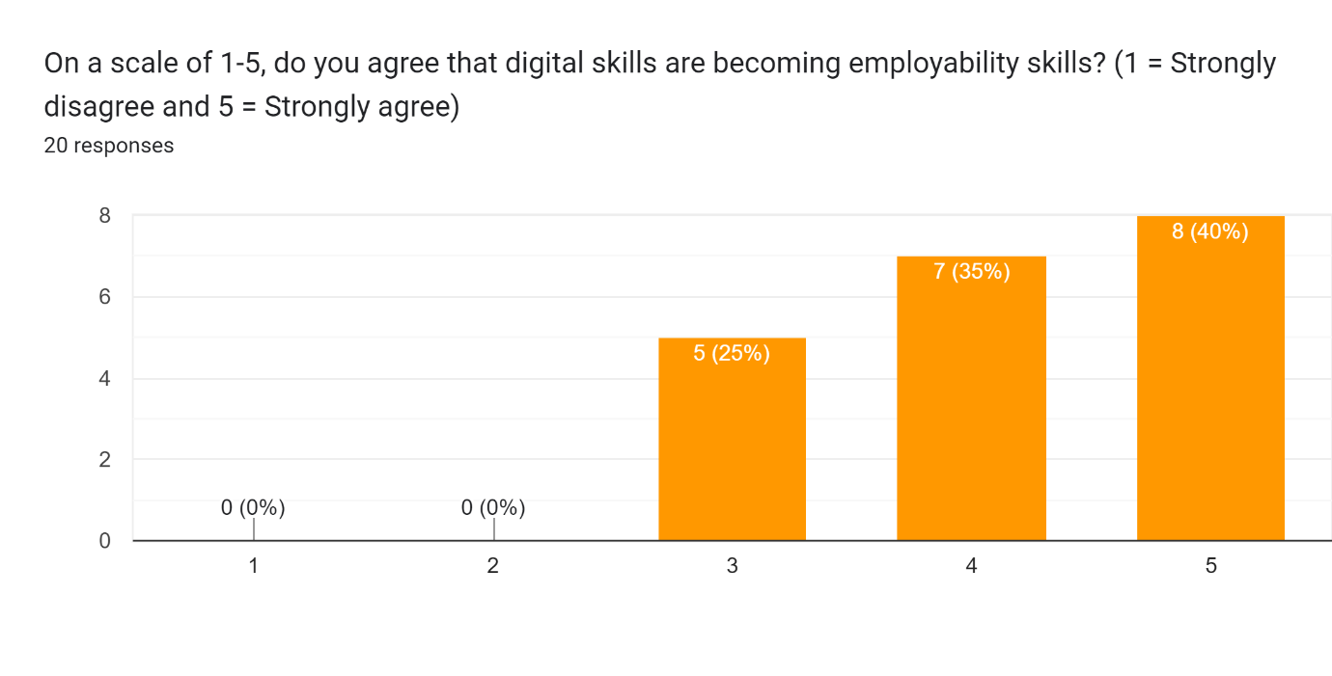
40% of the respondents strongly agreed that digital skills are becoming one of the employability skills days by and 35% agreed.
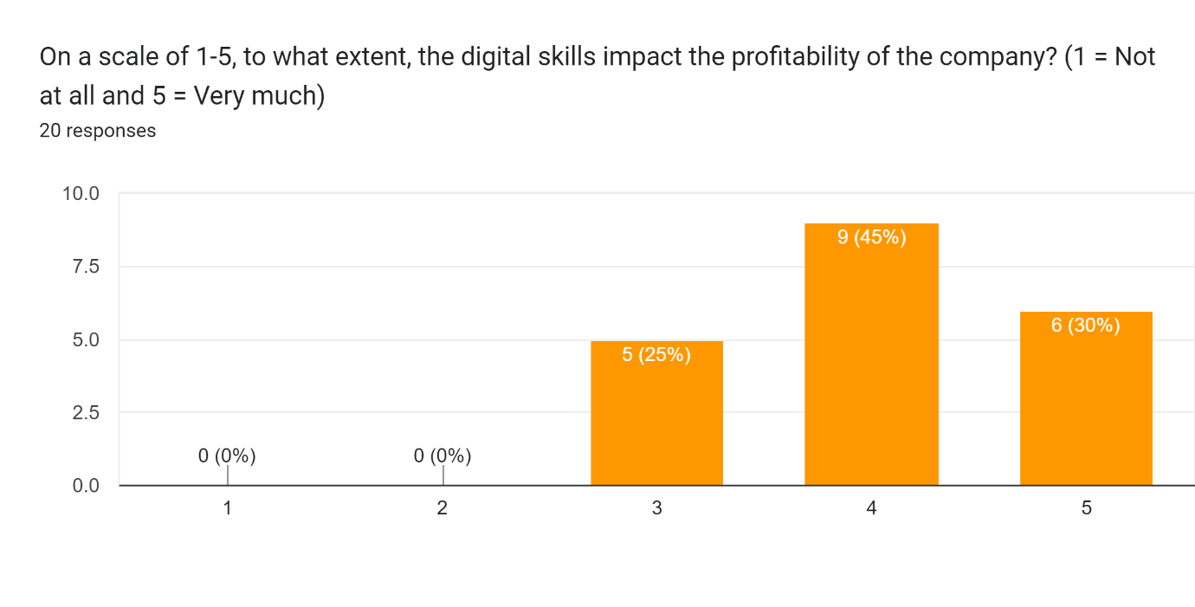
45% of the employees think that the profitability of the company increases because of digital skills.
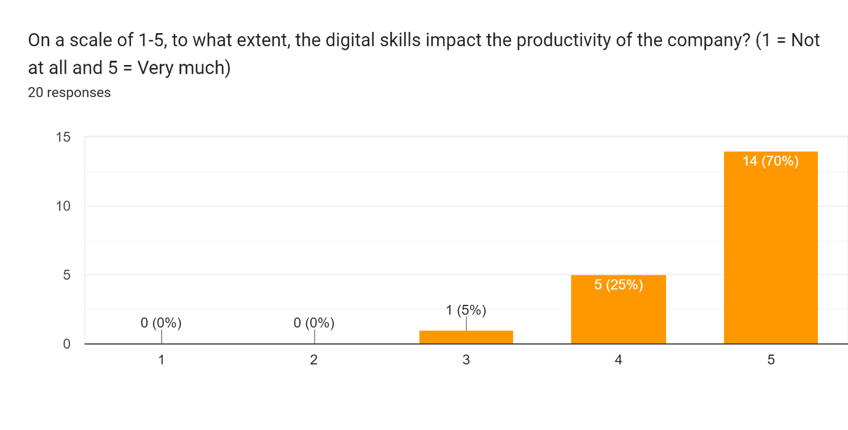
70% of the employees of Unilever PLC think that the productivity of the company increases because of digital skills in the employees.
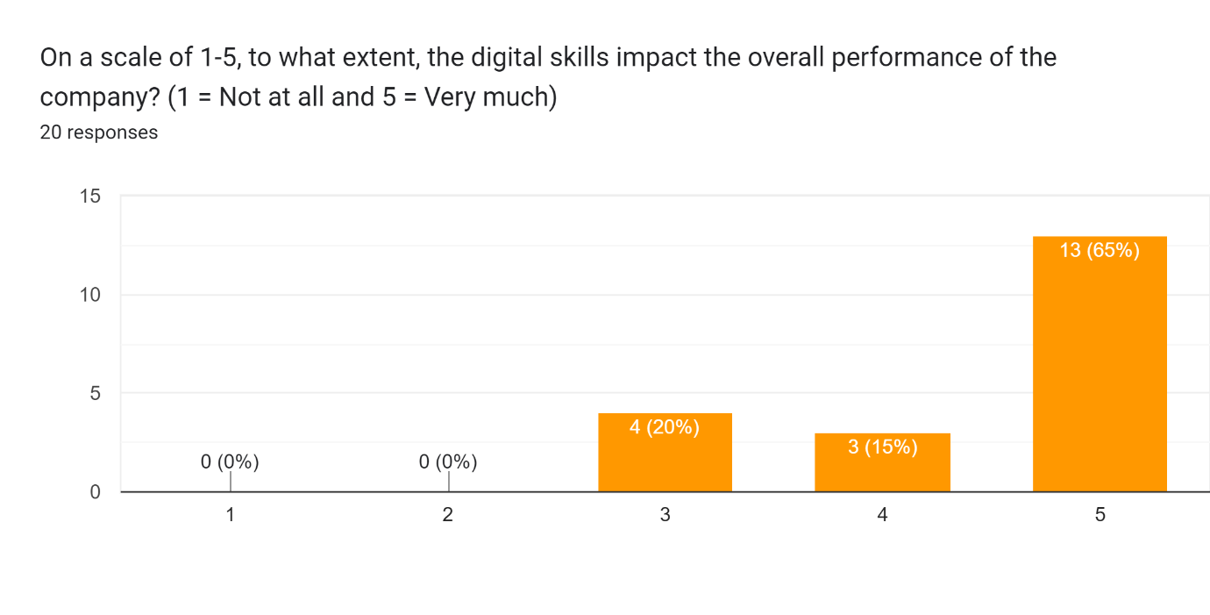
65% of the employees agreed that the company’s overall performance has developed due to the utilisation of employees' digital skills.
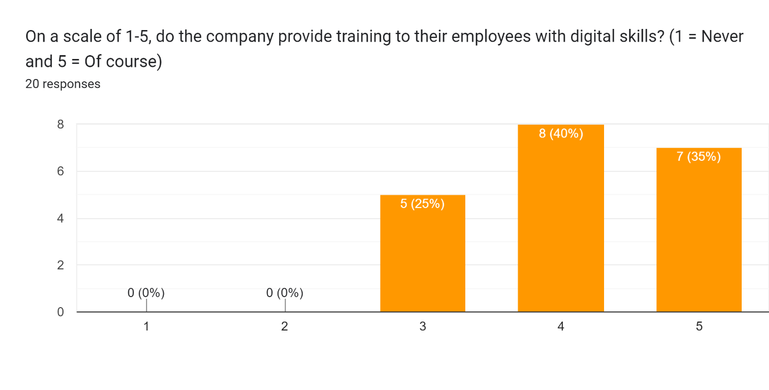
40% of the respondents agreed that the company is ready to provide training to the employees with digital skills.
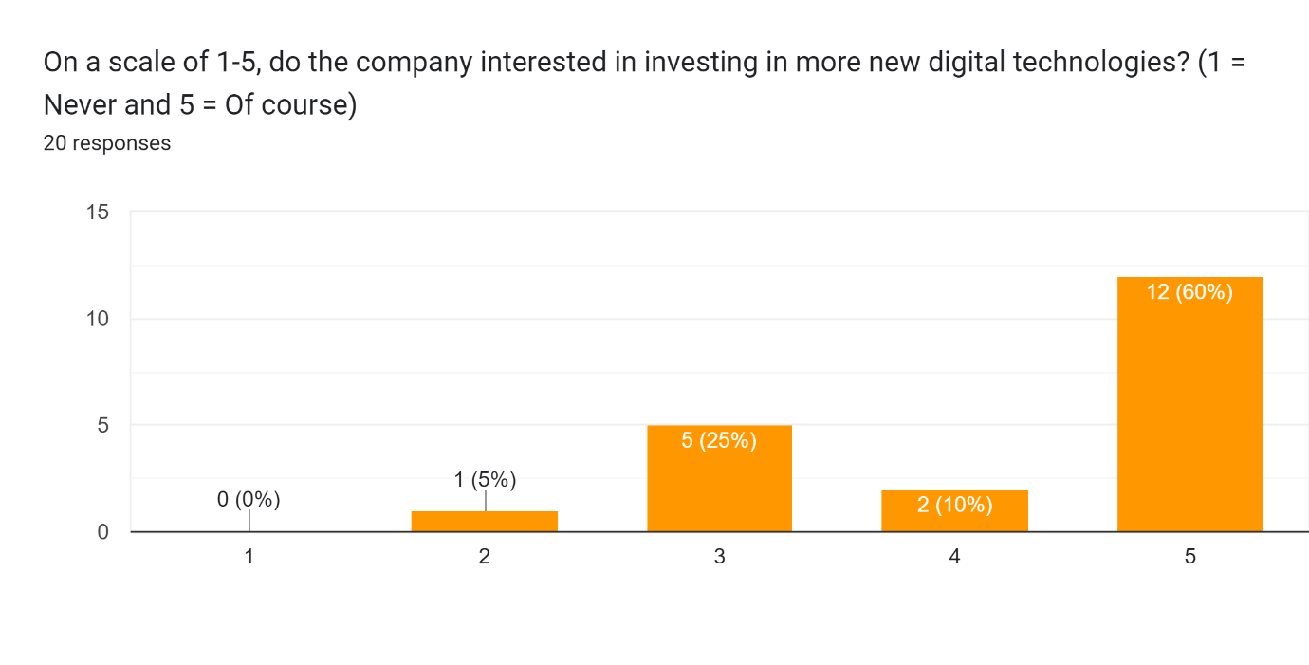
60% of the employees mentioned that the company is ready to invest in more new digital technologies.

Discussion
According to the findings from the primary data collection, almost everyone agreed that digital skills are required for a person to do official tasks in the company. Most of them agreed that digital skills are getting one of the employability skills. The profitability, productivity and overall performance of the company have increased according to the employees of Unilever PLC. In addition, they also mentioned that Unilever PLC is quite ready to provide training to the employees for new digital skills and adopt more new digital technologies. The appropriate data is shown in the above pictures in the results section. Those were the results from the primary data collection.
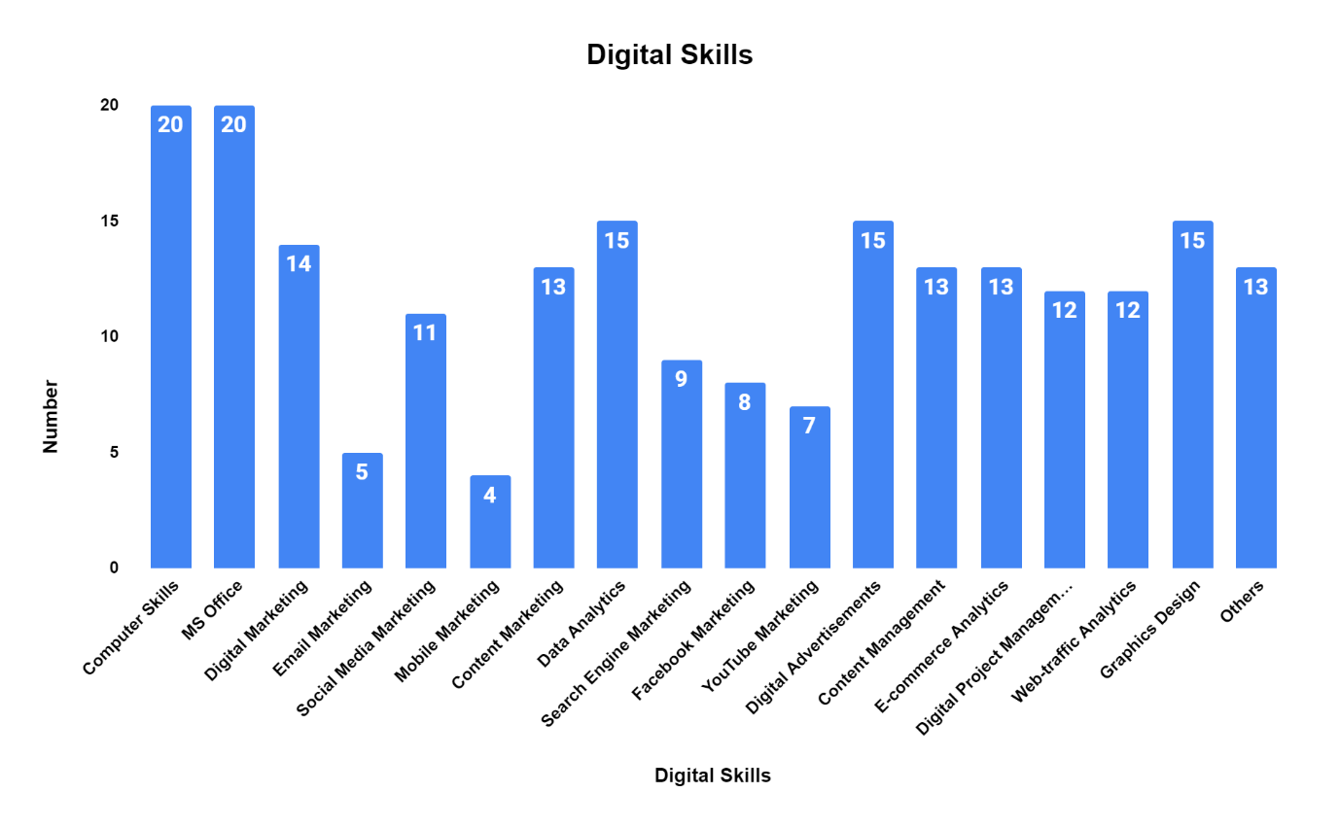
Since a small amount of data is collected, the focus must be directed toward secondary data collection. Secondary data is collected from various resources. Secondary data found that computer skills and expertise in excel have become one of the basic needs for a person(Chaffey and Ellis-Chadwick, 2014). Every person must be able to have those skills. For developed, developing and under-developed countries, every people should focus on those. The second most important digital skill is digital marketing(Sari, 2021). Reputed universities around the world had already started courses on digital marketing(Chaffey and Ellis-Chadwick, 2015). Nowadays, digital marketing courses are available on online and YouTube. Digital marketing includes social media marketing, advertisements, content marketing, PR, Facebook marketing, YouTube Marketing and so on. Under these marketing, graphic designing skill, video editing, photoshops etc. skills are mandatory. The reason digital marketing is getting prioritised among all the digital skills is that the world is getting digitalized. Learning, medication, treatment, shopping, entertainment, cinema, games, jobs everything can be done sitting at home using the internet and other digital technologies. So, companies are trying to attract people digitally using different digital platforms (Faisal, 2016). Digital platforms such as Facebook, YouTube, Instagram, LinkedIn, Reddit, Pinterest, and Quora are the top platforms of the world that are getting highlighted by companies to grab customers’ attention(Fernández, 2020). Apart from these platforms, website marketing and website advertisement is popular. By clicking the link people easily can access the product or service(Lee, 2014). Those are all from the point of view of the company to get as much as market share. But to do so, the companies need experts and employees who can do the job for the company. Major courses on digital marketing and web development are getting popular among students(Van Deursen, 2016). Digital skills let people earn during their studies sitting at home. Hence, the companies are also willing to employ candidates who already have experience in the field or who have practical knowledge of doing such(Fernández, 2020). However, companies nowadays do not only check the educational qualifications, they also find digital skills which are unique and which can be applied to the job. Previously, companies did not have separate digital departments. But now, almost every company has a digital marketing department and all the departments have a digitalised section to do the job(White, 2019). This is why digital literacy and digital skills are in demand and the demand would increase in future(Sabri, El Hana, Sic-Sic and Andriuzzi, 2021).

Conclusions
Before concluding the research, the findings from the research can be expressed in a sentence that digital skills are becoming one of the necessities for survival in the competitive digital market(Morris, 2019). Some recommendations can be made for both big and small companies around the world after analysing the primary and secondary data. They are mentioned below.
- All companies must hire digitally skilled people.
- Skill tests can be done before recruitment.
- A Digital training and development program should be arranged once a year.
- Customer acquisition costs should be invested in digital marketing to acquire customers easily.
To conclude the research, it can be said that the research is completed the findings are positive in favour of digital skills. The implementation of digital skills makes a company efficient (Sabri, El Hana, Sic-Sic and Andriuzzi, 2021).

Reference list
Ayan, S., 2018. Business research methodology.
Chaffey, D. and Ellis-Chadwick, F., 2014. Marketing digital. Distrito Federal: Pearson Educación.
Chaffey, D. and Ellis-Chadwick, F., 2015. Digital marketing.
Chandra, V. and Harindran, A., 2017. Research Methodology. Pearson Education India.
Faisal, A., 2016. Marketing Strategies in Online/Digital Marketing. Account and Financial Management Journal.
Fernández, Y., 2020. Digital Skills and Digital Literacy: New Trends in Vocational Training. International Journal of Early Childhood Special Education, 12(1), pp.370-377.
Lee, S., 2014. Digital Literacy Education for the Development of Digital Literacy. International Journal of Digital Literacy and Digital Competence, 5(3), pp.29-43.
Morris, N., 2019. Understanding Digital Marketing: Marketing Strategies for Engaging the Digital Generation. Journal of Direct, Data and Digital Marketing Practice, 10(4), pp.384-387.
Sabri, O., El Hana, N., Sic-Sic, E. and Andriuzzi, A., 2021. Marketing digital. Paris: Vuibert.
Saikkonen, L. and Kaarakainen, M., 2021. Multivariate analysis of teachers’ digital information skills - The importance of available resources. Computers &amp; Education, 168, p.104206.
Sari, K., 2021. COVID-19 Infodemic: Underlining the importance of digital literacy skills. Public Health and Preventive Medicine Archive, 9(1), p.1.
Van Deursen, A., 2016. Digital skills. Palgrave Macmillan.
White, J., 2019. Digital literacy skills.

Appendix
Survey Questionnaire for ‘The Impact and Importance of Digital Skills in Job and Business: A Case Study in Unilever PLC’
Q1 | Can you name some of the digital skills that are mandatory for an employee?
Q1 | Computer Skills | MS Office | Digital Marketing | Email Marketing | Social Media Marketing
Q1 | Mobile Marketing | Content Marketing | Data Analytics | Search Engine Marketing | Facebook Marketing
Q1 | YouTube Marketing | Digital Advertisements | E-commerce Analytics | Digital Project Management | Web-traffic Analytics
Q1 | Graphics Design |  |  | Others
Q2 | On a scale of 1-5, do you agree that digital skills are very important for an employee to work at the company? (1 = Strongly disagree and 5 = Strongly agree)
Q2 | 1 | 2 | 3 | 4 | 5
Q3 | On a scale of 1-5, do you agree that digital skills are becoming employability skills? (1 = Strongly disagree and 5 = Strongly agree)
Q3 | 1 | 2 | 3 | 4 | 5
Q4 | On a scale of 1-5, to what extent, the digital skills impact the profitability of the company? (1 = Not at all and 5 = Very much)
Q4 | 1 | 2 | 3 | 4 | 5
Q5 | On a scale of 1-5, to what extent, the digital skills impact the productivity of the company? (1 = Not at all and 5 = Very much)
Q5 | 1 | 2 | 3 | 4 | 5
Q6 | On a scale of 1-5, to what extent, the digital skills impact the overall performance of the company? (1 = Not at all and 5 = Very much)
Q6 | 1 | 2 | 3 | 4 | 5
Q7 | On a scale of 1-5, do the company provide training to their employees with digital skills? (1 = Never and 5 = Of course)
Q7 | 1 | 2 | 3 | 4 | 5
Q8 | On a scale of 1-5, do the company interested in investing in more new digital technologies? (1 = Not at all and 5 = Very much)
Q8 | 1 | 2 | 3 | 4 | 5

