Behaviour and Learning: Approaches to Classroom Management
ECES5016

Student number: 2200299

Contents page

Presentation slides ………………………………………………………………………… 3
Supporting materials ……………………………………………………………….….… 14
Link to the presentation recording ………….……………………………………….…. 20
Presentation slides

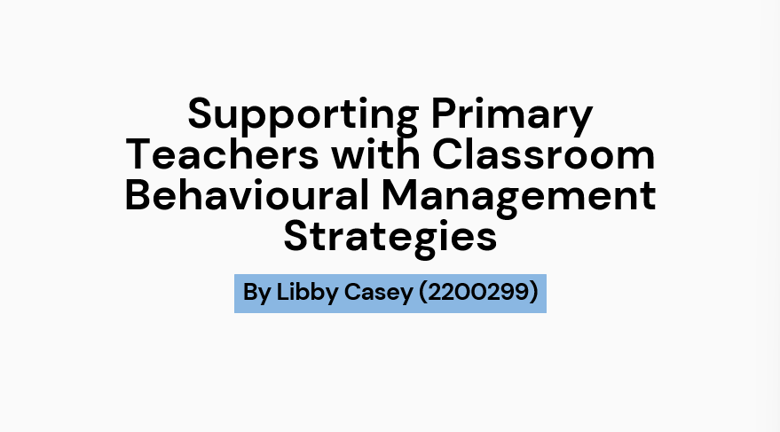

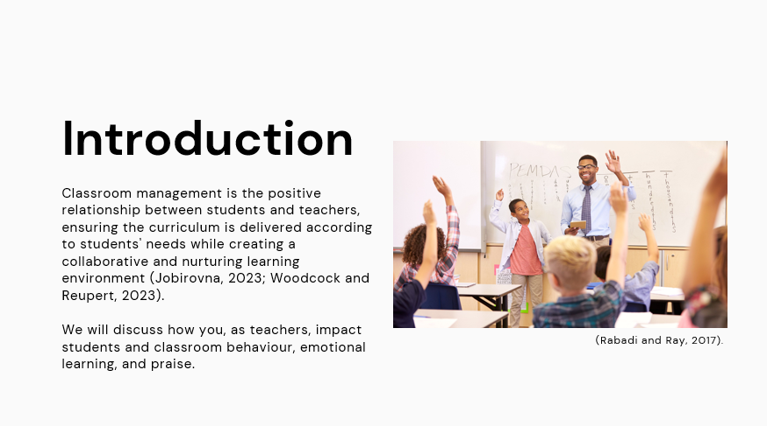

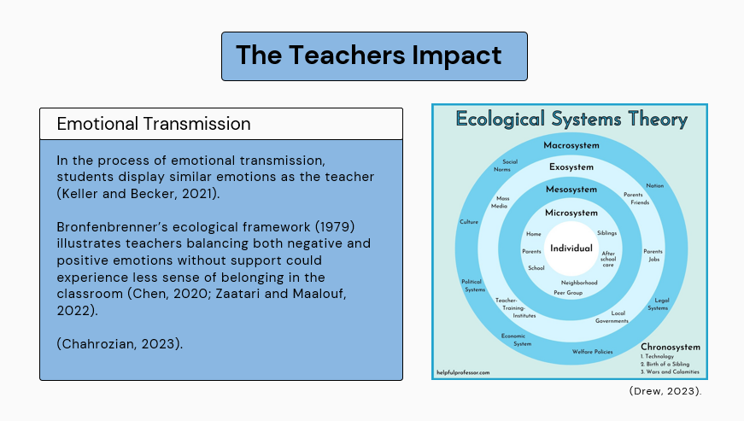
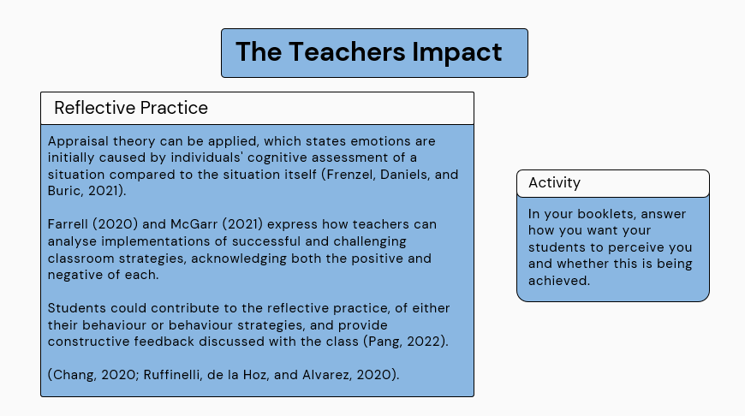

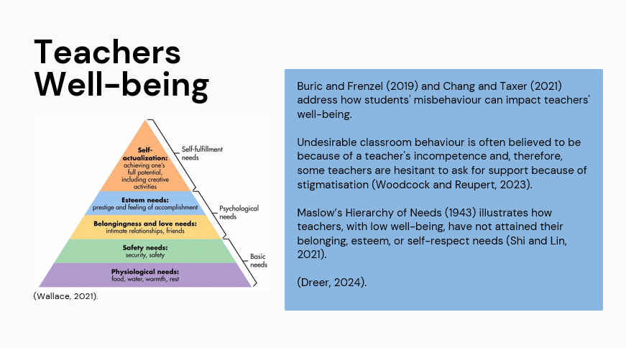

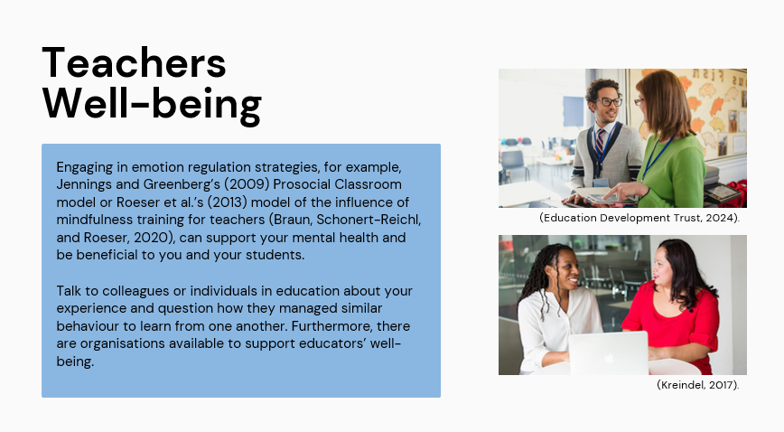

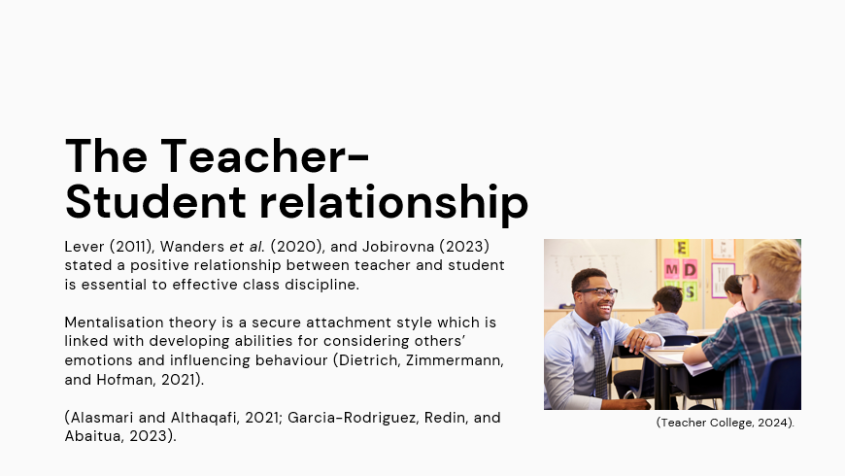

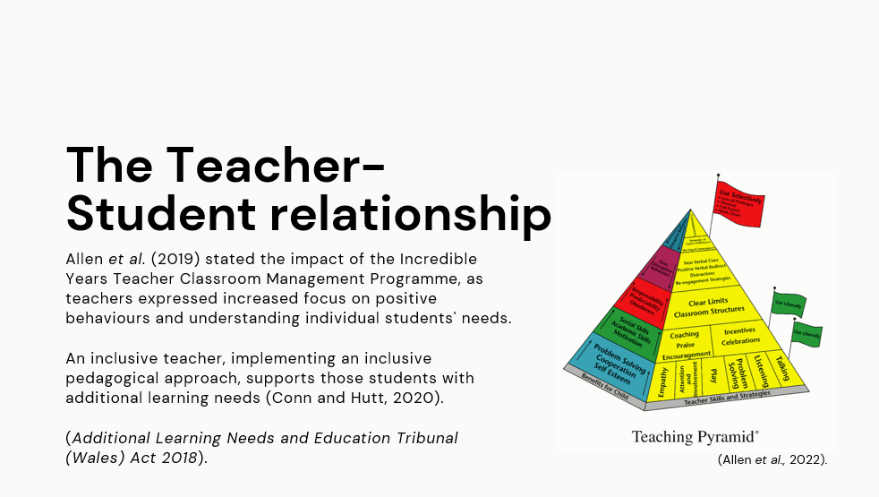

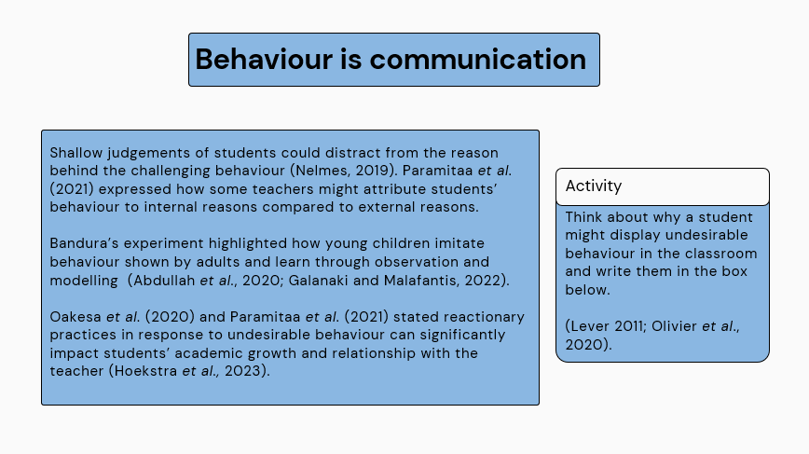

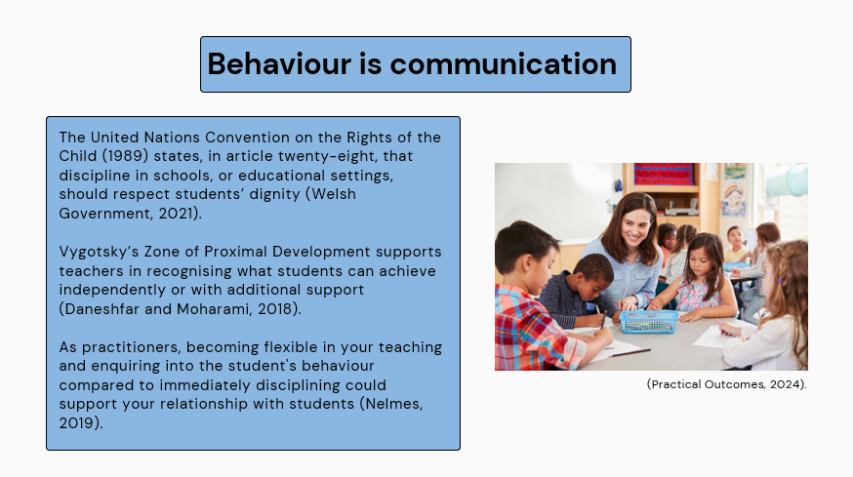

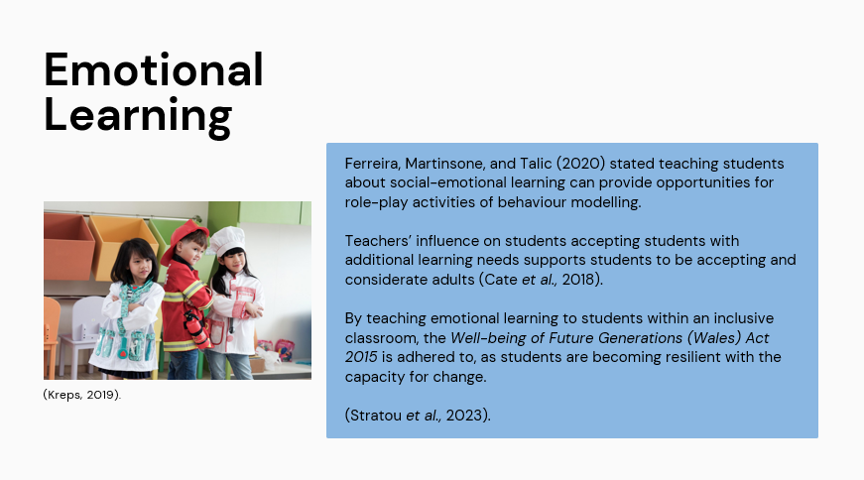

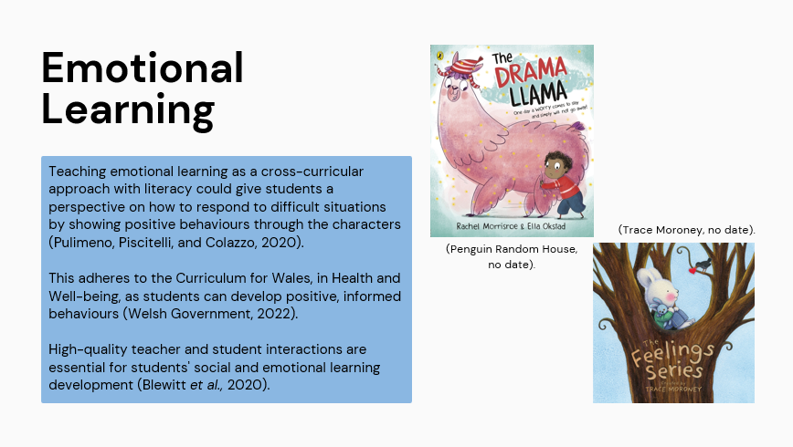

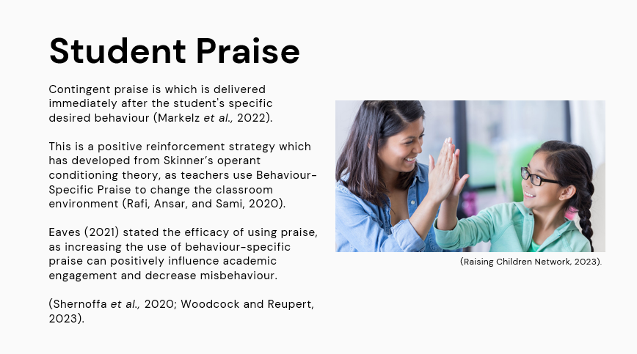

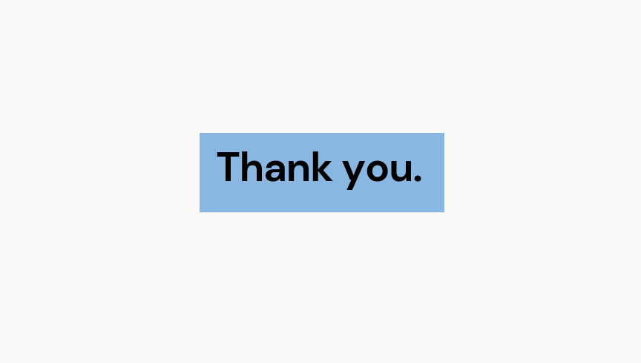

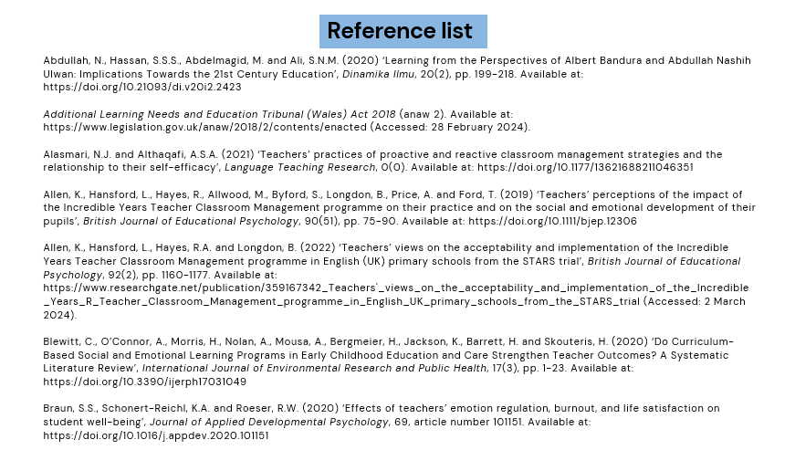

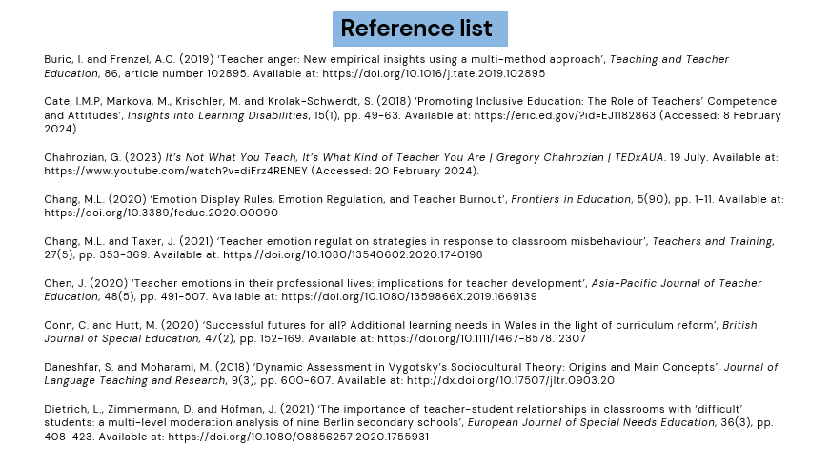

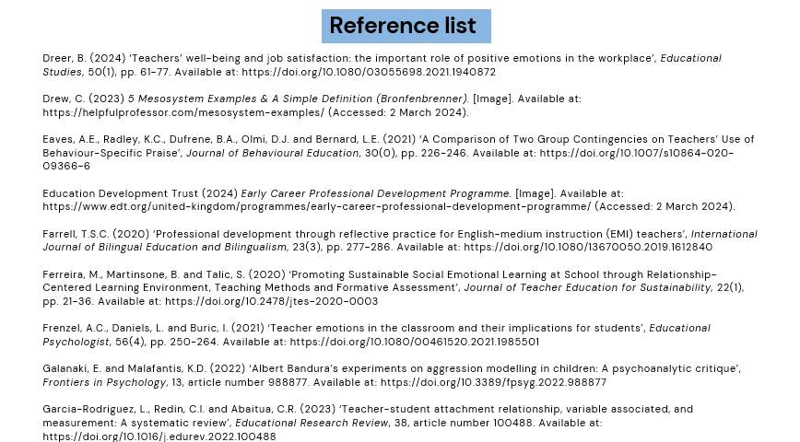

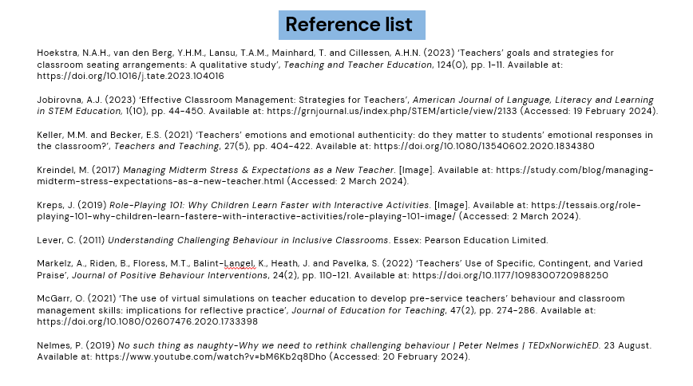

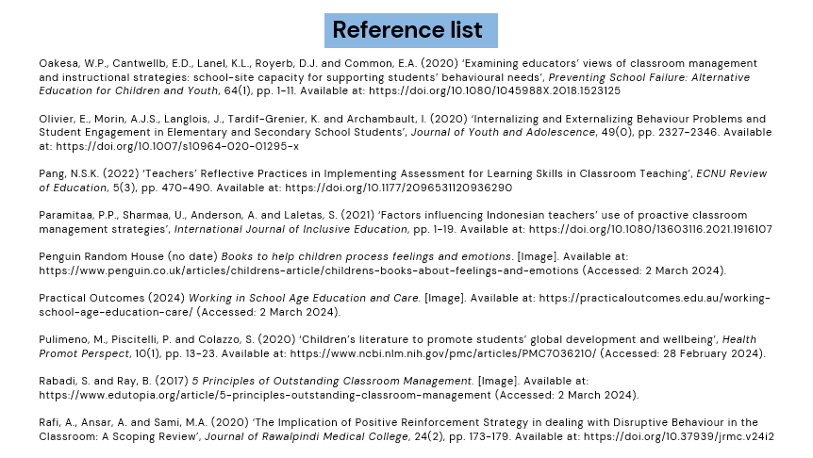

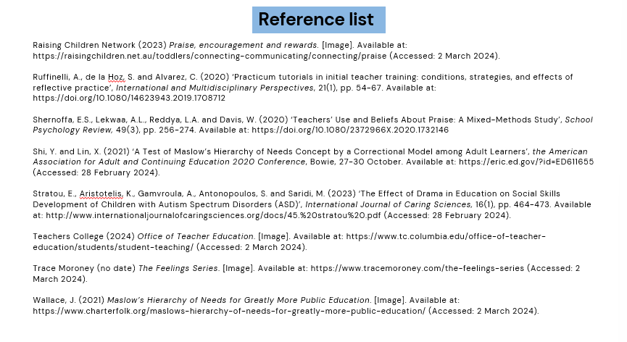

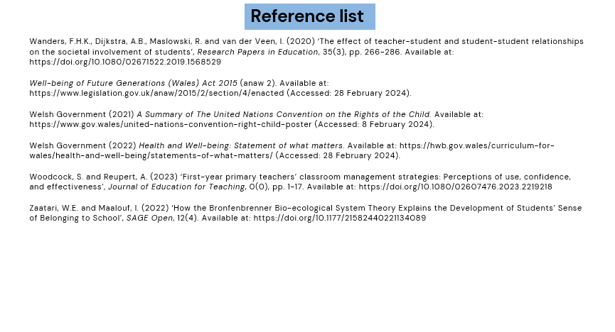

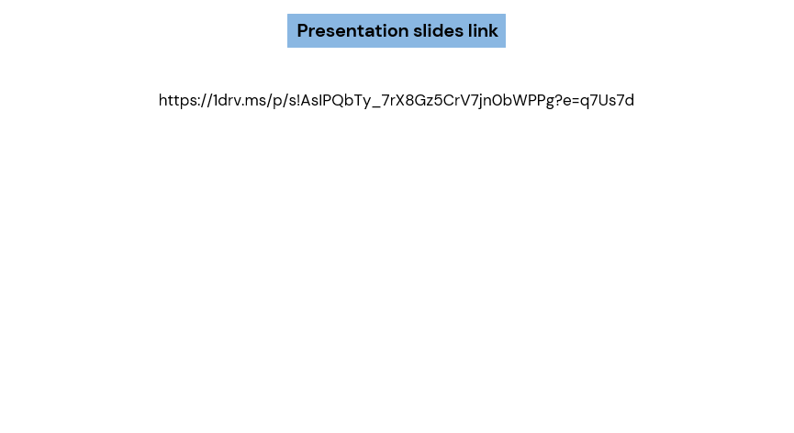

Supporting materials

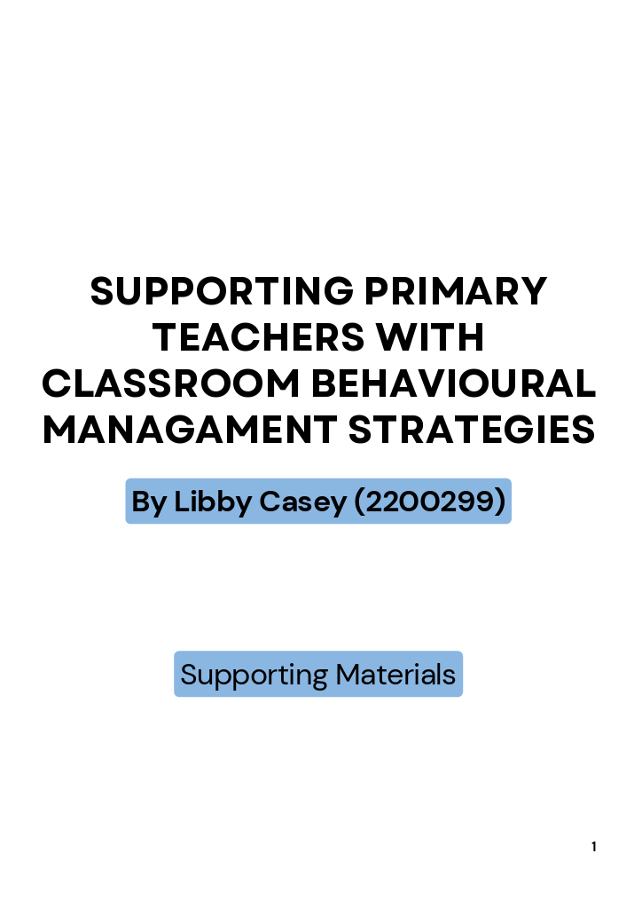
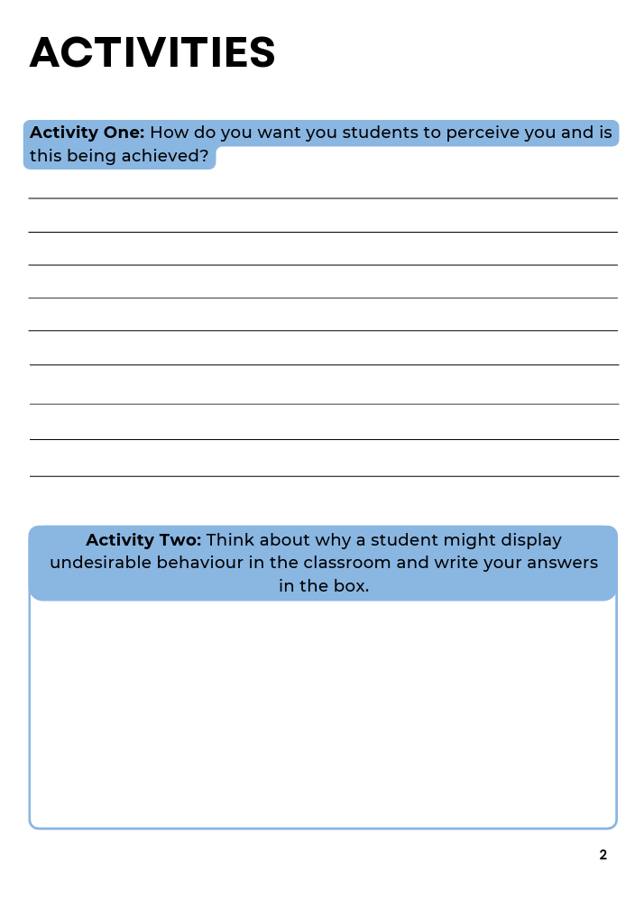

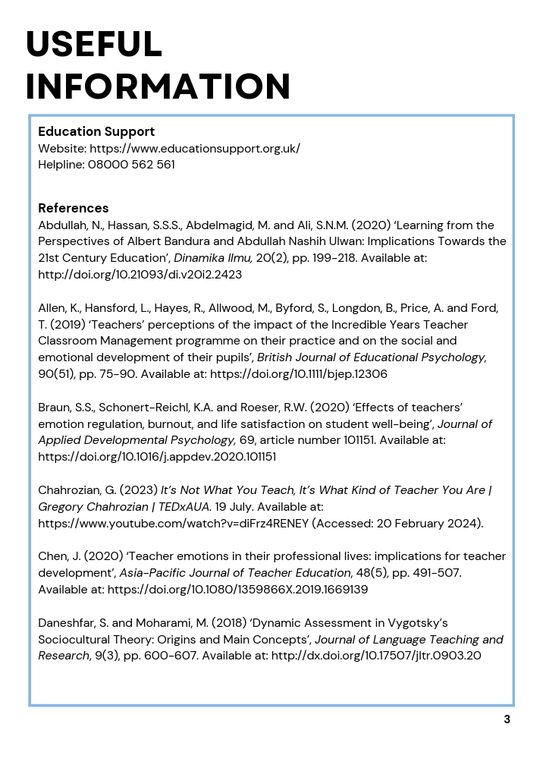
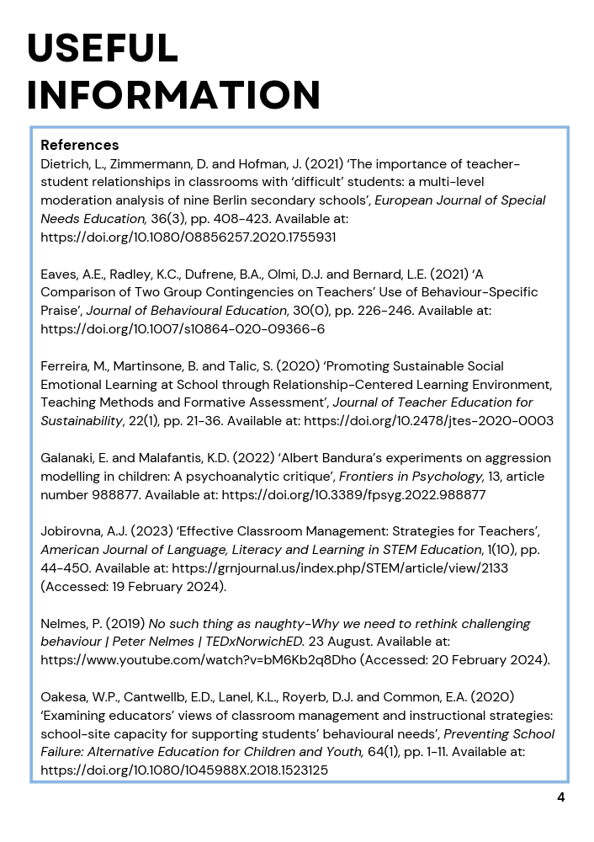
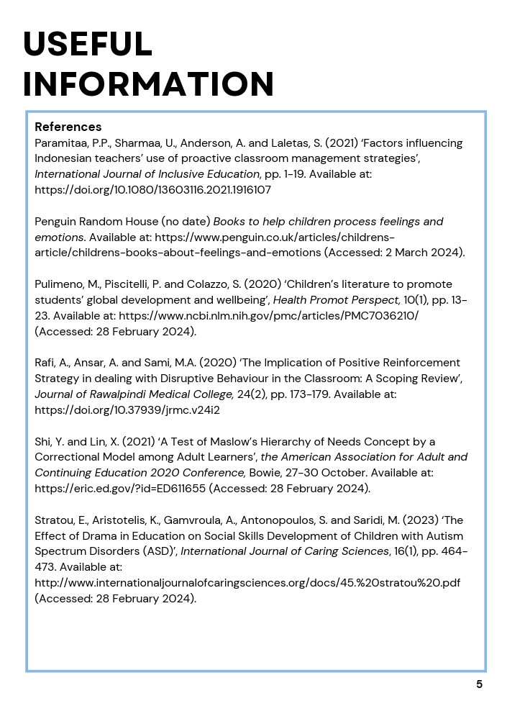
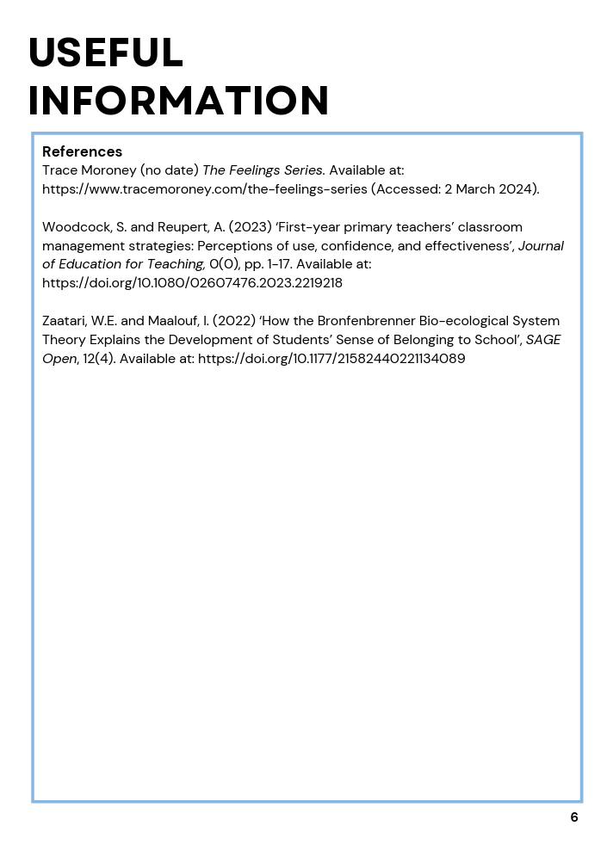
Link to the presentation recording.
https://uowtsd.sharepoint.com/:v:/r/teams/ECES5016BehaviourandlearningApproachestoclassroommana987_GRP-LibbyCaseypresentation/Shared%20Documents/Recordings/New%20channel%20meeting-20240304_084937-Meeting%20Recording.mp4?csf=1&web=1&e=DcK3Q0&nav=eyJyZWZlcnJhbEluZm8iOnsicmVmZXJyYWxBcHAiOiJTdHJlYW1XZWJBcHAiLCJyZWZlcnJhbFZpZXciOiJTaGFyZURpYWxvZy1MaW5rIiwicmVmZXJyYWxBcHBQbGF0Zm9ybSI6IldlYiIsInJlZmVycmFsTW9kZSI6InZpZXcifX0%3D

