3/24/2025
University of Wales Trinity Saint David
London campus
E-Portfolio Link:
Module Name: Learning In the Digital Era
Module Code: ACCA 4025

Student Name: Sunny Anibaba
Student ID: 2210976
Group: 1

Lecturer’s Name: Dipo Dunsin, Koushik Modak

LDE Assignment 1
E-Portfolio
Table of Contents
Introduction 2
Main Body 2
Task 1: Essential Academic and Employment Skills for the future career Path 2
Task 1 (a): Report on Essential Academic and Employment Skills 2
Task 1 (b): Evaluation of Task 1 (a) based on Similarity report 2
Task 2: Collaborative Mind Map and Individual Poster 2
Mind Map (Collaborative) 2
Poster (Individual) 2
Task 3: Virtual Collaboration and RefWorks 2
Report on Virtual Collaboration 2
Step-by-step process of using RefWorks with visuals 2
Task 4: E-Portfolio Creation and Evaluation 2
Task 4 (a): E-Portfolio Creation 2
Task 4 (b): Illustrative Review of E-Portfolio tool Selection 2
Conclusion 2
References 2
Task 1 References: 2
Task 3 References: 2

Introduction

Essential skills for study and employment how these skills will help me in my chosen career

Essential skills are the foundation of success in today’s fast-changing world. These transferable abilities spanning cognitive, interpersonal, self-management, and digital domains help individuals think critically, communicate effectively, solve problems, and adapt to change. Employers value these skills because they drive productivity, collaboration, and innovation in competitive environments. [1]
Key examples include critical thinking, which supports logical analysis and creative solutions; communication, which ensures clarity and teamwork; and adaptability, which helps navigate evolving processes. Skills like time management and digital literacy boost efficiency, while leadership and teamwork foster collective achievement and organisational success. [2]

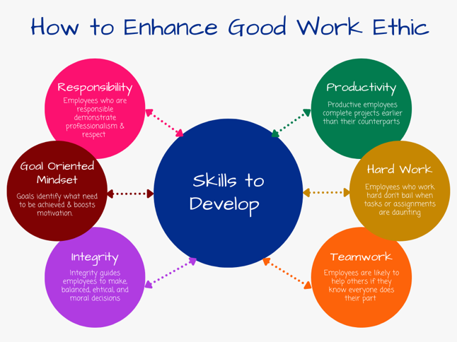
[3] How To Enhance Good Work Ethic Students Acquiring Educational Skills for Work [4]

In my career, these skills will allow me to collaborate effectively, tackle challenges, and contribute to strategic objectives. Communication ensures my ideas are understood, problem-solving demonstrates initiative, and adaptability proves I can handle change. I will build trust through professionalism and a strong work ethic, while analytical skills enable informed, data-driven decisions that support growth and operational excellence. These capabilities also strengthen project management, improve stakeholder engagement, and enhance overall performance. [5]
To showcase these abilities, I will align them with job requirements, explain how they add measurable value, and share real examples such as using communication to strengthen client relationships. I will also highlight growth potential by showing willingness to learn, like improving digital editing skills to enhance creativity. Additionally, I will demonstrate how my budgeting experience can reduce costs and improve financial performance, contributing to sustainable business outcomes.
By cultivating and applying these essential skills, I will position myself for long-term success, career advancement, and meaningful contributions to any organisation.

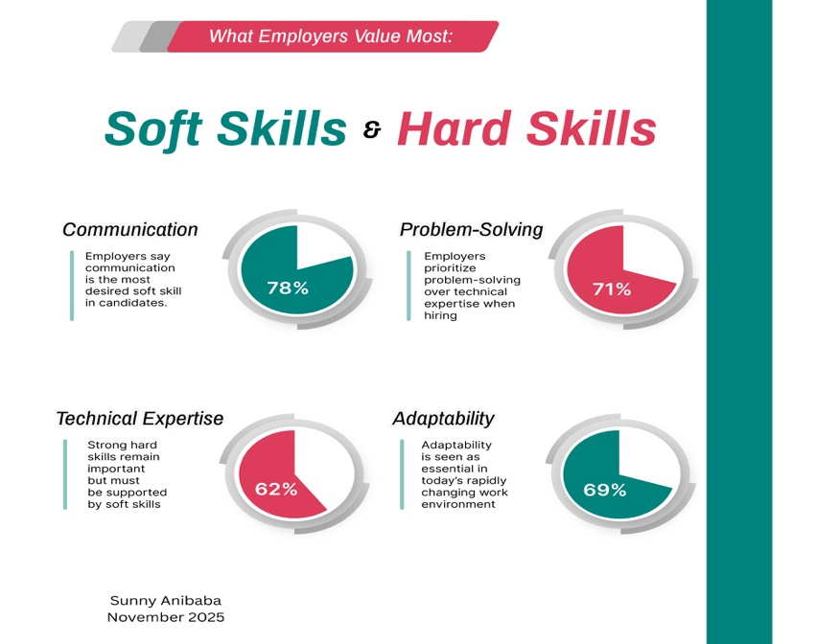

What employers value most

Bibliography

[1] | L. C. J. P. Mengru Sun, “Wiley Online Library,” 27 July 2020. [Online]. Available: https://onlinelibrary.wiley.com/doi/abs/10.1111/hsc.13107. [Accessed 19 November 2025].
[2] | S. J. Z. a. R. Klimoski, “The Interface of Leadership and Team Processes,” Sage Journals, vol. 27, no. 1, March 2002.
[3] | P. Naik, “The Learning Hub,” 22 September 2023. [Online]. Available: https://www.linkedin.com/pulse/essential-skills-every-employee-should-have-pratik-naik/. [Accessed 19 November 2025].
[4] | D. o. Education, “Skills for Career,” [Online]. Available: https://www.skillsforcareers.education.gov.uk/. [Accessed 19 November 2025].
[5] | J. W. a. M. E. S. Dennis T. Ray, “Career Skills: Our Process and Where We Are Today,” ASHS Publications, vol. 27, no. 5, 2017.

