
Skills for the Workplace
Module Assignment Submission
Student Name: | John Scott
Student Number: | 2225835
Module No: | BMSK5011
Module Title: | Developing Workplace Critical Thinking

Statement of Confirmation of Authenticity
By the act of making this submission, the student declares that this is the work of the student named above. The work has not, in whole or in part, been knowingly presented elsewhere for assessment, or where assessment has been built on a previous assessment, this has been identified. Where materials have been used from other sources it has been properly acknowledged. If this statement is untrue, the student acknowledges that an assessment offence has been committed.
Attention is drawn to the plagiarism and unfair practice policies of both the University and of ILM.

Contents
INDUCTION 4
Section 1: Critical Thinking 4
Section 2: Values, Attitude, Beliefs & Behaviours 6
Section 3: My own values, beliefs & attitudes 9
Section 4: Management Theories 10
Section 5: identifying a management theory in your own workplace. 15
Section 6: Conclusion 15
References 16

INTRODUCTION

Not only is having the ability to think critically helpful in today's workplaces, but it is essential in order to succeed in the constantly changing and competitive environment of today's workplaces. Thinking critically is the basis upon which decision-making, problem-solving, and creativity are created, and ultimately, it is the engine that drives the success of a company. The basics of critical thinking, its importance in the workplace, the connection of values, beliefs, and attitudes, and the use of management theories specifically classical as developed by Frederick Taylor in creating an environment that is beneficial to critical thinking are all subjects that are discussed further in this piece.
I will then consider whether professional values, attitudes and beliefs differ from personal attitudes values and beliefs when in the workplace and working under the specific management theory. Further consideration will be given to whether a different person would find it easier or more difficult to fit into the values, attitudes and beliefs of the theory.

Section 1: Critical Thinking

In a statement by Scriven & Paul (1987) critical thinking is defined as;
“The intellectually disciplined process of actively and skillfully conceptualizing, applying, analyzing, synthesizing, and/or evaluating information gathered from, or generated by, observation, experience, reflection, reasoning, or communication.”

This is also the views of Burns & Sinfield (2016) who stated;
“Critical thinking is the art of making clear, reasoned judgements based on interpreting, understanding, applying and synthesising evidence gathered from observation, reading and experimentation.”

What is critical thinking?

Critical thinking is having the skills to analyse, combine, and draw information in order to get a logical conclusion. It involves the use of rationality, facts, and logic in order to evaluate situations, question assumptions, and investigate different points of view. Instead of taking information at face value, critical thinking can be defined by the practice of questioning, investigating, and searching for a greater understanding of the subject matter.

How Can You Think Critically?

As explained by Hooks (2013)
“Critical thinking requires us to use our imagination, seeing things from perspectives other than our own and envisioning the likely consequences of our position.”

The learning of the abilities in critical thinking includes a number of key elements. To start with, it is necessary to develop an inquisitive mindset, which is defined by individuals questioning assumptions and seeking clarification for themselves. In addition, it requires a growth of thinking abilities in order to break down difficult problems into components that can be easily managed. In the third place, critical thinkers are open-minded individuals who acknowledge that there are a variety of opinions and are aware of new ideas. Having the ability to express one's opinions and participate in constructive conversation is another reason why strong communication skills are essential.

This is the RED Model;

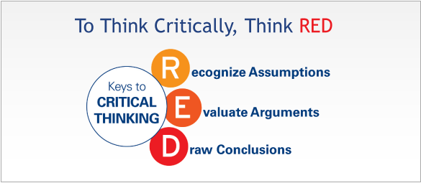

It has been suggested by Wulandari, R., Baedhowi, & Hindrayani, A. (2021) that “This model is believed to be very helpful in developing critical thinking skills.”
Recognize assumptions, evaluate arguments, and draw conclusions are the three processes that make up the RED model, which is a popular model for thinking critically developed by Pearson TalentLens. Recognize assumptions, evaluate arguments, and draw conclusions. Recognising the underlying ideas or assumptions that influence one's point of view is an essential part of the ability to recognise assumptions. Evaluating arguments involves deciding whether or not the evidence that is offered to support a claim is legitimate and whether or not it is relevant. To come to a conclusion, you need to put together different pieces of information and make decisions based on careful consideration and analysis.

Why is critical thinking important?

The ability to think critically is highly important for effectively dealing with the difficulties of the modern workplace for a number of different reasons. In the first place, it encourages individuals to make decisions that are informed by providing them with the ability to evaluate evidence, understand consequences, and reduce risks. The second benefit is that it encourages development by supporting creativity, experimentation, and the investigation of alternative ways to address problems. Also critical thinking helps individuals develop adaptation, which allows them to better deal with uncertainty and change while retaining their resilience. Evidence suggests that critical thinking is key in today's world and this is supported by author Best, J. (2021) where he states;
“Critical thinking has gotten humanity where it is today, and it is vitally necessary if things are going to continue getting better.” This implies that critical thinking is and should continue to be a fundamental skill we should all learn.

The benefits of critical thinking

The benefits of critical thinking go beyond the abilities of the person to include the improvement of organisational efficiency. Companies that place a high value on critical thinking create a culture that values intellectual strictness, which in return contributes to the growth of continuous improvement and development. Looking at Tripathy, M. (2020) this is supported by stating “The growth or fall of an organisation largely depends on how the leaders see through things. Critical thinking assists in doing just that.”
It is easier for employees who are skilled in critical thinking to find answers for problems in a successful way, which in return increases both production and efficiency. The ability to think critically also encourages teamwork and constructive resolution of conflicts, which lays the framework for strong teams and positive dynamics in the workplace.

My personal reflection on critical thinking

Critical thinking is an important part of how I deal with problems at work and make decisions in my personal life. I think of it as an important tool for problem-solving, making decisions, and encouraging new ideas at work. I don't think critical thinking is just looking at numbers or arguments in great detail. It also means going into situations with an open mind, asking questions about what you think you know, and looking at things from different points of view. It's about being aware of my own and other people's biases and actively seeking out different points of view to come to well-informed decisions.
Developing my critical thinking skills has given me the confidence and clarity to deal with tough problems. Critical thinking helps me break down problems into manageable parts, find their root causes, and come up with creative solutions, whether I'm coming up with plans, assessing ideas, or fixing problems. Additionally, in a workplace that changes quickly and where uncertainty is common, critical thinking helps me find my way through the unknown and move through change with flexibility and strength.
I think of critical thinking as more than just a useful skill. It's also a way of looking at the world that promotes curiosity about things, humility, and a desire to keep learning throughout one's life. Not only do I become more effective at work by constantly improving my critical thinking skills, but I also grow and develop as a person. I truly believe that critical thinking is not only a skill but also a way of thinking. It is this way of thinking that gives me the confidence, creativity, and drive to do my best when I face challenges. I value this set of skills and work hard to keep improving them because I know they will help me in both my personal and professional life.

Section 2: Values, Attitude, Beliefs & Behaviours

What are values, attitudes, beliefs and behaviours?

The manner in which individuals view and approach critical thinking within the setting of the workplace is significantly affected by the values, attitudes, beliefs, and behaviours that they show.

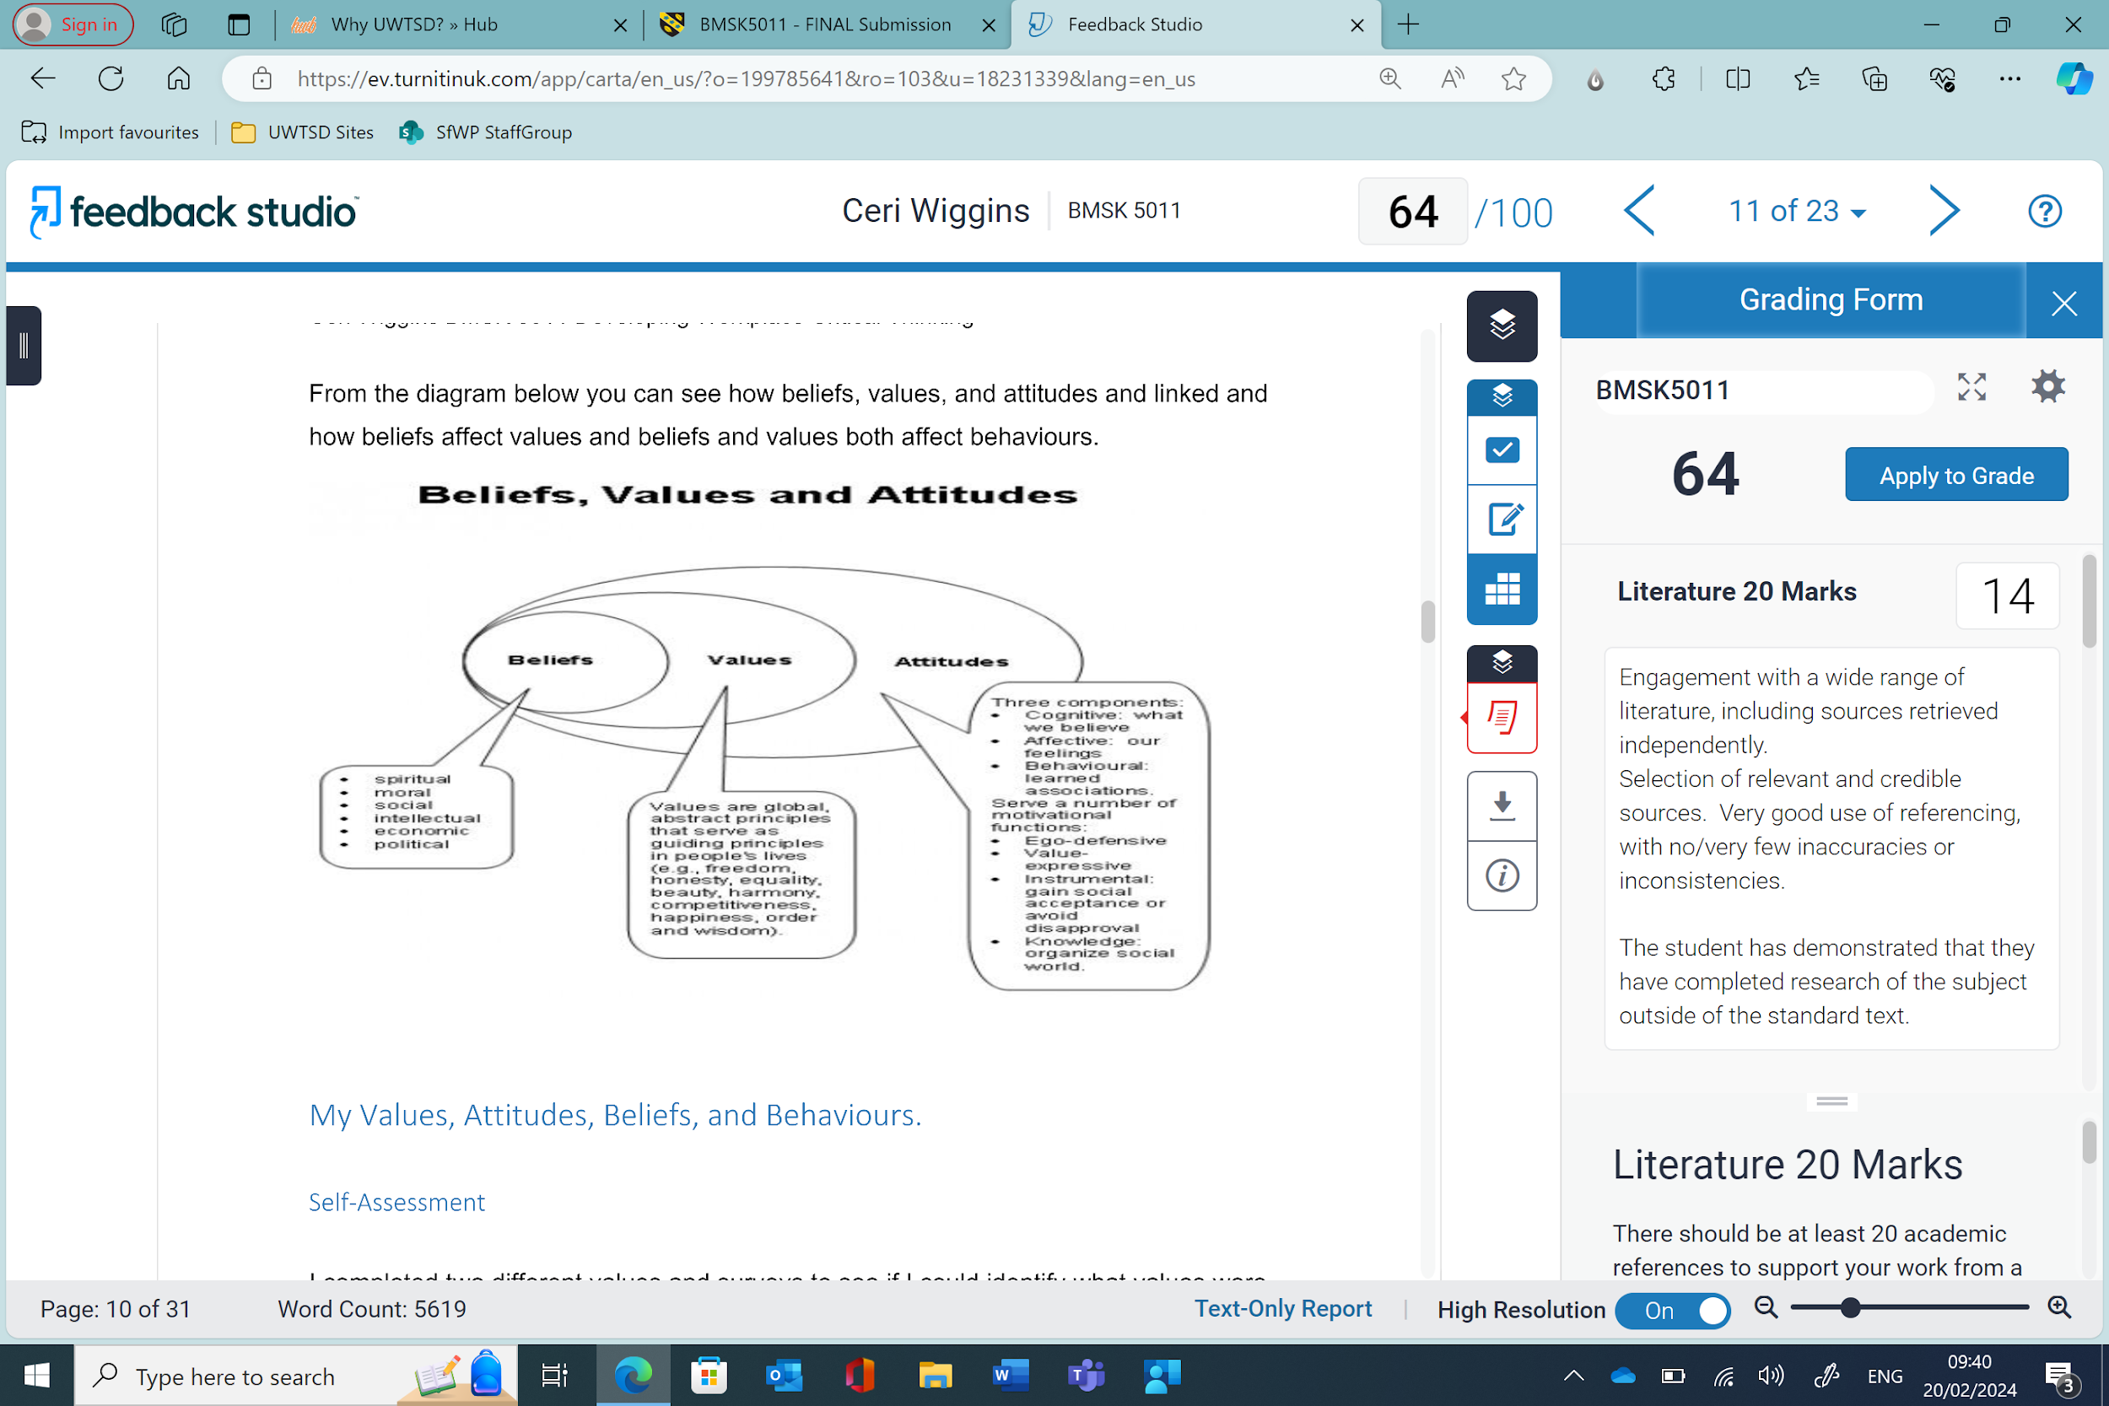
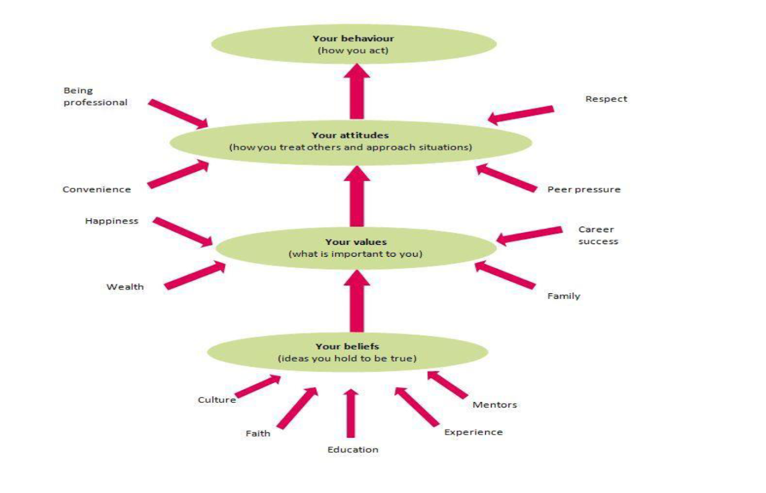
Values

The choices and behaviours that people are affected by values, which are beliefs that are strongly held and valued. These can be things like money, happiness, family, friends or success. Values usually start as beliefs and grow into values the more important it becomes to the person. Looking at Whakatutuki, H. (2018) they state that “Values are stable long-lasting beliefs about what is important to a person. They become standards by which people order their lives and make their choices. A belief will develop into a value when the person’s commitment to it grows and they see it as being important.”
The culture and attitude of a company are shaped by its organisational values, which in return influence the way in which critical thinking is promoted and rewarded in the workplace. I think it’s important to hold good values as this helps define you as a person.

Attitudes

Attitudes usually come from values and beliefs, individuals traits or biases towards certain beliefs or behaviours can be seen in their attitudes. Whakatutuki, H. (2018) states that “Attitudes are the mental dispositions people have towards others and the current circumstances before making decisions that result in behaviour. People primarily form their attitudes from underlying values and beliefs.” Being positive towards critical thinking can be seen by having attributes such as intellectual humility, intellectual curiosity, and a readiness to question the current state of things. I think it's important to have a positive mental attitude within the work environment as this can help with morale and personal success.

Beliefs

The opinions or assumptions that people have about themselves, other people, and the world are what we mean when we talk about beliefs. It is possible for beliefs to either help or hinder critical thinking, depending on how well they fit with proof and reason. This could be culture, religion, education or even experiences. Personal beliefs are important however it's essential to recognise and acknowledge other people's beliefs as well as your own. Looking at Whakatutuki, H. (2018) they state that “A belief is an idea that a person holds as being true. A person can base a belief upon certainties (e.g. mathematical principles), probabilities or matters of faith.”

Behaviours

The actions and behaviours that individuals show in response to a variety of situations are all referred to as behaviours that they display. The behaviours of active listening, seeking feedback, and engaging in reflective practices are all examples of behaviours that are beneficial to critical thinking.

Section 3: My own values, beliefs & attitudes

A greater understanding of the challenges of my approach to critical thinking in the environment of work may be achieved by reflection of my own views, values, and attitudes.

Values

My values include maintaining high ethical standards and creating a supportive environment at work. I place an importance on honesty, teamwork, and continuous development. Working as part of a team and helping one another out is something I value highly.

Beliefs

I have a strong belief in the ability of inclusiveness and diversity in the workplace to increase my views and encourage creativity, which is what motivates me to push for the development of fully inclusive environments in which all different voices are heard and valued. I believe that teamwork is essential in maintaining the effective running of businesses.

Attitudes

My attitudes on critical thinking are that it can help better decision making, help make better informed decisions and gives the ability to identify misinformation given which can help stop issues arising in the workplace.

I completed the Hollands personal values assessment (see appendix A) and my feedback was;

Social;
“Social individuals are often humanistic, idealistic and concerned with the welfare of others. They enjoy helping, training, counseling or developing others. They are generally focused on human relationships and interpersonal dynamics. Social types seek opportunities to work as part of a team, solve problems through discussions and utilize interpersonal skills. Because they genuinely enjoy working with people, they communicate a warm and tactful manner. They view themselves as understanding, helpful and skilled in teaching. The preferred work environment of the social type encourages teamwork and allows for significant interaction with others. Typical social careers include teacher, counselor, social worker, minister, social scientist and human resources professional.” (https://hr.ucdavis.edu/departments/learning/toolkits/career-mgmt/assess/holland-themes)

Enterprising;
“Enterprising individuals are often energetic, ambitious, adventurous, sociable and self-confident. They enjoy activities that require them to persuade others, such as sales and marketing, and seek out leadership roles. They are invigorated by using their interpersonal, leadership and persuasive abilities to obtain organizational goals or economic gain. They are often effective public speakers and are generally sociable. They view themselves as assertive, self-confident and skilled in leadership and public speaking. The preferred work environment of the enterprising theme encourages them to engage in activities such as leadership, management and sales, politics, marketing and rewards them through the attainment of money, power and status. Typical enterprising careers include sales, marketing, politics and business.” (https://hr.ucdavis.edu/departments/learning/toolkits/career-mgmt/assess/holland-themes)

I agree with the outcome of this assessment as it aligns with my own values, attitudes and beliefs.

Section 4: Management Theories

Management theory has changed along with the needs of businesses and society as a whole. It is important to understand the different management theories in order to understand the rules that decide how companies make decisions, run, and work efficiently. The goal of this is to look at some of the most important management theories, mainly the Classical Management Theory and the Scientific Management Theory, and weigh the pros and cons of each.

There are multiple types of management theories but some of the main ones are:
1. Classical Management Theory
“Classical management theory, also known as bureaucratic management theory, is a school of thought that focuses on the formal structure of organizations and the principles of management. It is based on the works of early management theorists such as Henri Fayol and Max Weber, who emphasized the importance of hierarchy, division of labor, and impersonal relationships in organizations” (Taylor, 1911).
2. Scientific Management Theory
“Scientific management theory, also known as Taylorism, is a management approach developed by Frederick Taylor in the late 19th century. It focuses on the systematic study of work processes to improve productivity and efficiency” (Taylor, 1911).
3. Administrative Management Theory
“The administrative management theory, developed by Henri Fayol, emphasizes the importance of a clear organizational structure and defined roles and responsibilities within an organization” (Fayol, 1916)
4. Behavioural Management Theory
“The behavioural management theory emphasizes the importance of understanding individual and group behavior in the workplace” (Robbins & Judge, 2019).
5. Systems Management Theory
“The systems management theory emphasizes the importance of understanding the interrelationships and interactions within an organization's various subsystems, such as the technical, social, and environmental aspects” (Katz 1978).
6. Human Relations Management Theory
“According to the human relations management theory, the focus is on understanding the needs and motivations of employees to improve productivity and satisfaction in the workplace.” (Kelly, 2015)
7. Modern Management Theory
“Modern management theory has evolved over time to encompass various perspectives and approaches to effectively manage organizations and resources” (Banerjee, 2021).

The classical theory of management is:

During the late 1800s and early 1900s, classical management theory began to be used. It's mostly about how to make organisations more efficient, structured, and hierarchical.

Pros:

Classical management stresses a clear chain of command and clear definition of roles and responsibilities, which makes things less unclear and raises accountability.
Companies can be more efficient and productive by giving each task to a specific person.
Standardised rules and procedures make sure that an organisation's operations are consistent and predictable.
Classical management principles can be used in a wide range of industries and by organisations of all sizes. They provide a basic framework for how management should be done.

Cons:

The structure may make it harder to adapt and come up with new ideas, especially in places where things change quickly.
Trying to be as efficient as possible can make workers tired and unhappy, so it's important to pay attention to things like their health and happiness.
Traditional management doesn't pay much attention to the people who work for them, seeing them as resources rather than unique people with their own needs and goals.
The structure's levels of authority and the way things are handled by the management may make it harder to implement new ideas or make changes that are needed.

Theory of Scientific Management;

Frederick Taylor came up with the idea of Scientific Management Theory in the early 1900s. Its goal is to make work processes more efficient by measuring and analysing them in a planned way.

Pros:

When companies study their work processes scientifically, they can find and get rid of inefficiencies that slow them down. This makes them more productive.
Scientific management supports standardised procedures because they make results more predictable and less likely to vary.
Train your employees, by putting an emphasis on training and specialisation gives workers the skills they need to do their jobs well.
Taylor suggested performance-based incentive systems that would encourage workers to do more work.

Cons:

Scientific management sees workers as parts of a machine and doesn't care about their individual needs or creativity.
Workers may think that scientific management is too controlling and nosy, which can make them angry and lower their morale.
It puts efficiency ahead of other business goals, which means it might not pay attention to things like employee happiness and new ideas.
Some critics say that scientific management principles might not work in all situations, especially in creative or knowledge-based fields where standard procedures could stop new ideas from coming up.

In conclusion, both Classical Management Theory and Scientific Management Theory helped build the foundations for modern management. However, each has its own pros and cons. To be an effective manager, you need to take different theories and combine them in a way that works for your organisation. You should also try to find a balance between efficiency, employee satisfaction, and new ideas.

Management theory

I am going to be taking a deeper look into classical management theory and identifying some criticism and suggestions for improvement.

Classical Management Theory gave us basic ideas that have shaped how we run businesses for years. However, even though it helped establish structured management practices, it has been heavily criticised for not being able to be used or effective in modern business settings. Some people have said bad things about Classical Management Theory, so let's look into those complaints and suggest ways to make it better.

Some issues classical management has;

As Ajayi and Ayodele (2011) stated “The scientific and classical theory ‘tend to create more problems at the place of work rather than solving them; this is because the classicist out-rightly failed to recognise human being as an essential part of the input, process and output of company.”
Hierarchical structures and standard procedures are important in classical management, which can lead to strict managerial structures. Some people believe that this official way of doing things makes it harder to be flexible and come up with new ideas, especially in places where things change quickly and are always changing.
Some say that Classical Management Theory treats workers like resources or parts of a production process, not taking into account their individual needs, motivations, and creativity. This mechanical view doesn't take into account the people who work for companies, which makes workers unhappy, angry, and low on morale. This can be backed up by (Aydin & Yavuz, 2021) who say that “Classical management has been criticized for its emphasis on organizational productivity at the expense of neglecting the human factor.”
In classical management, efficiency and productivity are the most important things. This can mean that other goals, like employee happiness, health, and social responsibility, aren't always met. This narrow focus doesn't look at how managerial decisions affect society, culture, ethics, and the environment as a whole. Because Classical Management Theory is so bureaucratic, companies often don't want to change. Maintaining the current regime and following set procedures may make it harder to come up with new ideas, change with the times, and be flexible as a company.

Ideas for Making Things Better:

Accept and use flexibility and adaptability instead of strict management procedures, businesses should use designs that are more adaptable and flexible. This means giving employees the power to make choices, encouraging an environment of creativity, and encouraging people from different departments to work together so that the company can adapt to changing market conditions.
To create a good work lifestyle, it's important to see employees as valuable assets instead of just resources. As a manager, you should put your employees' health, happiness at work, and personal growth first by giving them freedom, useful feedback, and chances to learn and move up.
These days, managers should think about more than just making money. They should also think about how their decisions will affect people's lives and what is right and wrong. In every part of their business, companies should follow ethical standards, support diversity and inclusion, and take part in corporate social responsibility (CSR) programmes.
“To enhance classical management theory by incorporating features from human relations management theory, it is essential to consider the interpersonal aspects of organizational behavior and employee motivation. Human relations management theory emphasizes the significance of understanding human needs, social dynamics, and employee satisfaction in achieving organizational goals” (Gabris, 2007). “By integrating these principles into classical management theory, organizations can foster a more collaborative and engaging work environment, leading to improved employee morale and productivity” (Akhter, 2021).
Managers should use proactive approaches to change management to get staff to accept change. This means clearly explaining why the change is necessary, letting employees help make decisions, giving them training and support, and celebrating successes to encourage them to keep doing what you want them to do.
The conclusion is that Classical Management Theory has some problems, even though it is what modern management is based on. Companies can move towards more flexible, humane, and socially responsible management styles that better handle the complicated challenges of the 21st century by responding to criticism and making the changes that are suggested above.
Section 5: identifying a management theory in your own workplace.

As a staff member at Castell Howell, I have disagreed with the way things are usually run, which is based on Classical Management Theory. This way of doing things focuses on efficiency and hierarchy, but it doesn't always take into account the values, beliefs, and attitudes that I and other staff hold important, like putting employees' health, wealth, and happiness first and supporting flexibility at work.
The strict rules and set ways of doing things in classical management theory may have worked well for Castell Howell in the past, but I don't think it can meet the changing needs and demands of today's workers. Which is why I believe the staff turnover is high.
I think that the happiness and wellbeing of staff should be the most important thing for any business. I believe in making the workplace a place where people feel valued, encouraged, and given the tools they need to do well in their personal and business lives. Employees should feel free to share their concerns, ideas, and goals without worrying about being punished.
I also believe in workplace flexibility, because I know that everyone has different needs and responsibilities outside of work. Giving staff the ability to balance their work and personal lives, like by letting them work different hours or work in different parts of the shop floor would make them happier, more engaged, and more likely to stay with the company.

Castell Howell could change to a management theory that focuses on employees like the human relations theory, which is in line with my own and many others values, attitudes and beliefs. This means adding more schemes that help employees learn and grow. It also means looking at policies and procedures again to make sure they support work-life balance and freedom, giving staff the resources they need to be successful at work and happy in their personal lives.

Section 6: Conclusion

Critical thinking supports innovation, problem-solving, and decision-making in today's businesses. It evaluates events, questions assumptions, and examines other views using rationality, facts, and logic. Critical thinkers need an inquiring mind, good communication skills, and the RED Model. Critical thinking promotes informed decision-making, development, and changes beyond individual skills. Critical thinking encourages intellectual strictness and ongoing progress in companies.

Values, attitudes, beliefs, and behaviours strongly influence workplace critical thinking. People's values shape their life. Values and beliefs shape attitudes and behaviours including active listening, feedback, and reflection. You could look at their values, beliefs, and attitudes to understand workplace critical thinking issues. Creativity and achievement require high ethical standards, a supportive atmosphere, and inclusivity and diversity.

Better decision-making, informed decision-making, and workplace misinformation spotting need critical thinking. Social people are idealistic, humanistic, and focused on relationships, whereas managers are active, ambitious, and self-confident. Management theories like Classical Management Theory and Scientific Management Theory have emerged to better understand how firms make choices, function, and perform efficiently. Scientific management studies work processes to increase productivity and efficiency, while classical management emphasises formal organisation structure and principles. Effective managers blend theories and balance efficiency, employee happiness, and fresh ideas.

Classical Management Theory has been criticised for failing to adapt to new corporate environments. It treats workers as resources and prioritises efficiency and production over employee satisfaction, health, and social responsibility, according to experts. Companies struggle to develop and adapt due to the theory's bureaucracy. Flexible plans allow employees to choose, promote innovation, and work together to adapt to changing market conditions, improving businesses. Managers should prioritise employee health, happiness, and personal growth and consider society, culture, ethics, and the environment when making choices. Human relations management theory in classical management theory may boost morale and productivity by encouraging collaboration and engagement. Companies should apply human relations theory to address employees' needs, beliefs, and attitudes and promote work-life balance and independence.

References

Ajayi, I.A., & Ayodele, J.B. (2011). Fundamentals of educational management. Ado Ekiti: Green Line Publisher (N.d.).
Akhter, N. (2021). Keith davis’s human relations theory could create human relations to reach sound industrial relations (sirs) in the garment sector of bangladesh. Khulna University Business Review. https://doi.org/10.35649/kubr.2020.15.1.5
Aydın, E. and Yavuz, M. (2021). Evaluation of management processes according to the managers of basic education institutions. Journal of Education and Future, (20), 49-60. https://doi.org/10.30786/jef.643571
Banerjee, S. (2021). Decolonizing Management Theory: A Critical Perspective. Journal of Management Studies.
Best, J. (2021). Afterword: Why Critical Thinking Is Important. In Is That True? (1st ed., pp. 151-). University of California Press. https://doi.org/10.2307/j.ctv1h9dkkc.18
Burns, T., & Sinfield, S. (2016) Essential Study Skills: The Complete Guide to Success at University (4th ed.) London: SAGE, p94.
Corkery, L. (2022, October 31). Holland’s occupational themes. Human Resources. https://hr.ucdavis.edu/departments/learning/toolkits/career-mgmt/assess/holland-themes
Fayol, H. (1916). General and industrial management. Pitman.
Gabris, G. T. (2007). Human relations management theory. Encyclopedia of Public Administration and Public Policy, 938-941. https://doi.org/10.1081/e-epap2-185
Hooks, B. (2013). Teaching critical thinking: Practical wisdom. Taylor & Francis Group.
Katz, D., & Kahn, R. L. (1978). The social psychology of organizations (2nd ed.). Wiley.
Kelly, J. (2015). Human relations movement. Wiley Encyclopedia of Management, 1–1. https://doi.org/10.1002/9781118785317.weom110055
Robbins, S. P., & Judge, T. A. (2019). Organizational behavior. Pearson.
Scriven, M., & Paul, R. (1987). Defining critical thinking. https://www.criticalthinking.org/pages/defining-critical-thinking/766
Taylor, F. W. (1911). The principles of scientific management. New York, NY: Harper & Brothers.
Taylor, F. W. (1911). The principles of scientific management. New York, NY: Harper & Brothers.
Tripathy, M. (2020). Dimensions of critical thinking in Workplace Management & Personal Development: A conceptual analysis. Multidisciplinary Journal for Education, Social and Technological Sciences, 7(2), 1. https://doi.org/10.4995/muse.2020.12925
Whakatutuki, H. (2018, May 14). Personal beliefs, values, attitudes and behaviour. Immigration Advisers Authority. https://www.iaa.govt.nz/for-advisers/adviser-tools/ethics-toolkit/personal-beliefs-values-attitudes-and-behaviour/
Whakatutuki, H. (2018, May 14). Personal beliefs, values, attitudes and behaviour. Immigration Advisers Authority. https://www.iaa.govt.nz/for-advisers/adviser-tools/ethics-toolkit/personal-beliefs-values-attitudes-and-behaviour/
Whakatutuki, H. (2018, May 14). Personal beliefs, values, attitudes and behaviour. Immigration Advisers Authority. https://www.iaa.govt.nz/for-advisers/adviser-tools/ethics-toolkit/personal-beliefs-values-attitudes-and-behaviour/
Wulandari, R., Baedhowi, & Hindrayani, A. (2021). Measuring critical thinking skills with the red model. Journal of Physics: Conference Series, 1808(1), 012030. https://doi.org/10.1088/1742-6596/1808/1/012030

Appendix

Appendix A;


