Laura Ene 2129390

Module: Professional Career Development
Module code: BMSW4005
Assignment Title: Professional career development report and role-play (Task-2)

Table of Content
Introduction 1
A personal reflection on role-playing 1
Personal development plan 4
Self-evaluation Plan 5
SWOT Analysis 6
Action steps 8
Conclusion 9
Reference 11
Appendix 1 12
Appendix 2 13

Introduction
The purpose of this study is to evaluate the effectiveness of a new wellness programme at a medium-sized retail organisation. The programme is designed to improve morale and productivity by focusing on employees' emotional and physical health. Quantitative and qualitative techniques will be used to collect information for the research. Employee surveys taken both before and after the implementation will provide quantitative data, while focus groups will provide qualitative information. In addition, we will undertake a literature analysis on employee wellness programmes to identify the most important variables in their success. The results of the research should aid in the development of efficient wellness programmes for medium-sized retail businesses, as well as provide light on the influence such initiatives have on organisational outcomes and employee well-being.

A personal reflection on role-playing
The Gibbs reflective cycle is a method for thinking critically about one's actions and drawing conclusions regarding personal growth (Adeani, Febriani and Syafryadin, 2020). Graham Gibbs, a professor of social psychology at Oxford University, came up with the idea. The Gibbs reflective cycle may be utilised for self-reflection and analysis in a number of situations. Introduction, emotional reaction, appraisal, analysis, conclusion, and suggestions for future action make up the six overall parts. The approach has been effectively used in many different industries as a means of self-reflection and growth (Sekarwinahyu et al., 2019).
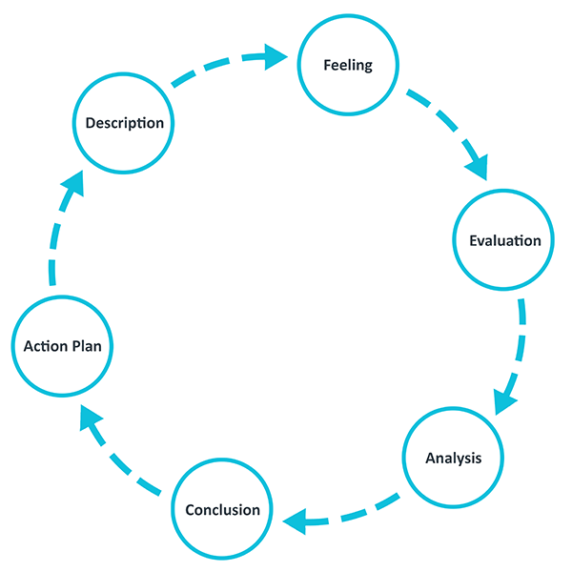
Figure: Gibbs Model of Reflection
(Source: ED, 2020)
Description
The time spent playing the role-playing game was enjoyable. The manager of the company, played by Stefanel Lazar, who also played the part of my interviewer interviewed me in a formal and adequate manner. He probed me with a number of inquiries about my previous employment, my capabilities and my limits, as well as my availability to work on weekends or outside normal business hours. I responded with audacity and made an effort to demonstrate my skills and knowledge.
Feelings
At first, I was a bit nervous since it was my first interview for a position as a Nail Technician and Manager. On the other hand, as the interview progressed, I started to feel more at ease and confident in my answers to the questions. It made me happy that I was able to provide satisfactory responses to all of the questions asked.
Evaluation
I get the impression that the role-playing exercise was successful overall. I feel that I was able to effectively demonstrate both my experience and my abilities since I was able to provide replies that were relevant to all of the questions that were asked of me. On the other hand, given that a few of my responses were quite lengthy, I feel that I should have attempted to be more concise while providing my responses.
Analysis
After giving it some thought, I have come to the conclusion that I performed satisfactorily in the role-playing session. I was able to confidently convey my skills and experiences, and I was able to provide appropriate responses to all of the questions that were posed to me. On the other hand, I should have probably paid more attention to how I carried myself and made an effort to seem more self-assured.
Conclusion
I've come to the conclusion that participating in the role-playing session was, on the whole, a positive experience for me. I feel that I was able to provide satisfactory responses to all of the questions that were asked of me and that I was effective in showcasing both my skills and my experiences. Having said that, I am aware that there is room for improvement in terms of both my communication skills and my body language.
Action Plan
My plan of action is to put in more practise before my next interview so that I can improve my communication abilities as well as my body language. To convey a sense of self-assurance to others, I'm going to work on improving my posture, eye contact, and tone of voice. In addition, I will do mock interviews with myself to hone my responses to common interview questions and improve my capacity to provide concise and efficient replies. In addition, I will do a more in-depth investigation of the company as well as the industry in order to improve my readiness for any questions that may be associated with the position.

Personal development plan
SMART goal setting is an effective method for improving one's life and career. Goals that are clear, measurable, agreed upon, realistic, and have a deadline may help individuals focus their efforts and take action. If you want to stay motivated and make steady progress towards your objectives, whether they are short, intermediate, or long-term, you need a clear plan and direction.
Short-term Goal
Specific | In particular, I want to improve my skills by enrolling in a course at a nail art institute.
Measurable | I plan to do a formal nail art training course in the next three months.
Agreed | I will discuss this target with my manager and request time off to attend the course if he or she agrees.
Realistic | The training programme must be affordable given my current financial situation and my time available away from work.
Time-bound | By the conclusion of the next quarter, this training course will be complete.

Mid-term Goal
Specific | To climb the corporate ladder and become a team leader.
Measurable | I will contribute to the training and mentorship of new workers and achieve high levels of customer satisfaction as evidence of my leadership qualities.
Agreed | I will discuss this aim with my manager and request the opportunity to take part in more leadership training and to take on additional responsibilities.
Realistic | Becoming a team leader is an attainable objective, and I want to get there by honing my skills and gaining relevant work experience.
Time-bound | I plan to devote the next calendar year to making progress on my goal.

Long-term Goal
Specific | In the next five years, I want to launch my own nail care company.
Measurable | I want to establish my own nail salon, therefore I will create a business plan and try to get investors. This is an attainable objective.
Agreed | I will let my loved ones know about my goals for the future and seek their support and advice.
Realistic | I plan to get the proper training, knowledge, and funding before launching my own hair salon after researching the industry and selecting an appropriate location.
Time-bound | I want to open my own nail shop within the next five years.

Self-evaluation Plan
Distinctive leadership style: My style of leadership is collaborative, encouraging of initiative, and focused on outcomes. Getting to know my team members well is crucial to me because it allows me to support them in developing their strengths and addressing their weaknesses (Forbes, 2020). It's also crucial, in my opinion, to inspire team members to step up and find creative solutions to problems on their own. Productivity is important to me, therefore I make it a point to always work towards achieving the company's goals.
Motivating Power: What motivates me to show up for work every day is the opportunity to have a positive impact on the lives of people and the growth of the organisation. The best parts of my job are helping my teammates succeed in their roles and knowing that together we are making a difference. I thrive under pressure and like the challenge of finding new ways to solve old problems.
Explanation of prior experiences: Thanks to my previous roles, I have expertise managing teams in a wide range of settings. My role as sales manager required me to supervise a team of salespeople and ensure they met or exceeded their targets. Providing my team with clear goals and the means to achieve them has motivated them to work together productively. In addition, I worked closely with my colleagues to evaluate their progress and devise strategies for increasing output.
In my previous role as a project manager, I led interdisciplinary teams to make sure projects were finished on time and under budget. By giving my team members clear instructions and helpful resources, I was able to motivate them to perform at their highest potential. In addition, I encouraged an environment where ideas could be freely shared and everyone felt comfortable speaking out when necessary.

SWOT Analysis
SWOT analysis is a helpful tool for development on many levels, including personal and professional development. It's a method for pinpointing internal and external factors that might affect the final result of a project or a person's performance (Forleo and Palmieri, 2019). Businesses and individuals may better concentrate their efforts and accomplish their objectives if they take the time to evaluate their own strengths, weaknesses, and opportunities. A SWOT analysis may be used by an individual or a team to identify opportunities and threats and develop strategies for overcoming them.
Strengths
Employers are looking for candidates that are capable of working effectively with others in a team environment. Open lines of communication are essential to productive cooperation, and demonstrating that I care about the group as a whole by volunteering for different tasks demonstrates that I have such concerns. In today's highly competitive and constantly changing industry, the ability to take up new abilities rapidly is another trait that is highly prized. To keep up with the most recent advances in my field, I need to be prepared to face new difficulties and learn new information. My capacity for organisation and attention to detail will serve me well in managing projects and producing quality work. This is not the least of my many strengths.
Weakness
It is easy to comprehend why procrastination is such a persistent problem for a great number of people. Even if I am skilled at managing my time, I may be even more productive and successful if I avoid procrastinating and instead focus on the things that are most important to me. My unwillingness to say "no" to other people might lead to me taking on more work than I can reasonably do, which would then cause me to feel anxious. Learning to set boundaries for myself and prioritise my own requirements may help me avoid burnout and ensure that I complete my goals without sacrificing my wellbeing or happiness. This is one of the many benefits of developing this skill.
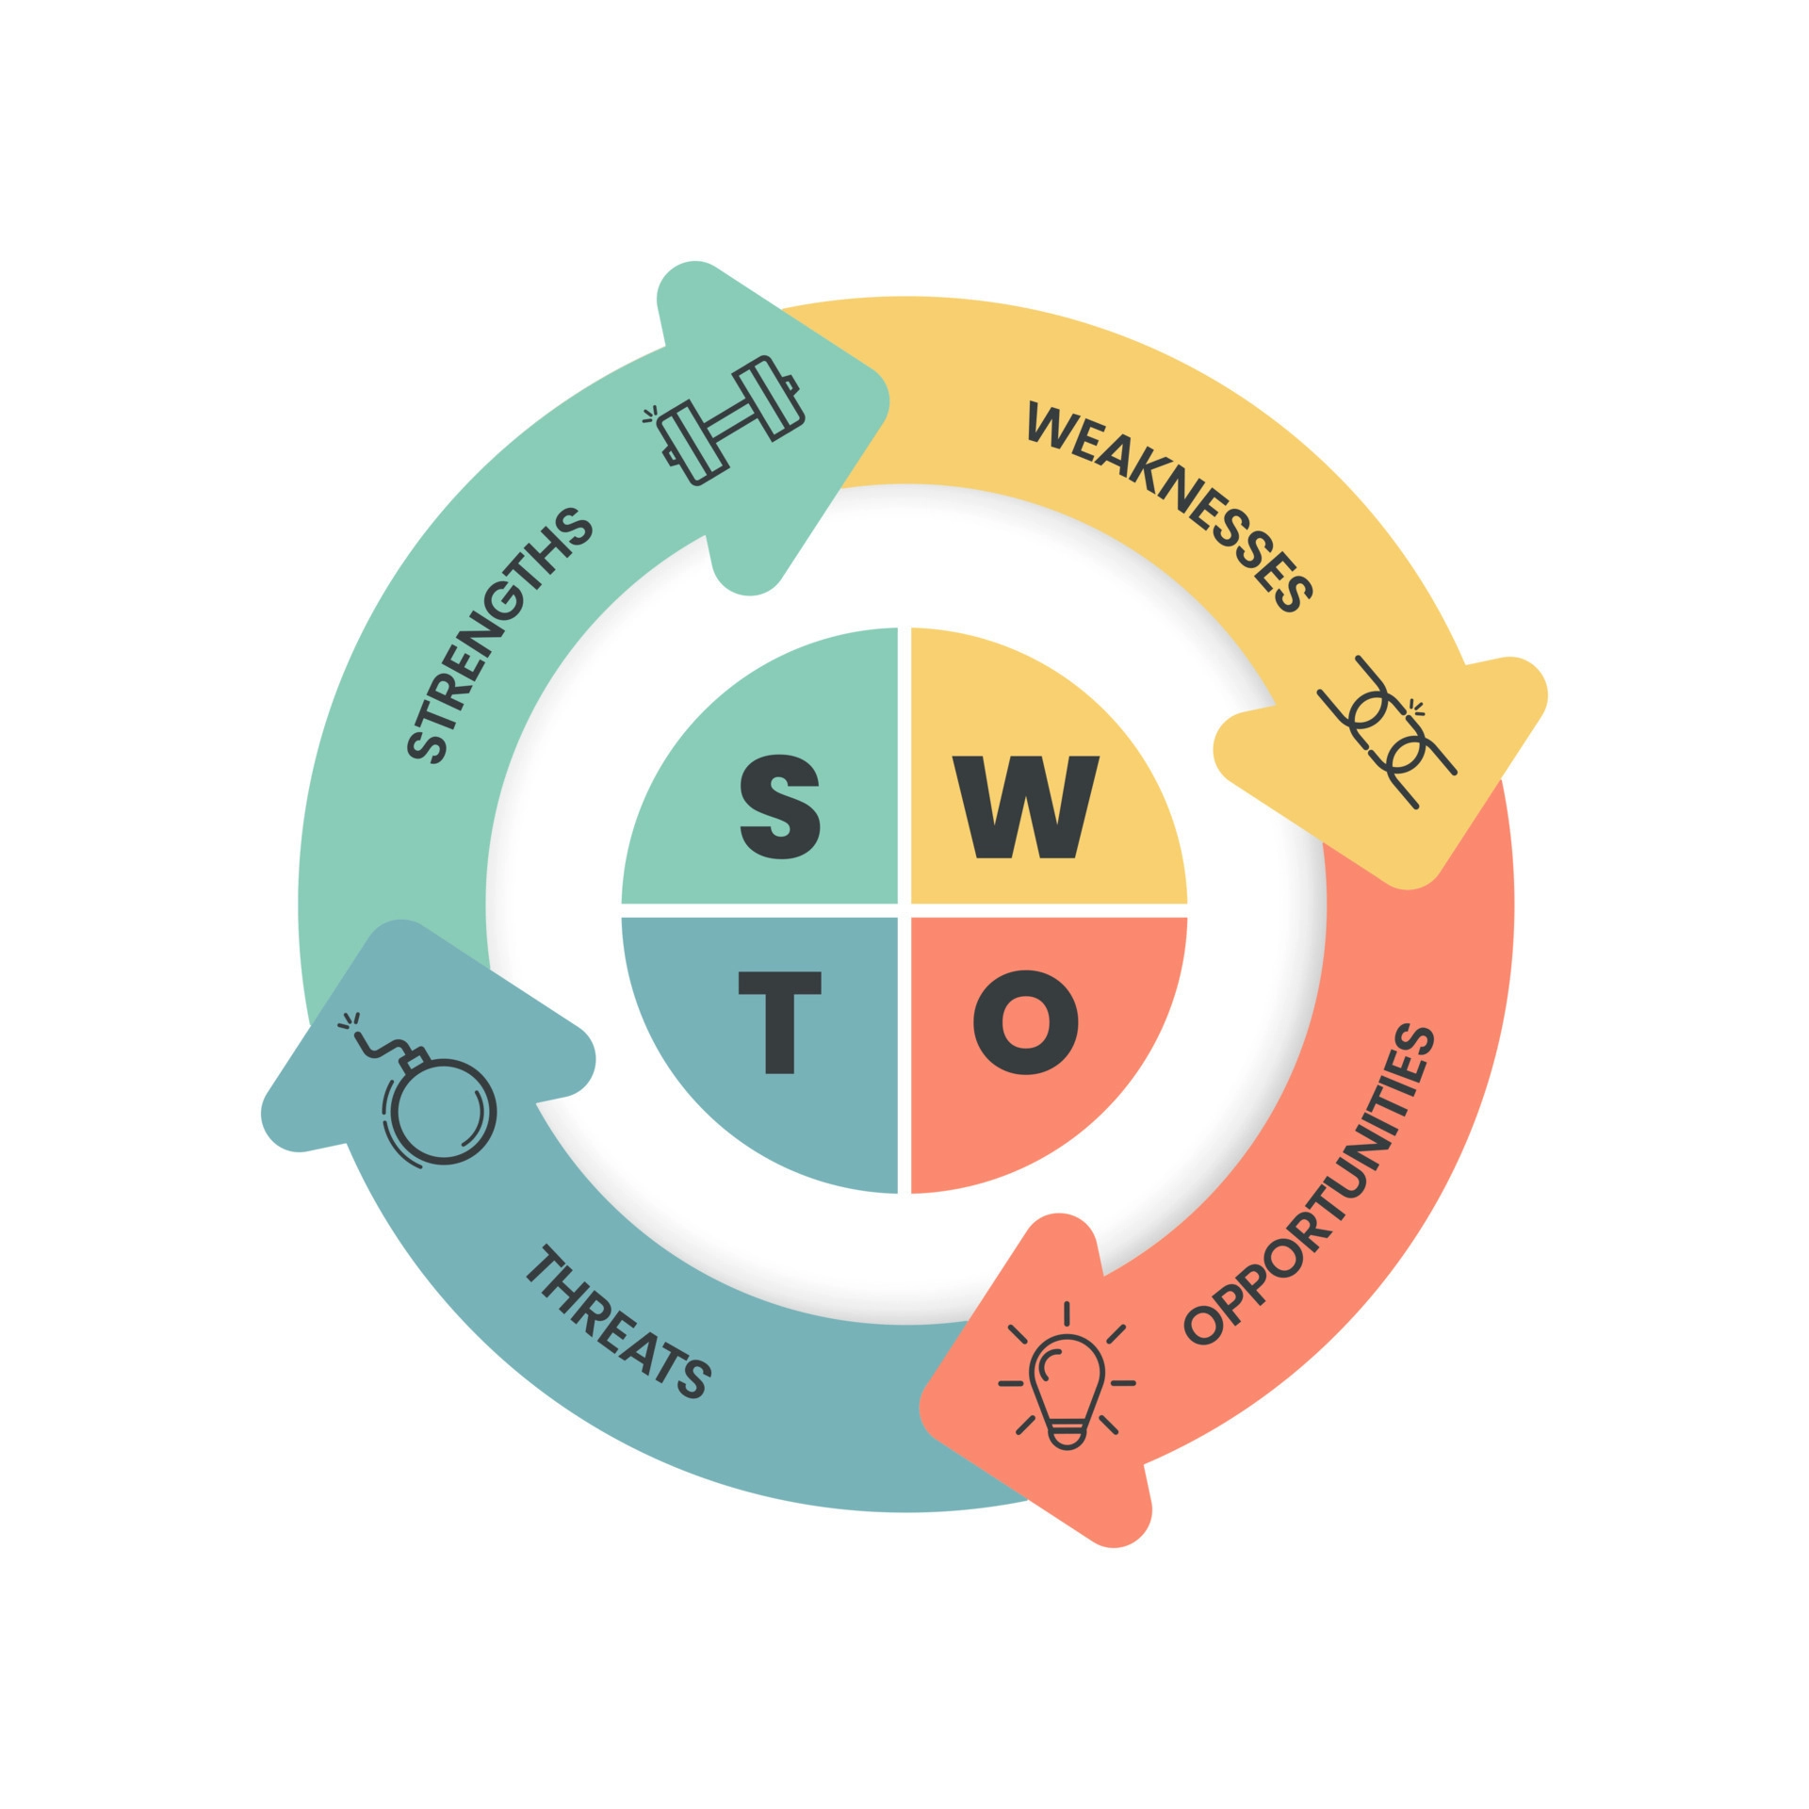
Figure 2: SWOT Analysis
Source: Created by Learner
Opportunities:
It's possible that expanding my knowledge can help my progress in my work and in other aspects of my life. It has the potential to teach me new skills and put me in a position to have greater work chances. Taking on new challenges might help me develop professionally and boost my marketability to both future employers and the employers I now have. In addition, networking gives me the opportunity to meet other experts in my industry, increase the breadth and depth of my expertise, and possibly find new career opportunities. Building relationships is vital for both personal and professional growth since it raises the chance of future collaborations and partnerships. This makes relationship-building important for both.
Threats
Because of technical and automated advancements, many jobs that were formerly considered secure are becoming outdated, which creates a huge risk for many people in today's rapidly changing labour market. Maintaining a high degree of knowledge and being current with the most recent advancements in my industry are two things that are necessary if I want to preserve my competitive edge in today's work market. The threat of intense competition is something that many people must face, particularly those whose careers take them into profitable industries. It is essential to differentiate myself from the competition by highlighting my unique abilities and attributes. Developing a strong personal brand, expanding one's professional network, and continuing one's education are all effective options in this respect.

Action steps
To get rid of my weakness I make some action steps and also a time limit.
Weaknesses | How to deal with the defect | Time Limit
Procrastination: | To begin overcoming my procrastination, I want to set priorities and break down large, daunting tasks into smaller, more doable ones. Furthermore, I will set and stick to firm deadlines for every work. I will also do my best to stay focused and avoid being distracted while I'm working. | 10 - 15 days
Difficulty Saying "No": | Last but not least, I want to work on boosting my confidence and finding methods to differentiate myself from others in my field. In order to establish my own identity, I want to highlight my many strengths. In addition, I'll look for opportunities like seminars and volunteer work where I may gain new skills and information. This will put me ahead of the competition in today's tight job market. | 6- 8 days
Lack of Confidence: | Last but not least, I want to work on boosting my confidence and finding methods to differentiate myself from others in my field. In order to establish my own identity, I want to highlight my many strengths. In addition, I'll look for opportunities like seminars and volunteer work where I may gain new skills and information. This will put me ahead of the competition in today's tight job market. | 7 - 10 days

Conclusion
The ultimate purpose of this research was to use introspection to delve into many aspects of both professional and personal growth. I was able to take stock of my situation, identify my strengths and weaknesses, and plot a course of action with the aid of the SWOT analysis, self-evaluation, and action planning. In addition, I laid up an approach to achieve my development goals and reach my maximum potential. This study's results show the importance of self-reflection for both career and personal development. It has also shown the value of working actively towards one's personal and professional objectives and accepting responsibility for one's own growth. Overall, I've picked up a lot of helpful information from this research that I think might be of benefit to others on their own paths to personal growth and professional success.

Reference
Adeani, I.S., Febriani, R.B. and Syafryadin, S., 2020. USING GIBBS’REFLECTIVE CYCLE IN MAKING REFLECTIONS OF LITERARY ANALYSIS. Indonesian EFL Journal, 6(2), pp.139-148.
ED, 2020, “Gibbs' Reflective Cycle”, Available at https://www.ed.ac.uk/reflection/reflectors-toolkit/reflecting-on-experience/gibbs-reflective-cycle#:~:text=One%20of%20the%20most%20famous,analysis%2C%20conclusion%20and%20action%20plan. [Accessed on 20th April 2023]
Forbes, 2020, “Why Leaders Should Focus On Strengths, Not Weaknesses”, Available at https://www.forbes.com/sites/forbescoachescouncil/2020/02/06/why-leaders-should-focus-on-strengths-not-weaknesses/?sh=468f1ba43d1a [Accessed on 20th April 2023]
Forleo, M.B. and Palmieri, N., 2019. The potential for developing educational farms: A SWOT analysis from a case study. The Journal of Agricultural Education and Extension, 25(5), pp.431-442.
Sekarwinahyu, M., Rustaman, N.Y., Widodo, A. and Riandi, R., 2019, February. Development of problem based learning for online tutorial program in plant development using Gibbs’ reflective cycle and e-portfolio to enhance reflective thinking skills. In Journal of Physics: Conference Series (Vol. 1157, No. 2, p. 022099). IOP Publishing.

Appendix 1
Job application form
Application for [job title] - NAIL TECHNICIAN AND MANAGER POSITION
Your details
Name: LAURA ENE
Education and training
Please give details:

HIGH SCHOOL IN ROMANIA
FOUNDATION YEAR: BUSSINESS AND MANAGEMENT,UNIVERSITY OF WALWS TTRINITY SAINT DAVID

Qualifications
Please give details:

CERTIFICATE OF PARTICIPATION: BASIC SCULPTING GEL THEORY AND PRACTICAL TRAINING
PROFESSIONAL STANDARDS FOR THERAPISTS- GUILD TRAINING INTERNATIONALS-20 NOVEMBER 2022
GEL NAILS- CIA NAILS AND BEAUTY-21 NOVEMBER 2022

Employment history
Your current or most recent employer
Name of employer: ADRIAN MANEA
Job title:SECRETARY
Length of time with employer:8 MONTHS
Reason for leaving: I HAVE A PASSION FOR NAILS
Duties: ADMINISTRATIVE,ORGANIZATIONAL,MANAGERIAL AND MARKETING ACTIVITIES

Previous employers
Please tell us about other jobs you have done and about the skills you used or learned in those jobs.

KFC MANAGER- COMMUNICATION,EMPATHY,FLEXIBILITY,ORGANISATION,RESPONSIBILITY,WORK UNDER PRESSURE AND FAST, A GOOD LEADER,POSITIVITY
SALES ASSISTANT-COMMUNICATION,RESPONSIBILITY,WORK IN STRESSFUL SITUATIONS WITH ANGRY CUSTOMERS
SECRETARY- TO MANAGE THE DOCUMENTS

Supporting statement
Please tell us why you applied for this job and why you think you are the best person for the job.

I applied for this job because it is a passion of mine. I am the best person because I am a hard working,serious,attentive to details , on time for work. I have the skill and capabilities to do well in the position and earn good profit for the company.

Right to work in the UK
Do you need a work permit to work in the UK? No
References
Please give the names and contact details of 2 people who we can ask to give you a reference. We may ask them before an employment offer is made. We will not ask your current employer until we get your permission.
ENE ADRIAN STANCULESCU
ADRIAN MANEA
Declaration
I confirm that to the best of my knowledge the information I have provided on this form is correct and I accept that providing deliberately false information could result in my dismissal.

Name: LAURA ENE
Signature: LAURAE
Date: 15.04.2023

Appendix 2
- How did you hear about this vacancy?
- What would you say your greatest professional strength is?
- How do you feel about working weekends or late hours?
- How do you deal with pressure or stressful situations?
- How quickly do you adapt to new technology?
- Do you have any questions for us?

