
Strategic capapility
Ileana Ciricu-2108842

June 21, 2024
university of wales trinity saint david
Module: Developing Strategic Capability (BMSW6011_SWAN)

Executive Summary
This report has critically analysed Toyota's strategic development over the past five years, focusing on its transition towards electrification, commitment to innovation, and global mobility leadership. Toyota's strategic endeavors, including the ambitious goal to sell 3.5 million electric vehicles (EVs) globally by 2030 and the introduction of new models, underscore its commitment to sustainability and meeting evolving market demands. However, challenges such as its late entry into the EV market, high investment risks, supply chain vulnerabilities, and the need to balance investment in BEVs with traditional models have been identified as areas requiring strategic refinement. The analysis suggests that Toyota's adaptability, strong brand recognition, and innovative capabilities have positioned it as a leader in the automotive industry. To maintain this leadership and navigate future challenges, the report recommends accelerating BEV development, diversifying and enhancing supply chain resilience, investing in digital and autonomous driving technologies, and furthering sustainability initiatives. By adopting these strategies, Toyota can address the identified challenges, capitalise on growth opportunities, and continue to lead in the transition towards a more sustainable, innovative, and customer-centric automotive landscape.
Table of Contents
Executive Summary 1
1.0 Introduction 2
2.0 Findings 2
2.1 Task 1: Introduction 2
2.2 Task 2: Analysis of the Current Strategy 5
2.2.1 Current Strategy of Toyota 5
2.2.2 Impact of External and Internal Influences When Deciding Their Strategy and Drivers 5
2.2.3 The focus of Strategy and Inward and Outward Facing 7
2.2.4 The Type of Strategy and The Direction 8
2.2.5 The Scope of The Strategy and Its Basis 9
2.3 Task 3: Critical Analysis of Advantages and Disadvantages of The Current Strategy 10
2.3.1 Advantages 10
2.3.2 Disadvantages 12
3.0 Task 4: Conclusion 13
4.0 References 13
5.0 Appendices 16
BCG Matrix 16
SWOT 18
PESTLE 18
Porter 5 Forces 21
Stakeholder Analysis 21

1.0 Introduction
The proposed assignment aims to carry out a strategic analysis of the selected organisation, which is Toyota Motor Corporation. The analysis is carried out using different models to measure the external and internal environment of the companies, such as PESTLE, SWOT, BCG Matrix, Porters' five forces analysis, and stakeholder analysis. These models are helpful in assessing internal and external drivers, which have influenced the company to opt for its current strategy, which is the electrification of cars or offering “eco-friendly cars” in the market. According to the findings of the report, the current strategy of Toyota Motor Corporation is oriented towards the supply of environmentally friendly cars and provision of value connected to social infrastructure by attaining zero life cycle CO2 releases from its vehicles to assist in developing a sustainable world, eradicating causalities from traffic accidents, and enhancing transportation efficiency by means of the joint transport of people and things. The main external force which drives this strategic choice of Toyota Corporation is tax advantages. This business-level strategy of electrification, which derives from the competitive advantage of the company to beat market competition, is driven by attaining tax advantages. This strategy has also been driven by another external market force, which says that 42% of Gen-Z (those between the ages of 18 and 25) in Singapore, 35% in the UK, and 30% in the US would choose to purchase an EV in the next few years.

2.0 Findings

2.1 Task 1: Introduction
The proposed assignment aims to carry out a strategic analysis of the selected organisation, which is Toyota Motor Corporation. In 1933, Kiichiro Toyoda, the founder's son, oversaw the division of Toyoda Automatic Loom Works, which was responsible for producing automobiles. This was the beginning of Toyota's history (Toyota Global, 2023). In 1929, Kiichiro Toyoda embarked on a journey to Europe and the United States to explore the automotive industry. He subsequently started studying gasoline-powered engines in 1930. In the 1960s, Toyota started to grow, establishing a new R&D centre, establishing a foothold in Thailand, producing its ten million models, winning the Deming Prize, and forming alliances with Hino Motors and Daihatsu (Toyota Industries Corporation, 2024). Likewise, November 12, 1962, saw the construction of the first Toyota outside of Japan at São Bernardo do Campo, Brazil. Toyota shipped its one million vehicles before the end of the decade, solidifying its global footprint (Toyota Industries Corporation, 2024). The company’s vision is to be the most successful and respected car company globally, and its mission is to attract and attain customers with high-value products and services and the most satisfying ownership experience globally (Toyota Global, 2023).
In the last five years, Toyota Motors has seen major strategic development from expanding its operations to electric vehicles to focus on sustainability and from technological innovation geographical expansion (Kawai, 2022). The company has increased its transition to electric vehicles (EVs) and hybrid models targeted at reducing carbon emissions and greenhouse gas (GHG) emissions from the environment in the last five years. Substantial investments have been made in solid-state battery technology and expanding its EV product line which is comprised of bZ series (Kantar, 2023). Further, in the last five years, the company has strategically started to focus on hydrogen fuel cell technology in its vehicles in order to develop hydrogen-powered vehicle infrastructure. In the last five years, Toyota Motors has also made the digital transformation and smart mobility (Annual Report, 2023). The introduction of Toyota Mobility Foundation and Woven Planet Holdings depicts a dedication and commitment towards autonomous driving, linked cars, and initiatives of smart cities. Collaborations with technology giants have increased the capabilities of Toyota in AI, and robotics as well as software development (Marcus Luc, 2024).

Following these strategic developments, the company has also experienced a significant rise in revenue and profitability. For instance, in FY2023, the company reported revenue of Yen37.5 trillion, which is an increase from Yen31.38 trillion FY2022 figure 1 (Statista, 2023). Similarly, the net profit of the company was Yen 4.94 trillion in FY2023 (Xinhua, 2024).
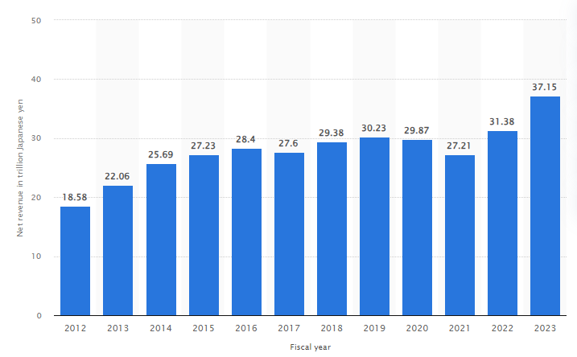
Figure 1 Revenue growth of Toyota. Statista 2023.
In addition, the market share of the company has also remained higher as compared to its rivals. For instance, the market share of Toyota in FY2023 has remained at 12% as compared to 10.9% held by Volkswagen Group (Counterpoint, 2023). On the other hand, General Motors remained the third largest automaker with an 8.4 market share, as depicted in Figure 2 below.
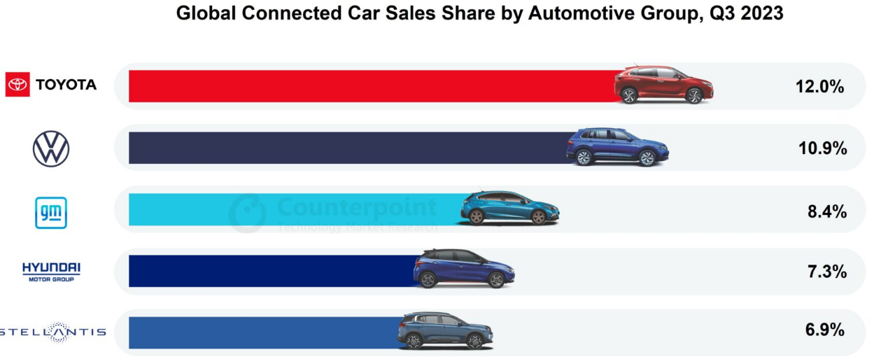
Figure 2 Global Market Share of Toyota 2023. Source: Counterpoint 2023
Likewise, according to Toyota Industries Corporation (2024), the company is owned by several shareholders, which are comprised of Toyota Motor Corporation, a major shareholder with 76,600 shares, and Denso Corporation, the second major shareholder of the company with 29, 647 shareholdings.

2.2 Task 2: Analysis of the Current Strategy

2.2.1 Current Strategy of Toyota
The current strategy of Toyota Motor Corporation is oriented towards the supply of environmentally friendly cars and provision of value connected to social infrastructure by attaining zero life cycle CO2 releases from its vehicles to assist in developing a sustainable world, eradicating causalities from traffic accidents, and enhancing transportation efficiency by means of the joint transport of people and things (Park and Chen, 2022). The company aims to achieve this strategic aim through the “Electrification of Cars,” which is also referred to as “Eco-car Strategy.” The company is discovering all obtainable options in powertrain development. It is under the belief and perspective of Sarangal et al. (2023) that the company can construct a mobility society which is energy efficient by enabling governments and markets to select the cars finest suited to regional energy and infrastructure circumstances and enabling customers to select the cars with the specific characteristics finest suited to their needs such as automated driving, fuel-efficient and contribution towards reducing environmental damages by shifting to electric vehicles and reducing carbon emissions into the environment (Xiao et al., 2021).
For the time being, one doable and very realistic way to contribute to lowering CO2 emissions is to continue developing technologies for conventional engines, which are still widely used. In order to achieve our aim of creating a hydrogen-powered, low-carbon society, Toyota is simultaneously striving to develop and expand the usage of fuel cell vehicles (FCVs), the pinnacle of eco-cars, and pursuing additional projects in collaboration with a variety of partners (Toyota Global, 2023). Another alternative for zero-emission cars, electric vehicles (EVs), are also being developed at a faster pace by the corporation (Counterpoint, 2023). In order to do this, it launched a new firm to carry out collaborative technology development. It formed the EV firm Planning Department in addition to a business and capital partnership with Mazda Motor Corporation (Toyota Industries Corporation, 2024).

2.2.2 Impact of External and Internal Influences When Deciding Their Strategy and Drivers
There are several external market forces and internal drivers that have led the company to opt for current strategic choices such as electrification or supplying eco-friendly cars. The main external force which drives this strategic choice of Toyota Corporation is tax advantages. This business-level strategy of electrification, which derives the competitive advantage of the company to beat market competition, is driven by attaining tax advantages. For instance, according to Park and Chen (2022), most countries support green initiatives for business enterprises and provide them with tax advantages. Similarly, in the case of Toyota, as indicated by the Political factor of PESTLE (Appendix 3), the Japanese government has introduced tax reforms where tax incentives up to JPY1.5b for Digital Transformation and up to JPY5b for Carbon Neutrality are offered to companies EY (2021), it is a positive external force which supported eco-friendly measures of Toyota and offered it tax advantages. It is also aligned with Porter's generic theory of differentiation, where firms are required to differentiate their products in terms of distinct values and advantages, as Toyota has chosen to focus on social and environmental infrastructure in its strategic choices (Xiao et al., 2021). As a result, this strategy has supplied eco-friendly cars in the market with an increased quantity because the reduction in taxes is reflected in the operational expenditures of the company, contributing towards the rise in production. For instance, Toyota has planned to accelerate its production of EVs by 20% by FY026 (NIKKEI Asia, 2023).
This strategy has also been driven by another external market force described in the Social factor of PESTLE (Appendix): the demand for EV vehicles has increased.
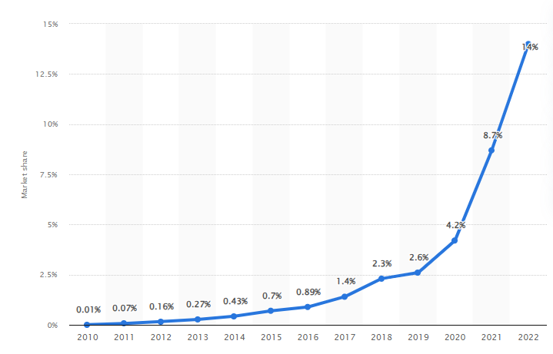
Figure 3 Market Share of Global EV Market. Statista 2023
According to Figure 3, the market share of EVs globally has increased significantly from 8.7% to 14% during FY2020-2022. It is also supported by the external market force, which is a social determinant in PESTLE (Appendix 3), which says that 42% of Gen-Z (those between the ages of 18 and 25) in Singapore, 35% in the UK, and 30% in the US would choose to purchase an EV in next few years (Kantar, 2023). It is also supported by economic factors, another external market force under PESTLE, which indicates that inflation in Japan has been reduced to 2.5%, making electrical energy cheaper source to power electric powered cars. Therefore, the strategy of Toyota to shift to electric vehicles, particularly for developed markets, is highly effective and driven by external market forces. It is because its EVs are serving as star and cash cow products for the company as per the BCG matrix (Appendix 1), whereas Nasuno (2022) also argues that companies are required to invest in cash cow products to generate consistent revenue. The external market forces specified in Porter's five forces analysis (Appendix 4), where the bargaining power of customers and competitive rivalry are high forces due to the increasing demand for EV and hybrid vehicles (Marković and Mijušković, 2022). Hence, shifting electrification and carbon neutrality programs is a highly efficiency strategic choice of Toyota and its Strategic Business Units (SBUs), and products changed their directions as per the changing needs of the target market.

2.2.3 The focus of Strategy and Inward and Outward Facing
The focus of Toyota is to address challenges created by market competition by developing its competitive edge. According to the arguments of Sarangal et al. (2023), the business-level strategy of the company is a creative method that enables a business to highlight its distinctive qualities, strengthen its competitive advantage, and support the cohesive operation of its many divisions to address market competition. Similarly, Toyota follows a strategy which demonstrates strategic drivers which are market driven. For instance, there is rising competition in the electric and hybrid vehicles market following increasing preferences for customers for eco-friendly and electrified vehicles (Tan et al., 2023).
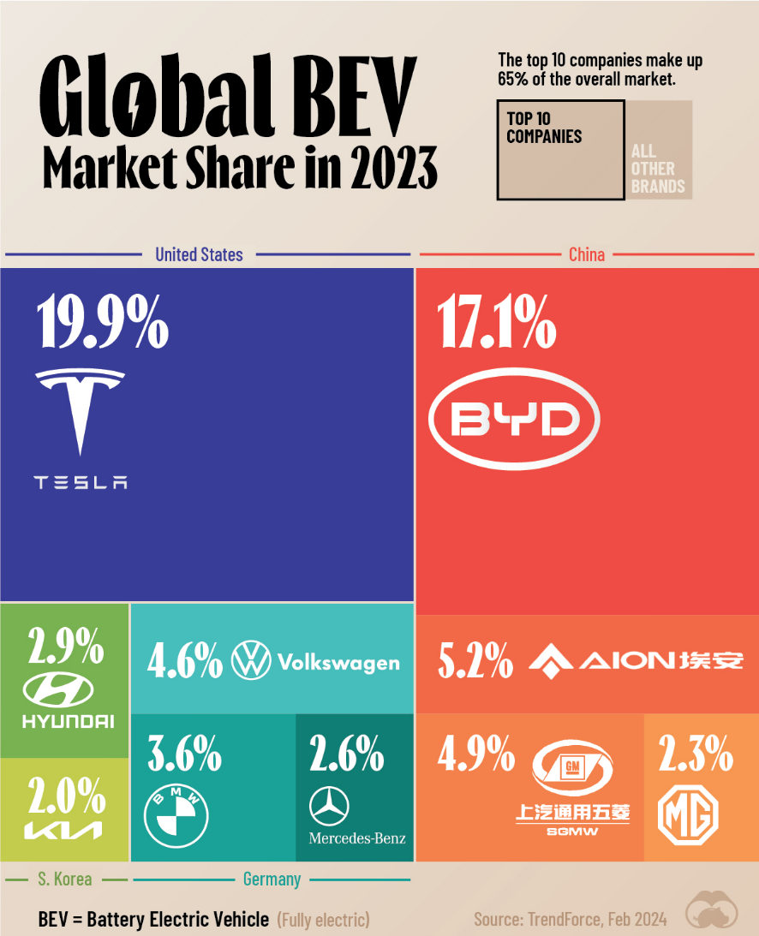
Figure 4 Market Competition in EV Market Sector Marcus Luc 2024
As shown in Figure 4, there is rising competition in the EV market, as Tesla holds a substantial share of 19.9% in the EV market, followed by 17.1% held by BYD (Marcus Luc, 2024). Therefore, Toyota is left behind in the market competition and needs to enter the EV and Hybrid market while holding significant strengths of its already strong brand reputation and global presence (SWOT Analysis, Appendix 2) and opportunities of growing EV market (Opportunities-SWOT, Appendix 2). Therefore, it can be articulated that Toyota’s strategy of electrification and eco-friendly cars is a result of combined outward-facing external market drivers in terms of opportunities for growing market demand for EVs (Zhang, 2020). The second is high-market rivalry for EV (Porter's five forces, Appendix 4) and resources in terms of strengths, which is inward inward-facing driver of this strategic change.
On the other hand, the stakeholders also supported this significant shift of business model to electric and hybrid vehicles. For instance, one of the primary stakeholders of Toyota, Hiroki Nakajima, Executive Vice President, and Chief Technology Officer, with power and high influence (Stakeholder Analysis, Appendix 5), set the future course of automobile production at Toyota (Zero Hedge, 2024). He also proposed a variety of other plans, including emerging technology integration of lithium-ion batteries in cars for better mileage performance. It is aligned with stakeholder theory, which posits that diverse stakeholders are characterized by a range of interests, as each stakeholder has unique expectations, requirements, and values (Annual Report, 2023). Therefore, at Toyota, the finance heads (Stakeholder Analysis, Appendix 5), who are mainly directed towards profitability and financial well-being with higher power and low interest towards EV and hybrid vehicles, welcomed the strategic choice in seek of rising profitability prospects by serving growing market (Statkevych and Shapoval, 2020). This also indicates that the electrification strategy of Toyota to offer EV and hybrid vehicles is a consequence of both inward and outward facing factors, which is efficient as per changing car market dynamics.

2.2.4 The Type of Strategy and The Direction
According to the arguments of Trencher (2020), static business frameworks offer a steady and static structure, which is effective for examining the present state of a business enterprise, comprehending its strengths and weaknesses, and recognising prospects and threats. At the same time, Lee (2021) stipulates that dynamic business frameworks are flexible and change with varying circumstances. They are designed to help companies navigate complexity, uncertainty, and swift change in the business environment. In light of these arguments, it can be articulated that the strategy of electrification and eco-friendly cars adopted by Toyota is dynamic. This is because Mokudai (2020) argues that for companies operating in highly dynamic and ever-changing markets like the automobile sector with continuous technological advancements and facing technological disruption is important to be adaptive and flexible with the capability to complexity and rapid change in the industry.
Similarly, Toyota effectively and immediately recognised the changing market dynamics of the vehicle market, such as preferences and demand for electric and hybrid vehicles as well as driver-less automated cars shown in Figure 5 (Ritchie and Roser, 2024). Therefore, it adopted a dynamic strategy to invest and grow in this developing market.
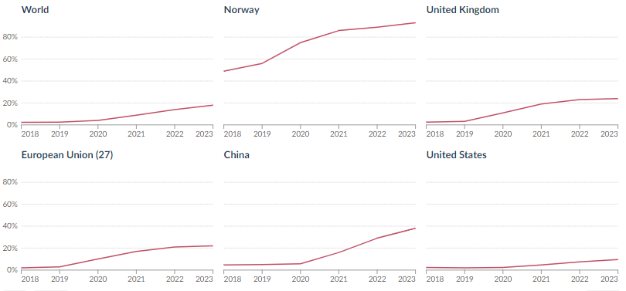
Figure 5 Share of Electric Vehicles and Driver-less Cars 2018-2023 Ritchie and Roser, (2024)
Following these statistics, the company’s strategic direction shifted to growth and investment in the electric vehicle market. Such as the company invested heavily in solid-state batteries which pose a substantial challenge to Tesla (Toyota Industries Corporation, 2024). Tesla produced aggregate revenue and earnings of $96 billion and $15 billion, correspondingly (Toyota Global, 2023). The revenue of Toyota and earnings are almost three times greater at $299 billion and $44 billion (Zero Hedge 2024). It indicates that Toyota’s strategic direction is investment and growth in the EVs and hybrid car market. It is also followed by external influence, where customers are the most important external stakeholders with low power in decision making but high interest (Stakeholder Analysis, Appendix 5) in buying hybrid, electric and automated cars influenced this strategic direction of Toyota.

2.2.5 The Scope of The Strategy and Its Basis
The scope of the electrification and eco-friendly cars strategy adopted by Toyota is focused on a single SBU, which indicates that it has a narrow scope. As the company is more focused towards electrifying consumer vehicles or private vehicles and keeping commercial vehicles such as trucks and cargo vans diesel and petrol-powered, it can be articulated that the scope of the strategy is narrow (Ko, 2023). However, the strategy is long-term, between 5 to 10 years plan, as shown in Figure 6 below.
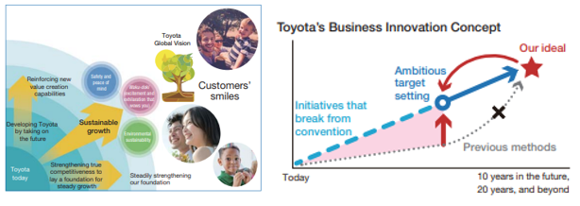
Figure 6 Long-term Strategic Plan of Toyota. Toyota Global, 2023
As per facts shown in Figure 6, aligned with the differentiation strategy of Porter Zhang and Huang (2021), the company is focused towards sustainability growth, that is, zero-carbon or carbon neutrality objectives attainment through supplying eco-friendly electric cars. This ambitious target setting is based on 10 years future, 20 years and beyond. This means that Toyota has a strong strategic focus in the long term (Kawai, 2022). These arguments indicate that the company has robust strategic capability as it is able to derive its strategic shifts corresponding to changes in the external market, and internal drivers influencing strategic change within the company. Lastly, the Strategic Capability of Toyota is also indicated by its efforts to address market competition and challenges of continuous technological advancements by showing its capability to remain adaptive to rapid change in the automobile industry.

2.3 Task 3: Critical Analysis of Advantages and Disadvantages of The Current Strategy

2.3.1 Advantages
The current strategy adopted by Toyota has provided it with substantial advantages in terms of financial, operational, and strategic objectives. Aligned with the arguments of Park and Chen (2022), the strategy of the company focused towards differentiation and targeted at changing needs and preferences of customers must come up with substantial revenue streams and net income generation capability. These arguments are found to be true and evident in the case of Toyota (Xiao et al., 2021). Its electric vehicle segment showed tremendous growth and contributed to an increase in the company’s revenue and net income (Annual Report, 2023).
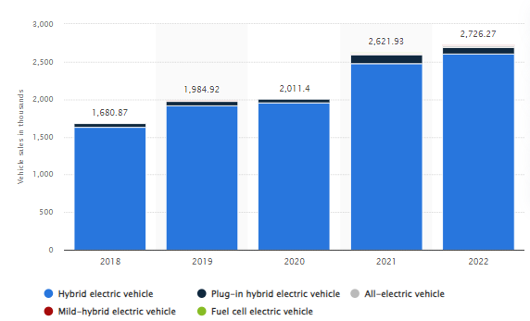
Figure 7 Toyota’s alternative fuel vehicle sales between 2018 and 2022, by segment (in 1,000 units) Statista 2023
The statistics shown in Figure 7 articulate that the company’s sales revenue from alternative-fueled vehicles surged to 2,726.27 in FY2022 from 2,621.93 vehicles sold in FY2021. It has also contributed to a substantial increase in Toyota’s revenue during the last years, as depicted in figure 1 above, where the revenue has increased to Yen37.5 trillion from Yen31.38 trillion FY2022 (figure 1) (Statista 2023). On the other hand, the operating profitability of the company has also increased to Yen2,995,697 million in FY2022 from Yen2,197,748 million in FY2021 (Statista 2023). It shows that entering the EV and hybrid market has been a financially viable strategy for the company.
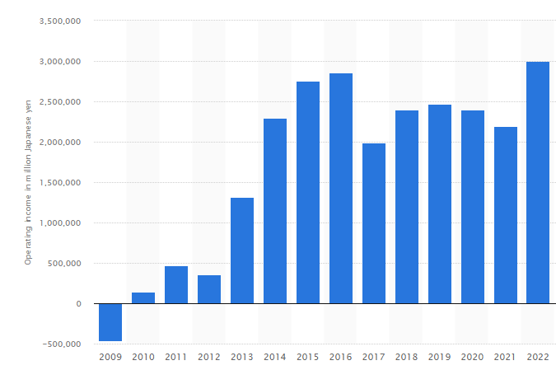
Figure 8 Rise in Operating Profit. Statista 2023
Another advantage received by the companies after following green initiatives and designing eco-friendly products is waste minimisation, thereby achieving cost advantages as companies following these initiatives shift to recycling, reusing, and repairing the 3R concept (Sarangal et al., 2023). Similarly, as a result of its current strategy, Toyota, following its green, sustainable, and eco-friendly measures to supply electric vehicles, opted for waste minimisation programs, which provided its cost advantages (Annual Report, 2023). For instance, after the waste minimisation initiatives following the shift to producing hybrid-electric vehicles (HEV), the company is able to reuse, recycle and use repaired batteries to save costs. As its production cost has declined substantially, and performance in terms of profitability per unit increased, as depicted in Figure 9 below (Annual Report, 2023). It can be observed that production cost is down as compared to producing gasoline traditional vehicles, and profit per unit is increased from producing HEVs compared to traditional gasoline vehicles.
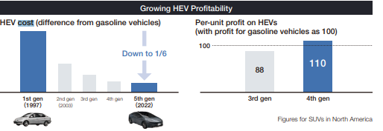
Figure 9 Cost and Profitability of Toyota After Shifting to HEV. Annual Report 2023
These advantages are aligned with the arguments proposed by Nasuno (2022) that opting for waste minimisation and green or sustainable initiatives contributes towards saving operational costs, and the 3R concept leads to reduced supply chain, inventory handling and carrying costs of the companies. These advantages are reflected in the case of Toyota. Moreover, the company also has attained strategic advantages in terms of competitive advantage (Marković and Mijušković, 2022). For instance, low operational cost advantages can be passed on to consumers in terms of low-cost vehicles, which can contribute towards the maximisation of revenue streams of the company. Sarangal et al. (2023) argue that diversified revenue streams or product diversification strategies allow companies to diversify their dependence on multiple product lines so that revenue decline from one segment can be offset by maximized revenue from other product segments, such as HEVs in the case of Toyota Company.

2.3.2 Disadvantages
Apart from several advantages of the electrification strategy achieved by Toyota, it comes with several disadvantages as well, which are discussed in the current section. First, particularly in emerging economies, Toyota is voicing valid concerns over the existing inequitable distribution and insufficient capacity of the infrastructure for charging (Tan et al., 2023). They predict it will take a long time to overcome the obstacle that they feel will prevent broad EV adoption: the availability of dependable and easily accessible charging networks (Lee, 2021). This is a serious issue for EV adoption, in my opinion. Although they are taking the necessary steps to make EVs widely accepted, they still require a suitable infrastructure for charging before they can be used extensively. Hence, this advantage is aligned with the arguments of Zhang and Huang (2021) that in developing markets, automobile companies struggle to boost sales of HEV due to a lack of charging infrastructure. Similarly, Toyota is left behind in introducing HEV in developing markets such as India, Pakistan, and Bangladesh.
Moreover, although there is no denying the success of Toyota's hybrid cars, some contend that the automaker was a little late in adopting completely electric vehicles, with brands like Tesla having already made substantial headway in the EV industry before Toyota started to focus on it. In addition, global economic trends, government regulations, and incentives all have a significant impact on the EV business (Park and Chen, 2022). The diverse regulatory environments seen in different nations present difficulties for strategic planning and standardisation. Thirdly, another advantage is the one-time investment cost of the current strategy. For instance, Xiao et al. (2021) is of the opinion that shifting to the HEV segment, automobile firms manufacturing traditional vehicles are required to invest massive amounts in changing production plants and assembly lines as these cars require to manufacture of several electronic components such as solid-state and lithium-ion batteries which is ad an added investment for the automobile companies initially (Kawai, 2022). Moreover, according to CNBC (2023), the current strategy poses another challenge which is addressing the issue of long-time to charge for solid state batteries installed on HEVs. This disadvantage is also confronted by Toyota in terms of installing heavy and expensive batteries with still limited range, which is an added cost for the company and adds to the disadvantage in terms of increasing product prices for consumers with the probability of compromising on sales revenue targets from HEVs.

3.0 Task 4: Conclusion
From the analysis, critical discussion, and arguments in the above report, it can be summarised that there are certain areas where the strategy of Toyota Motors Corporation is. For instance, at first, the report concludes that aligned with changing market dynamics and preferences of consumers, particularly Generation-Z customers for eco-friendly cars or HEVs, the company has been found to make significant investments in the HEV segment. It is driven by external market forces analysed in the PESTLE model, that due to economic factors, inflation effects can be countered with electric vehicles, which is a cost-friendly option for consumers. Also, aligned with the legal, environmental and attainment of SDGs 2030 specified in the PESTLE model, the company’s eco-friendly cars and HEVs can contribute towards the attainment of these goals. On the other hand, the report also summarises that the company’s electrification strategy is also aligned with today's environment of market competition where other automobile companies are competing by offering technologically equipped HEVs and AI-driven cars. Therefore, Toyota has also aligned its strategy according to this environment, as highlighted in Porter's five forces analysis under the competitive rivalry section.
In addition, today's environment of the automobile sector also demands it become a cost leader in the market, as signified in Porters' five forces analysis, that the bargaining power of customers is high, and consumers have multiple choices to buy cars from. Therefore, waste minimisation strategies and the 3R concept adopted by the company are aligned with cost control measures, which can result in reducing operational costs to offer price-competitive products in the market. Hence, it can be argued that Toyota achieves strategic capability to remain successful in today’s competitive averment and ensures its survival in the automobile sector in the long run.
However, there are certain areas found in terms of disadvantages of the current strategy where Toyota requires improvement in future within its organisation strategy. For instance, it has been found that the company’s vehicles are equipped with solid-state batteries with longer charging time and low mileage. It is a massive hurdle in the successful implementation of the electrification strategy in future. Therefore, the company holds the strategic option to improve its research and development activities to develop and install batteries with shorter charging time with longer mileage, which can enhance the driving experience of the customers. Another strategic option the company holds is to innovate its driving features, such as Tesla has introduced drive-less cars with added convenience. To address this market challenge and market competition, Toyota can also focus on this consumer segment of the automobile industry to ensure its survival automated car segment.

4.0 References
Annual Report 2023. Available at: https://www.annualreports.com/HostedData/AnnualReports/PDF/NYSE_TM_2023.pdf (Accessed: 27 May 2024).
CNBC 2023. Toyota is investing $35 billion into EVs. But some say it may be too late., CNBC. CNBC. Available at: https://www.cnbc.com/2023/01/17/why-toyota-is-battling-criticism-it-has-been-too-slow-to-invest-in-evs.html (Accessed: 28 May 2024).
Counterpoint 2023.Two-thirds of Cars Sold in Q3 2023 Featured Embedded Connectivity Counterpoint. Available at: https://www.counterpointresearch.com/insights/global-connected-car-sales-q3-2023/ (Accessed: 28 May 2024).
EY 2021. Japan’s 2021 Tax Reform introduces tax incentives for carbon neutrality and digital transformation (no date) EY. Available at: https://www.ey.com/en_gl/tax-alerts/japan-s-2021-tax-reform-introduces-tax-incentives-for-carbon-neutrality-and-digital-transformation (Accessed: 28 May 2024).
IEA 2024. Trends in electric cars – Global EV Outlook 2024 – Analysis, IEA. Available at: https://www.iea.org/reports/global-ev-outlook-2024/trends-in-electric-cars (Accessed: 24 May 2024).
Kantar 2023. Understanding Consumer Attitudes Towards Electric Vehicles (no date) Kantar. Shape your brand future. Available at: https://www.kantar.com/inspiration/research-services/understanding-consumer-attitudes-towards-electric-vehicles-pf (Accessed: 24 May 2024).
Kawai, T., 2022. Evaluation of Toyota’s Strategy for Electric Vehicles in Counteracting Platformers—Based on the Theories of Dynamic Managerial Capabilities and Dynamic Platform Strategy—. Journal of Strategic Management Studies, 14(1), pp.67-87.
Ko, W.L., 2023. Case Study on Marketing Strategy Direction in the Electric Vehicle Era: Focusing on the Case of Hyundai Motors Case of Re-entry into the Japanese Market. Global studies, (7), pp.79-95.
Lee, J., 2021. Adaptation strategies of Hyundai motor group to the green shift in automotive industry post Covid-19. In Japanese Business Operations in an Uncertain World (pp. 47-61). Routledge.
Marcus Luc 2024. Visualizing Global Electric Vehicle Sales in 2023, by Market Share. https://www.visualcapitalist.com/visualizing-global-electric-vehicle-sales-in-2023-by-market-share/#google_vignette
Marković, D. and Mijušković, V., 2022. Disruptions and Competitive Strategies in the Automotive Industry. In Transdisciplinarity (pp. 207-227). Cham: Springer International Publishing.
Mokudai, T., 2020. Strategic flexibility in shifting to electrification: a real options reasoning perspective on Toyota and Nissan. International Journal of Automotive Technology and Management, 20(2), pp.137-155.
Nasuno, K., 2022. Progress of Electric Vehicles and Transformation of Supply Chain in the Japanese Automobile Industry. In Frameworks and Cases on Evolutional Supply Chain (pp. 46-67). IGI Global.
NIKKEI Asia 2023. Toyota to make 20% of new vehicles in Europe electric by 2026, Nikkei Asia. Nikkei Asia. Available at: https://asia.nikkei.com/Business/Automobiles/Toyota-to-make-20-of-new-vehicles-in-Europe-electric-by-2026 (Accessed: 24 May 2024).
Park, Y. and Chen, Y., 2022. The R&D Direction and Business Strategy: The case study on the cooperation of EV and battery makers.\
PwC 2023. Japan Corporate - Taxes on corporate income. Available at: https://taxsummaries.pwc.com/japan/corporate/taxes-on-corporate-income (Accessed: 24 May 2024).
Reuters 2024. Japan household spending logs biggest drop in 35 months in January. Available at: https://www.reuters.com/markets/asia/japan-jan-household-spending-logs-biggest-drop-35-months-2024-03-08/ (Accessed: 25 May 2024).
Ritchie, H. and Roser, M. (2024) Tracking global data on electric vehicles, Our World in Data. Available at: https://ourworldindata.org/electric-car-sales (Accessed: 25 May 2024).
Sarangal, R., Kumar, A., Bathla, D., Chauhan, P., Dangwal, A. and Mehta, M., 2023. Strategic Alliance Between Toyota and Suzuki: Is It a Win for Toyota or a Loss for Suzuki?. In Cases on the Resurgence of Emerging Businesses (pp. 206-214). IGI Global.
Statista 2023. Global EV market share, Statista. Available at: https://www.statista.com/statistics/1371599/global-ev-market-share/ (Accessed: 25 May 2024).
Statista 2023. Toyota alternative fuel vehicle sales by segment 2022, Statista. Available at: https://www.statista.com/statistics/1181404/alternative-sales-of-toyota-by-segment/ (Accessed: 25 May 2024).
Statista 2023. Toyota operating income, Statista. Available at: https://internal.statista.com/statistics/279642/operating-income-of-toyota/ (Accessed: 25 May 2024).
Statista 2023. Toyota total net revenue 2023, Statista. Available at: https://www.statista.com/statistics/262752/total-net-revenues-of-toyota/ (Accessed: 24 May 2024).
Statkevych, K. and Shapoval, A., 2020. Development of promotion hybrid technology policy of cars as an social-ethical marketing element.
Tan, K.M., Yong, J.Y., Ramachandaramurthy, V.K., Mansor, M., Teh, J., and Guerrero, J.M., 2023. Factors influencing global transportation electrification: Comparative analysis of electric and internal combustion engine vehicles. Renewable and Sustainable Energy Reviews, 184, p.113582.
Toyota Global 2023. Available at: https://www.toyota-global.com/pages/contents/investors/ir_library/annual/pdf/2017/ar17_2_en.pdf (Accessed: 28 May 2024).
Toyota Industries Corporation 2024. All rights reserved. (no date) Stock Information and Ratings, Stock Information and Ratings | Toyota Industries Corporation. Available at: https://www.toyota-industries.com/investors/stock/index.html (Accessed: 26 May 2024).
Trading Economics 2023. Japan Inflation Rate. Available at: https://tradingeconomics.com/japan/inflation-cpi (Accessed: 25 May 2024).
Trencher, G., 2020. Strategies to accelerate the production and diffusion of fuel cell electric vehicles: Experiences from California. Energy Reports, 6, pp.2503-2519.
Xiao, B., Ruan, J., Yang, W., Walker, P.D. and Zhang, N., 2021. A review of pivotal energy management strategies for extended range electric vehicles. Renewable and Sustainable Energy Reviews, 149, p.111194.
Xinhua 2024. Toyota logs record net profit in fiscal 2023. Xinhua. Available at: https://english.news.cn/20240508/b3b74264823a439998bf746f7b1d4ab6/c.html#:~:text=TOKYO%2C%20May%208%20(Xinhua),demand%20and%20the%20yen’s%20depreciation. (Accessed: 28 May 2024).
Zero Hedge 2024. Why Toyota May Have the Best Strategy in the EV Race (1970) OilPrice.com. Available at: https://oilprice.com/Energy/Energy-General/Why-Toyota-May-Have-the-Best-Strategy-in-the-EV-Race.html (Accessed: 24 May 2024).
Zhang, J. and Huang, J., 2021. Vehicle product-line strategy under government subsidy programs for electric/hybrid vehicles. Transportation Research Part E: Logistics and Transportation Review, 146, p.102221.
Zhang, L., 2020. ARCHITECTURAL INNOVATION STRATEGIES UNDER AUTOMOTIVE ELECTRIFICATION TREND Case Study of Chinese New Entrants Automaker (Doctoral dissertation, Waseda University).

5.0 Appendices

BCG Matrix
Category | Products/Segments | Characteristics | Strategy
Stars | Hybrid Vehicles (e.g., Toyota Prius) | High market growth, high market share | Invest heavily to maintain and grow the market position
Stars | Electric Vehicles (e.g., Toyota bZ4X) | High market growth, increasing market share | Continue R&D and marketing efforts to capitalise on growth
Cash Cows | Toyota Corolla | Low market growth, high market share | Maximise profit and maintain market position with minimal investment
Cash Cows | Toyota Camry | Low market growth, high market share | Sustain profitability and leverage the established reputation
Question Marks | Hydrogen Fuel Cell Vehicles (e.g., Toyota Mirai) | High market growth, low market share | Invest selectively to increase market share and develop infrastructure
Question Marks | Compact SUVs in emerging markets | High market growth, uncertain market share | Evaluate the potential for growth, invest based on market response
Dogs | Traditional ICE Models (some models) | Low market growth, low market share | Divest or reposition to minimise losses
Dogs | Certain niche or older models | Declining sales, low profitability | Phase out or reallocate resources to more promising segments

SWOT
Strengths | Weaknesses
Strong brand reputation and global presence | Slow adaptation to rapid EV market changes in comparison to competitors
Leadership in hybrid technology | Recalls affecting brand image and financial costs
Robust financial performance and substantial R&D investment | Dependence on traditional markets with slower growth rates
Extensive and efficient manufacturing capabilities | Higher production costs in some regions
Opportunities | Threats
Expanding electric vehicle (EV) market | Intense competition from both traditional and new automakers
Growth in emerging markets | Regulatory changes and stringent emission norms
Development of autonomous driving technology | Economic fluctuations and supply chain disruptions
Strategic partnerships and collaborations | Rapid technological advancements requiring continuous adaptation

PESTLE
Political | The political factors include government policies such as taxation regulations or political relationships with other countries, which affect the company's operations or its financial stability (Park and Chen, 2022).  For instance, the corporate tax rate in Japan has remained stable at 23.2% in FY2023-2024, which does not affect Toyota’s profitability (PwC, 2023).  Tax relief by the Japanese government for green measures, like JPY5b for Carbon Neutrality (EY, 2021).  Political unrest or significant sales in nations such as Bangladesh and Pakistan, where Toyota has manufacturing plants, cause business interruptions (Zhang, 2020). This covers the possibility of political upheaval, civil unrest, and other disturbances that have an impact on Toyota's production, supply chain, or sales procedures (Trencher, 2020).
Economic | Economic factors are comprised of inflation, exchange rate and consumer consumption patterns or buying power that affect a company’s long-term growth and sales revenue (Sarangal et al., 2023).  According to the report of Trading Economics (2024), the inflation rate in Japan has been reduced to 2.5% in 2024 as compared to 2.8% in FY2023. This indicates that the Toyota company is expected to face a decline in production and operational costs, particularly in terms of overhead expenditures. Therefore, this factor is favourable for the company in terms of reduced operational expenditures and can lead to surplus funds and increased cash availability for business expansion, and research and development projects.  Further, there is one unfavourable factor which can negatively affect Toyota company is a decline in consumer spending. For instance, the report of Reuters (2024) signifies that in Japan, household expenditure fell 6.3% in January compared to the same month last year, marking the 11th consecutive month of declines. That was the largest decrease since February 2021 and was worse than the consensus market estimate of a 4.3% decline. It indicates that Toyota can further experience a decline in sales in the Japan region because the decline in consumer spending reflects the declined spending power of the consumers (Kawai, 2022).
Social | Social factors are comprised of changes in consumer preferences or shifts in consumers’ tastes, which require companies to invest in products and services targeting the changing needs and wants of the consumers (Ko, 2023).  Globally, about fourteen million new electric vehicles were registered in 2023, increasing the total number of vehicles on the road to forty million. This figure roughly matched the sales projection from the Global EV Outlook 2023 (GEVO-2023).  Younger people, both those who now own cars and those who do not, are more inclined to think about purchasing an EV. Singapore, the US, and the UK all clearly show this pattern. For example, 42% of Gen-Z (those between the ages of 18 and 25) in Singapore, 35% in the UK, and 30% in the US would choose to purchase an EV (Kantar, 2023).  This is due to the fact that more millennial customers prefer fuel-efficient and environmentally friendly cars. Therefore, it is also a favourable external factor for Toyota as it has already entered the EV market Tan et al., (2023) and can expect rising demand in future for its EV segment, particularly in developed nations.
Technological | Toyota has the chance to sell certain of its items, such as replacement parts and accessories, online by enhancing its e-commerce skills or by taking advantage of outside e-commerce service providers (Xiao et al., 2021). The firm has the chance to improve its mobile applications and associated services to boost customer engagement and loyalty, which can improve the brand's reputation and raise the possibility of auto sales (Nasuno, 2022).
Environmental | Toyota has the chance to provide more environmentally friendly products, including electrified or more fuel-efficient vehicles. Ecological issues are addressed in the corporate social responsibility (CSR) and ESG strategy of Toyota for sustainability and associated goals (Marković and Mijušković, 2022). This tactic gives the business a chance to strengthen the perception of its brand while raising the bar for its cars (Zhang, 2020).
Legal | There are rising concerns and legal implications for environmental protection, such as the Sustainable Development Goals 2030 (Park and Chen, 2022). In this regard, The Toyota Environmental Challenge 2050 is comprised of minimising and optimising water usage, creating a society and systems based on recycling, and creating zero CO2 emissions from life cycles, new vehicles, and plants (IEA, 2024).

Porter 5 Forces
Force | Analysis
1. Competitive Rivalry | High: The automotive industry is highly competitive, with numerous global players like Volkswagen, GM, and Ford. Toyota faces intense competition in both traditional and EV markets (Zero Hedge, 2024).
2. Threat of New Entrants | Moderate: The automotive industry has high entry barriers due to the significant capital investment required for manufacturing, R&D, and establishing a brand (Ritchie and Roser, 2024). However, new entrants like Tesla and other start-ups are increasing competition, especially in the EV sector (Toyota Industries Corporation, 2024).
3. Bargaining Power of Suppliers | Low to Moderate: Toyota has a vast and diversified supply chain, reducing supplier power. However, the reliance on specific high-tech components such as semiconductors can increase supplier influence, particularly in times of shortages (Kawai, 2022).
4. Bargaining Power of Buyers | High: Consumers have numerous choices and can easily switch brands, giving them significant bargaining power (Mokudai, 2020). In addition, the availability of information online empowers buyers to make informed decisions, further increasing their power (Kantar, 2023).
5. Threat of Substitutes | Moderate to High: The threat of substitutes is increasing with the rise of alternative transportation modes such as ride-sharing services such as Uber and Lyft, public transportation improvements, and the growing popularity of EVs and hybrid vehicles from other manufacturers (Xinhua, 2024).

Stakeholder Analysis
 | High influence | Low influence
Low power | Customers | Suppliers, employees
High Power | Executive Vice President and Chief Technology Officer | Finance head

