Deborah O’Sullivan: 2112757

Introducing a new digital solution into secondary care to coincide with the Nurse Staffing Levels (Wales) Act 2016.

Introduction

The Welsh Government introduced the Nurse Staffing Levels (Wales) Act 2016, to ensure there are enough nurses available to provide care to patients across all secondary care settings in Wales. Hospitals across Wales will now have to show the mitigation processes to ensure there are adequate nurses in each clinical area (Welsh Government, 2021). The annual NHS quality reports from health boards must include how they are improving their workforce numbers and skills (RCN, 2022). This report will evaluate how a digital solution can improve the management of nurse staffing and ensure the provision adequate staffing levels within the health board.

Background

Studies have shown that there is a direct link between the level of registered nurses and the rate of patient mortality (Sloane et al, 2018), and inadequate staffing levels can also lead to patients’ poor experience of care (International Council of Nurses, 2009). Another study by Musy et al (2021) looked at the various shift patterns nurses were working alongside the acuity of the patients on the ward. The longitudinal study showed that a higher patient turnover alongside increased patient to registered nursing levels, also has a link to increased mortality. McHugh et al (2021) studied nurse staffing levels following a safer staffing policy introduced in Australia, and results showed that there was an increase in nurse staffing levels in hospitals where the policy was mandated.

The Welsh levels of care tool is an all-Wales tool designed to determine the acuity for each patient and the level of nursing care they need. It is scored from one to five, with five meaning the patient needs one to one nursing care, and a score of one means the patient needs routine care (NHS Wales, 2017). Each clinical area is required to audit the patients’ acuity using the Welsh levels of care tool at the same time each day for two months of the year. The score is entered into the Welsh Health and Care Monitoring standards (HCMS) system, an all- Wales repository, and this data is extracted by the health board into a Power-BI app to show data as a dashboard.

The way in which data is collected for patient acuity at present involves scoring the patients’ acuity on paper, and then entering this onto the HCMS once at a desktop computer. Once entered onto the system, it is not easily accessible for viewing by the ward staff.

The staffing rota is available within the e-rostering system in use across the health boards but is not available for all staff to view due to the lack of devices, so a paper copy of the ward rota and daily staff allocation is usually kept where all staff can view it throughout the day and make changes. This means there are two versions of the information.

The biggest issue currently regarding staffing is the process around the allocation of staff to wards that are short, especially at short notice. Wards can request through the temporary staffing department for shifts to be covered ahead of time. However, this department is not linked in with clinical areas and if the acuity of the patients on the ward changes and there is a need to increase the staffing at short notice, this is often passed onto the senior nurse on call to manage.

A digital solution is needed to assist with the management of staffing within the wards. It should provide real time data which can be visible to all as required.
Although a digital tool would allow transparency of staff levels in each area, it would not directly address the nurse staffing act requirements. The job of the health board would be to utilise the technology to show how they are mitigating the risks of staffing levels in line with the Nurse staffing (Wales) Act. The Welsh Government summary report in 2021 on the Welsh health boards’ mitigation into the staffing act highlighted that there are inconsistencies across Wales regarding the use of e-rostering systems and unreliable reporting of staffing data, (Welsh Government, 2021).

Methods

A process of how ward staff currently manage the staffing flow was mapped, and shows the current interventions carried out. Figure 1 highlights the need for change to improve the staffing management.

Figure 1. Process map
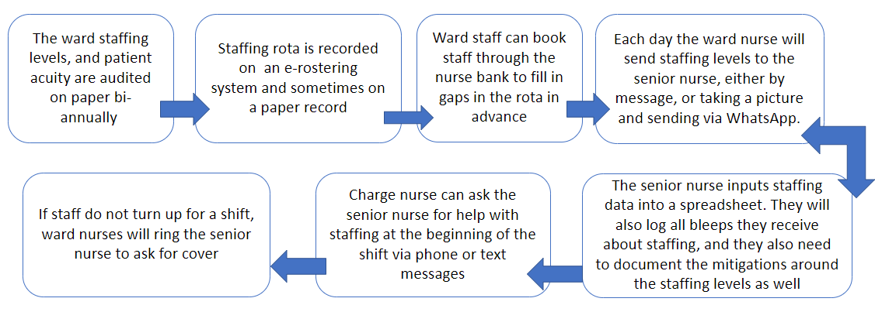

Although this process map shows some of the tasks involved, there are other factors which have an impact on staffing.
- Staffing numbers may change throughout a shift, for example due to sickness.
- The current process takes up a lot of time for ward nurses to organise staffing. At times, the problem solving can take the nurse away from the patient care.
- If staff members do not turn up for a shift or there are gaps in the rota, it can leave the ward unsafe until the issue is resolved.
- Asking staff to move to another ward at the start of their shift may lead to anxiety and low morale amongst the nursing team.
- The acuity of the patients can change during a shift which may affect the level of nursing care needed.
- Using a messaging system for all ward team leaders to communicate their staffing issues is not sustainable, and the messages are harder to triage from a long list.
- Ward staff also attend bed management meetings most days in person, and this takes them away from patient care.
- The recording of the shift bleeps each day by the senior nursing team is shared with the directors of nursing.

Various stakeholders within the nursing team were interviewed and asked what they would like from a digital tool to assist them managing staffing levels in their area. User stories followed from this, and the responses are as below:

- “As a ward nurse, I want to be able to use the Welsh levels of care to score my patients’ acuity and input this into the system so it’s visible straight away. I want to be able to write notes as I audit. If I am the nurse in charge, I want to be able to amend the staffing numbers for that shift to reflect any changes.”

- “As a ward manager, I want to view the acuity of all the patients on my ward and view the staffing levels for the remainder of the day, week or month at the click of a button. I want to be able to manage the staffing levels throughout the shift to reflect any changes. I want to be able to clearly see any gaps in staffing for shifts which need filling. I want to view historical data also.”

- “As a senior nurse, I want to be able to view the staffing levels and patient acuity on each of the wards in my area. I want to have a clear visual picture of where there are gaps in the staffing levels. I want to view all the data as a graph or dashboard.”

- “As a directorate manager, I want a full view of the staffing levels in each of the clinical areas in my clinical board for inspections, to help with investigations and complaints, and to see trends in patient acuity and staffing levels. I want the system to assist me with generating reports.”

A gap analysis of the process currently used by staff and the health board to manage staffing was undertaken, and from this, along with the user stories, an options appraisal and functional requirements were collated.

Results

Gap analysis

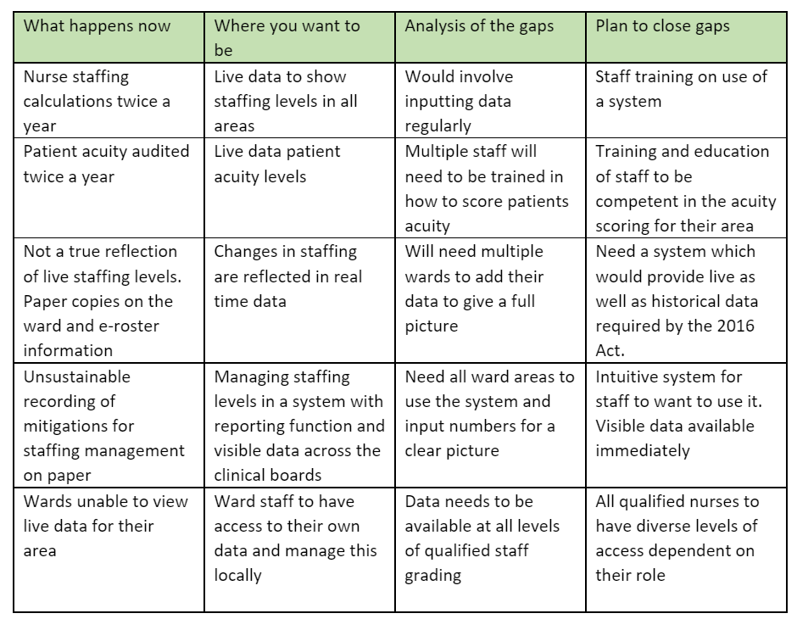

The gap analysis shows there needs to be a more efficient way of communicating with the departments regarding staffing. There is duplication of information, and a lot of time is spent on staff using the phone to organise and communicate to the senior staff.

There is no transparent way to view the overall staffing levels at any one time. Entering data onto a spreadsheet is time consuming and the entries from each shift are only shared with the directorate leads. A digital tool which allows visibility of staffing levels would lead to more efficiency in managing it. The acuity levels are not currently audited regularly so ward staff are having to communicate this in person.
If the system were to have interoperability with the temporary staffing booking and e-rostering system, it could help to reduce the number of shifts which are being put out to agencies, and therefore save money.

The system needs to make it easy for the health board to report how it mitigates the risks of lower staffing levels. A new system should also allow transparency and auditing of decision making.

Table 1 shows the requirements for a new system following the gap analysis.

Table 1.

Functional and non-functional requirements

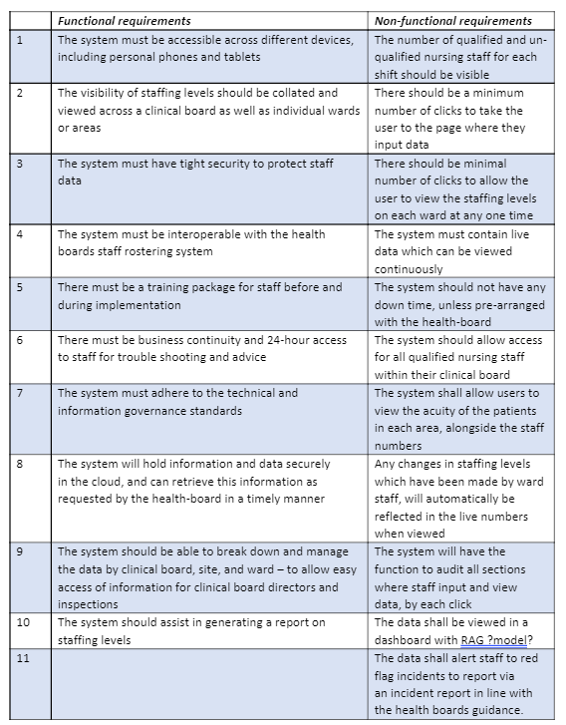

There is a risk that requirements from an off the shelf product may not be included in a commercial system and therefore the requirements should not be too detailed (Somerville, 2016, p.106). There will be a large number of users who would need to utilise the system so the system must also be intuitive to use. The health board may also want to write its own policy for using the system and when staff should be alerted to report incidents based on the data.

A risk log was included to highlight obvious risks; however, this log would need to be expanded once the finer details of the project are drawn out.

Table 2.

Risk log

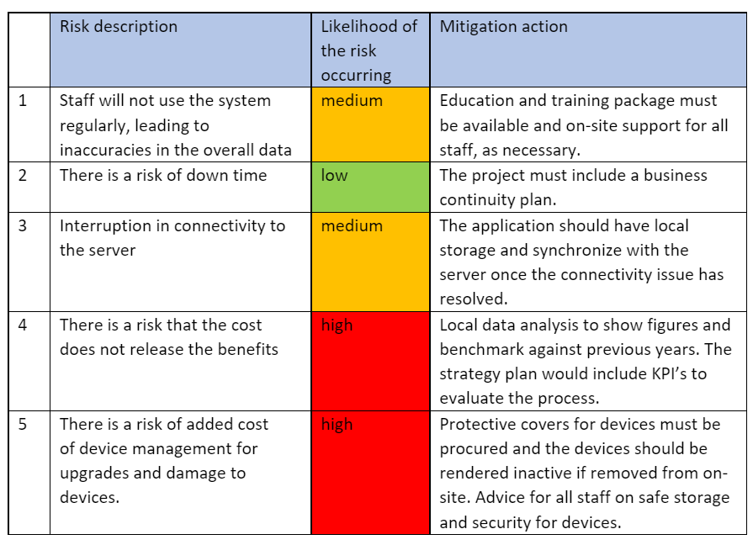

Options Appraisal

Option 1- Carry on as usual

- Currently, the staff on the wards and the nurse management team are spending a lot of time on chasing up staffing levels and the system in place is not sustainable. With new legislation on safe staffing, there is now more pressure to manage the information regarding the staffing levels and the acuity and reporting all mitigations.
- The data cannot be widely viewed by all, and it is not accessible to all nursing staff.
- The paper records can get lost, and information is duplicated.

Option 2- Build an API between the e-roster system and the HCMS.

- The acuity of patients could be viewed on the HCMS if an API was built, and there would be available staffing levels to view as needed on the e-rostering system. This would require role-based access control (RBAC) for staff, and this would need monitoring and governance over the data.
- The e-rostering system is an off the shelf product, and the HCMS is an all-Wales system. it may be difficult to build an API which would integrate the data.

Option 3- Buy an off the shelf product

- An off the shelf system would need to hold data on staffing levels, patient acuity and allow staff to view live data.
- It could be personalised to include the functionalities required by the 2016 Act.
- It may be quicker to implement once purchased if it is already a substantial product.
- Interoperability with the e-rostering system is required and it would need to be rolled out across all secondary care areas.

Data collection and analysis-

Any technology solution would need to hold data for the staffing levels on each ward and the patients’ acuity. The results should be viewed as a dashboard, chart or graph to make it easier for staff to understand their own data. Currently, the Welsh levels of care tool is colour coded so it would be ideal if the results matched this to make it easier to interpret at a quick glance. All information put into the system would need to be securely stored and instantly retrievable.

The data analytics team within the health board can also extract data for the health board depending on the need of the organisation. This can be fed back at a higher level and can be used to spot trends and align the information against serious incidents or complaints.

Knowledge management-

The organisation can share the reports generated from the data to benchmark against previous months or years, or against other health boards. The health board can use this data for the three – yearly staffing report for the Welsh Government. Using the trends of staffing alongside patient acuity can assist with the business case for more nurses if there is evidence to show a ward needs to increase their staffing levels.

Technical standards-

Cyber security is a big challenge in large organisations. The health board has an obligation to safeguard the data within its digital systems and protect them against cyber-attacks and data breaches or identity theft (Rachh, 2021). The system must be able to provide adequate security to protect staff data. An increase in interoperability within systems can expose organisations to new cybersecurity risks (Coventry and Branley, (2018). Using an interoperability standards framework such as HL7 FHIR (fast healthcare interoperability resources) data can be shared in a consistent manner between health boards and national data repositories (Digital Health.Wales, 2020). Access to various functions of the system should be dependent on staff roles.

Terminology within the system should be standardised across the health board, and if the system is provided by a commercial supplier, it should be standardised across the NHS. Wording used within the system should be familiar and must be intuitive to use.

A digital solution which can offer all the functionality and technological requirements would be difficult to build within the organisation. The development of an API would allow interoperability between systems, but it would not change the system itself. The HCMS is “clunky” and can be slow to load on a desktop. An off the shelf product which can meet the requirements of the organisation would be a better option for this task.

Evaluating outcomes-

Although the quantity of data is easy to measure, the quality is not. Scoring a patients’ acuity is subjective and can be biased. Two different areas with similar patients may have different acuity levels depending on the nurses who are using the tool to score them. The technology cannot change this, and this data would need to be scrutinised by the nurses within the clinical board to review the trends in acuity levels at a local level to troubleshoot.
Measuring the staffing levels in each area would be dependent on all ward areas utilising the system to get a clear picture across each clinical board.
The process of entering staffing levels and patient acuity can be measured within the system. At present, the management of staffing does take up a lot of time, but to measure this is difficult. An audit of the number of bleeps a senior nurse receives could be carried out using technology, but measuring the time taken to answer calls would be harder to monitor. Another audit could be carried out post implementation to see if there is a reduction in the number of calls regarding staffing. Ward nurses should see a reduction in the time spent managing staffing if they are using the new system regularly.

Lilford et al’s (2010) interpretation of the Donabedian causal chain, shows that each change in the process can lead to changes in the outcome. In this case, ward staff having the ability to view the levels of staffing and patient acuity in their area at any time, can influence the outcome of the management of their staffing levels. Additionally, the senior nurse on shift can quickly see which areas need extra staff, and which areas may be able to move staff to another ward. It would also change the outcome of the time spent for nursing staff making phone calls and being away from the patients’ bedside.

A new process map shows the changes in which nurses would manage staffing post implementation of the new staffing system
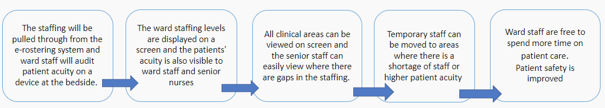
The new process chain is shorter as there are less steps to take with digital intervention. Although the outcome looks as though it has changed, this process chain does not include the time that staff will be auditing and inputting data into the system. This variable action may have an impact on the process, but interventions such as staff training and support may increase productivity and user experience.

The technology should not make the service intervention worse but may act as a substitute for the system already in place (Coiera, 2019). Providing a tool for which data is held in one place for many users to utilise does not immediately affect the outcome of nurse staffing, but it would assist in the decision making around providing safer staffing, leading to safer care. The information provided by the technology will need to be actionable however, for this to improve the service.

Discussion

A project board would be set up to ensure the smooth planning of the procurement, installation and implementation of the new system. An appointed project manager would lead on this.
If the system is procured, it would need to go through the procurement process, which would involve the health board sending its requirements out to tender. The procurement team within the health board would be responsible for ensuring all the necessary documents and forms have been completed and will lease with the project board on the progress. Companies will respond to the requirements and their responses will be scored with a weighting to decide which is the more suitable product. The health board would need to negotiate with the companies to ensure all their requirements will be met, including how they can extract their data if the system is own by a third party.
The project board would need to include stakeholders and regularly engage with users.

Once the system has been procured, the project board should ensure there is a plan to roll out the implementation across the health board. Due to the nature of the requirements, it would have a bigger impact if the hospital went live at the same time. If only one ward were using the system, or multiple wards within a clinical board spread across multiple sites, it would not provide the whole picture of staffing levels at any one time. It would be easier for directorate managers to view if all wards in their area were live.

For the project to be spread and scaled it could be expanded to areas not currently covered by the act such as mental health and community settings but could also benefit from having the electronic staffing system. This scaling would need to be added to the risk log and would increase the cost, but the staffing act is soon to be extended to cover these areas also.
There must be sufficient devices for each area, and staff must train to use them. Nurses would also need training on the safe staffing act and on scoring the patients acuity levels too. Staff should feel well supported to be confident to make relevant decisions about scoring them and then alerted to “red flags” to prompt them to escalate and fill in an incident form when needed. Due to the change in culture in nursing which this innovative technology would bring, there is a risk that staff will not use the system and may carry on managing their staffing the way they do now, and the project may fail. Having key stakeholders on board and willing to invest in the new system is key to its success (Greenhalgh et al, 2018). Nursing staff must feel supported enough to want to use the technology, and at the start of implementation the use of “floor walkers” to assist with face-to-face training would be a benefit to nursing staff. Due to the nature of their shift patterns, most staff would be unable to leave the ward for training and may not want to if asked to do this in their own time. Part of educating staff could involve showing the benefits of what the system can do and how it will have a positive outcome for them.

Key performance indicators can show how often the system is being used, what grade of staff are using it, and how often a certain ward is putting in data. With raw data available to view clinical boards can use this to pinpoint any wards where there is slow uptake or limited data. The health board can bench mark the new figures against historical data and staffing reports. They system may also assist with reporting on whether savings have been made on agency bookings since the start of the roll out. The KPIs can be set and reviewed monthly, or weekly depending on what they are.

The project is an iterative process and could be scaled up to include more clinical areas such as paediatrics and mental health wards as well as the community. The RCN in Wales is campaigning for the act to be extended to wider areas and the Welsh health boards all support this (RCN Wales, 2022). The system would encourage compliance with the maintenance of the staffing levels due to the transparency of information available.

In the future, it may be possible for the system to have interoperability with the patient flow system already in place in the health board. This would mean that operational staff could have a picture of the bed status, patient acuity and staffing levels across each ward and site. This would improve operational decision making on closing wards if deemed unsafe to leave open due to staffing or moving staff to other areas. There would be evidence available for the nursing management team to be able to make that decision and reasoning to back it up. The system should improve the amount of time ward managers and nurses spend on managing their staff and allow the manager to have supernumerary status on the ward which the RCN recommends. The health board could also publicly publish their nurse staffing levels.

References

Coventry, L. and Branley, D. (2018) ‘Cybersecurity in healthcare: A narrative review of trends, threats and ways forward’, Maturitas, 113, pp. 48-52.

Digital Health.Wales (2020) FHIR for interoperability in Wales.
Available at: https://digitalhealth.wales/news/fhir-interoperability-wales (Accessed: 15 May 2022).

Greenhalgh, T., Wherton, J., Papoutsi, C., Lynch, J., Hughes, G., A’Court, C., Hinder, S., Procter, R. and Shaw, S. (2018), ‘Analysing the role of complexity in explaining the fortunes of technology programmes: empirical application of the NASSS framework’, BMC Medicine, 16(1), pp. 66-undefined.

International Council of Nurses (2018) Evidence based safe nurse staffing. Available at https://www.icn.ch/sites/default/files/inline-files/ICN%20PS%20Evidence%20based%20safe%20nurse%20staffing_0.pdf (Accessed: 20 April 2022).

Lilford, R.J., Chilton, P.J., Hemming, K., Girling, A.J., Taylor, C.A. and Barach, P. (2010) ‘Evaluating policy and service interventions: framework to guide selection and interpretation of study end points’, BMJ (Online); BMJ, 341(7775), pp. 715-720.

McHugh, M.D., Aiken, L.H., Sloane, D.M., Windsor, C., Douglas, C. and Yates, P. (2021) ‘Effects of nurse-to-patient ratio legislation on nurse staffing and patient mortality, readmissions, and length of stay: a prospective study in a panel of hospitals’, The Lancet, 397(10288), pp. 1905-1913.

Musy, S.N., Endrich, O., Leichtle, A.B., Griffiths, P., Nakas, C.T. and Simon, M. (2021) ‘The association between nurse staffing and inpatient mortality: A shift-level retrospective longitudinal study’, International journal of nursing studies, 120(103950)

NHS Wales (2017) Welsh levels of care Edition 1. Available at: http://www.1000livesplus.wales.nhs.uk/sitesplus/documents/1011/Published%20Welsh%20Levels%20of%20Care%20%20edition%201.%20English%20version..pdf (Accessed 20 April 2022).

NHS Wales (2018) Nurse Staffing Wales Act (2016): Operational guidance. Available at: www.wales.nhs.uk/sitesplus/documents/863/Enc.%204%20operational%20handbook%20%2027%20feb%202018%20FINAL%20for%20publication.pdf (Accessed: 20 April 2022).

Rachh, A. (2021) ‘A study of future opportunities and challenges in digital healthcare sector: Cyber security vs. Crimes in digital healthcare sector’, Asia Pacific journal of health management, 16(3), pp. 7-15.

RCN (2022) UK staffing for safe and effective care: State of the nation’s nursing labour market. Available at: https://www.rcn.org.uk/professional-development/publications/staffing-for-safe-effective-care-labour-nursing-market-2022-uk-pub-010-108 (Accessed: 10 May 2022)

RCN Wales (2022) Progress and Challenge in Delivering Safe and Effective Care 2022: How NHS Wales has implemented the Nurse Staffing Levels (Wales) Act 2016. Available at: https://www.rcn.org.uk/Professional-Development/publications/progress-and-challenge-in-delivering-safe-and-effective-care-2022-uk-pub-010-279 (Accessed: 10 May 2022).

Sloane, D.M., Smith, H.L., McHugh, M.D. and Aiken, L.H. (2018) ‘Effect of changes in hospital nursing resources on improvements in patient safety and quality of care: a panel study’, Medical care, 56(12), pp. 1001.

Somerville, I. (2016) Software Engineering. 10th edn. Harlow, Essex, England: Pearson.

Welsh Government (2015) Health standards framework. Available at: https://gov.wales/sites/default/files/publications/2019-05/health-and-care-standards-april-2015.pdf (Accessed: 1 May 2022).

Welsh Government (2021) Nurse Staffing Levels (Wales) Act 2016- Statutory summary of nurse staffing level reports 2018-2021. Available at: https://gov.wales/sites/default/files/publications/2021-12/nurse-staffing-levels-wales-act-2016-statutory-summary-of-nurse-staffing-level-reports-2018-2021.pdf

