Robin Williamson-gillie (1800974)

Science M3X01513
Forces in equlibrium

Contents
- Rationale ……………………………………………………………………………………………………………………….2
- Hypothesis……………………………………………………………………………………………………………………..2
- Equipment list ………………………………………………………………………………………………………………..2
- Practical set up…………………………………………………………………………………………………………………2
- Method……………………………………………………………………………………………………………………………3
- Risk assessment……………………………………………………………………………………………………………….3
- Results………………………………………………………………………………………………………………………………3/4
- Conclusion……………………………………………………………………………………………………………………….4/5

Rationale
The aim of this experiment is to see how the edition of mass to a string in-between two springs, causes the angle to change. The purpose of carrying out the experiment is to prove that the method of resolving forces at an angle is correct.
Hypothesis
As the mass is applied and increasing in the experiment, the angle at the centre of the string (theta) will decrease. This in turn will increase the force, due to the smaller angle causing a concentration of the forces.
Method and practical setup
Equipment list
- Metre rule
- Spring X2
- Protractor
- String
- Spirit level
- Clamp stand
- Cello tape
- 50g masses totalling 600g
- 30cm rule
Equipment setup
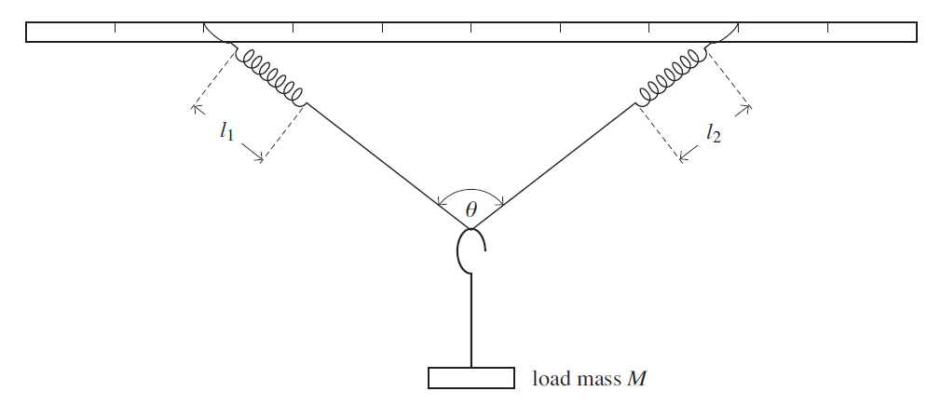
Clamp the metre rule into the clamp stand. Attach the springs at equal distances either side of the clamp using cello tape, check that the metre ruler is level in the clamp using the spirit level. Then attach the string to the ends of the string. The equipment should be set up to look like the diagram below.

Method
- Once the equipment is set up the practical is ready to begin.
- Measure the length of the springs at rest using the 30cm rule. Go low to the ground so that the springs are eye level.
- Measure the angle as shown in the diagram above (theta) using a protractor, while the string is at rest. Again go down to eye level to make sure the correct reading is recorded.
- Then hang the mass hanger of 50g with an additional 50g weight on it totalling 100g, hang this at the centre of the string.
- Wait for the mass to stop oscillating (stop moving).
- Once the weight has stopped oscillating, measure the length of both springs using the 30cm rule, also measure the angle at theta using the protractor. Record all this data into your results table.
- Repeat step 6, with 100g increments, until a total of 600g is reached.
- Repeat the experiment stating from no mass all the way up to 600g. In the end giving you two results for both the string lengths and the angle.
- Once all the data is collected the average will need to be worked out.
Risk assessment
Due to the type of experiment that this is, there is an extremely low risk of injury. There are only a few minor possible risks. The first is that the weights could possibly fall of the side onto ones foot, this could cause I injury to the foot, to reduce this risk, wear substantial foot ware and be careful when handling the weights so that they wont fall onto the floor. The second and final risk is that the springs could detach from the metre rule and hit one in the face. To make sure that this does not happen, the cello tape that attaches the springs to the metre rule should be checked that they are secure. This will reduce the chance of them coming of when they are under tension from the masses and causing possible injury.
Results
this results table below shows, the mass used in grams, the lengths of spring 1 and spring 2 and both measurement attempts, these are all measured in millimetres/mm. the table also shows the angles and both measurements from both attempts, it also shows the average angle or theta m, both are measured in degrees. The final column of the graph shows the mass over cos theta m over two, theta m being the average angle.
mass/ g | spring 1 length/mm |  | spring 2 length/mm |  | springs mean average lengths/mm | angle (theta)/degrees |  | average angle (theta m)/degrees | M (mass)
 | attempt 1 | attempt 2 | attempt 1 | attempt 2 |  | attempt 1 | attempt 2 |  | cos (theta m/2)
0 | 51 | 51 | 51 | 51 | 51 | 180 | 180 | 180 | 0
100 | 84 | 85 | 69 | 70 | 77 | 110 | 112 | 111 | 177
200 | 114 | 113 | 98 | 95 | 105 | 101 | 102 | 102 | 318
300 | 138 | 139 | 124 | 120 | 130 | 93 | 92 | 93 | 436
400 | 163 | 165 | 142 | 141 | 153 | 85 | 83 | 84 | 538
500 | 184 | 185 | 174 | 168 | 178 | 81 | 79 | 80 | 653
600 | 212 | 208 | 192 | 189 | 200 | 78 | 75 | 77 | 767

The graph below shows the average length found from the experiment against the mass over cos theta m over 2. The graph also shows a line of best fit.

Percentage-uncertainties

Conclusion
The results that have been found show that the hypothesis written at the beginning was correct. This can be seen in both the graph and the table.
The proof that the angle decreases as the mass increases can be seen in the results table. At the weight of 100g the average angle 111 degrees, where as at the final mass of 600g the average angle is 77 degrees. These results prove the hypothesis as it shows that as the mass increased the angle decreased.
The second part of the hypothesis is proven in the graph above. The idea that as the angle decreases the force or M/cos (theta m/2), increase. This proof is shown by the strong positive correlation in the graph. However the perfect results would go through the origin, as currently it does not showing that there have been errors that occurred in the experiment.
These possible errors could be;
- Parallax error. This can affect the results, because if the eye is not level with the measuring equipment different results could be found. To reduce this error the results were taken from eye level.
- Small amounts of repeated measurements not taken could mean that any possible anomalies could not be seen. To improve the results of the experiment, at least three measurements at each weight should be taken so that any anomalies can be seen and a better average can be worked out.
- Another way to reduce possible errors occurring is to use more accurate equipment such as a Vernia calliper. This would give more accurate results as it measures to smaller and precise units.
- Another possible error that could of occurred is that the masses were still oscillating (moving), when the measurements were taken, this could cause great affect to the results. To stop this the masses should have stopped moving before the measurements were taken.



