Cheryl Evans

1919675

(UWTSD)
11/12/2020

A report on effective team working.
Effective team-working and communication.

University of Wales Trinity Saint David

Executive summary

The difference between a team and a group, Will be examined throughout this report. People within a team are working together or independently to successfully achieve or reach the same goal.

Contents list
Contents
1.0 Executive summary 1
2.0 Contents list 2
3.0 Introduction 3
3.0 Findings 4
5.0 Conclusions 10
6.0 Recommendations 11
8.0 Bibliography/Reference list 12
References 12
Bibliography 12
References 13
References 13

3.0 Introduction

Findings
- Belbin, (1981) Theory.
- Bruce Tuckman, (1965) Theory.
- John Adair, (1934) Leadership Model.
- Patrick Lencioni Quote.

There are team-work theories on how to improve the performance of a team in the workplace. According to Belbin, (1981) By applying his theories it can be possible to create a successful team in the workplace. Dr. Meredith Belbin created a self-perception individual report questionnaire. This questionnaire identifies 9 characteristic behaviors.

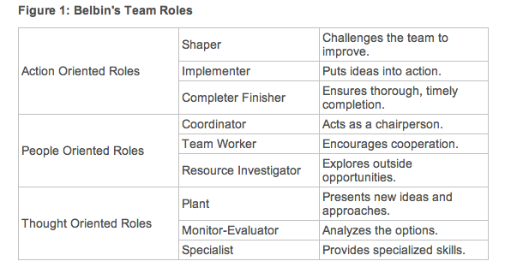
This Photo by Unknown Author is licensed under CC BY-NC-ND Accessed [online]
After taking the self-perception report questionnaire the participant's result or findings should be that they identify with 2-3 characteristic behaviours from Belbin’s, (1981) team role theories. These significant findings according to Belbin, (1981) are important when grouping co-workers together therefore creating unity in the workplace as a team.
For example, a strong-minded personality may overshadow an introverted character. Creating the introverted character to shy away. Making it impossible for the introvert to have a say or put their ideas forward. Therefore, the introvert may not contribute to a team project or may have little or any input within the team project at all. Consequently, subconsciously the strong-minded personality character may inevitably be to over baring for an introvert.
On the other hand, too many dominating personalities in the same team may result in conflict bring a negative dynamic to the team. Predominantly it is of great importance that co-workers work well together as a team. Working together as a team can lighten the workload. This may reduce stress for co-workers within the team.
Taking away the stress may improve productivity enabling the business to grow, generating new fresh creative ideas within the team which can be beneficial and valuable to the company. These are just a few positive examples from the Belbin, (1981) theory to improving the performance of a team within the workplace.

Workplace example:
Workplace dominance happened within a team meeting when a co-worker dominated the meeting. Which left no time for diverse opinions, their dominance lead to monopolizing the discussions in the meeting, they came across aggressive leaving others to feel unsafe in their workplace environment. This dominant co-worker likes to make progress which is a positive. But their assertiveness and their lack of self-awareness stifled the engagement of others therefore harming the morale of the team within that meeting.

Bruce Tuckman's, (1965) Team-Development Model
Dr. Bruce Tuckman published his 'Forming, Storming, Norming, Performing' model in 1965. He later added a fifth stage, Adjourning, in the 1970s.

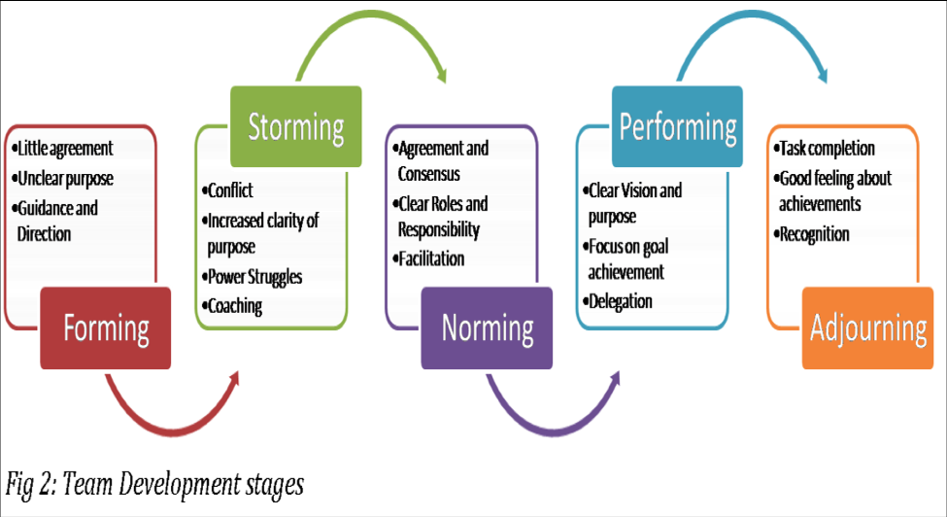
Accessed [Online]

The (Tuckman’s,1965) theory model has been developed to give formation for a group of people to tackle a project or task together as a team from the start of a project right the way through to the completion of the project. It is suggested that a team of people will not come together at the beginning of a project fully formed or functioned to work together as a team.
By applying the (Tuckman,1965) theory to a team it suggests that a team can attempt to grow and develop when passing through clearly defined stages, aspiring from a group of individuals to striving to become a team working together to achieve the same end goal and achievements as a team.

John Adair, (1934) Theory.
John Adair has become best-known for his Action Centred Leadership model. There are three elements to this theoretical model.
- Achieving Task.
- Managing Team/Group.
- Managing Individual.

The model is based on three overlapping circles. These three overlapping circles show that the three elements can overlap when managing /leading a team or group.
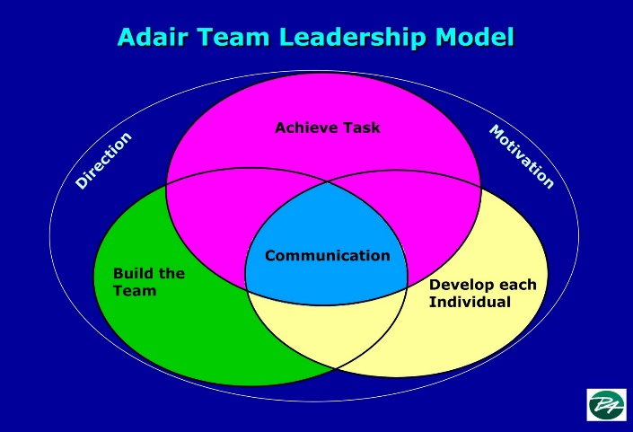
Accessed [Online]
According to Adair, (1934), his model can improve the performance of a team within the workplace. And by applying his leadership model can result in a positive outcome within a team. Example allocating responsibilities, planning, or defining tasks may often enough result in achieving the TASK.
Communicating, building team spirit, motivation & discipline can shape and build the TEAM/GROUP.
Counseling individuals, coaching individuals, developing individuals, and motivating individuals can enable a member of the team to complete the task set for oneself as an INDIVIDUAL.

Patrick Lencioni Quote.

“Not finance. Not strategy. Not technology. It is teamwork that remains the ultimate competitive advantage, both because it is so powerful and so rare.” -- Patrick Lencioni

[Online]

The differences between a group and a team.
There can be a variety of people in a group. Such as a collection of individuals independently attending a job interview. Even though the group has joined for a common interest and mutual outcome. They individually coordinate working towards their goal but with individual efforts.

On the other hand, a team of people shares a common purpose of working within a team. A team of people comes together to reach a mutual goal or outcome. At times, a project may need a team member to work independently within the team, but they will be still be working towards the same goal as their team members. Working together as a team tends to maximize team members' strengths alternatively minimizing team members' weaknesses.

Workplace Example.
The difference between groups and teams in my place of work are that as a group of individual people we all are part of the same company. We share a common purpose we are individually accountable for our contribution and performance. But working as individuals we lack positive synergy. (2 + 2 = 5 effect)
On the other hand, when we come together as a team of co-workers, we share a common goal. Everyone contributes within the team. Decision making is made as a team. No one is left unheard. This creates a trusting atmosphere effectively we all engage within the task. Everyone is mutually working together as a team to achieve the end goal.

Effective teamwork in organisations.
The need for effective teamwork within an organisation ensures that all tasks are understood. According to (Belbin,2010, p. 48) This can be achieved when effective leadership takes place within the team. When good Leadership is applied to a team within an organisation such as delegating. Predominately task can be achieved successfully and predominantly projects can be complete efficiently.
Leadership plays an important role within a working team. By assigning the right person to a task within a team a leader should be giving direct responsibility to an individual and matching the team members ability to the requirements of the task. This ensures the individual team member to reach their common goal (Badelisile M. Maseko, 2019, p. 5) successfully. Enhancing the performance of a team. This approach of work ethic can build-up confidence for individuals within a team increasing competence and productivity. Which in return will be effective for the organisation.
This can also be achieved by a great level of communication within a team. Good communication can motivate a team therefore team members can support each other when needed. These actions will help maintain trust within the team. Trust provides a healthy, happy yet beneficial workplace environment within in the workplace or organisation.

Workplace Example.
An effective workplace example withing the workplace came about when the store was due to have a visit from the company’s Chief executive officer (CEO). James the Store manager has great communication and delegation skills is very efficient and organised. Therefore, this character trait had empowered the team to accomplish the important tasks that needed to be complete for the visit from the company’s CEO. Together as a team all tasks where complete and the outcome of the visit was a positive one. James has shared with us his appreciation which boosted the moral of the team.
There have been times of poor leadership within the workplace. Poor communication can effectively coast the company time and money. This can hinder the team’s morale and self-esteem when a task that has been delivered incorrectly consequently breaking the trust between leader and co-workers.

Effective conflict handling and delegation.
The conflict handling is a key component as it should stop disruption and disturbance in the workplace therefore giving the opportunity to share the perspective and improve the outcome for everyone involved. Unfortunately, not every team’s in the workplace will have the same outcome neither the successful in their goals. Teams in the workplace may fail due to conflict, the team character personalities within the team, may disrupt the dynamics of the team. Also, when there is poor communication within a team there can be an eruption of conflict. The result of this action may result in low morale within the team, creating arguments resulting in deadlines not being met.
These negative aspects or experiences may be avoided if a leader or delegator takes the responsibility of the team and steps into take charge.
This is where Belbin, (1981) nine heterogenous behavioural roles taxonomy are put into practice workplace. Belbin, (1981) created a self-perception questionnaire. This should be done before working with others within a team or group.
Therefore, assigning the right team member to the right part of the project or task in hand. Also determine which team members work well together or not so well together. This strategy of approach gives the whole team an advantage as it can allow co-workers to show and use their qualities and strengths enabling the team to achieve the team’s goals.

5.0 Conclusions

By all counts, and with proven results, (Belbin, 1981) theories and the individual self-perception report questionnaire can work when applied to a group or team of people. This philosophy helps to navigate a team or group through the processes of a task or project. The findings show that good leadership with the knowledge and skill to delegate, support, coach and direct a team or group of people can be beneficial within an organisation. By applying structure to a team effective teamwork can take place offering team members self-worth, confidence, and a sense of belonging can creating a happy healthy workplace environment. The importance of producing the right balance or group dynamics within a team can boost productivity therefore jobs being complete on time to the highest standards efferently within the organisation.
Working as a team should give positive result when applied correctly to a team or group.

6.0 Recommendations

By acknowledging Belbin’s, (1981) and Tuckman’s, (1965) philosophy thought out the report it has shown by applying their theories to a workplace environment it could be beneficial when working in teams or groups of people. On the other hand, it is arguable to say that these theorise of philosophy may or may not be so effective in the 21st century. As employment has evolved over the years. Therefore, technology has dominated the workplace.
We depend on technology considerably more in the 21st century. We are forming a generation that seems to be working slightly less together within the working environment. Reducing the time, we spend with co-workers as a team within the workplace. There has been rapid change from working as a team or group from within the workplace to working from home as an individual team member. This may create new challenges for working effective and efficiently as a team or group withing a working environment. It could be suggested that without discarding the above theories there can be supplementary theories that can be added or used alongside the existing theories to resume the effectiveness of the above teamwork theories.

Bibliography/Reference list

Belbin, D. M., 2019. The Nine Belbin Team Roles. [Online]
Available at: https://www.belbin.com/about/belbin-team-roles/
[Accessed 22/11/2020].

Available at: https://okpalad.files.wordpress.com/2015/03/tuckman.png
[Accessed 22/11/2020].

The Action-Centred Leader.
John Adair
Jaico Publishing House.
2006
[Accessed 22/11/20].

Available at: John Adair Theory - Bing images.
[Accessed 23/11/2020].

Patrick Lencioni Quote.
Lencioni, P./ n.d. Patrick Lencioni and teamworking. [Online]
Available at: www.teambuilding.co.uk
[Accessed 24/11/2020].

Badelisile M. Maseko, R. v. W. A. O., 2019. Team coaching in the workplace: Critical success factors for implementation. SA Journal of human resource managment, 17(2018), p. 11.
Belbin, R. M., 2010. The managment of teams why they succeed or fail. second ed. Oxford: Elsevier Ltd..
lencioni, P., n.d. Patrick lenioni and teamwork teambuilding. [Online]
Available at: www.teamnbuilding.co.uk
[Accessed 24 11 2020].

Bibliography
Badelisile M. Maseko, R. v. W. A. O., 2019. Team coaching in the workplace: Critical success factors for implementation. SA Journal of human resource managment, 17(2018), p. 11.
Belbin, R. M., 2010. The managment of teams why they succeed or fail. second ed. Oxford: Elsevier Ltd..

lencioni, P., n.d. Patrick lenioni and teamwork teambuilding. [Online]
Available at: www.teamnbuilding.co.uk
[Accessed 24 11 2020].

References
Badelisile M. Maseko, R. v. W. A. O., 2019. Team coaching in the workplace: Critical success factors for implementation. SA Journal of human resource managment, 17(2018), p. 11.

Belbin, R. M., 2010. The managment of teams why they succeed or fail. second ed. Oxford: Elsevier Ltd..

lencioni, P., n.d. Patrick lenioni and teamwork teambuilding. [Online]
Available at: www.teamnbuilding.co.uk
[Accessed 24 11 2020].

