

Student Name: Anane Frimpong
Student ID: 2436557
Module Code: ACCA4022
Assignment Title: Operating Systems Assignment
Lecturer: Rajeev Nath

Table of Contents
Introduction 4
Key Functions of Operating Systems 4
Process Management 4
Memory Management 5
File System Management 6
Device Management 6
Network Management 7
Windows CLI Commands 9
Process Management 9
File Management 10
Network Commands 11
User Management 12
Task Scheduling 13
Linux CLI Commands 14
Process Management 14
File Management 15
Network Commands 16
User Management 18
Task Scheduling 18
Windows Batch Scripts 19
Script 1: Multiplication Tool 19
Script 2: File Checker Tool 20
Linux Bash Scripts 21
Script 1: Multiplication Script 21
Script 2: Directory Checker 22
Conclusion 23
References 23

Introduction
Operating systems are an essential part of modern computers since they act as the connection between the computer user and the hardware resources. An OS manages various aspects like system processes, memory, file systems, peripherals, and guarantees efficient application execution. Popular operating systems such as Microsoft Windows and Linux have GUIs and CLIs, hence allowing flexible interaction by users with the computer. This paper discusses the primary roles of the operating systems and how they are put into practice through Windows and Linux commands. Also included in this report is the use of scripts to execute repetitive tasks [1].

Key Functions of Operating Systems

Process Management
Process management is an important responsibility of the operating system. It includes the creation, scheduling, and deletion of processes in an effective way. The process is a program being executed, and the operating system makes sure that processes can execute concurrently without interference. In addition to basic process handling, modern operating systems implement advanced techniques to improve efficiency and responsiveness. One important concept is multithreading, where a single process is divided into multiple threads that can execute concurrently. This allows better utilization of CPU resources, especially in multi-core systems.
An operating system schedules different processes using scheduling techniques, which allows for better performance and efficiency. Process synchronization and process communication are other areas managed by the operating system [2].
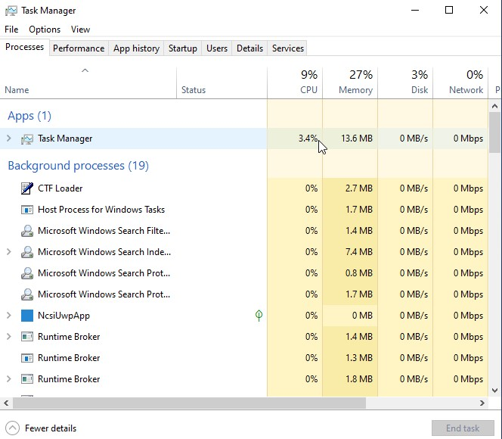
Figure 1: Windows Task Manager displaying active processes
Figure 1 illustrates the Windows Task Manager, which displays active processes, CPU usage, and the performance of the whole system. Using this tool, users can keep track of their processes and even kill some processes when required. Good process management results in improved stability and efficient use of system resources.

Memory Management
Memory management refers to the way memory is allocated and de-allocated in the computer by various processes. It ensures that all processes have enough memory without inter-process intrusion into memory. This method utilizes the technique of virtual memory, paging, and segmentation so as to make good use of memory resources. Virtual memory allows memory space to expand on disk, enabling the computer to run bigger programs.
Operating systems also use caching mechanisms to store frequently accessed data in faster memory, reducing access time and improving overall performance. Additionally, swapping is used when memory is full, temporarily moving inactive processes to disk storage to free up RAM.
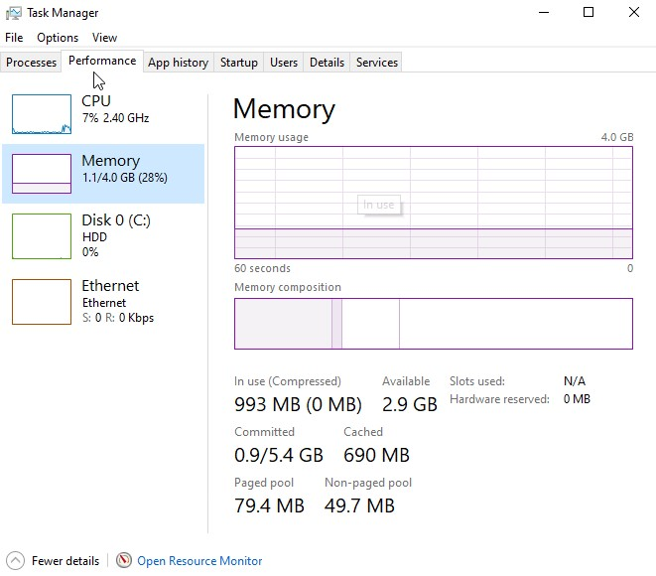
Figure 2: Memory usage in Windows Task Manager
Figure 2 shows memory utilization in Windows Task Manager. Good memory management helps to achieve proper system performance and avoids memory leakage during multitasking operations.

File System Management
Effective management of the file system enables proper storage and manipulation of information in an efficient manner. Operating systems provide a systematic approach to the management of files and directories in terms of storage. The file management subsystem is responsible for handling permissions, naming, and storage of files. The modern operating systems utilize the use of various file systems like NTFS for windows and EXT4 for Linux [3].
The operating system also supports file compression and encryption, allowing users to save storage space and protect sensitive data. Encryption ensures that unauthorized users cannot access confidential information.
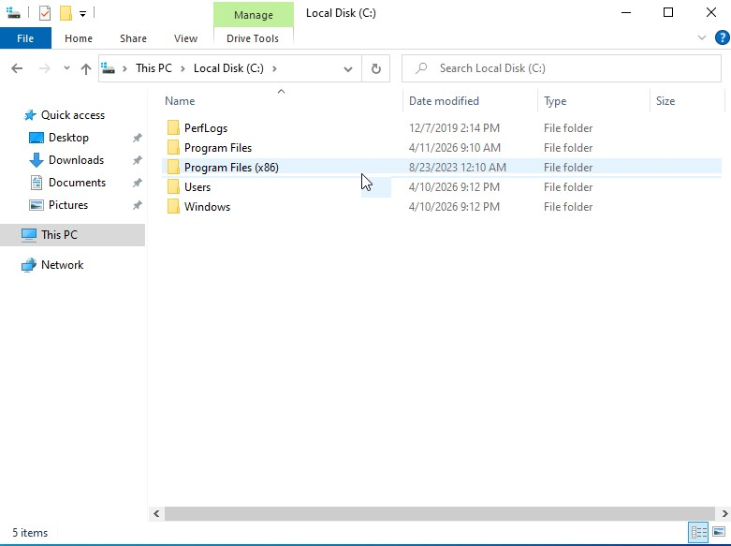
Figure 3: File management using Windows File Explorer
As depicted in Figure 3 below, File Explorer in windows provides a convenient way of handling files and folders within windows. In general, this function is crucial in ensuring data safety and accessibility; therefore, it forms an integral part of operating systems.

Device Management
Device management deals with hardware components such as printers, keyboards, and hard drives. In this regard, an operating system uses device drivers that ensure effective interaction between the hardware and the software. Good device management allows for effective device management through proper control of input/output processes. In addition, device drivers act as intermediates between the hardware and the software.
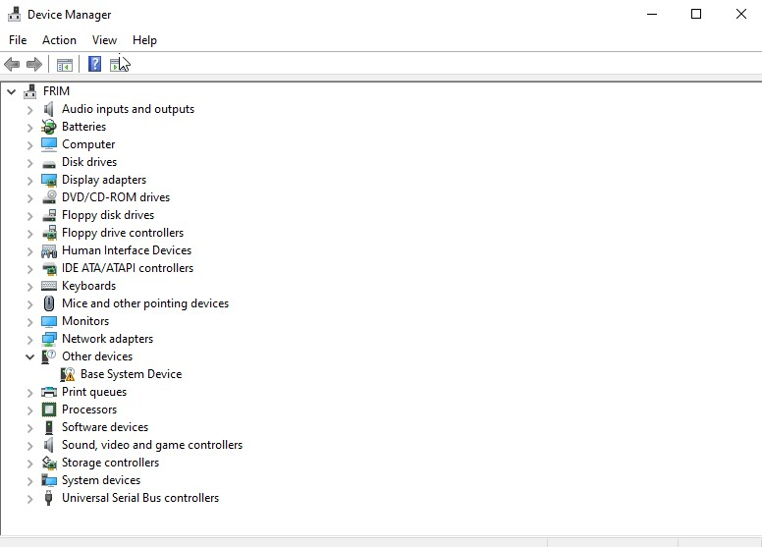
Figure 4: Device Manager showing hardware components
Figure 4 below shows the Device Manager, which is an interface whereby one can manage their installed hardware and check any device-related problems. The operating system also ensures proper device allocation, especially when multiple processes request access to the same hardware. It uses scheduling techniques to manage device usage fairly and efficiently. Another key feature is plug-and-play functionality, which allows new hardware devices to be detected and configured automatically without manual intervention. This improves user convenience and reduces setup time. Efficient device management leads to compatibility and efficiency in performance.

Network Management
Network management helps with the communication between computers and networks. The operating system manages network connections, IP addresses, and data transfers. The operating system provides protocols like TCP/IP, ensuring reliable communication. Network management also involves network performance monitoring and solving connection issues [4].
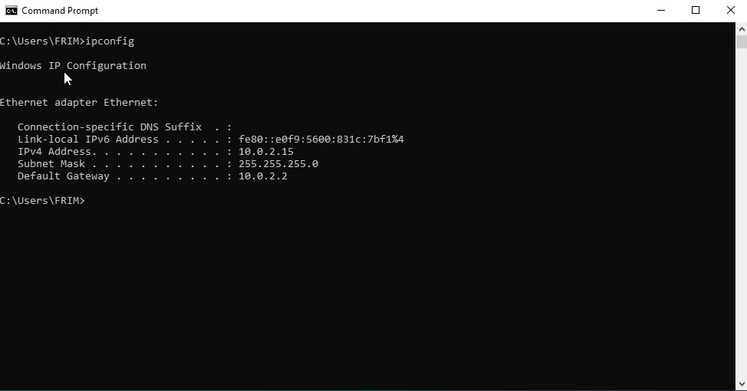
Figure 5: Network configuration using ipconfig command
Figure 5 shows the ipconfig command, showing the network settings, including the IP address and gateway. This process is critical for Internet access, data exchange, and communication in modern computing systems. Network troubleshooting tools, such as ping and traceroute, help diagnose connectivity issues by identifying delays or failures in data transmission.

Windows CLI Commands
The Windows Command-Line Interface (CLI) provides powerful tools for system administration and automation. It allows users to perform tasks efficiently without relying on graphical interfaces.

Process Management

tasklist
tasklist command is used to display the list of running processes and shows the ID of each process along with its memory usage.
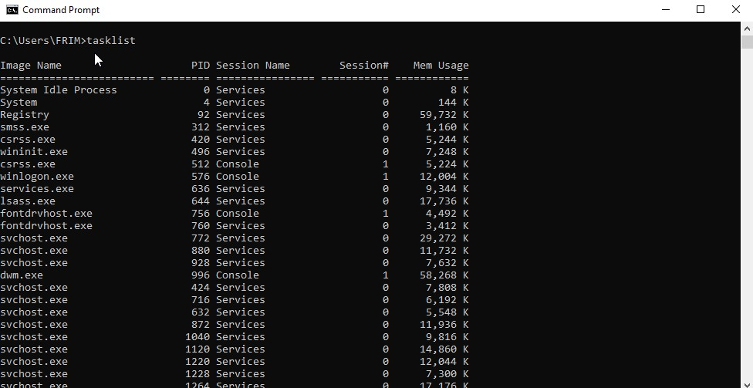
Figure 6: tasklist command output

taskkill
taskkill command is used to forcefully end a particular process. It proves helpful if some program stops responding.
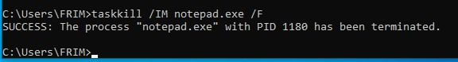
Figure 7: taskkill command execution

File Management

dir
dir command lists out files and folders located at the current working place. In this way, we can navigate through the filesystem.
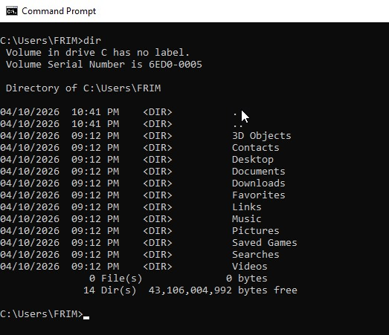
Figure 8: dir command output

ren
ren command is used to rename file or directory in windows OS. Figure 9 shows how ren command actually works.
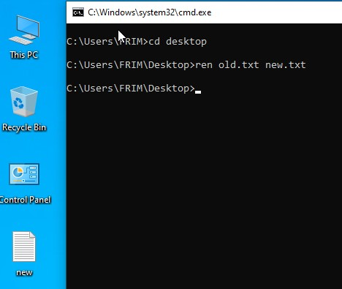
Figure 9: ren command execution

move
move command is used to move file or folder from one location to another inside windows OS.
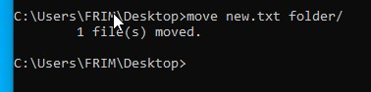
Figure 10: Demonstrates file relocation.

Network Commands

ipconfig
Ipconfig command shows network configuration and includes the IP address and subnet mask.
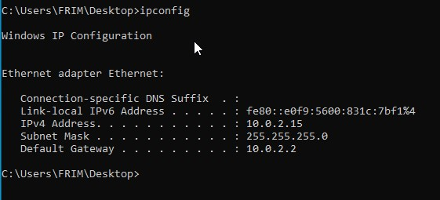
Figure 11: ipconfig output

ping
Ping command is used to tests the network connection. It sends packets to target to check its availability and responsiveness.
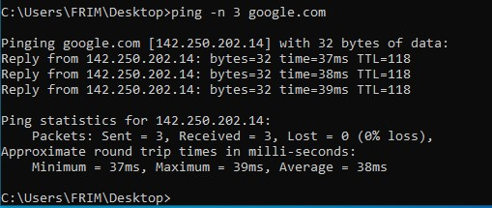
Figure 12: ping results

netstat
netstat command lists down all the active connections and open ports. It helps you monitor network activity and troubleshoot connection issues.
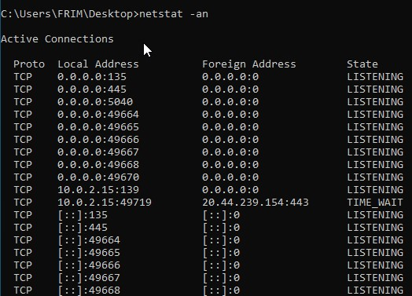
Figure 13: netstat output

User Management

whoami
whoami command identifies the current user logged in to the system, the group associated with it and its privileges.
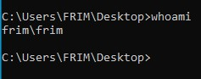
Figure 14: whoami output

net user
Net user command shows information regarding the user account and allow you to add, remove or modify user details.
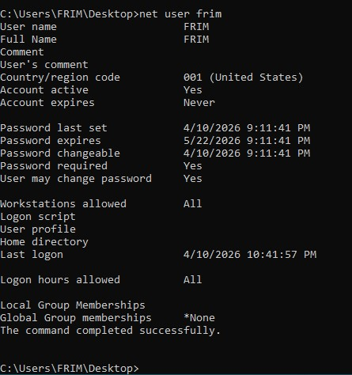
Figure 15: net user output

Task Scheduling

schtasks /query
Schtasks /query displays all the scheduled tasks on a system, their details, next run time and status.
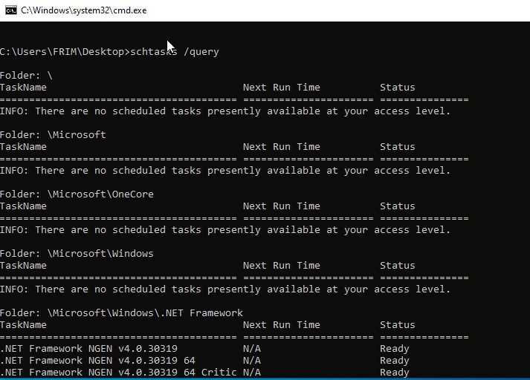
Figure 16: schtasks output

Linux CLI Commands
Linux offers an efficient command line interface (CLI) often referred to as shell or terminal [5]. It is a command line program that accepts input commands to execute operating system functions. Following are some of the most common and most used Linux CLI commands:

Process Management

ps
ps command in linux is ued to display active processes. It display currently running processes, their process id, their CPU usage and memory consumption.
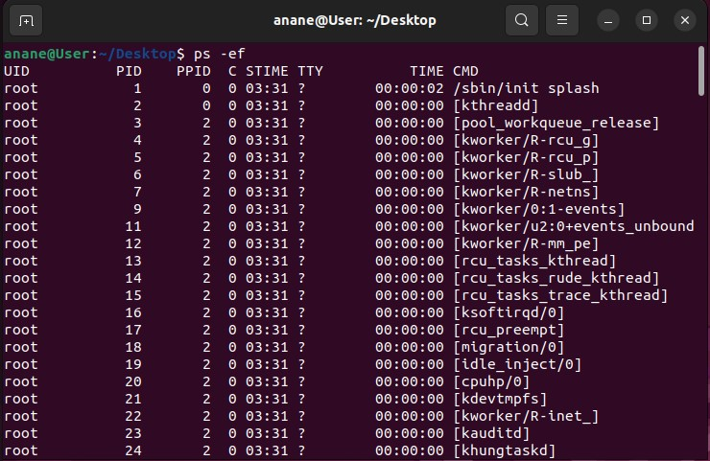
Figure 17: ps command output

htop
htop command is used to view and manage system resources in real-time. It gives you the information about CPU, memory and swap usage.
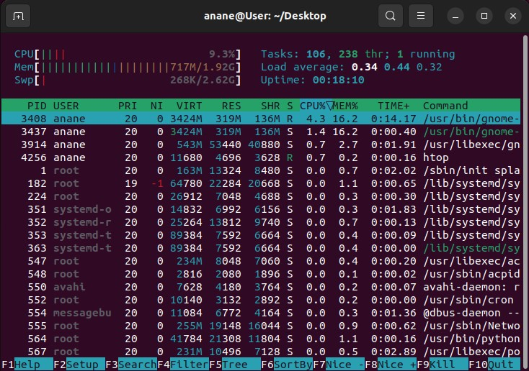
Figure 18: top command output

File Management

ls
ls command is used to list files and directories inside current directory. It comes with multiple options like –a to view any hidden file or directory or –t to view the time at which the file is created or last modified.
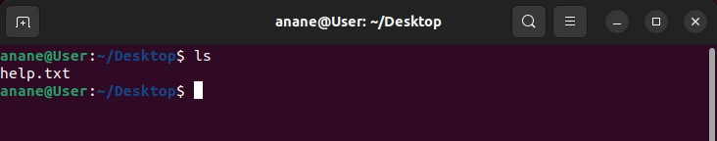
Figure 19: ls output

mv
mv stands for move command is used to files or directories from one location to another inside OS.
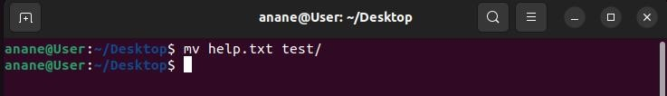
Figure 20: mv command output

chmod
chmod command is used to change the permission mode of files or directories implying who can read from, write to and execute the file. It improves the security of the system.
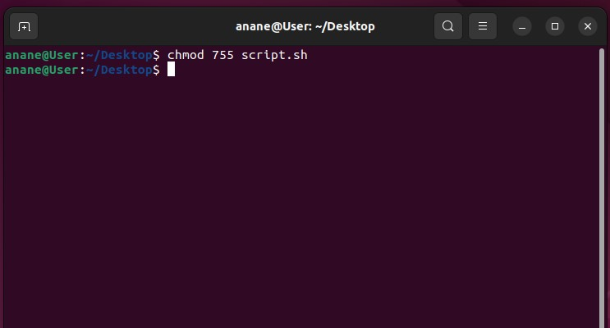
Figure 21: chmod output

Network Commands

ip a
ip a command shows network configuration and includes the IP address and subnet mask.
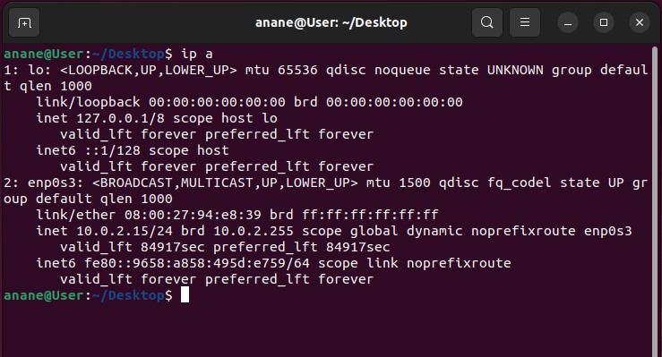
Figure 22: ip a output

ping
Ping command is used to tests the network connection. It sends packets to target to check its availability and responsiveness.
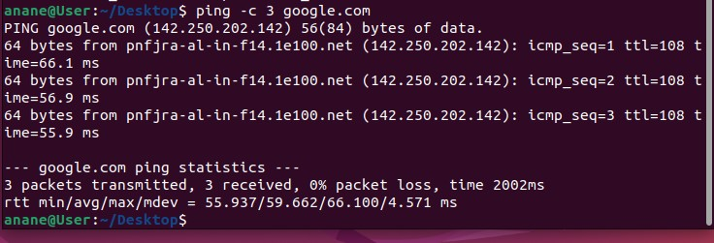
Figure 23: ping output

ss -l
ss command display detailed information about network connection. It retrieves socket information from kernel. It comes with multiple arguments which help filters out the output.
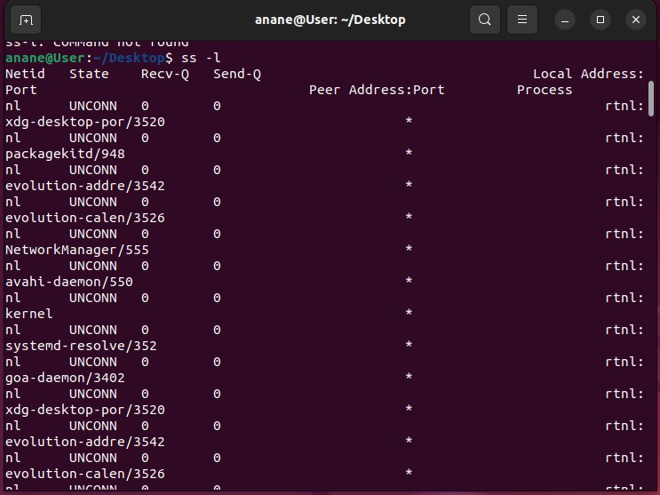
Figure 24: ss output

User Management

who
who command generates a list of all users currently logged into the system.
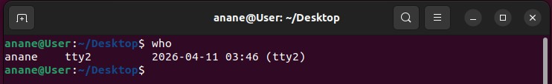
Figure 25: who command output

groups
groups command shows the list of the groups, the current active user is a part of.
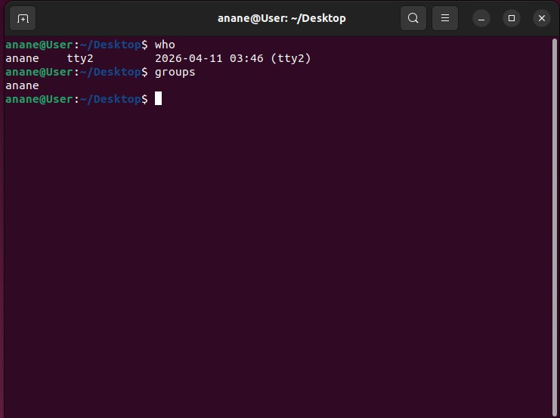
Figure 26: groups output

Task Scheduling

crontab
crontab is used to create, manage and automate scheduled tasks in Linux Operating System.
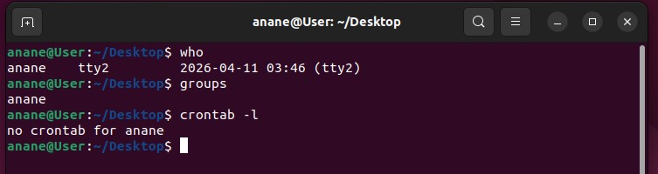
Figure 27: crontab output

Windows Batch Scripts
Using batch scripting allows user to automate repetitive tasks in the Windows Operating System Environment. Commands in batch script are executed in an orderly manner.

Script 1: Multiplication Tool
The script asks for input from the user, store them in variables and does the multiplication based on the values stored in variables and mathematical functions and output the result.

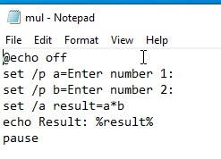
Figure 28: Batch multiplication script code

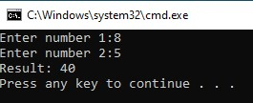
Figure 29: Script execution output

Script 2: File Checker Tool
The script checks whether a particular file exists or not in the system using a conditional statement. If a file exists, then a particular message is printed to the console, and vice versa.
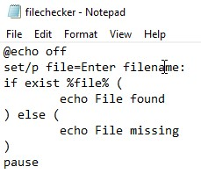
Figure 30: File checking script code

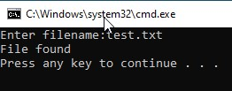
Figure 31: Script execution output

Linux Bash Scripts
Bash scripting allows user to automate repetitive tasks in the Linux Operating System Environment. Commands in batch script are executed in an orderly manner.

Script 1: Multiplication Script
The script receives two numerical values, store them in variables and multiplies them, showing how variables and arithmetic operations are worked in Linux OD.
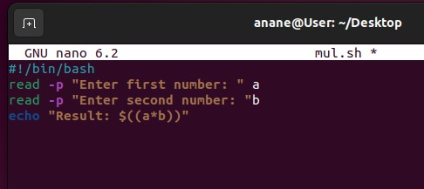
Figure 32: Bash multiplication script
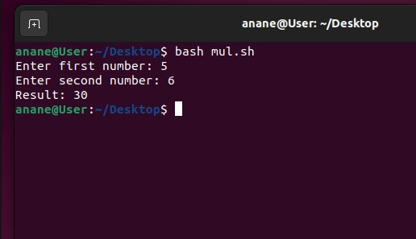
Figure 33: Script execution

Script 2: Directory Checker
The script checks whether a directory exists using conditional statements. If the directory exists, a message confirming that is shown; otherwise, the user is prompted accordingly.
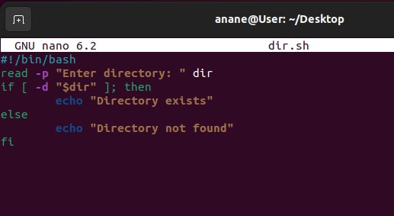
Figure 34: Directory check script
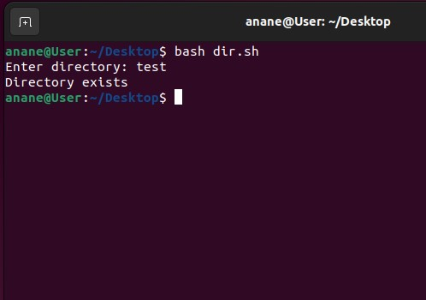
Figure 35: Script output
This script can be helpful in system administration for checking whether a directory exists before proceeding to other tasks.

Conclusion
In conclusion, operating systems are crucial for managing system resources and ensuring efficient communication between hardware and software components. This article discussed some of the key functions of an operating system, which include process, memory, file, device, and network management. Besides, the article showed practical applications of command-line tools available in Windows and Linux, highlighting their significance in system administration. Furthermore, Bash scripting techniques have been utilized to automate some tasks and improve efficiency and productivity. In general, knowledge about operating systems and their command-line functionality is essential for modern computing and problem-solving skills.

References
- A. S. Tanenbaum and H. Bos, Modern Operating Systems, vol. 2. 2014.
- D. A. Patterson and J. L. Hennessy, “Computer Organization and Design: The Hardware Software Interface - RISC-V Edition,” Elsevier, vol. 01, 2019.
- C. McClure, Windows Server 2019 Administration Fundamentals. Birmingham, UK: Packt Publishing, 2019.
- J. M. Kizza, Guide to Computer Network Security, 4th ed. in Computer Communications and Networks. New York, NY: Springer, 2017. doi: 10.1007/978-3-319-55606-2.
- R. Blum and C. Bresnahan, Linux Command Line and Shell Scripting Bible, 4th ed.
Indianapolis, IN: John Wiley \& Sons, 2020.

