Marketing Plan
Student’s name: Vasilica Matei
Student’s id: 2241185
Course name: Hotel management

Table of Contents
Component A (Opportunity of increasing Customer Base) 3
1. Introduction 3
1.1 The purpose of the marketing plan 3
1.2 Who is it being prepared for? 3
2. Situation Analysis 3
2.1 5 ‘C’s 3
2.1.1 Company: SWOT analysis (Microanalysis) 3
2.1.2 Customers: Segmentation and Targeting 3
2.1.3 Competitors: Perceptual positioning map, Bowman's strategy clock 4
2.1.4 Collaborators: Demonstrate an awareness of your organisation's B2B Relationships, Partnerships, and Franchises 5
2.1.5 Climate: PESTLE (Macro analysis) 5
2.1.6 Marketing Mix 6
3. Objectives 6
3.1 SMART targets 6
4. Strategy 7
4.1 Discuss and explain your organisation's new value proposition if there is a change 7
4.2 What strategy will the business use? Ansoff’s matrix 8
4.3 What changes will be required to the Marketing mix? 8
5. Tactics 8
5.1 What strategies? RACE framework 8
5.2 Discussion of how the new communications tactics can be used to assess the issues identified in the situational analysis 9
5.3 Examination of the hotel's current communications/social media/ emails/Similarweb results, how can it improve? Where are they lacking and what did they miss? What steps can be introduced 9
6. Action 10
6.1 Gannt Chart 10
7. Control 10
7.1 Discuss how we will measure success/Metrics/KPIs 10
8. Conclusion 11
Component B 12
Introduction 12
Situation analysis and objectives 12
Strategy and Tactics 12
Action and Control 12
Conclusion 13

Component A (Opportunity of increasing Customer Base)

1. Introduction

1.1 The purpose of the marketing plan
As described by Desai and Vidyapeeth (2019, p. 199), a marketing plan refers to the operational document that describes how an organisation is planning to outreach and advertising to target a specific market. The present marketing plan has been developed for Six Senses which provides services such as wellness spas, luxury resorts and five-star hotels. This marketing plan can help Six Senses to build a strong customer base and increase its profitability.

1.2 Who is it being prepared for?
This marketing plan is prepared for Six Senses and its marketing managers so that by focusing on the 5’C’s, SWOT analysis and marketing mix they can improve their marketing approach.

2. Situation Analysis

2.1 5 ‘C’s

2.1.1 Company: SWOT analysis (Microanalysis)
Strengths | Weaknesses
- Positive internal environment  - Globally renowned reputation | - Negative reviews of customers  - Financial management issues during focusing on the sustainable practices
Opportunities | Threats
- Social media marketing  - Expansion in the global market | - High Competition  - Negative brand image

2.1.2 Customers: Segmentation and Targeting
Segmentation
As stated by Chaffey and Smith (2022), demographic, behaviour, psychographic and geographic the four segmentation to divide the market. Six Senses follows demographic and geographic segmentation to divide its consumers as per their age, gender and location.
Targeting
Age | 26 to 50 years
Gender | Female, male and LGBTQ+
Income | Medium to high

2.1.3 Competitors: Perceptual positioning map, Bowman's strategy clock
Positioning map
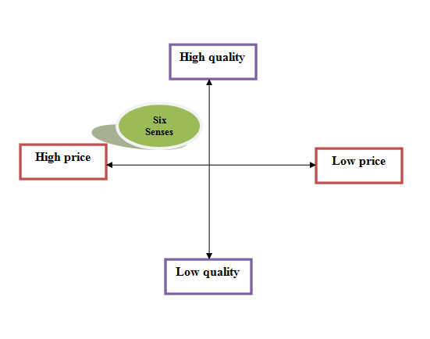
Figure 1: Positioning map
(Source: Developed by the learner)
Bowman's strategy clock
As opined by Fahy and Jobber (2019), Bowman’s strategic clock refers to the marketing position of a firm to attract customers and gain a competitive advantage. Six Senses can follow the differentiation strategy among eight positions to offer unique services from its competitors and hold a strong market position.
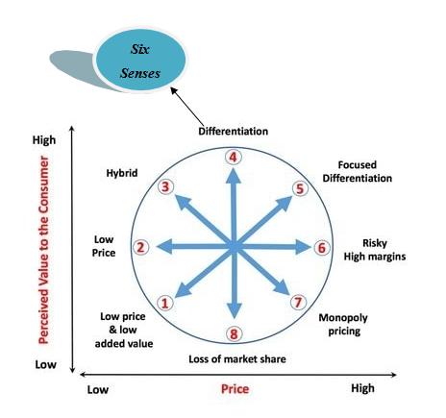
Figure 2: Bowman's strategy clock
(Source: Developed by the learner)

2.1.4 Collaborators: Demonstrate an awareness of your organization’s B2B Relationships, Partnerships, and Franchises
Six Senses follows the B2C relationship which refers to the company directly providing its services to its customers. Six Senses also has partnerships with the United States Coalition on Sustainability to manage its sustainable practices. Six Senses predominantly franchises the brand and manages hotels independently in more than 100 countries, (sixsenses.com, 2023).

2.1.5 Climate: PESTLE (Macro analysis)
Factors | Description | Impact
Political | Post-Brexit | Disruption in the supply chain
Economical | Increasing inflation rate | Decreased the customer numbers
Social | Frequent changes in customer trends | Affects the profitability
Technological | Highly-advanced technology | Allows to use digital marketing strategy
Legal | Equality Act 2010 | Avoiding discrimination
Environmental | Sustainable approach | Brand recognition

2.1.6 Marketing Mix
Product | Wellness spas, luxury resorts and five-star hotels
Price | Dynamic pricing
Place | U.K and other 100 countries
Process | High-quality and luxury hospitality services
Physical evidence | 139 in U.K
Promotion | Social media platforms
People | Trained and experienced staff

3. Objectives

3.1 SMART targets
Objectives | Specific | Measurable | Attainable | Relevant | Time-bound
To expand the business in the global market | Important to build a strong customer base and increase brand recognition, (Percy, 2023). | By analysing the sales margin of Six Senses to determine its growth process in the international market. | By using the latest digital marketing strategies and using advanced technologies for promoting the services of Six Senses. | Needed to increase brand recognition and increase customers. | 5 months
Increase the profitability of the company | Essential to gain a competitive advantage in the market and build a strong customer base, (Hartanto et al., 2022, p. 589). | Gathering positive feedback from guests | Improving the hospitality services of Six Senses | Required to gain a competitive advantage | 4 months

4. Strategy

4.1 Discuss and explain your organisation's new value proposition if there is a change
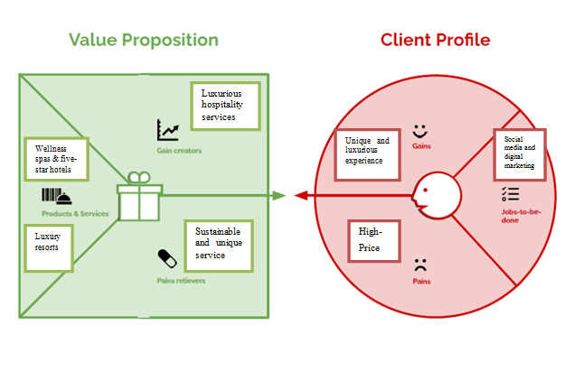
Figure 3: Value Proposition canvas
(Source: Developed by the learner)
As per the new value proposition mentioned above Six Senses can focus on its social media and digital marketing to promote its services and communicate with its customers. Customers can get a luxurious, sustainable and unique hospitality experience from the company with dynamic prices, (Deepak and Jeyakumar, 2019).

4.2 What strategy will the business use? Ansoff’s matrix
As mentioned by Ferrell et al., (2021), the four key factors of Ansoff's matrix are product development, market penetration, market development and diversification. Six Senses can follow the market penetration strategy to increase the sales of its existing services of five-star hotels and spas in the existing customer base by using effective promotional and distribution strategies. Market penetration strategy can help the firm to overcome poor reviews on social media and build a brand reputation, (Karg and Funk, 2020).
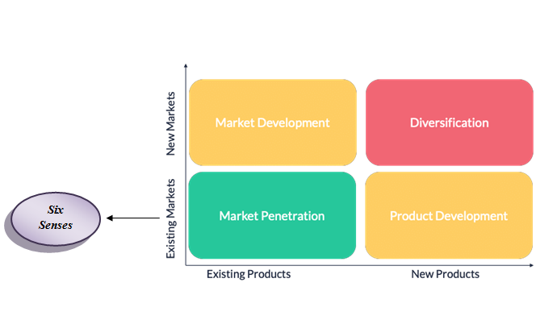
Figure 4: Ansoff’s matrix
(Source: Developed by the learner)

4.3 What changes will be required to the Marketing mix?
The market mix of Six Senses can include the latest social media advertising strategies such as promoting services through famous social media influencers.

5. Tactics

5.1 What strategies? RACE framework
As per the views of Jin et al., (2019, p. 568), the four phases of the RACE framework are research, action & planning, relationship building & communication and evaluation.
Research | Six Senses in this stage needs to identify the latest digital marketing tools that can be used by the firm to reach a maximum number of customers.
Action and planning | In this stage, Six Senses can focus on using an effective marketing plan by using different social media channels such as Facebook, Instagram or Pinterest to promote its unique hospitality services.
Communication and relation building | The current and changing customer trends can be adopted in this stage by using social media sources to modify the services for improving customer services, (Dolnicar, 2022, p. 850).
Evaluation | In the last stage, Six Senses can develop a strong customer base by providing them with personalised services and gaining a competitive advantage in the market.

5.2 Discussion of how the new communications tactics can be used to assess the issues identified in the situational analysis
As per the above-mentioned situation analysis, it can be said that Six Senses can use Email marketing for communicating with its customers and identify the issues which have faced by them. The firm can also reply to its customers on social media platforms to gain positive feedback about the hotels and resorts for developing a strong customer base, (Jobber and Ellis-Chadwick, 2019).

5.3 Examination of the hotel's current communications/social media/ emails/Similarweb results, how can it improve? Where are they lacking and what did they miss? What steps can be introduced
Currently, the hotels, spas and resorts of Six Senses use Email marketing, social media platforms and its official website for communicating with its consumers. Six Senses can also use a chat platform where customers can get quick responses regarding their queries or issues with the services. It has been identified that hotels of Six Senses are unable to adapt to the changing customer trends frequently which causes negative experiences for consumers. Six Senses can focus on following customer trends through social media and adopting them in their services to overcome this issue.

6. Action

6.1 Gantt Chart
Activities | Week 1 | Week 2 | Week 3 | Week 4 | Week 5 | Week 6 | Week 7
Internal and external market assessment
Recognition of consumer trends
Resource aggregation
Execution
Control Activity
Review

7. Control

7.1 Discuss how we will measure success/Metrics/KPIs
Sales volume | As opined by Lee and Kotler (2019), increase sales volume refers to the effectiveness of the chosen marketing strategy to attract customers towards the business.
Consumer acquisition cost | This can help Six Senses to generate customer conversion along with attracting new customers.
Website traffic generation | As stated by Morrison (2022), higher traffic generation refers to the increasing market expenditure of the firm. Hence, the higher traffic generation of Six Senses can help it to understand its growth in the global market.
Increased profitability | Customer’s positive attitude towards Six Senses from social media platforms.
Brand recognition | Increasing the profit of the firm can lead Six Senses to adopt the latest customer trends to improve brand recognition, (Park, 2020).

8. Conclusion
Thus, it can be concluded that the present marketing plan can allow Six Senses to improve its marketing practices by using the latest trends and technology for gaining a competitive advantage. This marketing plan includes an overall situational analysis that helps to determine the factors which are affecting the operations of the business. Different models and frameworks have been also used to improve the marketing plan to develop a strong customer base for Six Senses.

Component B

Introduction
As opined by Pride and Ferrell (2019), a marketing plan allows a business to expand its business and build a strong customer base to increase its profitability. Hence, the present marketing plan is developed for the company Six Senses so that it can increase its profitability and develop a strong customer base.

Situation analysis and objectives
The situation analysis includes SWOT analysis, segmentation, targeting, positioning, Bowman’s strategy clock, Pestle analysis and the marketing mix of Six Senses. As per the overall situational analysis, it has been identified that Six Senses is a renowned brand in the global market however currently the firm is facing issues regarding adopting the changing customer trends. Six Senses follows a dynamic pricing strategy for providing luxurious and high-quality hospitality services. The target customer of the business are people from 26 to 50 prefer to get luxurious services and are frequently associated with business trips. As per the SMART targets the key objectives of Six Senses are:
- To expand the business in the global market
- Increase the profitability of the brand

Strategy and Tactics
As per the new value proposition map Six Senses can use social media and digital marketing to promote its services and products. Among the four factors of the Ansoff Matrix, Six Senses can use market penetration to offer its already existing products to the same customer base. However, the marketing mix can be improved by using social media influencers for promoting the services of Six Senses. By following the six stages of the RACE framework Six Senses can imply its marketing plan. Additionally, the use of email marketing can allow the firm to communicate with its customers. Six Senses can also use a chat platform to provide quick responses to its customers to resolve their queries and issues related to services provided by the brand.

Action and Control
Six Senses by using external and internal market research, identifying the customer trends and controlling the overall activity can successfully implement the marketing plan. In addition to that by measuring the consumer acquisition, sales volume, traffic generation and profit margin the firm can control its overall marketing plan.

Conclusion
Thus, it can be concluded that the presentation described an effective marketing plan for Six Senses so that it can build a strong customer base and adopt the changing customer trends quickly. The application of the RACE model, PESTLE analysis, SWOT analysis and Ansoff Matrix has been described in this presentation to manage the marketing plan successfully.

References
Component A
Chaffey, D. and Smith, P.R., 2022. Digital marketing excellence: planning, optimizing and integrating online marketing. Taylor & Francis.https://books.google.com/books?hl=en&lr=&id=GmmdEAAAQBAJ&oi=fnd&pg=PP1&dq=marketing+plan+&ots=aux28DH-g5&sig=yb_Cds_sG6AdEXLkV1OBcfrO68w
Deepak, R.K.A. and Jeyakumar, S., 2019. Marketing management. Educreation Publishing. https://books.google.com/books?hl=en&lr=&id=_DmvDwAAQBAJ&oi=fnd&pg=PA1&dq=marketing+plan+&ots=u48-mngqZe&sig=2RryIE6OylVS7pkEfrjiIh6ywdc
Desai, V. and Vidyapeeth, B., 2019. Digital marketing: A review. International Journal of Trend in Scientific Research and Development, 5(5), pp.196-200.https://www.academia.edu/download/90185943/ijtsrd23100.pdf
Dolnicar, S., 2022. Market segmentation for e-tourism. In Handbook of e-tourism (pp. 849-863). Cham: Springer International Publishing. https://link.springer.com/content/pdf/10.1007/978-3-030-48652-5_53.pdf
Fahy, J. and Jobber, D., 2019. EBOOK: Foundations of Marketing, 6e. McGraw Hill.https://books.google.com/books?hl=en&lr=&id=RssvEAAAQBAJ&oi=fnd&pg=PP1&dq=marketing+plan+&ots=6brKCTp_T6&sig=oRSCAd0aTZmCX3kyPuKc_8zvE38
Ferrell, O.C., Hartline, M. and Hochstein, B.W., 2021. Marketing strategy. Cengage Learning.https://books.google.com/books?hl=en&lr=&id=SewfEAAAQBAJ&oi=fnd&pg=PP1&dq=marketing+plan+&ots=PgWzBDMj46&sig=gzEjFopuNgjE7y1TVstGQj1LLj0
Hartanto, Y., Firmansyah, M.A. and Adhrianti, L., 2022, April. Implementation Digital Marketing Pesona 88 Curup in to Build Image for the Decision of Visit Tourist Attraction. In 4th Social and Humanities Research Symposium (SoRes 2021) (pp. 589-594). Atlantis Press. https://www.atlantis-press.com/proceedings/sores-21/125973433
Jin, S.V., Muqaddam, A. and Ryu, E., 2019. Instafamous and social media influencer marketing. Marketing Intelligence & Planning, 37(5), pp.567-579.https://www.emerald.com/insight/content/doi/10.1108/MIP-09-2018-0375/full/html
Jobber, D. and Ellis-Chadwick, F., 2019. EBOOK: Principles and Practice of Marketing, 9e. McGraw Hill. https://books.google.com/books?hl=en&lr=&id=IMovEAAAQBAJ&oi=fnd&pg=PR1&dq=marketing+plan+&ots=4Q5mUiy2Hb&sig=fQZoklLBk4ePNGzuJk_3IY_LxHo
Karg, A. and Funk, D., 2020. Strategic sport marketing. Routledge. https://books.google.com/books?hl=en&lr=&id=8G3wDwAAQBAJ&oi=fnd&pg=PP1&dq=marketing+plan+&ots=iuXMWby0Xy&sig=K5XqG7UZZ4aWMUL64B_oAD8agKs
Lee, N.R. and Kotler, P., 2019. Social marketing: Behavior change for social good. Sage Publications.https://books.google.com/books?hl=en&lr=&id=2T9_DwAAQBAJ&oi=fnd&pg=PT19&dq=marketing+plan+&ots=3vZfxuck4_&sig=L5HyXO4gpDq-AzsKjUI8bhn-VKQ
Morrison, A.M., 2022. Hospitality and travel marketing. Taylor & Francis.https://books.google.com/books?hl=en&lr=&id=N6iIEAAAQBAJ&oi=fnd&pg=PT18&dq=marketing+plan+&ots=EH1jMJ7TfX&sig=4OTwQEhBCvgw7xZEwSYUwUeb3Fo
Park, S., 2020. Marketing management (Vol. 3). Seohee Academy. https://books.google.com/books?hl=en&lr=&id=p6v7DwAAQBAJ&oi=fnd&pg=PT18&dq=marketing+plan+&ots=XyYuig9W4b&sig=BPeaDmhFFqoJaIdU3dqTwHriYtI
Percy, L., 2023. Strategic integrated marketing communications. Taylor & Francis. https://books.google.com/books?hl=en&lr=&id=0oOsEAAAQBAJ&oi=fnd&pg=PT12&dq=marketing+plan+&ots=JmWn-HebtO&sig=guyi5cv2cToWBlI4K7gzbk9ko5A
sixsenses.com, 2023: Luxury resorts, wellness spas, and Five star hotels: Six senses Luxury Resorts, Wellness Spas, and Five Star Hotels | Six Senses. Available at: https://www.sixsenses.com/en (Accessed: 15 June 2023).
Component B
Pride, W.M. and Ferrell, O.C., 2019. Marketing. Cengage Learning.https://books.google.com/books?hl=en&lr=&id=AaCgEAAAQBAJ&oi=fnd&pg=PP1&dq=marketing+plan+&ots=HJ3whL_eEV&sig=CQTrqy4cRZEJMj3nULFng6TrWJ8
Appendices
Appendix 1: Presentation slides
Slide 1
Slide 2
Speaker notes
As opined by Pride and Ferrell (2019),
Hence, the present marketing plan is developed for the company Six Senses so that it can increase its profitability and develop a strong customer base.
Slide 3
Speaker notes
As per the overall situational analysis, it has been identified that Six Senses is a renowned brand in the global market however currently the firm is facing issues regarding adopting the changing customer trends. Six Senses follows a dynamic pricing strategy for providing luxurious and high-quality hospitality services. The target customer of the business are people from 26 to 50 prefer to get luxurious services and are frequently associated with business trips. As per the SMART targets the key objectives of Six Senses are:
To expand the business in the global market
Increase the profitability of the brand
Slide 4
Speaker notes
Among the four factors of the Ansoff Matrix, Six Senses can use market penetration to offer its already existing products to the same customer base. However, the marketing mix can be improved by using social media influencers for promoting the services of Six Senses. By following the six stages of the RACE framework Six Senses can imply its marketing plan. Additionally, the use of email marketing can allow the firm to communicate with its customers. Six Senses can also use a chat platform to provide quick responses to its customers to resolve their queries and issues related to services provided by the brand.
Slide 5
Speaker notes
In addition to that by measuring the consumer acquisition, sales volume, traffic generation and profit margin the firm can control its overall marketing plan.
Slide 6
Speaker notes
The application of the RACE model, PESTLE analysis, SWOT analysis and Ansoff Matrix has been described in this presentation to manage the marketing plan successfully.
Slide 7
Slide 8

