Exploring how artists have approached the concepts around ‘gender’.

Student name: Samantha Hamblet
Student number: 2200174
Module: Research in context ADAD5003
Program of study: Fine Art: Studio, Site and Context (BA)
Word count: (excluding title page, Table of contents, list of illustrations, works cited, and bibliography)
Tutor: Alex Duncan

Submitted in partial fulfilment of the requirements for The degree of BA (Hons): Fine art: studio, site and context, University of Wales Trinity Saint David, Swansea (15th December 2022)
Table of contents
List of illustrations………………………………………………………………………………………………………………………………3
Introduction……………………………………………………………………………………………………………………………………….3
Jenny Saville………………………………………………………………………………………………………………………………………4
Paula Rego…………………………………………………………………………………………………………………………………………6
Grayson Perry……………………………………………………………………………………………………………………………………8
Conclusion……………………………………………………………………………………………………………………………………….11
Works cited……………………………………………………………………………………………………………………………………..12
Bibliography…………………………………………………………………………………………………………………………………….12

List of illustrations
Figure 1. Saville, J. (1992). Propped. [oil]. Available at: https://www.artnet.com/artists/jenny-saville/propped-WUzhPypU46quylUVo_Zo1Q2 (Accessed: 01/12/23)................................................................................................................5
Figure 2. Rego, P. (1998). The abortion pastels. [pastel]. Available at: https://www.seattleartistleague.com/2022/06/24/paula-regos-abortion-series/
(Accessed: 03/12/23)……………………………………………………………………………………………………………7
Figure 3. Perry. G (2000) Claires Coming Out Dress [ textiles]. Available at: http://www.artnet.com/Magazine/reviews/laplaca/laplaca7-21-17.asp
(Accessed: 04/12/23)…………………………………………………………………………………………………………..9
Authors Declaration: I declare that all the material debated in this essay is my own work.
Introduction
Gender is a complex aspect of human identity and has always existed due to socially constructed roles, behaviours, and expressions associated with femininity and masculinity. There is a spectrum of gender identities as it is an internal feeling, unlike sex which is biological. It has a crucial role in how people perceive themselves and how they interact with other people in society. For this essay, I will be looking at the traditional roles placed upon females and males.
More specifically, I am going to look at gender roles in society and how it has caused a greater disadvantage for women due to the expectations on them because of patriarchal norms that have been constructed throughout history so men can hold power over them. I will be exploring this by looking into the male gaze theory. The male gaze theory is about viewing women in a sexualized way from a male perspective. This has been explored by the philosopher John Berger. ‘Men look at women. Women watch themselves being looked at’ (Berger, 1972, pg.42). Berger elucidated the power dynamics of gender that are in art and society, specifically about how women have been presented and perceived. He has discussed how art upholds traditional gender roles as women are typically depicted through the male gaze. John Berger is an important philosopher to look at because his insights led to further discussions about gender dynamics. Furthermore, I will be researching women artists who have explored the concepts around gender roles in their personal art practice which include Jenny Saville and Paula Rego. Additionally, I will be looking at Grayson Perry to see how a male artist explores gender in comparison to the female artists. This will allow me to gather proof of the difference between men and women artists.
My intention with this essay is to show the imbalance between men and women and why feminism is important for the future of gender. I will be doing this through thorough research of dissecting the traditional norms in society and seeking a deeper understanding of its impact on artists. with I will dismantle and challenge these gender roles as a woman who has personally seen and faced these challenges.
Jenny Saville
The first artist I am going to be researching is Jenny Saville. Saville is a British artist known for her provocative paintings of nude plus-size women. Her work intends to challenge societal beauty standards for women and she does this by painting distorted and diverse forms of the female figure. She portrays the rawness of the human body and her paintings normalize this as it raises awareness of different body types which is important because women are made to feel like they should hate their bodies if they don’t meet beauty standards. This idea is explored in the book Gender Troubles (Butler, 1990). Butlers invites the reader to consider how norms surrounding being attractive are socially constructed due to gender roles. This links into Saville’s display of the female figure because they are both showing that the extent a body fits into beauty standards and Is seen as attractive is solely based on misogynistic societal expectations for the genders.
Explores the discomfort that women have been made to feel about the substance of their own Bodies

(Tate, 2022, pg. 236)

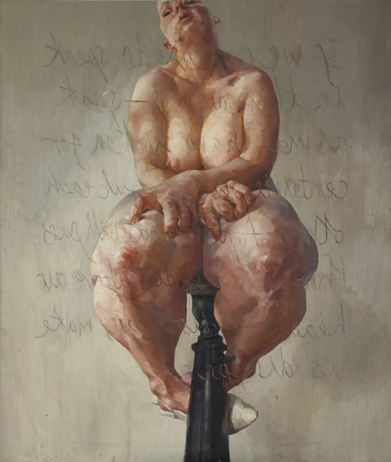

Figure 1
An art piece I am going to explore is Saville, J. (1992). Propped. [oil]. This piece is a significant painting by Saville and it displays a nude self-portrait of her sitting on a chair with her arms crossed on her lap. This pose is significant because Saville is covering her body which portrays her being in desperation to hide it which connotes insecurity and still being uncomfortable with herself due to there still being a struggle to accept her body because of the expectations placed upon her as a woman. This small detail in Figure 1 emphasizes the resistance to her journey with self-love and acceptance that comes with being a plus-size woman due to being in a misogynistic society.
Saville’s figure claws at her flesh, struggling to exist within the narrow confines of the role prescribed to her by a patriarchal society.

(Sotheby's, 2018)
Her features in Figure 1 are very exaggerated to seem larger than they are with oversized hands and legs. The chair she is sitting on has been painted at the centre bottom leading up toward the figure. This emphasizes attention on the figure which adds a sense of immediacy to the viewer. The colours used are muted realistic skin colours. The realistic colour palette makes the piece very fleshy and raw. I have chosen to look at this piece by Saville because it challenges the traditional portrayal of the female body and intends to reevaluate societal norms. The brush strokes are an important aspect of Saville’s’ practice as she focuses on adding texture, boldness, and distortion. This expressive art style adds a sense of intimacy which adds an emotional impact to hook the audience. Because of this effect on the audience, it adds emphasis on the encouragement to reconsider their opinions of what they know about the female body and beauty standards. This links to the concept of gender because it challenges what a woman is supposed to look like as the intentional distortion of this painting enhances the rolls and curves of the figure to add plus size representation.
This research into Saville’s art practice has led me to the outcome that her work is presenting that women’s bodies have these beauty standards put onto them for the pleasure of men. This is because of the male gaze theory which is evident in the quote “sees us in a way that aligns with expectation” (Travis Alabanza, 2021, pg. 10). This quote explains that when men look at women, they are expecting them to behave and look a certain way that meets societal beauty standards places upon women.
Paula Rego
The next artist I am going to explore who has looked at gender in their art practice is Paula Rego. Rego was a Portuguese artist known for her figurative paintings, drawings, and prints. Her artwork typically displayed scenes of emotional and psychological undertones. Rego’s art explores issues relating to gender, power, and societal expectations. She has explored the challenges women face in a variety of different scenarios which is why I have chosen to investigate her.

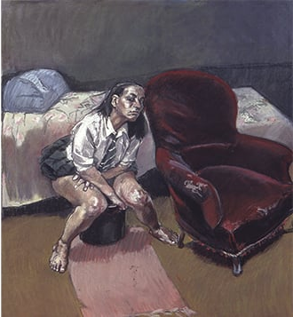

Figure 2
The art piece I am going to explore by her is Rego. P (1998) the abortion pastels [pastel]. This is a series depicting women’s experiences with abortions. In figure 2, it displays a schoolgirl crouched over her bucket beside a bed. There is what seems a rug on the floor trailing up to the figure which creates a trail toward the figure to insert importance onto the painting. The rug leading up to the figure reminded me of a red carpet which in the context of Hollywood and celebrity importance, it emphasises the significance of the figure from the perspective of the viewer. This could be seen as a technique to encourage the viewer to take the issues Rego is trying to convey more seriously as the trailing rug makes the figure become the spotlight of the painting. This could have the effect of getting the viewer hooked on the piece which makes them take the issue more seriously. Rego has used pastels to add dark contours around the face to give off a distressed expression on the schoolgirl to make the viewers uncomfortable. In this series, Rego explores the complexities and distress that women had to face because they did not have proper access to abortion healthcare during this time In Portugal. “In 1998 a referendum to legalize abortion in Portugal failed”. (Cameron, 2020). The rawness of this subject adds emotional depth and honesty to the situation. The shock factor from this series gave her more publicity which led to awareness of what was happening to women. This links to gender roles in society because it shows how women aren’t seen as able to make their own choices involving their bodies. This is a reoccurring theme throughout Regos’s work.
she described the devastating effect of backstreet abortions on women, causing mutilation and sometimes death

(Tate, 2022, pg.290)
Rego’s abortion pastel series relates directly to my research into gender roles in society. This is because she has explored how women have been dehumanized by having their rights stripped away from them which is evident in the fact safe and legal abortions were hard to access. Her work presents the effects of a patriarchal society and how it has led to the oppression of women. Furthermore, the dehumanization is evident in the quote “This world has always belonged to men”. (De Beauvoir, 1949, pg.26)
Grayson Perry
Finally, I am going to explore the artist Grayson Perry. Perry is a British artist known for his diverse work that explores gender and societal conventions. He is known for his alter ego, ‘Claire’ which is a cross-dressing persona he involves in his practice. He tackles the societal expectations of gender by challenging stereotypes for men and does this through humour. Perry is a male artist and I chose to look at him in this essay to show the differences between male and female artists when exploring gender in artwork. Exploring his artwork will give me a useful perspective for this essay as I will gain insight into how a male artist navigates themes relating to gender.

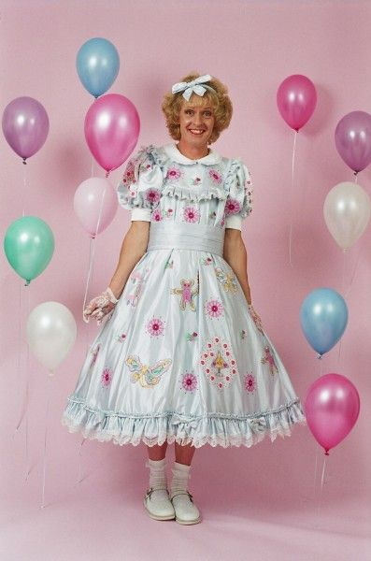

Figure 3
The art piece I will be exploring by him is Perry. G (2000) Claires Coming Out Dress [ textiles]. This piece is a long evening gown with frills and embroidered details of feminine imagery e.g., flowers and butterflies. It has a pink, red and gold colour palette that could symbolize femininity, passion and exploration of identity. I have chosen to look at this piece because it is a symbol for his alter ego Claire which makes it a statement piece of self-discovery with his journey with gender. The Descent of Man (2017) is a book written by Perry in which he explores masculinity in contemporary society. He talks about his journey and experience with gender through personal anecdotes and reflections. This personal touch enriches the book as it invites readers to have more of an understatement of the issue which encourages them to reevaluate what they know about masculinity. Perry explains how he uses his art as a form of self-expression and as a tool for challenging societal expectations. For example, in Figure 3, he wears this cross-dressing dress as a form of resistance as it disrupts traditional norms.
Perry’s approach to tackling gender roles is vastly different compared to female artists. Although male and female artists both struggle with gender roles, their perspectives on gender can not be the same. Female artists like Jenny Saville and Paula Rego create serious artwork about their lived experiences as women and they tackle themes such as body image, sexism and oppression. On the other hand, Male artists like Grayson Perry approach the subject from an outsider’s perspective and can use humour in their artwork which shows how it does not affect them as greatly as women because the use of humour makes the issue seem less shocking. Grayson Perry’s artwork also highlights issues caused by men by the patriarchy. He is making the same point in that the patriarchy is damaging to all genders but in a light-hearted fashion. By using his alter ego, he is exploring how femininity is dismissed in men and masculinity is expected. Whilst gender issues affect men less, Perry draws a light on how destructive a patriarchy is for everyone.

Conclusion
Therefore, it can be concluded that gender is an ongoing problem in society with the impact mainly being upon women. My research into Jenny Saville, Paula Rego, and Grayson Perry has led me to many discoveries about the concept of gender. The critical aspects that I explored in this essay were: beauty standards for women, women’s healthcare, and the difference between male and female art about gender being significant because women are oppressed.
I discovered that Jenny Saville’s artwork challenges traditional representations of the female form by resisting conventional expectations as she displays a less-seen type of body. She portrays this through the use of her colour palette, brush strokes that create texture and raising awareness of plus-size bodies. By defying these conventional norms, her work invites the viewer to reevaluate their perception of women.
Next, I discovered that Paula Regos’s artwork dives into the struggles of being a woman in society. She uses her work as a dialogue for gender as she confronts the diverse experiences that women must endure such as abortion politics. She aims to show the realities of what it is like to be a woman in a patriarchy. Perry’s goal in her artwork was to raise awareness and to dismantle the patriarchal war on women.
Furthermore, Grayson Perry’s artwork explores gender through his alter ego, Claire. From his work, I have gathered that he is a gender anarchist as he goes against societal expectations of being masculine and embraces his femininity. In his work, he shows his personal struggle with identity which he portrays through the use of humour. Using humour makes his work seem not as serious as the women artists I looked at which demonstrates the different levels of effect of gender roles in society on men and women. By looking at Perry, I have learned to expand my discovery of how damaging the patriarchy is as it goes beyond women and is harmful to all things feminine.
This essay was a call for action as we should be focusing on embarking on awareness and continued protest for equality. Although it is not certain, if everyone came together we will collectively move towards an inclusive society that has dismantled and moved past outdated gender roles so all individuals despite their gender can thrive in harmony, and ‘the male gaze’ will be a theory of the past.

Works Cited
Alabanza, T. (2021) Gender. London: Tate Gallery Publishing Ltd. New York, NY
Berger, J. (1972). Ways of seeing. London: British Broadcasting Corporation.
Cameron, S. (2020). The importance of Paula Regos Abortion Series. [online]
Reckitt, H., Gosling, L., Robinson, H., Tobin, A., Balshaw, M. and Xabier Arakistain (2019) The art of feminism: images that shaped the fight for equality. London: Tate Publishing
Sotheby’s (2018). The Groundbreaking Self-Portrait That Launched Jenny Saville’s Career. [online] Sothebys.com. Available at: https://www.sothebys.com/en/articles/the-groundbreaking-self-portrait-that0-launched-jenny-savilles-career
Bibliography
Alabanza, T. (2021). Gender. London: Tate Gallery Publishing Ltd. New York, NY
Berger, J. (1972). Ways of seeing. London: British Broadcasting Corporation.
Butler, J. (1990). Gender Trouble: Feminism and the subversion of identity. London: Routledge
Cameron, S. (2020). The importance of Paula Regos Abortion Series. [online] National Galleries of Scotland. Available at: https://www.nationalgalleries.org/art-and-artists/features/importance-paula-regos-abortion-series
De Beauvoir, S. (1949). The second sex. Vintage classics
Perry, G. (2017). The descent of man. London: Penguin Books
Reckitt, H., Gosling, L., Robinson, H., Tobin, A., Balshaw, M. and Xabier Arakistain (2019). The art of feminism: Images that shaped the fight for equality. London: Tate Publishing.
Sotheby’s (2018). The Groundbreaking Self-Portrait That Launched Jenny Saville’s Career. [online] Sothebys.com. Available at: https://www.sothebys.com/en/articles/the-groundbreaking-self-portrait-that0-launched-jenny-savilles-career

