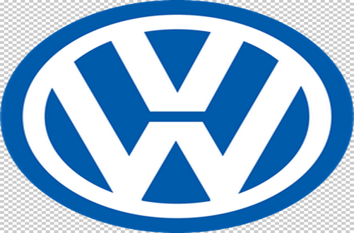
STRATEGIC ANALYSIS OF VOLKSWAGEN

By: Anton Mersinkov

UNIVERSITY OF WALES TRINITY SAINT DAVID

Course: LCBB6004

Table of Contents
Introduction 3
Volkswagen Company 3
Key Business Strategies 4
Resources and Capabilities 8
Competitiveness and Sustainability 11
Recommendations for Sustainability and Competitiveness Enhancement 14
Conclusion 15
Bibliography 16

Introduction
Today, multinational automotive companies face serious operational challenges in the globalised automotive industry. Current operational challenges in the globalised automotive industry result from dynamics in customer habits, technology, legislation, technology, and competition. Successful automotive companies utilise strategic analysis procedures in streamlining operations and guiding decision-making processes (Whittington, 2020). Specifically, the analysis procedure allows professionals to dissect market factors and trends that influence organisational performance. The analysis procedure enables multinational companies to choose suitable operational strategies for specific market conditions (Whittington, 2020). Notably, Volkswagen has depended on strategic analysis procedures in dealing with major operational challenges in the current century. Recent reports indicate that these strategies enable the company to capitalise on its strengths in overcoming operational problems and exploiting market opportunities. Hence, the current study utilises different strategic analysis tools in evaluating key business strategies, resources and capabilities, and sustainability practices for Volkswagen.

Volkswagen Company
Volkswagen (VW) refers to a German automotive that emerged in 1937 and operates within the global automotive industry. The multinational company designs, manufactures, and sells motorcycles, testing systems, turbomachinery, special gear units, engines, industrial turbines, vehicles, chemical reactor systems, automobile spare parts, and propulsion components. The company also provides mobility, fleet management, customer financing, insurance and banking, and leasing services in different continents globally. VW offers its products under brand names like Bugatti, Cupra, Scania, Ducati, Porsche, Volkswagen, Audi, Lamborghini, and Bentley in Europe, Asia Pacific, South America, and North America. The company operates 119 production facilities in 29 nations, employs around 676,000 employees, and sells products in around 150 nations (Volkswagen Group, 2023). The automaker makes around $293.6 billion in annual revenues and approximately $15.6 billion in annual profits through its global operations (GlobalData, 2023). Essentially, its current operations align with its mission to provide profitable, competitive, and innovative products/services that surpass the expectations of its shareholders, customers, employees, and dealers. Volkswagen focuses on providing premium, differentiated, affordable, and environmentally sustainable products to its target customers.

Key Business Strategies
Strategic analysis frameworks indicate that VW changed its strategies after the "dieselgate" scandal of 2015 to promote its profitability and competitiveness in the market. The scandal forced the company to pay approximately $35.25 billion in buyback schemes, civil settlements, compensation, and fines. New strategies have supported the multinational company in addressing its internal problems, strengthening its brands, and overcoming market challenges. In this case, the Ansoff Matrix is a suitable framework for examining the current business strategies for VW (Clarissia, 2020). The 2x2 strategic framework analyses four growth strategies for a business organisation, including market development, market penetration, product development, and diversification strategies. The four strategies enable Volkswagen to accomplish expansion and growth objectives while dealing with the related risks. Notably, the German automaker has capitalised on diversification, product development, market penetration, and market development strategies in accomplishing continuous development objectives. 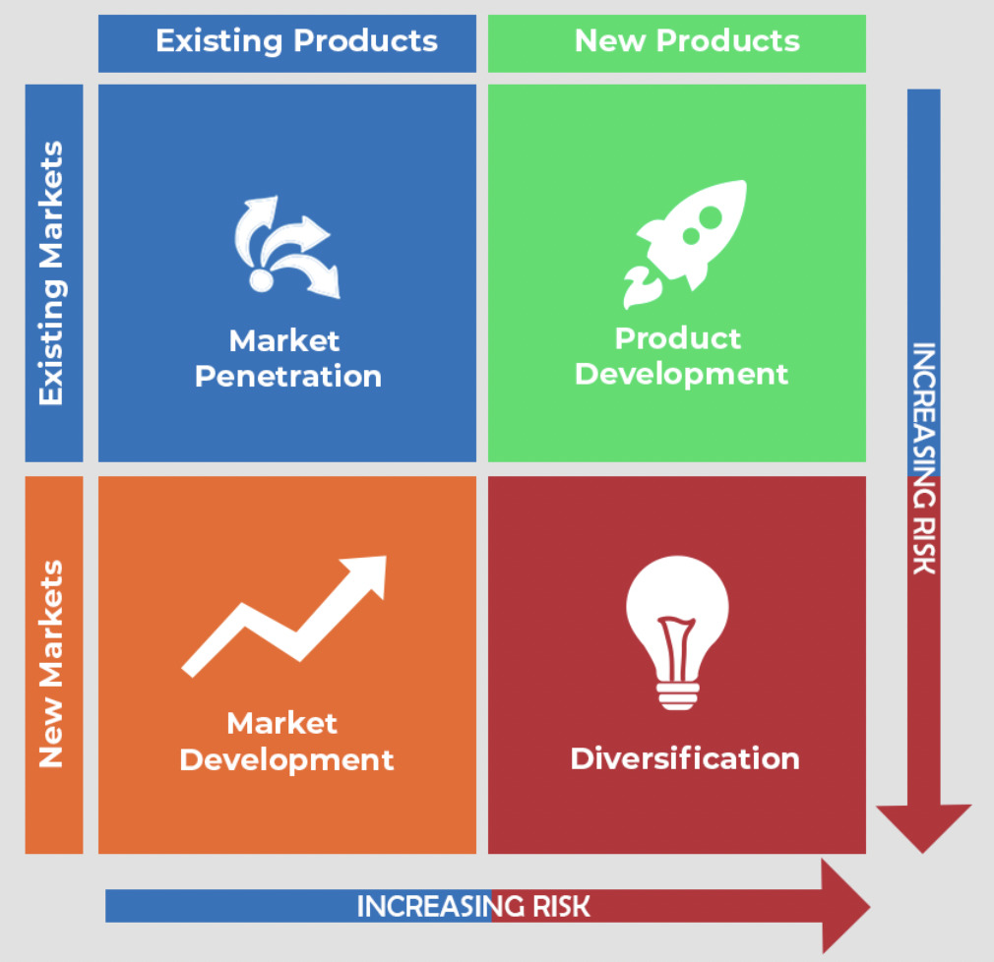
The Ansoff Matrix (Heart of Codes, 2023)

The market penetration initiative enables businesses to enter new markets and accomplish market share growth. The market penetration strategy for VW has elements like production capacity optimization, marketing improvement, distribution enhancement, and competitors’ acquisition. For instance, the automotive company has strengthened its dealer distribution network in the UK, the US, Europe, and Asia (Vassiliadis et al., 2022). The company depends on service improvement and product modification strategies in enhancing satisfaction among its customers. The product development initiative has enabled VW to manufacture and sell fuel-efficient and environmentally sustainable vehicles. Investment in innovative marketing strategies has supported the company in reaching numerous customers in the global automotive industry. The market penetration strategy has also necessitated the implementation of innovative distribution channels to reach new consumer groups and segments in the target market. Furthermore, the automotive company has focused on improving its production capacity by establishing new production facilities in different regions globally.
The market development approach represents VW’s efforts to create new channels and markets for products and services in the market. Various market development activities for this automotive company are regional expansion, R&D, international expansion, and customer education. The R&D supports the automaker in identifying new consumer segments and markets for its different services and products. The R&D program enables the company to comprehend consumer behaviours, trends, and cultures within the target markets. The company depends on marketing and communication strategies in enlightening consumers about brands, services, and products. The strategies create an education procedure that enables clients to understand its new services and products. The communication strategy enables clients to make informed purchase decisions, which reduces the chances of dissatisfaction after the transaction completion. The expansion strategy has supported the automaker in exploiting available opportunities in domestic and international markets.
The current management for Volkswagen considers product development as an important growth strategy. The product development procedure entails improving existing products and creating new products to address growing consumer needs. Therefore, the product development program for the automaker features strategies like product modification, new product creation, product quality optimisation, and R&D. For instance, the R&D program provides creativity, knowledge, and innovation that facilitates product quality optimisation and new products development (Casolaro et al., 2020). The initiative has supported the German automaker in developing eco-friendly and electric automobiles to address the growing need for environmental sustainability. The quality optimisation procedure has supported the company in reducing recall rates among Porsche and Volkswagen vehicle brands. Adequate funds allocation to the R&D program has supported the automotive company in producing electric vehicles and fuel-efficient vehicles, which allows it to compete effectively with electric vehicle manufacturers like Tesla.
Diversification represents a development initiative that enables companies to provide different product and service categories. VW depends on this strategy in maintaining relevance in current consumer markets, which enables it to remain competitive, innovative, and competent (Volkswagen, 2020). The diversification procedure for this automaker features initiatives like horizontal diversification, acquisitions and mergers, creating new business ideas, and vertical diversification. The vertical diversification procedure is a business development initiative that involves introducing new items to existing product lines. On the contrary, horizontal diversification involves creating a new product line to address emerging market trends and consumer behaviours. Horizontal and vertical diversification has supported the company in maintaining relevance in the current automotive industry. Volkswagen has depended on acquisitions and mergers in reducing costs and overcoming challenges of service and product diversification. Recent acquisitions for the German automaker are Fleet Logistics (2019), Diconium (2020), and Europcar (2022).

Resources and Capabilities
SWOT Analysis provides precise information about VW’s resources and capabilities that supports its business strategies. Weaknesses and Strengths are internal factors that influence the company’s performance. Recent analysis proves that the German automaker possesses strengths like financial stability, product innovation, diversification, technological advancement, R&D, an effective marketing program, and an effective HRM program (Lee et.al., 2021). Technological advancements and innovation allow the company to manufacture durable cars with superior features. The company provides a diversified portfolio of vehicles to its diverse consumer populations, including sports cars, Luxury Sedans, and SUVs (Vassiliadis et al., 2022). The manufacturer equips its cars with features like elegant interiors, great styling, an in-car infotainment system, and iDrive to optimise consumer satisfaction and comfort. However, the company has weaknesses like low environmental sustainability, relatively low sales volumes, and poor management structure. Recent research indicates that the company lags in the manufacturer of energy-efficient and electric vehicles compared to its key competitors. Relatively low sales volumes prove that the company trails competitors like Toyota in the development process. A conventional hierarchical management structure is blamed for the slow modernization and technological advancement in this company.
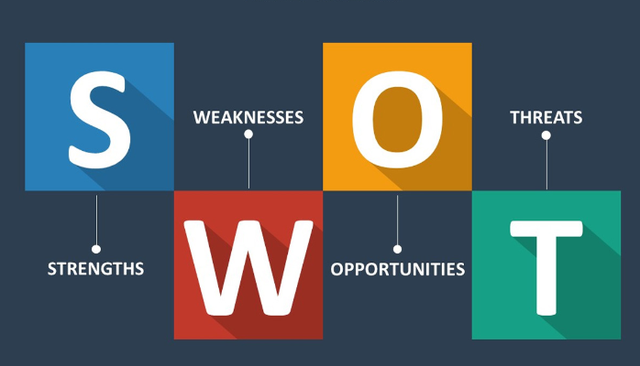
SWOT Analysis (Mindtools, 2023)

Threats and opportunities are external factors that influence Volkswagen’s performance in the current business environment. Existing opportunities for the company in the automotive industry are autonomous driving technology, electric vehicles, digital transformation, emerging markets, and environmental sustainability. For instance, environmental pollution concerns have increased the demand for electric vehicles globally, which offers the company a revenue-optimisation opportunity. Similarly, autonomous driving technology serves a potential revenue stream for vehicle manufacturers. Digital transformation offers manufacturers an opportunity for integrating in-car services, connectivity, and ride-sharing technologies with their vehicles (Wassiliadis et al., 2022). Still, VW faces multiple threats in the international automotive industry, including cybersecurity risks, regulatory changes, competition pressure, technological disruption, and environmental sustainability concerns. Strict safety standards, environmental regulations, and quality standards expose the company to reputation risks. The competition pressure from players like Hyundai Motors, Tesla, Toyota, Ford Motor, Mercedes-Benz Group, BMW Group, and Renault prevents VW from expanding its market share. The company’s complex supply chain is vulnerable to disruptions from trade disputes, pandemics, natural disasters, and geopolitics. Rapid technological advancement poses a threat to conventional business models and creates cybersecurity risks.
The current administration for the company has focused on addressing its weaknesses, capitalising on strengths, seizing new opportunities, and overcoming emerging threats in the international automotive industry. Markedly, the company’s management has depended on numerous resources and capabilities in addressing threats and seizing opportunities available in the global automotive industry (Barney & Hesterly, 2018). Various resources that have supported the company in overcoming external threats and internal weaknesses include human resources, finances, R&D program, and technology. For instance, the company has depended on human resources in enhancing its innovation and productivity in the past five years. In this respect, the company has utilised strong compensation programs in retaining and attracting competent employees in its production, distribution, and administration facilities (Hill et al., 2019). The company has depended on advanced technology and its financial capability in supporting its research, expansion, and product development processes. For instance, the R&D program can support the company in manufacturing autonomous, electric, and energy-efficient vehicles.

Competitiveness and Sustainability
Volkswagen has implemented different strategies to adapt to the macro environmental variables of the current automotive industry. Current management for this automaker understands that these macro environmental variables are beyond its control. The PESTEL analysis tool indicates that the company must focus on adapting to economic, political, social-cultural, legal, technological, and environmental factors. First, the automaker focuses on keeping abreast with political situations in different nations, including the UK. Currently, the company’s management has focused on adapting to changes in UK laws in the post-Brexit period, including import tariffs and trade laws (Chang, 2018). New trade laws create a situation where customers must pay additional fees for vehicles imported from foreign automotive companies (Tetlow & Stojanovic, 2018). Second, the company focuses on dealing with economic trends and conditions that influence its growth, profitability, and operations. The administration considers that Brexit, Russo-Ukraine War, and the Covid-19 pandemic have created unfavourable interest rates, exchange rates, and tax policies for the business. The management considers that the current economic situation has created unemployment and fuel price increase, which has reduced the demand for fossil fuel-powered vehicles.
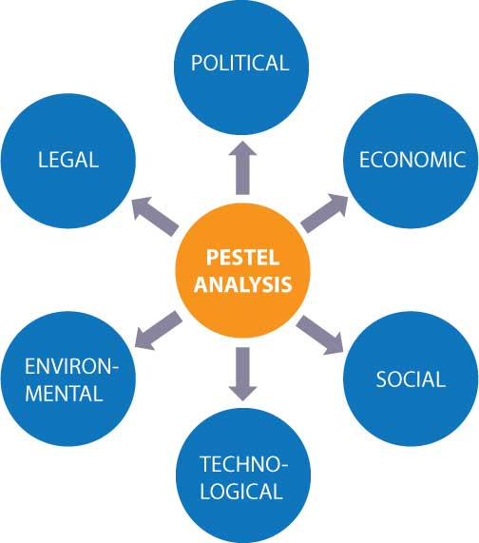
PESTEL Analysis (SafetyCulture, 2023)

Third, VW focuses on dealing with social-cultural factors influencing its operations in different regions and nations. Social-cultural factors influencing the automaker’s performance include consumer behaviours, consumer trust, cultural preferences, demographics, and lifestyle trends. For instance, current attitudes towards environmental sustainability have increased the demand for hybrid, electric, and fuel-efficient vehicles in most societies. The company also focuses on addressing the demand for reliable and safe vehicles in the market. VW also focuses on designing vehicles that address the unique cultural preferences of clients located in different continents and regions. The current situation further necessitates the consideration of lifestyle trends, demographic characteristics, and safety trends during the design of automobiles. Fourth, the automotive company considers technological factors that influence the demand for financial services and motor vehicles. Various technologies that define competition in the automotive industry are hybrid technologies, the Internet of Things, autonomous driving, electric vehicles, artificial intelligence, and manufacturing technology. For example, manufacturing technologies like 3D printing, robotics, and automation support automotive companies in improving product quality, reducing operational costs, and increasing production efficiency.
Fifth, Volkswagen has focused on increasing its competitiveness and profitability while implementing environmentally sustainable strategies. The German automaker has accomplished this objective by considering current environmental issues, including resource scarcity, emission standards, waste management strategies, resource scarcity, biodiversity, and energy efficiency. The company understands the seriousness of emission standards following the Dieselgate scandal of 2015. VW considers that eco-friendly alternatives for diesel and petrol engines have helped in slowing down climate change (Volkswagen Newsroom, 2021). The company understands that waste management strategies like recycling help in reducing raw materials’ extraction rate and protecting local diversity (Zhang et al., 2021). Finally, the company understands the need to adhere to labour laws, emission regulations, safety standards, and intellectual property laws. VW focuses on ensuring the reliability of vehicular safety features like seat belts, stability controls, brakes, and airbags. The development of electric, energy-efficient, and hybrid vehicles also requires the company to adhere to intellectual property laws.

Recommendations for Sustainability and Competitiveness Enhancement
Generally, Volkswagen can adopt different sustainability measures in optimising its competitiveness in the future. Strategic sustainability initiatives that can offer this company a competitive advantage in the international automotive industry are green strategy, strategic sustainability, CSR (corporate social responsibility), and business ethics. The strategic sustainability initiative would involve sustainable manufacturing practices and eco-friendly product development. The initiative means that the company concentrates on producing eco-friendly products like electric cars, solar panels, and energy-efficient engines. The automotive company should focus on reducing energy and water consumption in the production phase through energy-efficient machine usage and green building constructions. VW should invest in green strategies like recycling, sustainable raw materials usage, sewage treatment, waste minimization, and solar energy usage. Sustainable natural resource usage can support the company in reducing carbon emissions and protecting local biodiversity.
Strengthening the CSR program can support the German automotive company in accomplishing the environmental sustainability goal and strengthening its brand image. Notably, a proper CSR program allows businesses to balance profit optimisation goals with stakeholder protection requirements (Barney & Hesterly, 2018). The statement implies that the program can support the company in protecting the interests of stakeholders like shareholders, customers, governments, employees, and local communities (Grant, 2018). For instance, VW should ensure that resource extraction and manufacturing practices do not destroy ecosystems and endanger human life. In this regard, the automotive company should engage local communities in making decisions concerning resource extraction and plant locations. The CSR program design would also entail providing a comfortable and safe environment to employees working in its offices, warehouses, and manufacturing facilities. Additionally, this business organisation should utilise business ethics in guiding the design of its CSR, green strategy, and strategic sustainability program. Ethical principles that can guide the business in balancing sustainability with competitiveness enhancement interests include fairness, transparency, responsibility, honesty, respect, and accountability.

Conclusion
Strategic analysis tools indicate that Volkswagen has effectively utilised sustainable and innovative strategies in addressing operational challenges in the global automotive industry. The analysis proves that the multinational company focuses on rebuilding trust with customers after the scandal tainted its image. The Ansoff Matrix indicates that the company has been using growth strategies like market development, market penetration, product development, and diversification strategies in the past five years. For instance, the company has depended on domestic and international expansion strategies in optimising its competitiveness, profitability, and revenues. The company possesses strengths like financial stability, product innovation, diversification, technological advancement, R&D, an effective marketing program, and an effective HRM program. The strengths can enable the company to seize new opportunities in the automotive industry, including autonomous driving technology, electric vehicles, digital transformation, and emerging markets. Green strategy, strategic sustainability, CSR (corporate social responsibility), and business ethics can further support the company in improving its competitiveness in the current automotive industry.

Bibliography
Barney, J. B. & Hesterly, W. S., 2018. Strategic Management and Competitive Advantage:
Concepts and Cases. 6 ed. Essex: Pearson Education Limited.
Casolaro, F. and Cristiani, M., 2020. The Volkswagen Case: Analysis of a “Scandalous” Growth.
Decision Making in Social Sciences: Between Traditions and Innovations, pp.503-513.
Chang, W.W., 2018. Brexit and its economic consequences. The world economy, 41(9), pp.2349-
2373.
Clarissia, S.M.S., 2020. A study on Ansoff Matrix Technique: As a growth strategy and an
adaptive learning technique adopted in the leading brand of products. BIMS Journal of Management, 18.
GlobalData, 2023. Volkswagen AG: Overview. [Online] Available at.
https://www.globaldata.com/company-profile/volkswagen-ag/ [Accessed on: 22 July
2023]
Grant, R. M., 2018. Contemporary Strategy Analysis. 10 ed. NJ: John Wiley & Sons, Inc.
Heart of Codes, 2023. Why is BCG Matrix of Google Important ? [Online] Available at.
https://heartofcodes.com/why-is-bcg-matrix-of-google-important/ [Accessed on: 22 July
2023]
Hill, C. W. L., Schilling, M. A. & Jones, G. R., 2019. Strategic Management, Theory & Cases.
13 ed. Boston: Cengage Learning.
Lee J, Kim J, Kim J, Choi S., 2021. "Why Localization Is
Necessary as a Business Strategy in Emerging Markets: The Case Comparison of Hyundai and Volkswagen" Journal of Open Innovation: Technology, Market, and Complexity 7, no. 3: p. 190.
Mindtools, 2023. SWOT Analysis [Online] Available at:
https://www.mindtools.com/amtbj63/swot-analysis [Accessed on 23 July 2023]
SafetyCulture, 2023. Using PESTLE Analysis in Strategic Business Planning [Online] Available
at: https://safetyculture.com/topics/pestle-analysis/ [Accessed on 23 July 2023]
Tetlow, G. and Stojanovic, A., 2018. Understanding the economic impact of Brexit. Institute for
government, pp.2-76.
Volkswagen, 2020. The future on hand ANNUAL REPORT 2020 [Online] Available at:
https://annualreport2020.volkswagenag.com/group-management-report/sustainable-value-enhancement/sales-and-marketing.html [Accessed on 23 July 2023]
Volkswagen Group, 2023. Profile: The Volkswagen Group. [Online] Available at:
https://www.volkswagen-group.com/en/profile-15933 [Accessed on 24 July 2023]
Volkswagen Newsroom, 2021. Significant CO2 savings possible: latest-generation diesel engines
approved for fuels made from residual and recycled materials [Online] Available at: https://www.volkswagen-newsroom.com/en/press-releases/significant-co2-savings-possible-latest-generation-diesel-engines-approved-for-fuels-made-from-residual-and-recycled-materials-7691 [Accessed on 24 July 2023]
Wassiliadis, N., Steinsträter, M., Schreiber, M., Rosner, P., Nicoletti, L., Schmid, F., ... &
Lienkamp, M., 2022. Quantifying the state of the art of electric powertrains in battery electric vehicles: Range, efficiency, and lifetime from component to system level of the Volkswagen ID. 3. Etransportation, 12, 100167.
Whittington, R., 2020. Exploring strategy: Text and cases (12th ed.). Harlow: Pearson.
Zhang, M., Atwal, G. and Kaiser, M., 2021. Corporate social irresponsibility and stakeholder
ecosystems: The case of Volkswagen Dieselgate scandal. Strategic Change, 30(1), pp.79-85.

