University of Wales Trinity Saint David
School of Engineering
Exercise on forecasting demand planning
Lauren Lloyd
2315243
Degree Apprenticeship in Logistics and Supply Chain Management
24th July 2025
Capacity Planning (ACMA5013)

LEVEL 5 ASSESSMENT SPECIFICATION

Student name: | Lauren Lloyd | Student ID number: | 2315243
Programme: | DA Program in and Supply Chain and Logistics
Module: | Capacity Planning
Module code: | ACMA5013 | Contribution to Overall Module Assessment (%): | 100%
Lecturer: | Dr Moutushi Tanha | Internal Verifier: | Dr Irina Neaga
Assignment Title: | Exercise on forecasting demand planning | Word count (or equivalent): | 2000 words
Submission deadline: | 15/07/2025 | Return date of provisional marks & written feedback: | Within 20 working term time days of submission date
Submission method: | All written assessments, where practical and possible, must be submitted via Turnitin unless otherwise instructed by the Lecturer. (Please DO NOT put this assessment specification into Turnitin or it will match many similarities with other students’ submissions.)  Alternative submission method (if applicable):  Late submission of the assessment will result in a late penalty mark. Penalties for late submission: Up to one week late, maximum mark of 40%. Over one week late, 0%. Only the Extenuating Circumstances Panel may approve a change to submission dates.
Academic honesty / referencing: | Academic honesty is required. In the main body of your submission, you must give credit to authors on whose research and ideas your work is based. Append to your submission a reference list that indicates the books, articles, etc. that you have used, cited or quoted in order to complete this assessment.

Module Learning Outcomes (from module syllabus)
Upon the successful completion of this module, the student should be able to:
- apply a range of forecasting and planning techniques required in logistics and supply chain management.

TASK DESCRIPTION

Use of Generative AI in Assessment

RESEARCH | For this assessment, you can use Generative AI to support you in research, including searching for bibliography, using tools to summarise, compare and interrogate materials. | Yes ​☒​  No ​☐​
STRUCTURE | For this assessment, you can use Generative AI to support you in structuring your submission, including creating a draft argument structure, identifying parts and headings, etc. | Yes ​☒​  No ​☐​
PROOFREADING | For this assessment, you can use Generative AI to check your own text/creation for grammatical and syntactical mistakes, including rephrasing of your own work within specific standards. | Yes ​☒​  No ​☐​
WRITING | For this assessment, you can use Generative AI to create text for submission. | Yes ​☐​  No ​☒​
CREATIVE | For this assessment, you can use Generative AI to create creative materials, such as images. | Yes ​☐​  No ​☒​
PROGRAMING | For this assessment, you can use Generative AI to create and check code. | Yes ​☐​  No ​☒​
NONE | For this assessment, you are not allowed to use any type of Generative AI support. This includes research support, structure support, writing/proofreading support and creative support. | Yes ​☐​  No ​☒​

AI Acknowledgement

I confirm that I have not present any AI-generated materials as my own work in this portfolio.

However, I acknowledge that I have used or may have used the AI in the research and proofreading of my portfolio.

Name: Lauren Lloyd
Student ID: 2315243

Table of figures
Table 1: Table showing Level only Forecast & Corrected Version Forecast 13
Table 2: Forecast for fall and holiday period 14
Table 3: MRP Explosion 17

Figure 1: The Product Life Cycle (Kaufholz, 2021) 9
Figure 2: Time Series Patterns (Shailesh, 2024) 12
Figure 3: Level Production Strategy 16
Figure 4: Chase Production Strategy 16

Table of Contents
Question 1. 6
Question 2. 11
Question 3 A 13
3.1A Level Only Model 14
3.2A Corrected Version 14
3.3A Forecasting Error 14
Question 3 B 14
3.1B determine the forecast for fall and holiday period 14
Question 4 15
Level production strategy (Marks: 7.5) 15
Chase strategy (Marks: 7.5) 16
Which strategy will you recommend to the company to follow? (Marks: 5) 16
Question 5 17
Do an MRP explosion for all items required to make these two garden tools. (15) 17
What actions, if any, should be taken immediately and what other potential problems do you see? (5) 19
References 19
Appendix 22

Question 1.
Discuss different types of quantitative and qualitative forecasting methods and application of these methods at your organization for predicting demand and sales of its products? Explain the nature of demand (spatial Vs temporal, regular Vs irregular and derived Vs independent nature of demand) and justify which one is applicable in your organizational demand for products it is producing and selling. Discuss how does use of forecasting techniques vary in terms of different stages of the Product Life Cycle. Is any collaborative forecasting used by your organization. If yes, explain this with all the steps of developing collaborative forecasting. (10+5+5+10 = 30)

Forecasting tools are used within organisations to help to predict demand and sales of its products in a more accurate manner and can be done through quantitative forecasting which involves using historical numerical data to predict future forecasting through the use of statistical models, or/ and qualitative forecasting which involves using human judgements and opinions to form a forecast (Caballar & Stryker, 2024).
Quantitative forecasting can be conducted in various ways, typically through time series, moving averages, and regression analysis (Haywood, 2023). Whereas qualitative forecasting can be conducted through market research, panel consensus, or gathering expert opinions (Delphi Method) (Haywood, 2023).
In Sony, quantitative forecasting is used to predict demand for future months/ years via time series and moving averages. In addition to this, Sony gathers qualitative data from our customers that could improve understanding of potential future sales.
For example, before each fiscal year, Sony receives a forecast from each of the customers which highlights projected sales in the upcoming year. Then at the end of that fiscal year, Sony compares the customer’s forecast with what was actually sold to them, highlighting any variances to what was forecasted. This helps as it enables Sony to understand where sales have been over forecasted/ under forecasted and by how much. In addition to this, Sony uses qualitative data to understand the reasoning behind the variances in sales i.e., whether there was a swing in demand from one product to another because of increased promotion. This is because quantitative data alone isn’t enough to predict sales accurately as there could be multiple factors behind the scenes that impacted previous results and therefore won’t reflect future sales. Qualitative data must therefore also be used to fill in and account for any assumptions and context (FasterCapital, 2025).

Demand as a whole is a customer’s willingness to purchase something in the market, generally linked to the price of the product that the business is supplying. There is an inverse relationship between demand and prices (Kelly & Perez, 2025). There are multiple categories within this, namely spatial, temporal, regular, irregular, derived, and independent demand.
Spatial demand is the demand for a product at a particular locations, whereas temporal demand refers to the amount of time associated to complete a product or task and can also focus on how products change over time (Dabasinskas & Sujetoviene, 2024).
Irregular demand is when demand generally tends to fluctuate unpredictably mostly due to external factors (Thompson, 2021). Businesses that face irregular demand will tend to struggle with capacity, staffing levels and cash flow (Thompson, 2021). On the other hand, regular demand is when demand is predictable and consistent throughout a period/ a year. An example of this is seasonality where products will face predictable demand levels due to specific seasons of the year. Sony generally experiences regular demand for its products with relatively similar demand annually. However, that does not mean that demand is the same month on month as generally Sony see increasing demand over the Christmas period for gifts.
Independent demand is when there is demand for finished goods directly. This is opposite to derived demand, which refers to the demand for parts that are required to produce finished goods (Brock, 2023). So, demand for these parts solely depend on demand for the related product. In Sony, both independent and derived demand is seen. As finished goods are produced at Sony, there are multiple products underneath this sku on the bill of materials that will have derived demand from it. An example of this is where a camera is the independent demand, the product will need carboard packaging, many capacitors, and sub-assembly boards which would be the derived demand.

The product life cycle demonstrates the stages each product goes through within the market (Kaufholz, 2021). The four key stages are highlighted in figure 1.
Figure 1: The Product Life Cycle (Kaufholz, 2021)
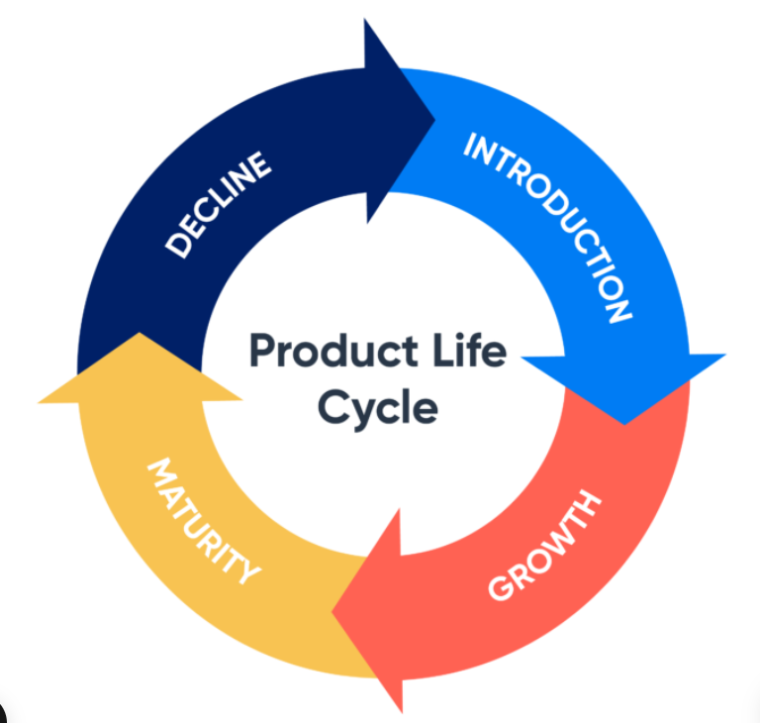
Throughout the product life cycle, the way in which forecasting techniques are used fluctuates as each stage is different and requires different information (Hu, et al., 2016).
In the initial stages of a product life cycle such as product development, there will not be a huge amount of quantitative data available for the product as it is new, therefore the only quantitative data a business can use is analysing other historical data for similar products on the market (Chambers, et al., 1971). However, this can leave various gaps in knowledge. Therefore, the business will have to rely further on qualitative data to form a more accurate forecast. In this situation, it is found that the three most popular forecasting techniques are market research, executive opinion, and sales force input (Khan, 2002).
Then, as the product begins to develop further into the testing and introduction phase, the information that the company requires will be slightly different. In this phase, the company would likely seek customer surveys to identify strengths and weaknesses. There will now be some sales data from purchases so the company will be able to start using this to form a forecast (Bendis, 2023). However, this must be done with caution as this is still a new product so the market response to it still isn’t concrete.
The next stage is rapid growth, where there is rapid sales increase and customer growth (Bibey, 2023). Companies will now have enough data to use statistical techniques to identify forecasts and any turning points (Chambers, et al., 1971). Albeit, qualitative data from customer surveys are still key when forecasting.
Lastly is the maturity stage where businesses tend to run promotions and advertisements, and sales have now steadied compared to the rapid growth stage. In this stage, businesses can now use current sales data to estimate what the future sales for the business will be, generally through the use of time series analysis and then using that data to forecast the future sales (Chambers, et al., 1971). Analysis of products in this stage must be done regularly so companies can identify and take action when or if their products start to enter the decline phase (Bendis, 2023).

Collaborative forecasting is a demand planning process in which multiple business functions work together to build a single forecast (Rajeckas, 2025). This is a stark difference to traditional forecasting where companies use mainly quantitative data and do not seek insight from other departments within the business, which often leads to incomplete and inaccurate demand forecasts (GEP, 2021).
The first step of developing a collaborative forecast within Sony is to set an objective that must be measurable, an example of this is to create a sales forecast for financial period 2024 and to measure how actual sales throughout the year compared to the sales forecast that was budgeted. Setting clear goals often improves the way a business performs as these help to evaluate progress with the goal and identify any room for improvements (Hall, 2020).
The next step is working out who should be involved in the forecasting process. Within Sony, the departments involved with creating a sales forecast typically are finance, planning, sales, account management, and the senior management team. Each department brings their own information and insights into the forecasting process.
Then, over a period of a month there are regular meetings that take place where all stakeholders are gathered to discuss customer’s forecasts and whether they believed the numbers based on their experience and past data. These discussions take place in person, with forecasts created in excel.
Once the forecast has been created and then approved, the next stage of reviewing the data kicks in. On a monthly basis, the team will re-group and compare the accuracy of what was sold in that period compared to the forecast, highlighting any differences and identifying the reasoning behind this. All of the background data collected in this stage will help make future forecasts more accurate within Sony.
Collaborative forecasting as a whole improves communication, trust, accuracy and joint decision making within businesses (Hollmann, et al., 2015). However, the success of collaborative forecasting depends on various factors such as the industry of the business, whether the demand is inelastic or elastic, and whether people in the business are confident sharing data with other members of the business (Hollmann, et al., 2015).

Question 2.
- Distinguish between typical time series patterns (trend, seasonality, cyclicality and random variation in demand). (10% out of 100%)
A time series is a sequence of data points that occur in successive points in time. When forecasting, the use of time series points can be used to predict future activity (Hayes, 2022). Within typical time series patterns, there are different components such as trend, seasonality, cyclicality and random variation (irregular). Charts that represent each of these elements are shown in figure 2.

Figure 2: Time Series Patterns (Shailesh, 2024)
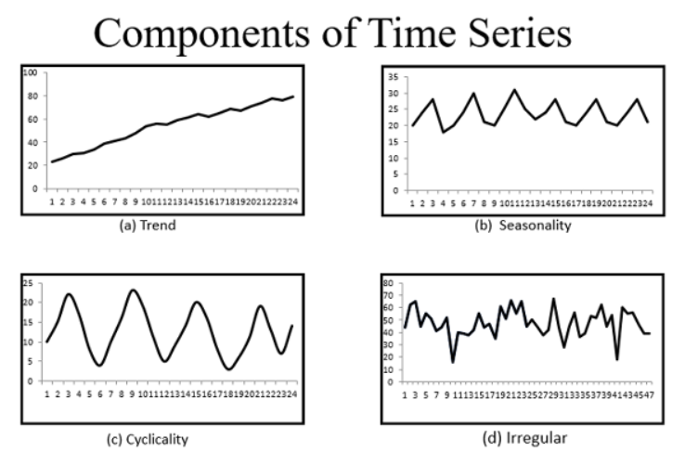
Trends as a typical time series pattern is where demand increases or decreases over time, which could represent an increase in sales for a product over time (Anish, 2020).
Seasonality is when demand for a product fluctuates throughout a period time, for example over a calendar year. This generally occurs due to different holidays and seasons throughout the year (Cerqueira, 2023).
Cyclical variation can often be confused for seasonality, but it differs as cyclical variation occurs over longer time periods. This is typically related to the economic climate and cycles, such as recessions (Manibhushan, 2022)..
Random variation is where demand for a product/ business is very unpredictable and fluctuates in a pattern that does not correspond to a trend, seasonality, or cyclical variation. This is hard to predict but typically co-insides with unexpected events or shifts in public perceptions (Peng, 2020).A
Analysing and understanding the demand patterns for the products a company supplies is key to the way it operates. It supplies companies with information surrounding customer preferences, prevents stockouts or overstock situations, and can also help businesses determine the correct pricing strategy (FasterCapital, 2025).

Question 3 A
Table 1: Table showing Level only Forecast & Corrected Version Forecast

Year | Quarter
Year | 1 | 2 | 3 | 4
Last year | 1200 | 700 | 900 | 1100
This year | 1400 | 1000 | F3 =?
Level Only Forecast | 1000 | 1080 | 1064
Corrected Version Forecast (rounded) | 1008 | 1117 | 1118

3.1A Level Only Model
Please see the results of the level only model in table 1. Please see workings out in Appendix 1

3.2A Corrected Version
Please see the results of the level only model in table 1. Please see workings out in Appendix 2

3.3A Forecasting Error
Range of forecast of actual demand for Q3 is 1064-800 < 1064+800
= 264<1864
Please see workings out in Appendix 3

Question 3 B

3.1B determine the forecast for fall and holiday period
Table 2: Forecast for fall and holiday period
Sales Period | Time Period (t) | Sales (Dt) ($000s) | Sales * Time Period | Time Period ^2 | Trend Quantity | Index | Trend qty * Index
Summer | 1 | 9458 | 9458 | 1 | 12053 | .78
Trans-season | 2 | 11,542 | 23084 | 4 | 12539 | .92
Fall | 3 | 14,489 | 43467 | 9 | 13025 | 1.11
Holiday | 4 | 15,754 | 63016 | 16 | 13512 | 1.17
Spring | 5 | 17,269 | 86345 | 25 | 13998 | 1.23
Summer | 6 | 11,514 | 69084 | 36 | 14484 | .79
Trans-season | 7 | 12,623 | 88361 | 49 | 14970 | .84
Fall | 8 | 16,086 | 128688 | 64 | 15456 | 1.04
Holiday | 9 | 18,098 | 162882 | 81 | 15942 | 1.14
Spring | 10 | 21,030 | 210300 | 100 | 16428 | 1.28
Summer | 11 | 12,788 | 140668 | 121 | 16915 | .76
Trans-season | 12 | 16,072 | 192864 | 144 | 17401 | .92
Fall | 13 | ? | ? | 169 | 17887 | 1.04 | 18602.5
Holiday | 14 | ? | ? | 196 | 18373 | 1.14 | 20945.2
Total | 78 | 176,723 | 1218217 | 650

Please see the forecast for fall and holiday period in table 2. See workings out in Appendix 4.

Question 4

Level production strategy (Marks: 7.5)
A level production strategy is where production in a company remains at a constant level despite demand variations. This means that finished goods inventory fluctuates throughout the year, decreasing in a high demand period and increasing in low demand periods (Swamidass, 2000).
The cost of a level production strategy is $490,480 (including the $2000 charge for starting inventory). See workings out in Figure 3.
Figure 3: Level Production Strategy

Chase strategy (Marks: 7.5)
A chase production strategy is where businesses align production output with the market demand, involving regular adjustments to the production capacity (Kumar, 2022).
The cost of a chase production strategy is $436,577.50 (including the $2000 charge for starting inventory). See workings out in Figure 4.
Figure 4: Chase Production Strategy

Which strategy will you recommend to the company to follow? (Marks: 5)
I would recommend this company to implement a chase strategy as although it means having to hire a new worker & run overtime, it also reduces costs and reduces the amount of inventory within the business. This leads to reduced holding costs in businesses, and will also lower the risk of holding stock of a product that will become obsolete (Kumar, 2022).
Nevertheless, there are risks associated with using the chase strategy within businesses, notably if there is a large and unexpected order for a product within the business and a chase strategy is used, it is unlikely that the business will be able to meet the new demand levels (Malindzakova, et al., 2024). Whereas if the company followed a level strategy there would be more ability to fulfil this order due to the increased stock carrying levels throughout.
However, it is important to note that an aim of this company is to study the markets response to the product and focus on developing it further, so it is vital to keep the manufacturing cost as low as possible to enable as much money as possible to be spent on R&D. This is another key reason why adopting a chase production strategy fits the current needs of this company more at this point in time compared to a level strategy.

Question 5

Do an MRP explosion for all items required to make these two garden tools. (15)
An MRP explosion works out the requirements of each part on a bill of material based on demand for the parent part (Krajewski, et al., 2018). This identifies what parts are needed and when.
Table 3: MRP Explosion
 | Garden Tool A |  |  |  |  | Garden Tool B
 | 2 weeks lead time |  |  |  |  | 1 week lead time
2xC |  | 1xE |  |  | 1xC |  | 2xD
1 week lead time |  | 2 week lead time |  |  | 1 week lead time |  | 2 week lead time
 |  | 1xF |  |  |  |  | 1xE
 |  | 1 week lead time |  |  |  |  | 2 week lead time
 |  |  |  |  |  |  | 1xF
 |  |  |  |  |  |  | 1 week lead time
C | Week 1 | Week 2 | Week 3 | Week 4 | Week 5 | Week 6 | Week 7
Gross Requirements |  |  | 200 |  | 400 | 300
Scheduled Receipts | 450
Projected on hand | 550 | 550 | 350 | 350 | 350 | 50 | 50
Net requirements
Planned order receipts |  |  |  |  | 400
Planned order releases |  |  |  | 400
E | Week 1 | Week 2 | Week 3 | Week 4 | Week 5 | Week 6 | Week 7
Gross Requirements |  |  | 100 |  | 500
Scheduled Receipts
Projected on hand | 50 | 50 | 500 | 500 | 0 | 0 | 0
Net requirements
Planned order receipts |  |  | 550
Planned order releases | 550
D | Week 1 | Week 2 | Week 3 | Week 4 | Week 5 | Week 6 | Week 7
Gross Requirements |  |  |  |  |  | 600
Scheduled Receipts | 50
Projected on hand | 120 | 120 | 120 | 120 | 120 | 0 | 0
Net requirements
Planned order receipts |  |  |  |  |  | 480
Planned order releases |  |  |  | 480
F | Week 1 | Week 2 | Week 3 | Week 4 | Week 5 | Week 6 | Week 7
Gross Requirements |  | 100 |  | 500
Scheduled Receipts
Projected on hand | 900 | 800 | 800 | 300 | 300 | 300 | 300
Net requirements
Planned order receipts
Planned order releases

What actions, if any, should be taken immediately and what other potential problems do you see? (5)
An action that should be taken immediately is to order a quantity of E to cover production demands. A potential problem I see based on this MRP explosion is the low inventory of parts C, E, and D. If a new order was placed for immediate delivery, the company would struggle to meet it due to low inventory on hand.
Another potential problem that could be foreseen is the knock-on impact it would have if any of the parts were delivered late, i.e., production delays, operational disruptions, and missed deadlines (Scheich, 2023). This results in poor customer satisfaction from late deliveries, potentially leading to fewer orders in the future.

References
Anish, A., 2020. Time Series Analysis. [Online]
Available at: https://medium.com/swlh/time-series-analysis-7006ea1c3326
[Accessed 20 July 2025].
Bendis, M., 2023. Guide to managing the product life cycle. [Online]
Available at: https://www.easystock.com/uk/blog-uk/inventory-management-product-lifecycle-planning/
[Accessed 24 July 2025].
Bibey, C., 2023. What is growth stage?. [Online]
Available at: https://www.benzinga.com/money/what-is-growth-stage
[Accessed 20 July 2025].
Brock, T., 2023. Derived Demand: Definition, How It's Calculated, and Uses. [Online]
Available at: https://www.investopedia.com/terms/d/derived_demand.asp
[Accessed 22 July 2025].
Caballar, R. D. & Stryker, C., 2024. What is Forecasting?. [Online]
Available at: https://www.ibm.com/think/topics/forecasting
[Accessed 21 July 2025].
Cerqueira, V., 2023. 3 Types of Seasonality and How to Detect Them. [Online]
Available at: https://towardsdatascience.com/3-types-of-seasonality-and-how-to-detect-them-4e03f548d167/
[Accessed 20 July 2025].
Chambers, J. C., Mullick, S. K. & Smith, D. D., 1971. How to Choose the Right Forecasting Technique. [Online]
Available at: https://hbr.org/1971/07/how-to-choose-the-right-forecasting-technique
[Accessed 25 July 2025].
Dabasinskas, G. & Sujetoviene, G., 2024. Spatial and Temporal Changes in Supply and Demand for Ecosystem Services in Response to Urbanization. Land, 13(4), p. 454.
FasterCapital, 2025. Demand analysis definition: What Is Demand Analysis and Why Is It Important. [Online]
Available at: https://fastercapital.com/content/Demand-analysis-definition--What-Is-Demand-Analysis-and-Why-Is-It-Important.html#:~:text=Demand%20analysis%20is%20a%20crucial%20aspect%20of%20understanding,to%20changes%20in%20price%2C%20income%2C%20and%20other%20variable
[Accessed 22 July 2025].
FasterCapital, 2025. Forecasting Techniques: a comparison of qualitative and quantitative methods. [Online]
Available at: https://fastercapital.com/content/Forecasting-techniques--A-comparison-of-qualitative-and-quantitative-methods.html
[Accessed 18 July 2025].
GEP, 2021. What is collaborative forecasting and why supply chains need it. [Online]
Available at: https://www.gep.com/blog/technology/what-is-collaborative-forecasting-and-why-supply-chains-need-it
[Accessed 22 July 2025].
Hall, R., 2020. Why forecasting is important for business success. [Online]
Available at: https://www.baass.com/blog/why-forecasting-is-important-for-business-success
[Accessed 20 July 2025].
Hayes, A., 2022. What is a time series and how is it used to analyse data. [Online]
Available at: https://www.investopedia.com/terms/t/timeseries.asp#:~:text=A%20time%20series%20is%20a%20data%20set%20that,asset%2C%20security%2C%20or%20economic%20variable%20changes%20over%20time.
[Accessed 23 July 2025].
Haywood, 2023. Forecasting METHODS - Qualitative and Quantitative Walkthrough in Excel. s.l.:s.n.
Hollmann, R. L., Scavarda, L. F. & Thome, A. M. T., 2015. Collaborative planning, forecasting and replenishment: a literature review. International Journal of Productivity and Performance Management, 64(7), pp. 971-993.
Hu, K., Acimovic, J., Erize, F. & Mieghem, J. A. V., 2016. Forecasting Product Life Cycle Curves: Practical Approach and Empirical Analysis. SSRN Electronic Journal.
Kaufholz, R., 2021. Product Forecasting: Understanding Demand Throughout the Product Life Cycle. [Online]
Available at: https://www.toolsgroup.com/blog/forecasting-over-the-product-lifecycle/
[Accessed July 17 2025].
Kelly, R. C. & Perez, Y., 2025. Demand: How It Works Plus Economic Determinants and the Demand Curve. [Online]
Available at: https://www.investopedia.com/terms/d/demand.asp
[Accessed 21 July 2025].
Khan, K. B., 2002. An exploratory investigation of new product forecasting practices. Journal of Product Innovation Management, 19(2), pp. 133-143.
Krajewski, L. J., Malhotra, M. K. & Ritzman, L. P., 2018. Operations Management: Processes and Supply Chains, 12th Edition. s.l.:s.n.
Kumar, P., 2022. Chase (Demand Matching) Strategy. [Online]
Available at: https://themba.institute/materials-management/chase-demand-matching-strategy/
[Accessed 21 July 2025].
Malindzakova, M., Malindzak, D. & Kubik, A., 2024. Seasonal Data Cleaning for Sales with Chase Demand Strategy. Standards, 4(2), pp. 52-65.
Manibhushan, 2022. Seasonal Variations and Cyclical Variations. [Online]
Available at: https://www.mathclasstutor.com/2020/08/Seasonal-cyclical-variations.html
[Accessed 24 July 2025].
Peng, R. D., 2020. A Very Short Course on Time Series Analysis. [Online]
Available at: https://bookdown.org/rdpeng/timeseriesbook/
[Accessed 20 July 2025].
Rajeckas, S., 2025. Collaborative forecasting: Definition, benefits & implementation guide. [Online]
Available at: https://redstagfulfillment.com/collaborative-forecasting/
[Accessed 23 July 2025].
Scheich, C., 2023. 8 Supply Chain Challenges Arising From Delayed Orders. [Online]
Available at: https://blog.tryleverage.ai/blog/8-supply-chain-challenges-delayed-orders
[Accessed 22 July 2025].
Shailesh, 2024. Various Techniques to Detect and Isolate Time Series Components Using Python. [Online]
Available at: https://www.analyticsvidhya.com/blog/2023/02/various-techniques-to-detect-and-isolate-time-series-components-using-python/
[Accessed July 20 2025].
Swamidass, P. M., 2000. LEVEL STRATEGY FOR CAPACITY PLANNING. Encyclopedia of Production and Manufacturing Management, pp. 360-360.
Thompson, S., 2021. What is Irregular Demand. [Online]
Available at: https://www.ibtimes.com/terms/i/irregular-demand
[Accessed 24 July 2025].

Appendix
1 – level only model using the equation of the “level only” model i.e.
Ft+1 = α At + (1 –α) Ft

.2A+(1-0.2)F
.2*1100+.8*975
=1000

.2A1+.8*F1
.2*1400+.8*1000
=1080

.2A2+.8*F2
.2*1000+.8*1080
=1064
Appendix 2 – Trend Corrected Version

The trend-corrected version of the model is a set of equation that can be stated as:
St+1 = α At + (1 – α) (St +Tt)
Tt+1 = β (St+1 – St) + (1 – β) Tt
Ft+1 = St+1 + Tt+1

S1 = 0.2*1100+0.8*(975+0)
S1 = 1000

T1= 0.3*25+0.7*0
T1=7.5

F1=1000+7.5
FT=1007.5

S2= 0.2*1400+0.8*(1000+7.5)
S2=1086

T2= 0.3*86+0.7*7.5
T2=31.05

F2=1086+31.05
F2=1117.05

S3=0.2*1000+0.8*(1086+31.05)
S3=1093.6

T3=0.3*7.6+0.7*31.05
T3=24

F3=1093.6+24=1117.6

Appendix 3 – forecasting error
Forecasting error = Sf Square root (1400-1000)^2+(1000-1080)^2/1 = 407.9
95% confidence = 1.96
Y= f3+-z(sf)
1064+-1.96*407.92
=1064 +- 800

Appendix 4 – fall and holiday period

Formula for trend line using equation T = a+bt
T = 11567.08+486.13*13=17887
17887*1.04=18602.48
11567.08+486.13*14=18373
18373*1.14=20945.22
Where b = ∑ Dt (t) – N (D‾)(t‾)/ ∑ t² - Nt‾²
B = 1218217-12*(176723/12)*(78/12)/650-12*(6.5)^2
B =1218217-(12)(14726.92)(6.5)/650-(12)(6.5)^2=486.13
And a = D‾ - bt‾
A = (176723/12)-486.13(6.5)=11567.08

