

Module code: LCLM6005
Module Title: Independent Project
Component: Element 1
Topic: Investigation of the key security concerns related to the incorporation and management of AI tools and systems in the technology industry: A Case Study of Revolut Group Holdings Ltd.

Student Name: Razvan Constantin Morariu
Student ID: 2227088
Supervisor Name: Roopa Aruvanahalli Nagaraju

11/2025

Table of Contents
Element 1: Dissertation 4
Chapter 1: Introduction 6
1.1 Introduction 6
1.2 Background and context 6
1.3 Company Overview 6
1.4 Problem Statement 6
1.5 Research Aim and Objectives 7
1.6 Research Questions 7
1.7 Rationale of the research 7
1.8 Project Significance 7
1.9 Dissertation Structure 8
1.10 Summary 8
Chapter 2: Literature Review 9
2.1 Introduction of the Chapter 9
2.2 Evaluating the influence of the AI-driven techniques on tech-based companies’ operational efficiency 9
2.3 Examining the major security threats, along with the vulnerabilities, that are affecting the security factors of the systems of AI utilised by the fintech companies 10
2.4 Offering the most suitable recommendation for the fintech companies that can be used while deploying, along with using the AI systems for avoiding fraud, as well as cyberattacks 11
2.5 Theoretical Literature 13
2.6 Conceptual Framework 14
2.7 Literature Gap 14
2.8 Chapter Summary 14
Chapter 3: Methodology 16
3.1 Introduction 16
3.2 Research Onion Framework 16
3.3 Research Philosophy 16
3.4 Research Approach 17
3.5 Research Choice 17
3.6 Research Strategy 17
3.7 Design of the research 18
3.8 Data Collection Tools 18
3.9 Data Analysis 18
3.10 Time Horizon 18
3.11 Timeline 19
3.12 Ethical Considerations 19
3.13 Summary 19
Chapter 4: Results and Discussion 20
4.1 Introduction 20
4.2 Qualitative Data Analysis 20
4.3 Quantitative Data Analysis 28
4.4 Discussion 32
4.5 Summary 34
Chapter 5: Recommendations, Conclusion and limitations of the research 35
5.1 Recommendations 35
5.2 Conclusion 36
5.3 Research limitations 37
References 38
Appendices 44
Appendix 1: Gantt Chart 44
Appendix 2: List of Figures 45

Element 1: Dissertation
Acknowledgement
I want to express my gratitude to all the people who have helped me complete my dissertation properly. I want to express heartfelt acknowledgement to my guide and tutors who provide me necessary guidance regarding the topic and the dissertation structure. The constructive criticism of my peers has assisted me in completing the process effectively, and due to this, I want to thank them. I also want to express my thankfulness to my family and friends for their steadfast love, which has helped me to complete the whole process properly.

Abstract
Within the current digital era, AI have become the new face of progress as well as innovation, which affects work, industries, and society in many different ways. On that account, the following study has investigated the security concerns in managing and implementing AI in Revolut Group Holdings Ltd. For that purpose, the aim and objectives of this research along with the problem statement and background, have been provided here. The literature review section has extracted different insights related to the research objectives from various literature within the current knowledge. The methodological choices taken by the researcher have also been highlighted here. Lastly, the researcher has collected both secondary qualitative and quantitative information and interpreted them to deduce outcomes that are answers to the questions. Some practical recommendations and limitations of the study have also been highlighted here.

Chapter 1: Introduction

1.1 Introduction
AI has played a pivotal role in shaping the current tech-based operations, which are used by companies across different industries to develop effective business strategies. On that account, the security concerns that companies face while using AI have become an important concern in the current digital era. Hence, this section of the project will explore the key security issues related to the incorporation and management of AI tools in Revolut Group Holdings Ltd. Within this context, this particular section will provide a problem statement, company overview, along with the aim and objectives.

1.2 Background and context
Within the current business environment, tech companies have developed a robust network to use AI within their business. They are treating the process of AI management and incorporation as a strategic business initiative, not just a technology project. Through different ways, AI has helped companies that offer tech-based services to their customers. They foster innovation, ensure better decision making, enhance customer experience and reduce costs (Revolut, 2024). Companies like Revolut Group Holdings Ltd have been using AI for these benefits and have developed efficient business operations. However, within the current market, the rise of AI has also highlighted the security risks that it poses. Without a proper governance network, the companies will find themselves in a tricky situation where they can face cyber-attacks (Riabchuk, 2025). Hence, the researcher will explore these aspects for a clearer understanding.

1.3 Company Overview
Revolut Group Holdings Ltd. is a multinational British fintech company that offers digital banking services to customers through a mobile app. This company was founded in 2015 by Nikolay Stornsky and Vlad Yatsenko to provide retail and business banking solutions to customers. Additionally, this private financial company aims to help people manage their money in a few taps while removing issues from financial management. Currently, the company has more than 65 million personal customers and more than 500 thousand business customers globally (Revolut, 2025).

1.4 Problem Statement
The incorporation as well as management of AI systems has raised some unique security issues that extend beyond the traditional digital threats. These risks are found in the overall AI life cycle, from data collection, model training, maintenance, and other aspects, and are responsible for creating new vulnerabilities (Law, 2025). Data poisoning, evasion attacks, supply chain vulnerabilities, issues of data leakage and other issues have been found within these AI systems. Therefore, companies like Revolut Group Holdings Ltd need to be more aware of these issues (Dębniak, 2025). Therefore, the researcher will discover different types of security concerns related to AI systems in fintech companies for better comprehension.

1.5 Research Aim and Objectives
Aim
To understand the key security concerns related to the incorporation and management of AI tools and systems in Revolut Group Holdings Ltd.
Objectives
To figure out the present AI-driven techniques that Revolut Group Holdings Ltd is using in their business operations and its impact on their operational efficiency.
To examine the major security threats as well as vulnerabilities that are affecting the security factors of the AI systems used by Revolut Group Holdings Ltd.
To recommend the most suitable strategies that Revolut Group Holdings Ltd can use while deploying and using AI systems to avoid fraud and cyberattacks.

1.6 Research Questions
What are the present AI-driven techniques that Revolut Group Holdings Ltd is using in their business operations, and its impact on their operational efficiency?
What are the major security threats as well as vulnerabilities that are affecting the security factors of the AI systems used by Revolut Group Holdings Ltd?
What are the most suitable strategies that Revolut Group Holdings Ltd can use while deploying and using AI systems to avoid fraud and cyberattacks?

1.7 Rationale of the research
Due to the rise of the use of AI systems in recent markets, the risks related to this prospect have also increased. Additionally, the limited studies that highlighted these types of issues based on financial technology companies have been seen in the current literature. Therefore, by exploring this topic, the gaps in current knowledge can be extinguished. Furthermore, through the findings of this research, the other companies can also develop a clear understanding of this issue, making this topic a very important aspect.

1.8 Project Significance
A financial tech company, Revolut Group Holdings Ltd, has been used for this research to investigate the specific issue. On that account, the research will help in finding different insights related to tactics, challenges and tactics related AI systems. This will help the other companies to understand different aspects related to the incorporation as well as the administration process related to AI tools. These findings will work as a manual for these companies while using AI.

1.9 Dissertation Structure
Aspects | Details
Chapter 1: Introduction | Within this section, the aim and objectives, along with research questions, will be highlighted. Following that, the background, problems and significance with rationale will also be discussed here.
Chapter 2: Literature review | This section will assess the different resources of literature to gain a clear understanding of the research objectives. Furthermore, theoretical and conceptual aspects related to the security risks of AI in businesses will also be disclosed.
Chapter 3: Methodology | This particular chapter will highlight the different ways through which the data has been collected and interpreted. The use of mixed secondary methods will be highlighted within this chapter.
Chapter 4: Results and Discussion | This section will analyse the qualitative and quantitative information found through the secondary sources.
Chapter 5: Recommendations, Conclusion  and limitations | Recommendations for Revolut Group Holdings Ltd, the overall summary of the project, along with limitations, will be illustrated here.

1.10 Summary
This chapter has highlighted the aim and objectives which are based on the security risks related to AI systems in Revolut Group Holdings Ltd. Consequently, the company and topic background, problems along with rationale have been highlighted here.

Chapter 2: Literature Review

2.1 Introduction of the Chapter
Conducting a comprehensive literature review is significant as this offers a comprehensive assessment of the existing research as well as theories. This directly enables the researcher to recognise the knowledge gaps, avoiding duplication and building comprehensive work for enhancing the work quality. A well-conducted and proper research will help the researcher establish a solid foundation which will support the research objectives. The current AI process followed by tech businesses will be discussed in this section. Possible challenges faced by this company, and proactive measures to overcome them, will also be mentioned here.

2.2 Evaluating the influence of the AI-driven techniques on tech-based companies’ operational efficiency
Automation of repetitive tasks
According to Tyson and Zysman (2022), AI-driven automation helps organisations handle repetitive tasks faster by which they become capable of saving time and improving efficiency within different departments. This way, the machines can perform routine work without rest and ensure consistent quality as well as higher productivity. Employees can focus on roles that are creative, strategic and focused on customer insights which help in improving workplace satisfaction and fostering innovation. Businesses benefit from lower costs and reduced human error rates due to implementation of AI-driven techniques which increases long-term growth. However, as discussed by Spencer (2025), automation may replace human jobs and cause unemployment as well as anxiety amongst workers. This can also reduce employees’ opportunity to develop their skills as they have to depend more on machines. Using automation more also limits human judgement and flexibility in complex or unexpected situations.
Streamlined workforce and optimised process
As opined by Tupa (2024), AI-driven techniques streamline the staff community by automating time-consuming tasks and improving coordination between teams. Thus, the techniques can handle scheduling, data entry and communication efficiently which reduce workload on employees and save time. They can focus on strategic and creative tasks which motivates them and results in higher productivity. AI also optimises procedures by analysing operations and identifying areas for improvement. Alongside, as per Tenakwah and Watson (2025) systems that are driven by AI detect inefficiencies, predict future needs and provide solutions that enhance performance. Automated systems by AI implementation ensure smoother flow of work, better decision-making and faster delivery. As a result, companies achieve higher quality standards while maintaining cost-effective and consistent operations.
Real-time data analysis
According to Ionescu and Diaconita (2023), AI allows real-time data analysis and enables faster and smarter decision-making within tech-based businesses. While it processes large datasets instantly, it identifies trends, risks and opportunities that human beings may easily overlook. Organisations gain better insight into customer behaviour by AI which improves their overall efficiency and competitiveness. The commercial decisions become more accurate which save time and reduce operational costs. On the contrary, as depicted by Kovari (2024), AI systems heavily depend on data quality and integrity. Therefore, biased data can lead to inaccurate and unfair decisions which damage the reputation and trust of the companies. Additionally, continuous real-time decision-making may reduce human involvement by which emotional intelligence and ethical judgement can be limited in critical business situations.
Increased accuracy and decreased errors
As per Sharipov (2025), AI-based techniques deliver high accuracy by performing calculations and analyses accurately and consistently without any distraction. These systems are efficient in minimising human errors in tasks such as analysis, forecasting and quality control which improves the overall results and boosts customer trust. AI tools also help in detecting mistakes before they cause serious issues which not only saves resources but also ensures security. Meanwhile, as highlighted by Lukashova-Sanz et al. (2023), a flawed model can produce significant errors and they sometimes remain unnoticed until damage happens. Relying extremely on AI may weaken human awareness which reduces accountability and problem-solving skills.

2.3 Examining the major security threats, along with the vulnerabilities, that are affecting the security factors of the systems of AI utilised by the fintech companies
Adversarial attacks
According to Vučinić and Luburić (2022), the cyberattacks, usually manipulate the AI models through the introduction of subtle and sometimes imperceptible data for altering the input data to force the adjoin of incorrect data. Concerning this, the process is manifested in several ways, which include the major issues of evasion attacks. This refers to be the common form of adversarial AI, in which the cyberattacks manipulate the input data for deceiving an already trained AI model in the organisation. Contrarily Mirza et al. (2023) stated that, data poisoning is also a major issue for fintech companies, as the attackers inject corrupted data within the training dataset of the AI model. Due to this issue, the organisations often face intense vulnerabilities in AI systems under specific circumstances. Therefore, the differentiation lies in the context of faulty information and the reconstruction of personal data due to data theft in organisations.
Model theft as well as extraction
As opined by Ghelani et al. (2022), earlier, the cyber attackers have the capability to steal the proprietary AI models through repeatedly querying, along with evaluating the output for their reverse-engineering in the inner logic. Concerning this issue, the fintech firms are facing issues in compromising the intellectual property of the company, along with achieving a competitive advantage. On the contrary Olutimehin (2025), later, have said that, backdoor attacks are one of the major vulnerabilities in the operational section of the fintech companies. The distinct differences arise due to the backdoor attacks, the AI systems in the fintech companies are triggered for activating the malicious as well as predefined actions.
Data along with privacy leakage
Earlier Folorunso et al. (2024), stated that, the vast datasets that are utilised for training along with operating the AI systems are containing confidential personal information. Therefore, the model inversion attacks are reconstructing the sensitive training data of the AI model through analysing their output. Concerning this, proprietary as well as personal information of the customers and the employees is potentially exposed in front of cyberattacks. Later, Omieno et al. (2025) stated that, currently, the attackers are determining the specific single point of data through analysing their outputs. Due to this reason, the attackers have the insights regarding the training dataset of the AI model, which is revealing the personal information of the private users. Therefore, the differentiation lies in the types of cyberattacks and the procedure of exposing the personal information of users.

2.4 Offering the most suitable recommendation for the fintech companies that can be used while deploying, along with using the AI systems for avoiding fraud, as well as cyberattacks
Secure AI development, along with the deployment of the AI lifecycle
According to Despotović et al. (2023), earlier stated that, the fintech companies can form a cross-sectional team, which will contain a majorly of the experts for AI implementation, cybersecurity as well as legal compliance. After that, all the roles as well as responsibilities of the employees will be clearly defined with established and strong governance policies that will effectively cover the whole AI lifecycle. Contrarily Olaiya et al. (2024), later said that, team development will not be sufficient. Instead of that, the fintech firms can also integrate security measures from the initial stage of AI development. Therefore, the organisations will also include threat modelling, for anticipating AI attacks, along with ensuring the personnel have access to the data.
Utilise AI defensively against fraud as well as cyberattacks
As opined by George (2023), earlier said that, the fintech companies adopt the process of implementing AI as well as machine learning models for having real-time monitoring of user behaviour and network traffic. With the help of these systems, the firms will establish the normal baseline regarding access behaviour, along with can immediately showcase the flag deviations that will indicate the controversial activity. Later Khang (2025), stated that, despite using the real-time monitoring systems, the fintech firms can also strengthen the authentication systems of AI algorithms. By following this method, the companies will utilise the behavioural biometrics that will help in analysing the micro-patterns, which will include mouse movements. In fact, through strengthening the AI patterns, the businesses will identify the unusual activities, along with triggering the multi-factor authentication when required.
Maintaining continuous vigilance
As stated by Aaron et al. (2024), earlier, the fintech organisations can perform a regular penetration test as well as red team exercises that will particularly target the AI systems. Further, the utilisation of vulnerability tools will also support in analysing the issues in scanning as well as testing against AI-specific attacks. Eventually, the organisations can also implement the explainable AI systems for ensuring transparency in the decision-making process of AI, particularly for the high-risk applications. Contrarily Oko-Odion (2025), stated that, the fintech organisations can also educate their staff regarding the unique risks associated with the implementation of AI, along with social engineering attacks. Therefore, the comprehensive training will also help in building a security-aware culture in the organisations that will effectively complement the technical control. Thus, the differentiation lies in the security testing, along with building trust with the stakeholders, which will be applicable for the company.

2.5 Theoretical Literature
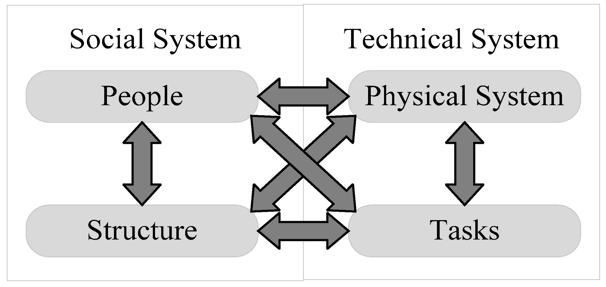
Figure: Socio-technical systems theory
Source: (Guest et al., 2022)
Analysis
According to Guest et al. (2022), the socio-technical systems theory helps in idealising different factors related to the consideration of fintech implementation in the tech–based companies. Therefore, through this theory, the organisations are able to understand as well as design in a better way regarding the interaction among the social as well as technical elements. All these factors are considered to be the interdependent parts of the single system. Considering this, the main goal of this theory is to maintain the joint optimisation, in which the technical performance as well as human quality of the work will be improved simultaneously. Earlier Simoens et al. (2022), stated that, the socio-technical systems help to mitigate the risks related to insider threats and human vulnerabilities through creating a strong security culture and offering continuous training, along with usable processes. Therefore, the organisation can shift their focus and exclude the blame from the human error for designing the resilient systems that will be account for the human behaviour. Contrarily Luther et al. (2023), later stated that reduction of the human-associated vulnerability will not be the only thing done by the STS approach. Instead of that, the fintech companies can utilise this approach in AI models that will be trained on the context of the incomplete or biased historical data. Further, the socio-technical systems theory will also recommend the companies in utilising the diverse as well as representative datasets for identifying, along with addressing biases throughout the AI lifecycle.

2.6 Conceptual Framework
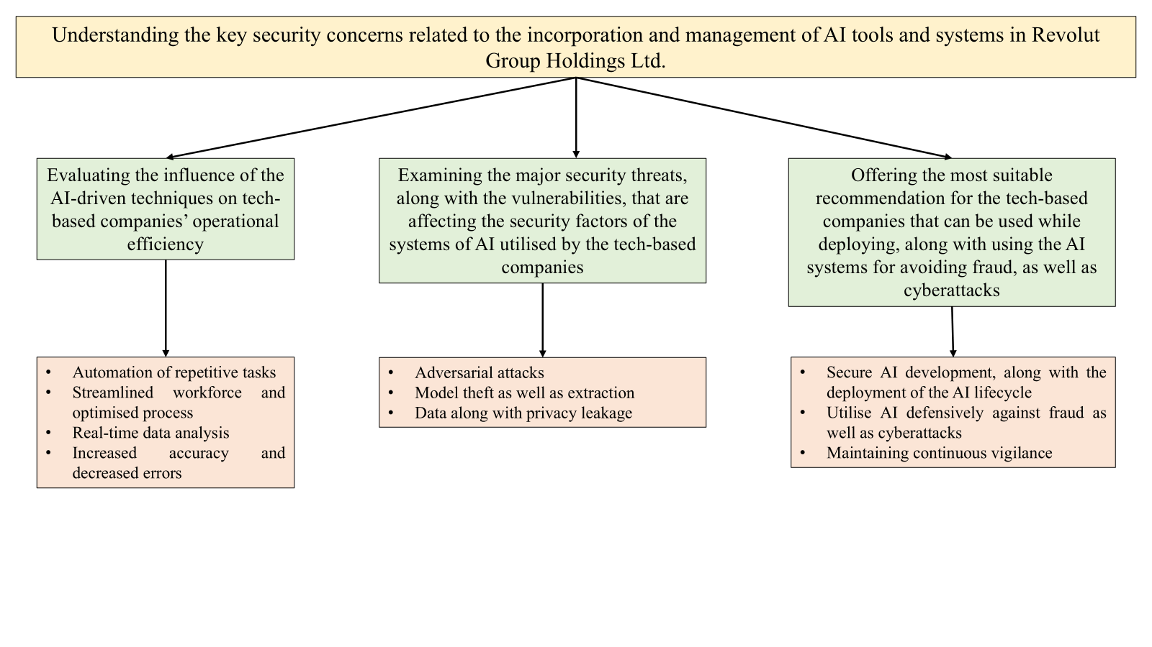
The aim of the research is to understand the most significant safety concerns which are related to the incorporation and management of AI-driven systems used in Revolut Group Holdings Ltd. Thus, this study has discussed how automation of repetitive tasks, real-time data analysis and so on impact the operational efficiency of tech-based companies. The discussion has mentioned the adversarial attacks, model theft and extraction and more as major security threats that affect the safety factors of tech-based businesses. This context has ensured that AI can be used for security concerns, prevention of frauds and cyberattacks and maintaining consistent awareness.

2.7 Literature Gap
The study has ensured rightful sourcing from evident addresses which have provided secondary information. However, all the data used in this research is derived from old arguments and used literature. Restraints in getting company-related specific data in Google Scholar have been stated as primary gaps of this research. Although some sources were valid, they were not accessible and the study has regretted it to not involve those important insights into the work.

2.8 Chapter Summary
The study has reviewed the influence of AI-driven tools on the tech-based companies that use the systems. These analysed influences have included automation of repetitive tasks, streamlining of operations, increased accuracy and decreased mistakes and so on. Further, the research has stated certain security concerns including adversarial attacks and so forth. According to the findings of this study, for fraud prevention, AI is commendable. Therefore, the research has cohered the gaps of this empirical analysis and recommended socio-technical systems theory as a sustainable norm for the company to implement AI correctly.

Chapter 3: Methodology

3.1 Introduction
The way of explaining the ways through which a researcher aims to conduct a study is called research methodology (Bianchi, 2021). Within this section, the layers of the onion model, the different types of methodological choices and justification of using the specific type of method will be delivered here for better understanding.

3.2 Research Onion Framework
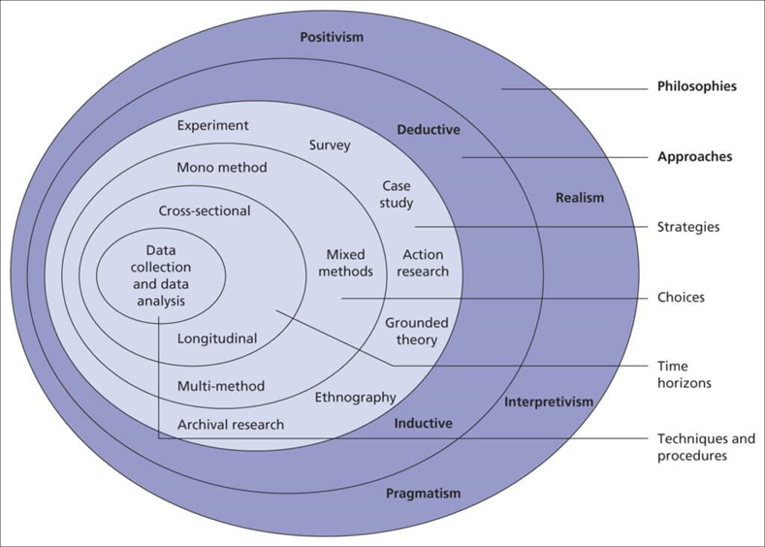
Figure: Research Onion
Source: (Orth, and Maçada, 2021)
This is a very important framework that helps researchers to design research methodology, which highlights choices from wider assumptions to specific methods. There are six distinct layers within this model and they help in developing decisions that ensure cohesion in the research design. Within this research, the use of this model has helped in ensuring that the decisions are consistent as well as logically connected (Orth, and Maçada, 2021).

3.3 Research Philosophy
From the onion framework, this layer is the foundational beliefs, along with assumptions about specific knowledge that develops the foundation of research. On that account, positivism, interpretivism, and pragmatism are the types of philosophy (Bianchi, 2021). From these types, pragmatism philosophy has been used due to its supportive nature towards both qualitative as well as numerical data. This aspect focuses on the practical outcomes as well as problem-solving solving which has helped the researcher to address the complexities of security risks related to AI. Due to these aspects, a comprehensive understanding has been gained which has deduced relevant outcomes (Research-methodology, 2025a).

3.4 Research Approach
This approach refers to the process of developing a broader method that will help in making decisions about data collection as well as evaluation for the study. On that account, there are three types of approaches and they are inductive, deductive, as well as abductive (Hurley et al., 2021). From this division, the abductive approach has been used as it helps in explaining complex and incomplete observations which has been ideal for understanding the hidden risks related to AI. With the help of this approach, the researcher has been able to derive conclusions that has new information related to the new techniques to solve AI-based security concerns (Van Hulst and Visser, 2025).

3.5 Research Choice
From the implications of the onion model, the decision to use only quantitative or qualitative data or both types of data are called the research choice. Mono, multi as well as mixed methods are used in research and they are types of methodological choices. Within this context, the academic investigator has chosen the mixed-method aspect to use both qualitative and quantitative information (Costa, 2024). Accordingly, by using the mixed method, the researcher has gained a more comprehensive as well as complete knowledge about the complexities of AI systems. Lastly, the researcher has been able to conclude a richer and nuanced answer to the research questions based on AI in Revolut Group Holdings Ltd (Watkins, 2022).

3.6 Research Strategy
Within the onion model, the research strategy refers to the entire plan for evaluating the research objectives and answering the questions by highlighting the strategies. Case studies, surveys, interviews, action research as well as observation are the different types of research strategies. For this study, the case study strategy has been utilised to gain a more in-depth as well as contextual insights related to the topic in a real-world setting. Additionally, the researcher has been able to conclude relevant outcomes based on the research objectives, based on the holistic view of the research findings (Thomas, 2021).

3.7 Design of the research
The research design is the aspect that highlights the blueprint or plan that details the ways through which a study can be conducted. They are classified into three types and they are exploratory, descriptive as well as conclusive designs. For this specific research, the exploratory design has been used to gain an understanding of the current changes in the AI systems and related risks. Moreover, this aspect has helped in uncovering new insights which have allowed the user to answer the research questions (Research-methodology, 2025b).

3.8 Data Collection Tools
The instruments that are generally used by users to accumulate information are the data collection tools. There are primary and secondary tools that are used for gathering data. For this research, the researcher has used secondary data collection tools. Graphs, charts, industry reports and others have been used to accumulate numerical data. Additionally, articles, blogs, journals and scholarly articles have also been used by the researcher to gain concept-based information. These tools have assisted the academic investigator in gaining secondary information based on different AI-driven techniques, challenges and security risks as well as possible solutions (Hillier, 2022).

3.9 Data Analysis
Data analysis is the process of analysing and interpreting the accumulated data and they are divided into quantitative and qualitative analysis processes. For this secondary research, both types of analysis processes have been utilised. The researcher has used secondary graphs and charts from authentic sources and analysed them for a better understanding (Formpl, 2025). Within the secondary qualitative study, a thematic analysis has been conducted by developing themes based on objectives by using the data from books and web sources. This in-depth mixed analysis has allowed the researcher to deduce comprehensive and specific outcomes (Hillier, 2023).

3.10 Time Horizon
This layer of the onion model is typically the timeline within which a research study is completed. Within this context, cross-sectional and longitudinal time horizons are the types of this aspect. Here, the cross-sectional one has been used to gain a clear snapshot of the current risk associated with the AI systems in the fintech company. Additionally, this aspect has helped in studying multiple variables and the current status of AI systems in tech businesses which has allowed the deduction of specific results (Cherry, 2024).

3.11 Timeline
(Refers to the Appendix)

3.12 Ethical Considerations
Within this context, the research has maintained academic integrity by conducting the study ethically. On that account, citing the sources and acknowledging the original authors has been done to ensure research ethics. Furthermore, the investigator has avoided any bias and misinterpretation of the collected information (Rothstein, 2021). Lastly, the Data Protection Act 2018 has also been followed to ensure data protection (Gov.UK, 2025).

3.13 Summary
From the implications of this chapter, this has been found that mixed method research has been used in this research. By collecting and interpreting both qualitative and quantitative information, this research has ensured the development of comprehensive and specific outcomes.

Chapter 4: Results and Discussion

4.1 Introduction
The research to understand the key security concerns regarding the management and incorporation of AI tools and processes of Revolut Group Holdings Ltd. will be performed in this analysis. The literary analysis identifies some gaps which will be addressed in this chapter with the assistance of the secondary research process. The qualitative data analysis will be performed in this context, using thematic analysis. Alongside this, the detailed quantitative assessment will be evaluated in this context by assessing graphs and charts. A detailed discussion will be provided here where the findings data will be compared with the literature discussion.

4.2 Qualitative Data Analysis
Thematic analysis is a specific form of qualitative research useful for identifying and analysing patterns in the data accessed from secondary sources. This is a widely used approach by researchers to deeply investigate any topic aligning with the objectives of the study. Here, separate themes will be created based on the research questions and online articles, blogs, and relevant websites will be analysed.
4.2.1 Theme 1: Current AI-driven techniques used by Revolut Group Holdings Ltd in their business operations, and their impact on their operational efficiency

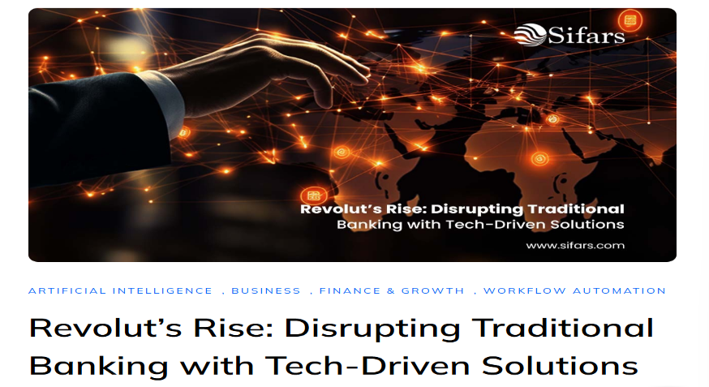
Figure: Revolut’s Rise: Disrupting Traditional Banking with Tech-Driven Solutions
Source: (Sifars, 2025)
Revolut Group Holdings Ltd is currently using AI tools and machine learning to detect fraud and financial breaches. Sherlock, the specific AI tool, can figure out the fraudulent activities related to transactions per second. Besides this, the AI card scam detection feature used by Revolut was able to prevent 475 million Pounds of money fraud in 2024 (Sifars, 2025). Besides this, the automation of the detection of unsafe transactions saved the operational cost for maintaining the functions of the business. Whenever any scam card payment is noticed, the AI system refuses to process the transaction and initiates the intervention of the app to inform customers about the fraud. AI support is a huge factor in the client operations of the company, using virtual chatbots to provide immediate support. Such tools are effective in handling repetitive tasks, reducing pressure from manual labour. Faster response to customer queries helped to enhance the user experience. Besides this, an AI-operated data analytics system is efficient in predicting customer behaviour and adding personalisation to their experience. Apart from that, improved marketing campaigns are able to target the right audience for the brand. Different from the legacy banks, the company uses AI to assess real-time behavioural data. Here, users are allowed to transfer money to more than 30 currencies. Utilising a predictive analytics system, the brand can tailor the financial products and set achievable goals for the upcoming period (Sifars, 2025). The most useful thing about AI is that it has decreased the back-office workloads by automating the reporting tasks. Along with that, to mitigate the physical phone theft, Revolut put a high focus on utilising biometric data to protect accounts. The organisation has also launched the AI-based customer verification program to avoid unwanted scams and build consumer trust.
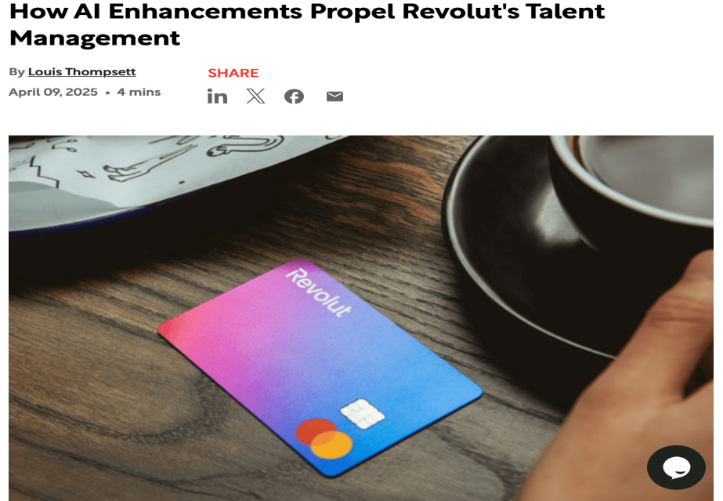
Figure: How AI Enhancements Propel Revolut's Talent Management
Source: (Thompsett, 2025)
Revolut has already introduced AI-based talent management tools for enabling firms to achieve optimal productivity of the workforce. In the present digital space of the financial sector, the brand is focused on using technologies to enhance the capabilities of workers with a cost-friendly approach. Applying such tools, the brand is trying to simplify its hiring process and drive staff engagement to fulfil the market demands. Including AI from the initial selection stage to performance analysis, Revolut is keen to address the pressure of administrative tasks in the HRM functions (Thompsett, 2025). From 2023, the organisation is offering advanced AI features to evaluate data from multiple sources and give useful information to the managers. Automation in the summarisation of interviews reduced the risks of the documentation process and streamlined the performance management procedures. Collecting relevant data from meetings, skill analysis and peer feedback through AI tools enabled the brand to drive team engagement through implementing effective motivational factors. The tactic also helped the company to detect the individual staff concerns and enhance brand responsiveness. Delivering data-driven information is analysed by the HR team to improve the company culture and increase productivity of the workforce. Replacing repetitive task completion, AI empowered the managers to put more attention on the training of the team (Thompsett, 2025).
4.2.2 Theme 2: Major security threats as well as vulnerabilities that are affecting the security factors of the AI systems used by Revolut Group Holdings Ltd.
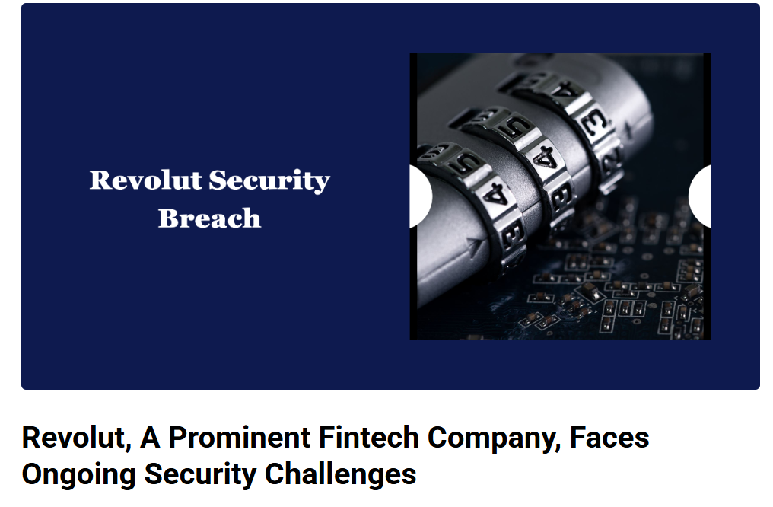
Figure: Revolut, a prominent fintech company, Faces Ongoing Security Challenges
Source: (World Finance Council, 2023)
Threats present in the AI systems of Revolut include general cyber-attack issues and AI usage-related problems. Manipulation occurs in the dataset of AI to analyse the transaction details. Besides this, evasion attacks are present to steal the AI model of Revolut for disrupting the system flows. Social engineering is identified as a major security threat to the company in terms of increasing phishing attacks or malware activities. In some cases, personal information of customers has been directly accessed by the third party through an internal system. Additionally, bugs are present in the software used by Revolut, which are responsible for exploiting the AI models. Poor infrastructure of cloud services and security frameworks is failing to protect sensitive data. Although the company is operating AI for ensuring high-level security, this still has some challenges linked with algorithmic bias (World Finance Council, 2023). Some customers made complaints about the frozen accounts caused by security breaches in the past. A feature named Black Box in the AI models is posing challenges to the company in complying with the auditing. Reverse engineering attacks are also hampering the security control system of Revolut. Machine learning attacks are also included in the AI management system of the brand to disrupt the user interface and hamper the functioning of the model. Unauthorised access to the user accounts is becoming an alarming threat to the company, reflecting the weaknesses present in cyberspace (World Finance Council, 2023). Inability to protect the confidential data by the business made the consumers unhappy and reduced their satisfaction level. All these events are raising doubts about the efficiency of the fraud detection system and the customer service of the company. Hence, the approach of the brand to overcome such security challenges might play a vital role in shaping the future success and brand reputation in the fintech industry.

Figure: Revolut Data Breach: A Critical Reminder for Enhanced Digital Banking Security
Source: (Hypersign, 2024)
Revolut has revealed that phishing attacks are generally common in the business, allowing unwanted access to the database. Confidential customer information like names and email addresses is theft by the fraudulent activities of third parties. Quick action is taken by the company to minimise the risks related to digital banking operations. Such events have severely impacted the consumer trust and engagement with the company. The breach of data resulted from the theft of consumer data during crypto trading. Here, this is essential to mention that the crypto industry is already dealing with major financial crimes and cyber threats (Hypersign, 2024). Therefore, robust security measures are required to ensure safety during the offerings of cryptocurrency in their online transactions. Corruption or poisoning of data is found as the reason behind improper decisions for risk detection. Chatbots of Revolut are not properly secure and are attacked by criminals who are difficult to identify by the human employees. The AI system of the brand operating the marketing and customer support system is vulnerable to exploring sensitive data. Besides this, the rapid changes in the AI landscape also put pressure on the company to comply with such modified guidelines. Apart from that, in case of the addition of new AI solutions to the old system leads to the development of a more complex system (Hypersign, 2024).
2.3 Theme 3: Suitable strategies that Revolut Group Holdings Ltd can use while using AI systems to avoid fraud and cyberattacks
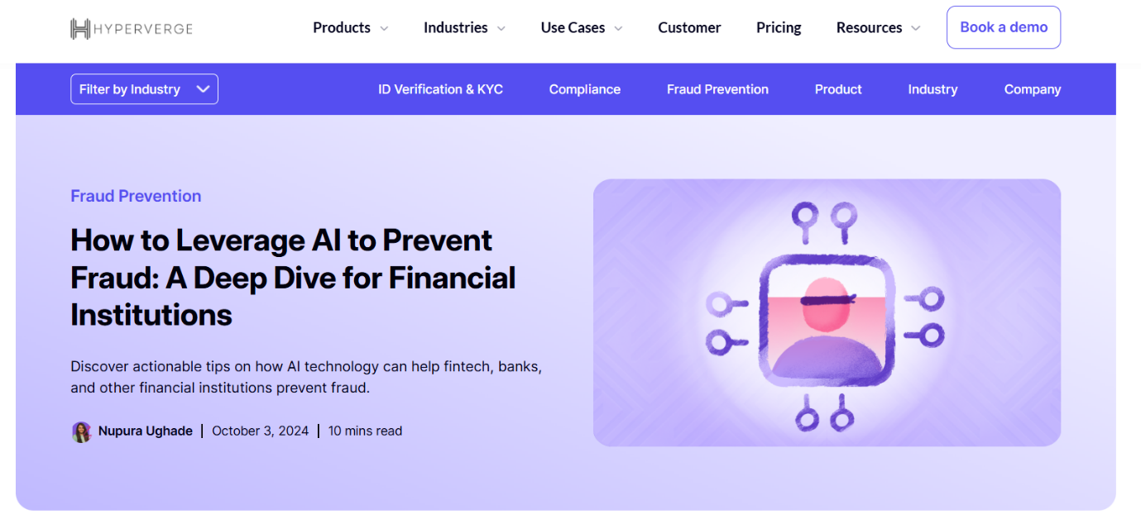
Figure: How to Leverage AI to Prevent Fraud: A Deep Dive for Financial Institutions
Source: (Hyperverge, 2024)
Revolut Group Holdings Ltd. can utilise an AI framework to prevent cyberattacks with real-time behavioural analytics. Monitoring the transactions, any changes in the customer purchasing pattern can be easily identified. When a customer is misguided to engage in fraudulent activities, AI systems are able to notify the risks of cyberthreats to the customers. Better protection for the system can be provided with the analysis of real-time data. An AI-powered cybersecurity model can be implemented in such a way that quick actions will be taken to avoid data breaches. Besides this, Revolut should enforce authentic verification of the consumer information. An effective monitoring framework for checking the security of data is essential for the proper functioning of the AI system.
Additionally, the company has to put major focus on avoiding the replacement of human thoughts by AI (Hyperverge, 2024). Getting a vast amount of personal financial data, Revolut has to obey the regulations of the GDPR Act. For that purpose, strong encryption of data and obtaining consent for data usage from the customers are required. While selecting fraud detection software, Revolut needs to keep a high focus on accuracy to minimise false positives. Transparency is also required to align the digital framework with the core business objectives. A holistic protection system against various types of fraud is needed to overcome cyber threats like phishing attacks and social engineering. In that context, machine learning can be utilised to add an AI framework and predict risk rules. Data mining techniques can be helpful to figure out irregular patterns and forecast future outcomes (Hyperverge, 2024).

Figure: The Role of AI in FinTech Fraud Detection
Source: (Amos, 2025)
Artificial Intelligence is a valuable resource or tool to detect financial fraud or data breaches for the fintech industry. AI can read the typing habits of individuals and spot abnormal movements. While opening the banking app, login attempts should be restricted to prevent phishing attacks. Besides this, a silent monitoring system can be implemented to avoid regulatory pressure of false positives. A proper mapping of the interconnection between various parts can be difficult for the business. Besides this, AI can identify criminal activity found in financial transaction apps, ensuring better authentication of the consumer data. Transparent reporting should be used to keep detailed records of the documents and risks (Amos, 2025). Every decision taken by the brand has to be data-driven, creating strong communication with the customers. Integration of AI in Revolut with advanced features can be helpful to build long-term consumer trust. With efficient chatbots and other tools, customer service can be improved. In comparison to human error, the company could be able to catch the alerts related to historical data. Moreover, investors in Revolut should dedicate their resources to ensuring enhanced security of cyberspace under the operation of AI (Amos, 2025). That will be beneficial to protect the customer assets for the future. Along with that, promotion of customer education regarding various fraudulent activities should be prioritised by the business. AI models can also support the brand to find out unusual transactions by analysing the amount, time and location.

Figure: Cybersecurity & Fraud Prevention: How to Safeguard Your FinTech Business
Source: (Silveira, 2024)
The fintech industry is extremely driven by innovation and the usage of advanced technology. AI adds top-most security to the data protection system of the companies. Data breaching is the main issue which reveals the personal information of customers to cybercriminals. Machine learning may offer strong protection against the fraudulent activities associated with Revolut. Before any serious damage, active actions can be taken by the business. Strong passwords or an encryption system should be utilised in the AI-driven data governance mechanism of the business. Regular upgradation of the software is needed, and sufficient training on the cybersecurity measures has to be ensured by the IT team of Revolut. Along with this, weaknesses of the business can be tested to avoid future possible threats to the business. Besides this, multi-factor authentication can be established by the business to beat the intentions of cybercriminals (Silveira, 2024). Along with that, a dedicated team can be formed to understand the customer perceptions and their overall journey with the brand. Furthermore, Data Loss Prevention (DLP) solutions can be included in the AI-driven data security systems in Revolut. In that context, accounts reported with any kind of cyber-attacks should be closed immediately to obstruct any further violation of data privacy guidelines. Following the continuous advancement in AI technology, the company can execute Deepfake Detection Alerts for preventing fraud. A proper reasoning regarding the changed model should be clear to the workforce for building a solid trust among them. The cloud infrastructure of the business must establish fair AI services that obey the financial regulations and ensure strict access controls (Silveira, 2024).

4.3 Quantitative Data Analysis
4.3.1 Theme 1: The current AI-driven technologies used by Revolut Group Holdings Ltd in their business operations, along with their impact on operational efficiency

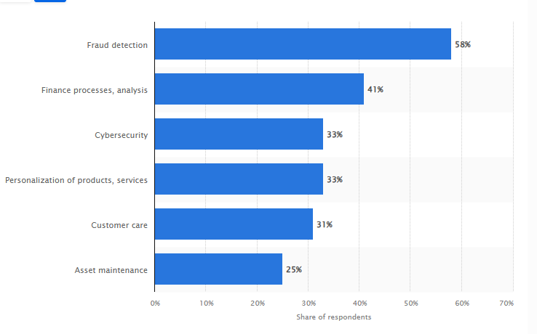
Figure: AI usage in Fintech companies globally
Source: (Thormundsson, 2022)
Analysis
As per the above graph, within the fintech industry, the utilisation of AI is the most effective thing for maintaining their operational efficiency. With the help of AI, the fintech companies are able to improve fraud detection through the combination of supervised learning algorithms with having a better understanding of the behaviour of customers. Therefore, the graph is showcasing that the AI is improving the fraud detection to almost 58%, and improving the financial processes to approximately 41%. Further, the detection of cybersecurity has also reached to almost 33% and the personalised products and services have also experienced the growth of 33% in Revolut Group Holdings Ltd. After that, the customer care section of that organisation has also been developed by the utilisation of AI to almost 31%. Even the Revolut Group Holdings Ltd has also enriched their asset maintenance to approximately 25%. Further, the organisation has also stated that, their cost structure in the operational process has been decreased to 30% after the utilisation of AI-driven technologies like Machine learning. Eventually, the transactional process and their efficiency level have also improved to almost 47% after the utilisation of cloud-based AI compared to traditional systems.
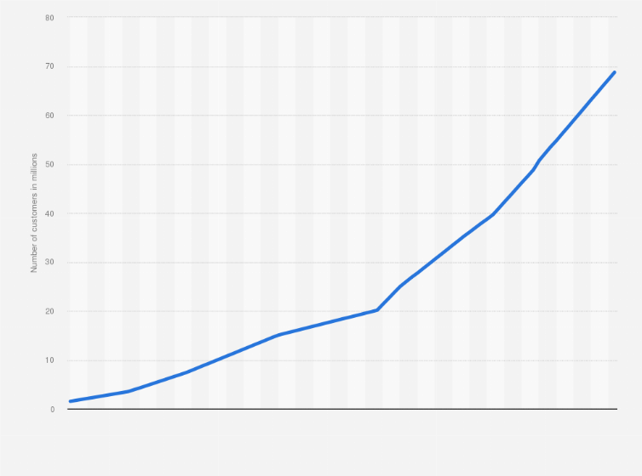
Figure: Customer Growth after using AI in Revolut Group Holdings Ltd
Source: (Statista, 2025)
Analysis
As per the above graph, the Revolut Group Holdings Ltd is experiencing intense growth of customers after the utilising of AI in the banking and operations sections. Concerning this, the graph has showcased that, in 2018, in mid-February, the number of customers has been estimated to be almost 1.5 million. After the calculation, the number of consumers in the bank has increased to approximately three million in November in that same year, which is 2018. With the help of predictive maintenance and AI-powered chatbots, the organisation has experienced exceptional growth in their number of its customers. As per the calculation, in July 2022, the company has reached 20 million customers which has showcased 40% growth in the numbers as compared to the previous years. Just in the next year, Revolut Group Holdings has also experienced 50 million customers in the latter part of 2024, which has offered 50% growth from the earlier years. Besides this, due to the rapid growth of customers, the company has increased their revenue to almost 72% to 3.1 billion pounds compared to 2023. Therefore, the increasing number of customers has offered the organisation effective growth in customer satisfaction, which has been driven by the superior service experiences.
4.3.2 Theme 2: The major security concerns encountered by the Revolut Group Holdings Ltd that are affecting their AI systems and operational systems
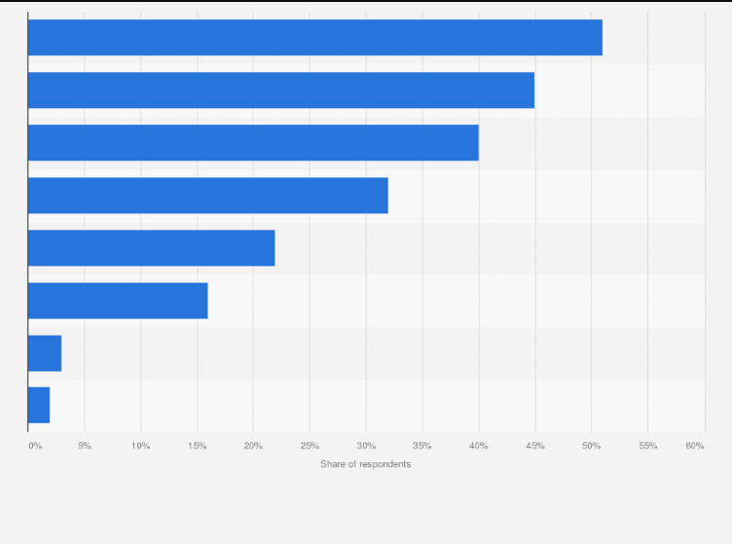
Figure: Security concerns faced by the Revolut Group Holdings Ltd while using AI
Source: (Thormundsson, 2025)
Analysis
According to the above graph, the organisation has encountered several security concerns after the utilisation of AI in their financial transactions and operational sections. Concerning this, the company has experienced the hacking of sensitive data of customers in large amounts, which included their personal data as well as financial transactions. Due to this breach, a significant amount of data can be exposed to the hackers and affected almost 50,150 customers of Revolut Group Holdings Ltd. Further, the AI models of that company have also deliberately corrupted 63% of the personal data of the company, which the organisation has affected the ability of their systems. Concerning this, the organisation is unable to detect major fraud as well as other threats over a significant period of time, along with creating a silent failure in the organisational performance. Further, the company has also effectively faced 61% of the cyber scams in the initial section of 2024. Eventually, the purchase scam has been reported to almost 63% and the financial scam has also increased to almost 15% which has been accounted for approximately 59% of the monetary loss. Within the organisation, the card scam has also noticed 30% after the effective usage of predictive AI and responsible AI.
4.3.3 Highlighting the suitable strategies that Revolut Group Holdings Ltd can utilise while implementing as well as utilising AI systems for avoiding fraud as well as cyberattacks

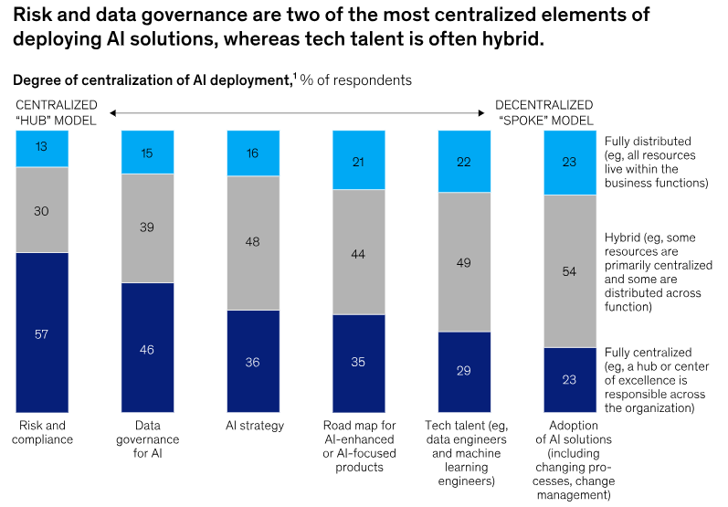
Figure: Risk and Data Governance strategies for reducing AI issues in the company
Source: (Mckinsey, 2025)
Analysis
By focusing on the above graph, there are different types of solutions that the Revolut Group Holdings Ltd can take to reduce their AI-related issues. Considering the factors, the company can deploy Mean time to detect as well as mean time to respond for identifying, along with resolving the security incident. Through this implementation, Revolut can reduce AI-powered issues and response times to almost 90%. In fact, the detection accuracy has achieved 95.7% after the utilisation of AI tools, which has increased the positive rate to almost 3.2%. Compared to the traditional rule-based approach, the accuracy rate can also reach to almost 82.4% after using automated AI-powered incident responses. After the implementation of the AI-compliances, the accuracy rate can increase up to 80% which will help in reducing financial penalties for the company. With the utilisation of Advanced Fraud as well as anomaly detection, the speed of the operational systems will increase by 95.7% and the biometric authentication will reach to 40%. Eventually, the Adversarial AI training can also uplift the fraud detection to almost 40% compared to the earlier traditional practices.

4.4 Discussion
Organisations adopt AI tools and practices in their operations to manage their business operations. With this advanced technology, organisations address the issue of model integrity, operational security and data integrity. Adopting AI tools as well as systems, the businesses faced many key security concerns which required addressing properly to streamline their business operations. The research has discussed different AI tools and processes, like automation and real-time data analysis. While integrating these advanced technologies, the organisation Revolut Group Holdings Ltd has faced many complexities like model theft, privacy leakage and more. Addressing these challenges is necessary to adopt the advanced technology systematically.
Current AI-driven techniques used by Revolut Group Holdings Ltd, along with their impact on operational efficiency
Organisations follow different AI tools along with a system in their operations, which help them to improve their operational efficiency. As discussed by Tyson and Zysman (2022), the literary discussion has highlighted some of the processes that tech-based companies have followed. For managing repetitive tasks, tech-based businesses adopt automation. This way, they perform their routine work with higher efficiency and productivity. This way, the workplace satisfaction is enhanced and organisations involve their workforce in innovative processes. Alongside this, using AI applications, the companies streamline their staff community as well as automate time-consuming activities. Real-time data analytics has also been performed in tech-based businesses to perform smarter as well as faster decision-making. This way, the organisations enhanced their business accuracy while minimised errors. This literary analysis has provided information based on past studies and collected real-time information, and the findings have been presented. Addressing the financial breach as well as fraud activities, Revolut Group Holdings Ltd. utilise AI tools. Alongside this, they have started using AI card scam detection features, which help them to prevent 475 million pounds of money fraud in the year 2024. Alongside this, the corporation adopts AI tools as well as processes to manage its workforce to reach optimal productivity. With these tools, the corporation has simplified its hiring activities and engaged staff effectively. The quantitative assessment has discussed that using AI tools and practices, the fintech businesses easily understand customer behaviours as well as detect fraud activities.
Major security issues, along with vulnerabilities that affect the security factors of the AI systems
The literary context has mentioned some challenges that the tech-based businesses have experienced, which affect their security factors of AI processes. While using AI systems, the businesses faced cyber-attacks which manipulate the information input. As stated by Vučinić and Luburić (2022), tech-based companies faced many complexities in compromising the intellectual property. The businesses, when they adopt AI tools in their operations, assess a vast range of customer data, and due to this, that information is exposed to cyber attackers. The tech-based companies faced these complexities in their operations, which hamper their market reputation along with their business activities. These threats, as well as vulnerabilities, affect the security factors that the companies have faced while adopting AI tools and systems. On the other side, the findings section, through performing qualitative and quantitative data analysis, has delivered some company-based security hazards. Revolut Group Holdings Ltd. has faced cyber attacks as well as AI-based complexities. Alongside this, phishing attacks are another common issue, and due to this, confidential customer data has been disclosed to a third party. This situation also affects crypto trading greatly, and customers face issues regarding this. The quantitative data analysis has highlighted the situation of cyber-attacks and hacking of customers' sensitive information. These types of fraud and threats have highlighted the failure of organisational performance.
Strategies that Revolut Group Holdings Ltd can use while adopting AI systems to manage fraud and cyberattacks
The tech-based strategies require some strategies to address their complexities. The literary discussion has mentioned some strategies based on the complexities faced by businesses. As mentioned by Despotović et al. (2023), the organisations are required to maintain AI development as well as the deployment of the AI lifecycle. Alongside this, the context has outlined the importance of utilising AI defensively against cyberattacks and fraud. Maintaining continuous vigilance is necessary for tech-based companies to manage the comprehensive training activities. Socio-technical systems theory has also been discussed here to address the complexities of tech-based businesses. On the other side, some strategies have been provided in the findings section based on Revolut Group Holdings Ltd. The company is required to follow an effective monitoring system and collect data regarding customer purchasing patterns. This way, the organisation can protect their data from cyber threats effectively. Alongside this, using AI tools, the business can manage its fraud activities as AI can understand the writing patterns and identify any fraudulent activities. A strong password, along with encryption, is necessary for managing this issue. Following the mean-time system, Revolut Group Holdings Ltd. can manage its response time and reduce complexities as outlined in the quantitative data analysis.

4.5 Summary
The chapter has performed research on key security concerns that are required to be maintained throughout the integration of management and integration of AI processes. This researcher has performed secondary research by collecting information from different websites and industry articles regarding the key security matters of AI. The chapter has discussed the qualitative assessment by generating themes based on the research objectives and assessing the information regarding the Revolut Group. Alongside this, different AI-driven techniques that followed in the said business and the challenges they faced have been specified in this assessment. Based on this information, some strategies have also been specified in this context that may assist the business. The quantitative data analysis has been performed based on the graph and chart data related to AI tools and princesses. A detailed discussion has been provided in this section.

Chapter 5: Recommendations, Conclusion and limitations of the research

5.1 Recommendations
Implementing AI and auditability for the core models
While the AI systems intend to make proactive decisions like transaction blocking and fraud identification, this is needed to implement explainability. Implementing this strategy will enable the organisation to log the model decision in a transparent manner and conduct a regular audit. This will also enable the business in terms of recognising why the payment process got blocked or stopped. Additionally, implementing this process will also support the business to incorporate user-friendly features and document properly, which will minimise the risks as well as support in maintaining compliance (van Wingerden and Weigand, 2025).
Adopting an in-depth architecture
Developing proficient ML or AI cannot be only a security issue, as those processes can be targeted by advanced data positioning, model transposition and others. Henceforth, Revolut may take significant measures to layer their protection, and they should incorporate a secure data pipeline, strong access control and others. For example, while the firm will implement an automated fraud detection process, it may be able to minimise the reduction or unnecessary financial losses (Øvrelid, 2025).
Strengthening the device endpoint
Most of the services of Revolut will take comprehensive steps to improve their services through mobile applications. According to the market research, this organisation faced significant vulnerabilities regarding the mobile applications compared to its peers. Considering this, the firm should implement strong device verification measures like jailbreak detection. Secure coding and push app updates will also support the business to minimise the risk of the endpoints while becoming a weak link within the wider AI ecosystem (Alvi, 2025).
Establishing robust data
The AI system basically strongly depends on the data, considering this, the organisation should incorporate rigorous investment for training and determining data compliance. Regularly auditing data will enable the business to minimise bias, while proactively managing the deletion of the previous data. Significantly maintaining the consumer details and enforcing the data lifecycle control will also be needed. Apparently, deploying proactive data security measures and ensuring that the data feeding is safeguarded at rest, and the logs will also be maintained properly (Chintoh et al., 2025).
Continuous threat Modelling
The AI systems within the business often encounter significant challenges like evasion attacks, data positioning, alongside model extraction. In relation to this, Revolut should implement threat modelling, which will be aligned with the AI implementation. Deploying the automated adversarial test and red teaming models will support the business in assessing the anomalous framework output. Furthermore, this will also enable the business to integrate an AI-driven tool-responding playbook (Verreydt et al., 2025).
Optimise employee training related to AI
Revolut should allocate a large number of resources for training purposes by focusing on offering knowledge regarding secure usage, AI risks, as well as threat recognition. Fostering awareness on social engineering, phishing, and significant AI-driven systems will enable the business to minimise human error and vulnerabilities (Bastida et al., 2025).

5.2 Conclusion
The research has attempted to understand the main security concerns of the implementation of AI in the business systems of Revolut Group Holdings Ltd. Relevant literature sources related to the incorporation of these tools in the fintech industry have been reviewed to gain a broader context. The onion model propounded by Saunders has been utilised to formulate the methodology of this research. Only secondary data from mixed sources has been consulted to maintain data accuracy and reduce ethical concerns. A case study strategy has been taken to interpret and evaluate information from different journals and articles to answer the study’s questions. Evaluation of the various information has shown that Revolut is actively using AI and other smart tools in its banking operations to improve service delivery and talent management. This integration has helped the organisation to streamline and accelerate its processes and also prevent digital banking fraud. Information phishing attacks and customer data thefts have been identified as the main security threats in the findings of this research. Data breaches and fraudulent transaction activities due to improper AI implementation have impacted the reputation of Revolut among its customers. Apart from these issues, some suggestive measures have also been looked into for addressing the faced challenges. Real-time behavioural analytics for potential fraud attempts have been found as helpful for this situation. Additionally, adherence towards the GDPR roles and other available regulations in the UK has also been suggested to the company to follow.

5.3 Research limitations
Certain limitations have been encountered during the conduct of this research regarding its data selection and resource availability. The study has used a secondary case study strategy where only the pre-existing sources have been consulted. This has created a data limitation where the entire discussion has been based on existing information. The chosen topic of this specific research has studied the integration of AI tools in the business operations of Revolut and their security concerns. Therefore, the inclusion of primary data could have assisted the research in combining its findings with the provided information from the company’s officials. Surveying Revolut employees regarding their opinion and attitude towards this business transformation through AI could have been useful. This research has instead used qualitative and statistical data from authorised secondary sources and used them to address its objectives and questions. Although this has helped to avert ethical risks, it has also limited the process to external assumptions and observations. The inclusion of smart data analytics and AI software in the fintech operations of Revolut Group Holdings Ltd has created data breach risks. This aspect has a potential impact on the organisational operations and employee performance which has not been clearly understood through the inspection of only secondary sources. These aforementioned limitations need to be addressed by researchers er who will inspect a similar topic in future studies. A broader set of primary data alongside secondary sources could have been included to address the specific internal security challenges faced by the respective firm.

References
Aaron, W.C., Irekponor, O., Aleke, N.T., Yeboah, L. and Joseph, J.E. (2024) ‘Machine learning techniques for enhancing security in financial technology systems.’ International Journal of Science and Research Archive, 13(1), pp.2805-2822.
Alvi, S. (2025) 8 Endpoint Security and. Handbook of AI-Driven Threat Detection and Prevention: A Holistic Approach to Security, p.130.
Amos, Z. (2025) The Role of AI in FinTech Fraud Detection. [Online] Available at: https://www.fintechweekly.com/magazine/articles/ai-fintech-fraud-detection (Accessed 20 October 2025).
Bastida, M., García, A.V., Taín, M.Á.V. and Araujo, M.D.R. (2025) ‘From automation to augmentation: Human Resource's journey with Artificial Intelligence.’ Journal of Industrial Information Integration, p.100872.
Bianchi, L. (2021) ‘Exploring ways of defining the relationship between research philosophy and research practice.’ Journal of Emergent Science, 20, pp.32-37.
Cherry, K. (2024) How Do Cross-Sectional Studies Work?. [Online] Available at: https://www.verywellmind.com/what-is-a-cross-sectional-study-2794978 (Accessed 18 October 2025).
Chintoh, G.A., Segun-Falade, O.D., Odionu, C.S. and Ekeh, A.H. (2025) ‘Cross-jurisdictional data privacy compliance in the US: Developing a new model for managing AI data across state and federal laws.’ Gulf Journal of Advanced Business Research, 3(2), pp.537-548.
Costa, J. (2024) ‘Mixed Methods in Educational Large-Scale Studies: Integrating Qualitative Perspectives into Secondary Data Analysis.’ Education Sciences, 14(12), p.1347.
Dale, A., Arber, S. and Procter, M. (2025) Doing secondary analysis. Taylor & Francis.
Dębniak, M. (2025) AI in FinTech: Threats, Risks, and Challenges. [Online] Available at: https://www.stxnext.com/blog/ai-in-fintech-threats-risks-and-challenges (Accessed 15 October 2025).
Despotović, A., Parmaković, A. and Miljković, M. (2023) ‘Cybercrime and cyber security in fintech.’ In Digital transformation of the financial industry: approaches and applications (pp. 255-272). Cham: Springer International Publishing.
Folorunso, A., Adewumi, T., Adewa, A., Okonkwo, R. and Olawumi, T.N. (2024) ‘Impact of AI on cybersecurity and security compliance.’ Global Journal of Engineering and Technology Advances, 21(01), pp.167-184.
Formpl. (2025) What is Secondary Data? + [Examples, Sources, & Analysis]. [Online] Available at: https://www.formpl.us/blog/secondary-data (Accessed 18 October 2025).
George, A.S. (2023) ‘Securing the future of finance: how AI, Blockchain, and machine learning safeguard emerging Neobank technology against evolving cyber threats.’ Partners Universal Innovative Research Publication, 1(1), pp.54-66.
Ghelani, D., Hua, T.K. and Koduru, S.K.R. (2022) ‘Cyber security threats, vulnerabilities, and security solutions models in banking.’ Authorea Preprints.
Gov.UK. (2025) Data protection. [Online] Available at: https://www.gov.uk/data-protection (Accessed 18 October 2025).
Guest, D., Knox, A. and Warhurst, C. (2022) ‘Humanizing work in the digital age: Lessons from socio-technical systems and quality of working life initiatives.’ Human relations, 75(8), pp.1461-1482.
Hillier, W. (2022) What Is Secondary Data? A Complete Guide. [Online] Available at: https://careerfoundry.com/en/blog/data-analytics/what-is-secondary-data/ (Accessed 18 October 2025).
Hillier, W. (2023) A Step-by-Step Guide to the Data Analysis Process. [Online] Available at: https://careerfoundry.com/en/blog/data-analytics/the-data-analysis-process-step-by-step/ (Accessed 18 October 2025).
Hurley, E., Dietrich, T. and Rundle-Thiele, S. (2021) ‘Integrating theory in co-design: An abductive approach.’ Australasian Marketing Journal, 29(1), pp.66-77.
Hypersign. (2024) Revolut Data Breach: A Critical Reminder for Enhanced Digital Banking Security. [Online] Available at: https://www.hypersign.id/blogs/tpost/aerjs5n2m1-revolut-data-breach-a-critical-reminder (Accessed 20 October 2025).
Hyperverge. (2024) How to Leverage AI to Prevent Fraud: A Deep Dive for Financial Institutions. [Online] Available at: https://hyperverge.co/blog/ai-fraud-prevention/ (Accessed 20 October 2025).
Inglethorpe, R. (2023) Developing soft skills. [Online] Available at: https://www.clevry.com/en/blog/developing-soft-skills/ (Accessed 22 October 2025).
Ionescu, S.A. and Diaconita, V. (2023) ‘Transforming financial decision-making: the interplay of AI, cloud computing and advanced data management technologies.’ International Journal of Computers Communications & Control, 18(6).
Khang, A. ed. (2025) AI-Powered Cybersecurity for Banking and Finance: How to Enhance Security, Protect Data, and Prevent Attacks. CRC Press.
Kovari, A. (2024) ‘AI for decision support: Balancing accuracy, transparency, and trust across sectors.’ Information, 15(11), p.725.
Law, M. (2025) The New Engine Room: The Rise of AI in FinTech. [Online] Available at: https://fintechmagazine.com/news/the-new-engine-room-the-rise-of-ai-in-fintech (Accessed 15 October 2025).
Lukashova-Sanz, O., Dechant, M. and Wahl, S. (2023) ‘The influence of disclosing the ai potential error to the user on the efficiency of user–ai collaboration.’ Applied Sciences, 13(6), p.3572.
Luther, B., Gunawan, I. and Nguyen, N. (2023) ‘Identifying effective risk management frameworks for complex socio-technical systems.’ Safety science, 158, p.105989.
Mckinsey. (2025) The state of AI: How organizations are rewiring to capture value. [Online] Available at: https://www.mckinsey.com/capabilities/quantumblack/our-insights/the-state-of-ai (Accessed 21 October 2025).
Mirza, N., Elhoseny, M., Umar, M. and Metawa, N. (2023) ‘Safeguarding FinTech innovations with machine learning: Comparative assessment of various approaches.’ Research in International Business and Finance, 66, p.102009.
Oko-Odion, C. (2025) ‘AI-Driven Risk Assessment Models for Financial Markets: Enhancing Predictive Accuracy and Fraud Detection.’ International Journal of Computer Applications Technology and Research, 14(04), pp.80-96.
Olaiya, O.P., Adesoga, T.O., Ojo, A., Olagunju, O.D., Ajayi, O.O. and Adebayo, Y.O. (2024) ‘Cybersecurity strategies in fintech: safeguarding financial data and assets.’ GSC Advanced Research and Reviews, 20(1), pp.50-56.
Olutimehin, A.T. (2025) ‘Advancing cloud security in digital finance: AI-driven threat detection, cryptographic solutions, and privacy challenges.’ Cryptographic Solutions, and Privacy Challenges (February 13, 2025).
Omieno, O.A., Reuben, J.M. and Ngarenon, T. (2025) ‘Cloud Security Challenges and Framework Development for Kenyan Fintechs.’ International Journal of Research and Innovation in Applied Science, 10(2), pp.409-424.
Orth, C.D.O. and Maçada, A.C.G. (2021) ‘Corporate fraud and relationships: a systematic literature review in the light of research onion.’ Journal of Financial Crime, 28(3), pp.741-764.
Øvrelid, E. (2025) ‘Managing the Socio-Technical Interplay of Architecture, Business, and Learning in Architectural Transformation.’ The case of finance.
Ralph, P. and Baltes, S. (2022) November. Paving the way for mature secondary research: the seven types of literature review. In Proceedings of the 30th ACM Joint European Software Engineering Conference and Symposium on the Foundations of Software Engineering (pp. 1632-1636).
Research-methodology. (2025a) Research Philosophy. [Online] Available at: https://research-methodology.net/research-philosophy/ (Accessed 17 October 2025).
Research-methodology. (2025b) Exploratory Research. [Online] Available at: https://research-methodology.net/research-methodology/research-design/exploratory-research/ (Accessed 18 October 2025).
Revolut. (2024) Revolut reveals 2025 vision, with AI assistant, mortgages, and ATMs on the horizon. [Online] Available at: https://www.revolut.com/en-HR/news/revolut_reveals_2025_vision_with_ai_assistant_mortgages_and_atms_on_the_horizon/ (Accessed 15 October 2025).
Revolut. (2025) About Us. [Online] Available at: https://www.revolut.com/discover-our-company/ (Accessed 15 October 2025).
Riabchuk, A. (2025) AI In FinTech: Revolution Or Threat?. [Online] Available at: https://www.forbes.com/councils/forbestechcouncil/2025/04/09/ai-in-fintech-revolution-or-threat/ (Accessed 15 October 2025).
Robinson, J. (2022) Learn From Your Past Experience with Gibb’s Reflective Cycle. [Online] Available at: https://crowjack.com/blog/strategy/reflection-models/gibbs-reflective-cycle (Accessed 22 October 2025).
Rothstein, M.A. (2021) ‘Informed consent for secondary research under the new NIH data sharing policy.’ Journal of Law, Medicine & Ethics, 49(3), pp.489-494.
Sharipov, R. (2025) ‘Analysis and Reduction of Errors in AI Models.’ The American Journal of Engineering and Technology, 7(05), pp.202-210.
Sifars. (2025) Revolut’s Rise: Disrupting Traditional Banking with Tech-Driven Solutions. [Online] Available at: https://www.sifars.com/en/blog/revolut-rise-disrupting-traditional-banking-aisolutions/#:~:text=Revolut%20uses%20AI%2Dpowered%20fraud,solutions%20compared%20to%20legacy%20banks (Accessed 19 October 2025).
Silveira, S. F. (2024) Cybersecurity & Fraud Prevention: How to Safeguard Your FinTech Business. [Online] Available at: https://ubiminds.com/en-us/fintech-cybersecurity-and-fraud-prevention/ (Accessed 20 October 2025).
Simoens, M.C., Fuenfschilling, L. and Leipold, S. (2022) ‘Discursive dynamics and lock-ins in socio-technical systems: an overview and a way forward.’ Sustainability Science, 17(5), pp.1841-1853.
Spencer, D.A. (2025) ‘AI, automation and the lightening of work.’ AI & society, 40(3), pp.1237-1247.
Statista. (2025) Estimated monthly customer growth of Revolut from 2018 to 2025. [Online] Available at: https://www.statista.com/statistics/943068/estimated-growth-of-online-banks-globally/?srsltid=AfmBOoqJ83gAsrRHu6N0PvXLyjcziSaQTc2UI6LgScKqJHzz9t_bvDjL (Accessed 21 October 2025).
Tenakwah, E.S. and Watson, C. (2025) ‘Embracing the AI/automation age: preparing your workforce for humans and machines working together.’ Strategy & Leadership, 53(1), pp.32-48.
Thomas, G. (2021) ‘How to do your case study.’
Thompsett, L. (2025) How AI Enhancements Propel Revolut's Talent Management. [Online] Available at: https://fintechmagazine.com/articles/revolut-transforming-talent-management-challenges-with-ai (Accessed 19 October 2025).
Thormundsson, B. (2022) AI use cases in financial services industry worldwide as of 2020. [Online] Available at: https://www.statista.com/statistics/1197955/ai-financial-services-global/ (Accessed 21 October 2025).
Thormundsson, B. (2025) Organizational obstacles to implementing responsible artificial intelligence (AI) in 2024. [Online] Available at: https://www.statista.com/statistics/1612833/responsible-ai-training-obstacles/?srsltid=AfmBOor0XEesB4Ck9FBPUWhfI3Gy6Uq7rZG-N7UzKUw_3FMgm9e5G4cA (Accessed 21 October 2025).
Tupa, J. (2024) ‘The Application of AI for the Modelling and Optimisation of Technological Processes.’
Tyson, L.D. and Zysman, J. (2022) ‘Automation, AI & work.’ Daedalus, 151(2), pp.256-271.
Van Hulst, M. and Visser, E.L. (2025) ‘Abductive analysis in qualitative research.’ Public Administration Review, 85(2), pp.567-580.
van Wingerden, A.B. and Weigand, H. (2025), May ‘AI Auditing: Towards a Practicable Model.’ In International Conference on Research Challenges in Information Science (pp. 172-182). Cham: Springer Nature Switzerland.
Verreydt, S., Landuyt, D.V. and Joosen, W. (2025) ‘Run-time threat models for systematic and continuous risk assessment.’ Software and Systems Modeling, 24(5), pp.1451-1473.
Vučinić, M. and Luburić, R. (2022) ‘Fintech, risk-based thinking and cyber risk.’ Journal of Central Banking Theory and Practice, 11(2), pp.27-53.
Watkins, D.C. (2022) Secondary data in mixed methods research. Sage Publications.
World Finance Council. (2023) Revolut, a prominent fintech company, Faces Ongoing Security Challenges. [Online] Available at: https://worldfinancecouncil.org/news/revolut-a-prominent-fintech-company-faces-ongoing-security-challenges/ (Accessed 19 October 2025).

Appendices

Appendix 1: Gantt Chart
Activity | Week 1 | Week  2 | Week  3 | Week  4 | Week  5 | Week  6 | Week  7 | Week  8 | Week  9 | Week 10 | Week 11 | Week 12 | Week 13 | Week 14 | Week 15
1. Choosing the topic
2. Development of Aim and Objectives
3. Formation of Research Objectives
4. Literature Review
5. Research Methodology
6. Data Analysis and Findings
7. Conclusion and Recommendations

Appendix 2: List of Figures

