Systems Thinking Design Report

Emma Hughes 2313851

Lecturer: David Holley
Module: Level 5 Systems Engineering
Module code: ACDA5021

Table of Contents
1. Introduction 3
2. How the toolset was used 4
2.1 Key customer requirements 4
2.2 Using the Pairwise 5
2.3 QFD 1 and results 7
2.4 Functional Means List and Functional Means Analysis 8
2.5 QFD 2 and results graph 9
2.6 P-Diagram 10
2.7 What/Why table 11
2.8 Manufacturing and critical steps 11
2.9 Waste and EOD Disposal 12
References 12
Appendix 13

Introduction
The design process for this project relied on a structured Systems Engineering toolset to translate the customer requirements into a practical, technically justified solution. Each tool helped the team understand the problem from a different angle, gradually narrowing the design space until only the most feasible concept remained. As the team member responsible for Research and Development, the author used these tools to identify what the system needed to achieve, explore a wide range of possible technologies, and justify the final selection of a drone-based detection and neutralisation system.
The tools also helped the author understand how the system would behave in the harsh desert environment, what features were essential for reliable operation, and where the main risks and failure modes lay. By combining requirements analysis, functional mapping, design feature evaluation, and failure-mode thinking, the author provided evidence-based recommendations that shaped the final concept. The following sections explain how each tool supported the identification of key customer requirements, critical system functionality, concept derivation, design choices, potential failure modes, critical features, manufacturing considerations, process controls, and end-of-life disposal.

How the toolset was used

Key customer requirements
The first stage of the design process involved gathering requirements from all relevant stakeholders (Figure 1 in the Appendix) to understand the system's full scope. These requirements came from the user, customer, logistics team, design team, manufacturing, disposal, and the legislative bodies responsible for safety and compliance. The user emphasised that the system had to be simple and safe to operate, easy to maintain, and capable of detecting, locating, and clearing both the M15-HE and OZM-72 mines. The customer focused on the need for high mechanical reliability and consistent performance in the harsh desert environment described in the case study. The logistics team highlighted the importance of a system that can be transported and deployed from a Land Rover or Toyota HiLux without specialist equipment. The design team noted the hostile environment in which the system would operate and added a requirement that it withstand bullet and fragment attacks. Manufacturing and disposal teams stressed the need to minimise environmental impact throughout the system’s life cycle and to cooperate with legislative bodies on standards such as IMAS, COSHH, REACH, ADRM, STANAGs, Def Stans, and HSE, covering everything from manufacture and transport to storage and disposal.
Together, these requirements created a clear picture of the operational, environmental, and regulatory constraints the system had to meet. For the R&D role, these requirements set acted as the baseline for evaluating potential drone platforms, sensor combinations, and neutralisation methods. It ensured that every technical decision made later in the process could be traced back to a specific stakeholder need, helping the author justify why certain technologies were selected and why others were ruled out.

Using the Pairwise
To reduce the long list of stakeholder requirements, the team conducted a pairwise comparison (Figures 2 and 3). This method involves comparing each requirement against every other requirement and deciding which one is more important in the context of the case study. The scoring system allowed the team to quantify these judgements and produce a list of essential system functions.
The pairwise exercise was particularly valuable because it helped the team to think about the scenario realistically. Instead of treating all requirements as equally important, the method highlighted which functions were essential for the system to succeed in the desert. The final prioritised requirements were:
- Be deployed. The system needs to be deployed quickly and easily, using only the vehicles available in the scenario. This means it must be compact, lightweight, and simple to set up without specialist equipment. Deployment speed was critical because delays increase exposure to environmental hazards and potential threats.
- Survive the desert environment. The system must operate reliably in extreme desert conditions. Environmental resilience became one of the highest-scoring requirements because failure in this area would render the system unusable.
- Resist kinetic attack. The system needs to tolerate small-arms fire or fragmentation. This requirement reflects a real-world threat and ensures the system can continue functioning long enough to complete its task.
- Interface with an energy source. The system needs a stable energy supply capable of supporting the mission duration. This requirement influenced decisions around battery capacity, power management, and charging options.
- Receive command. A dependable communication link is essential to avoid loss of control, especially in a narrow desert valley where GPS and radio signals may be affected by terrain or interference.
- Move. Whether by flight or ground mobility, the system needs to position itself accurately to perform detection and clearance tasks. Movement must be controlled, stable, and predictable.
- Detect mine. The system must detect both the M15-HE and OZM-72 mines. This requires sensors capable of penetrating sand and identifying buried threats without too many false positives. Detection accuracy is one of the highest-scoring functions because it directly affects mission success.
- Communicate the location of mine. The system needs to record and transmit the mine's exact location. Accurate communication is essential for clearance and ensuring the safety of personnel.
- Clear mine. The system must safely neutralise or remove the threat. This requirement ultimately supported the selection of thermite as a lightweight, stable option.
- Be recoverable. To reduce waste and cost, the system should be retrievable after completing its task, if safe to do so.
- Be disposable. If recovery is not feasible, the system must be safely disposed of on-site in accordance with applicable standards. This ensures compliance with environmental and legislative requirements.

How the Pairwise Comparison Informed the R&D Work
The pairwise results were especially important for the R&D role because they directly shaped the technical direction of the project:
- They showed that environmental resilience, detection accuracy, and safe neutralisation were the highest-priority needs.
- This ruled out several ideas, such as ground-based systems, which would struggle with soft sand, heat, and recovery risks.
- The emphasis on movement, command reception, and energy interface pointed strongly toward an aerial platform with stable flight and reliable communication.
- The high priority given to mine detection and location communication justified focusing on GPR and magnetometer sensors.
- The selection of thermite as a lightweight, stable neutralisation method that a drone could carry supports the requirement to clear mines safely.
- The need for the system to be recoverable or disposable influenced the decision to use a reusable drone platform with minimal expendable components.
The pairwise comparison didn’t just prioritise requirements, it effectively narrowed the design space and pointed the R&D work toward a drone-based solution.

QFD 1 and results
The QFD 1 matrix (Figure 4) was used to translate stakeholder requirements into system functions that would drive the design. This tool allowed the team to see, in a structured way, how strongly each requirement contributed to each function.
To quantify these relationships, the team used a 1–3–9 scoring scale, where 1 indicated a weak relationship, 3 a moderate one, and 9 a strong, direct influence. This meant that requirements with a major impact on a function, such as environmental survivability influencing “Survive desert environment”, were scored highly. In contrast, requirements with only a minor or indirect influence received lower scores.
Once all requirements were scored, the QFD produced a weighted total for each function. This revealed which functions were most heavily influenced by the stakeholder needs and therefore most critical to the system’s success. The highest-scoring functions were:
- Be deployed
- Interface with energy source
- Receive command
- Move
- Detect mine
These results showed that the system’s requirement to be deployed quickly, powered reliably, controlled effectively, moved accurately, and detect mines consistently mattered more than any other functions.
Functional Importance Graph
Once the QFD was complete, the results were plotted on a functional importance graph (Figure 5). Seeing the functions visually made it easier to understand the important ones. Deployment, power interface, command reception, movement, and detection stood out. Other functions, such as recoverability and disposability, remained relevant to the overall system but did not influence its performance.
How the Graph Informed R&D Decisions
This graph helped justify the choice of a drone-based solution. The emphasis on movement and command reception pointed directly toward a platform that is steady in the desert, responds accurately to operator input, and maintains a reliable communication link. The importance of quick, easy deployment supported the choice of drones over ground robots, which would have struggled with the soft sand and uneven terrain.
The strong weighting on detection also supported the decision to prioritise a 2-sensor system for greater accuracy in detecting mines.
The graph also reinforced the need for environmental resilience. Even though ‘Survive desert environment’ wasn’t the highest-scoring function, it still influenced R&D's focus on drones with robust environmental sealing, heat-resistant materials, and stable hover capability.

Functional Means List and Functional Means Analysis
The Functional Means List (FML) (Figure 6) was a useful tool for opening the design space before narrowing it back down again. It allowed the team to think out of the box about different systems and concepts that could achieve the essential functions. The table included potential means for deployment, movement, detection, communication, and neutralisation, ranging from sensible engineering solutions to deliberately extreme or unrealistic ideas. The point of the exercise was to make sure the team didn’t overlook anything.
Once a full list was created, the team highlighted options that were realistic for the scenario. This filtering step was important because the FML included everything from inflatable structures and teleportation to animals/humans and reactive armour.
A few examples illustrate how the FML shaped the design direction:
- Detect mine: The list included options such as cameras, probing, animals, smell-based detection, and even children/POWs. After reviewing the terrain and the mine types, the team highlighted GPR and magnetometer as the most realistic and reliable options.
- Move: The movement options ranged from wheels, tracks, and legs to wings, hover systems, and even burrowing. Ground-based movement was quickly ruled out because soft sand, uneven terrain, and the risk of triggering mines made it unreliable and unsafe. The highlighted option was aerial movement, which avoided ground contact entirely and allowed the system to position itself precisely over suspected mines.
- Communicate location: The FML included communications from flags and flares to physical markers and audio signals. The team highlighted GPS, mapping, and grid referencing as the most reliable and least intrusive options.
- Clear mine: The list included mechanical methods (scooping, ploughing, raking), explosive initiation, directed energy, and heat-based methods. Mechanical options were ruled out because they required physical contact with the ground, increasing the risk of detonation. Explosive methods added unnecessary danger and complexity.
Once the realistic options were highlighted, the team developed three Functional Means Analyses (FMAs) (Figures 7,8,9) to explore how different combinations of means could form complete system concepts:
- Low-cost FMA: This concept focused on affordability and simplicity. While it was attractive from a budget perspective, it lacked the environmental resilience and capability needed for the desert environment.
- High-tech FMA: This looked at more advanced technologies such as autonomous navigation and complex sensor arrays. Although technically impressive, it introduced unnecessary complexity and increased the risk of failure. It also went above the practical constraints of the scenario.
- Reliable FMA: This concept prioritised robustness, environmental resilience, and dependable performance. It used proven technologies rather than experimental ones and focused on meeting the essential requirements identified earlier.
The reliable FMA led to the selection of the DJI Matrice 350 RTK [1] as the platform. It offers stable flight, strong environmental sealing, a good payload capacity, and compatibility with both the Zond Aero 500 GPR [2] and the MagNIMBUS magnetometer [3]. Combined with a lightweight thermite charge for neutralisation, this configuration met the essential requirements without unnecessary complexity.

QFD 2 and results graph
The second QFD (Figure 10) matrix was built on QFD 1 by taking the essential system functions and mapping them directly to the design features that could deliver them. While QFD 1 helped the team understand what the system needed to do, QFD 2 focused on how the system would achieve those functions.
Each function was compared against potential design features. These features included remote control systems, battery types, propeller configurations, and environmental sealing, as well as niche elements such as tamper indicators, temperature sensors, high-ground-clearance structures, and explosive storage options.
Using the same 1–3–9 scoring scale as in QFD 1, the team assessed which feature contributed to which function. This produced a detailed matrix showing the features that most influenced system performance. The highest-scoring features were:
- Remote control — for command reception and operator control.
- Battery performance — energy interface, flight duration, and sensor operation.
- Propeller stability — for controlled movement and stability during detection and neutralisation.
- Ingress protection — for surviving dust, sand, and wind in the desert environment.
- Temperature-resistant materials — to prevent heat-related failures.
- GPR and metal detection sensors — directly tied to the core function of detecting both mine types.
Lower-scoring features, such as recyclability, modular resale value, or selling components as parts, were still noted but clearly did not drive the system's performance. They were therefore deprioritised for the R&D phase.
Relevance to the R&D Role
For the R&D work, QFD 2 was extremely helpful because it translated the abstract functional needs into concrete technical requirements. It confirmed that the chosen platform needed:
- strong environmental sealing to cope with dust and heat
- reliable power systems to support flight and sensors
- stable flight characteristics for accurate detection
- the ability to carry multiple sensors simultaneously
- robust communication links for command reception
Feature Importance Graph
After completing QFD 2, the results were plotted on a feature-importance graph (Figure 11) to visualise the weighted contributions of each design feature. This graph made it immediately clear which features were driving the design, and which ones were secondary considerations.
How the Graph Informed R&D Decisions
The feature importance graph helped validate the decisions the team had already made. It showed that the features most critical to system performance were ones that the Matrice 350 RTK already possessed or could easily support.
The graph also helped justify why certain features were not prioritised. For example, while recyclability and modular resale value were included in the matrix, their low importance scores meant they did not influence the R&D decisions. This ensured that the design remained focused on performance and safety.

P-Diagram
The author developed a P-Diagram (Figure 12) focused on drone flight. This identified:
- Signal factor: remote control
- Noise factors: wind, rain, dust ingress, electromagnetic interference, system weight, manufacturing tolerances, material quality, wear and tear, heat warping
- Control factors: flight stabilisation, strengthened materials, environmental seals, routine maintenance, major maintenance cycles, interchangeable parts
- Output: stable drone movement
This tool helped the author understand how external conditions and internal variations could affect the drone’s behaviour in the desert. It also highlighted which control measures were important for maintaining reliable flight during detection and neutralisation tasks.

What/Why table
The What/Why table (Figure 13) helped identify the design control parameters that mattered most. Environmental sealing and flight stabilisation were the most critical controls for maintaining performance in the desert environment. This reinforced the need for a drone with an IP-rated body, stability, and robust construction.

Manufacturing and critical steps
The drone and systems were to be Commercial-Off-The-Shelf, so they did not need to be manufactured. The toolset still helped identify key controls when looking for the systems:
- ensuring environmental sealing (IP-rated assembly)
- integrating sensors securely into the drone payload system
- using temperature-resistant and dust-tolerant materials
- maintaining consistent quality across units to reduce variation
Critical process steps included:
- applying environmental seals correctly
- verifying flight stabilisation systems
- ensuring battery and power systems are installed safely
- performing pre-flight checks
- carrying out routine maintenance after each flight
- conducting major maintenance after a set number of missions

Waste and EOD Disposal
The disposal requirements were considered throughout the toolset. The system uses:
- reusable drone hardware
- non-explosive neutralisation charges
- recoverable sensors
- minimal expendable components
This reduces environmental impact and simplifies end-of-life disposal. The disposal team confirmed that the system could be processed in line with IMAS, REACH, and HSE requirements.

References

[1] | DJI, “DJI Enterprise,” DJI, 2006. [Online]. Available: https://enterprise.dji.com/matrice-350-rtk. [Accessed 25 04 2026].
[2] | SPH Engineering, “DJI Enterprise,” 2006. [Online]. Available: https://enterprise.dji.com/ecosystem/gpr-zond-aero-500-ng. [Accessed 25 04 2026].
[3] | AlphaGeo, “AlphaGeo,” SPH, 2015. [Online]. Available: https://alphageouk.com/collections/magnetometer/products/magnimbus-atomic-total-field-magnetometer. [Accessed 25 04 2026].

Appendix
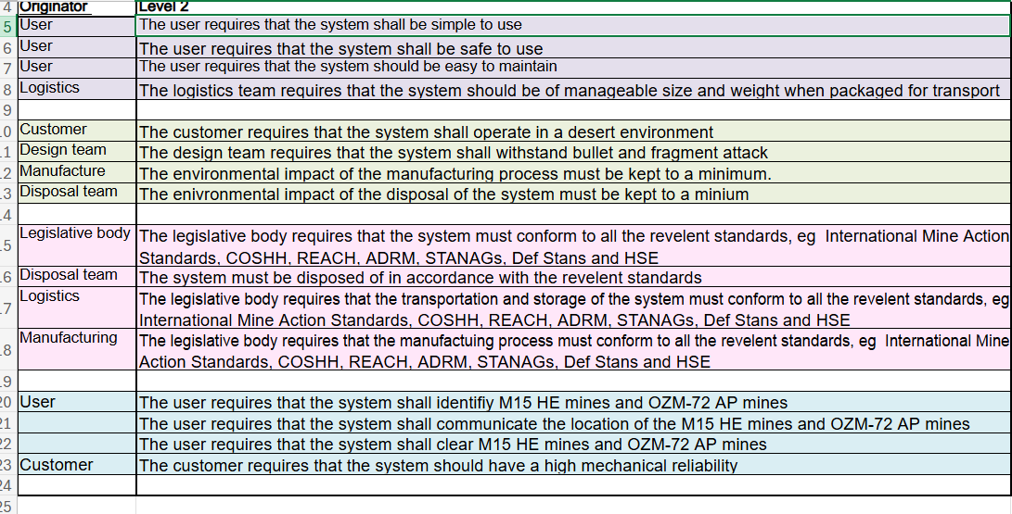
Figure 1 – Requirements
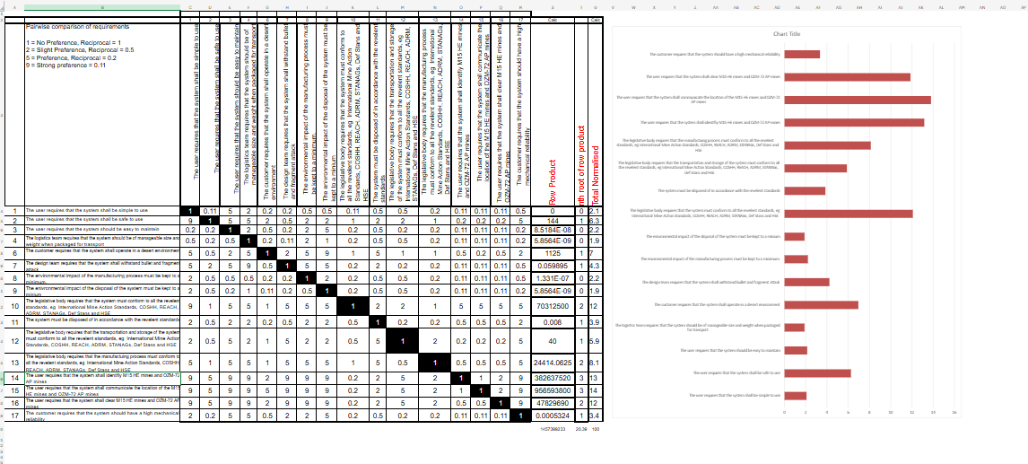
Figure 2 – Pairwise
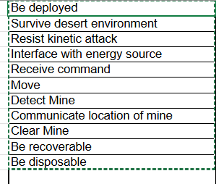
Figure 3 – Results of Pairwise
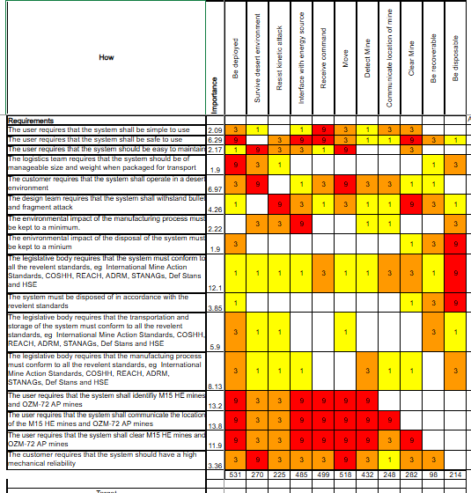
Figure 4 – QFD 1
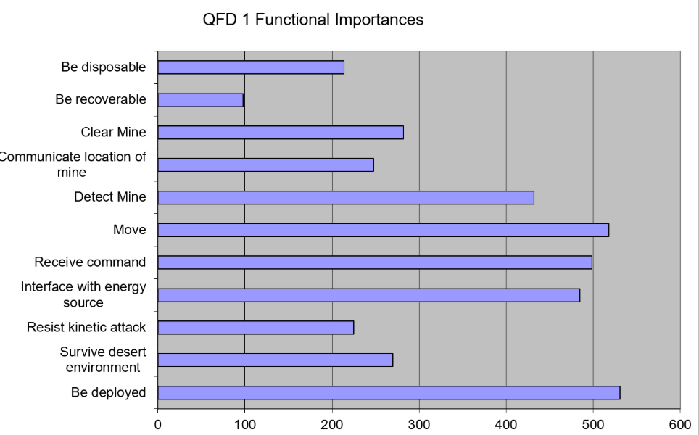
Figure 5 – QFD 1 Graph Results
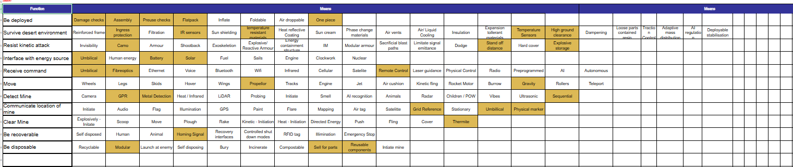
Figure 6 – Final FML
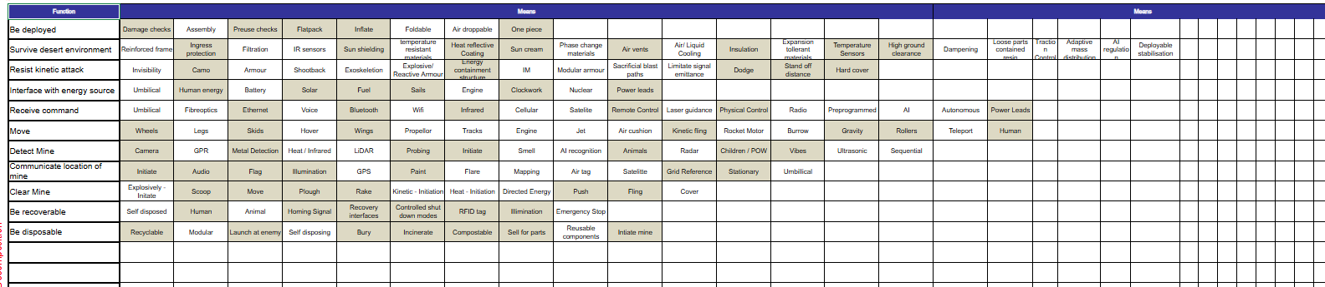
Figure 7 – Low-cost FMA

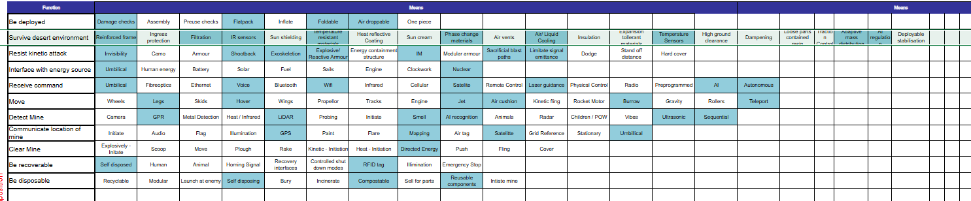
Figure 8 – Hi-Tech FMA
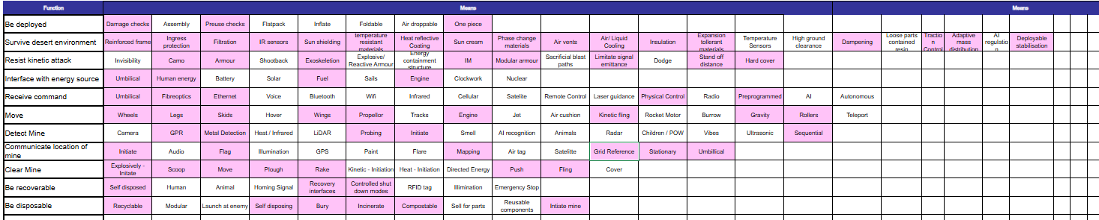
Figure 9 – Reliable FMA
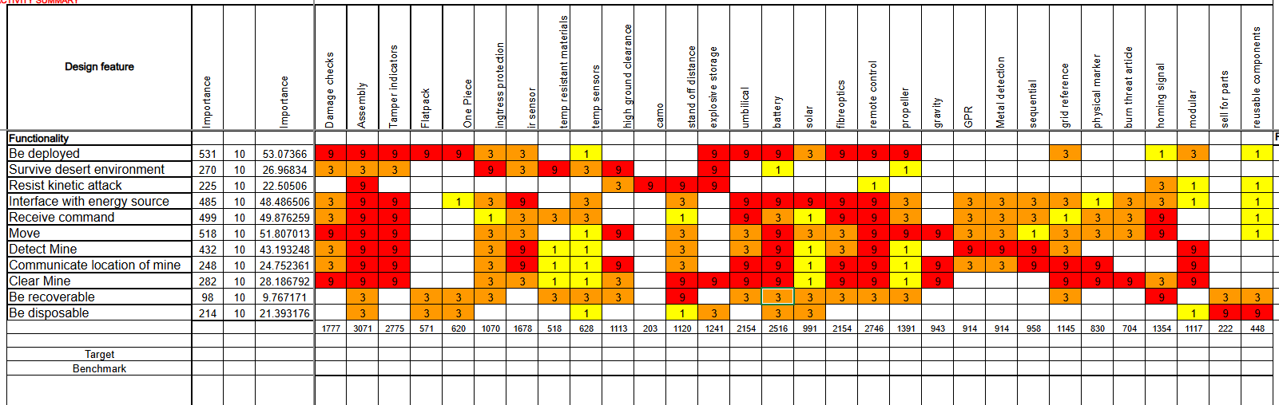
Figure 10 – QFD 2
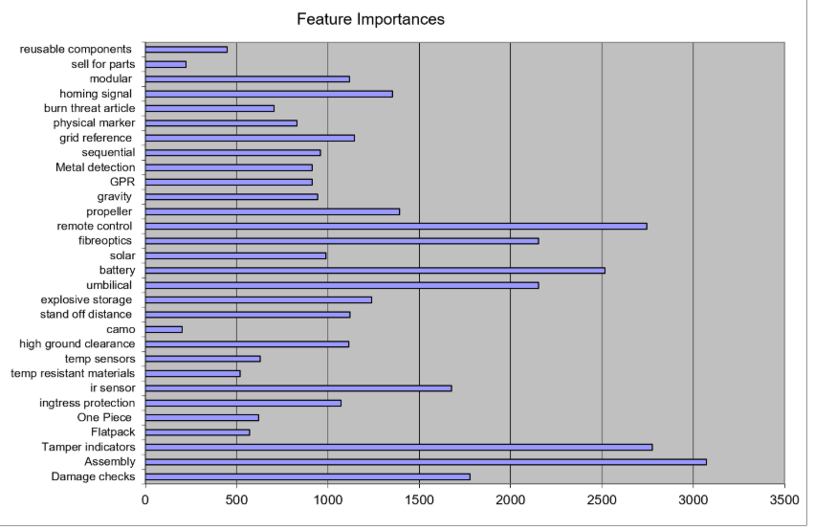
Figure 11 – Results Graph of QFD 2
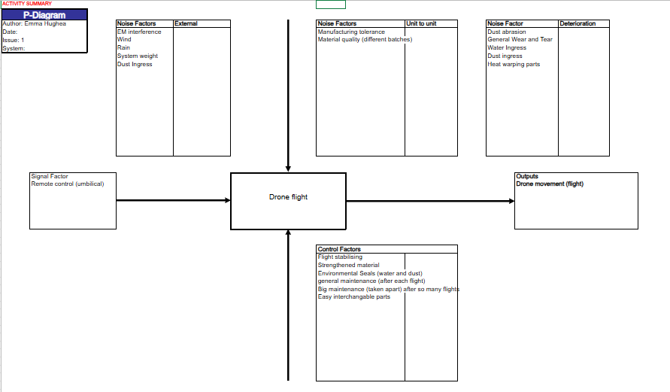
Figure 12 – P-Diagram
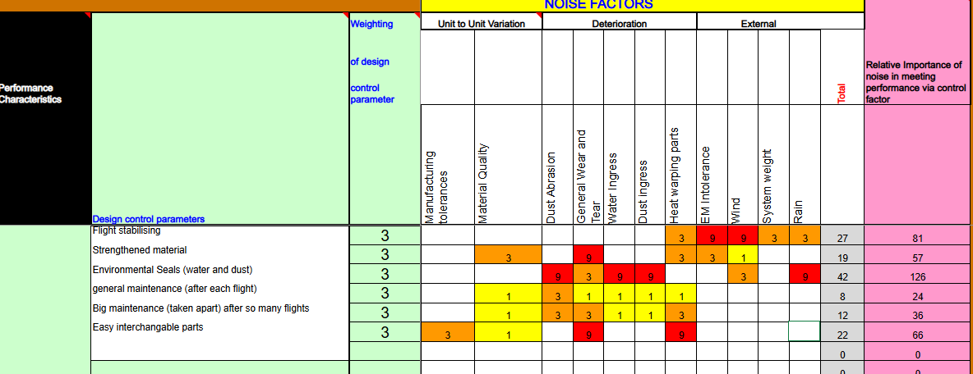
Figure 13: What/Why table

