

Student Name: Krunal Ashokbhai Sorathiya
Student ID: 2430614
Module Name: Strategic Management
Module Code: LCMB7003
Lecturer’s Name: Dr Jayalakshmi Gopalkrishnan / Dr Shengfeng Mei
Topic: Organizational Expansion Plan for Nando’s
Word Count: 5236

Executive Summary
An analysis of market attractiveness, organisational capabilities, competitive forces and suitable entry strategies is critically looked into in this strategic management report for the purpose of feasibility analysis of Nando’s to venture into China. The report uses the PESTLE, Porter's Five Forces, VRIO and Porter's Diamond models to determine China as a high-growth market with increasing disposable incomes, growing interest in global foods, high digital penetration and favourable prospects of differentiated food brands. China offers more long-term opportunities than the oversaturated casual-dining sector in the UK.
The market entry options were evaluated, and decided to use the Joint Venture, supported by the strategic digital alliances was identified as the most successful strategy. This will enable Nando's to tap into local know-how, overcome the complicated food-service policies and expand efficiently in key cities in China. The Cost Focus and Differentiation Strategy led to Competitive positioning, and Market Development with the selective adaptation of products proved to be the best route to grow the business according to the Ansoff Matrix.
The opportunity to implement sustainable expansion is achieved with a staged market entry strategy, risk evaluation, and the combination of CSR and BCG. Performance monitoring will be conducted using a Balanced Scorecard with the financial, customer, internal process, and learning perspectives, with a Triple Bottom Line framework added. Generally, the plan offers a powerful, expansive avenue to successful Nando’s expansion into China.

Table of Contents
1. Introduction 5
2. Selection of Organisation and Target Market 5
2.1 Company Overview 5
2.2 Justification for selecting the target country (Target country: UK and China) 6
2.3 Strategic rationale for expansion 10
3. Comprehensive Strategic Analysis 11
3.1 Macro-Environmental analysis of UK and China 11
3.2 Industry and competitive analysis for UK and China 16
3.3 Internal strategic analysis 19
3.4 National competitiveness 20
3.5 Critical Reflection on Tools Used 22
4. Strategy Development and Formulation 22
4.1 Entry Strategy Options 22
4.2 Recommended Market Entry Strategy 24
4.3 Phased Used for Market Entry purposes 26
4.4 Competitive Strategy by using Porter’s Generic Strategy 27
4.4 Ansoff Matrix Positioning 28
4.5 Risk Assessment 29
5. Performance Evaluation Framework 31
5.1 Use of the balance scorecard for performance evaluation 32
5.2 Triple Bottom Line (TBL) Measurement System 37
6. Conclusion 39
Reference list 40

1. Introduction
Strategic management assists organisations to locate areas where the organisation can use the opportunities to gain a competitive advantage and be sustainable in the dynamic global business environment. In the case of consumer-facing businesses, like Nando's, expansion to foreign markets needs an evidence-based grasp of the target clients, the competitive environments and culture. Through standards for aligning internal capabilities with external market conditions, strategic decision-making would be stronger and future focused. This report focuses on Nando's as an international expansion strategy of the globally recognised casual dining brand to the two promising markets in the United Kingdom (UK) and China. The markets provide unique opportunities, which align with the brand name and expansion goals of Nando’s. This plan underlines the potential of Nando to maximise its market presence in these regions and generate long-term value through a systematic study of segmentation, targeting, and positioning (STP), and strategic justification of entering these regions. The analysis will also inform strategic decisions that will enable the company to have a presence across the globe and, at the same time, meet the needs of different consumers.

2. Selection of Organisation and Target Market

2.1 Company Overview
Nando's is a chain of international casual restaurants that has its origins in South Africa and was started in 1987. It is internationally known because of its Portuguese Mozambican-inspired flame-grilled peri-peri chicken, bright brand image and cultural dining performance. With offices and restaurants spread across more than 30 countries over the years, the company has grown to cover over 1200 restaurants, mostly in the UK, Australia, and certain parts of Africa. Nando’s also focuses on differentiating through its signature peri-peri marinades, customisable spice levels, relaxed seating, and Afro-Portuguese visual branding.
The company primarily adheres to the fast-casual dining approach, which fosters convenience and high-quality food, attracting young professionals, families, and students.
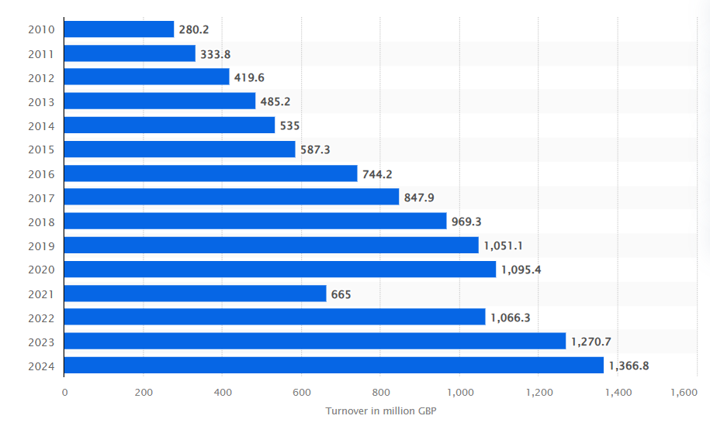
Figure 1: Revenue of Nando's globally (2010 to 2024) (in million GBP)
(Source: Companies House, 2024)
Following an effective strategy and proper leadership boosts Nando's corporate reputation. To achieve this competitive advantage based on product uniqueness, affordability, and customer experience, Nando’s persists in seeking strategic opportunities for expansion in the high-growth, multicultural global markets.

2.2 Justification for selecting the target country (Target country: UK and China)
Justification for selecting the UK
The UK has been recognised as one of the most successful Nando’s markets abroad, which gives Nando’s good brand visibility and good consumer demand. The multicultural society in the country embraces the world cuisines, including the spicy and flavourful peri-peri foods. The UK has good purchasing power and a well-developed restaurant sector, which makes it suitable for expansion and further product innovations because of high urbanisation (Zhang et al., 2024).
Justification for selecting China
China has a fast-developing economy, with rising consumption of foreign cuisines. The increasing middle-class, shifting lifestyle choices and strong desires for western-style food provide Nando's with a good environment. The Chinese market appreciates differentiated flavours, convenience, and a social dining experience, which helps restaurants develop stronger brand propositions (Lyu, 2024).
Kl;’Table 1:STP analysis
Segmentation | Sub-segmentation | Targeting | Positioning
Demographic | Age: 16-45, students, young employees and families.  Income: Middle-income buyers, interested in affordable restaurants.  Income: Busy people and students who would like to have convenient and healthy foods.  Family size: Small to medium families that love casual dining. | Target middle-income urban customers who demand delicious yet cheaper foods. Target urban students and youths. | Position Nando’s as a low-cost, flavour-based, socially interactive restaurant amongst the young and active audiences (Chen et al., 2024).
Geographic | London, Manchester, Beijing and Shanghai, the urban centres.  High-dense living expanse and commercial and residential areas.  Locations where food tastes are multicultural (UK) and new food trends are being popularised (China). | Targeting large cities and urban regions with great pedestrian volume, high quality of dining culture and demand for foreign cuisine (Ji et al., 2024). | Establishing itself as a worldwide lifestyle brand which delivers international tastes to bustling urban societies.
Psychographic | Lifestyle: Trendy and health-conscious consumers who value bold flavours.  Personality: Dining out is receptive to new cuisines.  Values: Social, environmental sustainability, brand authenticity. | Target consumers who embrace experience as one of their cultural values in food consumption and ethical habits (Eze and Mena, 2024). | Status as a culturally diverse, socially aware brand that provides fun and flavourful food.
Behavioural | Dining: Frequent casual, online ordering and takeaway.  Loyalty: The Brand  can be customised in terms of the menu.  Occasional consumption: Family meals, weekend lunch, fast lunch. | Target for loyalty applications, delivery services and student promotions to win over target repeat clientele and digitally aware customers. | Position as a restaurant to give people an experience of sharing time and having their own customised peri-peri dishes (Catolico et al., 2025).

2.3 Strategic rationale for expansion
Nando's expansion in the UK is expected to follow the greater penetration in the market due to product innovation, menu diversification and improved digital experiences. The UK has a stable economic climate, a high level of consumer familiarity and a cultural inclination towards foreign flavours, and thus long-term growth is feasible (Ajetunmobi and Laobangdisa, 2024). Enhancing the network of Nando’s within the UK also contributes to the brand consistency, efficiency and development of the other European markets.
China is a strategic opportunity because of its high population and is a high-growth area that is fast modernising its food culture and increasing its demand for international cuisines. Expansion to China will enable Nando’s to diversify geographically, thereby relying less on the current markets. The interest of the Chinese in spicy taste and social dining can also be utilised by Nando’s to position peri-peri chicken as a better, more modern alternative to the already available fast-casual meals.
Table 2: Rationale for choosing the UK and China
Strategic Factor | UK | China
Market Potential | Mature, stable market with proven success for Nando’s; strong demand for peri-peri cuisine. | Large, fast-growing market with increasing interest in Western-style dining.
Consumer Behaviour | Multicultural population receptive to global flavours; high casual-dining frequency. | The rising middle class is seeking unique flavours and social dining experiences.
Competitive Advantage | Strong brand recognition and an efficient supply chain supporting further expansion. | Opportunity to differentiate with spicy, flavour-rich offerings in a competitive but evolving market.
Digital & Delivery Growth | Established digital platforms enable enhanced customer engagement. | An advanced digital ecosystem supports scalable delivery and marketing.

3. Comprehensive Strategic Analysis

3.1 Macro-Environmental analysis of UK and China
PESTLE analysis
The PESTLE framework helps identify external forces that shape operational choices, market penetration plans, and long-term competitiveness.
Political factor
The UK is a stable country regarding political practices, clear laws and clear food safety policies, which are ideal for Nando’s. On the other hand, the political climate of China is defined by the centralisation of the state and rigid regulatory control, particularly in regard to foreign companies, which makes franchising, food imports and licensing processes more complicated (Zhang et al., 2025). Moreover, the pro-consumer and pro-innovation strategies of China in the food and beverage sector do favour foreign investment in the industry and hence long-term prospects of expansion.
Economic factor
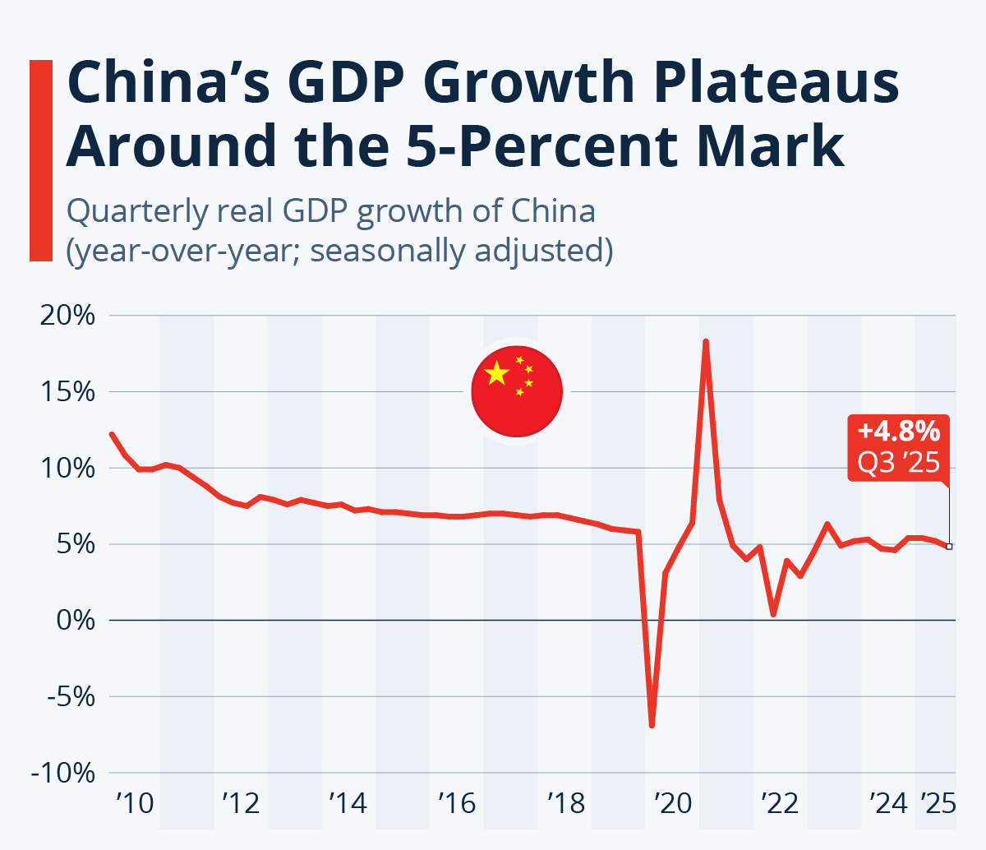
Figure 2: Increasing GDP of China
(Source: Buchholz, 2025)
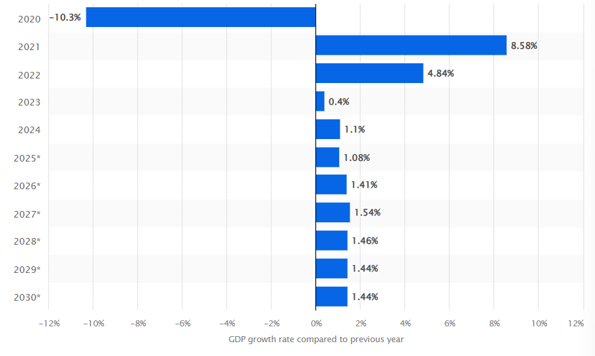
Figure 3: Gross domestic product (GDP) growth rate of the UK (2020 to 2030)
(Source: IMF, 2025)
Based on the images highlights that the increasing GDP of China, 4.8% and the increasing GDP of the UK, enhance a favourable environment for successful expansion.
The purchasing power of the UK is high, and the consumption patterns of the citizens towards food are well-established, and the inflation levels are stable, driving steady consumer demand in the casual restaurant sector. Whereas the increasing population of middle-income populations in China acts as a stimulus behind the urge for international cuisines, aids to increase in disposable income enables people to engage in the higher availability of premium casual foods (Tang et al., 2024).
Social factor:
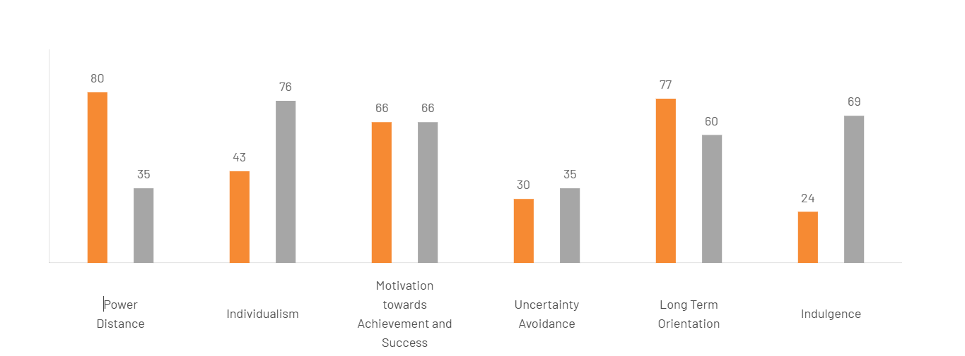
Figure 4: Cultural stability of the UK and China
(Source: ‌The Culture Factor Group, 2025).
Multiculturalism in the UK and China helps to affect the tastes of consumers in the UK, with global tastes like peri-peri being well accepted. Buying behaviour is shaped heavily by health awareness and the requirement to purchase food that was ethically produced (Varzakas and Antoniadou, 2024). Global dining demands in China are on the increase due to a high rate of urbanisation, changing lifestyle and greater exposure to the western culture. Which helping to
Technological factor:
Both the UK and China markets are characterised by developed digital ecosystems. The UK has an effective online delivery infrastructure and loyalty applications. The technological implementation in China is even better, as it has AI-based delivery systems, mobile payments and platform-based marketing (Zhang et al., 2025). These ecosystems can be used by Nando’s to increase delivery activities, as well as enhance brand awareness.
Legal factor
The legal environment in the UK is transparent, which will provide the business with stability, whereas in China, the business must be cautious about licensing, joint-venture policies and importation laws.
Environmental factor
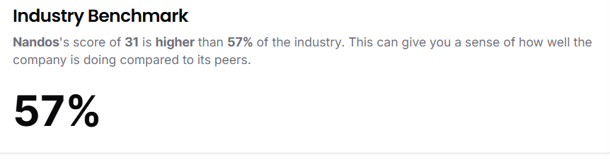
Figure 5: Nando’s sustainability report
(Source: ‌Ditchcarbon.com. 2025)
Nando’s has a reputation for being sustainable also meshes well with the increasing sensitivity of both markets, in regard to the environment. The UK focuses on environmental conservation and sourcing ethically. China is gradually focusing on green development, and any company that does not embrace eco-friendly practices in its operations will be sidelined.
Table 3: PESTLE analysis
Factor | Pestle for the UK | PESTLE for China
Political | UK stable regulations | China is strict but supportive of foreign investment.
Economic | UK mature economy with strong purchasing power | China's rapid growth and rising middle class.
Social | UK multicultural and health-focused | China values social dining and global cuisines.
Technological | Advanced digital platforms in both markets | China leads in mobile payments and AI-driven delivery.
Legal | UK transparent laws | China has complex licensing and compliance requirements.
Environmental | Increasing demand for sustainability in both markets | Nando’s ethical sourcing aligns well.

3.2 Industry and competitive analysis for UK and China
Porter's Five Forces Analysis
The Five Forces model is used to evaluate the competitive positioning of Nando's as a company in the UK and China.
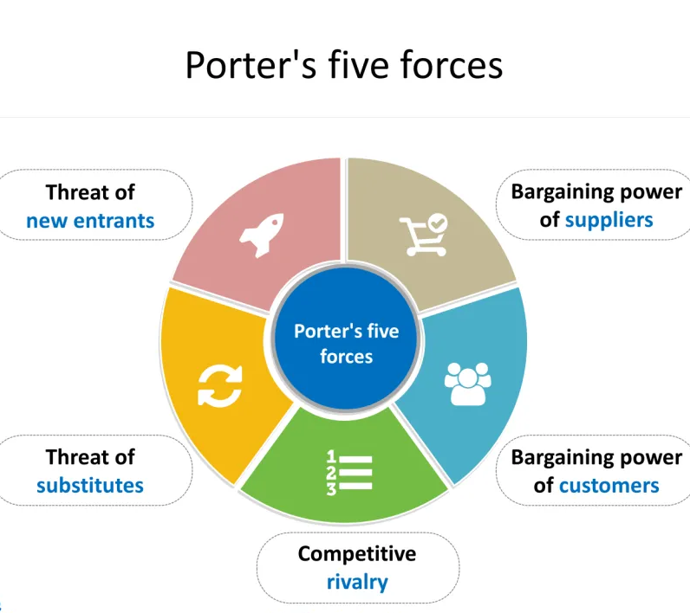
Figure 6: Porter's five forces
(Source: YourFreeTemplates, 2019)
Competitive rivalry
Both markets have intense rivalry of fast-food outlets (McDonald's, KFC), casual-dining outlets (Wagamama, PizzaExpress) and new delivery-only outlets. The intense competition dictates that Nando’s will need to focus on how it separates itself using peri-peri flavours, brand culture and customer experience.
Threat of new entrants
It has medium entry barriers in the United Kingdom owing to the level of competition that has been developed, the cost of operation and regulation. In China, although the growth is high, entry into the market is complicated because one needs to be licensed.
Bargaining power of suppliers
Nando’s uses specialised peri-peri ingredients, despite that regular sourcing of ingredients is significant. The predictable supply chains and suppliers minimise risk in the UK. However, the research of Forné and Leer (2025) highlights that importation rules and the localisation of supply chains in China can raise supplier dependence.
Bargaining power of buyers
Consumers possess a variety of restaurant choices, which strengthens their power. Chinese people are very sensitive to prices, whereas UK customers place more emphasis on ethics and quality. Affordability and value-added experience must be maintained in the two markets (HUANG and KHANTONG, 2024).
Threat of substitutes
The risk of substitution is further increased by the heterogeneous food culture in China. Nando’s must respond to this by offering exceptional flavours, tailor-made and remarkable dining experiences.
Table 4: PORTER's five forces analysis
Force | Summary
Rivalry | High competition from global and local dining brands.
New Entrants | Moderate; regulations and branding deter entry.
Suppliers | Moderate dependence on specialised ingredients.
Buyers | High power due to many dining alternatives.
Substitutes | High, especially from diverse local cuisines.

3.3 Internal strategic analysis
VRIO analysis
Table 5: VRIO analysis
Resource/Capability | Valuable | Rare | Inimitable | Organised | Strategic Implication
Peri-peri Recipe & Unique Flavours | Yes | Yes | Yes (proprietary recipe) | Yes | Sustained competitive advantage
Strong Global Brand Identity | Yes | Yes | Moderately (culture-based) | Yes | Competitive advantage
Customer Experience & Store Ambience | Yes | No | No (can be copied) | Yes | Temporary competitive advantage
Efficient Fast-Casual Operating Model | Yes | No | No | Yes | Competitive parity
Ethical Sourcing & Sustainability Practices | Yes | Yes | Yes | Yes | Sustained competitive advantage
Digital Capabilities (loyalty apps, delivery partnerships) | Yes | No | No | Yes | Temporary advantage
Skilled Workforce & Training Systems | Yes | No | Moderately | Yes | Competitive advantage

3.4 National competitiveness
Porter’s Diamond
The Diamond Model created by Porter allows evaluating the role of national conditions in the UK and China in determining competitiveness in Nando’s.
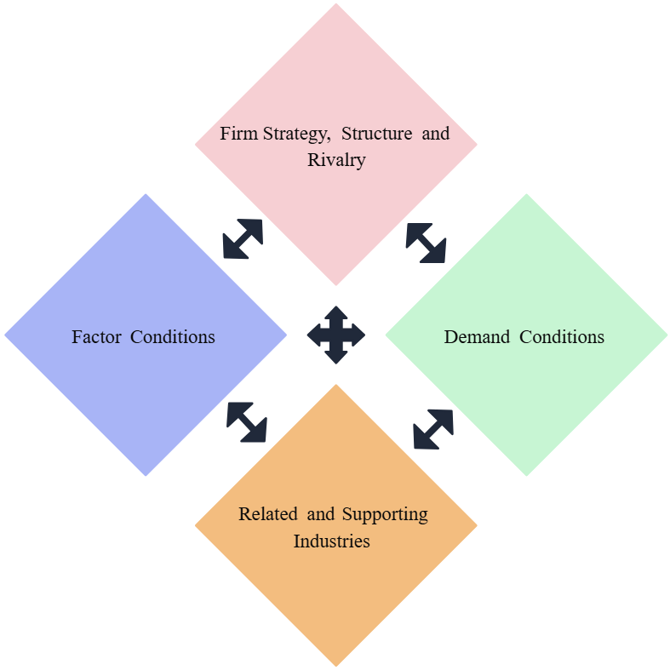
Figure 7: Porter's Diamond Model
(Source: Creately, 2024)
Factor conditions
The UK encompass the provision of a skilled labour force, advanced networks on logistics networks, and robust digital infrastructure, which promotes the efficient running of restaurants and the supply-chain reliability (Suali et al., 2024). China is also a source of plenty in terms of labour, fast modernising logistics infrastructure and a very advanced digital payment ecosystem, which improves delivery and interactivity with customers.
Demand Conditions
The UK has full-grown consumers used to different cuisines worldwide, product demand is always constant, and the peri-peri products have a market. The burgeoning middle-income population and the rising interest of many Chinese people in Western cuisine form a distinctive demand, particularly among the young urban consumers in need of new tastes (Lyu, 2024).
Related and Supporting Industries
Strong industrial support in the two countries in terms of delivery platforms, marketing agencies and agricultural suppliers is available. Research by Ren and Lin (2024) highlights that the use of a Chinese vertically integrated digital system provides a distinctive competitive advantage to scale fast.
Firm Strategy, Structure and Rivalry
Strong Strategy, Structure and Rivalry are influenced by Competition in the two markets. Though it puts pressure, this creates more innovation, menu adjustment and operational efficiency.
The UK offers stability and market maturity, whereas China offers high growth potential and strong digital competitiveness to improve the global strategic position of Nando’s.

3.5 Critical Reflection on Tools Used
The application of PESTLE, Porter's Five Forces, VRIO and Porter's Diamond makes a systematic way of comprehending the international expansion situation of Nando’s. All tools point to various aspects of strategic decision-making. PESTLE is a good model to consider the macro-environmental factors, but it has a generalisation tendency due to the wide range, and it lacks a measure of impact and urgency. Porter's five forces provide clear information about the competitive situation in an industry; however, they presuppose that the situation in the market is stable, and it does not necessarily happen in a rapidly changing market such as China.
The VRIO framework can be useful in determining the internal strengths, with the unique recipe and sustainability practices of Nando’s, developing a long-term benefit. But VRIO does not explicitly deal with the interactive effect of resources on the external market forces, and its use needs to be supplemented by other tools to provide a full view. The Diamond of Porter adds value to the understanding of national competitiveness but is not as effective as the one to explain the strategies of the firm based on the countries. Based on the business analysis, it has been understood that Nando’s gets a favourable position for business expansion in the Chinese market.

4. Strategy Development and Formulation
Nando's plan to expand into China, as its high growth potential market is characterised by the increasing middle class, growing demand in the international dining experiences and the digitally developed consumer climate. China is scalable in the market with no competition, menu innovation, and greater digital integration ability, unlike the UK, which is already mature and saturated with Nando's products and services.

4.1 Entry Strategy Options
Among the entry modes, which Nando’s can adopt when expanding to China, there are a number of exercises with clearly defined benefits and constraints:
Franchising
Franchising is a method that enables quick expansion with local partners who are native to the area and have existing networks. This saves on capital investment and operational complexity.
Joint Venture (JV)
A JV with a Chinese hospitality company or food service offers area knowledge, regulatory policies, and operations. It will enable the sharing of risk, access to supply chains, and entry into the digital ecosystems of China, including WeChat Pay, Meituan and Ele.me. The biggest problem is the possible disagreement of the management styles, cultural variations, and common control of decision-making (Bodendorf et al., 2024).
Wholly Owned Subsidiary (WOS)
A WOS offers the utmost flexibility on brand, processes and menu innovations. It enables quality and capture of all profits (Manhas et al., 2024).
Strategic alliance with a delivery partner
Use of strategic alliances increases coverage; they fail to address issues like supply-chain localisation.
Master franchise model
The Asian expansion can be fast-tracked by the use of a master franchise system with regional distributors in major cities such as Shanghai, Beijing and Guangzhou, and at the same time, since strict compliance guidelines allow negotiated control.
Table 6: Opportunity and risk of every entry strategy
Entry Strategy | Description | Opportunity | Risk
Franchising | Partnering with local operators to open outlets. | Low investment, rapid expansion, and local market knowledge. | Less control over quality and brand consistency.
Joint Venture (JV) | Shared ownership with a Chinese food-service company. | Local expertise, easier regulatory navigation, shared risk. | Cultural differences, potential decision-making conflicts.
Wholly Owned Subsidiary (WOS) | Full ownership of operations. | Maximum control, consistent brand standards. | High cost, higher regulatory complexity.
Master Franchise | Granting exclusive regional rights to one partner (KASIM, 2024). | Fast scaling, reduced capital burden. | Requires strict monitoring of franchisee performance.
Strategic Alliances | Partnerships with platforms like Meituan/Ele.me. | Strong digital reach and customer access. | Limited influence on operational execution.

4.2 Recommended Market Entry Strategy
The most appropriate strategy Nando’s should use in this case is this two-layered approach, including a joint venture and master franchise model, as it helps to make primary and secondary expansion fruitful.
OLI framework
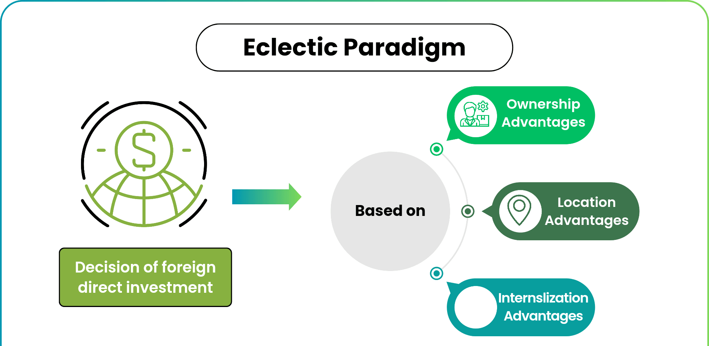
Figure 8: OLI framework
(Source: Ailani, 2024)
Ownership Advantages: The proprietary peri-peri recipe Nando's has, and its good brand identity gives Nando's a competitive advantage.
Location Advantages: The huge urban population, the presence of digital ecosystems and the growing consumption by the middle-income population of China make it a worthy place to enter (Rahman et al., 2025).
Internalisation Advantages: A JV is the option that will enable Nando’s to exert sufficient control over the brand standards as well as extract the advantages of local expertise.
Cultural and Regulatory Fit
JV offers easier acquiring of business licences and food safety certifications, and real-estate purchases.
Digital Integration
Local partners help to ensure a smooth merge into platform-based ecosystems, including.
WeChat environment, Alipay and Meituan and Ele.me courier services.
Aids in making scalable expansion
Using the JV has stabilised the brand presence and operating model. Nando can adopt a Master Franchise model to expand regionally and reduce capital investment.

4.3 Phased Used for Market Entry purposes
Phase | Strategic Plan | Timeframe
Phase 1: Market Preparation | Regulatory checks, JV negotiation, supplier localisation, and pilot menu development. | 0–6 months
Phase 2: Pilot Launch | Open 2–3 flagship stores in Shanghai and Beijing; establish digital presence on WeChat & Meituan. | 6–18 months
Phase 3: Market Penetration | Launch Master Franchise agreements; expand to Guangzhou, Shenzhen, and Chengdu. | 18–36 months
Phase 4: Consolidation & Growth | Strengthen supply chains, introduce loyalty apps, CSR programmes, and local menu innovations. | 36–60 months

4.4 Competitive Strategy Analysis
Porter's Generic strategy have three approaches: cost leadership, which follows a low-cost producer, differentiation follows a unique product offering, and focus makes a narrow market segment. In that case, Nando’s follows a Differentiation Strategy to compete in China, where consumers put high value on novel dining experiences, good brand identity, and varieties of flavour. Nando’s should implement a differentiation strategy.
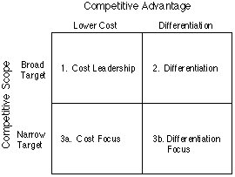
Figure 9: Porter’s Generic Strategy
(Source: Porter’s Generic Competitive Strategies)
Justification
Unique Product Offering: The peri-peri flavour profile will be new and unique in China, providing a culturally attractive hot flavour that meets the regional taste (Fekecs, 2024).
Experience-Driven Dining: Chinese people value ambience, social appeal and online communication much, none of which Nando's does not serve in their stores in an emphatic manner.
Health-Conscious Positioning: The increase in the popularity of grilled products with less unhealthy eating habits opens up a window of opportunity to move beyond the fried-chicken market leaders like KFC or Dicos.
Sustainability Differentiation: Following ethical sourcing and low-carbon strategy in CSR, Nando’s will attract the attention and demand of the increasing number of Chinese who are attentive to the brand in China (Dabral et al., 2025).
Therefore, long-term brand strength and competitiveness in the market are best achieved through differentiation.

4.4 Ansoff Matrix Positioning
Market Penetration
Expand market share in the current markets; however, it is not suitable for Nando's in China to develop a new market.
Market Development
Expanding into new geographic markets by using existing products. This has great relevance given the fact that the objective of Nando’s is to offer peri-peri chicken in the Chinese cities (Cavus et al., 2024).
Product Development
Innovation in new products to be offered in the current markets. This may be done by Nando’s later in order to adjust to Chinese tastes (including Sichuan peri-peri, rice bowls).
Diversification
Introducing new products in new markets- greater risk and inappropriate in the first instance.
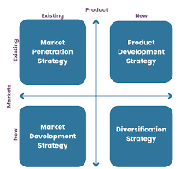
Figure 10: Ansoff matrix
(Source: ‌Oxford College of Marketing, 2023)
Justification for choosing Market Development
China is a new market where Nando's will present its existing core menu, only to be later supplemented by mild foreignisation. Market development is low risk and faster entry and worldwide branding (Hasan et al., 2024).

4.5 Risk Assessment
Table 7: Risk Assessment
Sl. No. | Risk Name | Risk Description | Likelihood (1–5) | Impact (1–5) | Risk Rating (L×I) | Mitigation Strategy
1 | Regulatory Delays | Complex food licences and JV approvals may slow entry. | 3 | 5 | 15 | Work with local partners.  Ensure compliance;  Engage CSR transparency reports (Jakubowska et al., 2024).
2 | Supply-Chain Disruption | Difficulty sourcing peri-peri ingredients locally. | 4 | 4 | 16 | Build local farms,  partner with sustainable suppliers (CSR)  Invest in “Star” supply-chain units (BCG).
3 | Cultural Misalignment | The menu may not fit local taste preferences initially. | 3 | 4 | 12 | Introduce localised menu items;  Develop community-testing CSR events.
4 | Strong Competition | intense rivalry between Western and local brands. | 4 | 3 | 12 | Differentiation strategy;  Invest in “Question Mark” regions through BCG expansion.
5 | Digital Integration Failure | Weak adoption on WeChat, Meituan or Alipay reduces reach. | 2 | 5 | 10 | Build strong digital alliances  CSR-driven tech inclusion campaigns.
Table 8: Risk Matrix
Overall Impact of the Risks |  | The Severity of the Risks
 |  | 1 | 2 | 3 | 4 | 5
Probability of the Risks | 1 | 1 | 2 | 3 | 4 | 5
Probability of the Risks | 2 | 2 | 4 | 6 | 8 | 10
Probability of the Risks | 3 | 3 | 6 | 9 | 12 R3 | 15 R1
Probability of the Risks | 4 | 4 | 8 | 12 R4 | 16 R2 | 20
Probability of the Risks | 5 | 5 | 10 R5 | 15 | 20 | 25

5. Performance Evaluation Framework
Performance Evaluation Framework is vital to the idea of ensuring that Nando's expansion into China is being strategically monitored, controlled and significantly improved.

5.1 Use of the balance scorecard for performance evaluation
Balanced Scorecard (BSC) and triple bottom line theory are a perfect best fit since the system considers organisational performance in a wider scope and not just the financial metrics. It upholds four major perspectives, namely: Financial, Customer, Internal Processes and Learning and Growth, and keeps the operational activities within the long-term strategic objective.

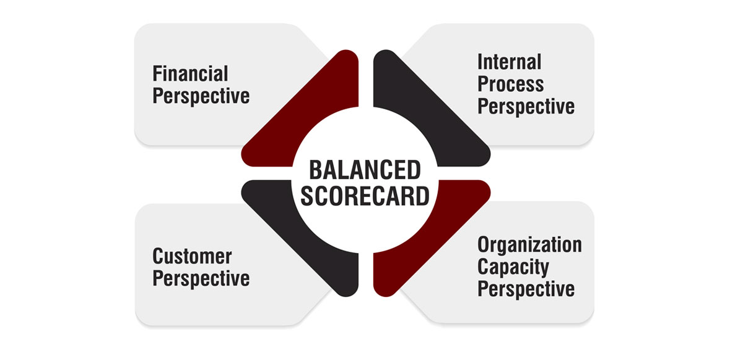
Figure 11: Balance Scorecard
(Source: The Strategy Institute, 2024).
Financial Perspective
Financial KPIs will determine the effectiveness of the China market entry in terms of profitability and shareholder value. International expansion requires a large initial investment; as such, keeping track of financial results is the only way the strategy will ensure its sustainability (Attah et al., 2024).
Table 9: Financial Perspective
KPI | Description | Target (Year 1–3) | Purpose
Revenue Growth Rate | Measures the year-on-year increase in total sales. | 12–18% annually | Indicates demand for peri-peri products in China.
Operating Profit Margin | Profit after operating expenses. | 8–12% | Ensures operational efficiency and cost control.
Return on Investment (ROI) | Profit relative to total investment in China. | Break-even by Year 3 | Evaluates long-term financial viability.
Average Transaction Value (ATV) | The average customers spend per order. | CNY 65–75 | Helps track upselling and menu pricing effectiveness.
Cost of Goods Sold (COGS) Ratio | Percentage of cost relative to sales. | < 40% | Ensures supply-chain efficiency and local sourcing success.
The restaurant market in China is fast expanding yet very competitive, and Nando's needs to recognise the need to keep an eye on the revenue, profit margin and ROI. Revenue Growth, ATV is indicative of the take-up of the peri-peri brand by the consumers, and Operating Profit Margin and COGS ratio determine control of costs, which is critical when supply chains are being localised. ROI can be used in deciding on whether the investment in a joint venture and master franchise will be sustainable.
Customer Perspective
The customer KPIs will measure the attractiveness, satisfaction, as well as customer retention of Nando’s in China. As the Chinese market is very competitive and digitally oriented, the measures which are customer-centric play a critical role.
Table 10: Customer Perspective
KPI | Description | Target | Strategic Importance
Customer Satisfaction Score (CSAT) | Satisfaction rating collected via apps/platforms. | ≥ 85% | Reflects the quality of food and service.
Net Promoter Score (NPS) | Likelihood of customers recommending Nando’s. | +40 or higher | Measures brand advocacy and loyalty.
Customer Retention Rate | Percentage of repeat customers. | ≥ 60% | Essential for long-term market stability.
Digital Engagement Rate | Interaction on WeChat Mini-Programs, Meituan page views, etc. | ≥ 20% month-on-month growth | Indicates digital visibility and relevance.
Delivery Order Ratio | Percentage of total orders via online delivery. | 50–60% | Critical in China’s delivery-dominated market.
The digital-priority dining culture in China involves customer satisfaction and loyalty, which is an important differentiator. CSAT and NPS document immediate feedback regarding the quality of food and service experience. Delivery Order Ratio is of extreme topicality, as in large Chinese cities, most of the restaurant turnover is delivered. Digital Engagement Rate will make certain that Nando’s is visible and competitive on other platforms like Meituan, Dianping and Wechat.
Internal Process
The KPIs for internal processes gauge operational efficiency, service quality, and supply chain performance. In China, where the speed, quality and consistency of the consumer demands are high, an efficient internal process is essential (Bodur et al., 2024).
Table 11: Internal Process
KPI | Description | Target | Strategic Value
Order Preparation Time | Time taken to prepare meals. | < 12 minutes | Fast service increases customer satisfaction and delivery efficiency.
Supply Chain Localisation Rate | 60% of ingredients sourced locally. | ≥ 60% | Reduces costs, supports CSR and improves freshness.
Quality Compliance Score | Adherence to food safety and brand standards. | ≥ 95% | Essential due to strict Chinese regulations.
Inventory Turnover Ratio | The speed at which inventory is used. | 10–15 turns/year | Minimises waste and maintains ingredient quality.
Delivery Accuracy Rate | Correct orders delivered through platforms. | ≥ 98% | Enhances reputation and customer trust.
The fast-paced operations, supply-chain capacity, and food quality are the determinants of success in the fast-moving market in China. The Time to prepare the Orders and the Delivery Accuracy Rate help to retain customers and make them satisfied. Quality Compliance Score becomes necessary because of the stringent food-safety standards of China. Inventory Turnover and Supply-Chain Localisation save on costs and help sustainability, which is one of the foundations of Nando's CSR commitments.
Learning and Growth
The Learning and Growth perspective emphasises employee growth, innovativeness ability and organisational culture. Penetrating China needs qualified human resources, domestic cultural knowledge and continuous innovation.
Table 12: Learning and Growth
KPI | Description | Target | Strategic Importance
Employee Training Hours per Staff | Time spent on cultural, operational and service training. | 40–50 hours annually | Ensures service consistency and cultural alignment.
Employee Retention Rate | Percentage of staff retained yearly. | ≥ 85% | Reduces training costs and builds a strong culture.
Innovation Index | Number of new menu items/local adaptations introduced. | 2–3 per year | Supports market alignment and differentiation.
Digital Capability Development | Staff proficiency in digital tools and delivery interfaces. | 90% staff are certified | Enhances customer experience and ordering efficiency.
Employee Engagement Score | Satisfaction and motivation level. | ≥ 80% | Drives productivity and better customer service.
The ability in the workforce directly impacts the service quality, which is critical to a brand with a culturally new market entry. The number of hours that employees have spent in training and the number of employees retained render the workforce experienced and steady. Digital Capability Development shows the value of taking advantage of the highly digital economy in China. Index of Innovation facilitates localisation of the menu- a necessary competitive advantage. The Engagement of the employees leads to high performance and improved relations with the customer.

5.2 Triple Bottom Line (TBL) Measurement System
Triple Bottom Line (TBL) offers a sustainable performance measurement framework, which considers economic, social and environmental performance. In the case of Nando’s entering China, the TBL will help to engage in long-term responsible development and increase brand recognition, create trust, and operational efficiency among the stakeholders.

Table 13: Triple Bottom Line theory
(Source: UW Online Collaboratives, 2022)
Prosperity
Some of the economic measures will include the increase in revenue obtained through new stores, gross profit margin, the ratio of return on investment (ROI) and cost savings in the supply chain. These measures guarantee the viability of Nando's expansion and also the exploitative nature of the huge Chinese market (Hasan et al., 2024).
People
The social indicators of importance are welfare standards of employees, employment hours, gender balance ratios, customer satisfaction rates, and initiatives that are aimed at communing with the community, like food donation programs. In that case, observing the development of workforce and customer perceptions can enable Nando’s to enhance its social contribution and respond culturally to the demands of Chinese consumers (Tamang, 2024).
Planet
Current KPIs that can be used to evaluate the reduction of carbon footprint, energy efficiency in the kitchen, reduction of food waste, recycling, and sustainable sourcing of chicken will be evaluated. The environmental responsibility is also achieved through the implementation of eco-friendly packaging and control over water consumption. Collectively, TBL will make sure that the Nando’s expansion will be sustainable in its profitability, as well as in terms of ethics and environmental responsibility.

6. Conclusion
In this strategic management report, Nando’s has been evaluated in terms of its potential expansion into the Chinese market through an exhaustive set of analytical tools, and the instruments used are the PESTLE, Five Forces, Porter's, VRIO, as well as Porter's Diamond. The review points out that China is one of the fastest-growing economies with high consumer interest in external food activities, sophisticated online ecosystems, and an increasing middle generation- it would be a better prospect in the market than the UK. Entry strategy analysis shows that a Joint Venture backed by digital alliances is the best offering, a balance between local insight, control and scalability.
The strategy development used theoretical lines like that of Porter's Generic Strategies and the Ansoff Matrix, and the final conclusion was that the combination of Market Development and product adaptation will position Nando in the best position to succeed in China. The risk assessment table also informs that there are operational, cultural, regulatory, and supply-chain risks, and the mitigation strategy to these risks has to involve CSR initiatives and long-term alignment of portfolios using the BCG matrix. The TBL and Balanced Scorecard frameworks provide the developed systems of continuous performance monitoring at the level of financial, customer, internal processes and sustainability.
In general, the given plan will allow realising the growth of Nando’s into China in a structured, competitive, ethical, and globally consistent way.

Reference list
Journal articles
Ajetunmobi, O.A. and Laobangdisa, S. (2024) ‘The effect of cultural and socio-economic factors on consumer perception’, in Consumer Perceptions and Food, pp. 23–44. Available at: https://www.researchgate.net/profile/Mesfin-Tenagashaw/publication/385186742_Consumers'_Perceptions_of_Fortified_Foods/links/67bcaeef8311ce680c7385a9/Consumers-Perceptions-of-Fortified-Foods.pdf#page=43
Attah, R.U., Garba, B.M.P., Gil-Ozoudeh, I. and Iwuanyanwu, O. (2024) ‘Advanced financial modeling and innovative financial products for urban development: strategies for economic growth’, International Journal of Engineering Research and Development, 20(11), pp. 1362–1373. Available at: https://www.researchgate.net/profile/Ifechukwu-Gil-Ozoudeh/publication/387058065_Advanced_Financial_Modeling_and_Innovative_Financial_Products_for_Urban_Development_Strategies_for_Economic_Growth/links/675dc856e9427c77e9107d50/Advanced-Financial-Modeling-and-Innovative-Financial-Products-for-Urban-Development-Strategies-for-Economic-Growth.pdf
Bodendorf, F., Feilner, S. and Franke, J. (2024) ‘How do joint ventures and non-equity strategic alliances impact the complexity of the supply chain and thus supply chain performance?’, Supply Chain Management: An International Journal, 29(4), pp. 685–705. Available at: https://www.researchgate.net/profile/Frank-Bodendorf/publication/379566902_How_do_joint_ventures_and_non-equity_strategic_alliances_impact_the_complexity_of_the_supply_chain_and_thus_supply_chain_performance/links/66b215c48f7e1236bc3e59d6/How-do-joint-ventures-and-non-equity-strategic-alliances-impact-the-complexity-of-the-supply-chain-and-thus-supply-chain-performance.pdf
Bodur, O., García, Á.M., Poszvek, G. and Durakbasa, N.M. (2024) ‘Quality in production and service’, in Proceedings of the International Symposium for Production Research. Cham: Springer Nature Switzerland, pp. 509–531. Available at: https://www.researchgate.net/profile/Osman-Bodur-2/publication/391421052_Quality_in_Production_and_Service/links/6818aac260241d514022a509/Quality-in-Production-and-Service.pdf
Catolico Jr, P., Oluyinka, S.A., Palmiano, J.P., Yao, A.J., Alejo, H. and Gonzales, R. (2025) ‘Consumers’ relationship proneness, benefits, and satisfaction in select casual dining restaurants in Malabon City’, Environment and Social Psychology, 10(6), p. 3488. Available at: https://www.researchgate.net/profile/Solomon-Oluyinka/publication/394666337_Consumers_Relationship_Proneness_Benefits_and_Satisfaction_on_Select_Casual_Dining_Restaurants_in_Malabon_City/links/68a52174d9261f6f51ad5a20/Consumers-Relationship-Proneness-Benefits-and-Satisfaction-on-Select-Casual-Dining-Restaurants-in-Malabon-City.pdf
Cavus, O., Tiwari, S., Sthapit, E. and Cifci, I. (2024) ‘Fine dining with the package service: master chefs’ perspectives’, Journal of Foodservice Business Research, pp. 1–26. Available at: https://www.researchgate.net/profile/Erose_Sthapit2/publication/380743349_Fine_dining_with_the_package_service_master_chefs%27_perspectives/links/664ca77622a7f16b4f40ad5e/Fine-dining-with-the-package-service-master-chefs-perspectives.pdf
Chen, Y.V., Wong, I.A., Leong, A.M.W. and Huang, G.I. (2024) ‘Having fun in micro-celebrity restaurants: the role of social interaction, foodstagramming, and sharing satisfaction’, International Journal of Hospitality Management, 120, p. 103768. Available at: https://thuvienso.hoasen.edu.vn/bitstream/handle/123456789/15919/Having%20fun%20in%20micro-celebrity%20restaurants%20The%20role%20of%20social%20interaction.pdf?sequence=1
Dabral, P., Nayak, S. and Piramanayagam, S. (2025) ‘Which attributes are important for patrons of fine-dining restaurants? A choice-based conjoint analysis’, Cogent Business & Management, 12(1), p. 2549518. Available at: https://www.tandfonline.com/doi/pdf/10.1080/23311975.2025.2549518
Eze, C.C. and Mena, B. (2024) ‘The role and importance of consumer perception’, in Consumer Perceptions and Food. Singapore: Springer Nature Singapore, pp. 3–22. Available at: https://www.researchgate.net/profile/Mesfin-Tenagashaw/publication/385186742_Consumers'_Perceptions_of_Fortified_Foods/links/67bcaeef8311ce680c7385a9/Consumers-Perceptions-of-Fortified-Foods.pdf#page=23
Fekecs, M.G. (2024) Analysis of Hungarian fine dining restaurants’ marketing activities. Available at: https://dolgozattar.uni-bge.hu/57758/1/Analysis%20of%20Hungarian%20Fine%20Dining%20restaurants%20final%20submission.pdf
Forné, F.F. and Leer, J. (2025) ‘The chef and the supplier: the role of the supply chain in fine dining creativity’, International Journal of Sociology of Agriculture and Food, 31(1), pp. 1–14. Available at: https://ijsaf.org/index.php/ijsaf/article/download/556/438
Hasan, M.M., Rayhan, Z., Mukta, R.T. and Faruq, O. (2024) ‘Research on adapting marketing techniques to different cultural, economic and regulatory environments for entering new international markets’, Informatics. Economics. Management, 3(4), pp. 257–277. Available at: https://cyberleninka.ru/article/n/research-on-adapting-marketing-techniques-to-different-culture-economics-and-regulatory-environment-to-entering-new-international
Huang, Y. and Khantong, P. (2024) ‘Influence of price strategy on customer satisfaction in the restaurant business’, Procedia of Multidisciplinary Research, 2(10), pp. 59–59. Available at: https://so09.tci-thaijo.org/index.php/PMR/article/download/5356/3328
Jakubowska, D., Dąbrowska, A.Z., Pachołek, B. and Sady, S. (2024) ‘Behavioural intention to purchase sustainable food: Generation Z’s perspective’, Sustainability, 16(17), p. 7284. Available at: https://www.mdpi.com/2071-1050/16/17/7284
Ji, Y., Wang, Z. and Zhu, D. (2024) ‘Exploring the impact of urban amenities on business circle vitality using multi-source big data’, Land, 13(10), p. 1616. Available at: https://www.mdpi.com/2073-445X/13/10/1616
Kasim, M.B. (2024) The feasibility study of Mushārakah and Muḍārabah in the franchise industry. Available at: https://etd.uum.edu.my/11600/2/s95234_01.pdf
Lyu, J. (2024) ‘Research on integration strategies and cultural adaptability of regional cuisines in China’s urban dining environments’, in SHS Web of Conferences, 207, p. 01032. Available at: https://www.shs-conferences.org/articles/shsconf/pdf/2024/27/shsconf_icdeba2024_01032.pdf
Lyu, J., (2024). Research on integration strategies and cultural adaptability of regional cuisines in China’s urban dining environments. In SHS Web of Conferences (Vol. 207, p. 01032). EDP Sciences Available at: https://www.shs-conferences.org/articles/shsconf/pdf/2024/27/shsconf_icdeba2024_01032.pdf
Manhas, P.S., Sharma, P. and Quintela, J.A. (2024) ‘Product innovation and customer experience: catalysts for enhancing satisfaction in quick service restaurants’, Tourism and Hospitality, 5(3), pp. 559–576. Available at: https://www.mdpi.com/2673-5768/5/3/34/pdf
Rahman, A., Rowlinson, S., Xia, B., Mahmood, M.N. and Hubbard, B. (2025) ‘Testing the multinational contracting OLI framework: Australia as a host market’, Engineering, Construction and Architectural Management. Available at: https://www.academia.edu/download/124852648/Published_Paper_2_2025_10_1108_ecam_12_2024_1651.pdf
Ren, C. and Lin, X. (2024) ‘Digital transformation, competitive strategy choices and firm value: evidence from China’, Industrial Management & Data Systems, 124(4), pp. 1656–1676. Available at: https://www.researchgate.net/profile/Changman-Ren/publication/379505837_Digital_transformation_competitive_strategy_choices_and_firm_value_evidence_from_China/links/66c0dc9a2ff54d6c9ed9e6e8/Digital-transformation-competitive-strategy-choices-and-firm-value-evidence-from-China.pdf
Suali, A.S., Srai, J.S. and Tsolakis, N. (2024) ‘The role of digital platforms in e-commerce food supply chain resilience under exogenous disruptions’, Supply Chain Management: An International Journal, 29(3), pp. 573–601. Available at: https://www.emerald.com/insight/content/doi/10.1108/SCM-02-2023-0064/full/pdf
Tamang, S. (2024) Cultural influences on employee dynamics and customer service in multinational fast food chains. Available at: https://www.theseus.fi/bitstream/handle/10024/876646/Tamang_Sharmila..pdf?sequence=2
Tang, C., Xie, X., Wei, G., Pan, L. and Qi, Z. (2024) ‘Exploring the evolutionary characteristics of food security in China and the United States from a multidimensional perspective’, Foods, 13(14), p. 2272. Available at: https://pmc.ncbi.nlm.nih.gov/articles/PMC11275272/pdf/foods-13-02272.pdf
Varzakas, T. and Antoniadou, M. (2024) ‘A holistic approach for ethics and sustainability in the food chain: the gateway to oral and systemic health’, Foods, 13(8), p. 1224. Available at: https://www.mdpi.com/2304-8158/13/8/1224
Zhang, J., Tang, S. and Sun, P. (2025) ‘From command-control to lifecycle regulation: balancing innovation and safety in China’s pharmaceutical legislation’, Healthcare, 13(6), p. 588. Available at: https://www.mdpi.com/2227-9032/13/6/588
Zhang, W., Liu, J. and Wen, L. (2024) ‘A study of the influence of the stability of the population’s income and expenditure on the development of restaurant chains’, Heliyon, 10(15). Available at: https://www.researchgate.net/publication/382857687_A_study_of_the_influence_of_the_stability_of_the_population's_income_and_expenditure_on_the_development_of_restaurant_chains
Zhang, Z., Kang, Y., Lu, Y. and Li, P. (2025) ‘The role of artificial intelligence in business model innovation of digital platform enterprises’, Systems, 13(7), p. 507. Available at: https://www.mdpi.com/2079-8954/13/7/507
Web references
Ailani, G. (2024). Eclectic Paradigm. [online] Wallstreetmojo.com. Available at: https://www.wallstreetmojo.com/eclectic-paradigm/.
Buchholz, K. (2025). Infographic: China's GDP Growth Plateaus Around the 5-Per cent Mark. [online] Statista Daily Data. Available at: https://www.statista.com/chart/17747/china-quarterly-gdp-growth/?srsltid=AfmBOoqZrFIDYRtv4J2g49su7q8NVJjWRCi_tIq7d0_4scUuTUBCLdm9. [Accessed 4 Dec. 2025].
Companies House (2024) Revenue of Nando’s worldwide from 2010 to 2024 (in million GBP) [Graph]. Statista. Available at: https://www.statista.com/statistics/652683/nando-s-revenue-united-kingdom-uk/.
Creately (2024). Porter’s Diamond Model | Creately. [online] creately.com. Available at: https://creately.com/diagram/example/Ec1LwCuMShz/porters-diamond-model.
‌Ditchcarbon.com. (2025). Nandos Sustainability Report. [online] Available at: https://ditchcarbon.com/organizations/nandos.
IMF. (April 22, 2025). United Kingdom: Real gross domestic product (GDP) growth rate from 2020 to 2030 (compared to the previous year) [Graph]. In Statista. Retrieved December 04, 2025, from https://www.statista.com/statistics/263613/gross-domestic-product-gdp-growth-rate-in-the-united-kingdom/?srsltid=AfmBOop5h3qI7WoIBN07Ba0iTwtQERjpXyd3dudexxNCfiUN4NfOH1ed
‌Oxford College of Marketing (2023). Using The Ansoff Matrix to Develop Marketing Strategy. [online] Oxford College of Marketing. Available at: https://blog.oxfordcollegeofmarketing.com/2016/08/01/using-ansoff-matrix-develop-marketing-strategy/.
‌The Culture Factor Group (2025). Country Comparison Tool. [online] The Culture Factor Group. Available at: https://www.theculturefactor.com/country-comparison-tool.
The Strategy Institute (2024). A Comprehensive Guide to Implementing the Balanced Scorecard Framework. [online] www.thestrategyinstitute.org. Available at: https://www.thestrategyinstitute.org/insights/a-comprehensive-guide-to-implementing-the-balanced-scorecard-framework.
University Of Cambridge (2020). Porter’s Generic Competitive Strategies (Ways of Competing). [online] University of Cambridge. Available at: https://www.ifm.eng.cam.ac.uk/research/dstools/porters-generic-competitive-strategies/.
‌UW Online Collaboratives (2022). An Explanation of the Triple Bottom Line. [online] UW Extended Campus. Available at: https://uwex.wisconsin.edu/stories-news/triple-bottom-line/.
‌YourFreeTemplates (2019). Porter’s five forces template - Free PowerPoint Templates. [online] Free PowerPoint Templates. Available at: https://yourfreetemplates.com/porters-five-forces-template/.

