Josh Willis (2405267)

cybersecurity assignment
Networks and Cybersecurity

Table of Contents
Cyber Threats 2
Security policies and mitigation 3
Proactive monitoring 3
Training and awareness 4
References 5

Cyber Threats
RaaS
Ransomware is itself a criminal business, it begins with a developer of ransomware will create the code and then begin to sell this on to other like-minded criminals wanting to use this to their own benefit, these customers of the ransomware are known as affiliates. The use of ransomware holds approximately 20% of all the cybercrime activities occurring daily. The ransomware affiliates will have a few different options to purchase and attain the ransomware code these can be from a monthly payment to have access to the tools or a one payment to have all the code and tools, finally the affiliate and the operator will share the profits gained from these often the affiliate having less than the operator [1]. Ransomware works in the way of blocking access to a user to enter and use their own device while encrypting all the files that are stored within the device. The access point begins at the network and lets the criminal plant the ransomware into the devices network while also taking device information to then use as blackmail later. The aim of all of this is to then demand a fee of money from the user to regain access to their device and the data they have, the demanded payment will often be wanted in the form of a cryptocurrency and the user will be directed to an anonymous website to make the transaction [2].

Vishing
Vishing is voice phishing this the intended purpose of this is to make phone calls or possibly leave voice messages that are fraudulent in their nature. These techniques are meant to lure unexpecting victims into giving away personal details such as bank information, log in details and credit card information. Details acquired from these vishing scams are then used for financial crimes and identity theft. Most common victims of vishing scams are elderly as they may have less of an understanding of the dangers of scams also new employees to companies as they will not be familiar with all callers and are easily susceptible to these scams [3].

Supply chain compromises
These attacks are done by infiltrating third-party systems or tools, these are commonly written as JavaScript or are open source code that are then sent to clients of the infiltrated party, as to be believed a trusted source to receive any updates or software from, the clients download the hidden malware within the normal package granting access into the device and offering the cybercriminals to gain the users personal information and commit financial crimes and potentially sell on all the details they receive to others who are willing to buy these details and information on users [4].

Risk of cloud adoption and hybrid work
Having hybrid clouds offers a balance of both public and private clouds, these clouds offer a cost-effective solution to run data clouds. Data leakage is a big concern for hybrid clouds as these clouds are used through the internet. The resulting situation of multiple access points is loss of devices will offer strangers the access to important data and creates vulnerable gateways into the clouds. Having gaps in the security parameters of the private clouds receive less security updates and protections when comparing to the public clouds in which have their security updated regularly to ensure the protection of all sensitive information that is stored on the clouds [5].

Security policies and mitigation
The zero-trust model works on a system in which all access is restricted to users and requires a verification of identity before use of the system this is also carried out on devices to prevent any outside devices joining the network. Zero trust is a model of combining many principles and protections into a private network [6]. The NIST cybersecurity framework is an extremely simple and flexible model which is easy to bring into to any network or organisation to help track any possible risks of cyber threats in private networks [7]. The ISO 27001 is recognised as the worlds standard for information security management system. This system is suitable for all organisations of any size. It aims to offer a way of implementing protections within networks, meaning ways to manage risks and protect data in the company [8].
Policies that can be implemented to help ensure protection begins with setting up an authentication process in which users and devices within the network must carry out regularly to gain access to system features this can be done with two step authentication apps, other features that can be implemented is offering a 6 monthly change of user passwords to prevent any data leaks occurring and passwords being passed into unsafe hands where data then is easily accessed through the network. Companies offering firewalls and blocks for employees opening outside sourced files that are not previously verified as safe to open.

Proactive monitoring
An excellent tool to input into a network is SIEM (security information and event management) this is a tool in which begins with taking in all the data from a system this can be logs of data events, vulnerability feeds and threat intel and more, but using these keys parts of data the SIEM is able to track and find high fidelity alerts for users to follow and resolve and these will all be displayed in the order of severity starting with the biggest risk to the network. The SIEM as a tool is beneficial to relieve any pressure on security analysts and protect all the sensitive data within the network [9].
SOAR (security orchestration automation and response) is a tool that works as a middleman to help determine attacks before they occur or as they occur. The SOAR tool creates cases of the threats that may occur and as these may be threats which have not been faced before the cases will be assigned to an analyst who then is guided by the tool to reduce the threat to nothing of a worry this then can be something the SOAR will be able to deal with in automation in the future however still monitored by analysts through created cases. The SOAR is an in between for full security automation and human security checks [10]
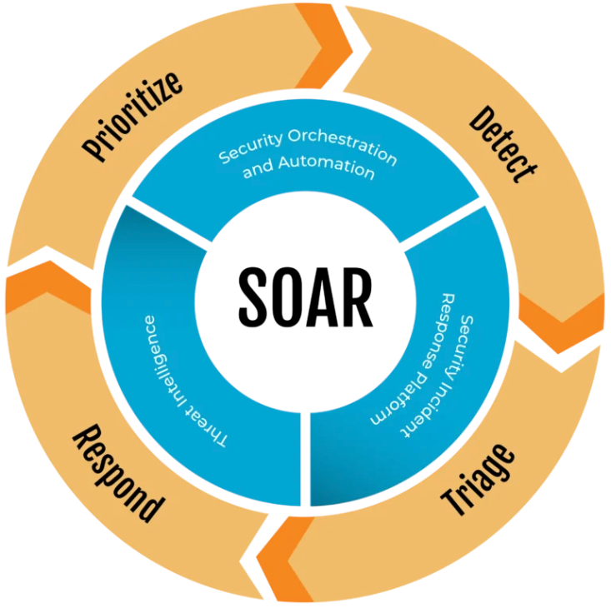
.

Figure showing the flow and process of the SOAR security tool [11]

Training and awareness
Training users of networks on ways to be safe and protected from threats can be done in many ways one way is by operating a continuous phishing and vishing simulations these can be done monthly to bi-monthly. These will prompt internal network users to click unknown links in emails and if this is done it will prompt the user who has fallen for this phishing attempt to complete a course on phishing and vishing showing ways to prevent and make recognisable to users. Carrying out these simulations will develop the ability to recognise real from fake when interacting with foreign links.
Another way of awareness for cybersecurity is acting with a clean cyber environment this is done by engaging with regular data backups within networks to protect sensitive information and avoid ransomware attacks being damaging to organisations. Having regular updates to hardware as well as the software can remove and fix any vulnerabilities that may have led to attacks [12]. Continuing with a frequent awareness meeting and training course will help ultimately make all network users aware and cautious to different types of attacks and threats in the cyber environment.

References
[1] J. Holdsworth and M. Kosinski, “Ransomware as a service,” Ibm.com, Sep. 05, 2024. https://www.ibm.com/think/topics/ransomware-as-a-service
[2] National Cyber Security Centre, “A Guide to Ransomware,” www.ncsc.gov.uk, 2025. https://www.ncsc.gov.uk/ransomware/home
[3] Cisco, “What Is Vishing?,” Cisco. https://www.cisco.com/site/us/en/learn/topics/security/what-is-vishing.html
[4] Cloudflare, “What is a supply chain attack?,” Cloudflare.com, 2020. https://www.cloudflare.com/en-gb/learning/security/what-is-a-supply-chain-attack/
[5] “​Understanding Common Risks in Hybrid Clouds,” cloudsecurityalliance.org. https://cloudsecurityalliance.org/blog/2020/07/14/understanding-common-risks-in-hybrid-clouds
[6] CloudFlare, “Zero Trust Security | What’s a Zero Trust Network? | Cloudflare UK,” Cloudflare, 2025. Available: https://www.cloudflare.com/en-gb/learning/security/glossary/what-is-zero-trust/
[7] IBM, “What is the NIST Cybersecurity Framework?,” Ibm.com, Oct. 14, 2021. https://www.ibm.com/think/topics/nist
[8] International Organization for Standardization, “ISO/IEC 27001 standard – information security management systems,” ISO, 2022. https://www.iso.org/standard/27001
[9] IBM, “What is security information and event management (SIEM)? ,” IBM, Jun. 23, 2023. https://www.ibm.com/think/topics/siem
[10] IBM, “SOAR,” Ibm.com, Feb. 08, 2023. https://www.ibm.com/think/topics/security-orchestration-automation-response
[11] S. Saxena, “Why a SOAR Team is Critical for Managing Cyber Security Attacks,” Medium, Nov. 14, 2024. https://infosecwriteups.com/why-a-soar-team-is-critical-for-managing-cyber-security-attacks-b6d7633854da
[12] “Employee Cybersecurity Awareness Guide | Fortinet,” Fortinet, 2023. https://www.fortinet.com/uk/resources/cyberglossary/cybersecurity-awareness

