COMPONENT 1: INDIVIDUAL PRESENTATION (ACADEMIC POSTER)
Module code: BMHP6029

Lutfa Begum
Student No. 2320441
Lecturer: Neale Haddon

Figure 1: VectorMine (2021) illustrates the cycle of bipolar disorder.
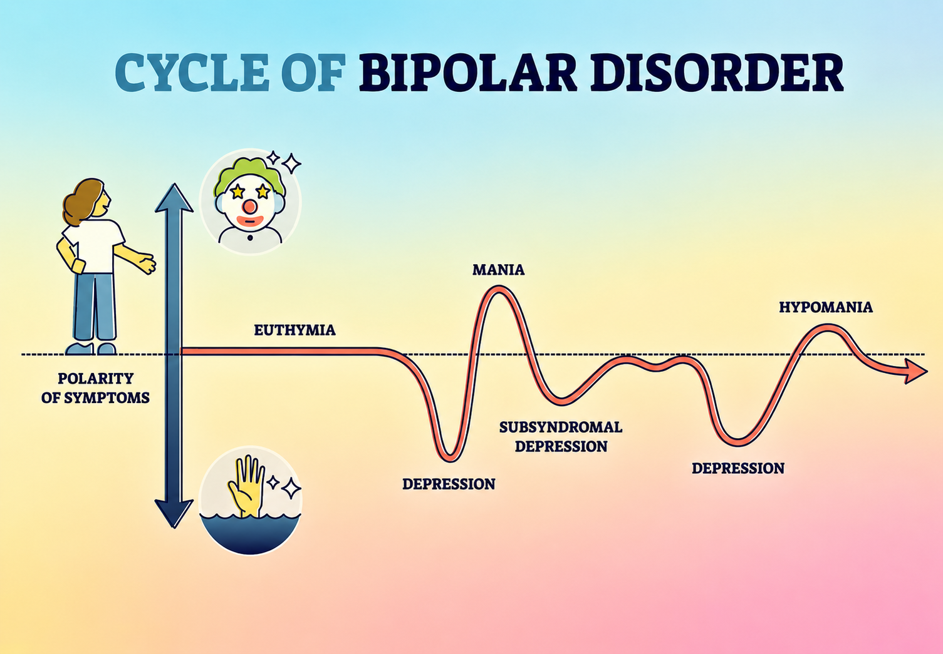
Critical Point: These laws improve patient safety and protect legal rights. However, compulsory treatment may reduce autonomy, so professionals should always use the least restrictive approach and involve patients in decisions whenever possible.

The Mental Health Act (1983, amended 2007) allows compulsory assessment or treatment when a person is at serious risk, while the Mental Capacity Act (2005) protects people who may be unable to make specific decisions and promotes decision-making in their best interests (Mind, 2024; NHS, 2024).

Critical Point: Although combined treatment is more effective than medication alone, access to specialist services remains unequal because of long waiting times, workforce shortages and regional differences in care (The King's Fund, 2024; WHO, 2025).

Current treatment combines mood stabilisers, psychological therapies (e.g. CBT), psychoeducation and community mental health support to reduce relapse and improve quality of life (NICE, 2023; NHS, 2024). Recovery-focused care encourages shared decision-making, independence and long-term wellbeing.

Critical Point
ICD-11 improves diagnostic consistency; however, diagnosis should consider the individual's cultural background, lived experience and clinical assessment, rather than relying only on diagnostic criteria (Gaebel, Stricker and Kerst, 2020).

Critical point:
ICD-11 supports accurate diagnosis and treatment planning. However, overlapping symptoms with depression and other mental disorders may result in delayed or incorrect diagnosis (Gaebel, Stricker and Kerst, 2020).

ICD-11 Bipolar Disorders
- Type I: At least one manic episode.
- Type II: Hypomanic episodes with major depressive episodes.
- Common symptoms include mood changes, reduced need for sleep, impulsive behaviour and depression (WHO, 2024; WHO, 2025).

5. Mental Health Act and Mental Capacity Act

Critical point:
The move from supernatural beliefs to medical diagnosis improved care and reduced harmful practices. However, historical institutionalisation often ignored patients' rights and dignity, highlighting the importance of today's person-centred and recovery-focused care (WHO, 2025).

Historically, bipolar disorder was misunderstood and often linked to supernatural beliefs, moral weakness or possession. During the asylum era, many people experienced isolation, restraint and poor living conditions rather than effective treatment (Porter, 2003). Later, Emil Kraepelin identified manic-depressive illness, helping shift understanding towards a medical condition.
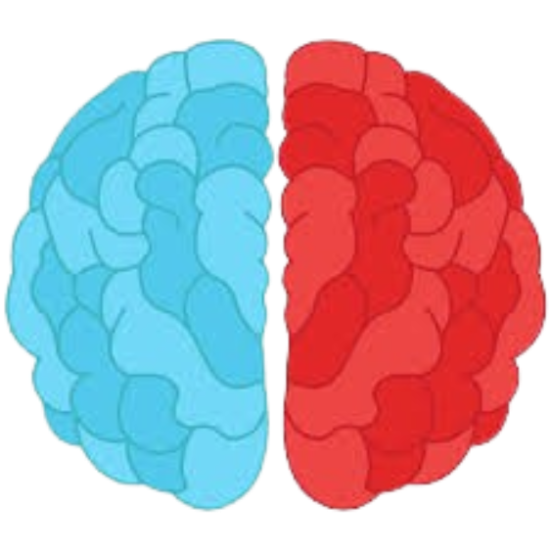
Bipolar Disorder: ICD-11 Classification, Historical Care and Contemporary Provision
"Understanding the past, using evidence in the present, and building fairer futures for recovery and inclusion."

2. ICD-11 CLASSIFICATION
3. HISTORICAL UNDERSTANDING
4. Contemporary Treatment and Care

Introduction
Bipolar disorder is a long-term mental health condition characterised by episodes of mania, hypomania and depression, affecting mood, behaviour and daily functioning (WHO, 2025; NHS, 2024). ICD-11 classifies bipolar disorder under Mental, Behavioural and Neurodevelopmental Disorders, providing an internationally recognised framework for diagnosis (WHO, 2024).

Past | Today
Asylums | Community care
Restraint | Recovery model
Isolation | Person-centred care
Custody | Shared decision-making
Table 1:Comparison of historical and contemporary approaches to bipolar disorder care.

Bipolar Disorder: ICD-11 Classification, Historical Care and Contemporary Provision
"Understanding the past, using evidence in the present, and building fairer futures for recovery and inclusion."

Figure 2: Core components of multidisciplinary treatment for bipolar disorder (adapted from NICE, 2023; NHS, 2024).

Recovery focuses on helping people with bipolar disorder live meaningful and independent lives through rehabilitation, education, employment and community support. Multidisciplinary teams provide personalised care to improve wellbeing and reduce relapse (NHS England, 2023; RCPsych, 2024).

CRITICAL PERSPECTIVE
While ICD-11 classification and modern treatments are valuable, they must be used with caution. Over-reliance on diagnosis and medication can ignore the social roots of distress and reduce people to a label. A holistic, trauma-informed and culturally sensitive approach is essential (Haslam et al., 2021).

9. Conclusion

Critical point:
Recovery is not simply the absence of symptoms. While rehabilitation promotes independence and social inclusion, limited community resources and housing shortages can delay long-term recovery for some individuals.

CRITICAL PERSPECTIVE
While ICD-11 classification and modern treatments are valuable, they must be used with caution. Over-reliance on diagnosis and medication can ignore the social roots of distress and reduce people to a label. A holistic, trauma-informed and culturally sensitive approach is essential (Haslam et al., 2021).

Key Elements of Person-Centred Care
❤️ Hope 👤 Person-centred care 🏡 Community inclusion 🎯 Independence 🌱 Quality of life

● Evidence-informed practice ● Rights, choice and dignity

- •

Bipolar disorder has evolved from being poorly understood to a condition managed through ICD-11 classification, evidence-based treatment and recovery-focused care. Although modern services have improved diagnosis and outcomes, challenges such as stigma, unequal access and delayed diagnosis remain. A person-centred, rights-based approach is essential to improve long-term recovery and quality of life (WHO, 2025; NICE, 2023).

- Improve early diagnosis and timely referral.
- Increase access to specialist bipolar services and psychological therapies.
- Reduce stigma through mental health education and awareness campaigns.
- Strengthen community rehabilitation and recovery-focused support.
- Ensure care is person-centred, culturally sensitive and based on the least restrictive legal approach (WHO, 2025; NICE, 2023; Mind, 2024).

8. Recommendations for Future Practice

Critical point:
Future improvements require not only better treatments but also greater investment in mental health services, workforce development and equal access to care for all.

Although mental health policies promote equality and inclusion, people with severe mental illness continue to experience significant health inequalities. Therefore, reducing stigma requires both public education and equitable access to high-quality mental health services.

Critical point:

Stigma, discrimination and social inequality can reduce access to mental health services, employment and education for people with bipolar disorder. Public awareness has improved, but negative attitudes and misunderstanding remain common (Atanasova et al., 2019; UK Government, 2023).

6. Social, Cultural and Political Context

7. Recovery and Rehabilitation

References
Atanasova, D., Koteyko, N., Brown, B. and Crawford, P. (2019) ‘Representations of mental health and arts participation in the national and local British press, 2007–2015’, Health, 23(1), pp. 3–20. Available at: https://doi.org/10.1177/1363459317708823
Gaebel, W., Stricker, J. and Kerst, A. (2020) ‘Changes from ICD-10 to ICD-11 and future directions in psychiatric classification’, Dialogues in Clinical Neuroscience, 22(1), pp. 7–15. Available at: https://doi.org/10.31887/DCNS.2020.22.1/wgaebel
Mind (2024) Mental Health Act reform. Available at: https://www.mind.org.uk/about-us/our-policy-work/mental-health-act-reform/ (Accessed: 21 June 2026).
National Institute for Health and Care Excellence (NICE) (2023) Bipolar disorder: assessment and management (CG185). Available at: https://www.nice.org.uk/guidance/cg185 (Accessed: 28 June 2026).
NHS (2024) Bipolar disorder. Available at: https://www.nhs.uk/mental-health/conditions/bipolar-disorder/ (Accessed: 24 June 2026).
Porter, R. (2003) Madness: A Brief History. Oxford: Oxford University Press.
Royal College of Psychiatrists (2024) Mental health rehabilitation services. Available at: https://www.rcpsych.ac.uk/mental-health/treatments-and-wellbeing/mental-health-rehabilitation-services (Accessed: 30 June 2026).
VectorMine (2021) Cycle of bipolar disorder and rapid emotional mood changes outline diagram: Labeled educational psychological behavior and mental illness explanation on symptoms polarity axis vector illustration [Vector illustration]. Adobe Stock. Available at: https://stock.adobe.com/uk/images/cycle-of-bipolar-disorder-and-rapid-emotional-mood-changes-outline-diagram-labeled-educational-psychological-behavior-and-mental-illness-explanation-on-symptoms-polarity-axis-vector-illustration/473242366 (Accessed: 2 July 2026).
World Health Organization (2024) ICD-11 for Mortality and Morbidity Statistics. Available at: https://icd.who.int/browse/2024-01/mms/en (Accessed: 20 June 2026).
World Health Organization (2025) Bipolar disorder. Available at: https://www.who.int/news-room/fact-sheets/detail/bipolar-disorder (Accessed: 26 June 2026).

