Marketing plan written for Travelodge
Sumaiya Begum Tanni
2211676
Marketing Essentials: BMIH4005
Luciana Suardi
Introduction
The purpose of a marketing plan is to summarise an effective advertising strategy to increase customers. Marketing plan is a way that allows businesses to examine the growth and success of the company, whilst knowing the future routes to take, ensuring the companies effective. This marketing plan is being prepared for couples because it will bring them closer and persuade customers to approach this hotel. Customers will experience a new sense of hospitality through Travelodge couple packages. Effectively attracting new consumers, will assist on the growth of the company and allow business owners to promote their brand to targeted audiences.
Situation analysis
In relation to marketing plan, Travelodge is a well-known hotel brand which was built in 1985. Since 2020, Travelodge has come very far, this was accomplished by promoting strategies and increasing their rate by 62.6% to compete with different hotels. The current positioning of Travelodge is that it is known to be one of the biggest hotel companies in the UK (please see appendices 2). Competitor analysis is a marketing strategy to use when trying to figure out the strengths and weaknesses of other market competitors, such as Britannia Sacha hotel. Hotel location matters as Britannia Sacha hotel being nearby, can increase competitions. Hence, becoming a threat to hotel industries like Travelodge (please see appendices 2). As of now, Travelodge’s strength is having affordable rooms for less amount by putting up discounts on the website. Competitor analysis will give business owners insight of what is missing from the competing brands enabling them the opportunity to add what can be missing to their business. This is an excellent way for the business to reach its full potential and fully take advantage of any new décor or rooms they have created during the pandemic. Weaknesses can be addressed by ensuring that they are improving on the negative feedback from consumers. It’ll allow changes, assuring the business strives and encouraging new customers to approach Travelodge. The hotel can introduce couple packages to their customers, through events or advertisements, which can increase their business and increase profit giving customers a purpose to stay.
Strengths | Weaknesses | Opportunities | Threats
- Leisure activities that keep customers entertained  - Rooms for much more affordable prices | - Less staff, making it harder for customer satisfaction  - Lack of technology in the hotel rooms  - Noisy environment | - Having Travelodge couple packages for age groups that are more likely to visit hotel  - Flexible pricing for hotel rooms | - Pandemic caused a huge loss to hotel business  - Intense competition from nearby hotels

Objectives
The aim of this marketing plan is to use digital marketing to advertise Travelodge coupe packages to attract customers and reattract previous customers. A simple way to market Travelodge Piccadilly Hotel is to mainly focus on the existing customers, while investing time into improving and further attracting newer customers. Digital marketing is a way to engage with consumers by raising awareness of the brand and ensuring it reaches the potential customers. The purpose of digital marketing is to develop people’s interests via the company’s advertisement, leading them to investigate the brand further on social media platforms and websites. Travelodge Piccadilly hotel can showcase the product by using websites and advertisements. Furthermore, emails can be sent to existing customers and potential customers informing them about special offers and discounts available. This will allow customers to have access to discounts, special offers, which can effectively expand new customers.
Strategy
Travelodge couple packages is an incredible way to bring couples closer. As, it will give them the opportunity to choose a room specifically designed to meet their own individual’s needs. This will allow couples to experience a good stay, enjoying the comfort and speciality of the room. A way to promote the Travelodge couple packages is by uploading it on social media, advertise it on TikTok and display images on the website, writing a small description of new couple rooms. By doing this, it will instigate potential customers, urging them to book a room at Manchester Travelodge Piccadilly hotel. It is necessary for Travelodge Piccadilly to utilize the strengths in the business, by understating and taking full advantage of the resources they already have. For example, this brand has rooms which are available for a more affordable price that not necessarily many other companies will do. Hence wise it is of great consequence to fully capitalise other company’s weaknesses and use it to do competitor analyse.
Tactics
Businesses nowadays require great offers that can easily be accessible by customers. For example, in order to get through to customers they would require a customer profile which involves the company’s website, surveys and reliable source of information. This will give business owners a brief idea of what consumers really look for in a hotel. Currently, Travelodge Piccadilly hotel is offering suitable leisure activities, which can be seen as an advantage to consumers, as it is only a short walk away. They also offer rooms called superooms which include blackout curtains, adjustable shower, mood lights and a whole new décor (Travelodge Manchester P ,2022). Businesses can grow through promotion, this will help reach the targeted audience as a company may reach out to specific influencers and invite them to the hotel. Furthermore, this will allow influencers to promote Travelodge Piccadilly hotel in Manchester, further increasing the rate of customers (please see appendices 1).
Travelodge Piccadilly in Manchester updated the interior design of the hotel as research conducted by Terblanche and Kidd (2021) demonstrated the appearance of the hotel creates visible appeal to increase business rates. Moreover, this allows an effective way to encourage new potential consumers to sojourn at this hotel due to the luxurious new décor in adherence to the seasonal influence (please see appendices 4). In addition to this, Budget hotel Travelodge is willing to collaborate and do a partnership with Travelodge Piccadilly in order to redecorate and upgrade the rooms. The new facilities will ensure customers are left with satisfaction and are receiving the correct service for a much more affordable price. A way for customers to locate the area is to search it up on maps or google, this will show them any nearby food areas or activities, which can be found close by.
Control
There are many disadvantages and advantages factors that can affect the pricing of the hotel rooms, (please see appendices 3). A simple way to measure the success of a hotel business is by having a secured pricing that adds up all the profit the hotel has achieved so far. Firstly, to increase profit it is important to target a key component and offer an outstanding service. Therefore, it is important to take into consideration the latest trends and hotels selling proposition to figure out what they are doing different to attract consumers. The pricing strategy works according to trends, social media, and reviews online. If Travelodge Piccadilly has something different to offer, then more people will be eager to go there. This can have a huge impact on how much profit the hotel is making, thus it is important to focus on what really benefits customers.
Conclusion
In conclusion, Manchester Travelodge Piccadilly, is overall a fantastic hotel to stay at however it could use minority improvements to attract potential customers. This can be done by designing rooms for customers to reach their given expectations. By introducing a couple package on the website, social media platforms and advertising, customers might be fascinated by the difference it is creating in the hotel industry.

References:
Bhasin, H (2019), What is Bowman's Strategy Clock?, Marketing91. Available at: Bowman’s Strategy Clock - What is Bowman’s Strategy Clock? (marketing91.com) (Accessed 27th November 2022).
Bowman, C,& Faulkner, D.(2020), Bowman's Strategic Clock: Give Your Product the Market Position it deserves, Business Strategy Hub. Available at: Bowman’s Strategic Clock: Give Your Product the Market Position it deserves | Business Strategy Hub (bstrategyhub.com) (Accessed 2nd November 2022).
Britannia Hotel. (2001, 2022), Britannia Sachas Hotel, Manchester, United Kingdom - Lowest Rate Guaranteed!. Available at: Britannia Sachas Hotel, Manchester, United Kingdom - Lowest Rate Guaranteed! (hotelsone.com) (Accessed 29th November 2022).
Bucy, E.P. (2003) “Media credibility reconsidered: Synergy effects between on-air and online news,” Journalism & Mass Communication Quarterly, 80(2), pp. 247–264. Available at: https://doi.org/10.1177/107769900308000202 (Accessed 22nd November 2022).
Bush, T.(2016, 2021), SWOT Analysis Opportunities: Definition & Examples, PESTLE Analysis. Available at: SWOT Analysis Opportunities: Definition & Examples (pestleanalysis.com) (Accessed 24th November 2022).
Bush, T.(2019, 2020), PESTLE Analysis Explained (With Examples), PESTLE Analysis. Available at: PESTLE Analysis Explained (With Examples) (Accessed 30th November 2022).
Catala Consulting. (2022), What is a SWOT analysis of a Hotel?, Catala Consulting. Available at: What is a SWOT analysis of a Hotel? (catalaconsulting.co.uk) (Accessed 24th November 2022).
Chen, J. (2022), What Is a Marketing Plan? Types and How to Write One, Investopedia. Available at: What Is a Marketing Plan? Types and How to Write One (investopedia.com) (Accessed 21st November 2022).
Hallstrom, C.(2017), How to Attract the Right Customers for Your Hotel, HermesThemes. Available at: How to Attract the Right Customers for Your Hotel - HermesThemes (Accessed 24th November 2022).
Hogarty, S. (2022), What is a marketing plan and why is it important?, Ideas. Available at: What is a marketing plan and why is it important? (wework.com) (Accessed 21st November).
Hotel Revenue Management. (2021), Hotel pricing strategies - How do hotels calculate prices, Pricepoint. Available at: Hotel pricing strategies - How do hotels calculate prices (pricepoint.co) (Accessed 24th November 2022).
Panda, M. (2022) (PDF) Digital Marketing - Researchgate, Digital Marketing . Departments of Electronics and Telecommunication . Available at: https://www.researchgate.net/publication/358646409_DIGITAL_MARKETING (Accessed: November 22, 2022).
Terblanche, N.S. and Kidd, M. (2021) “Exploring an in-store customer journey for customers shopping for outdoor apparel,” Journal of Retailing and Consumer Services, 63, p. 102722. Available at: https://doi.org/10.1016/j.jretconser.2021.102722 (Accessed 22nd November 2022).
Travelodge Manchester Piccadilly.(2022), Manchester Piccadilly Hotel, Travelodge Manchester Piccadilly - New Design. Available at: Travelodge Manchester Piccadilly - New Design (Accessed 21st November 2022).
Travelodge Manchester Piccadilly.(2022), Travelodge Manchester Piccadilly, Travelodge. Available at: Travelodge Manchester Piccadilly - New Design (Accessed 23rd November 2022).
Travelodge. (2020), Our rooms, Travelodge. Available at: Our rooms - Travelodge (Accessed 27th November 2022).
Travelodge.(2019), Hotels near Manchester Piccadilly, Travelodge. Available at: Hotels near Manchester Piccadilly - Travelodge (Accessed 24th November 2022).
Zhukova, N. (2021), How To Do Competitor Analysis and Improve Your Digital Marketing Strategy with Semrush, Semrush Blog. Available at: How to Do Competitor Analysis in Digital Marketing [2021] (semrush.com) (Accessed 29th November 2022).

Appendices 1:
Political | Economical | Social | Technological | Legal | Environmental
Changes in government policy  Changes in regulations and laws | Low-cost hotel prices  Changes in interest rates | New trends for people  Lifestyle development | Technologies maybe advanced in other places  Good internet connection | Consumer laws for protection  Employment laws – it sets rules and regulation on how an employee should be treated | Reusable products  Saving water and not wasting too much when showering  Controlling noise pollution
Health and safety laws that changes  Corrupting leaders  Higher chance of competition | Higher demand of business  Brexit causing a huge loss to businesses | Hotel companies may have higher demand of lower cost pricing | Not many technologies available in rooms  Growing demand for technologies available in hotels | Misleading advertisements  Tax benefits to allow businesses to grow | Climate change  Environmental impact can cause bad reputation to the brand
Appendices 2:
Strengths | Weaknesses | Opportunities | Threats
- Leisure activities that keep customers entertained  - Rooms for much more affordable prices  - Brand recognition | - Less staff, making it harder for customer satisfaction  - Lack of technology in the hotel rooms  - Noisy environment | - Having Travelodge couple packages for age groups that are more likely to visit hotel  - Flexible pricing for hotel rooms  - Accessible and easy online booking | - Pandemic caused a huge loss to hotel business  - Increased amount of strong competition in the hotel industry  - Intense competition from nearby hotels

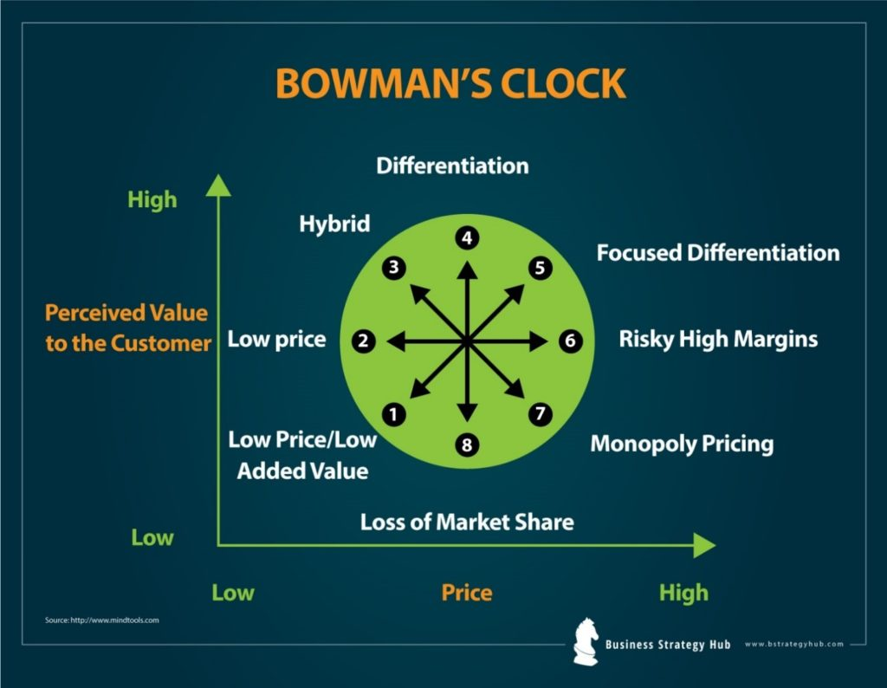
Appendices 3:

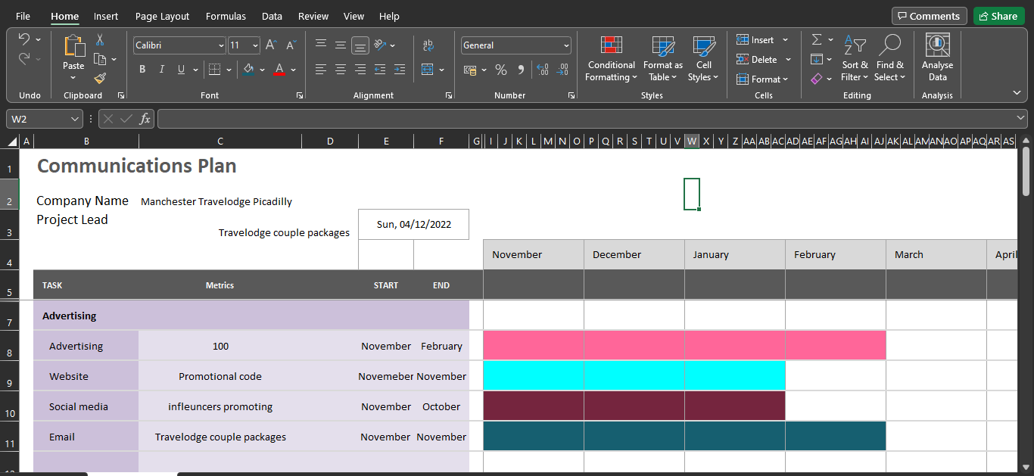
Appendices 4:

Marketing Plan Presentation for Travelodge Assignment 2



