Objects which are representative for the thematic area of death.
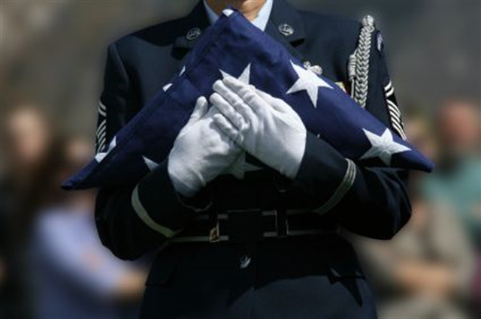
Martin & Castille Funeral Home recognizes that all soldiers, police officers, firemen and paramedics have committed themselves to protecting the citizens of our community. We believe it is important that these brave men and women are provided with the opportunity to protect their own families, as well, from the dangers they face when an unexpected death occurs. Martin & Castille will honor those who sacrifice their life in the line of duty with a full funeral service, including merchandise.

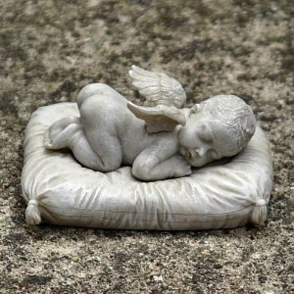
Headstone for the death of a baby

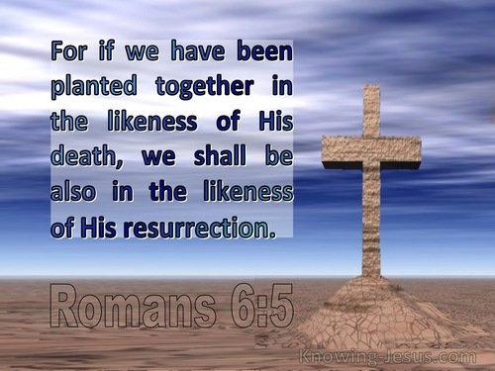
The empty cross, a Christian representation of the death of Christ and His resurrection.

