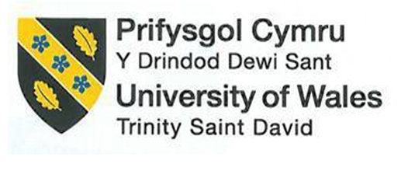

ASSIGNMENT 1:
“FEASIBILITY PLAN FOR AN INTERNATIONAL MEETING”

"EMBRACING NEURODIVERSITY IN HOSPITALITY: PATHWAYS TO INCLUSION".

MODULE NAME: INTERNATIONAL MEETINGS MANAGEMENT FOR THE HOTEL INDUSTRY – LEVEL 6
MODULE CODE: BMIH6007
STUDENT NAME: TATIANA-ELENA BACALU
STUDENT NUMBER: 2224927
LECTURER NAME: CHRIS WILKIN

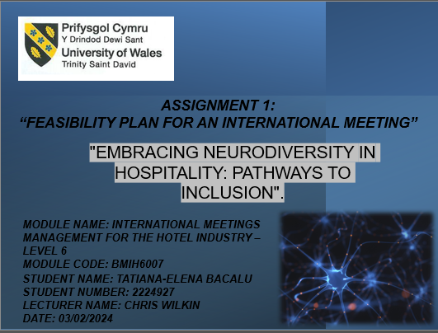

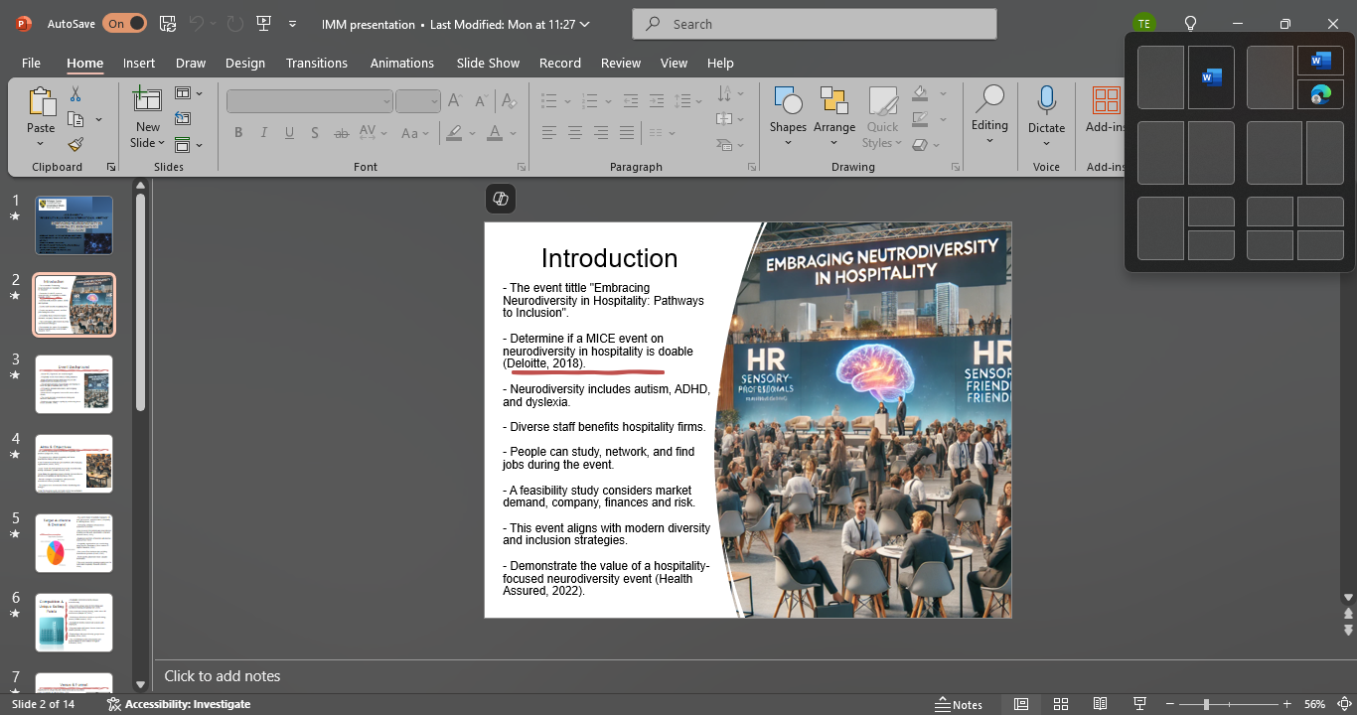
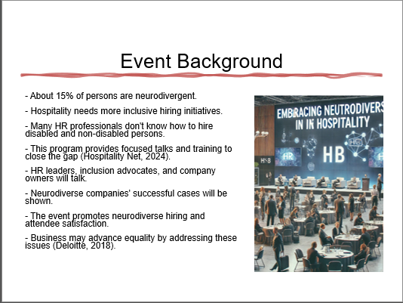
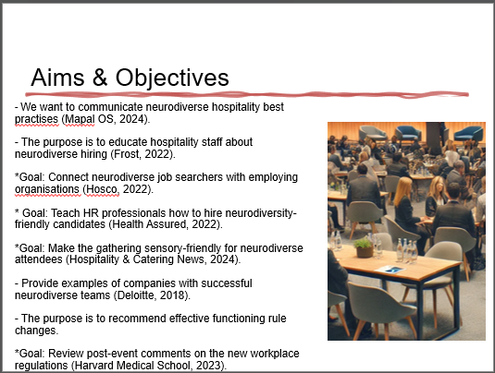
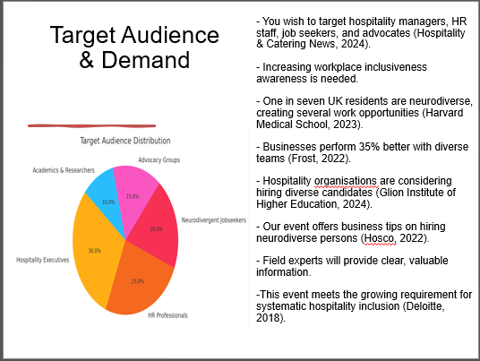
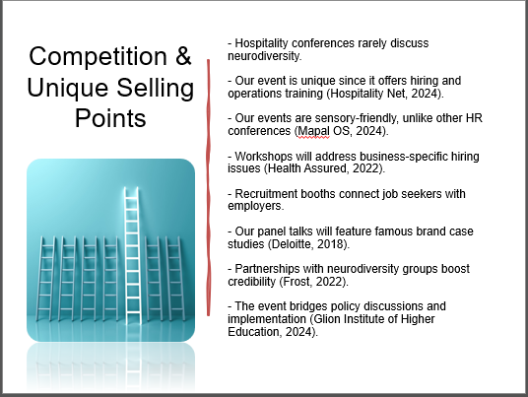
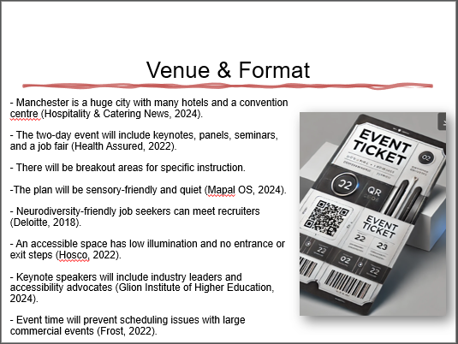
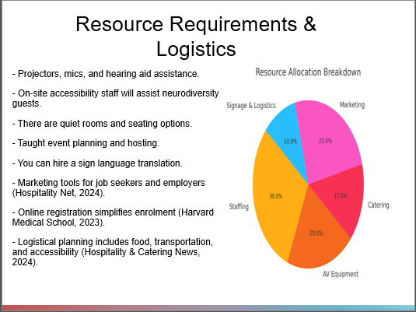
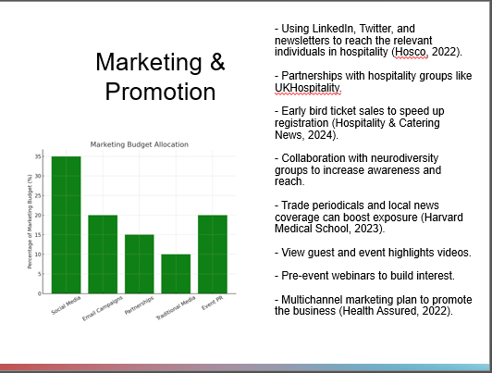
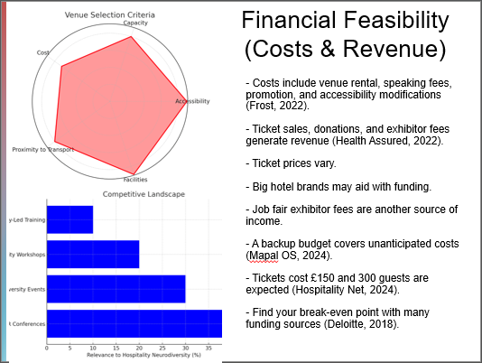
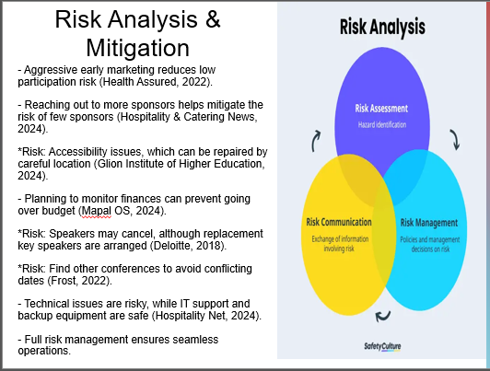
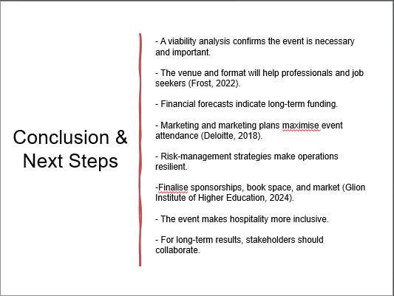
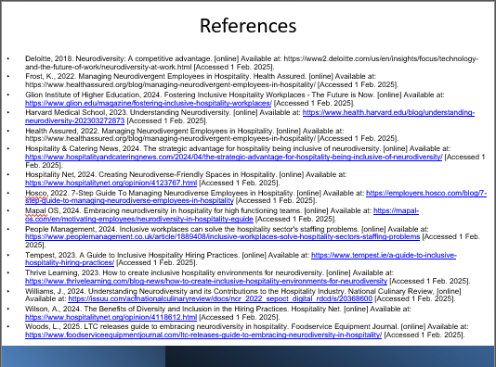
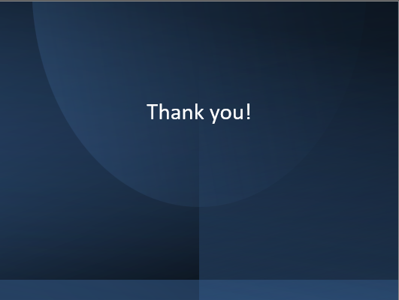

References

Deloitte, 2018. Neurodiversity: A competitive advantage. [online] Available at: https://www2.deloitte.com/us/en/insights/focus/technology-and-the-future-of-work/neurodiversity-at-work.html [Accessed 1 Feb. 2025].
Frost, K., 2022. Managing Neurodivergent Employees in Hospitality. Health Assured. [online] Available at: https://www.healthassured.org/blog/managing-neurodivergent-employees-in-hospitality/ [Accessed 1 Feb. 2025].
Glion Institute of Higher Education, 2024. Fostering Inclusive Hospitality Workplaces - The Future is Now. [online] Available at: https://www.glion.edu/magazine/fostering-inclusive-hospitality-workplaces/ [Accessed 1 Feb. 2025].
Harvard Medical School, 2023. Understanding Neurodiversity. [online] Available at: https://www.health.harvard.edu/blog/understanding-neurodiversity-202303272873 [Accessed 1 Feb. 2025].
Health Assured, 2022. Managing Neurodivergent Employees in Hospitality. [online] Available at: https://www.healthassured.org/blog/managing-neurodivergent-employees-in-hospitality/ [Accessed 1 Feb. 2025].
Hospitality & Catering News, 2024. The strategic advantage for hospitality being inclusive of neurodiversity. [online] Available at: https://www.hospitalityandcateringnews.com/2024/04/the-strategic-advantage-for-hospitality-being-inclusive-of-neurodiversity/ [Accessed 1 Feb. 2025].
Hospitality Net, 2024. Creating Neurodiverse-Friendly Spaces in Hospitality. [online] Available at: https://www.hospitalitynet.org/opinion/4123767.html [Accessed 1 Feb. 2025].
Hosco, 2022. 7-Step Guide To Managing Neurodiverse Employees in Hospitality. [online] Available at: https://employers.hosco.com/blog/7-step-guide-to-managing-neurodiverse-employees-in-hospitality [Accessed 1 Feb. 2025].
Mapal OS, 2024. Embracing neurodiversity in hospitality for high functioning teams. [online] Available at: https://mapal-os.com/en/motivating-employees/neurodiversity-in-hospitality-eguide [Accessed 1 Feb. 2025].
People Management, 2024. Inclusive workplaces can solve the hospitality sector's staffing problems. [online] Available at: https://www.peoplemanagement.co.uk/article/1889408/inclusive-workplaces-solve-hospitality-sectors-staffing-problems [Accessed 1 Feb. 2025].
Tempest, 2023. A Guide to Inclusive Hospitality Hiring Practices. [online] Available at: https://www.tempest.ie/a-guide-to-inclusive-hospitality-hiring-practices/ [Accessed 1 Feb. 2025].
Thrive Learning, 2023. How to create inclusive hospitality environments for neurodiversity. [online] Available at: https://www.thrivelearning.com/blog-news/how-to-create-inclusive-hospitality-environments-for-neurodiversity [Accessed 1 Feb. 2025].
Williams, J., 2024. Understanding Neurodiversity and its Contributions to the Hospitality Industry. National Culinary Review, [online] Available at: https://issuu.com/acfnationalculinaryreview/docs/ncr_2022_sepoct_digital_rdcd/s/20368600 [Accessed 1 Feb. 2025].
Wilson, A., 2024. The Benefits of Diversity and Inclusion in the Hiring Practices. Hospitality Net. [online] Available at: https://www.hospitalitynet.org/opinion/4118612.html [Accessed 1 Feb. 2025].
Woods, L., 2025. LTC releases guide to embracing neurodiversity in hospitality. Foodservice Equipment Journal. [online] Available at: https://www.foodserviceequipmentjournal.com/ltc-releases-guide-to-embracing-neurodiversity-in-hospitality/ [Accessed 1 Feb. 2025]

