

Assessment Component 2

Written Essay

Student name: Maritza Estefania Ramirez Rivera

Student ID:2022095

Module name: Children, Young People and Families

Module code: (BMHP5004_LON)

Lecturer name: Leila Surani

Assignment Title: Assessment 2 Written Assignment (Essay)

Word count:

Introduction:
This essay aims to present and theoretically analyse the ideas and arguments put forward by methodology within the paradigm of children and childhood study throughout the years, based on the belief that childhood is a social construction. The studies literature review method supports the idea that childhood is socially created. The diversity in cultures and beliefs vary from society to society and circumstances to context. Even within the same community, childhood fluctuates based on other social characteristics like gender and socioeconomic status. In modern culture, children are treated differently from adults because childhood is seen as a unique period of life. This can manifest itself in a number of ways, for example through rules specifying what children are allowed to do, what they are obliged to do and what they are not.

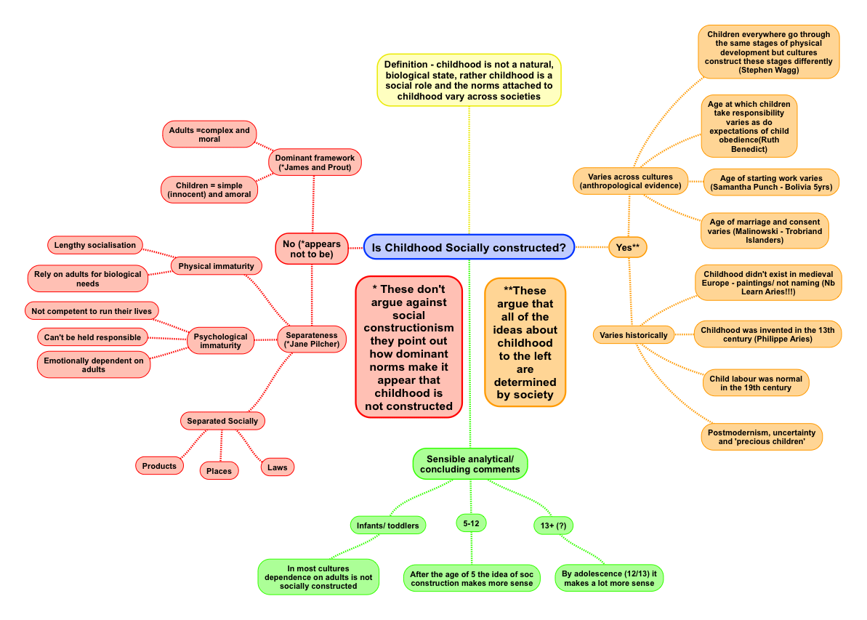
What is Chilhood

When we do not refer to the exact meaning of childhood, any infant, baby ,teenager in the period before puberty, we mention the relationship of children's needs or dependencies, such as love, respect, protection, care, education and maintaining their innocence is essential. In modern culture, children are treated differently from adults because childhood is seen as a unique period of life.
A good childhood always depends on the education parents give their children, which is a significant factor in our society so that the infant can grow healthy and happy without suffering traumas or mental issues that could affect their emotional and mental health in future.
Social Constructions Childhood & Society
Focusing on advances in the status of children, the position of children has swiftly evolved over the last 50 years from being seen but not heard to be at the centre of society. Sociologists are examining the causes of this rapid transformation. According to Philippe Ariès (2014). L’enfant et la vie familiale sous l’Ancien régime. Paris: Éd. Du Seuil, Dl.

Investigated the past of childhood from the Middle ages the late modern era. They determined that childhood development had undergone several changes, from considering youngsters as many adults to removing children from adult life. However, changes in children's experiences in recent decades have piqued the curiosity of modern sociologists. While many say this situation has improved, disparities in childhood experiences across cultures, gender and class divisions, and ethnic groupings must be acknowledged since it is difficult to talk about a universal childhood experience. We may look at the evolution of children's rights in the United Kingdom during the previous 50 years. There is a universal consensus that society has become more child-centred, while considerable differences exist across socioeconomic strata. In most families, children's needs take precedence over those of adults, yet some sociologists argue that there is some control over children's lives in exchange. Others would claim that, despite being at the centre of society, the adult world intrudes on children's experiences. The contemporary childhood era is vanishing as youngsters are exposed to the adult world before they are ready.
Others, on the other hand, say that features of childhood, notably financial reliance, are being prolonged into early adulthood and the influence of the clipped-wing generation. Regardless of these differences, sociologists may all agree that childhood has changed, but why? There are many possibilities for this change in children's positions, which we shall analyse. First, we will look at the extension of obligatory schooling to 18 and the expectations of enrolling in higher education; second, we will look at technical advancements; and finally, we will look at perspectives on relationships. Finally, it is essential to study the impact of media saturation and capitalism on providing children with a more meaningful role in society. One factor for children's improved condition is the extension of compulsory education till the age of 18. Children in previous generations would leave school at 16 years old, and in some instances sooner, enabling families to maximise their economic potential; however, as compulsory education expanded, this increased parents' financial dependence. This has been exacerbated by eliminating , the education maintenance allowance, and student grants, which creates financial constraints on parents if their children pursue more credentials. With higher student expenses, more young people prefer to study at home. Some institutions even offer online tuition, which reduces costs for students but increases the financial strain on parents since children remain at home.
Another factor that has influenced children's positions is technological advancements. Children now have more access to the adult world through the internet and more robust interactions with others via social media. This has resulted in parents increasing their supervision of children to ensure their safety; however, the media has also provided end benefit to parents by increasing their use of technology as a tool by which they may keep children occupied via the use of digital babysitters such as streaming services. TV and tablets have meant that children have increasingly become media consumers, but they have also become media creators with various social media websites. Instagram, Facebook, Tick tock, and YouTube are centred on other children's activities. Other technological advances have meant that parents can use digital surveillance to monitor their children, from watching their physical location through GPS on phones to monitoring their activity in cyberspace. Reproductive technology such as (IFV t is a kind game that mostly children play nowadays .that make the family structure divided. Due to much involve of children in front of the screens.) Allows individuals who would not have been able to do so in the past to become parents, all of which contribute to children being seen as an investment. A further influence on the status of children has been the changing nature of partnerships. While some sociologists argue about relationship between contemporary society. The children born under a stable parent status are more productive emotionally and secured.

The impact Factor in past & today
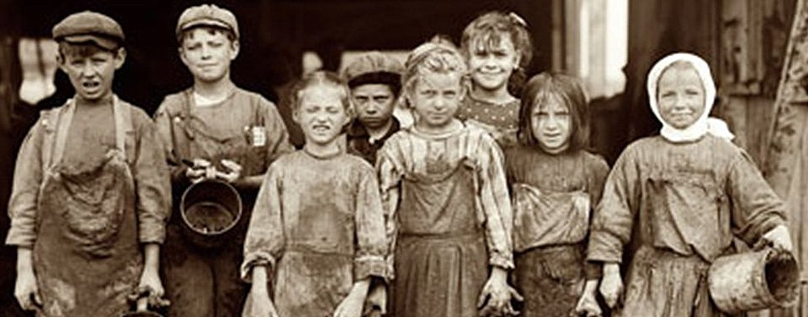
Forced labour in Victorian times and the working circumstances suffered by children were commonplace in the 19th century. Child welfare services did not exist as they do today.
During Victorian times, children had to work to help their parents pay their bills.
Many children grew up with 10 or more siblings. They were sometimes jammed into a room with grandparents and other relatives. Children were not educated at school. They went to labour as early as four and five years old, despite dangerous and filthy working circumstances. The needy Children were allowed to labour up to 18 hours each day in mines, chimneys, cleaning streets, sweepers, clothing and hat manufacturers, agricultural workers, servants, and textile mills.
Children were inexpensive to hire and worked long hours. They were not well compensated; the employment was sometimes risky since youngsters were ordered to accomplish tasks that adults could not. They climbed into and cleared chimneys. They emerge coated in soot, with wounds and bruises. After a 12-year-old boy died while sweeping a chimney in 1875, a new legislation was enacted to safeguard chimney sweeps, requiring them to be registered with and overseen by the police. Laws were enacted to prevent tragedies like this from occurring, such as the Chimney Sweepers Regulations Act 1840, which were now severely enforced. Children worked in factories and mills, crawling under machinery to repair and clean it. This was perilous since one may get entangled in the equipment and be wounded or perhaps die. The 1833 factory made it unlawful for children under the age of nine to work in factories; children from nine to thirteen were confined to working a 48-hour week, which was eight hours more than the average adult working week today. If a family was impoverished, they were sometimes forced to reside in a workhouse, where they would work to earn their keep. When they were released, they had to wear a workhouse uniform. Children were taught to read and write and may be sold to labour in factories and mines. Thomas Agnew founded the Society for the Prevention of Cruelty to Children in 1891. Individuals such as Lord Shaftesbury and Thomas Agnew were instrumental in bringing about true change. According to Tomas Agnew, a journey to New York in 1881 was inspired by a visit to the New York Society for the Prevention of Cruelty to Children. On his return to Liverpool, he summoned a city council and on April 19, 1883, he founded the Liverpool Society for the Prevention of Cruelty to Children (LSPCC). Similar organisations sprung up around the country, notably Anthony Ashley-London Cooper's Society for the Prevention of Cruelty to Children (London SPCC), founded on July 8, 1884. Reverends Benjamin Waugh and Edward Rudolph served as joint secretaries to Ashley-Cooper, the London SPCC's initial president. 1st Baroness Angela Burdett-Coutts was a co-founder of the institution, which later became the National Society for the Prevention of Cruelty to Children (NSPCC) in 1889, with Queen Victoria as patron.


With current situation of children and families which are governed by legislations and strict regulations regarding their health and social care .Everyone have clear understanding and better approach to adhere their welfare and well-being .With current situation of children and families which are governed by legislations and strict regulations regarding their health and social care .Everyone have clear understanding and better approach to adhere their welfare and well-being.
Nowadays, social factors for children and their level of life are changing if we analyse what was the Victorian era in society, for example, family shift to the size of the family, Laws, a better knowledge of what children need, the function of media, and the importance of the legislation.
Society has changed from thinking children should be seen but not heard to listening to their needs. We must understand why this has occurred and the implications for children and adults. We will investigate some of the following reasons for the shift from an adult-centred to a child-centred society: first, changes in family size, particularly the decrease in the number of children.
Second, we will look at some of the legislation that has resulted in more excellent child protection. Then we will look at how society has developed a better understanding of childhood as a distinct stage of life. Finally, we will examine the media's and capitalism's role in creating child-centeredness in contemporary society. Change in the family is one explanation for the rise in child-centeredness. This is supposed to make children rare in society than earlier generations, so adults must devote more attention to these youngsters every 15 years. The Office of National Statistics investigates changes in childbirth among women using a process known as cohort analysis. They count women born in a given year, such as 1997, and analyse how many children they have, how old they are when they have children, and so on. They will compare this to other cohorts, allowing them to make cross-sectional comparisons to evaluate how attitudes about having children have evolved since 2012. They compared the cohorts born in 1930 and 1940 to those born in 1967 and 1982 and discovered that the fertility rate of women by their 30th birthday had decreased from 2,4 children in 1930 to just over one child for women in 1982, demonstrating a shift in attitudes with women waiting longer to have children and having fewer of them. This makes children more unique in society, with fewer than 23% of the UK population under the age of 19 in 2019 and less than one in every five individuals in the UK under the age of 16. The second cause for child-centeredness growth has been laws to preserve the right of safeguarding. Schools and the healthcare system This is also true for vulnerable adults, Idea of the state policing the family a further policy that was introduced to children was the children's (Act of 1989)According to this act to protect the rights and welfare of children and is constantly reviewed and updated to deal with potential threats to child well-being another policy is the extension of compulsory extended. The conservative government in 2015, as part of their austerity measures, extended the period of childhood, with young people being unable to leave school at 16, while removing housing benefits for those under 25. This placed emphasis on parents to provide for their children's welfare into their twenties. The effect of these pieces of law was to ensure that parents were responsible for the health and economic well-being of the children for whom they were responsible, and that children were monitored to ensure that parents who did not comply were sanctioned. Another factor for the rise in child-centeredness is a better understanding of childhood medical developments, which means society has a better understanding of paediatric care, resulting in more children surviving into adulthood than in earlier generations. However, we have a better grasp of the influence of adults' activities on the emotional and cognitive development of children in past generations. Assumptions were established about children's conduct being intrinsic rather than taught. At the same time, a better understanding of conditions that affect behaviour, such as autism spectrum disorder and attention deficit hyperactivity disorder, was gained. More importantly, investigate how these situations, Have affected children and relevant strategies to help them friction in society, psychologic there has been a greater emphasis on making childhood a period of innocence and happiness in the twenty-first century with more excellent discussions around the people of parents and parenting children lives others centeredness looks at the role of the media particularly in creating panic about threats to childhood and behaviour of young adults this plays a the fears that parents have of losing their children leading them control to behaviours of children through limiting their access to resources in controlling their time and space this fear is heightened by children born in the new Millennium being part of a digital generation. v channels, websites and social media to actively target children and parents' influences and patterns of consumption Margo Etal suggest that these processes allow capitalism to invade all aspect of children, from clothing and food and toys to gadgets, every monitory of children linked to the capitalist.
Products recent surveys have suggested that pester power cost the average family between £150,000 and £185,00 per year for snacks, and drinks days out. Toys all feed the profit of capitalism companies have expanded the adult market to children, games, literature, music, and subscription that once service targeted adults, now targeting children. Estimate of this suggests that the cost of raising children is between 150 ends 185000 pounds from birth to 18 years age meaning that children's markets are incredibly lucrative for companies. However, the status of the children is the same. The growth of child society can be seen as a western phenomenon, and ever with western society, there are variations based on class, gender, and ethnicity that influence childhood experiences. Some critics would suggest that protecting children is forcing social control upon them; a kitten has suggested the existence of what she calls age patriarchy. The time-space and bodies of children are often controlled by adults, and the predominantly adult role in has child-centred society improves the position of children well. Womack has suggested that children in the UK unhappiest in the developing world and often.
The table for substance misuse, mental health issues in teenagers, pregnancy and delinquency, While we can conclude that society has become more child-centred in contemporary society, sociologists question whether the excessive focus on children has a lid on the imposition of adult problems into the younger generation.
Vulnerability Children ,young people and families
What exactly do we mean by "vulnerability"?
There is no universally accepted definition of childhood vulnerability. Because of unique features, a kid may be prone to hazards and bad results, the influence of action or inaction by other individuals, and their physical and social surroundings.
Additional factors include the child's physical, emotional, health, and educational needs; any harm the child has experienced or may be at risk of experiencing; and the ability of the child's carers and broader family environment to meet the child's needs, or indeed to cause harm - this could include homelessness or poor housing conditions.
the lack of supporting connections in a child's life; the larger community and societal circumstances outside of the family, such as crime, the built environment, community cohesiveness, and resilience.
This list is not comprehensive, and children may encounter one or more of these variables with varying degrees of severity throughout their lives, even into adulthood. For this study, 'vulnerable children' are defined as children who are more likely to suffer physical or mental damage and have poor outcomes due to one or more variables.
Global Inequalities for every child According UNICEF
- No discrimination
- Making right real
- Heath,water,food,eveiroment
- Social &economic help

Recommendations:
Multiples -Agency cooperation working, together,school,social worker, Health care &Social care ,psychology to take early interventions if the case require even local authorities in case necessary ( www.nspcc.org.uk/keeping-children-safe/our). substance use (NSPCC, 2018).
Conclusion
Some ideas for activities you can do. Learn about income inequality around the world. Raise awareness about income equality in your school and community. Raise awareness about income equality in schools and the community. Learn about how policies, laws and economic structures can lead to inequalities locally and globally. Join or support organisations working to reduce income inequality in the UK and around the world.
References
Philippe Ariès (2014). L’enfant et la vie familiale sous l’Ancien régime. Paris
Asgeir Falch-Eriksen, Backe-Hansen, E. and Springerlink (Online Service (2018). Human Rights in Child Protection : Implications for Professional Practice and Policy. Cham: Springer International Publishing.

Close, P. (2014). Child labour in global society. Bingley, U.K.: Emerald.
Rory McDowall Clark (2010). Childhood in Society for Early Childhood Studies. SAGE.
Tobin, J. (2019). The UN Convention on the Rights of the Child. OUP Oxford.
Rory McDowall Clark (2016). Childhood in Society for the Early Years. Learning Matters

Britt, R. (2009) Is Modern Society Ruining Childhood? [online] available at: http://www.livescience.com/7713-modern-society-ruining-childhood-html
Cunningham, H. (2006) The Invention of Childhood, London: BBC Boos
Kehily, M.J. (2013) Understanding Childhood: A Cross Disciplinary MApproach.Milton Keynes: Open University Press.
McDowall Clark, R. (2013) Childhood in Society for Early Childhood Studies, 2nd Edition. London: Sage
Oliver, B. and Pitt, B. (2010) Working with Children, Young People and Families, Exeter; Learning Matters
Pound, L. (2014) The Historical Background of Early Childhood Care and Education: Influencing Factors. In Mukherji, P. and Dryden, L. (Eds) Foundations of Early Childhood: Principles and Practice. London: Sage
Wright, H. R. (2015) The Child in Society. London: Sage
Close, P. (2014). Child labour in global society. Bingley, U.K.: Emerald.
Rory McDowall Clark (2010). Childhood in Society for Early Childhood Studies. SAGE.
Tobin, J. (2019). The UN Convention on the Rights of the Child. OUP Oxford.
Honey man, K. (2016). Childhood and Child Labour in Industrial England. Routledge.

Wright, H. R. (2015) The Child in Society. London: Sage.
Safeguarding and Protecting Children with Disabilities and SEN. (n.d.). Optimus Education eBooks.

Struthers, A.E.C. (2021). Protecting invisible children in England: how human rights education could improve school safeguarding. Human Rights Education
Review, 4(3), pp.45–64. doi:10.7577/hrer.4473.

‌LOUGHRAN, G. (2008). Learning to act: The Children Act 1989. Children & Society, 5(1), pp.11–20. doi:10.1111/j.1099-0860.1991.tb00515.x.

‌Sheehan, R., Rhoades, H. and Stanley, N. (2012). Vulnerable children and the law : international evidence for improving child welfare, child protection and children’s rights. London ; Philadelphia: Jessica Kingsley Publishers.

Cooper, J. (2021). In need of what? Section 17 Provision under the Children Act 1989. Children & Society. doi:10.1111/chso.12519.
NSPCC Learning. (n.d.). NSPCC Learning home. [online] Available at: https://learning.nspcc.org.uk/media/1432/nspcc-families-facing-adversity-helplines-report. [Accessed 4 Jan. 2023].

NSPCC (2022). Safeguarding children and child protection. [online] NSPCC Learning. Available at: https://learning.nspcc.org.uk/safeguarding-child-protection.
‌Holmes, D. (2022). Safeguarding Young People. Jessica Kingsley Publishers.
Children’s Commissioner for England. (2018). Childhood vulnerability in England 2018. [online] Available at: https://www.childrenscommissioner.gov.uk/wp-content/uploads/2018/07/Childrens-Commissioner-Vulnerability-Report- [Accessed 4 Jan. 2023].
‌

‌

‌

‌

‌

‌

‌

