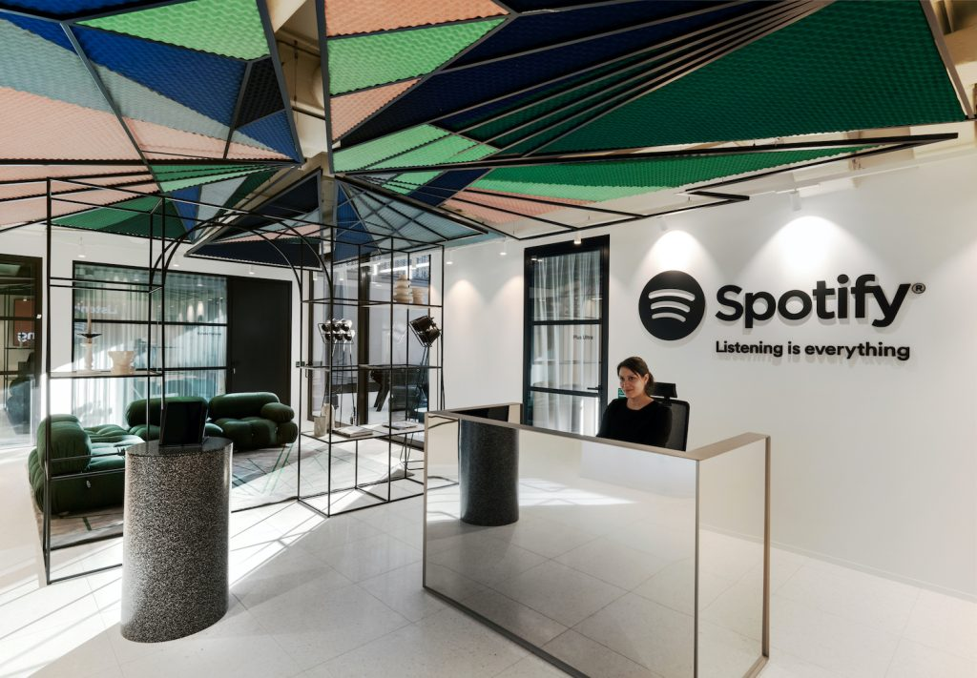

How Organisations are Influenced by the Wider Business Environment

Spotify
The Inter-cultural workplace

Laura Clarke
2105356

Executive Summary
This report explores the cultural environment that operates within the wider business context of a business, namely Spotify, the global streaming service. Within this report we aim to identify the internal and external factors that are influencing the context, culture and human resources of the wider business environment. This report explores the companies manifestos and aims to provide organisational overview and context, before exploring how HR manage employees, and how employees are given autonomy to manage themselves. A SWOT, PESTLE and VUCA are included within the body of the report and the report is summarized with a conclusion and recommendations for the company moving forward.

Contents
executive summary 2
Introduction 3
Organisational Overview and Context 3
SWOT 5
PESTLE 6
Organisational Culture 7
HR Management 8
Conclusion 11
recommendations 11
References 13

Introduction
This report aims to provide an in-depth analysis of ‘Spotify’, including a review of the business and its organisational culture, management styles, mission statements, ethos and business strategy, and will contain both a SWOT and PESTLE analysis of the business model and a review of the current management style, to be followed by a VUCA model addressing current issues being faced by the company. the report will contain a number of recommendations that Spotify could take forward to improve the business.
organisational overview and context
Spotify is a Swedish music streaming firm, offering digital copyright restricted music and podcasts, including a library of more than 82 million songs from record labels and media companies, launched in 2008: the company was created in an attempt to combat music piracy and the illegal downloading and sharing of music that was damaging the music industry (BBC News, 2018) The company now boasts over 157 million customers, (71 million of these paid subscription account holders) (Monaghan, 2018) and offering a ‘free with ads’ model and an advert free subscription model, the company gains revenue from advertising and subscriptions and is valued at over 22 billion US Dollars (Spotify Technology Net Worth 2018-2022 | SPOT) Despite the high value and floatation on the stock market, the company has never successfully recorded annual profit and is said to be in “perennial start-up mode” (Bloomberg, 2023)
The company have offices in 43 cities including Europe, North and Latin America, the Asian Pacific and the Middle East and offer ‘work from anywhere’ as a standard for all staff, working to the time zone of their specified main location.
Spotify, as a company is described as a “people-driven, autonomous framework for “scaling agile” (Brewer, 2022) and inspired the 2012 white paper by Henrik Kniberg & Anders Ivarsson in which the ‘Spotify method’ of working was examined, the company has a self-confessed aspirational work style, with small teams split into tribes, squads, chapters and guilds (Šmite et al., 2019) and the groups will remain focused on specific areas for a long time, this demonstrates the strong Task culture upheld by Spotify (Charles Handy Model of Organization Culture, n.d.) but also appears to be Silo working by another name and could potentially have a detrimental effect on business productivity (Cilliers & Greyvenstein, 2012.) Staff are encouraged to spend at least 10% of their time on free thought ‘hack days’ where they are encouraged to spend their time working on whatever they want, and this is a proven method to increase employee satisfaction and productivity (Johannsen & Zak, 2020)
As Spotify are aware of the possible detrimental effects of silo working, an annual survey of dependencies is carried out, which can result in reprioritization and/or reorganization (Šmite et al., 2019) The company have a traditional hierarchical management structure working above the tribes, squads, chapters and guilds, led by Founder, CEO and Chairman Daniel Ek
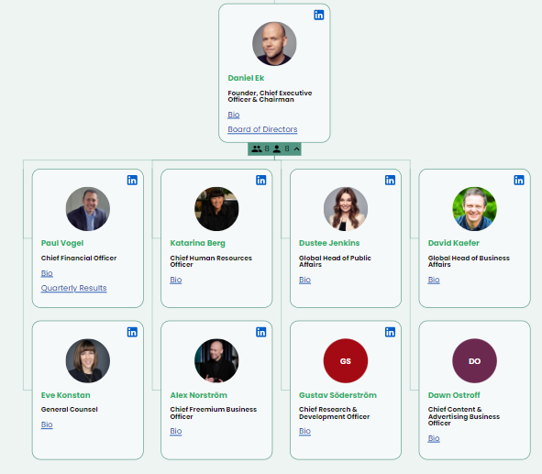
organimi.com

SWOT
Strengths  Majority of market share  Strong reputation.  Early move advantage (the first of its kind).  Variable quality options to account for unreliable internet quality.  Investing in R&D including AI  Simple pricing/Free at entry level  High staff retention | Weaknesses  High royalty costs  Prioritizing growth over profit  No offline streaming functionality  Very similar to competitors model
Opportunities  opportunity for further expansion  Potential for branded smart speakers and merchandise  Early adopter of video podcasts  Potential for additional partnerships (currently partnered with Samsung, Facebook, Vodafone and others) | Threats  Not a profitable business  Large number of competitors  Public criticism from artists and record labels

PESTLE
Political  Businesses thrive in times of peace and stability; Spotify need to be mindful that a large chunk of the European market may be disrupted.  Competition regulation should ensure fair play | Economic  ‘Cost of living’ affecting subscribers and advertisers.  Spotify have received a large number of funding packages and investors, investors may be keen to see returns.
Social  A growing population of younger people should increase the customer base, as well as acting as brand ambassadors.  Adapting to consumer trends, for example bespoke exercise plays lists and mindfulness podcasts.  Spotify carry out extensive market research to ensure they meet their customers’ needs. | Technological  Investment into R&D should ensure that Spotify technology remains ahead of its competitors and able to satisfy consumers.  App works well on most devices, and the company has partnered with mobile phone networks to offer ‘free trials’ of premium account  Social media ‘trends including ‘your year wrapped’ cause Spotify to become annually viral
Legal  Company must be mindful of regulations in different countries  High profile disputes with artists and labels over royalties and low rate of pay.  Strict wellbeing and H&S policies  ‘No retaliation’ policy for whistleblowers  Strong equality and diversity stance, including regular mandatory training for all staff | Environmental  Spotify have limited physical products but data centers have high environmental impact.  The company have a robust environmental policy and invest in renewable energy.

Organisational culture
Organisational culture is defined as the values and beliefs of an organization, and how that impacts on the business from the inside out, Peter Drucker is quoted as saying “culture eats strategy for breakfast” and the theorist Charles Handy identifies 4 distinct organisational structure styles, and attributes these to having distinct impact on organisational culture.
Handys’ styles are Power culture, Role culture, Task culture and Person Culture (Mulder, 2022) and based on the information provided by the Kniberg & Ivarsson white paper, it is clear that Spotify are an organisation that champion task culture. Spotify publish their value, these being striving towards being innovative, collaborative, sincere, passionate, and playful, and summarise what they expect from their employees in the following 3 rules.
“1. Do the right thing. Always act with honesty, integrity, and reliability. Keep
moral and ethical standards sky high.
2. Be nice. Treat people with dignity and respect, regardless of who they are
and where they came from. Stay decent and courteous in all relationships.
3. Play fair. Don’t cheat. Be careful to balance the interests of all groups
(stakeholders, artists, users, employees and the general public) when you go
about our business.” (Spotify)
An open, trusting organisational culture, with an emphasis on autonomy, personal and career growth and a ‘beehive’ rather than ‘ladder’ model of progression (Brown, n.d.) allows leaders and managers to guide and shape employees targets, while being focused on a common goal, and without a strict authoritarian leadership style can boost employee morale and productivity, and statistics from comparably.com show that 91% of Spotify employees surveyed felt that their work environment is positive (Spotify Happiness Score, Comparably) Line managers also carry out the same role as the staff they manage, adding to the team mentality and ensuring that all staff within a subgroup are ‘on the same page’ and the company encourage continuous 1-on-1 coaching sessions to encourage a growth mindset and state "We provide our people with lots of responsibilities and trust. It's okay and safe to fail, but you have to learn from it. If you make the same mistake twice, that might be a potential sign that you're not developing yourself enough. The growth mind-set needs to come from the employees themselves, as in the end we all need to get things done"(What It’s Like to Work the Spotify Way, 2023) Spotify are proudly inclusive, with regular training on Diversity, Equality and Inclusion, and a drive to recruit more people from minority and underrepresented groups. In the US workforce, 57% of employees are white, and the company recognize that 43% of the workforce comprising of nonwhite groups is not necessarily an accurate representation of their customer base and they strive to increase this through inclusive recruitment strategies and targeted advertising.
HR management
Human Resources Management is a tricky proposition at any workplace, as a Human Resources department must balance employee satisfaction and the good of the company as well as recruitment, administration, compensation and benefits, training and development, and employee relations and performance management (Coursera, 2023), however in a company like Spotify, which has grown rapidly and up to January 2023 was hiring an average of 1500 new staff members annually (A recruitment freeze has now been put in place in an attempt to combat global financial uncertainty (Stassen, 2023) The Human resources department has additional elements to take into account.
At Spotify, it is believed that you can train for skills, but internalized culture is a more difficult thing to change, therefore the internal recruitment teams have a robust hiring process, and the first stage of this is a ‘special and intensive culture interview’ which included personality testing, situational questions and other tests (Spotify: Cherishing a Start-Up Culture During Exponential Growth, 2023) this culture interview is the first stage of the application process, as the company only want to hire staff that will be a good fit with their innovative culture.
in order to truly define their culture and decide on their core values, the company held a world tour to hold bespoke ‘value workshops’ at all of the companies office, ensuring all staff members were included and their ideas heard. On an ongoing basis, local offices and teams are trained and encouraged to repetitively hold their own 'value workshops' in order to keep their core values relevant and up-to-date.
As the staff work within their small groups, the companies aim is that they will never feel like small parts in a large anonymous company, but rather fully autonomous members of a smaller start up, with the regular one to one and feedback meetings between staff and line managers ensuring that issues are dealt with as and when they arise.
The company use the power of digital technology to create what they call ‘digital alignment’ holding regular company wide meetings that all staff members and invited to attend, and these will include words from the founder and CEO, to ensure staff feel able to communicate with and to all levels of the companies management structure. (Spotify: Cherishing a Start-Up Culture During Exponential Growth, 2023)
Spotify use a recommended performance development cycle which runs annually, with ongoing one to ones and bi-annual development talks with individual employees using a ‘70/20/10’ model (70% of the time on the future, 20% on the present, and only 10% on the past.) (Personal Development Done Right: The Spotify Way, 2023) – while this appears to be a healthy method of monitoring and communicating with staff and ensuring that all targets are met and maintained, it is actually a very clever way of ensuring that the company are not left carrying any ‘dead weight’ – failure is ‘spun’ as an opportunity for growth, but should an employee continually not show growth the company have prompt dismissal policies and watertight policies to prevent any complaints, due to the ongoing mentoring and support that the employee will have received while their performance was being measured.
All staff at Spotify are offered ongoing learning opportunities, to upskill or change work direction, annual salary reviews (directly linked to performance) as well as global parental leave of 6 months and a robust mental health and wellbeing program which includes awareness and training, as well as counselling and professional treatment programs including for substance abuse. The company works on the ethos that you will not perform well at work if your health and wellbeing is suffering and takes a professional responsibility in assisting staff members (Caldas, 2020) .
In conducting research for the purposes of this report, it is clear that overall Spotify is a positive place to work, with a strong and nurturing workplace culture, and staff are overall happy in the workplace.
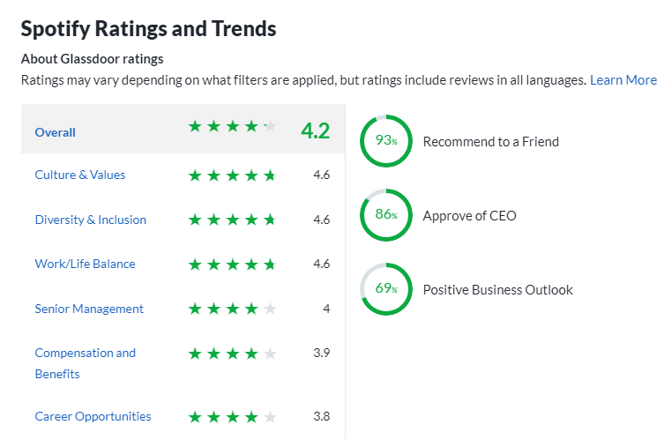
Glassdoor.com

There appear to be very few negative reviews of the company, or the HR strategy available online, this demonstrates a strong and positive workplace culture, as the companies ‘no retaliation’ whistleblower strategy forbids them from gagging ex-employees or taking any action against them.
Spotify have had their share of controversies, including user boycotts of the company while Spotify provided a platform for Covid 19 misrepresentation and false information (The company apologized and withdrew the podcasts) and multiple public disputes over the amount that artists are paid per stream. The company proclaims that it is providing a platform for musicians and performers to make a living, yet there has been comment that an artis would require “380,000 streams on Spotify just to make minimum wage” (Spotify’s Fatal Flaw Exposed)
Applying VUCA to Spotify helps us identify some more facts about the business and how it manages and addresses successes and issues.
Volatility- Spotify are operating in a market of high volatility, with several high profile competitors, such as Apple, who are also Tech giants with more resources and are not reliant on a single product for success are not at such risk, should Spotify love a large proportion of their market share toi current or emerging competitors, they may find themselves in a difficult position, especially due to the fact that the company has not yet recorded an annual profit. Staff were retained during the Covid 19 pandemic, but concerns about the companies longevity may cause staff to leave for other companies should it appear that Spotify is struggling in a volatile market. The company have also grown from volatility, being able to put full remote working strategies in place quickly due to Covid 19 was a relatively simple proposition as home working was already the standard, this demonstrates that the company is agile and responsive to staff need. The company state that they have always operated in ‘controlled chaos; so are primed for working in volatile situations (Kim, 2020)
Uncertainty- Following the uncertainty of Covid 9 businesses are now faced with the uncertainty of war and cultural issues, with areas of Europe and the middle east in flux and a global financial downturn affecting businesses Spotify must continue with their strong strategy of regular ongoing communication with staff in order to reassure and ensure that they feel included and consulted on their futures.
Complexity- The ongoing complexity of navigating global markets, floating on the stock market and the recruitment freeze is certain to trickle down to staff and add to the issues of uncertainty, in line with the prior section Spotify can combat this by ensuring that they maintain open channels of communication with staff and are honest and upfront about plans. The robust employee welfare program should go some way to deal with concerns and issues raised by staff.
Ambiguity- Spotify pride themselves on not being an ambiguous company, while the global situation may mean that there are some cases where companies must be ambiguous, but the company state “creating clarity on the things that we can control within our sphere of influence is key” (Kim, 2020)
Conclusion
In Conclusion, Spotify have a strong work culture, prizing culture over skills, and continuously upskilling staff and mentoring/monitoring progress to ensure that they are reaching their full potential. There are programs of support in place to address external issues that may impact on an individuals work and capability and there are regularly publicized, with the aim of showing that there is no stigma within the organization, just a desire for staff members to make the best of themselves.
A robust equality, diversity and belonging policy, which starts at the beginning of the hiring process ensures that there is a level of diversity and that staff members are the ‘right’ cultural fit for the company ethos.
There are very few (if any) negative reviews of working for Spotify available online, and those that are available contain constructive feedback rather than negative statements.
An open, supporting HR department, and an accountability from the very top levels of management structure ensure that there are limited unaddressed issues within the workforce, and the robust annual performance program ensures that any issues are identified and dealt with before any detriment is caused to the business as a whole.
Recommendations
In making recommendations for the ongoing HR management of Spotify it is important to note that overwhelmingly, staff are happy and feel supported by their employer and colleagues, however a happy and supportive workplace is not a replacement for a stable financial future, and it may be worth Spotify considering that while expansion and autonomy are valuable, staff members may not feel confident in remaining at a company that is in indefinite start up mode and is unable to record a profit, investments are unlikely to last forever and staff may become concerned about the long term stability of their jobs in a volatile market with multiple competitors.
This report recommends that Spotify, in line with their open communication policies, provide clarity on their long-term financial plans to report profit wider staff, in order to reassure them that their roles and skills will remain viable and to avoid ‘jumping ship’
The second recommendation provided by this report is that Spotify take a closer look at their prized model of tribes, squads, chapters and guilds to ensure that there is enough action being taken by line managers to avoid silo working, as there are reports of ‘bloated’ groups and slow development of products due to hyper-focus on small scale ideas and projects.

2849 words

References
BBC News. (2018, March 1). How Spotify came to be worth billions. https://www.bbc.co.uk/news/newsbeat-43240886
Bloomberg, L. L. |. (2023, January 18). Spotify Needs to Profit From a Music Revolution. Washington Post. https://www.washingtonpost.com/business/spotify-needs-to-profit-from-a-music-revolution/2023/01/18/e71c548c-96ef-11ed-a173-61e055ec24ef_story.html
Brewer, T. (2022, October 4). How Spotify Organizes its Org Chart. https://www.functionly.com/orginometry/real-org-charts/spotify-org-structure
Brown, E. (n.d.). Are leaders necessary? Lessons from the beehive. https://www.linkedin.com/pulse/leaders-necessary-lessons-from-beehive-erik-brown
C. (2023a, February 16). What Is Human Resources (HR)? Description, Duties, and Jobs. Coursera. https://www.coursera.org/articles/what-is-hr
C. (2023b, February 16). What Is Human Resources (HR)? Description, Duties, and Jobs. Coursera. https://www.coursera.org/articles/what-is-hr
Caldas, L. (2020, November 4). Hey, are you ok? HR Blog. https://hrblog.spotify.com/2018/09/21/hey-are-you-ok/
Charles Handy Model of Organization Culture. (n.d.). https://www.managementstudyguide.com/charles-handy-model.htm
Cilliers, F., & Greyvenstein, H. (2012). The impact of silo mentality on team identity: An organisational case study. Sa Journal of Industrial Psychology, 38(2). https://doi.org/10.4102/sajip.v38i2.993
Johannsen, R. L., & Zak, P. J. (2020). Autonomy Raises Productivity: An Experiment Measuring Neurophysiology. Frontiers in Psychology, 11. https://doi.org/10.3389/fpsyg.2020.00963
Kim, M. (2020, November 4). VUCA bootcamp: not a freakin’ work in progress! HR Blog. https://hrblog.spotify.com/2020/06/18/vuca-bootcamp-not-a-freakin-work-in-progress/
Makarova, O. (2023, January 19). Working in Silos: What Is It and How Can You Prevent It? nBold. https://nbold.co/working-in-silos/#:~:text=Working%20in%20silos%20describes%20a,their%20work%20separately%20without%20coordination.
Monaghan, A. (2018, April 3). Spotify’s stock market debut: everything you need to know. The Guardian. https://www.theguardian.com/technology/2018/apr/03/spotify-stock-market-debut-all-you-need-to-know
Mulder, P. (2022, October 22). Handy Model of Organisational Culture. Toolshero. https://www.toolshero.com/management/handy-model/
Organimi. (2022, October 31). Spotify&#039;s Organizational Structure [Interactive Chart] Organimi. https://www.organimi.com/organizational-structures/spotify/
Personal Development Done Right: The Spotify Way. (2023, January 8). Corporate Rebels. https://www.corporate-rebels.com/blog/spotify-development
Šmite, D., Moe, N. B., Levinta, G., & Floryan, M. (2019a). Spotify Guilds: How to Succeed With Knowledge Sharing in Large-Scale Agile Organizations. IEEE Software, 36(2), 51–57. https://doi.org/10.1109/ms.2018.2886178
Šmite, D., Moe, N. B., Levinta, G., & Floryan, M. (2019b). Spotify Guilds: How to Succeed With Knowledge Sharing in Large-Scale Agile Organizations. IEEE Software, 36(2), 51–57. https://doi.org/10.1109/ms.2018.2886178
Spotify. (n.d.). Spotify code of conduct and ethics.
Spotify: Cherishing a Start-Up Culture During Exponential Growth. (2023, January 9). Corporate Rebels. https://www.corporate-rebels.com/blog/spotify-2
Spotify happiness Score. (n.d.). Comparably.
Spotify &mdash; About Spotify. (2023, February 2). Spotify. https://newsroom.spotify.com/company-info/
Spotify Technology Net Worth 2018-2022 | SPOT. (n.d.). MacroTrends. https://www.macrotrends.net/stocks/charts/SPOT/spotify-technology/net-worth
Spotify’s Fatal Flaw Exposed: How My Closed-Door Meeting with Execs Ended in a Shouting Match. (n.d.). IOTM. https://www.indieonthemove.com/blog/2018/1/spotifys-fatal-flaw-exposed-how-my-closed-door-meeting-with-execs-ended-in-a-shouting-match
Stassen, M. (2023, January 25). Spotify wipes vacancies from global jobs board as hiring freeze hits after 500+ layoffs. Music Business Worldwide. https://www.musicbusinessworldwide.com/spotify-wipes-vacancies-from-global-jobs-board-as-hiring-freeze-hits-after-500-layoffs/
The Band Manifesto | Life at Spotify. (n.d.-a). https://www.lifeatspotify.com/being-here/the-band-manifesto
The Band Manifesto | Life at Spotify. (n.d.-b). https://www.lifeatspotify.com/being-here/the-band-manifesto
What It’s Like to Work The Spotify Way. (2023, January 6). Corporate Rebels. https://www.corporate-rebels.com/blog/spotify-1

