
APPENDIX GA36d

LEVEL 7 ASSESSMENT

Student name: | Gemma Bush | Student ID number: | 1804862
Programme: | Secondary PGCE
Module: | Investigating Contemporary Issues in Secondary Education
Module code: | ECSP7001 | Contribution to Overall Module Assessment (%): | 100%
Lecturer: | Shân Samuel-Thomas | Internal Verifier:
Assignment Title: | Investigating Contemporary Issues in Secondary Education | Word count (or equivalent): | 5,000 words
Submission deadline: | January 28th, 2019 | Return date of provisional marks & written feedback: | February 19th, 2019
Submission method: | All written assessments, where practical and possible, must be submitted via Turnitin unless otherwise instructed by the Lecturer. (Please DO NOT put this assessment specification into Turnitin or it will match many similarities with other students’ submissions.)  Alternative submission method (if applicable):  Late submission of the assessment will result in a late penalty mark. Penalties for late submission: Up to one week late, maximum mark of 50%. Over one week late, 0%. Only the Extenuating Circumstances Panel may approve a change to submission dates.
Academic honesty / referencing: | Academic honesty is required. In the main body of your submission you must give credit to authors on whose research and ideas your work is based. Append to your submission a reference list that indicates the books, articles, etc. that you have used, cited or quoted in order to complete this assessment.

Education in Britain is facing a serious problem. According to Wrigley (2005, p.72) “There is a strong correlation between low achievement and poverty…particularly…due to the high and chronic levels of child poverty.” The crisis that Britain has with the increased levels of child poverty has led to a heavy influence on the declining attainment of learners of which are living in these uncertain situations. Wales Centre for Equity in Education (2014, p.5) has further asserted that “children from poorer backgrounds lag behind at all stages of education”. Furthermore, it has been stated that “Wales has the highest rates of child poverty in the UK”; “1 in 3 children (200,000) in Wales live in relative poverty” (2014, p.6). These shocking statistics of this issue has led to schools attempting to tackle the ever growing problem through planning, particularly that of school improvement planning and departmental improvement planning. Nevertheless, the way in which these issues are met are in the hands of the school and its leadership team.

This report will critically discuss the correlation between low attainment and child poverty and will evaluate the efforts and strategies of School X’s intervention of ‘PREP’ conducted during form time towards tackling the poverty gap in order to raise attainment, a strong work ethic and build resilience. This evaluation will be set in the context of a discussion of the School Improvement Plan (SIP), (See Appendix 1), and how it has been implemented into the whole school scheme. This shall be followed by a critical analysis of the necessity of strategic planning in schools. A discussion concerning an analysis of the issue of poverty in the classroom, will conclude with strategies suggested in the literature used to help School X’s scheme and enable the school to move forward and improve progress in all learners, especially the attainment of Free School Meals (FSM) learners.
Before the paper proceeds to the critical evaluation of the issue of child poverty and its influence on attainment in schools, it is useful to discuss the context of the school. School Z is an “11 to 18 mixed, community school maintained by Rhondda Cynon Taff Borough Council. It is an English medium school with significant Welsh provision” (Estyn, 2016, p.1). School X serves a catchment area across the Rhondda Valleys and attracts learners from as far as Ogmore, Bridgend where the proportion of pupils that are eligible for Free School Meals (FSM) is 20.9% (My Local School, 2019), which is slightly higher than the 17.4% average for Wales (Estyn, 2016, p.1). Around 24% of learners are on School X’s additional learning needs register; close to the Welsh national average of 25.4%. Less than 1% of learners at School X have a statement of special educational needs, of which is below the national average (Estyn, 2016).

School X received a double good in its Estyn Inspection in 2016 and was commended for having a “very caring, inclusive and supportive ethos and provides high quality care, support and guidance for all pupils” (Estyn, 2016, p.2). Through this commendation of School X, Estyn examined that the prospects for the school’s future are good because “leaders communicate consistently high expectations for staff and pupils and challenge all members of the school community to achieve well” (Estyn, 2016, p.2). The highlights from the inspection have been built into the School Improvement Plan along with a broad range of educational areas, in an attempt to push the grading of the school upwards towards ‘Excellent’. The School Improvement Plan incorporates several elements of the school to develop throughout the academic year: assessment for learning, curriculum development, staff development and wellbeing, information for learning, independent and interdependent learning, improving provisions and outcomes for vulnerable learners and curriculum enrichment (See Appendix A).

The construction of a School Improvement Plan and a Departmental Improvement Plan can take two different approaches. Fidler provides two perspectives; ‘top-down’ and ‘bottom-up’ (1996, p. 89). A ‘top-down’ approach involves the leadership team of a school deciding the focus for the school for the forthcoming academic year, constructing the SIP amongst the few staff within this team and setting the agenda for the departments to follow. The DIP will then follow the guidance of the SIP to remain in line with the whole school improvement process. A ‘bottom up’ approach enables the departments and the teaching staff to set the agenda for the school. These staff members will usually be able to see what is happening on the ground of the school, of which, will enable them to discover what is required for the school to improve crucial areas, perhaps of concern. However, there are drawbacks for both approaches; top-down can be seen to not understand what is required in the departments and the individual lessons of the school, whilst, a bottom-up approach may fail to confer with other departments in order to unify the approaches taken across the school to improve recommendations.

The ‘top-down’ approach is the strategy that School X has adopted for their SIP and DIP. As previously outlined, the school has prioritised several areas of improvement for the school, splitting these into categories to streamline the improvement process of the school. One area of the SIP that will be focused on within this report is that of ‘Independent and Interdependent Learning’ and ‘Improving Provisions and Outcomes for Vulnerable Groups’ (See Appendix 1). Improvements within this section of the SIP focus on ‘excellent behaviour leading to a reduction in exclusions’, ‘develop a culture of excellence and high expectations’. The depth of the SIP incorporates the strong drive towards excellence in all learners that School X are moving towards. The focus of this report is to highlight the concern of child poverty and its effect on attainment of pupils, of which, is acknowledged in the areas displayed above that can also be located in the full SIP (See Appendix 1). The target to improve the impact of poverty with attainment is not exclusive to School X but rather a crucial target for the entirety of Wales and indeed the UK as a result of the chronic levels of child poverty that Wrigley suggested.

School X are not the only school whereby this issue has become an area to address. Estyn dedicated an entire report on the topic of ‘Pupil Deprivation’ and highlighted the critical obstacle: “it is evident from performance data that there is still much to do to raise the achievements of disadvantaged learners and that progress in addressing this issue has been slow” (2014, p. 2). Having discussed the issue of child poverty and its relation to the attainment of vulnerable learners, Estyn have addressed how it is best to improve statistics within the individual schools facing the ever growing problem. Estyn outline the most productive avenue as taking “a systematic, coherent whole-school approach to supporting disadvantaged learners” (2014, p.3). Furthermore, Estyn asserted: “prioritise tackling poverty and planning strategically to raise the performance of disadvantaged learners” (2014, p.3). The areas of focus suggested within this report demonstrate that School X have taken on board the suggestions from Estyn of a ‘whole-school approach’, hence the ‘top-down’ strategy of the SIP/ DIP. Additionally, as the report will develop upon in the following paragraphs, the intervention of PREP can be perceived as taking hold of the child poverty effecting attainment as a priority as well as a whole-school approach.

“One of the fundamental features of educational debate in the last twenty years has been the growing appreciation of school effectiveness and school improvement issues” (Cornforth, Evans, 1996, p. 11). A dominant term that has been utilised by literature surrounding school improvement, is that of ‘strategic planning’. In order to critically evaluate whether strategic planning is the best approach for the process of school improvement, a definition and explanation of ‘strategic planning’ is in order. Quinn (1980, p.7, located in Fidler, 1996, p.1) describes the strategy as follows: “the pattern or plan that integrates an organisation’s major goals, policies, and action sequences into a cohesive whole”. Furthermore, the essence of strategic planning can be perceived as “a disciplined effort to produce fundamental decisions and actions that shape and guide what an organisation…is, what it does, and why it does it” (Fidler, 1996, p.1). Collectively, the term expresses that the areas that a school, in this instance wants to improve, are brought together into one unified plan for improvement. This runs simultaneously alongside the essence of the organisation. In the case of School X, the essence of a “caring” (Estyn, 2016) ethos centred around a community can be featured in the SIP as School X will constantly be in a cyclical process of wanting to address their strength and seek to improve upon that particular area. This ultimately ties into the intervention that will be explored later in the report, School X’s PREP; a unique selling point (USP) for the school as a thriving organisation.

“Strategy is concerned with the long-term future of an organisation—that which makes it distinctive, the broad direction it takes” (Fidler, 1996, p.1). Ideas surrounding improvement can often lead to little success. Implemented and developing more resources into lessons, adding more activities may not result in the achievement of the ultimate goals of the school that need to be addresses; in this report, progression in the attainment of those learners that are living in child poverty. Additionally, due to the complex nature of a school and that each school has a different nature, leadership team, etc., the results will interchange between school to school even if they are all focusing their agenda on the same area (Chang, 2006). Chang expresses that there is no “single perfect way” to conduct strategic planning in a school environment due to the factors listed above, nevertheless, “what is generic to strategic planning and management are certain typical stages involving similar activities carried out in a similar sequence” (Chang, 2006, p.1).

Planning that is centred around a directed goal has been around throughout history, whilst the strategic planning as we understand it in the 21st century “evolved out of military strategy” (Billingham, 2012). Strategic planning came to the attention and was implemented into the business world during the 1950s and 1960s. Furthermore, “strategic planning in the education sector initially flowed out of the business practices as a result of people moving from the business sector into positions in education leadership and bringing with them a set of planning tools and paradigms” (Billingham, 2012).

Fidler has put forward a number of models of strategic planning in order to understand the process (See Appendix 2). The model displayed is a basic model of strategic management, simplifying the complexity of a strategic plan. The plan addressed has seven simple stages with regards to strategic planning. Firstly, deciding how to organise a school in the case of the report is required. This would involve in the case of School X, the leadership team to discuss how the improvement of the school will be addressed best. School X have decided upon a top-down approach to the organisation of the school and its improvement. The model moves further onto a decision made regarding the strategy used. In the case of School X, this will be PREP that will be discussed later in the report. The leadership team will have come together to discuss the issue at hand, child poverty and its link to their attainment; “take stock. Analyse” (Fidler, 1996, p.57) and use these statistics to deliberate upon the most effective intervention required for an improvement in this area. Once the agenda is set, strategies can be played around with in the decision making time. A variety of decisions can be discussed before settling on an intervention; PREP. Once the intervention has been decided upon, the plan can be created. In the case of School X, this is found in the SIP and its implementation runs across the whole school for best effect. The model put forward by Fidler is not one that has a finish line, rather, a model of strategic planning is one in which is in a constant cycle of improvement in itself. Once a plan has been implemented, new methods may arise in the near future, issues may develop, and another strategic plan is required. More often than not, teething problems will occur and will have to be modified via a newly developed strategic plan.

Nevertheless, “strategy is concerned with planning a successful future for a school” (Fidler, 1996, p.1). This is at the heart of the plans, SIPs and DIPs. The outcome of a successful school. Some strategic plans may be a big stride towards responding to many recommendations as an adequate school from Estyn or simple that the school is focusing on maintaining their success through careful planning and monitoring the progress. Regardless of the achievement of the school; unsatisfactory, adequate, good, excellent; what is paramount to that of strategic planning is “the drawing of objectives, aims, goals, targets…an effective organization knows where it wants to go, it is future orientated” (Morrison, 1998, p.35).

Strategic planning, however, has been perceived by some as not the best and most effective strategy for improvement. “Tom Peters described strategic planning as “death by a thousand initiatives”” (Billingham, 2012). Alternatively, Mintzberg expressed that organisations that have seen great success have used strategic planning, but, in a more relaxed, “less structured and rigid way” (Billingham, 2012). Other drawbacks to improvement via strategic planning explores the idea that a “certain amount of vision is required to provide the clarity and energy for promoting specific changes” (Preedy, Glatter, Wise, 2003, p. 186). In order for a school to improve areas of large concern, ultimately, a vision of the improvement needs to occur. An understanding of what improvement in an area will look like will make the planning process easier to comprehend. Those involved will be able to visually see the improvement over time through witnessing their ‘vision’ take place in real time. However, “vision by itself may get in the way if it results in impatience, failure to listen” (Preedy, Glatter, Wise, 2003, p.186). A solution to the focus of the vision could be a flip from a ‘top-down’ strategy of a SIP/DIP to a ‘bottom-up’ strategy. This would enable “those within the institution to be involved and take ownership of the change and improvement process” (Harris, Bennet, 2005, p.152). This would enable all those involved in the school to have an input into the planning of improvement and both staff members and learners will be able to provide guidance to whether the vision is achievable within the school or whether an alternative intervention needs to be discussed.

Welsh Government have utilised a model to explain the role of strategic planning in the education sector taking on board the importance of a ‘vision’ (See Appendix 3). “The school development planning cycle is set against a clear vision of what the school is aspiring to achieve” (Welsh Government, 2014, p.7). A shared response to strategic planning, centred around a school vision, is crucial in order to achieve as a whole school, in particular improving the attainment and engagement of those learners who are living in areas of poverty. Before discussing how School X’s intervention of PREP can be enhanced through strategic planning, the issue of the correlation between child poverty and attainment needs to be discussed.

As expressed at the beginning of the report, Wales has the highest levels of child poverty in the UK. Even more so, “many young people in Wales fall behind in their development before they start school” (Save the Children, 2019). The issue that began in the early years stage of the learner’s life, has progressed into secondary school, whereby the issue becomes more apparent. “There is a strong link between achievement and the level of entitlement to free school meals in schools: as the level of free school meals entitlement increases, the level of achievement decreases” (Welsh Government, 2019). “A key indicator of child poverty is the percentage of children living in households below 60% of the median UK household income” (Welsh Government, 2015, p.5). Appendix 4 displays a line graph of all four UK countries and the statistics of children that live in within the households below the 60% median. Wales’ statistics demonstrate a slight decrease of around 2% in 10 years, however, the figure still remains at around 32% of children living within these indicators. Furthermore, statistics from Stats Wales demonstrate that attainment levels in the core subjects at Key Stage 3 for free school meals learners are significantly lower than learners who are not entitled for FSM (See Appendix 5).

Appendix 5 figures display the full extent of the issue of child poverty and its correlation with lower attainment. The statistics demonstrate that of learners that are eligible for FSM, 72.1% were achieving the expected Level 5 + at Key Stage 3 in the core subjects: English, Welsh, Maths, Science. Whilst the statistics of learners that are not eligible for FSM indicates that in 2018, 91.6% were achieving the expected Level 5 + in KS£ core subjects. This is a gap of 19.5% between learners that are not eligible for FSM and learners that are. This current gap at KS3 is the reason why Estyn and the Welsh Government have targeted low levels of attainment due to child poverty as an issue that needs to be addressed both within the education system and outside it within the home. Furthermore, the statistics indicate that the attainment of boys is lower in both categories of eligible for FSM and not eligible for FSM. The statistics of the boys that are eligible for FSM demonstrate that only 65.1% of them are achieving the expected Level 5 + in comparison to 88.9% of boys that are not eligible for FSM. The gap between these boys is 23.8% further indicating the developing issue in the Welsh education system. Ultimately, these statistics indicate that a major change is in order to improve the attainment of students who are eligible for FSM and boys too (Stats Wales, 2018).
The statistics collected by the Welsh Government highlight the extent of the problem of child poverty in relation to low attainment in schools. Child poverty, as previously mentioned is an ever growing problem, particularly in the catchment area of School X that has led to 20.9% FSM learners amounting to one fifth of the learners in the entire school. These statistics for School X are slightly above average, further expressing the need for an intervention and close monitoring to occur in order to highlight the improvements being made. School X have established a need to improve these sections of the school by incorporating ‘Vulnerable Groups’ into the School Improvement Plan (See Appendix 1). School X have set their SIP to improve areas that Estyn have mentioned, and additionally, improve areas of which Estyn commended them on. One recommendation from the 2016 Estyn inspection links into both a recommendation and a commendation: “Improve the standards of key stage 4 in English and Welsh first language” (Estyn 2016, p.3). The recommendation has been drawn upon within the SIP in several areas, one of which is the focus of the report; vulnerable learners.

Appendix 1 addresses the improvement for areas within the school to aid the vulnerable learners in the comprehensive; FSM and ALN in particular. The progression towards improving provisions for these groups has an entire section of the SIP. The SIP takes on the responsibility to tackle the issues of low attainment from FSM learners and boys too. The main areas for improvement highlight the following: high quality planning for excellent teaching and learning experiences in lessons for both FSM learners and boys, achieving excellent academic outcomes for FSM learners and boys in all departments, pupils to display excellent behaviour leading to a reduction in exclusions for FSM learners and boys and improved attendance for the vulnerable groups. These four improvements to be made in the areas surrounding vulnerable learners highlight a number of avenues and actions to tackle the ever growing issue of child poverty and low attainment.

Actions that have been highlighted for the improvement of vulnerable groups at School X include the following: using Class Charts to identify issues and support escalating behaviour, evaluate the use of pupil voice and creation of DIPs encompassing the requirement to push the FSM learners and boy’s attainment up enough to match those that are not eligible for FSM. A further action however, that has not been mentioned on the SIP is that of the fairly new intervention to School X of PREP. Through my own observations through shadowing a form tutor and a telephone conversation with a deputy head of School X, I have considered this intervention to be a prominent action for targeting the attainment of learners with FSM.

PREP is a new intervention for School X. It is a unique selling point (USP) for the school with the learners at the heart of this change. PREP is currently in its second year of implementation, leading results and feedback to be too early to report on. PREP has been developed by the leadership team at School X proceeding a need to address the lives of all students. School X has implemented a change to the timetabling for the entire school; the initial first year of the intervention only applied to Year 7-8. The change to the timetabling has created the following: every form group returns to their form class three afternoon lessons a week (55 minute lesson). The form group returns for lesson 6 on Monday, Wednesday and lesson 4 on Friday. The decision to create such a change to the timetable developed out of the need for a wrap-around care for all learners. The purpose of this PREP time has encouraged learners to complete homework and prepare for the forthcoming lessons; e.g. if learners have tests to prepare for or group work to arrange and prepare. Furthermore, upon my own observations in a Year 7 form class, the learners settle into the lesson with 10 minutes of silent reading, of which seems to be a universal start to all PREP sessions at School X.

Furthermore, School X also altered the time of the timetable and the school day, including lesson numbers and times. The previous numbers of lessons per day at School X was 5, however, currently there are 6 lessons per day at 55 minutes each; reasons for the change have been to incorporate PREP sessions into the timetable. Additionally, the timetable for a Friday has received a drastic change; Friday now contains 4 lessons, finishing at 1:30pm. These dramatic changes have made a huge stride towards increasing the community awareness of School X and unifying the ‘caring’ attitude expressed in the 2016 Estyn report on a significantly larger scale; a whole-school approach. The early finish Friday feeds into the need to engage with the community; learners can go on a weekend break after the early finish Friday as opposed to skipping the entire school day, of which, enables the attendance levels to increase. Additionally, the early finish allows the learners to partake in activities after school if their parents are at work or have a fulfilling childhood as they should have completed their homework within PREP session and have the freedom to enjoy their youth.

Although this is a new intervention for School X and indeed the education system in general, the issue of the correlation of low attainment and child poverty has been largely documented within literature, targeting pastoral care as an action for change within a school. “A quality pastoral system recognises the scale” of a whole-school mission to change the statistics of a national crisis and the many pitfalls it will face before success. The pastoral system of School X is at the heart of the new intervention of PREP. Form tutors (also referred to as Learning Coaches) are at the centre of the scheme and enable the intervention to be as successful as possible. Additionally, a “school’s culture is shaped by its history, context and the people in it” (Preedy, Glatter, Wise, 2003, p.96). This is true to School X and its commitment to the community of the catchment area. There is a strong focus on having a connection to the community of the learners and understanding that the school plays an important role in the development of the learners that attend it. Furthermore, School X is one of the biggest employers of the locals in the catchment area, adding to the connection to a strong community. “A school modelled as community, according to Bryk and Driscoll, ‘is a social organization consisting of cooperative relations…where daily life for both adults and students is organized in ways that foster commitment among its members’” (Preedy, Glatter, Wise, 2003, p.24). With this in mind, School X has made strides to incorporate the community characteristic within the PREP intervention, where the Learning Coaches are perceived to be the learner’s main point of contact in the school, whereby the learners are able to turn to them for advice and understanding about matters that they feel comfortable discussing.

“In the present system teachers are the gatekeepers of change…but children’s learning will never be understood properly if teachers cannot spend time listening to the children” (Ruddock, Flutter, 2004, p.141). The importance of the Learning Coach role is to listen to the learners. As mentioned in the SIP, pupil voice is one action that can develop the improvement and School X’s intervention of PREP has ensured that learners will have ample time during the school week to converse with their peers and more importantly, learners will be able to communicate ideas to their form tutor within a safe environment. Furthermore, it “is important to know what pupils think will make a difference to their commitment to learning and, in turn, to their progress and achievement” (Ruddock, Flutter, 2003, p.2). The importance of the communication between the learners and the Learning Coach is paramount to the success and improvement of PREP within School X.

The implementation of the PREP intervention has become essential for School X in recent decades, whereby the make-up of a family has changed. “Few teachers still feel confident in assuming that their students come from two-parent nuclear families…family structures has become too pervasive to ignore” (Preedy, Glatter, Wise, 2003, p.20). With regards to the construct of a modern family, particularly in the catchment area of School X, it is not uncommon for students to live in a one-parent household, live with grandparents, with a foster family, or living as part of a blended family with step-parents and additional siblings. Through this change in the construct of families, the role of a Learning Coach is paramount to a learner’s development, both academic and socially.

In order to improve the provisions for the vulnerable groups, FSM and boys, the PREP sessions are aimed at providing a wrap-around care for the learners whereby they can build resilience. Resilience is a key buzz word for School X of which they are expecting the pupils to engage with and demonstrate throughout the school. Promoting resilience has been shown to engage learners and with the ultimate aim of raising attainment for the vulnerable learners in particular. “Bernard (1991) describes resilience as a set of qualities or protective mechanisms that give rise to successful adaption despite the presence of high risk factors during the course of development” (Cefai, 2008, p.21). Furthermore, ‘resilience’ engages with the issue at hand: “most definitions is that of competence and success despite severe and prolonged adversity and disadvantage” (Cefai, 2008, p.21). It is through these understandings of resilience of which School X should focus upon and make sure that learners that are most in need to resilience understand the importance of the term and how they still need to strive to achieve through times of struggle and hardship.

Cefai provides a model for building resilience in the classroom, of which I believe would be beneficial for furthering the success of PREP (See Appendix 6). Within this model, asserts the characteristics that School X have been striving to implement into the PREP sessions, however, the goals all come into one model. Characteristics include; sense of belonging, learning together, prosocial behaviour, inclusive, among many others. This model would be a perfect addition to the SIP in order to ensure that all Learning Coaches are aware of the overarching aims of the sessions and the reasoning for wrap-around care.

Furthermore, alongside the promotion of resilience within all learners particularly those that are deemed vulnerable: FSM and boys, PREP allows these learners to access resources they may not have access at home. The importance of PREP is a time to prepare for their forthcoming lessons, completing homework and conversing with peers and staff in a safe environment. To complete some pieces of homework in our modern education system often requires the use of an electronic device, however, those who are eligible for FSM may not have access to such a resource. This PREP time allows those learners to have access to a device to complete those homework tasks and saves them the embarrassment of not being able to complete the homework or struggling to complete the task in the household if there are issues in this aspect of their lifestyle; this could be the case of young carers. In this respect, FSM learners have been awarded a haven whereby they have the opportunity to complete their homework in school hours as opposed to trying to complete the tasks but lacking the resources. The purpose of PREP is ultimately for these reasons, putting the learners at the centre of the intervention.

Ultimately, the intervention of PREP within School X has overall, had a positive effect on learners in its early stages of implementation. The intervention is unique in more ways than one. PREP is a USP for School X as they seem to be the only school of its kind to be utilising form time in this way, alongside the progression towards building resilience. Furthermore, the learners are able to have their time after school to focus on their interests, whether that be sports, social life or family time. “The presence of the core concepts does not guarantee success, but their absence ensures failure” (Hargreaves, Fullan, 2009, p.9). The core concepts of PREP include building resilience and supportive pastoral care. These key concepts can be interpreted in different ways by Learning Coaches, however, without the focus of these, failure is imminent. Through my own observations within the Year 7, PREP seems to be beneficial for the social development of the learners, however, I have not had the opportunity to assess PREP sessions throughout the school to formulate a whole-school evaluation.
Furthermore, there are a number of next steps for School X as a result of this report. Firstly, the PREP sessions are valuable for the progression towards increasing levels of attainment for vulnerable learners. Nevertheless, the intervention is in its early stages where teething problems have occurred and need to be addressed. Indeed, my suggestions for improvement are as follows: to continue the transition towards improving PREP sessions, of which, the model of resilience-enhancing can aid the individual improvement of Learning Coaches attitudes. This model, I would argue should be a focus of the PREP sessions at its initial stages. Additionally, the PREP sessions should have a further emphasis on the core subjects beginning in Key Stage 3-5 in order to enable the FSM learners to achieve high achievements enabling further prospects for their future outside of education. This could be constructed through projects incorporating the Successful Futures document whereby the curriculum develops learners through four purposes: ambitious, capable learners; enterprising, creative contributors; healthy, confident individuals and ethical, informed citizens (Donaldson, 2015). As the Successful Futures Document comes into action and in the forthcoming years and is already being pioneered at School X, the four areas should take centre stage alongside resilience within these USP PREP sessions.

Word Count = 5327

References
- Billingham, J., (2012) Strategic Planning in Education – 3 Keys to Success, Available from: https://www.thoughtexchange.com/strategic-planning-in-education-3-keys-to-success/ (accessed on 26/01/2019)
- Cefai, C, (2008) Promoting Resilience in the Classroom: A Guide to Developing Pupils’ Emotional and Cognitive Skills, Jessica Kingsley Publishers
- Chang, G. C., (2006) Strategic Planning in Education: Some Concepts and Steps, Available from: https://unesdoc.unesco.org/ark:/48223/pf0000150191 (accessed on 26/01/2019)
- Cornforth, A., Evans, T., (1996) Striving for Quality in Schools, The Latchmere Press
- Donaldson, G, (2015) Successful Futures: Independent Review of Curriculum and Assessment Arrangements in Wales Welsh Government [online]. Available from: https://gov.wales/docs/dcells/publications/150317-successful-futures-en.pdf (accessed on 10/01/2019)
- Estyn, (2014), Pupil Deprivation, Available on: https://www.estyn.gov.wales/sites/default/files/documents/Pupil%20deprivation.pdf (accessed on 24/01/2019)
- Estyn, (2016), A Report on School X, [online], (accessed on 23/01/2019)
- Fidler, B., (1996), Strategic Planning for School Improvement, Pitman Publishing
- Hargreaves, A., Fullan, M., (1998), What’s Worth Fighting for in Education? Open University Press
- Harris, A., Bennet, N., (2005), School Effectiveness and School Improvement, Continuum. London, New York
- Morrison, K., (1998), Management Theories for Educational Change, Paul Chapman Publishing
- My Local School, (2019), Available from: http://mylocalschool.wales.gov.uk/School/6744081?lang=en (accessed on 22/01/2019)
- Preedy, M., Glatter, R., Wise, C., (2003), Strategic Leadership and Educational Improvement, The Open University
- Save the Children, (2019) Available from: https://www.savethechildren.org.uk/what-we-do/policy-and-practice/our-policy-areas/uk-poverty (accessed on 24/01/2019)
- Stats Wales, (2018), Available from: https://statswales.gov.wales/Catalogue/Education-and-Skills/Schools-and-Teachers/Examinations-and-Assessments/Key-Stage-3-Core-Subjects/results-by-freeschoolmealentitlement-gender (accessed on 26/01/2019)
- Ruddock, J., Flutter, J., (2004), How to Improve your School. Giving Pupils a Voice, Continuum, London, New York
- Wales Centre for Equity in Education, (2014), The Good News…What Schools in Wales are Doing to Reduce the Impact of Poverty on Pupils’ Achievement, Available from: https://s3-eu-west-1.amazonaws.com/csc-live-thinqi-storage/97/5d/33/83/a3bb45189940b06e95d6f812/Good-News-What-schools-in-Wales-are-doing-to-reduce-the-effect-of-poverty-on-pupils-achievement.pdf (accessed on 25/01/2019)
- Welsh Government, (2019), Achievement and Entitlement to Free School Meals, Available from: https://gov.wales/statistics-and-research/academic-achievement-free-school-meals/?lang=en (accessed on 25/01/2019)
- Welsh Government, (2015), Child Poverty Strategy for Wales, Available from: https://gov.wales/docs/dsjlg/publications/150327-child-poverty-strategy-walesv2-en.pdf (accessed on 24/01/2019)
- Welsh Government, (2014), School Development Plans, Available from: https://beta.gov.wales/sites/default/files/publications/2018-03/school-development-plans.pdf (accessed on 25/01/2019)
- Wrigley, T., (2005), Schools of Hope. A New Agenda for School Improvement, Trentham Books

Appendix 1 – School X’s Improvement Plan
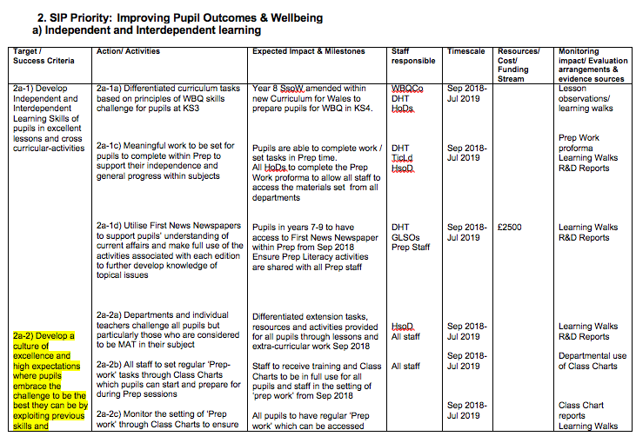
Appendix 1 is a copy of the relevant sections of School X’s Improvement Plan. It has been anonymised for confidentiality reasons.
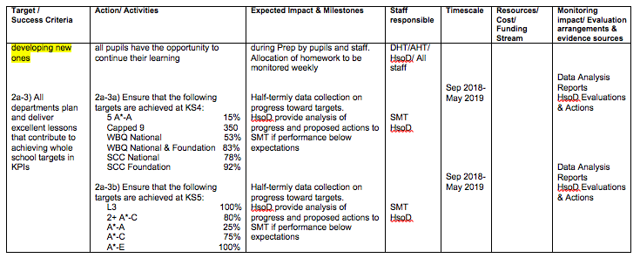
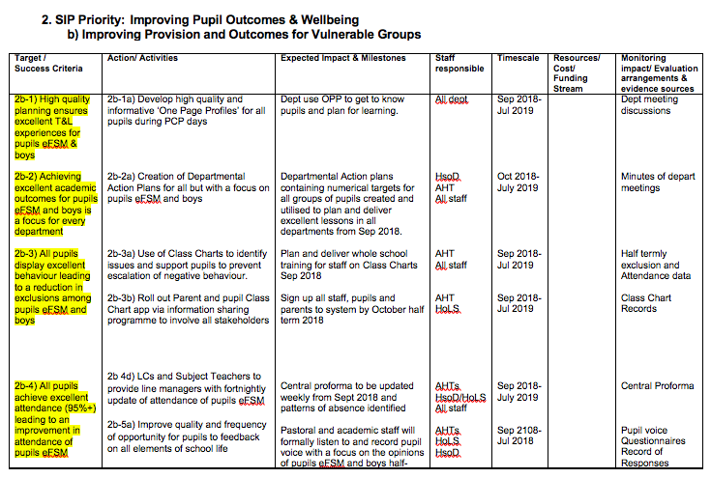

Appendix 2 – Basic model of strategic planning, Fidler, 1996
Appendix 2 is a basic model of strategic planning found in Fidler’s Strategic Planning for School Improvement, 1996, Page 57.

Appendix 3 – Welsh Government Model of Strategic Planning, 2014
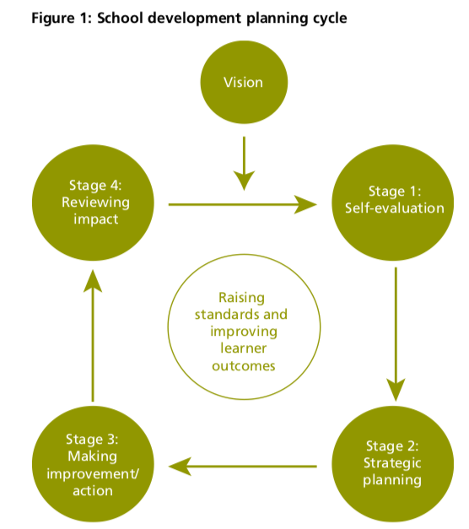
This is a model of strategic planning found in the Welsh Government document School Development Plans, 2014, p. 7.

Appendix 4 – Line graph of ‘Percentage of children living in households with less than 60 per cent of contemporary median household income’.
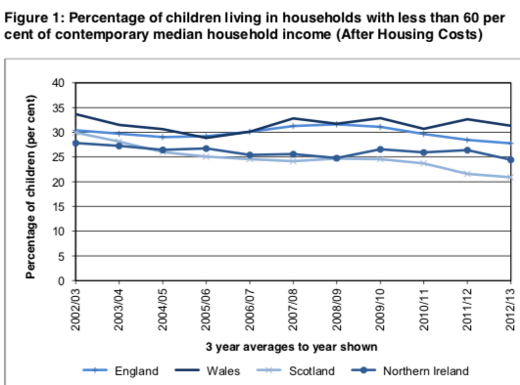
Appendix 4 is a line graph from the Welsh Government document Child Poverty Strategy for Wales, 2015, p. 6. The line graph contains dates 2002/03 – 2012/2013.

Appendix 5 – Results by Free School Meal (FSM) entitlement and gender – KS3 core subjects
Appendix 5 is a table of information concerning the attainment of FSM learners at KS3 core subjects in comparison to learners at the same level that are not entitled to FSM. The table can be found on Stats Wales.
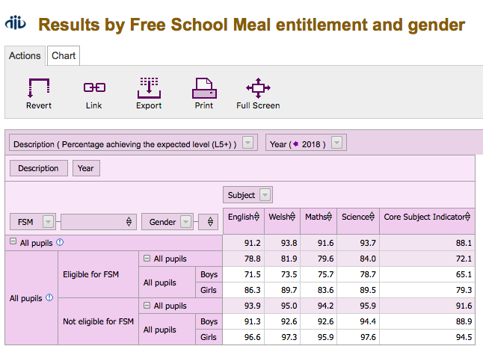
https://statswales.gov.wales/Catalogue/Education-and-Skills/Schools-and-Teachers/Examinations-and-Assessments/Key-Stage-3-Core-Subjects/results-by-freeschoolmealentitlement-gender

Appendix 6 – Resilience-enhancing classrooms
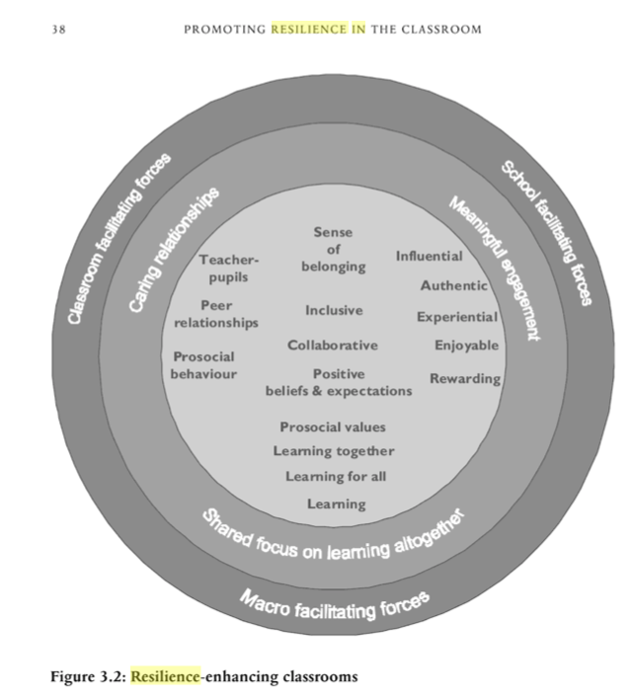
Appendix 6 is a model from Cefai’s Promoting Resilience in the Classroom: A Guide to Developing Pupils’ Emotional and Cognitive Skills, 2008, p. 38.

