“CRITICALLY EVALUATE AND REFLECT ON YOUR USE
OF THE QUALITIES OF THE HELPING RELATIONSHIP WITHIN YOUR SUBMITTED SKILLS PRACTICE”

BY JEREMY BAINBRIDGE.
STUDENT NUMBER: 1808881.
MODULE CODE: M6X01442.
SUBMISSION DATE: 30TH APRIL 2019.

SKILLS PRACTICE VIDEO DATED 12TH FEBRUARY 2019

Thinking systematically without bias about any given task or event is imperative in order to critically assess performance. Being able to critically assess our own performance or behaviour is essential for positive development. Just thinking about our performance, reflecting on how an interview went for example is something that we all do naturally, it’s a cognitive process on a relatively basic level that has evolved through millennia enabling our ancestors to learn about their environment, and learn from their mistakes and even the mistakes of others. Today, people critically assess events important to them, maybe aimlessly mulling them over with no positive outcome, but on a professional level there are many tools available that aid ones systematic assessment.
The foundation of this essay lays upon the reflective framework developed by Professor Graham Gibbs (1988). This tool is used here primarily due to its inclusion in the Midwinter and Dickson course textbook, and during research it appears to be by far the most reliable and popular system for our purposes. Other useful reflective models are for example the Kolb Reflective Cycle (1984)
This essay intends to not dwell on a deep description of this system, more delving directly in. However, Gibbs’s framework is cyclical, with six very distinct phases, each designed to provide a structure to reflection.
This reflection surrounds the skills performance videos recorded during the ‘triad’ sessions, specifically the video recorded on 12th February, where I performing as the helper, tends to a client we shall name as ‘L’. During this ‘triad’ a third party was present, making observations and critical assessment of my performance as means of feedback.
It is important to note that these triad training sessions are conducted using members of the course, and as such the client is not ‘real’. They are known by the helper as a co-student, and the environment is that of a training session, however, the clients bring genuine thoughts to the sessions and the helper uses skills developed during the course. The triads were conducted in small cubicles which suffice perfectly for their purpose.
Following on from the descriptive phase of the framework is the ‘self-awareness’ phase. For the responsibilities of a counsellor, self-awareness is imperative; being sensitive towards ones feelings allows us to recognise and differentiate between our own feelings and the feelings of the client as mentioned by Midwinter and Dickson (2015).
During the beginning of this session, I felt relaxed in the company of the triad and within the environment we shared. I felt relatively confident, but as only in a learning stage of my development in this field there was lots to focus upon while maintaining a free and open mind for the benefit of the client, therefore I was operating within the limits of my own knowledge and skills. My main thoughts initially centred upon stating the correct aspects during the opening stage stating the counselling contract, such as confidentiality, time, boundaries, limitations etc. As we agreed upon these factors, we were free to move on with the session. I felt comfortable focussing upon ‘L’, adopting the listening skills I had learnt. I was able to actively listen and felt empathy towards ‘L’ and unconditional positive regard, part of the core conditions set out by Carl Rogers (1957). I felt genuine congruence towards ‘L’ and a sincere appreciation of the individual and acceptance regardless of what secrets emerged, but as a training session, and ‘L’ only bringing relatively minor topics for discussion, ‘L’ may not have been ‘incongruent’. I felt ‘L’ was comfortable and our relationship was grounded before we began the triad due to our familiarity with each other as co-students, but for the purposes of the triad, we needed to move away from this familiarity and in a way, act out our session, enabling the helper to utilise the skills taught. I believe ‘L’ felt comfortable in my company, ‘L’ displayed openness in her words and freely spoke about her thoughts, I noticed no hesitation or holding back. Aside from the topic expressed by ‘L’ it was clear to me that the professional relationship was strong and trusting and could be easily maintained and I felt a reflection in this from ‘L’.
To evaluate or make judgement upon the session as is required for the third phase of the Gibbs framework I understand the aims of the session, to utilise the skills I have learnt as a fledgling helper. The skills required for efficient counselling, to be able to meet difficult topics and support the client in finding their own solutions is a complex one with a vast multitude of factors to be learned understood and emulated naturally into sessions. At this stage in my journey I believe that my skills enabled ‘L’ to open-up and talk freely about their thoughts which centred around a transition in their life, a metaphorical crossroads. I can not be sure if our session supported ‘L’ in their decision making at this stage in their life, and only this session between us exists, so it could be difficult to evaluate without follow-up sessions. However, ‘L’ appeared satisfied. The session itself went well I feel, although there are many points I need to consider and develop.
Moving on to the analysis phase. My performance of course needs honing, but at this stage I felt contented enough with the fact that ‘L’ was comfortable and able to talk freely about the topics of her choice. I moved through the contract stage well, but made a number of closed questions within the main stage of the session beginning with ‘do you think/why do you think’, which were intended to sway ‘L’ to explore their thoughts, but in reality do not act as such and I need to be wary of the questions I ask and use reflection and paraphrasing more. I must think carefully about the questions I ask; questions must only be used to clarify my understanding or ask how the client is feeling. I missed some important topics that ‘L’ expressed such as the conflict between herself and a fellow employee of raised employment status. This needed exploring, but I was concentrating upon the story of transition ‘L’ was expressing and missed an important aspect of ‘L’s out-pouring. I missed the emotion that ‘L’ was mentioning, her frustrations with the interpersonal conflict within the workplace which was I believe in retrospect the most important part of ‘L’s thoughts at the time. Despite engaging my listening skills, I failed to pick up on this obvious factor. I failed to ask how she felt about this conflict and explore deeper, focusing upon what seemed at the time to me to be the main factor which was the difficult decision in ‘L’s professional career, which choice to make, which was best choice for ‘L’. Utilising the observations of the third member of the triad, which are tremendously useful, and my own retrospect I am able to reflect back and identify these inadequacies. Using a standardised systematic framework, coupled with my own personal development in this field and recognise these areas of required development. Knowing ones-self, employing the core conditions set by Rogers (1957) and a deeper understanding of the models and experience of the great thinkers within this field are not enough, there is an entire range of factors that can only be developed via direct experience. Having a basic understanding of who ‘L’ is, is also not enough. There is much for me to learn if I am to become an efficient and successful helper.
The fifth phase of the Gibbs framework centres on a conclusion. An open and honest reflection upon the event and my performance. The outcome of the event, training aside, was a relatively successful triad session about which ‘L’ spoke positively about the experience. I felt reasonably satisfied as a trainee, but this and all other triad sessions bring up many aspects that I need to work upon, such is the purpose of the triad sessions. Such as the structure of any questions I ask. Listening in conjunction with true empathy, in order to appreciate how the client is feeling about the words they are expressing, the emotional connection to the clients words is all important and missing this is unacceptable even in a training session. My working knowledge of counselling may only be in its infancy, but I need to continue to face the challenge of learning this field inside-out. Learning from the leaders in this field and dedicating myself to this subject, this is the only way of fulfilling my aims towards this vocation.
The final stage of the reflective framework (although this framework can be used in a cyclical fashion) concentrates on an action plan going forward. Already mentioned within the body of this reflective essay is my need to dedicate myself to this field. I believe I do have a potential to perform very well, and I accept the challenges that lay ahead without hesitation of fear. The key to my academic success for me lays within the linear construct of time. This is something I have struggled with throughout the course, juggling two jobs, a two-year-old daughter and family life with my study. I have made adjustments to my working life, but I need to protect myself from distractions without failing in my responsibilities as a father. However, recent events may provide me with the opportunity needed to rectify this issue. I believe that my dedication, self-motivation and self-discipline are not in question. I need to do more reading around the topic. The course has been designed beautifully with resources galore, but without the time to explore these it makes the academic process less potent. Cataloguing all of the feedback observations from the triad sessions has been very useful. These critical highlights from the sessions are important to me as they hold the key to the areas my development needs attention. It is difficult to create an action plan for ‘L’, although I would have liked to have had a follow-up session to see how ‘L’ felt about her transitional decisions, and more importantly, to explore her feelings of conflict towards their fellow employee, which I had missed; possibly due to this subject being discussed with me outside of the session, I may have subconsciously ignored this as it was a topic previously discussed, however, the very fact that this conflict was mentioned within the session should have alerted me to its importance in ‘L’s feelings. Despite the structure of my questioning which needs attention, I perhaps need to employ more metaphorical questions that trigger emotional responses and thus enable me to attach perceived emotion from the client with the topics they mention. I would summarise this with, ‘must work harder’, continue to listen to the lecturers as they are the course guru’s and explore the writings of leaders within the field. Dr Stephen Joseph writes in Psychology Today (2012) “If you think it’s about smiling and nodding, you are doing it wrong”

REFERENCES.
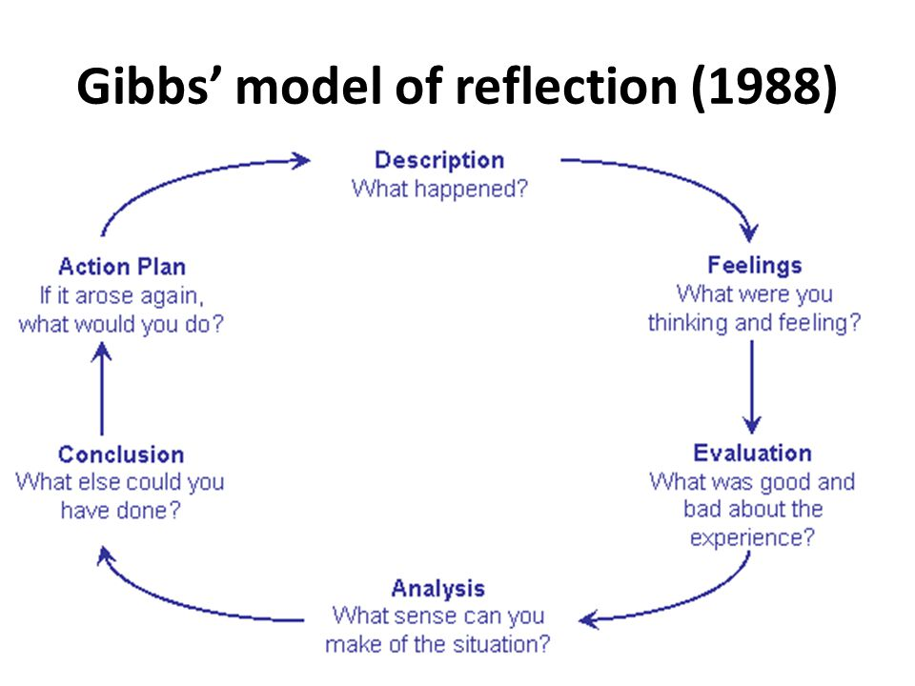

https://www.brookes.ac.uk/students/upgrade/study-skills.ref;ective-writing-gibbs/
Accessed 30th April 2019

https://counsellingtutor.com/basic-counselling-skills/clarifying-and-questions/
Accessed 29th April 2019

https://www.simplypsychology.prg/learning-kolb.html
Accessed 30th April 2019

Midwinter. R; Dickson. J. (2015) Embedding Counselling and Communication Skills, A Relational Skills Model. P.228-229 London: Routledge.

Midwinter. R; Dickson. J. (2015) Embedding Counselling and Communication Skills, A Relational Skills Model. P.13. London: Routledge.

https://www/psychologytoday.com/gb/blog/what-doesn’t-kill-us/201210/unconditional-positive-regard
Accessed 29th April 2019

https://positivepsychologyprogram.com/unconditional-positive-regard/
Accessed 29th April 2019

