UNIVERSITY OF WALES TRINITY SAINT DAVID
LONDON CAMPUS
Assignment 2
Learning in the Digital Era
Video Link: https://youtu.be/YoGs4S8n5oo

Module Name: Learning in the Digital Era
Module Code: ACCA 4025

Student Name: Swastika Sarker
Student ID:2441945
Group:1

Lecturer’s Name: Koushik Modak

Table of Contents
Introduction 2
Main Body 2
Conclusion 9
References 9

Introduction
This Assessment is structured around three major components planned to map out of clear path continuous personal and professional growth. (1) A Self-Evaluation (2) A Professional Development Plan (PDP). (3) A Summary of “Learning to Learn”.

Video Link: https://youtu.be/YoGs4S8n5oo

Slide 1 COVER PAGE
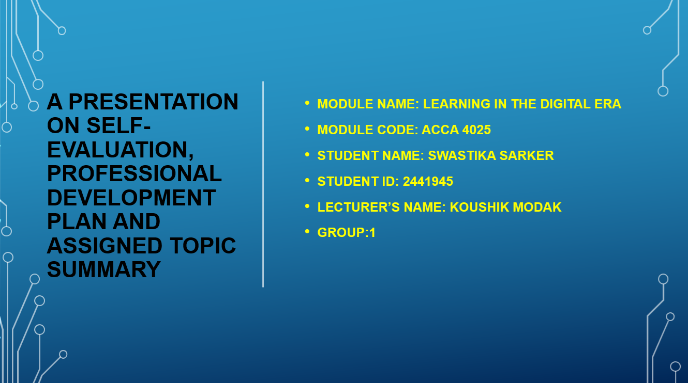

Slide 2 CONTENTS
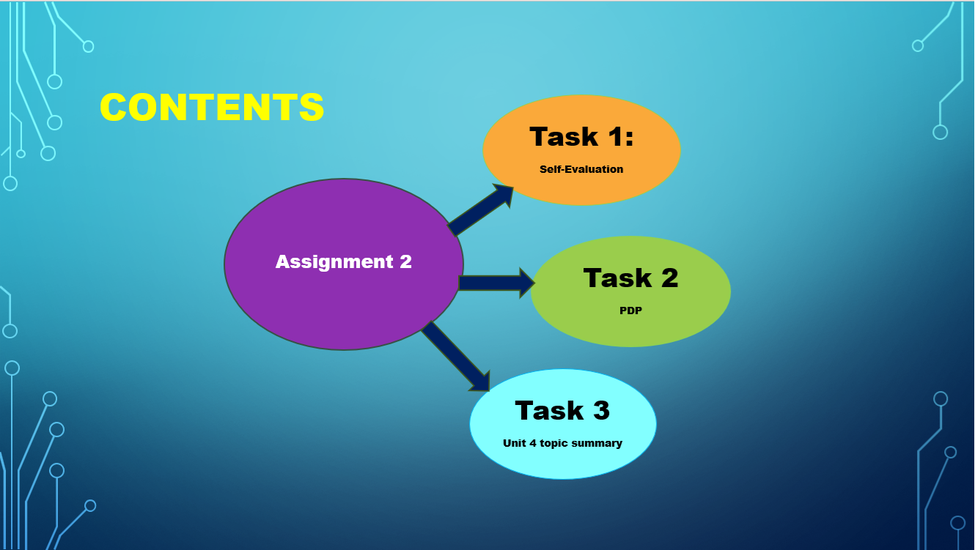

Slide 3 INTRODUCTION
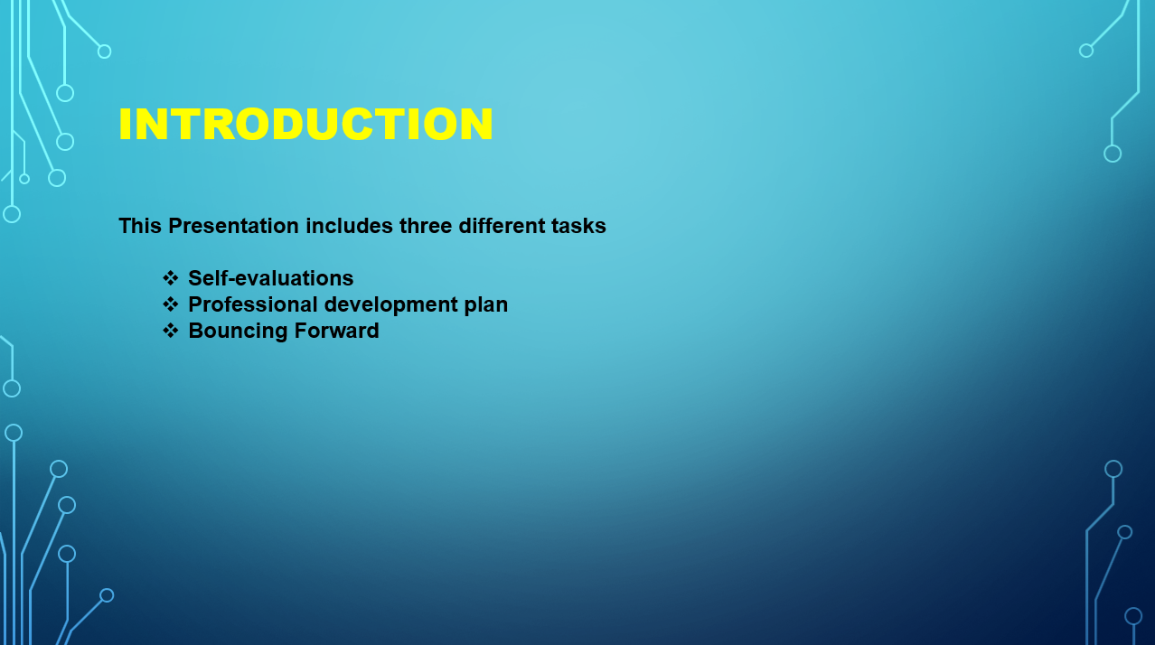

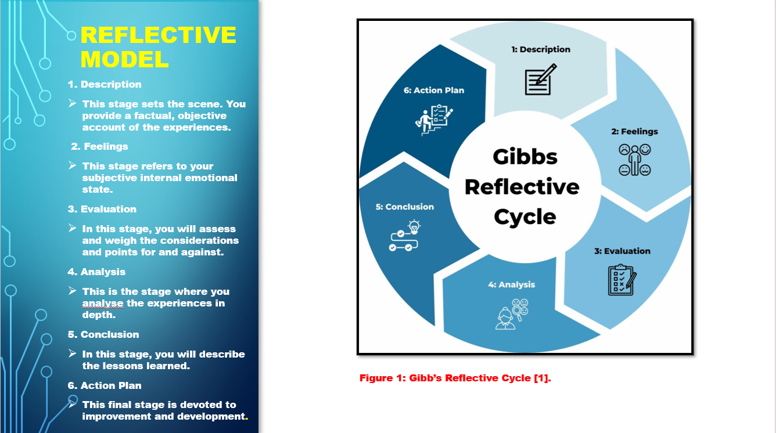
Slide 4 GIBB’s REFLECTIVE MODEL

Brief explanation:
The application of Gibbs' Reflective Model has delineated this new learning process through more distinct and rich categorizations. It began by examining what was happening and finding the stronger moments that helped lead to the entire experience. So, once I began to think about the feelings inside, I could acknowledge that I had some feelings of discomfort and the possible motivation from it. There was good, and things that disappointed me as I thought it through from evaluation, which made it more holistic. Eventually, I could think about why the situations came out that way on those tracks, and how I could use my reaction on the outcome. This would inform me of what needed to continue being done, and what should differ. Finally, in creating the action plan, I have gained actionable steps for how I could implement in similar situations ensuring that I approach similar incidents in the future more confidently and with greater awareness [1], [2].

Slide 5 TASK 1: SELF EVALUATION
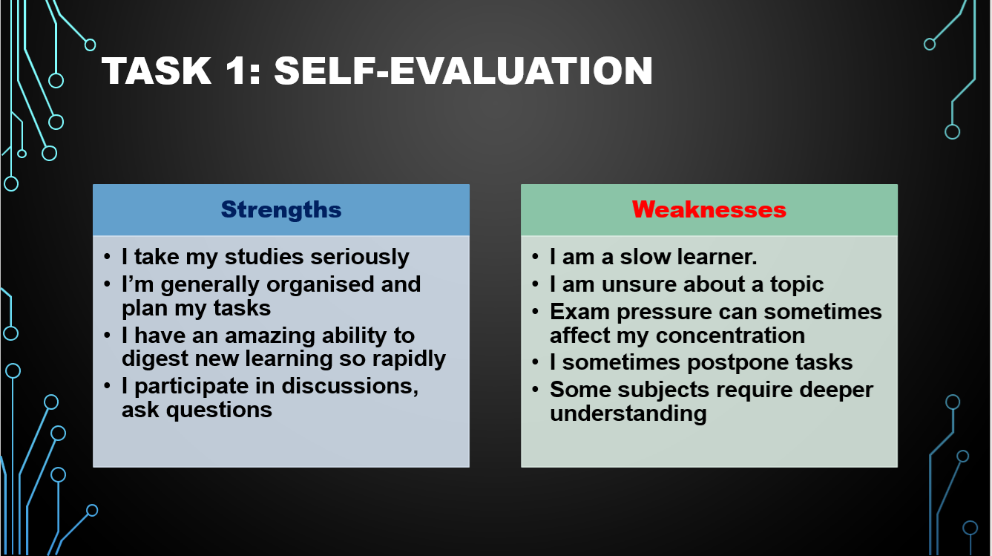

Brief explanation:
One of my greatest strengths is the self-discipline to which I contribute. I exercise responsibility in my work; I am punctual and try to concentrate and persevere in the face of learning difficulties. One of my major flaws is that I am slow to learn; I sometimes require more time to grasp new concepts. This creates tension as the deadline approaches, and I make sure to revisit what I have learned, get help from teachers and classmates, and use extra learning resources.

Slide 6 TRAITS GAINED FROM THE SELF EVALUATION

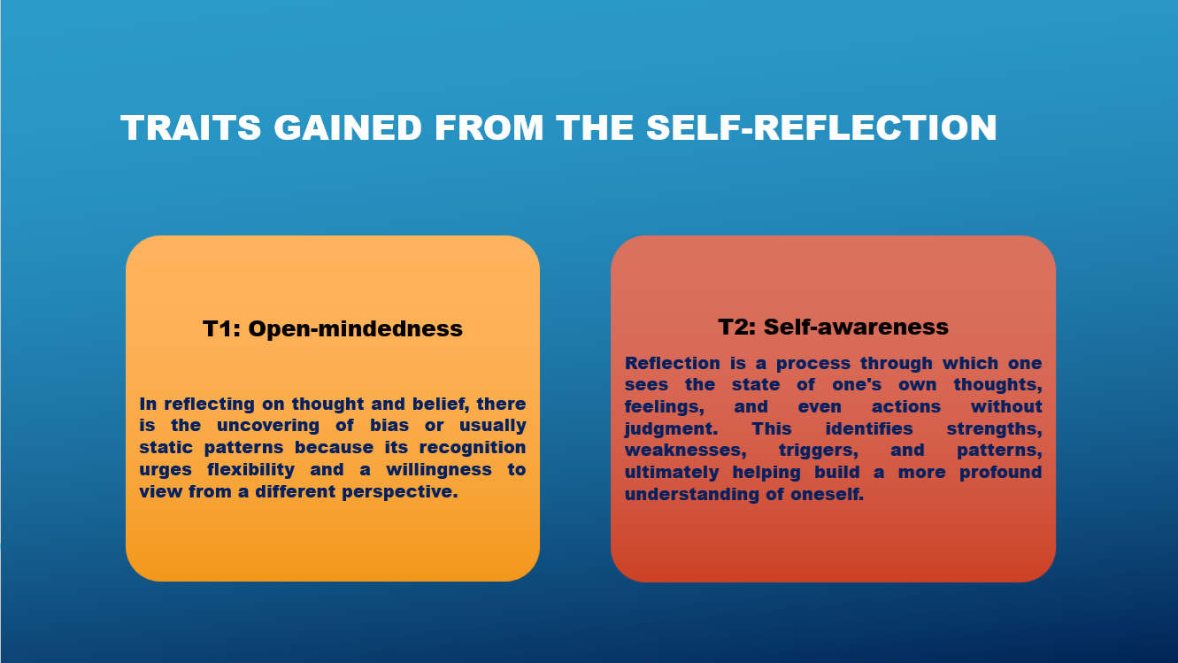

Slide 7: TASK 2: PROFESSIONAL DEVELOPMENT PLAN
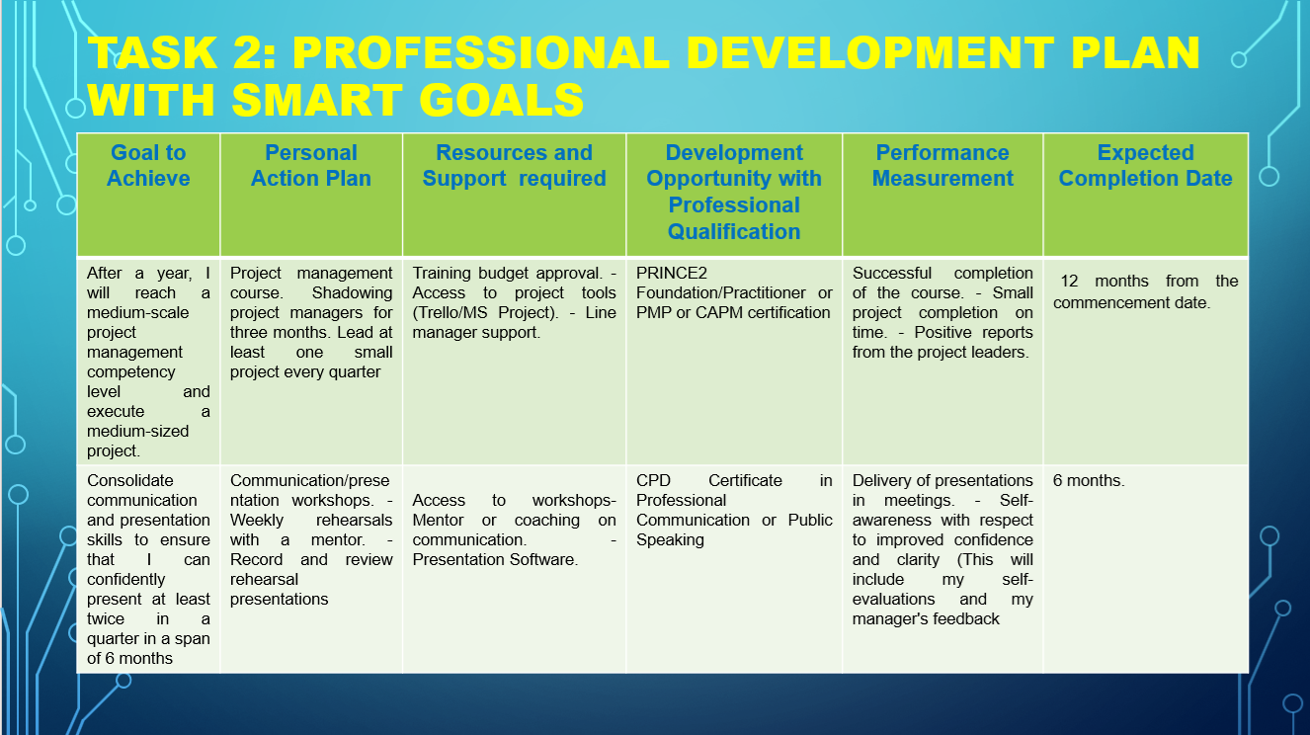

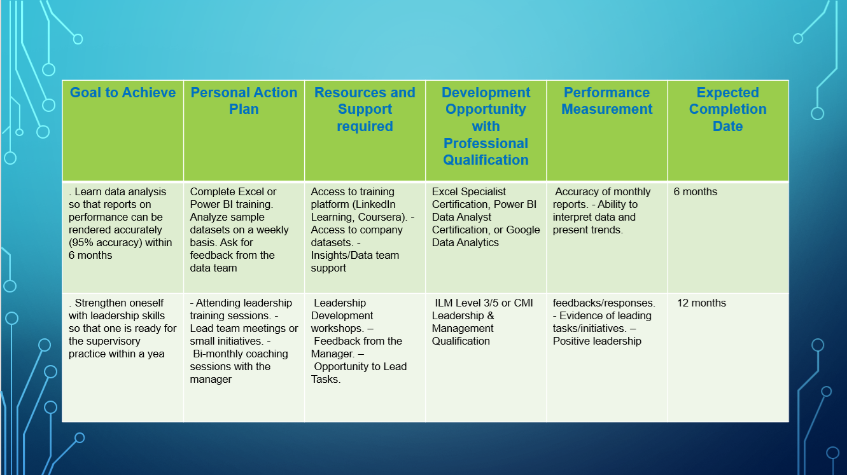

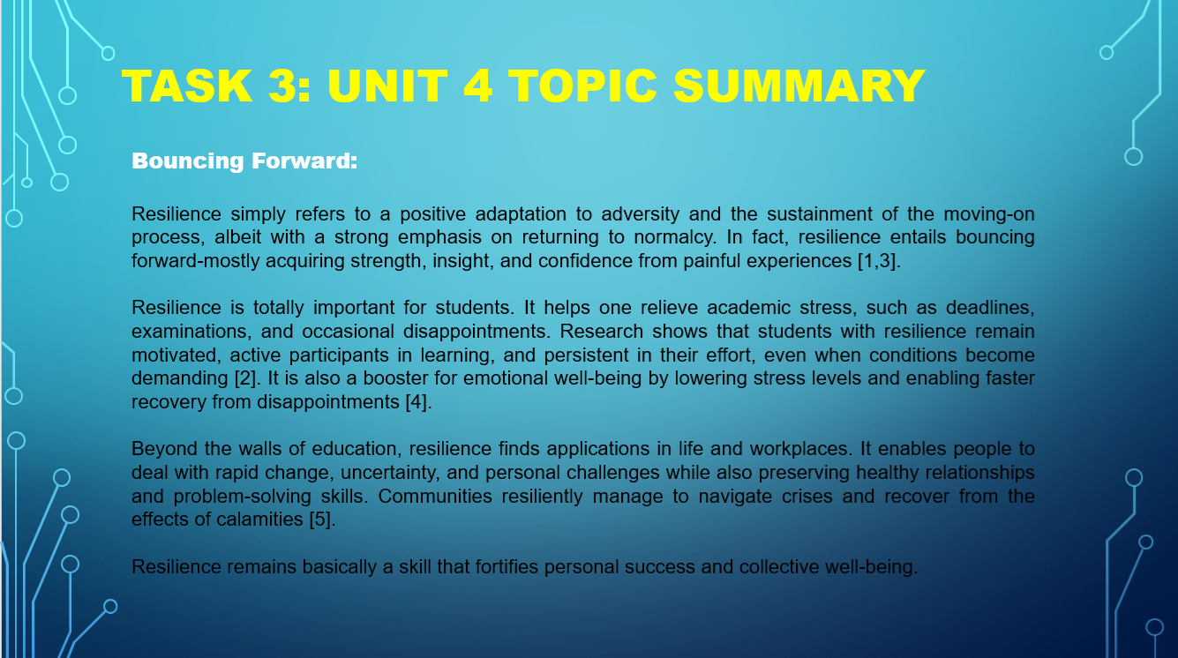
Slide 8: TASK 3: UNIT 4 TOPIC SUMMARY

Brief explanation:
Bouncing forward means coming out of adversity not just learning and getting back on track, but going forth, learning and growing. When you struggle — with school, with stress, with personal setbacks — a bounce forward motivates the mind to reflect and improve. It’s not one of suffering in defeat that is often suffered when things go to bad; a person who bounces forward is one whose look at what went wrong causes it to change track and strengthens how they approach the future. This mentality instils confidence in students, prepares them to solve problems, and keeps students motivated even when they get hard. Instead of standing in the way as obstacles, bouncing forward makes setbacks the best learning moments, the best steppingstone for success, the best way to do business — for life.

Slide 9 CONCLUSION

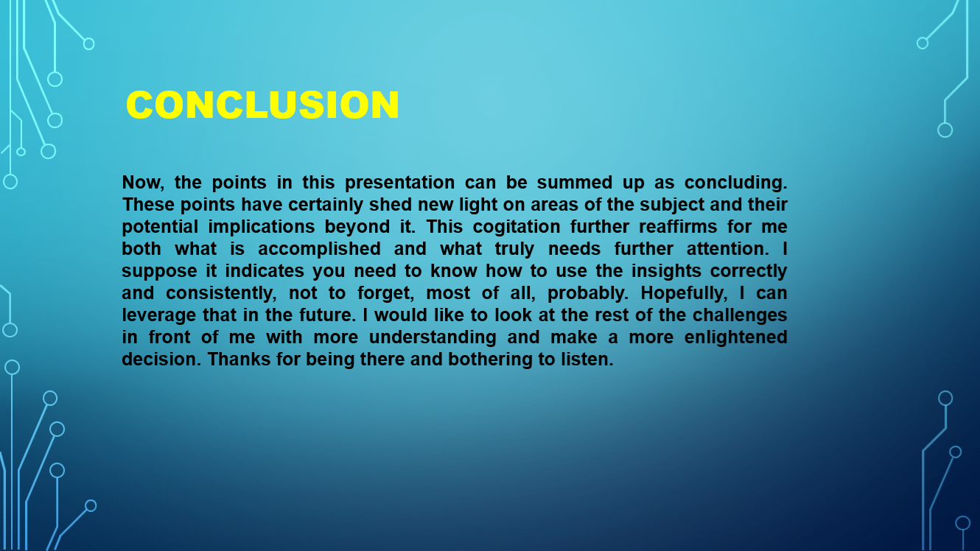

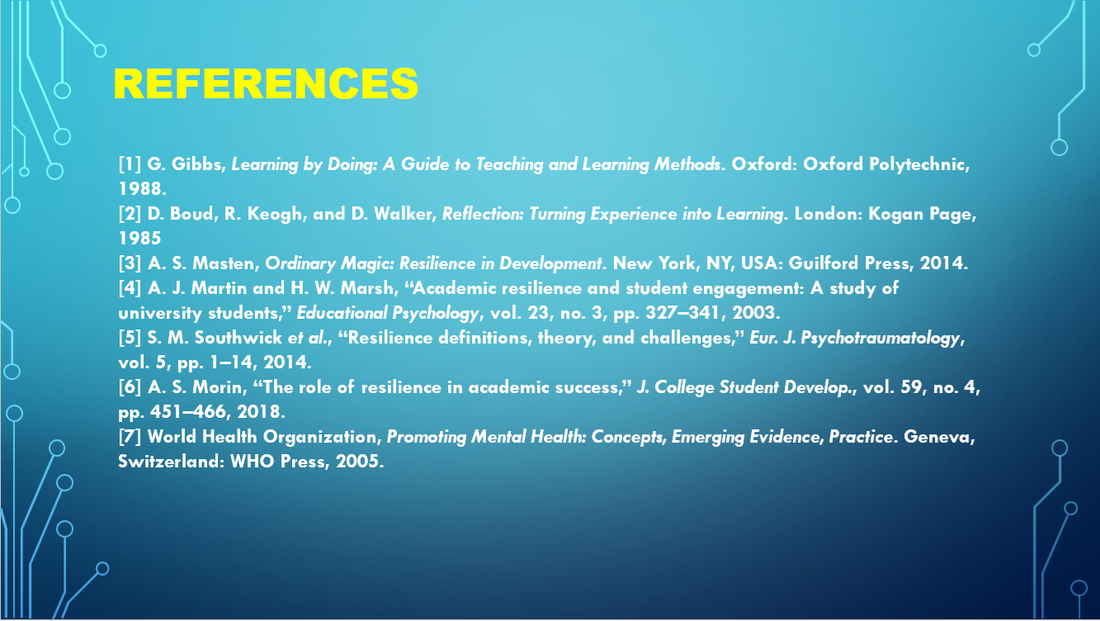
Slide 10

Conclusion
The evaluation helped me think about what I am good and bad at about those learning styles I have adopted. The development of the PDP allowed us to define specific goals and identify practical recommendations for self-improvement. The concept of bouncing forward enabled me to view obstacles and failures as learning moments, not stumbling blocks. And most importantly, this assessment made me think personally and took me closer to a self-directed growth mindset and thus, developed a head full of more positivity and resilience when it comes to my studies and future. PowerPoint is a suitable format for a presentation of clarity and visuals. It assists in organizing data in slides, images and charts. PowerPoint is more than presentation software; it is a means of understanding and sharing ideas with others. Education, business, and professional settings have generally accepted it.

References

[1] G. Gibbs, Learning by Doing: A Guide to Teaching and Learning Methods. Oxford: Oxford Polytechnic, 1988.
[2] D. Boud, R. Keogh, and D. Walker, Reflection: Turning Experience into Learning. London: Kogan Page, 1985
[3] A. S. Masten, Ordinary Magic: Resilience in Development. New York, NY, USA: Guilford Press, 2014.
[4] A. J. Martin and H. W. Marsh, “Academic resilience and student engagement: A study of university students,” Educational Psychology, vol. 23, no. 3, pp. 327–341, 2003.
[5] S. M. Southwick et al., “Resilience definitions, theory, and challenges,” Eur. J. Psychotraumatology, vol. 5, pp. 1–14, 2014.
[6] A. S. Morin, “The role of resilience in academic success,” J. College Student Develop., vol. 59, no. 4, pp. 451–466, 2018.
[7] World Health Organization, Promoting Mental Health: Concepts, Emerging Evidence, Practice. Geneva, Switzerland: WHO Press, 2005.

