Contextual Practices

Ways of Perceiving

(ADAD4010)

Tutors
Ryan L. Moule
Rob Jones
Julia Lockheart
Gwenllian Beynon
Scott Smith
Martin Bush

Samuel Evans – (1806669)
BA Creative Music Technology
1468 Words

Curation & Space

The concept of curation began originally with the Curate, a clergy member of the Catholic Church invested with the responsibility of care to the souls of the parish. The sentiment of faith, conservatism and preservation behind this concept has grown and evolved with society to encompass more than just the Church.
By modern times, curation is now seen most commonly as the responsibility of Museum and Gallery Directors charged with the duty of selection and care of objects of historical and artistic importance. The Macmillan Dictionary defines to curate as this:
“to select items from among a large number of possibilities for other people to consume and enjoy; applied to many areas including music, design, fashion, and especially digital media” (Macmillan Dictionary, n.d.)
This shows us that the concept of curation is not limited to just museums and art galleries, but also stretches through to almost every facet of modern media.
Curation in this sense can be seen as the force which guides and influences the world view of both the individual and of a society as a whole, much in the same way as the Curate of the Catholic Church, whose responsibility it is to guide and influence the members of the parish through faith and religion.
Context also plays a vital role when influencing people through curation. It can be derived from a number of circumstances, such as culture, politics and philosophy to provide a setting and meaning to an idea. The use of space in exhibitions can also provide context and change the way we perceive the curator’s ideas and intentions. Kali Tzortzi, in his paper on Spatial Concepts In Museum Theory And Practice says this:
“…the way museum layouts are used and how they function is not only about the
properties of individual spaces, but about the relations between spaces and how they affect each
other by coexisting simultaneously” (Tzortzi, 2015).

The Oppression of Dreams
  - An exhibition to highlight the oppression of ambition in the modern world.

As children we were taught to work hard in school, to get a good job, to find love and thus lead a happy, content and fulfilling life. However, as we stepped out into the wider society, we became aware of the true reality of the world, as Marjorie Joly points out in her article for The New Social Worker:
“I truly became aware of the inequality that marred the world and decided that I wanted to somehow change that reality. The big question that has haunted me since graduating is: How?” (Joly, 2017)
We live in a society that has a “lack of idealism” (Gulen, 2015), the people of today are living without a true sense of purpose and aspiration. We no longer dare to dream, a harsh world view that lacks optimism and idealism has been thrust upon us by the infrastructure of modern life, such as social media and government bureaucracy. This has oppressed any ambition for a life that is ultimately fulfilling.
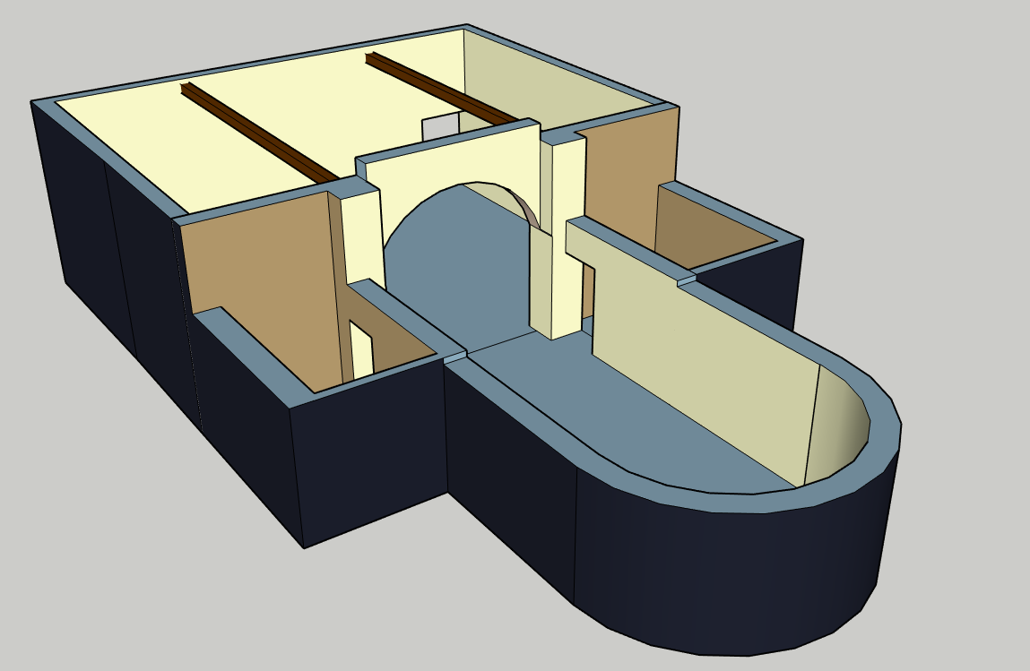
Figure 1: Model of the exhibition hall
This exhibition focuses on aspects of the infrastructure that, consciously or not, works to oppress and supress the ambitions of individuals and wider society, in order to maintain a status quo (Deutsch, 2005). This idea, posed originally by Morton Deutsch in his essay regarding oppression, aims to highlight how a superior power can use its resources to gain more “effective power” (Deutsch, 2005).
Morton Deutsch is quoted as saying:
“Effective power depends not only on the control or possession of resources to generate power but also upon the motivation to employ these resources to influence others, skill in converting these resources to usable power, and good judgment in employing this power so that its use is appropriate in type and magnitude to the situation in which is it used.” (Deutsch, 2005)
For example, Freedom House’s 2018 Freedom in the World survey concluded that the country of Turkmenistan was among the “worst of the worst” countries regarding the respect of political and civil freedoms, and is quoted as saying:
“Turkmenistan is a repressive authoritarian state where political rights and civil liberties are almost completely denied in practice.” (Freedom House, 2018)
While being regarded as the worst-case example of a superior power using its effective power to achieve and maintain it’s status quo, it is far from the only instance of this occurring in the modern world. Transparency International’s 2017 public opinion survey highlights that in the US:
“44 per cent of Americans believe that corruption is pervasive in the White House, up from 36 per cent in 2016” and “Almost 7 out of 10 people believe the government is failing to fight corruption, up from half in 2016” (Transparency International, 2017).
The exhibition deals with 5 different aspects of oppression today, namely the oppression of minorities, women, the crippling effects of debt, war and ignorance.
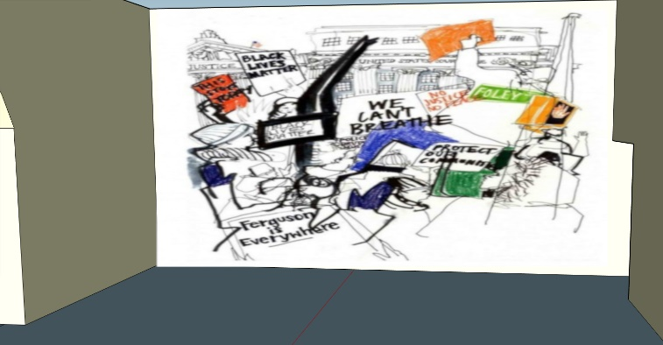
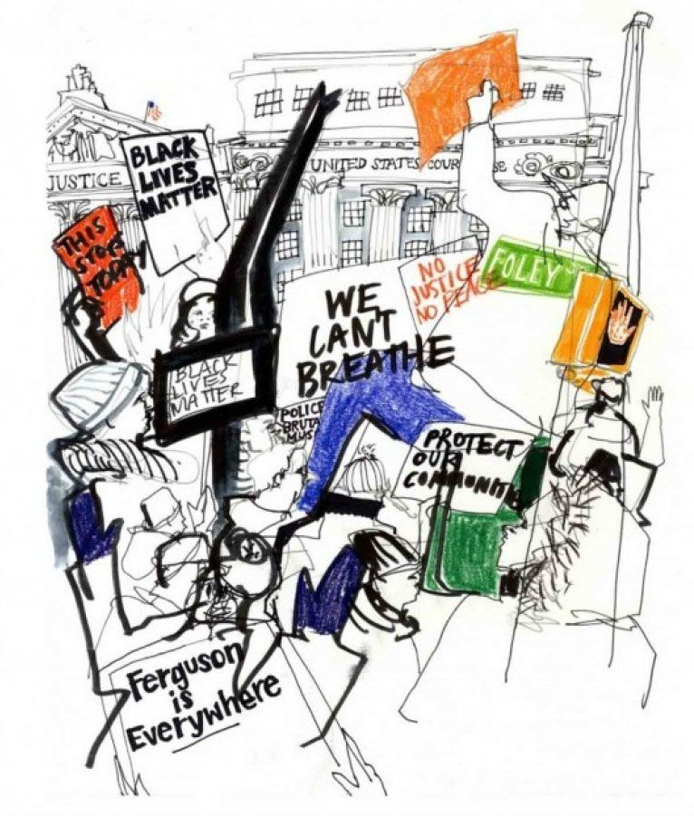
The first piece of the exhibition entitled Protestors in Foley Square in front of the United States Court House (2015), by artist Carly Larsson depicts at face value a protest in motion, supporting the rights and protections of black minorities in America. Its central theme revolves around the Black Lives Matter movement, an organization dedicated to protecting “freedom & justice for all Black Lives” (Black Lives Matter, 2013) and exposing corruption in police forces and the judiciary system across the US and internationally. On December 4th, 2014 after a grand jury failed to indict an NYPD officer over the killing of Eric Garner, Carly attended the Millions March Protest to create this “reportage illustration” (Larsson, 2014). She is quoted as saying:
Figure 2: Left Wall - Protestors in Foley Square in front of the United States Court House by Carly Larsson (2015)
Figure 3: Protestors in Foley Square in front of the United States Court House by Carly Larsson (2015)
“In addition to the hundreds of cops on the streets, there were hundreds more in vans following the protestors. It seemed like overkill for such a peaceful protest, and I definitely noticed that many of the cops were treating bystanders/commuters (and us, with our sketchbooks) with more respect than they showed the protestors.”
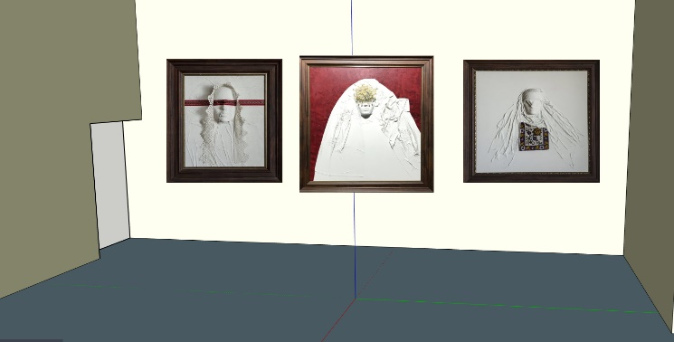
The second installation, which consists of three artworks, entitled Consciousness: Past and Present by artist Shqipe Kamberi, focuses around the oppression of women living in patriarchal societies around the world. The women displayed in the pieces are brides, and “represent someone without an identity” (Miftari, 2017). Kamberi is quoted as saying: “I have referred a lot to the Kanuni as it specifically has articles which indicate that women have absolutely no rights.”
Figure 4: Right Wall - Consciousness: Past and Present by Shiqpe Kamberi (2017)

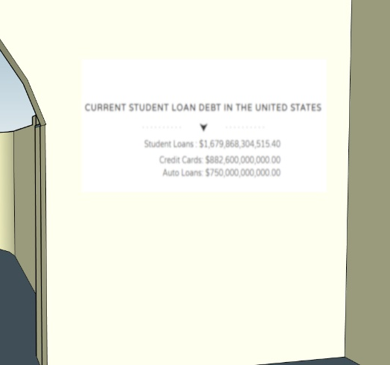
The third piece brings focus onto the oppressive nature of debt and consists of a projection of a live feed of the US Student Debt clock (collegedebt.com, n.d.). This is used to highlight that, due to financial restrictions, the ambitions, goals and ideas of millions of people (National Centre for Education Statistics, 2018) are by definition oppressed, simply by a lack of funds to achieve these ambitions.
Figure 5: Right Half Archway - Live projection of the US Student Debt Clock

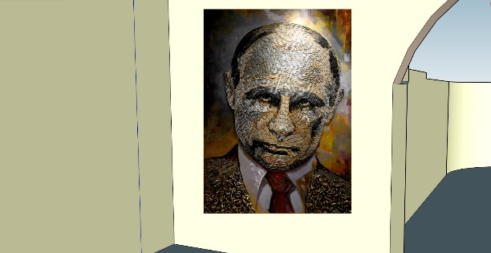
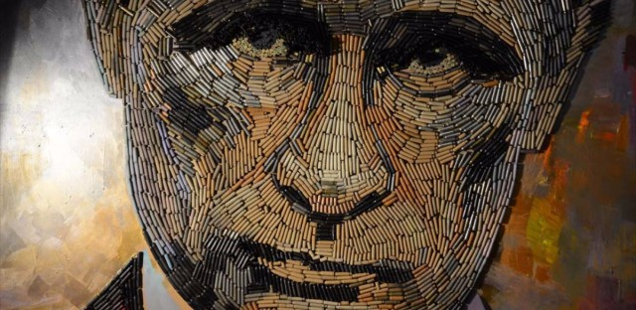
The fourth piece focuses on the most obvious and brutal form of oppression, war. The piece, entitled The Face of War by Ukrainian artists Daria Marchenko and Daniel Green, is a seven foot high portrait of Russian president Vladimir Putin, containing “5,000 bullet casings collected from the battlefront in Donbass, Ukraine” (Guse, 2018). Putin, among other politicians, has become infamous in recent years for his stance on using his effective power and resources in war, propaganda and voyeurism to achieve his own goals and ambitions, at the expense of others. This worrying trend can also be seen in other democracies across the world, such as the US president Donald Trump’s stance on immigration (Centre For Migration Studies, 2017) and the UK governments controversial stance on privacy (UK Government, 2016).
Figure 6: Left Half Archway - The Face of War by Daria Marchenko & Daniel Green (2018)
Figure 7: The Face of War by Daria Marchenko & Daniel Green (2018)

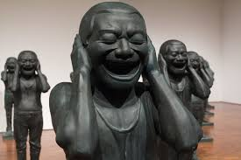
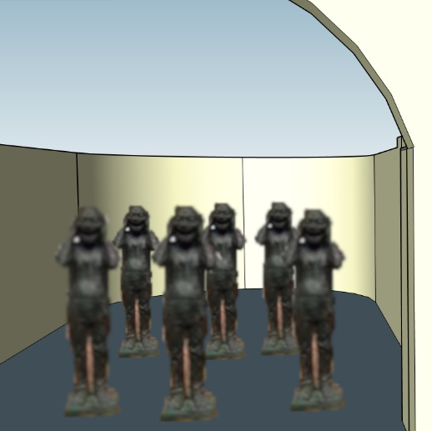
The fifth and final installation of this exhibition consists of Minjun Yue’s Chinese Contemporary Warriors, a piece consisting of 27 grinning terracotta warriors. Yue is quoted as saying: “A smile doesn’t necessarily mean happiness; it could be something else.” In this context, with hands clasped over their ears, the warriors represent the compliant, “Mindlessly happy in their uniformity, the compliant citizens of this absurd army recall the famed terra-cotta warriors from Xian. Rather than the serious visages of the warriors, however, these figures convey ‘see no evil, hear no evil, speak no evil.” (Garrison, 2011)
Figure 8: Centre Hall - Chinese Contemporary Warriors by Minjun Yue (2011)

Figure 9: Chinese Contemporary Warriors by Minjun Yue (2011)
In conclusion, this exhibition attempts to convey that there are numerous oppressive forces at work in the world today, stamping out our own goals and ambitions in order to replace them with their own. Be it government and police, debt, war or even our own ignorance there is seemingly no escape from it, to quote Marjorie Joly:
“How can I work to change a system that is defective by design? How can people of color take control of, and protect, their bodies in a system that seeks to strip them of their agency? These are ambitious, and at times seemingly impossible, tasks. But the answer was obvious - at least I thought it was.” (Joly, 2017)

Bibliography
Macmillan Dictionary, n.d. Macmillan Dictionary - Curate. [Online]
Available at: https://www.macmillandictionary.com/dictionary/british/curate_2
Tzortzi, K., 2015. Spatial concepts in museum theory and practice. Proceedings of the 10th International Space Syntax Symposium, p. 2.
Joly, M., 2017. The Fight Between Ambition and Reality. The New Social Worker, p. 1.
Gulen, F., 2015. Building a society of noble ideals. Fountain Magazine, June.
Deutsch, M., 2005. Maintaining Oppression. Beyond Intractability.
Freedom House, 2018. Freedom In The World 2018, s.l.: Freedom House.
Transparency International, 2017. Corruption In The USA: The Difference A Year Makes, s.l.: Transparency International.
Black Lives Matter, 2013. Herstory. [Online]
Available at: https://blacklivesmatter.com/about/herstory/
Larsson, C., 2014. Carly Larsson. [Online]
Available at: http://carlylarsson.com/blog/12/5/ericgarnerprotest
Miftari, N., 2017. "Consiousness: Past and Present" - The Oppression of Women, by artist Shqipe Kamberi. Creating Rights, December.
collegedebt.com, n.d. College Debt Clock. [Online]
Available at: http://collegedebt.com/
National Centre for Education Statistics, 2018. College and University Education Enrollment 2018-2027, s.l.: s.n.
Guse, C., 2018. A massive portrait of Putin made out of bullet shells from Ukraine is on view in NYC. TimeOut, January.
Centre For Migration Studies, 2017. President Trump's Executive Orders On Immigration And Refugees, New York: Centre For Migration Studies.
UK Government, 2016. Investigatory Powers Act 2016. [Online]
Available at: http://www.legislation.gov.uk/ukpga/2016/25/contents/enacted
Garrison, L. A., 2011. Milwaukee Art Museum’s Grinning Chinese Warriors. Urban Milwaukee, July.

Kanuni - A set of traditional Albanian laws

