
Digital Skills and Research Methods (BMSW4003_CARD)
ASSESSMENT TWO – Individual Report

March 31, 2023
simona marilena patrascu
Student number- 2123259

Contents
1.0 Log-in Weebly details 2
2.0 Importance of Primary or Market Research 3
2.1 Identify Customer Needs 3
2.2 Understand the Market 3
2.3 Reduce Business Risks 4
2.4 Improve Customer Satisfaction 4
2.5 Make Informed Decisions 4
2.6 Plan marketing strategies 5
3.0 Analysis of Questionnaire Data 6
4.0 Webpage and Rationale 10
5.0 Importance of SEO 13
5.1 How Primary Research Informs the SEO Strategy 13
6.0 References 15

1.0 Log-in Weebly details
Username: iliesimona1989@gmail.com
Password: SIMONA123456

2.0 Importance of Primary or Market Research
The act of gathering information directly from consumers or potential customers in order to better understand their requirements, interests, and behaviors is referred to as primary research, also known as market research (Seo et al., 2021). Primary research can take many forms, including surveys, focus groups, interviews, and observation. The importance of primary research for businesses cannot be overstated, as it provides a wealth of valuable information that can be used to inform product development, marketing strategies, and overall business decision-making.

2.1 Identify Customer Needs
Primary research helps businesses to identify the needs and preferences of their customers. By conducting surveys or interviews, businesses can collect information about what their customers are looking for, what features they prioritize in a product, and how much they are willing to pay for it. This knowledge may assist companies in creating goods and services that cater to the demands of their clients, which can enhance revenue and client retention. In order to match client requirements and maintain market competitiveness, firms might utilize this information to create new goods or enhance current ones.

2.2 Understand the Market
Primary research provides businesses with a better understanding of the market they operate in. By conducting market research, businesses can identify their target audience and learn about their competitors (Lim et al., 2020). This information can help businesses to create effective marketing strategies, positioning their products or services in a way that stands out from the competition. This can help businesses identify potential issues or areas for improvement, and make adjustments before investing significant time and resources into product development.

2.3 Reduce Business Risks
By conducting primary research, businesses can reduce their risks when launching new products or services. Businesses may avoid investing in goods or services that really are unlikely to succeed by knowing the demands and preferences of their consumers. This information can also help businesses to refine their products or services before launching them, reducing the likelihood of failure.

2.4 Improve Customer Satisfaction
Primary research helps businesses to improve customer satisfaction by providing them with the information they need to create products and services that meet their customers' needs. By creating products that meet their customers' needs, businesses can improve customer satisfaction and increase customer loyalty. This can lead to repeat business, positive reviews, and referrals.

2.5 Make Informed Decisions
Businesses receive the data they require to make educated decisions through primary research. Businesses may decide on product development, marketing, as well as pricing in an educated manner by gathering data about their consumers' requirements and preferences (Gavrilets et al., 2020). As a result, companies may be better able to keep one step ahead of their rivals but also make tactical choices that will increase their revenue.

2.6 Plan marketing strategies
Primary research can also be used to inform marketing strategies, such as identifying target audiences, determining the most effective channels for reaching them and developing messaging that resonates with them.
In conclusion, primary research is crucial for companies who wish to remain competitive and satisfy their client's expectations (Pinheiro et al., 2021). Businesses may produce better products, more effective marketing campaigns, and overall business strategies by using the valuable information that customers' requirements, preferences, and behavior provide.

3.0 Analysis of Questionnaire Data
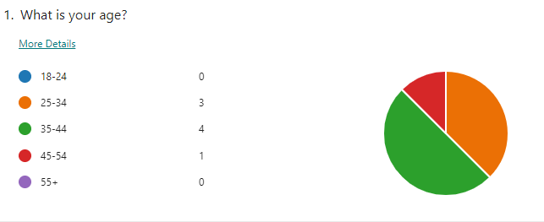
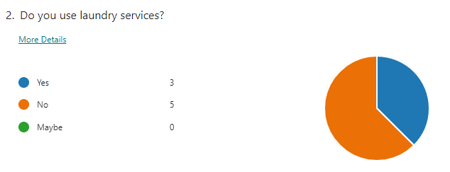
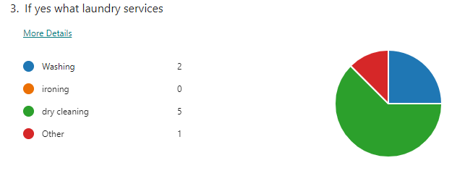
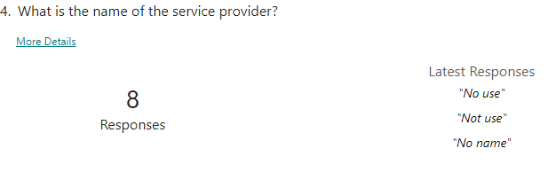
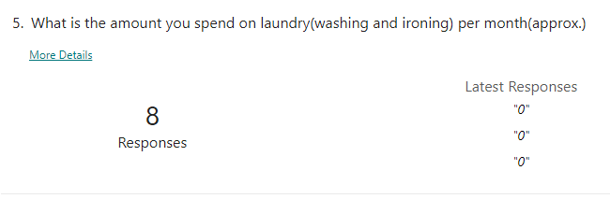
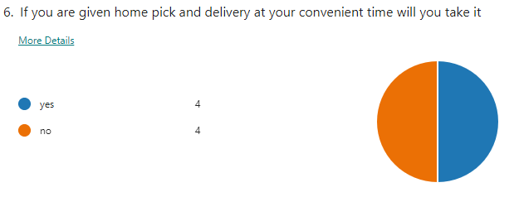
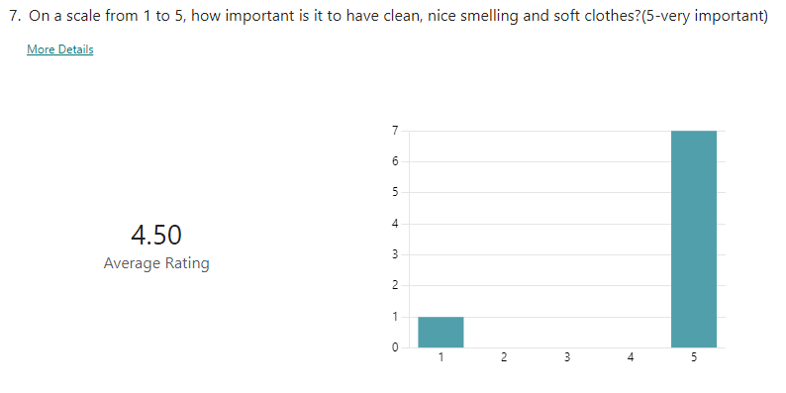
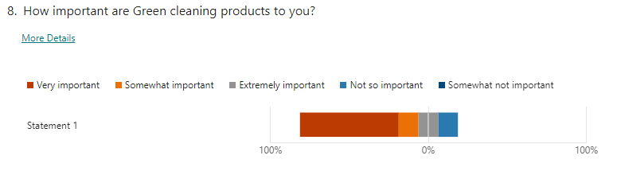


By offering insights into the requirements, tastes, and behaviors of customers, the survey results can have a substantial influence on a company proposal (Haira et al., 2022). Here are some ways the findings can influence a business idea:
Identify Customer Needs: The questionnaire data can help identify customer needs and preferences regarding laundry/ironing services. By understanding what factors influence their decision to use a laundry/ironing service, what features they expect, and how much they are willing to pay, a business can tailor its services to meet those needs.
Improve Service Quality: The data can also be used to evaluate customer satisfaction with current laundry/ironing services. By analyzing feedback, businesses can identify areas for improvement, such as faster turnaround times, better quality control, or more flexible delivery options.
Develop Marketing Strategies: The questionnaire data can also inform marketing strategies, such as identifying the target audience and developing messaging that resonates with them. For example, if the data shows that customers value freshness and cleanliness, the business can emphasize those qualities in its marketing.
Price Optimization: The data can also be used to optimize pricing strategies by understanding how much customers are willing to pay for laundry/ironing services. By pricing services competitively and offering discounts or loyalty programs, a business can attract and retain customers.
Online Platform Development: If customers are comfortable with using an online platform to place orders, the business can develop a user-friendly platform that allows customers to place orders easily and efficiently. By making the ordering process simple and straightforward, businesses can improve customer satisfaction and retention.
In summary, the questionnaire data can provide valuable insights that can inform a business idea, from identifying customer needs and preferences to optimizing pricing and developing marketing strategies (Jabeen et al., 2022). By leveraging this data, businesses can improve their services, attract and retain customers, and ultimately increase revenue and profitability.

4.0 Webpage and Rationale




Based on the questionnaire data provided and the website design linked, here is the rationale for how the data influenced the website design, including color theory:
Color Choice: The majority of respondents indicated that cleanliness and freshness were important factors in their decision to use a laundry/ironing service. Based on this finding, shades of blue and green were chosen for the website's color scheme as they are associated with cleanliness, freshness, and calmness.
Clear Pricing Information: The data showed that price was an important factor for customers in choosing a laundry/ironing service. To address this, the website prominently displays pricing information for the different services offered. The pricing page is easy to navigate, and customers can easily understand what services they are paying for.
Features and Services: The questionnaire data indicated that customers expected certain features from a laundry/ironing service, such as fast turnaround times and quality control. The website design reflects this by highlighting these features and providing clear information on how the business delivers on these expectations.
Online Platform Development: The questionnaire data also revealed that customers were comfortable with using an online platform to place orders. The website design, therefore, features an easy-to-use online ordering system that customers can use to place orders quickly and efficiently.
The questionnaire data influenced the website design in several ways, including the color scheme, pricing information, highlighting features and services, and the development of an online ordering platform. By incorporating the findings from the questionnaire data into the website design, the business can improve customer satisfaction, attract and retain customers, and ultimately increase revenue and profitability (Lim and Seo, 2019).

5.0 Importance of SEO
The technique of improving a website or webpage so that it appears higher on “search engine results pages (SERPs)” for pertinent keywords and phrases is known as search engine optimization (SEO). For businesses to enhance their website's organic traffic, exposure, and eventually revenue, SEO is crucial. In this talk, we will examine the significance of SEO as well as the way SEO strategy is influenced by primary research.
“The Importance of SEO”
Organic Traffic: Businesses may drive “organic traffic” with the use of SEO. Visitors that arrive at your website over search engine outcomes pages are referred to as organic traffic (SERPs) (Lazo-Amado et al., 2021). It is more likely that your website will rank higher in search engine results pages (SERPs) and draw more organic traffic if you optimize it for suitable keywords and phrases.
Increased Visibility: SEO helps increase the visibility of your website. Your website gains increased visibility to potential buyers when it appears on the top page of SERPs for pertinent keywords and phrases. More clicks result from greater visibility, which in turn increases revenue.
“Cost-Effective”: Compared to other internet marketing strategies like pay-per-click (PPC) advertising, SEO is a more economical marketing tactic. As SEO does not charge for clicks or impressions, it is ultimately a more cost-effective marketing tactic.

5.1 How Primary Research Informs the SEO Strategy
Primary research involves gathering information directly from your target audience through surveys, interviews, and other data collection methods (Romanova et al., 2021). Primary research helps businesses understand their target audience's needs, preferences, and behaviors, which, in turn, informs their SEO strategy. Below are some ways primary research informing the SEO strategy:
Keyword Research: Businesses may find the key phrases that their target market uses to search for goods and services online by doing primary research. With the aid of this information, businesses can better tailor the content of their websites to include pertinent keywords and phrases, raising the possibility that their websites will rank higher in SERPs.

6.0 References
Gavrilets, O., Chuchka, I. and Gajdoš, M., 2020. Management of the hotel industry enterprises competitiveness on the basis of digital technologies and marketing.
Haira, D., Sari, R.N. and Indrawati, N., 2022. The Importance of Social Entrepreneurship Orientation and Social Salience on Hospital Performance: The Mediating Role of Business Planning. Journal of Accounting and Strategic Finance, 5(1), pp.40-65.
Jabeen, F., Belas, J., Santoro, G. and Alam, G.M., 2022. The role of open innovation in fostering SMEs’ business model innovation during the COVID-19 pandemic. Journal of Knowledge Management, (ahead-of-print).
Lazo-Amado, M., Cueva-Ruiz, L. and Andrade-Arenas, L., 2021. e-Business Model to Optimise Sales through Digital Marketing in a Peruvian Company. International Journal of Advanced Computer Science and Applications, 12(11).
Lim, C.G., Lee, S.Y. and Seo, J., 2020. The signaling effect of ambidexterity of social enterprises on acquiring financial resources in South Korea. Annals of Public and Cooperative Economics, 91(4), pp.633-647.
Lim, H.W. and Seo, D.S., 2019. A Study on BMS by BDS for Distribution-Business: Business Model System by Buyer's Decision Step. Journal of Distribution Science, 17(4), pp.27-32.
Pinheiro, P., Daniel, A. and Moreira, A., 2021. Social enterprise performance: the role of market and social entrepreneurship orientations. VOLUNTAS: International Journal of Voluntary and Nonprofit Organizations, 32(1), pp.45-60.
Romanova, S., Maryanova, S. and Naumov, A., 2021, November. Analysis of the Key Financial Factors Affecting the Profitability of Enterprises in the Context of the Digitalization of the Economy. In Second Conference on Sustainable Development: Industrial Future of Territories (IFT 2021) (pp. 260-265). Atlantis Press.
Seo, H.S. and Kim, Y., 2020. Intangible assets investment and firms’ performance: Evidence from small and medium-sized enterprises in Korea. Journal of Business Economics and Management, 21(2), pp.421-445.
Seo, K., Woo, L., Mun, S.G. and Soh, J., 2021. The asset-light business model and firm performance in complex and dynamic environments: The dynamic capabilities view. Tourism Management, 85, p.104311.

