Dynamic Stress & Strain Investigation, Using Projectile Penetration On An Armour Plate.



Module: Physics
Module Code: ACDB 4007
By: Kieran Wusthoff
Table of Contents
Introduction 3
Methodology 4
Results 6
Images of Results: 850m/s 7
Images of results: 1000m/s 8
Discussion / evaluation 9
Conclusion 9
Bibliography 10
Appendix 10

Introduction
In this report the subject has investigated the shear stress and tensile stress that takes place on an armoured plate from penetration of a projectile. To carry out this experiment they digitally modelled a projectile and an armour plate. Then they ran the simulation and analysed the stress and tensile stress that takes place. Through research, the properties of aluminium demonstrate the values shown in the software. This created a material that simulates the behaviours of aluminium. Then they carried out the same research for my projectile. In this case, they would use the properties of copper, which creates a material that stimulates behaviours of copper.
The software used for this experiment is Abaqus. Abaqus is a software created by Dassault systems. This allows the user to create, edit, and analyse models [1]. By correctly inputting the data the user can also obtain visual results by then running the simulation. Abaqus’s qualities, capabilities and ease of use makes it the best software for the experiment.
Shear stress is the process of parallel layers sliding past each other is known as shearing. When an external force acts on an object, it undergoes deformation. If the direction of the force is parallel to the plane of the object, the deformation will be along that plane. The stress experienced by the object here is shear stress or tangential stress.
Shear stress can be calculated as follows: $τ=F/A$ where τ is the shear stress F is the force applied and A is the area of cross-section [2].
Tensile stress is the resistance of an object to a force that could tear it apart. It can be defined as the magnitude of force applied along an elastic rod, which is divided by the cross-sectional area of the rod in a direction perpendicular to the applied force. Tensile means the material is under tension and that there are forces acting on it trying to stretch the material.
Tensile stress uses the same formula as shear stress [3].
The Johnson’s Cook model is a “consistent and reasonable characterization of the material behaviour under the coupled effects of strain, strain rate and temperature on the material” [4]. Furthermore, the Johnson-Cook flow stress model adopts the modelling and predictions of material flow at elevated temperatures. To accurately simulate how materials act during simulation runs, we must follow Cook’s values.

Methodology
As stated in the introduction, the subject would be using the software Abaqus to create and run the simulation of a projectile penetrating an armour plate. Firstly, the subject consists of two parts. The first part they create is the projectile. The projectile in question is a 7.62mm. By carrying out research for dimensions of a 7.62mm projectile they can input these into Abaqus. The measurements for the 7.62mm projectile are as follows: A length of 32mm and a diameter of 7.62mm [5]. The part is named “7.62 projectile” and it’s a Solid 3D Deformable shape with a revolution of 360º. Following this, there is now a shape that represents a 7.62mm projectile. Appendix 1.
Next the subject creates the aluminium plate. The aluminium plate has dimensions 300mm x 300mm x 25mm. It is also a Solid 3D Deformable shape however it is an extrusion (rather than revolution) of 300mm. The subject selected these dimensions as they thought it would be best suited to a 7.62mm projectile. Appendix 2
Now that they have created the shape for both the projectile and the plate, they must add the material properties. By doing this they can make the models behave as they should in the simulation. The properties for the 7.62 can be seen in appendix 3. The properties for the aluminium plate can be seen in appendix 4.
Now that they have created the projectile and plate, they can create the corresponding sections. Once all section has been completed, they select the assemble module. This is where they alter the X, Y, Z coordinates so that the projectile is penetrating the centre of the aluminium plate at the correct starting point. Next, they go on to the step module. This is where they select dynamic explicit. From there they then enter the time for the simulation to run. For example, 1e-03 (0.001s).
Next, they move onto the load module. This is where they select the initial velocity and the direction in which the projectile is traveling. By selecting ENCASTRE they can restrain the edge faces of the plate. The plate will have no movement or rotation.
The next step is to mesh. They do this by selecting the MESH module. By starting with the projectile, they can apply the appropriate mesh and assign finite elements to that mesh. Next, they mesh the plate. Meshing the plate is the same process as meshing the projectile. Now that the mesh has been set the user has got to define contact between the plate and the projectile. They do this by going onto the INTERACTION module. This is to define the contact between the two surfaces. One surface is the projectile. However, to create the surface of the plate they have got to set nodes. This is the selection of the plate where the projectile might pass through. To create the nodes, they have got to stay in the MESH module. To create the contact, they go back onto the INTERACTION module. Here they select the surfaces and how they want the materials to react with each other upon penetration.
Finally, they move onto the LOAD module. By creating and naming their job they can submit their job for simulation. This can take some time especially if an error occurs. After approximately 3 – 5 mins the simulation runs smoothly without any errors showing a copper projectile penetrating an armoured plate.
In this simulation they carried out three tests. The main change was the projectiles velocity. The velocity’s that were test are as follows; v = 325m/s, v = 850 m/s, v = 1000m/s. They selected 325m/s which is just a little slower than the speed of sound. They selected 850m/s as that the actual muzzle speed of a 7.62mm projectile [6]. This would show the results that would most likely occur with a 7.62mm projectile. The speed of 1000m/s was selected as its close to Mach 2.9.

Results
The following images show the tensile and sheer stress’s that occurred at the three different speeds: v = 325m/s, v = 850m/s, 1000m/s

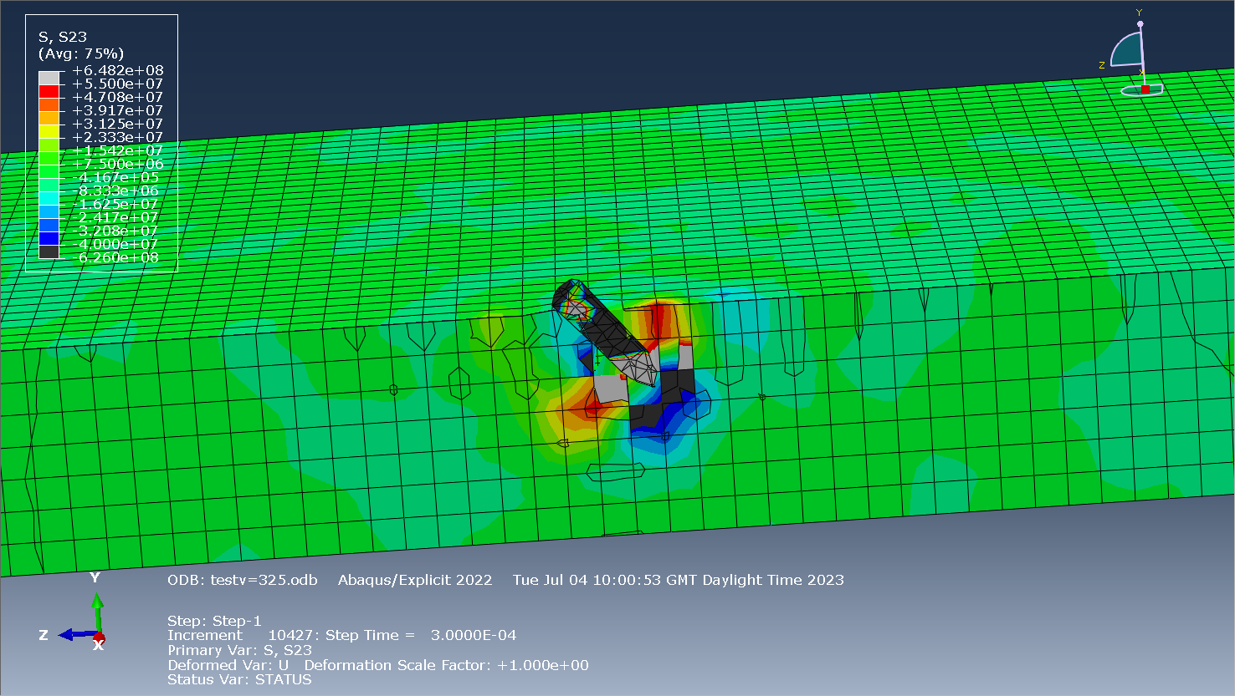
Figure 1 Sheer Stress at 325m/s
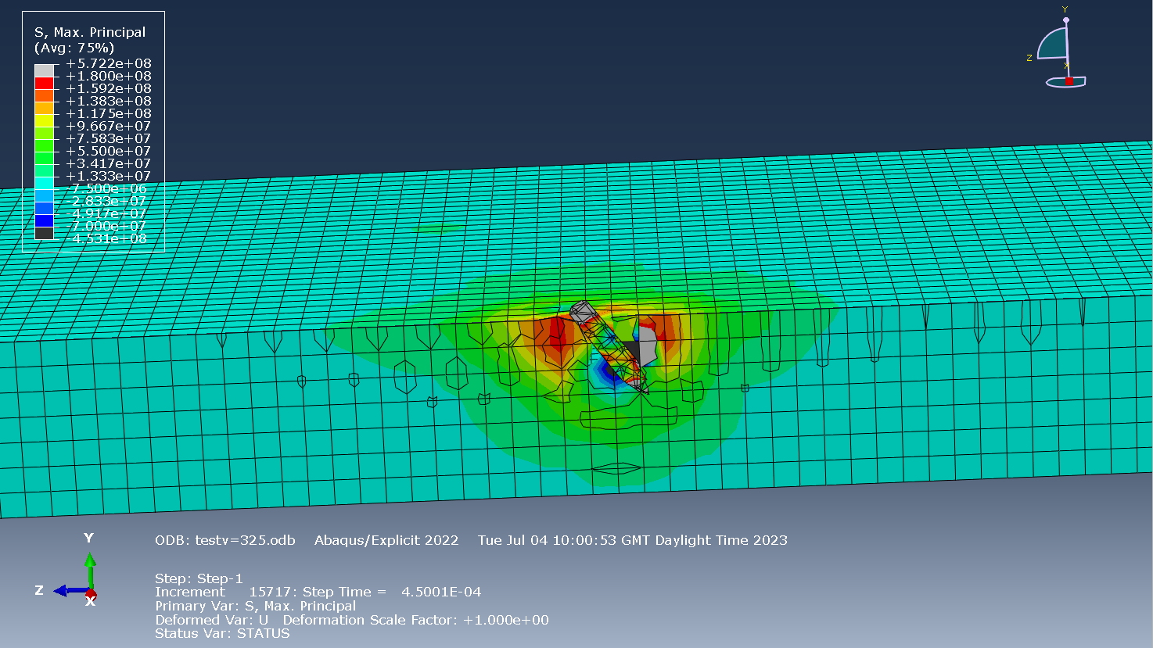
Figure 2 Tensile Stress at 325m/s
Figure 1 Shows the sheer stress of the projectile and the plate. Where the velocity is v = 325m/s. Figure 2 shows the max tensile stress that took place. The grey sections indicate where the stresses are at their highest. Blue and black indicates where they are at their lowest.

Images of Results: 850m/s

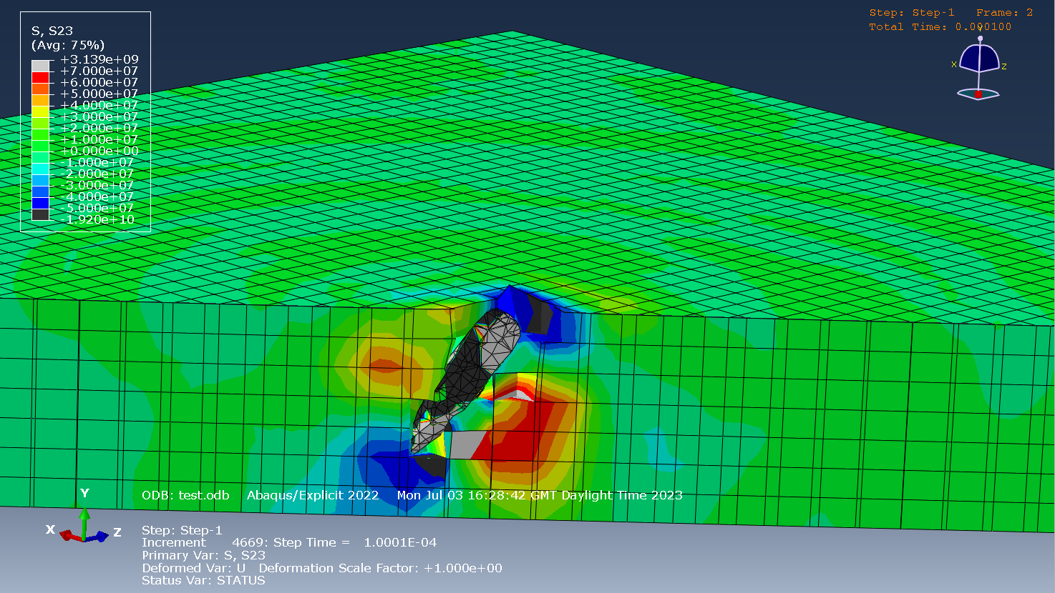
Figure 3: Sheer Stress at 850m/s

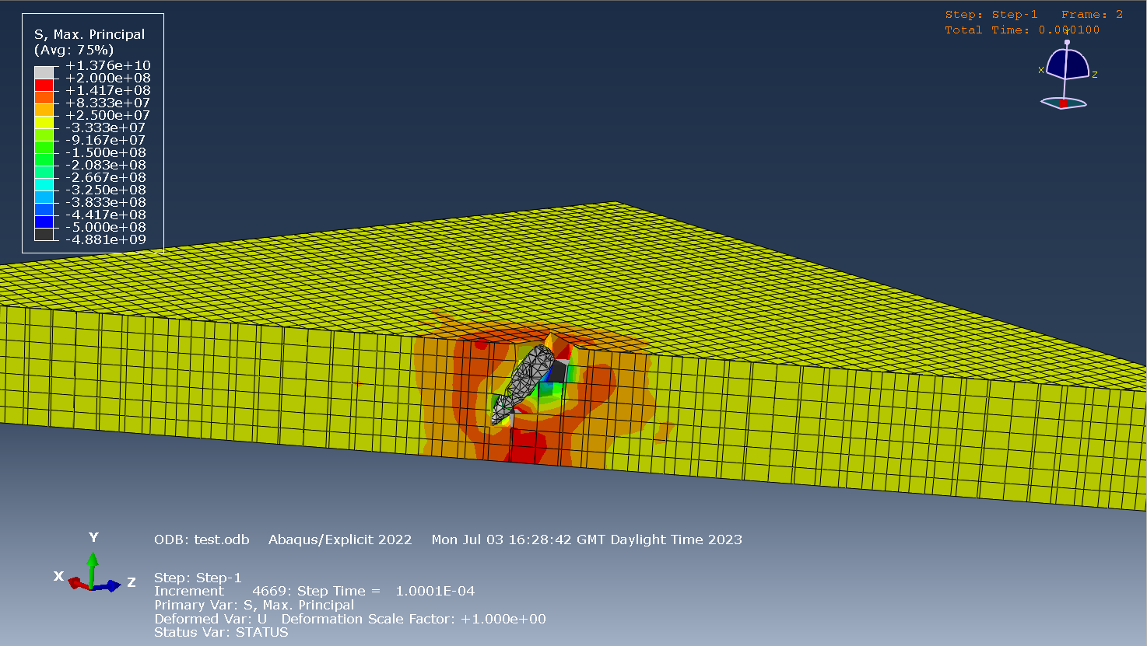
Figure 4: Tensile stress at 850m/s
Figure 3 Shows the sheer stress of the projectile and the plate. Where the velocity is v = 850m/s. Figure 4 shows the max tensile stress that took place. The grey sections indicate where the stresses are at their highest. Blue and black indicate where they are at their lowest.

Images of results: 1000m/s

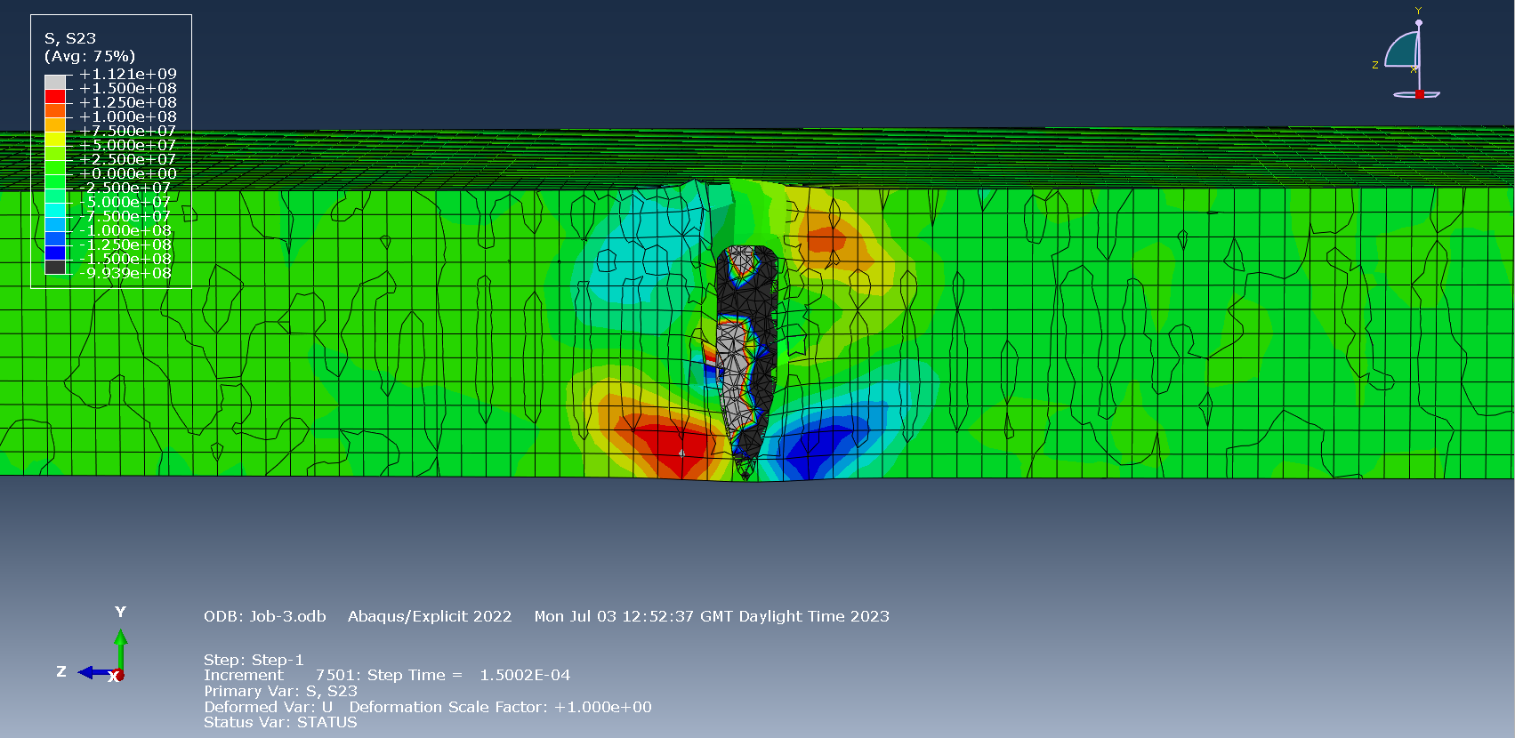
Figure 5: Sheer stress at 1000m/s

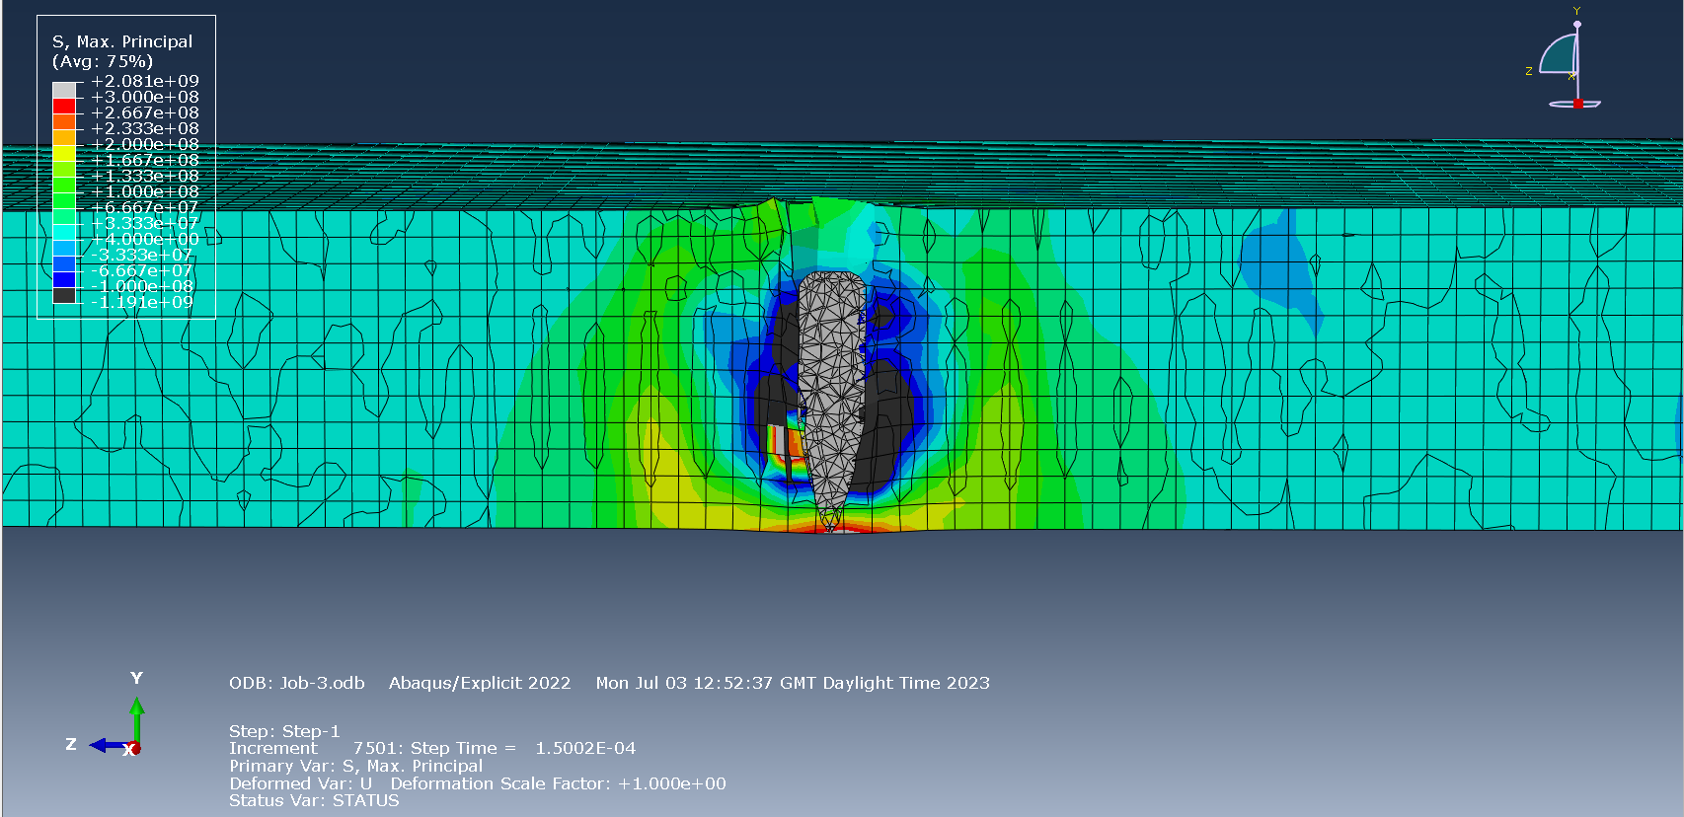
Figure 6: Tensile stress at 1000m/s
Figure 5 Shows the sheer stress of the projectile and the plate. Where the velocity is v = 1000m/s. Figure 6 shows the max tensile stress that took place. The grey sections show where the stresses are at their highest. Blue and black indicates where they are at their lowest.

For all three simulations the user thought that it was appropriate to take screenshots where the stresses are the highest upon penetration. The screenshots would aid them for the written report. It was also interesting to see how at different speeds the projectile would enter the armour and deflect within the plate. Despite the projectile having made direct contact with the plate. We can see this take place at tests: v= 325m/s and v= 850m/s. However, this does not happen at v= 1000m/s.
We can see that as the speeds of the projectile increase, stresses also tend to increase. The highest sheer stress recorded in each simulation are as follows: (v= 325m/s) = +6.482e+08, (v= 850) = 3.139e+9. However, at (v= 1000m/s) the result drops slightly to 2.081+8. These stress values can be seen in both projectile and plate.
The same applies when we look at the tensile stresses. The highest tensile stress recorded in each simulation are as follows: (v= 325m/s) =5.722e+08, (v= 850) =1.376e+10. However, at (v= 1000m/s) the result drops slightly to 1.121e+9. This is consistent with what we see in the sheer stresses.

Discussion / evaluation
By using more nodes and steps they might have been able to increase the accuracy of their results. Another opportunity to make their results more reliable would be to consider all the properties of a 7.62 round. For example, they could have tried a steel projectile with a copper jacket. Whilst this does mean making the simulation could take longer the user would most likely gain more accurate results. Overall, the simulation did run very well. However, they found Improvements could be made by making the simulation run smoother. The user did experience a few occasions where the simulation would not run. This was because the system found a fault (or faults) which needed rectifying before being able to run. By reading the diagnostic they could work out what went wrong and how to fix it. In future simulations the user would carry out further research on material properties. As stated previously the user is likely to gain more accurate results. In future experiments they would likely experiment the same armoured plate but with an alternative projectile. This way they can compare the results between different rounds. For example, instead of a 7.62mm they could use a 12.7mm. They would also fire the round at the same speeds as the 7.62 to make a direct comparison.

Conclusion
The aim of this assignment was to create a projectile and armoured plate which would then be used to calculate stress values that takes place at the point of penetration.
Overall, the simulation was a success. The user was successfully able to build a 7.62mm projectile and aluminium plate. They were then able to add their properties, run the simulation and obtain accurate stress and tensile stress results. By comparing the results were also able to see how the stresses changed due to the velocity of the projectile. They were also able to see how the projectile deflected within the are armoured plate and how the velocity also affected this.

Bibliography

[1] | “3ds.com,” Dassult Systems, 4 July 2023. [Online]. Available: https://www.3ds.com/products-services/simulia/products/abaqus/abaquscae/.
[2] | “BYJU'S.com,” © 2023, BYJU'S. All rights reserved. , [Online]. Available: https://byjus.com/physics/shearing-stress/.
[3] | “CorrosionPedia.com,” Janalta Interactive, [Online]. Available: https://www.corrosionpedia.com/definition/1073/tensile-stress. [Accessed 24 August 2020].
[4] | D. Won Jung and M. Murugesan, “National Library of Medicine,” 18 February 2019. [Online]. Available: https://www.ncbi.nlm.nih.gov/pmc/articles/PMC6416717/#:~:text=Subsequently%2C%20the%20Johnson%2DCook%20flow,estimated%20using%20the%20experimental%20results.. [Accessed 12 July 2023].
[5] | M. B. Karamis, A. A. Cerit and F. Nair, “Mutual Action Between MMCS Structure and Projectile After Ballistic Impact,” Journal of Composite Materials, vol. 42, p. 2486, 2008.
[6] | J. Kratchovíl and M. Drdlova, “Effects of the impact of 7.62 mm small-arms projectiles on various building materials,” IOP Conference Series, Czech Republic, 2018.

Appendix

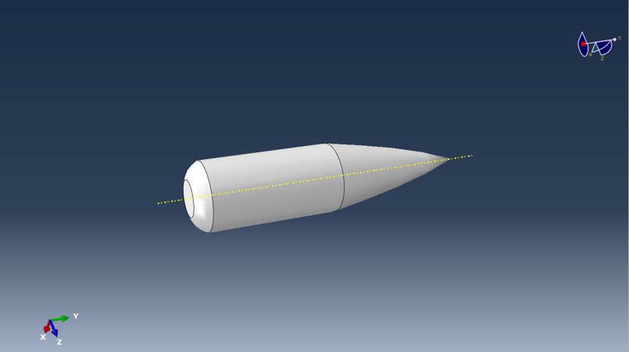
Appendix 1
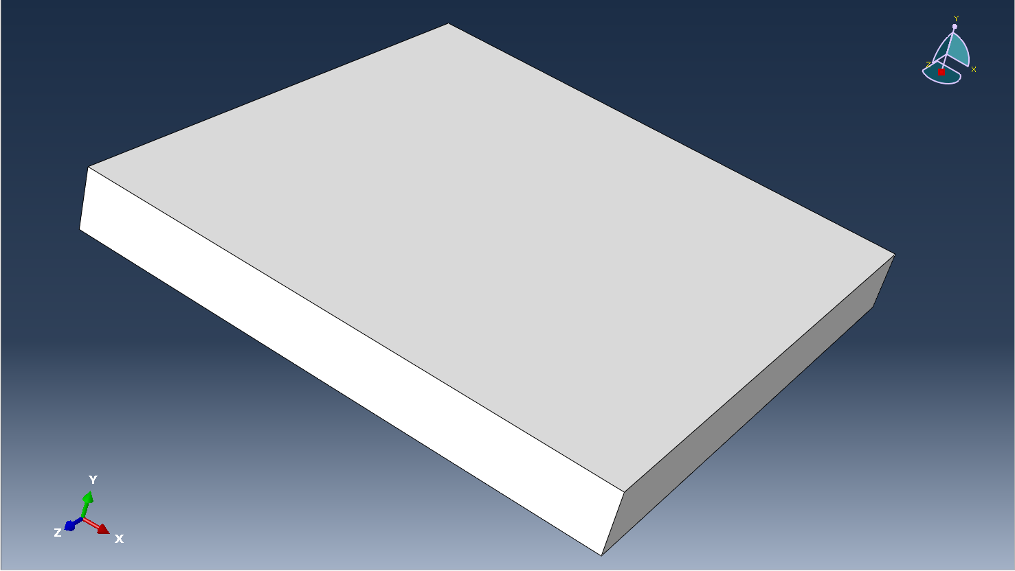
Appendix 2

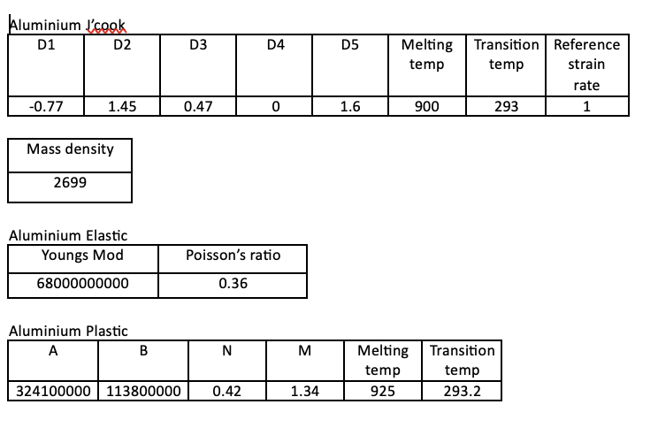
Appendix 3

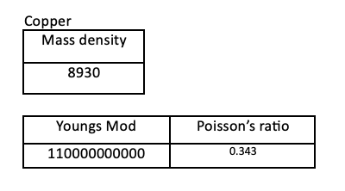
Appendix 4

